

Faculty of Computers and Artificial Intelligence

Computer Science Department

2021/2022

**CS 395 Selected Topics in CS-2**

**Research Project**

Team No. 4

|  |  |  |  |
| --- | --- | --- | --- |
|  | **ID** | **Name** | **Grade** |
|  | **201900364** | **سیف الدین رضا عبد الفتاح** |  |
|  | **201900404** | **عبد الرحمن اشرف امان الله** |  |
|  | **201900360** | **سيد حمدى سيد حميده** |  |
|  | **201900359** | **سيد انورسيد شعبان** |  |
|  | **201900378** | **شيماء محمد احمد فؤاد القصبجى** |  |
|  | **201900493** | **على رمضان على حامد** |  |

Delivered to:

**Dr. Wessam El-Behaidy**

**Eng. Salma Doma**

**Paper details:**

**Part A:**

**Author name:**  [**Jitendra V. Tembhurne**](mailto:jitendra.tembhurne@cse.iiitn.ac.in)**.**

**Paper name: A multi-class skin Cancer classification using deep convolutional neural networks.**

**Publisher name:** **Saket S. Chaturvedi, Jitendra V. Tembhurne & Tausif Diwan.**

**Year of publication: 04 August 2020.**

**Part B:**

**The dataset used: HAM10000**

**The implemented algorithms:**

**InceptionResNetV2:**

**InceptionResNetV2 has introduced significant simplification to the inception blocks. It is a variation of InceptionV3 model which borrows some ideas from ResNet models. Residual connections allow training much deeper neural networks, which lead to even better performance. The study [70] have shown that InceptionResNetV2 significantly accelerates the training of Inception networks with the help of residual connections. So, we included InceptionResNetV2 as a model after performing certain modifications i.e. added dense layer with ‘relu’ activation, dropout and softmax layers with seven outputs. The modified architecture then fine-tuned on 8912 images for 30 epochs wherein the learning rate is 0.0001 and SGD optimizer with momentum is 0.9.**

**Its results:** **The categorical accuracy  for  InceptionResNetV2 is  found to be 93.20%**

**Project Description Document:**

1. **General Information on the selected dataset:**

**The name of the dataset used:** **Blood Cell Images.**

**The link of dataset:**

[**https://www.kaggle.com/datasets/paultimothymooney/blood-cells**](https://www.kaggle.com/datasets/paultimothymooney/blood-cells)**.**

**The total number of samples in the dataset: 71 IMAGES.**

**The dimension of images: ( 120, 120, 3 ).**

**case of classification:**

**Number of classes: 4 Classes.**

**Labels: [ EOSINOPHIL, LYMPHOCYTE, MONOCYTE, NEUTROPHIL ]**

1. **Implementation details:**

**In classification projects:**

**The ratio used for training and the number of images:**

**Training: 80% , 9955 Images.**

**Validation: 10% , 1244 Images.**

**Testing: 10% , 1244 Images.**

**A block diagram of your implemented model to show the main steps, and specify in each block the used algorithm(s)**

**Specify any hyperparameters used in your model.**

**optimizer = "adam" , loss = 'sparse_categorical_crossentropy' ,**

**metrics = ['accuracy'] , activation='relu' ,activation='softmax'**

**, batch_size = 32, epochs = 15, Dropout(0.2)**

1. **Resultsdetails:**

**Specify the measures that are used in evaluation and show all these results for your model on testing data**

* **The measures used are Accuracy, Learning Curves and Confusion Matrix**
* **Testing data Accuracy = 97.20%**

* **Learning Curves**

* **Confusion Matrix**

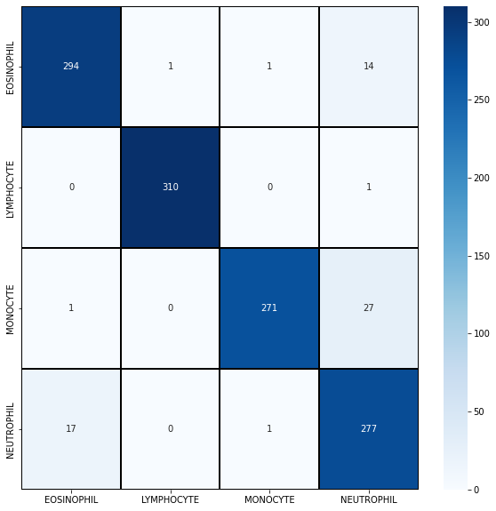

* **Optimization of model**
* **We optimized testing accuracy by changing the pre-processing steps by applying feature scaling by dividing each image by 255 and resizing images size to (120,120) instead of (240,240).**