**Tasks**



Figure 1 Tasks_1

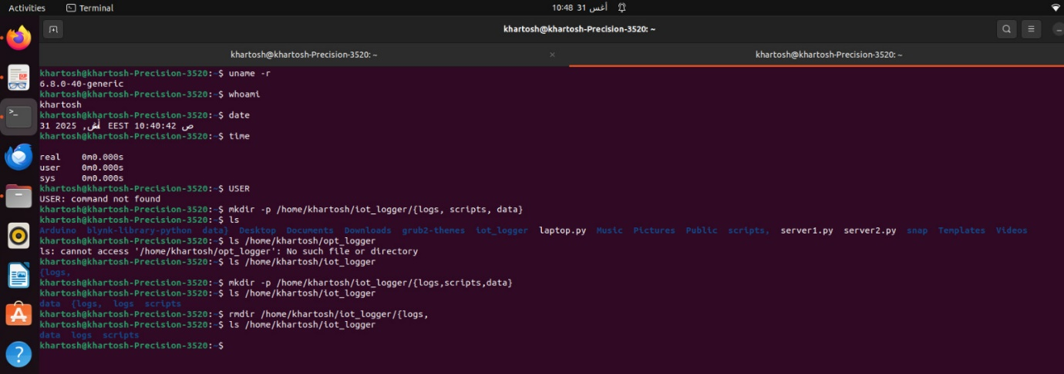

Figure 2 Tasks_2,3

**Open-Ended Questions**

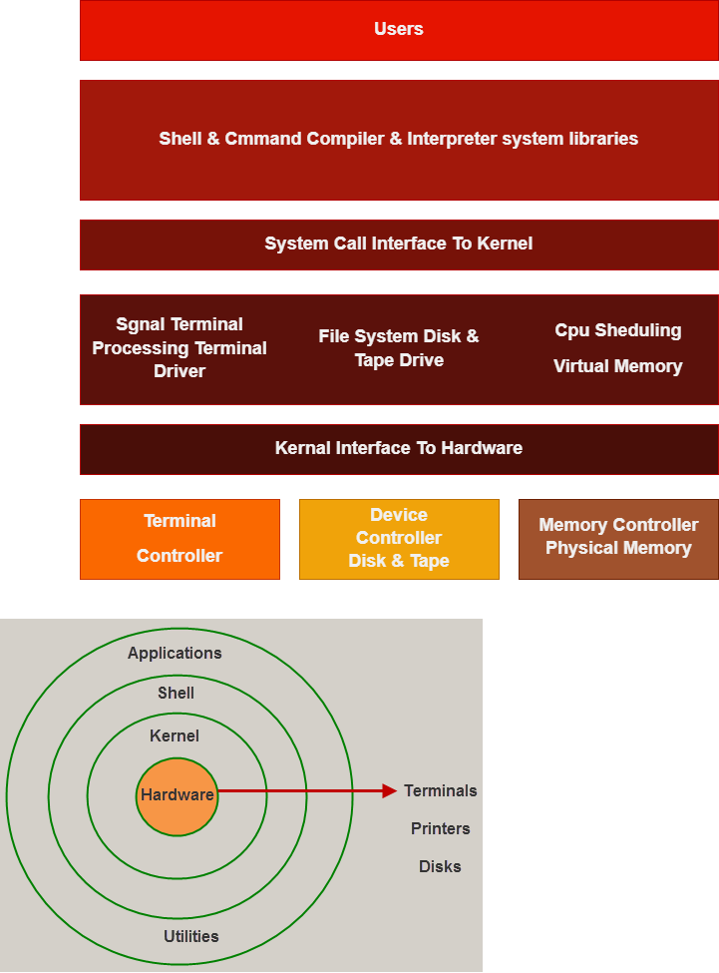

Figure 3 the Linux architecture layers

**/, /bin, /sbin, /usr, /etc, /var**

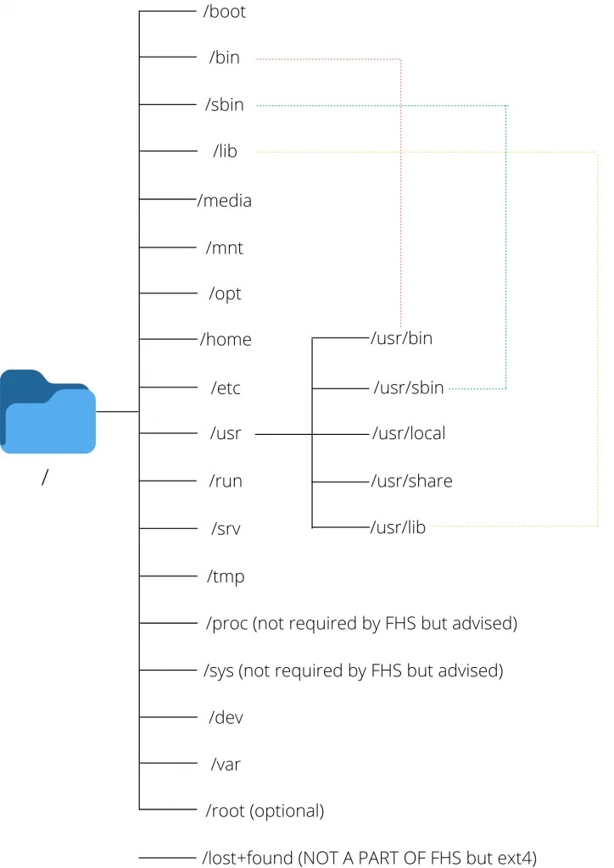

/var

/var is a standard directory that stands for "variable files"

This directory contains data that changes frequently while the system is running.

This directory is used to store data such as:

System Logs-Spool files-Cache from proxy servers-Databases-Temporary files required by programs

$ tree /var -L 1  
/var  
├── account  
├── adm  
├── cache  
├── db  
├── lib  
├── local  
├── lock -> ../run/lock

………….

/bin

The*/bin* directory contains binaries that are essential to the operating system.

This is used for trivial binaries used in the very early boot stage or ones that you need to have available in booting single-user mode. Think of binaries like cat, ls, etc.

/etc

The /etc directory in Linux is a critical system directory that contains configuration files and directories for the system and installed applications.

Its primary purpose is to store system-wide configuration settings that control the behavior of the operating system and various services.

/etc/passwd

/etc/fstab

/etc/hosts

/etc/network/interfaces

/usr

The /usr file system contains executable files that can be shared among machines.

The major subdirectories of the /usr directory are shown in the following diagram.

/sbin

For binaries with superuser (root) privileges required

It is like bin, but it specifically for administration commands.

/

Root directory, it refers for the base of the file system and the foundation of the Linux file system.

The Linux file system follows a tree-like hierarchy, starting from a single root directory, denoted by a forward slash. All other directories and files branch out from this root

**Why does Linux treat everything as a file?**

This statement is true because there are special files that are more than just files (named pipes and sockets, for instance), but to keep things simple, saying that everything is a file is an acceptable generalization. A Linux system, just like UNIX, makes no difference between a file and a directory, since a directory is just a file containing names of other files. Programs, services, texts, images, and so forth, are all files. Input and output devices, and generally all devices, are files, according to the system.

When you create a file or transfer a file to your system, it occupies some space on the physical disk and it is considered to be in a [specific format (file type)](https://www.tecmint.com/find-file-types-in-linux/).

**Explain the difference between a program and a process?**

In Computer Science, there are two fundamental terms in operating system: Program and Process. Program is a set of instructions written to perform a task, stored in memory. A process is the active execution of a program, using system resources like CPU and memory.

|  |  |
| --- | --- |
| Program | Process |
| The program contains a set of instructions designed to complete a specific task. | The process is an instance of an executing program. |
| A program is a passive entity as it resides in the secondary memory. | The process is an active entity as it is created during execution and loaded into the main memory. |
| Program exists at a single place and continues to exist until it is deleted. | The process exists for a limited period as it gets terminated after the completion of the task. |
| A program is a static entity. | The process is a dynamic entity. |
| The program does not have any resource requirement, it only requires memory space for storing the instructions. | The process has a high resource requirement, it needs resources like CPU, memory address, and I/O during its lifetime. |
| The program does not have any control block. | Process has its control block called Process Control Block. |
| The program has two logical components: code and data. | In addition to program data, a process also requires additional information required for the management and execution. |
| Program contains instructions | The process is a sequence of instruction execution. |