NTI July 2026
FPGA Course Projects
Documentation of Labs & Final Projects — Implemented in Verilog
Repository: SeifShaaban22/NTI-July2026-FPGA
Primary language: Verilog (100%) • Track: FPGA Digital Design

Table of Contents

Repository Overview
This repository contains the labs and final projects completed during the NTI July 2026 FPGA course, organized under the projects/ directory.
- Repository: SeifShaaban22/NTI-July2026-FPGA (GitHub)
- Primary language: Verilog (100%)
- Course track: FPGA Digital Design

What I Built
This repository documents progress from basic digital logic exercises to complete FPGA-style systems. It includes:
- 12 labs covering core Verilog and digital design concepts
- 2 final projects focused on real-world embedded digital systems
- A full modular datapath project combining memory, serial/parallel conversion, and ALU control

Labs Overview
Note: some lab folders may contain more than one source file, including testbenches.

Lab | Topic | Core Concept
1 | Introductory digital logic | Verilog foundations
2 | SIPO shift register | Serial-to-parallel conversion
3 | Combinational/sequential practice | Verilog fundamentals
4 | Tri-state driver | Output enable / bus sharing
5 | ALU design | Arithmetic & logic operations
6 | Design practice | Combinational/sequential skills
7 | Design practice | Hardware module testing
8 | RAM / memory module | Memory modeling, read/write
9 | Counter design | Register counters, verification
10 | FSM design | State encoding, next-state logic
11 | Debouncer & sequence detector | Input conditioning, pattern recognition
12 | Edge detection | Moore vs. Mealy pulse generation

Lab 1 — Introductory digital logic
Likely focused on the very basics of Verilog and hardware design foundations.

Lab 2 — SIPO shift register
What it does:
- Accepts serial input bit-by-bit
- Shifts data into a parallel register on each clock edge
- Supports active-low reset
- Uses a shift enable signal to control loading
What I learned:
- Shift-register design
- Sequential always blocks
- Reset handling
- Bit-wise data movement

Lab 3 — Core combinational/sequential logic practice
Likely covered additional Verilog fundamentals and logic building blocks.

Lab 4 — Tri-state driver / output enable
What it does:
- Passes data_in to data_out when enabled
- Drives high impedance (Z) when disabled
What I learned:
- Tri-state behavior
- Output enable control
- Bus-style signal sharing

Lab 5 — ALU design
What it does:
- Supports add, subtract, AND, XOR, OR, and pass-through
- Detects when input a is zero
- Selects operation using a 3-bit opcode
What I learned:
- Arithmetic and logic operations in Verilog
- case-based control logic
- Output flags
- Parameterized module design
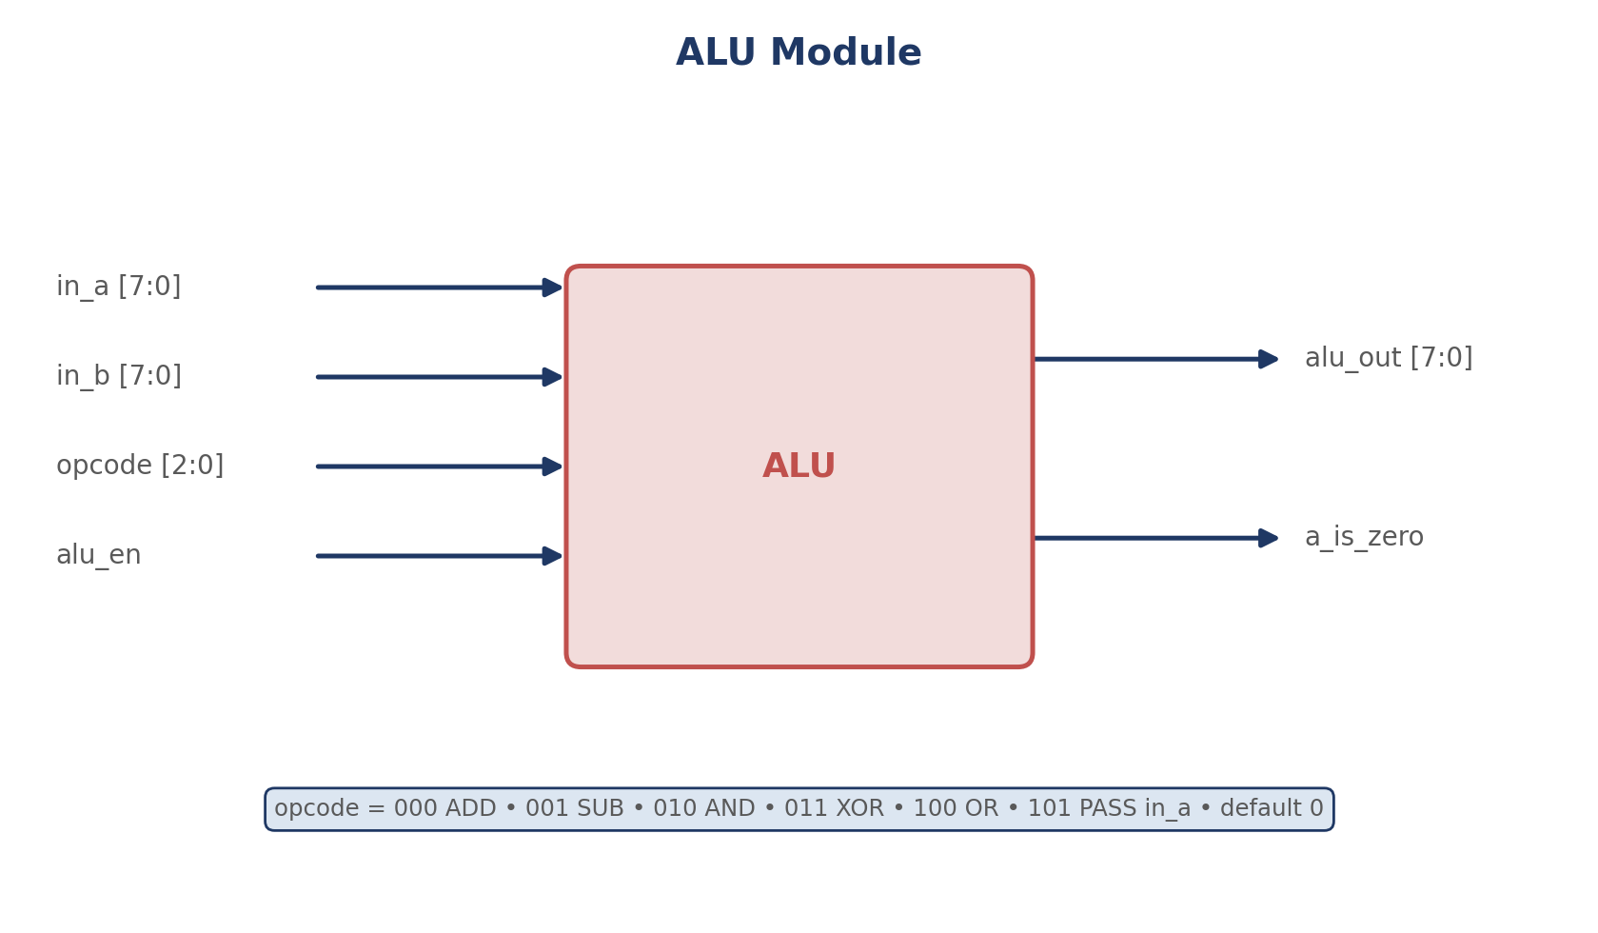
Figure 1 — ALU module: inputs, outputs, and supported opcodes.

Lab 6 — Additional Verilog design practice
Likely focused on extending combinational and sequential design skills.

Lab 7 — Additional Verilog design practice
Likely focused on building and testing more hardware modules.

Lab 8 — RAM / memory module
What it does:
- Stores data in an internal memory array
- Supports read and write operations
- Uses an address input to access memory locations
- Shares data through an inout bus in the lab version
What I learned:
- Memory modeling in Verilog
- Read/write control logic
- Indexed arrays for hardware storage
- Bus interfacing concepts

Lab 9 — Counter design and verification
What it does:
- Resets the count to zero
- Loads a specific value when load is active
- Increments when enab is active
- Includes a testbench that checks different scenarios
What I learned:
- Register-based counters
- Priority of control signals
- Simulation-based verification
- Testbench stimulus and expected checking

Lab 10 — FSM design
What it does:
- Uses a 2-segment FSM structure
- Tracks states S0, S1, and S2
- Produces outputs based on both state and input conditions
- Includes a dedicated testbench
What I learned:
- FSM state encoding
- State register and next-state logic separation
- Moore/Mealy-style output thinking
- FSM simulation and transition testing
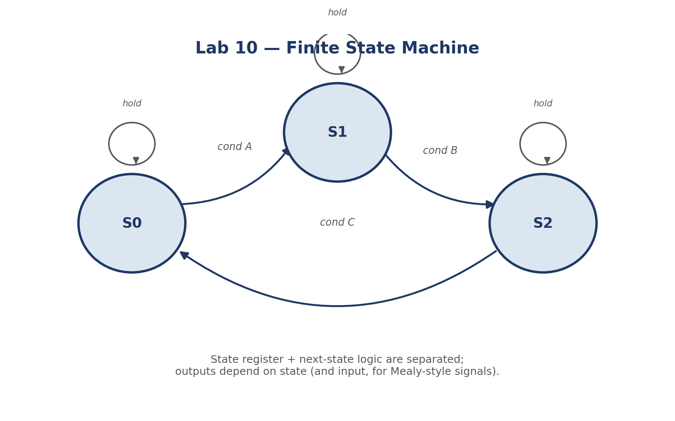
Figure 2 — Generic 3-state FSM structure used in Lab 10.

Lab 11 — Debouncer and sequence detector
What it does:
- Debouncer: filters noisy push-button input, waits for stable input before changing state, uses a counter-based timing approach
- Sequence detector: detects a specific input pattern using states, uses FSM-style pattern recognition
What I learned:
- Debouncing real-world signals
- FSMs for input conditioning
- Sequence detection concepts
- Timing-based validation of mechanical inputs

Lab 12 — Edge detection
What it does:
- Detects when a signal transitions from low to high
- Compares Moore-style and Mealy-style tick outputs
- Includes a testbench for waveform observation
What I learned:
- Edge detection logic
- Comparing Moore and Mealy outputs
- One-cycle pulse generation
- Timing-aware digital design

Final / Major Projects

Final Project — Modulus
A final project focused on modulus-based digital logic. This project likely built on arithmetic and control concepts developed across the labs.

Final Project — Traffic Light Controller
What it does:
- Controls traffic light outputs for multiple directions
- Uses FSM-based control
- Includes support for button input, emergency behavior, and empty-sensor input
- Drives seven-segment display outputs for status information
- Includes a full testbench for simulation
What I learned:
- Realistic FSM system design
- Multi-input control logic
- Output coordination across several subsystems
- Integrating counters, resets, and display logic in one design
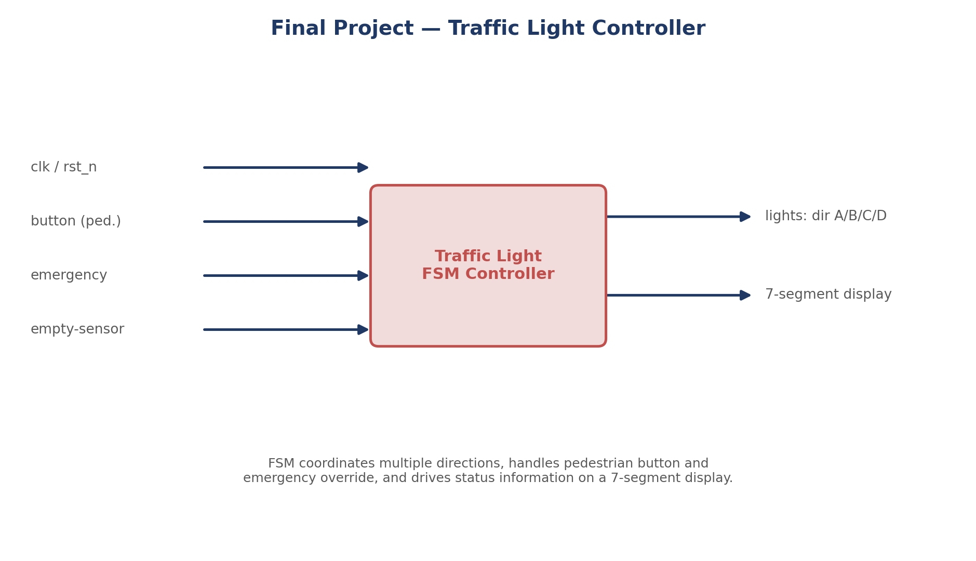
Figure 3 — Traffic light controller: inputs, FSM core, and outputs.

Full Project — Modular Datapath
Architecture:
- RAM stores 20-bit words
- PISO converts parallel data to serial
- SIPO reconstructs serial data into parallel form
- ALU processes the decoded word
- Top module connects everything together
Word format:
- alu_en in bit 19
- opcode in bits 18:16
- in_a in bits 15:8
- in_b in bits 7:0
What I learned:
- Modular system integration
- Datapath construction
- Serial and parallel data conversion
- Control signal routing between hardware blocks
- Building and verifying a complete FPGA-style pipeline
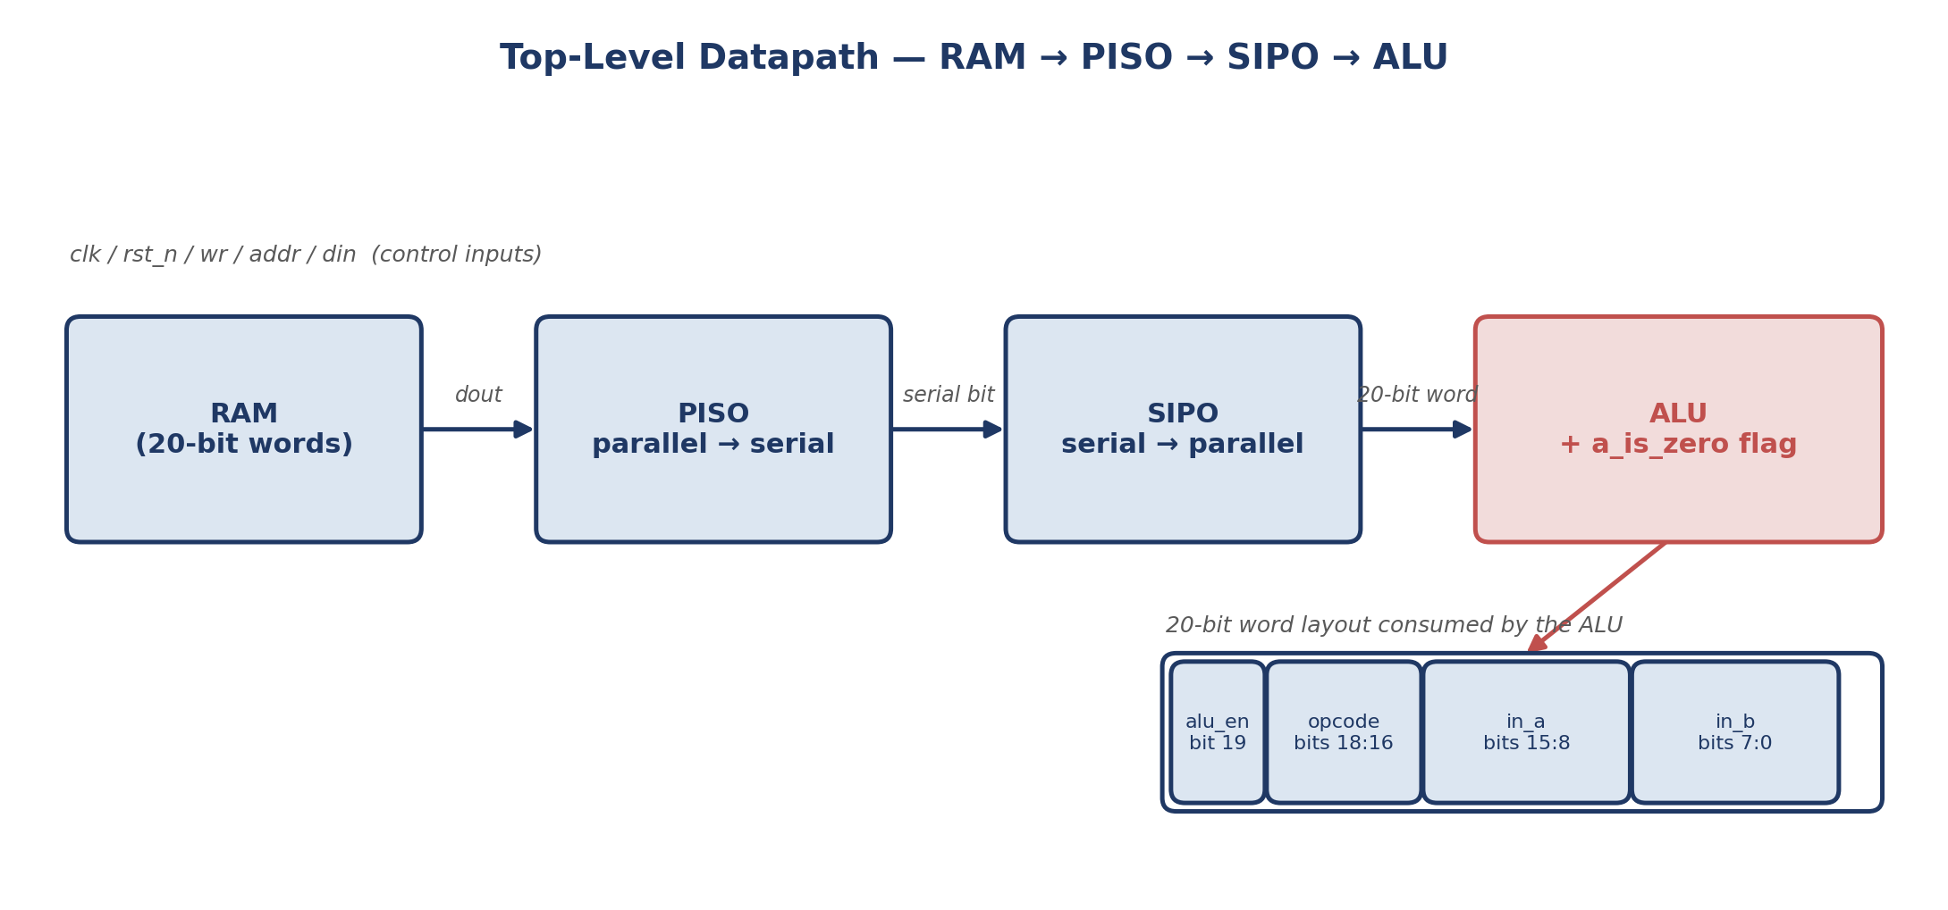
Figure 4 — Full project datapath: RAM → PISO → SIPO → ALU.

Skills Practiced
Across these projects, the following skills were practiced:
- Verilog RTL design
- Combinational and sequential logic
- FSM design and pattern detection
- Memory and counter design
- Serial/parallel data conversion
- Debouncing and edge detection
- Testbench creation and simulation
- Modular hardware system integration

Summary
This repository shows progression from basic Verilog exercises to more complete digital systems: how to design, connect, and test hardware blocks, and how to organize FPGA projects in a structured and reusable way.

Notes
This repository serves as a course portfolio for the NTI July 2026 FPGA training and documents progress from introductory labs to full final implementations.

