NAS Microfinance Management System (TZS)
Complete Idea Specification (TZS Currency + Mandatory Client Referral Info), Mathematical Lending & Overdue Engine, UI/UX Appearance Mockups, Desktop Key-Press & Mobile Touch Interaction Matrix, and Step-by-Step Implementation Blueprint
Document Version | 1.1.0 (October 20, 2026) — TZS Currency & Mandatory Referral Info
Primary Currency | TZS (Tanzanian Shilling) — Supports M-Pesa, Tigo Pesa, Airtel Money, HaloPesa, Bank, Cash
Client Referral Policy | Mandatory Referral / Guarantor on Every Client (Name, Phone, Relationship, Location/NIDA)
Target Platforms | Windows/Mac Desktop PC & Android/iOS Mobile Phone (Installable PWA + Cloud Sync Anywhere)
Multi-User Licensing | One-Time Activation Key System (Expires Immediately After Account Creation) + Super Admin Panel

1. Executive Summary & Core Vision
A cross-platform Progressive Web App (PWA) for managing financial assistance (loans) in Tanzanian Shillings (TZS) with mandatory Client Referral / Guarantor tracking, automatic interest calculation, strict deadline & overdue rollover enforcement, real-time PC-to-Phone synchronization outside the local network, and a one-time activation key licensing system for multi-user expansion.
- All financial assistance, interest, penalties, and repayments tracked and formatted in Tanzanian Shillings (TZS)
- Mandatory Referral / Guarantor Information on every client (Referral Name, Phone Number, Relationship, Location/NIDA, and Referral Trust Chain analytics)
- Real-time cloud synchronization between Desktop PC and Mobile Phone over any network (Wi-Fi, 4G, 5G) with local IndexedDB offline fallback
- Instant dashboard visibility of Total Principal Offered (TZS), Interest %, Expected Profit (TZS), Total Expected Collection (TZS), Realized Profit (TZS), and Overdue Loans
- Automated time-bound interest & 'Or Else' overdue penalty/rollover engine (e.g., 30 days for 20% interest, plus automatic rollover or daily penalty after day 30)
- Multi-tenant SaaS architecture with single-use expiring Activation Keys and Super Admin management portal

2. Mandatory Client Referral / Guarantor Specification
Referral Field | Requirement | Description & Usage
referral_name | string (required) | Full name of the person who referred or guaranteed the client (e.g., Musa Juma)
referral_phone | string (required) | Phone number of the referral (+255 7XX XXX XXX) for 1-click Call or WhatsApp escalation
referral_relationship | enum/string (required) | How the referral knows or guarantees the borrower
referral_location_or_id | string (optional) | Physical shop/office address, NIDA ID, or notes about the referral
referred_by_borrower_id | UUID (optional) | Links to an existing borrower record if the referral is also an active/past client

3. Financial & Mathematical Engine in TZS ('30 Days @ 20% Or Else')
Rule Code | Rule Name | Formula | TZS Example (TZS 500,000 @ 20% for 30d)
SIMPLE_ROLLOVER | Fixed Principal Cycle Rollover (Default) | F_penalty = ceil(days_overdue / D) * (P * r) | Loan of TZS 500,000 @ 20% for 30 days (TZS 600,000 due). On Day 31, Cycle 2 starts and adds +TZS 100,000. New Total Expected = TZS 700,000.
COMPOUND_ROLLOVER | Compound Unpaid Balance Rollover | New_Balance = B_rem * ((1 + r) ^ ceil(days_overdue / D)) | Loan of TZS 500,000 @ 20% for 30 days (TZS 600,000 due). On Day 31, adds 20% of TZS 600,000 (+TZS 120,000). New Total Expected = TZS 720,000.
DAILY_PENALTY | Daily Late Percentage Fee | F_penalty = P * r_daily * days_overdue | Loan of TZS 500,000 with 1% daily late fee. 5 days overdue adds +TZS 25,000. New Total Expected = TZS 625,000.
MANUAL_PENALTY | Manual Alert & Custom TZS Penalty | F_penalty = manual_tzs_amount_entered_by_lender | Lender clicks '+ Apply Penalty' or '+ Extend 7 Days' from the Loan Detail drawer.

4. Multi-User One-Time Activation Key Architecture
Key Format: NAS-YYYY-XXXX-XXXX (16 alphanumeric uppercase characters formatted with hyphens)
- 1. User enters Activation Key on Sign-Up screen
- 2. System checks activation_keys table: key exists, status == 'UNUSED', and (claim_expires_at IS NULL OR claim_expires_at > NOW())
- 3. User submits registration details (Business Name, Phone/Email, Password, Default Currency = TZS)
- 4. PostgreSQL transactional RPC creates auth user + profile, and updates activation_keys SET status = 'USED', used_by = new_user_id, used_at = NOW()
- 5. Key is permanently burned; any subsequent attempt to use the same key returns HTTP 409 'Activation key has already been used and expired.'

5. Screen-by-Screen Appearance Mockups & Every Key Press / Mobile Touch

SCREEN_01: Login & Activation Key Onboarding (TZS Workspace)
Desktop Layout: Centered split-tab card (520px width) on dark slate-navy canvas with live sync indicator in top bar.
Mobile Phone Layout: Full-screen vertical card with sticky bottom submit button and native paste button for activation key.
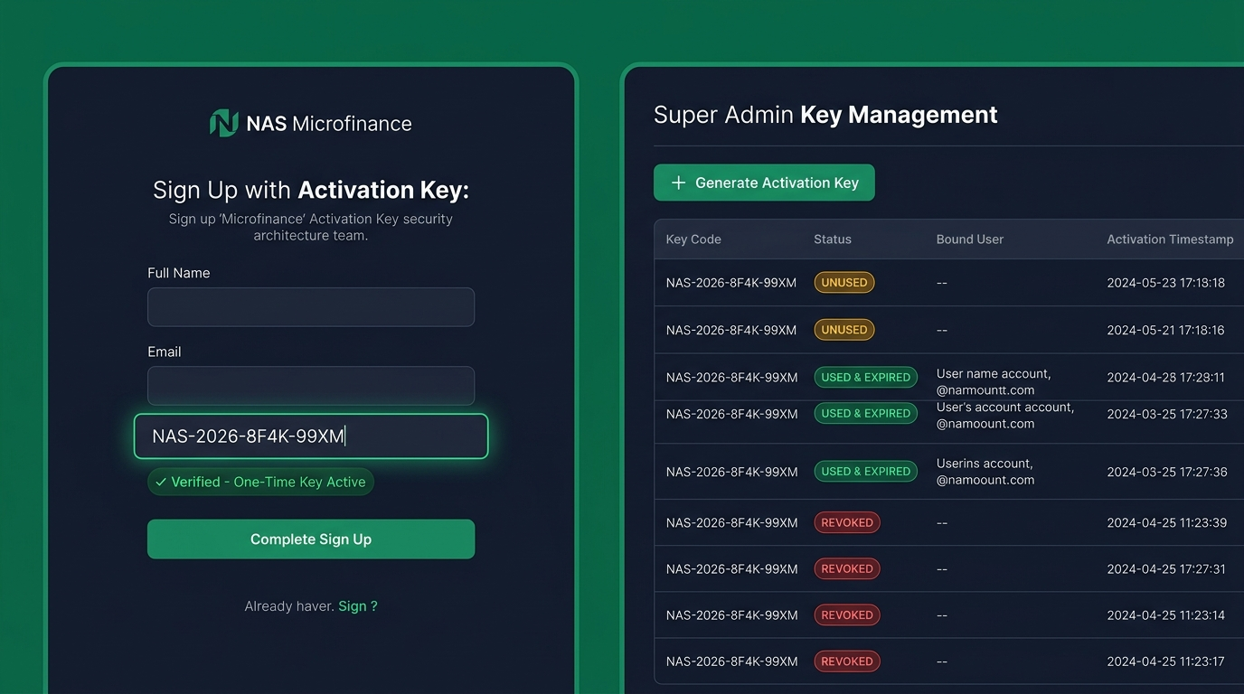
Figure: Visual UI Appearance Mockup for Login & Activation Key Onboarding (TZS Workspace)
Step / Feature | Desktop Key Press / Click | Mobile Phone Touch Gesture | Exact System & UI Response
Switch to Activation Tab | Press 'Alt+2' or click '[Activate New Account]' tab | Tap '[Activate New Account]' segmented control | Reveals Step 1 (Activation Key Input) and auto-focuses the key field.
Enter / Paste Activation Key | Type or press 'Ctrl+V' to paste 16-char key (e.g., NAS-2026-8F4K-99XM) | Tap '[Paste Key]' chip or type on uppercase alphanumeric keyboard | Auto-inserts hyphens every 4 chars, verifies key status against cloud DB in <150ms, and shows green 'Verified Single-Use Key' badge.
Complete Profile & Submit | Press 'Tab' through Business Name, Phone (+255...), Password -> Press 'Enter' | Fill fields using mobile 'Next' key -> Tap '[Activate & Launch TZS Workspace]' | Burns activation key atomically, initializes isolated TZS workspace, and redirects to Executive Dashboard.

SCREEN_02: Executive Dashboard in TZS (Desktop & Mobile)
Desktop Layout: Left navigation sidebar (240px) + Top Command Bar + 4 TZS KPI Summary Cards (Principal Offered: TZS 12,500,000, Expected Profit: +TZS 2,500,000, Total Expected Collection: TZS 15,000,000, Overdue Alert: TZS 1,800,000) + Active Loans & Referrals Table.
Mobile Phone Layout: Top status header + Hero Expected Collection Card (TZS 15,000,000) + 2x2 KPI Grid + Filter Chips + Swipeable Loan Cards showing Client & Referral + Floating '+' Button + Bottom Nav Bar.
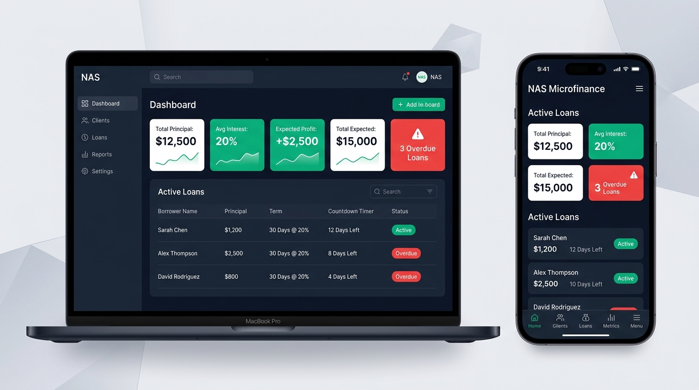
Figure: Visual UI Appearance Mockup for Executive Dashboard in TZS (Desktop & Mobile)
Step / Feature | Desktop Key Press / Click | Mobile Phone Touch Gesture | Exact System & UI Response
Global Search by Client or Referral | Press 'Ctrl+K' or '/' -> type Client or Referral name/phone | Tap Search icon in top bar -> type Client or Referral name/phone | Instantly filters borrowers and loans by either the borrower's details or their Referral/Guarantor's details.
Launch New TZS Loan Form | Press 'N' or click '[+ New Loan]' button | Tap floating emerald '(+)' button at bottom-right | Opens Screen 3 (New Financial Assistance + Mandatory Referral Modal / Bottom Sheet).
Filter Overdue Loans | Press 'O' or click red 'OVERDUE' KPI card | Tap '[Overdue]' filter pill | Filters list to loans past their due date, sorted by urgency and TZS rollover amount.
Quick Row Navigation & Referral Escalation | Press 'J'/'K' to select loan -> 'Enter' for details, 'P' to record payment, 'W' to message Client, or 'R' to contact Referral | Tap loan card for details, Swipe Right to record payment, Tap '[Client 💬]' or Tap '[Ref 📞]' | Opens Loan Detail Drawer, Repayment dialog, or pre-filled WhatsApp/Call to Client or Referral.

SCREEN_03: New Financial Assistance (Client + Referral Info & Live TZS Calculator)
Desktop Layout: 2-column modal dialog: Left column for (1) Client Details, (2) Mandatory Referral/Guarantor Details, (3) Principal in TZS, Rate %, Duration, and Overdue Rule; Right column for Live TZS Earnings & Referral Summary Card.
Mobile Phone Layout: Slide-up bottom sheet with Client & Referral inputs, Quick Preset pills ('7d @ 10%', '14d @ 15%', '30d @ 20%'), decimal keypad inputs, and sticky live TZS preview banner.
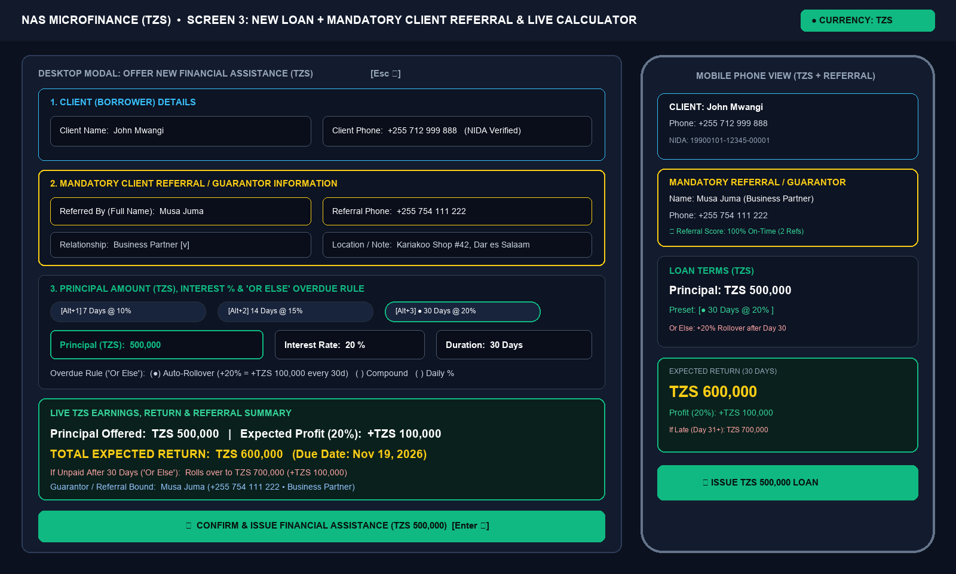
Figure: Visual UI Appearance Mockup for New Financial Assistance (Client + Referral Info & Live TZS Calculator)
Step / Feature | Desktop Key Press / Click | Mobile Phone Touch Gesture | Exact System & UI Response
Enter Client Information | Type Client Name & Phone (+255...) or select existing client from dropdown | Tap Client input -> pick existing client chip or enter new name & phone | If existing client is selected, auto-fills their saved Referral Information and displays their repayment trust score.
Enter Mandatory Referral / Guarantor Information | Press 'Tab' -> Enter Referral Full Name, Referral Phone (+255...), Relationship (e.g., Business Partner), and Location/NIDA note | Tap Referral fields (or tap '[Pick Existing Client]' as Referee) | Validates referral fields are complete and checks if this referral has any other referred clients currently Overdue.
Enter Principal Offered in TZS | Press 'Tab' -> Type numeric TZS amount (e.g., '500000') | Tap Principal (TZS) field -> numeric keypad opens -> tap '500000' | Auto-formats as 'TZS 500,000' and live preview immediately computes Expected Interest (+TZS 100,000) and Total Return (TZS 600,000).
Set Rate %, Duration Days & Overdue Rule | Press 'Alt+1' (7d@10%), 'Alt+2' (14d@15%), 'Alt+3' (30d@20%), and choose Overdue Rule | Tap preset pill '[30d @ 20%]' and tap Overdue Rule card | Displays Due Date and exact Day 31+ overdue projection in TZS (e.g., 'If unpaid after 30 days: becomes TZS 700,000').
Issue TZS Financial Assistance | Press 'Enter' or 'Ctrl+Enter' | Tap '[Confirm & Issue TZS Loan]' | Saves client, referral, and loan to DB, updates TZS dashboard KPIs, syncs across PC & Phone, and offers 1-click Receipt sharing.

SCREEN_04: Loan Detail, Overdue 'Or Else' Rollover, Referral Escalation & Repayment Drawer
Desktop Layout: Slide-over right drawer (580px) showing Overdue Banner, Client & Referral Contact Card, TZS Breakdown Cards, Mobile Money / Cash Repayment form, and Audit Timeline.
Mobile Phone Layout: Full-screen detail view with 1-tap Client & Referral Call/WhatsApp buttons and sticky bottom '[Record TZS Payment]' bar.
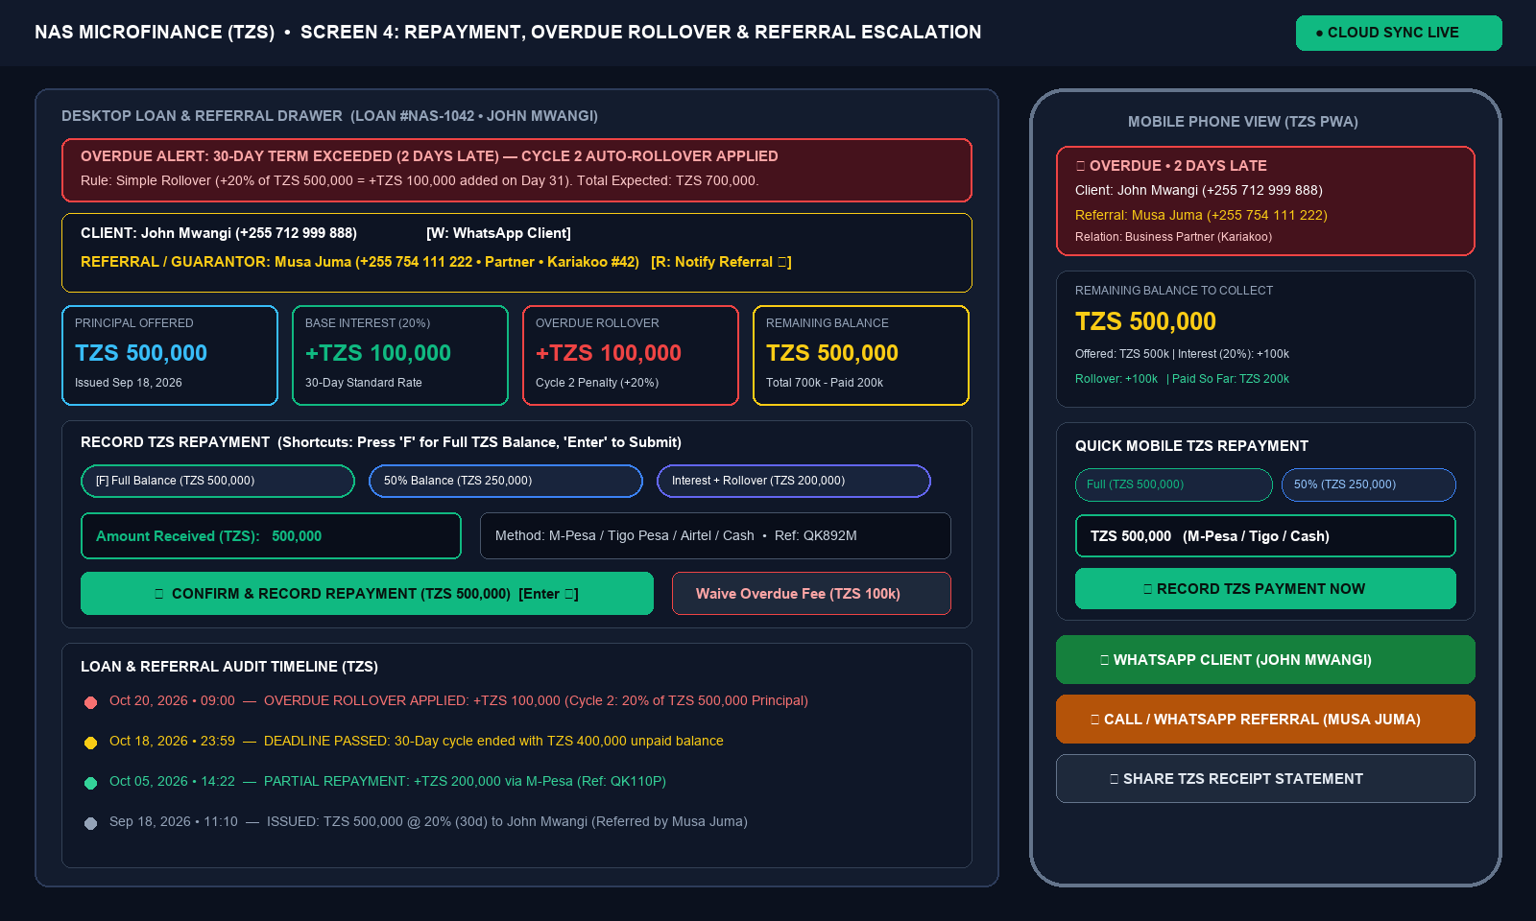
Figure: Visual UI Appearance Mockup for Loan Detail, Overdue 'Or Else' Rollover, Referral Escalation & Repayment Drawer
Step / Feature | Desktop Key Press / Click | Mobile Phone Touch Gesture | Exact System & UI Response
One-Click Full TZS Settlement | Press 'F' (Full Balance) then 'Enter' | Tap '[Full Balance (TZS 500,000)]' chip then tap '[Record Payment]' | Fills exact remaining TZS balance, marks loan as PAID, and transfers interest to Realized Profit (TZS).
Partial Repayment via Mobile Money / Cash | Type partial TZS amount -> Select M-Pesa / Tigo Pesa / Airtel Money / Cash -> Press 'Enter' | Enter partial TZS amount -> Select payment method -> Tap '[Record Payment]' | Deducts payment from remaining TZS balance, updates progress bar, and logs transaction reference in audit history.
Notify Referral / Guarantor on Overdue Loan | Press 'R' or click '[Notify Referral 💬]' | Tap '[Notify Referral 💬]' or '[Call Referral 📞]' | Opens WhatsApp or Phone Dialer to the Referral's phone number with loan & overdue details.

SCREEN_05: Client & Referral Directory + Credit Risk Profile
Desktop Layout: Searchable data table with columns: Client Name & Phone, Referred By (Name, Phone, Relation), Active Loan (TZS), Lifetime Profit Earned (TZS), and Trust Score.
Mobile Phone Layout: Contact cards displaying Client & Referral info with 1-tap Call, WhatsApp, and Trust Score badge.
Figure: Visual UI Appearance Mockup for Client & Referral Directory + Credit Risk Profile
Step / Feature | Desktop Key Press / Click | Mobile Phone Touch Gesture | Exact System & UI Response
Inspect Client & Referral Chain | Press 'B' -> Select client with 'Up/Down' -> Press 'Enter' | Tap 'People' tab -> Tap client card | Shows complete TZS borrowing history, guarantor/referral contact card, and any other clients referred by the same person.

SCREEN_06: Super Admin Activation Key Generator & User Manager
Desktop Layout: Admin console with Key Generator form at top and filterable Keys & Active Tenants table below.
Mobile Phone Layout: Admin tab with 1-tap '[Generate Key]' card and shareable key list.
Figure: Visual UI Appearance Mockup for Super Admin Activation Key Generator & User Manager
Step / Feature | Desktop Key Press / Click | Mobile Phone Touch Gesture | Exact System & UI Response
Generate New Activation Key | Press 'K' -> Press 'G' or click '[Generate Key]' | Tap Admin Key icon -> Tap '[Generate Key]' | Generates unique key 'NAS-2026-XXXX-XXXX' with status UNUSED.
Copy / Share Key with New User | Press 'C' or click '[Copy Key]' | Tap '[Share via WhatsApp]' | Copies key + invite instructions so the recipient can create their TZS lender account before the key expires.

6. Formal Step-by-Step Implementation Blueprint

Phase 1: Project Scaffolding & PWA Setup
- Next.js TypeScript + Tailwind CSS project initialized in workspace
- PWA manifest.json, icons, and offline service worker configured for PC & Mobile installation
- Responsive layout shell (Desktop Sidebar + Mobile Bottom Navigation)

Phase 2: TZS Financial Engine & Client Referral Model
- Pure TypeScript financial module (src/lib/finance-engine.ts) with TZS currency formatting
- Mandatory Client Referral / Guarantor validation and referral-chain risk badges
- Support for Principal (TZS), Interest %, Duration Days, Due Date, and all 4 Overdue 'Or Else' modes

Phase 3: Multi-User Auth & One-Time Activation Key System
- Database schema & Row-Level Security (RLS) for strict per-user isolation
- Sign-Up with Activation Key verification & atomic key burn (UNUSED -> USED)
- Super Admin Key Generator & User Licensing management screen

Phase 4: Executive TZS Dashboard, Loan + Referral Modal & Repayment Drawer
- Executive Dashboard with live TZS KPI cards (Offered, Interest %, Expected Profit, Overdue)
- New Financial Assistance modal/sheet with Client + Mandatory Referral fields and live TZS calculator
- Loan Detail & Repayment drawer with Mobile Money methods (M-Pesa, Tigo Pesa, Airtel Money, HaloPesa, Cash), 1-click Full Balance settlement, and Client/Referral WhatsApp reminders

Phase 5: Cross-Network Cloud Sync, Offline Queue & Keyboard Shortcuts
- Real-time sync via Supabase / Cloud API + local IndexedDB persistence
- Global desktop keyboard shortcuts (N, P, R, W, D, L, B, K, O, Ctrl+K, Esc) and mobile touch gestures
- Shareable TZS PDF/PNG Receipt generator showing Client, Referral, and Loan breakdown

Phase 6: Stage 2 Production Hardening & Live Operations (v1.2.0)
- Upgrade 1: Front-door authentication lock + in-app Admin/Lender Email, Phone & Password changer
- Upgrade 2: One-click 'Clear Sample Data (Start Fresh at TZS 0)' portfolio reset
- Upgrade 3: Full Edit & Delete controls for Clients, Mandatory Referrals, and TZS Loans
- Upgrade 4: Branded 192x192 & 512x512 PWA Icons, Service Worker, and in-app 'Install App' button
- Upgrade 5: One-click 'Export TZS Portfolio to Excel (CSV)' backup generator

7. Complete Markdown Wireframes & SQL Schema Reference
# NAS Microfinance Management System
## Complete Product Specification, UI/UX Appearance Mockups, Interaction Matrix & Step-by-Step Implementation Blueprint
- **Document Version:** 1.2.0 (Updated with **TZS Currency**, **Mandatory Client Referral Tracking** & **Stage 2 Production Hardening Plan**)
- **Date:** October 20, 2026
- **Live Production URL:** https://na-smicrofinance-management.vercel.app/
- **Primary Currency:** Tanzanian Shilling (**TZS**)
- **Platform Architecture:** Cross-Platform Installable Progressive Web App (PWA) — Windows/Mac Desktop & iOS/Android Mobile
- **Sync Architecture:** Real-Time Cloud Sync (Outside Local Network via HTTPS/WSS) + Local IndexedDB Offline Queue
- **Licensing Model:** Multi-Tenant SaaS with Single-Use Expiring Activation Keys & Super Admin Console
---
## Table of Contents
1. [Executive Summary & Core Vision](#1-executive-summary--core-vision)
2. [System Architecture & Cross-Network PC-to-Phone Sync](#2-system-architecture--cross-network-pc-to-phone-sync)
3. [Financial & Mathematical Engine in TZS ("The Lending & Or-Else Rules")](#3-financial--mathematical-engine-in-tzs-the-lending--or-else-rules)
4. [Client & Mandatory Referral (Guarantor) Tracking Engine](#4-client--mandatory-referral-guarantor-tracking-engine)
5. [Activation Key & Multi-User Licensing Engine](#5-activation-key--multi-user-licensing-engine)
6. [Screen-by-Screen Appearance Mockups & Every Key Press / Touch Interaction](#6-screen-by-screen-appearance-mockups--every-key-press--touch-interaction)
- [Screen 1: Login & Activation Key Onboarding](#screen-1-login--activation-key-onboarding)
- [Screen 2: Executive Dashboard in TZS (Desktop & Mobile)](#screen-2-executive-dashboard-in-tzs-desktop--mobile)
- [Screen 3: New Financial Assistance (Client + Referral Info & Live TZS Calculator)](#screen-3-new-financial-assistance-client--referral-info--live-tzs-calculator)
- [Screen 4: Loan Detail, Overdue "Or Else" Rollover, Referral Escalation & Repayment Drawer](#screen-4-loan-detail-overdue-or-else-rollover-referral-escalation--repayment-drawer)
- [Screen 5: Client & Referral Directory + Credit Risk Profile](#screen-5-client--referral-directory--credit-risk-profile)
- [Screen 6: Super Admin Activation Key Generator & User Manager](#screen-6-super-admin-activation-key-generator--user-manager)
7. [Global Keyboard Shortcuts (Desktop) & Touch Gestures (Mobile)](#7-global-keyboard-shortcuts-desktop--touch-gestures-mobile)
8. [Complete Database Schema & Security Policies (PostgreSQL / Supabase)](#8-complete-database-schema--security-policies-postgresql--supabase)
9. [Formal Step-by-Step Implementation Blueprint](#9-formal-step-by-step-implementation-blueprint)
---
## 1. Executive Summary & Core Vision
**NAS Microfinance Management** is a high-speed, precision financial assistance and lending tracker built for Tanzanian microfinance operators and individual lenders transacting in **Tanzanian Shillings (`TZS`)**.
### Core Objectives
1. **Instant TZS Financial Visibility:** Display at a glance the **Total Principal Offered (TZS)**, **Interest Percentage (%)**, **Expected Profit (Interest to Earn in TZS)**, **Total Expected Return (TZS)**, **Realized Profit (TZS)**, and **Overdue Balances (TZS)**.
2. **Mandatory Client Referral / Guarantor Traceability:** Every client (borrower) registered or offered financial assistance must have **Referral Information** recorded (Referral Full Name, Referral Phone Number, Relationship to Client, NIDA/ID or Workplace/Location Notes). If a client becomes overdue, you can contact their referral via Call or WhatsApp in one click/tap.
3. **Seamless PC & Phone Sync Anywhere:** Work seamlessly on a desktop/laptop computer at home or the office, and automatically synchronize in real time with a mobile phone anywhere in the world (over 4G/5G/Wi-Fi outside the local network), including offline caching when internet connectivity drops.
4. **Automated Time-Bound Interest & "Or Else" Overdue Enforcement:** Issue financial assistance for a defined period and rate (e.g., **30 days at 20% interest**), track countdowns to the exact day, and automatically calculate overdue penalties or cycle rollovers when a borrower exceeds the agreed deadline.
5. **Multi-User Activation Key System:** Allow new lenders to onboard only if they possess a valid **Activation Key** generated by the Super Admin. Once used to create an account, the activation key immediately expires (`USED`) and binds to that user's isolated workspace.
---
## 2. System Architecture & Cross-Network PC-to-Phone Sync
```mermaid
flowchart LR
subgraph Desktop["Windows / Mac Computer"]
D_UI["Desktop PWA / Browser UI\n(Keyboard Shortcut Driven)"]
D_IDB[("Local IndexedDB\nOffline Cache")]
D_UI <--> D_IDB
end
subgraph Cloud["Cloud Backend (HTTPS / WSS Anywhere)"]
Auth["Auth & Activation Key\nVerification Service"]
API["REST / GraphQL API\n+ Row-Level Security (RLS)"]
DB[("PostgreSQL Database\n(Multi-Tenant Isolated)")]
RT["Realtime WebSocket\nBroadcast Engine"]
Cron["Scheduled Overdue &\nRollover Worker"]
Auth --> DB
API <--> DB
DB <--> RT
Cron --> DB
end
subgraph Mobile["Mobile Phone (4G/5G/Wi-Fi Outside LAN)"]
M_UI["Installed Mobile PWA\n(Touch & Bottom-Sheet UI)"]
M_IDB[("Local IndexedDB\nOffline Cache")]
M_UI <--> M_IDB
end
D_UI <== "TLS 1.3 Sync & WebSockets" ==> API
D_UI <== "Live Push (<250ms)" ==> RT
M_UI <== "TLS 1.3 Sync & WebSockets" ==> API
M_UI <== "Live Push (<250ms)" ==> RT
```
---
## 3. Financial & Mathematical Engine in TZS ("The Lending & Or-Else Rules")
All monetary values are stored in integer/decimal **Tanzanian Shillings (`TZS`)** and formatted clearly with thousand separators (e.g., `TZS 500,000`).
### 3.1 Base Loan Calculation
Given:
- $P$ = Principal Amount Offered (e.g., `TZS 500,000`)
- $r$ = Interest Rate Percentage per cycle (e.g., `20%` = `0.20`)
- $D$ = Term Duration in Days (e.g., `30` days)
- $T_{\text{start}}$ = Issue Date
Then:
- **Expected Base Interest ($I_{\text{base}}$):**
$$I_{\text{base}} = P \times r$$
*(Example: $\text{TZS } 500,000 \times 0.20 = \text{TZS } 100,000$)*
- **Initial Total Expected Return ($E_{\text{initial}}$):**
$$E_{\text{initial}} = P + I_{\text{base}} = P \times (1 + r)$$
*(Example: $\text{TZS } 500,000 + \text{TZS } 100,000 = \text{TZS } 600,000$)*
- **Due Date ($T_{\text{due}}$):**
$$T_{\text{due}} = T_{\text{start}} + D \text{ days}$$
### 3.2 The "Or Else" Overdue & Penalty Engine (4 Selectable Modes per Loan)
When current date $T_{\text{now}} > T_{\text{due}} + G$ (where $G$ is optional Grace Period days, default `0`) and Remaining Balance $B_{\text{rem}} > 0$:
| Mode Code | Mode Name | Formula when Overdue | Concrete TZS Example ($P=\text{TZS } 500,000, r=20\%, D=30\text{d}$, Unpaid on Day 31) |
| :--- | :--- | :--- | :--- |
| **`SIMPLE_ROLLOVER`** *(Default)* | **Fixed Principal Rollover** | Adds $P \times r$ for each new overdue cycle $k = \lceil \text{days\_overdue} / D \rceil$ | Cycle 2 adds another **+TZS 100,000** ($20\%$ of original $\text{TZS } 500\text{k}$). New Total Due = **TZS 700,000**. |
| **`COMPOUND_ROLLOVER`** | **Compound Total Rollover** | Multiplies unpaid balance $B_{\text{rem}}$ by $(1 + r)$ each new cycle | Cycle 2 adds $20\%$ of $\text{TZS } 600,000$ = **+TZS 120,000**. New Total Due = **TZS 720,000**. |
| **`DAILY_PENALTY`** | **Daily Late Percentage** | Adds $P \times r_{\text{daily}} \times \text{days\_overdue}$ | At $1\%$/day overdue for 5 days: adds **+TZS 25,000**. New Total Due = **TZS 625,000**. |
| **`MANUAL_PENALTY`** | **Manual Custom Penalty** | Flags loan `OVERDUE` in red; lender clicks `+ Apply Penalty` to add custom TZS fee or extend date | Lender reviews client & referral situation and applies a custom TZS fee or grace extension. |
### 3.3 Repayment Allocation Order
When a borrower makes a partial payment $M_{\text{paid}}$ (via M-Pesa, Tigo Pesa, Airtel Money, HaloPesa, Bank, or Cash):
1. First clears **Accrued Penalties / Rollover Fees** ($F_{\text{penalty}}$)
2. Next clears **Expected Base Interest** ($I_{\text{base}}$) -> *Increments your Realized Profit (TZS)*
3. Finally clears **Principal Offered** ($P$) -> *Returns capital to your Available TZS Pool*
$$\text{Remaining Balance } (B_{\text{rem}}) = (P + I_{\text{base}} + F_{\text{penalty}}) - \sum M_{\text{paid}}$$
---
## 4. Client & Mandatory Referral (Guarantor) Tracking Engine
To protect your capital, **every client record requires Referral Information** before a loan can be issued:
| Field | Requirement | Description & Purpose |
| :--- | :--- | :--- |
| **Referral Type** | Required | Either **Existing Trusted Client** (linked to an existing borrower ID) or **External Referee / Guarantor** |
| **Referral Full Name** | Required | Full legal/known name of the person who referred or guaranteed the client (e.g., *Musa Juma*) |
| **Referral Phone Number** | Required | Tanzanian phone number (`+255 7XX XXX XXX`) with instant 1-tap Call & WhatsApp integration |
| **Relationship to Client** | Required | e.g., *Colleague, Business Partner, Family Member, Existing Borrower, Employer, Neighbor* |
| **Referral NIDA / ID / Location** | Optional | National ID number, workplace, or physical address of the referral |
| **Referral Trust & Chain Analytics** | Automatic | Tracks how many clients a referral has introduced and whether those referred clients pay on time! Alerts you if a referral's previous referrals are currently `OVERDUE`. |
---
## 5. Activation Key & Multi-User Licensing Engine
```mermaid
sequenceDiagram
autonumber
actor Admin as Super Admin (You)
participant Sys as NAS Cloud Backend
actor User as New Lender User
Admin->>Sys: Clicks "Generate Activation Key" (Plan: Lifetime / 365d)
Sys-->>Admin: Returns Key "NAS-2026-8F4K-99XM" (Status: UNUSED)
Admin->>User: Shares Key via WhatsApp / SMS / Email
User->>Sys: Opens Sign-Up -> Enters Key "NAS-2026-8F4K-99XM"
Sys->>Sys: Validates Key exists, Status == UNUSED, Not Expired
Sys-->>User: Shows Green Badge "Valid Activation Key"
User->>Sys: Submits Name, Phone/Email, Password (Currency Default: TZS)
Sys->>Sys: Atomic DB Transaction:\n1. Create User Account & Tenant Workspace\n2. Mark Key Status = USED, used_by = user.id, used_at = NOW()
Sys-->>User: Logs User into their Private TZS Dashboard
Note over User,Sys: Any second attempt to use "NAS-2026-8F4K-99XM" is rejected immediately!
```
---
## 6. Screen-by-Screen Appearance Mockups & Every Key Press / Touch Interaction
---
### Screen 1: Login & Activation Key Onboarding
#### Appearance Mockup (Desktop Split-Card & Mobile Full-Screen)
```text
+-----------------------------------------------------------------------------------+
| NAS MICROFINANCE MANAGEMENT (TZS) [Sync: Online ●] [Theme] |
+-----------------------------------------------------------------------------------+
| |
| +-------------------------------------------------------------+ |
| | [ Sign In ] [ Activate New Account ] | |
| +-------------------------------------------------------------+ |
| | STEP 1: ENTER ONE-TIME ACTIVATION KEY | |
| | +-------------------------------------------------------+ | |
| | | NAS - 2026 - 8F4K - 99XM [✓] | | |
| | +-------------------------------------------------------+ | |
| | [✓ Valid Key: Standard Lender License • One-Time Use] | |
| | | |
| | STEP 2: CREATE YOUR LENDER ACCOUNT | |
| | Full Name / Business Name: [ NAS Microfinance TZ ] | |
| | Phone Number or Email: [ +255 712 000 000 ] | |
| | Primary Currency: [ TZS (Tanzanian Shilling) ] | |
| | Password: [ •••••••••••• [👁] ] | |
| | | |
| | [ ACTIVATE & LAUNCH MY WORKSPACE (Enter ↵) ] | |
| +-------------------------------------------------------------+ |
| |
+-----------------------------------------------------------------------------------+
```
#### Every Key Press & Interaction (Screen 1)
| Step | User Action (Desktop Keyboard / Mouse) | User Action (Mobile Touch) | System Visual & Data Response |
| :--- | :--- | :--- | :--- |
| **1.1** | Press `Alt + 2` or click **[Activate New Account]** tab | Tap **[Activate New Account]** pill at top | Form slides to Activation Key onboarding view; cursor auto-focuses inside the Activation Key input box. |
| **1.2** | Type or `Ctrl + V` paste key `NAS20268F4K99XM` | Long-press -> **Paste** key from WhatsApp/SMS | Input auto-formats with hyphens (`NAS-2026-8F4K-99XM`). On the 16th character, triggers a live `POST /api/keys/verify` check. |
| **1.3** | Key validation completes (`<150ms`) | Haptic light vibration feedback on mobile | Border turns Emerald Green (`#10B981`), displays badge: `✓ Valid Key • Single-Use`. If already used, border turns Crimson Red (`#EF4444`): `✗ Key Already Used & Expired`. |
| **1.4** | Press `Tab` -> Type Business Name -> `Tab` -> Phone/Email (`+255...`) -> `Tab` -> Password | Tap each field; mobile keyboard shows `Next` button | Currency is pre-selected to **TZS (Tanzanian Shilling)**; password strength bar fills. |
| **1.5** | Press `Enter ↵` (or click **[Activate & Launch]**) | Tap **[Activate & Launch My Workspace]** | Runs atomic transaction (creates account + marks key `USED`), stores session, and transitions to **Screen 2 (Dashboard)**. |
---
### Screen 2: Executive Dashboard in TZS (Desktop & Mobile)
#### Desktop Appearance Mockup (1440x900 Viewport)
```text
+--------------------+-----------------------------------------------------------------------------+
| NAS MICROFINANCE | Search client, referral, phone... (Ctrl+K) [● Synced] [+ New Loan] |
|--------------------|-----------------------------------------------------------------------------|
| ● Dashboard [D] | FINANCIAL OVERVIEW (OCTOBER 2026 • TZS) Filter: [Active Cycle v] |
| ○ Loans [L] | +-------------------+ +-------------------+ +-------------------+ +-------+|
| ○ Clients/Ref [B] | | PRINCIPAL OFFERED | | EXPECTED PROFIT | | TOTAL EXPECTED | |OVERDUE||
| ○ Repayments [P] | | TZS 12,500,000 | | +TZS 2,500,000 | | TZS 15,000,000 | |1.8M TZ||
| ○ Calculator [C] | | 14 Active Loans | | Avg Rate: 20.0% | | Collected: 4.2M | |2 Loans||
| ○ Reports [R] | +-------------------+ +-------------------+ +-------------------+ +-------+|
|--------------------| |
| ADMIN | ACTIVE FINANCIAL ASSISTANCE & REFERRALS [All] [Due Soon] [Late] |
| ○ Activ. Keys [K] | +------------------------------------------------------------------------+ |
| ○ Settings [S] | | CLIENT & REFERRAL | OFFERED | RATE/TERM | EXPECTED | DUE IN | |
| | |---------------------|-------------|-----------|-------------|----------| |
| | | John M. (+255712..) | TZS 500,000 | 20% / 30d | TZS 600,000 | OVERDUE | |
| | | Ref: Musa J. (0754..| | +100k Roll| (TZS 700k) | [Pay][💬]| |
| | |---------------------|-------------|-----------|-------------|----------| |
| | | Sarah K. (+255754..)| TZS 1,500k | 20% / 30d | TZS 1,800k | 4 Days | |
| | | Ref: Asha R. (0784..| | +300k Int.| Rem: 1,200k | [Pay][💬]| |
+--------------------+-----------------------------------------------------------------------------+
```
#### Mobile Phone Appearance Mockup (390x844 Portrait Viewport)
```text
+---------------------------------------+
| NAS Microfinance [● Synced] [🔔 2] |
+---------------------------------------+
| TOTAL EXPECTED COLLECTION (TZS) |
| TZS 15,000,000 |
| Offered: 12,500,000 | Profit: +2.5M |
| Avg Interest: 20% | Overdue: 1.8M |
+---------------------------------------+
| [All (14)] [Overdue (2)] [Due Soon] |
+---------------------------------------+
| 🔴 JOHN M. DUE: 2d AGO |
| Ref by: Musa J. (+255 754 111 222) |
| Offered: TZS 500,000 • 20% (30 Days) |
| Expected: 600,000 -> Rollover: 700k |
| [ Record Pay ] [Client 💬] [Ref 📞] |
|---------------------------------------|
| 🟡 SARAH K. DUE: IN 4d |
| Ref by: Asha R. (+255 784 333 444) |
| Offered: TZS 1,500,000 • 20% (30d) |
| Expected: TZS 1,800,000 |
| [ Record Pay ] [Client 💬] [View ->] |
+---------------------------------------+
| (+) | <- Floating Action Button (New Loan)
| [🏠 Home] [📄 Loans] [👥 People] [🔑] | <- Sticky Bottom Navigation Bar
+---------------------------------------+
```
#### Every Key Press & Interaction (Screen 2)
| Action Goal | Desktop Keyboard / Mouse Action | Mobile Phone Touch Action | System Behavior |
| :--- | :--- | :--- | :--- |
| **Search by Client OR Referral** | Press `Ctrl + K` or `/` -> type client name, phone, or **referral name/phone** | Tap magnifying glass icon at top right | Instantly filters loans not only by the borrower, but also by **who referred them** (e.g., typing `"Musa"` shows all clients referred by Musa J.). |
| **Open "New Loan" Modal** | Press `N` or click **[+ New Loan]** | Tap the emerald floating `(+)` button at bottom right | Opens **Screen 3 (New Financial Assistance)** modal/bottom-sheet. |
| **Contact Referral on Overdue Loan** | Focus row (`J`/`K`) -> Press `R` (Contact Referral) or click `Ref:` link | Tap `[Ref 📞]` on the loan card | Opens quick action to Call or WhatsApp the **Referral / Guarantor** with a polite message informing them their referred client's assistance is overdue. |
---
### Screen 3: New Financial Assistance (Client + Referral Info & Live TZS Calculator)
#### Appearance Mockup (Desktop Modal & Mobile Slide-Up Sheet)
```text
+-----------------------------------------------------------------------+
| OFFER NEW FINANCIAL ASSISTANCE (LOAN IN TZS) [Esc ✕] |
+-----------------------------------------------------------------------+
| 1. CLIENT (BORROWER) INFORMATION |
| Client Full Name: [ John Mwangi ] [Existing v] |
| Client Phone Number: [ +255 712 999 888 ] |
| NIDA / ID / Collateral: [ NIDA: 19900101-12345-00001 ] |
| |
| 2. MANDATORY REFERRAL / GUARANTOR INFORMATION |
| Referred By (Name): [ Musa Juma ] [Pick Client]|
| Referral Phone Number: [ +255 754 111 222 ] |
| Relationship to Client: [ Business Partner [v]] |
| Referral Location/Note: [ Kariakoo Shop #42, DSM ] |
| |
| 3. PRINCIPAL & INTEREST TERMS (TZS) |
| Quick Presets: [ 7d @ 10% ] [ 14d @ 15% ] [● 30d @ 20% ] [Custom] |
| Principal Offered (TZS): [ 500,000 ] |
| Interest Rate (%): [ 20 ] % |
| Duration (Days): [ 30 ] Days |
| |
| 4. "OR ELSE" OVERDUE RULE (IF UNPAID AFTER 30 DAYS) |
| (●) Auto-Rollover (+20% of Principal = +TZS 100,000 every 30 days) |
| ( ) Compound Rollover (+20% of Unpaid Balance = +TZS 120,000) |
| ( ) Daily Late Penalty ( [ 1.0 ] % per day overdue ) |
| ( ) Manual Flag Only (Alert me in red, I will decide penalty) |
| |
| +-----------------------------------------------------------------+ |
| | LIVE TZS EARNINGS & RETURN PREVIEW | |
| | Principal Offered: TZS 500,000 | |
| | Expected Profit (20%): +TZS 100,000 | |
| | TOTAL EXPECTED RETURN: TZS 600,000 (Due Nov 19, 2026) | |
| | If Late (Day 31+): Becomes TZS 700,000 (+20% Rollover) | |
| | Guarantor / Referral: Musa Juma (+255 754 111 222 • Partner) | |
| +-----------------------------------------------------------------+ |
| |
| [ Cancel (Esc) ] [ Confirm & Issue TZS Loan (↵) ] |
+-----------------------------------------------------------------------+
```
#### Every Key Press & Interaction (Screen 3)
| Step | Desktop Keyboard / Mouse Action | Mobile Phone Touch Action | Live Calculation & UI Update |
| :--- | :--- | :--- | :--- |
| **3.1** | Type Client Name & Phone (`+255...`) -> press `Tab` | Tap Client fields -> enter name & phone | If existing client is picked, auto-populates their saved Referral Information so you don't have to re-type it! |
| **3.2** | Fill **Mandatory Referral Information**: Referral Name -> `Tab` -> Referral Phone (`+255...`) -> `Tab` -> Relationship (`Up/Down` arrows: *Colleague, Family, Business Partner, Existing Client, Employer*) -> `Tab` -> Referral Location/Notes | Tap Referral fields (or tap `[Pick Existing Client]` if referred by an existing borrower) | Checks if this Referral has referred other borrowers before and shows a badge (e.g., `✓ Reliable Referral: 2 past referrals paid 100% on time`, or a warning `⚠ 1 client referred by Musa is currently Overdue!`). |
| **3.3** | Press `Tab` to **Principal Offered (TZS)** -> type `500000` | Tap **Principal Offered (TZS)** -> numeric keypad opens -> tap `500000` | Auto-formats with commas (`500,000`) and updates the **Live TZS Earnings & Return Preview** on every keystroke (`Expected Profit: +TZS 100,000`, `Total Return: TZS 600,000`). |
| **3.4** | Press `Alt + 3` (`30d @ 20%`) or enter custom `%` & `Days`, and select the **"Or Else" Overdue Rule** | Tap preset pill `[30d @ 20%]` and tap desired Overdue Rule card | Preview box shows both the standard due amount (`TZS 600,000`) and the exact Day 31+ "Or Else" rollover amount (`TZS 700,000`). |
| **3.5** | Press `Enter ↵` | Tap **[Confirm & Issue TZS Loan]** | Validates that Client & Referral details are present, commits loan to DB, updates Dashboard KPIs, syncs across PC & Phone, and offers a 1-click **TZS Loan Receipt (with Client & Referral details)**. |
---
### Screen 4: Loan Detail, Overdue "Or Else" Rollover, Referral Escalation & Repayment Drawer
#### Appearance Mockup (Desktop Right Drawer & Mobile Full Screen)
```text
+-----------------------------------------------------------------------+
| ← Back (Esc) LOAN #NAS-1042 • JOHN MWANGI [Share Receipt] |
+-----------------------------------------------------------------------+
| 🔴 STATUS: OVERDUE (CYCLE 2 - AUTO ROLLOVER APPLIED) |
| Original Due: Oct 18, 2026 (2 Days Ago) • Next Rollover: Nov 17 |
+-----------------------------------------------------------------------+
| CLIENT & MANDATORY REFERRAL / GUARANTOR CARD |
| • Client: John Mwangi (+255 712 999 888) [Call 📞] [WhatsApp] |
| • Referral: Musa Juma (+255 754 111 222) [Call 📞] [Notify 💬]|
| Relation: Business Partner • Location: Kariakoo Shop #42, DSM |
+-----------------------------------------------------------------------+
| FINANCIAL BREAKDOWN (TZS) |
| +--------------------+--------------------+-----------------------+ |
| | Principal Offered | Base Interest (20%)| Overdue Rollover (+20%| |
| | TZS 500,000 | +TZS 100,000 | +TZS 100,000 (Cycle 2)| |
| +--------------------+--------------------+-----------------------+ |
| | Total Expected: TZS 700,000 | Paid So Far: TZS 200,000 | |
| | REMAINING BALANCE TO COLLECT: TZS 500,000 | |
| +-----------------------------------------------------------------+ |
| |
| RECORD A REPAYMENT (TZS) |
| Quick Fill: [ Full (TZS 500,000) ] [ 50% (250,000) ] [ Int (100k) ] |
| Amount Received (TZS): [ 500,000 ] Method: [ M-Pesa v ] |
| Receipt / Ref ID: [ M-Pesa QK892M... ] |
| [ ✓ RECORD PAYMENT OF TZS 500,000 (Enter ↵) ] |
+-----------------------------------------------------------------------+
```
#### Every Key Press & Interaction (Screen 4)
| Action Goal | Desktop Keyboard / Mouse Action | Mobile Phone Touch Action | System Behavior |
| :--- | :--- | :--- | :--- |
| **Pay Full TZS Balance in 1 Step** | Press `F` (Full Balance shortcut) then `Enter ↵` | Tap `[Full (TZS 500,000)]` pill then tap **[✓ Record Payment]** | Auto-fills `500,000`, marks loan as **`PAID / SETTLED`**, and moves expected profit into **Realized Profit (TZS)**. |
| **Record Partial Repayment (M-Pesa / Tigo Pesa / Airtel / Cash)** | Type partial TZS amount -> select Payment Method (`M-Pesa`, `Tigo Pesa`, `Airtel Money`, `Bank`, `Cash`) -> press `Enter ↵` | Tap `Amount Received` -> type TZS amount -> tap **[✓ Record Payment]** | Deducts payment from Remaining Balance, logs the mobile money transaction reference in the Audit Timeline, and updates PC and Phone immediately. |
| **Escalate to Referral / Guarantor** | Press `R` or click `[Notify 💬]` next to the Referral's name | Tap `[Notify 💬]` or `[Call 📞]` on the Referral card | Opens WhatsApp/Dialer directed to the **Referral (`Musa Juma`)** with a pre-filled Swahili/English template: *"Habari Musa Juma, tunakutaarifu kuwa mkopo wa John Mwangi (TZS 500,000) uliyemdhamini umevuka muda wake..."* |
---
### Screen 5: Client & Referral Directory + Credit Risk Profile
#### Appearance Mockup
```text
+---------------------------------------------------------------------------------------+
| CLIENTS & REFERRALS DIRECTORY (24) [Search Client or Referral...] [+ Client]|
+---------------------------------------------------------------------------------------+
| CLIENT NAME & PHONE | REFERRED BY (GUARANTOR) | ACTIVE LOAN | PROFIT EARNED| SCORE |
|----------------------|-------------------------|---------------|--------------|-------|
| Sarah K. | Asha R. (Colleague) | TZS 1,500,000 | +TZS 900,000 | 🟢 A+ |
| +255 754 000 111 | +255 784 333 444 | Due in 4d | (3 Loans) | 98% |
|----------------------|-------------------------|---------------|--------------|-------|
| John Mwangi | Musa Juma (Partner) | TZS 500,000 | +TZS 100,000 | 🔴 C |
| +255 712 999 888 | +255 754 111 222 | 2d OVERDUE | (1 Rollover) | 45% |
+---------------------------------------------------------------------------------------+
```
---
### Screen 6: Super Admin Activation Key Generator & User Manager
#### Appearance Mockup
```text
+-----------------------------------------------------------------------------------+
| 🔑 SUPER ADMIN: ACTIVATION KEYS & USER LICENSING [+ Generate New Key] |
+-----------------------------------------------------------------------------------+
| GENERATE ONE-TIME ACTIVATION KEY |
| License Tier: [ Standard Lender (Unlimited TZS Loans) v ] |
| Account Validity After Activation: [ Lifetime Access v ] (or 30d / 90d / 365d) |
| Key Claim Window (Before Use): [ 7 Days v ] |
| Note / Issued For: [ Client: David M. ] [ ⚡ Generate Key (G) ] |
+-----------------------------------------------------------------------------------+
| GENERATED KEYS LOG |
| KEY CODE | STATUS | ISSUED TO / CLAIMED BY | ACTIVATED AT |
|----------------------|--------------|-------------------------|-------------------|
| NAS-2026-9X2P-44LM | 🟢 UNUSED | Note: Client David M. | Waiting for claim |
| | | [📋 Copy Key] [Share 💬]| [Revoke] |
|----------------------|--------------|-------------------------|-------------------|
| NAS-2026-8F4K-99XM | ⚫ USED | david@example.com | Oct 20, 2026 13:40|
| | (Expired Key)| Workspace: Active (TZS) | [Suspend User] |
+-----------------------------------------------------------------------------------+
```
---
## 7. Global Keyboard Shortcuts (Desktop) & Touch Gestures (Mobile)
| Shortcut Key | Context | Exact Action |
| :--- | :--- | :--- |
| `Ctrl + K` or `/` | Global | Focus instant search (searches Client Name, Client Phone, **Referral Name**, or **Referral Phone**) |
| `N` | Global (outside inputs) | Open **New Financial Assistance (TZS Loan)** modal |
| `P` | Dashboard / Loan Row | Open **Record TZS Repayment** modal for selected loan |
| `W` | Focused Loan Row / Drawer | Send WhatsApp reminder to **Client (Borrower)** |
| `R` | Focused Loan Row / Drawer | Call or WhatsApp the **Client's Referral / Guarantor** |
| `D` / `L` / `B` / `K` | Global | Jump to **Dashboard** (`D`), **Loans** (`L`), **Borrowers & Referrals** (`B`), or **Admin Keys** (`K`) |
| `O` | Dashboard / Loans | Toggle filter for **Overdue ("Or Else") Loans Only** |
| `Alt + 1 / 2 / 3` | Inside New Loan Modal | Apply Loan Preset 1 (`7d @ 10%`), Preset 2 (`14d @ 15%`), or Preset 3 (`30d @ 20%`) |
| `F` | Inside Repayment Modal | Auto-fill **100% Full Remaining TZS Balance** |
| `J` / `K` or `↓` / `↑` | Tables & Lists | Move highlight cursor down / up through loans or clients |
| `Enter ↵` / `Esc` | Modals & Forms | Submit active form (`Enter`) or close active modal/drawer (`Esc`) |
---
## 8. Complete Database Schema & Security Policies (PostgreSQL / Supabase)
```sql
-- 1. PROFILES / TENANTS TABLE (DEFAULT CURRENCY: TZS)
CREATE TABLE profiles (
id UUID PRIMARY KEY REFERENCES auth.users(id) ON DELETE CASCADE,
business_name TEXT NOT NULL,
email_or_phone TEXT NOT NULL,
role TEXT NOT NULL DEFAULT 'LENDER' CHECK (role IN ('SUPER_ADMIN', 'LENDER')),
default_currency TEXT NOT NULL DEFAULT 'TZS',
default_interest_rate NUMERIC(5,2) NOT NULL DEFAULT 20.00,
default_duration_days INTEGER NOT NULL DEFAULT 30,
account_status TEXT NOT NULL DEFAULT 'ACTIVE' CHECK (account_status IN ('ACTIVE', 'SUSPENDED', 'EXPIRED')),
license_expires_at TIMESTAMPTZ,
created_at TIMESTAMPTZ NOT NULL DEFAULT NOW()
);
-- 2. ACTIVATION KEYS TABLE (ONE-TIME USE)
CREATE TABLE activation_keys (
id UUID PRIMARY KEY DEFAULT gen_random_uuid(),
key_code TEXT UNIQUE NOT NULL, -- e.g. 'NAS-2026-8F4K-99XM'
status TEXT NOT NULL DEFAULT 'UNUSED' CHECK (status IN ('UNUSED', 'USED', 'EXPIRED', 'REVOKED')),
plan_name TEXT NOT NULL DEFAULT 'STANDARD_LENDER',
validity_days INTEGER, -- NULL means Lifetime access once activated
claim_expires_at TIMESTAMPTZ,
notes TEXT,
created_by UUID REFERENCES profiles(id),
used_by UUID REFERENCES profiles(id),
used_at TIMESTAMPTZ,
created_at TIMESTAMPTZ NOT NULL DEFAULT NOW()
);
-- 3. BORROWERS (CLIENTS) TABLE WITH MANDATORY REFERRAL INFORMATION
CREATE TABLE borrowers (
id UUID PRIMARY KEY DEFAULT gen_random_uuid(),
user_id UUID NOT NULL REFERENCES profiles(id) ON DELETE CASCADE,
full_name TEXT NOT NULL,
phone_number TEXT NOT NULL,
national_id TEXT,
collateral_notes TEXT,
-- MANDATORY REFERRAL / GUARANTOR FIELDS
referral_name TEXT NOT NULL,
referral_phone TEXT NOT NULL,
referral_relationship TEXT NOT NULL, -- e.g., 'Business Partner', 'Colleague', 'Family', 'Existing Client'
referral_location_or_id TEXT,
referred_by_borrower_id UUID REFERENCES borrowers(id) ON DELETE SET NULL, -- Optional link if referred by existing client
trust_score INTEGER NOT NULL DEFAULT 100,
created_at TIMESTAMPTZ NOT NULL DEFAULT NOW(),
updated_at TIMESTAMPTZ NOT NULL DEFAULT NOW()
);
-- 4. LOANS (FINANCIAL ASSISTANCE IN TZS) TABLE
CREATE TABLE loans (
id UUID PRIMARY KEY DEFAULT gen_random_uuid(),
user_id UUID NOT NULL REFERENCES profiles(id) ON DELETE CASCADE,
borrower_id UUID NOT NULL REFERENCES borrowers(id) ON DELETE RESTRICT,
currency TEXT NOT NULL DEFAULT 'TZS',
principal_amount NUMERIC(15,2) NOT NULL CHECK (principal_amount > 0),
interest_rate_percent NUMERIC(6,2) NOT NULL CHECK (interest_rate_percent >= 0),
duration_days INTEGER NOT NULL CHECK (duration_days > 0),
issue_date DATE NOT NULL DEFAULT CURRENT_DATE,
due_date DATE NOT NULL,
overdue_rule TEXT NOT NULL DEFAULT 'SIMPLE_ROLLOVER'
CHECK (overdue_rule IN ('SIMPLE_ROLLOVER', 'COMPOUND_ROLLOVER', 'DAILY_PENALTY', 'MANUAL_PENALTY')),
daily_penalty_percent NUMERIC(5,2) DEFAULT 0.00,
grace_period_days INTEGER NOT NULL DEFAULT 0,
expected_base_interest NUMERIC(15,2) NOT NULL,
accrued_penalty_amount NUMERIC(15,2) NOT NULL DEFAULT 0.00,
rollover_cycles_count INTEGER NOT NULL DEFAULT 0,
total_expected_return NUMERIC(15,2) NOT NULL,
amount_paid NUMERIC(15,2) NOT NULL DEFAULT 0.00,
remaining_balance NUMERIC(15,2) NOT NULL,
status TEXT NOT NULL DEFAULT 'ACTIVE'
CHECK (status IN ('ACTIVE', 'DUE_SOON', 'OVERDUE', 'PAID', 'DEFAULTED')),
notes TEXT,
created_at TIMESTAMPTZ NOT NULL DEFAULT NOW(),
updated_at TIMESTAMPTZ NOT NULL DEFAULT NOW()
);
-- 5. REPAYMENTS TABLE (SUPPORTS M-PESA, TIGO PESA, AIRTEL MONEY, HALOPESA, BANK, CASH)
CREATE TABLE repayments (
id UUID PRIMARY KEY DEFAULT gen_random_uuid(),
user_id UUID NOT NULL REFERENCES profiles(id) ON DELETE CASCADE,
loan_id UUID NOT NULL REFERENCES loans(id) ON DELETE CASCADE,
amount NUMERIC(15,2) NOT NULL CHECK (amount > 0),
payment_method TEXT NOT NULL DEFAULT 'M_PESA'
CHECK (payment_method IN ('M_PESA', 'TIGO_PESA', 'AIRTEL_MONEY', 'HALOPESA', 'BANK_TRANSFER', 'CASH')),
reference_note TEXT,
paid_at TIMESTAMPTZ NOT NULL DEFAULT NOW(),
created_at TIMESTAMPTZ NOT NULL DEFAULT NOW()
);
-- 6. ROW-LEVEL SECURITY (RLS) FOR STRICT MULTI-USER ISOLATION
ALTER TABLE profiles ENABLE ROW LEVEL SECURITY;
ALTER TABLE borrowers ENABLE ROW LEVEL SECURITY;
ALTER TABLE loans ENABLE ROW LEVEL SECURITY;
ALTER TABLE repayments ENABLE ROW LEVEL SECURITY;
ALTER TABLE activation_keys ENABLE ROW LEVEL SECURITY;
CREATE POLICY "Users manage only their own borrowers"
ON borrowers FOR ALL USING (auth.uid() = user_id);
CREATE POLICY "Users manage only their own loans"
ON loans FOR ALL USING (auth.uid() = user_id);
CREATE POLICY "Users manage only their own repayments"
ON repayments FOR ALL USING (auth.uid() = user_id);
```
---
## 9. Formal Step-by-Step Implementation Blueprint
1. **Phase 1 — Project Scaffolding & PWA Foundation:** Initialize Next.js + TypeScript + Tailwind CSS + Lucide Icons in the workspace with installable Desktop/Mobile PWA manifest and offline storage (`IndexedDB`).
2. **Phase 2 — TZS Financial Engine & Client Referral Model (`src/lib/finance-engine.ts`):** Build and unit-test TZS formatting (`TZS 500,000`), interest & return math, the 4 Overdue Rollover modes, repayment allocation, and Referral Chain trust scoring.
3. **Phase 3 — Activation Key & Multi-User Auth System:** Build the Login/Activation Key onboarding flow (with atomic single-use key burn) and the Super Admin Key Generator panel.
4. **Phase 4 — Executive TZS Dashboard, Loan + Referral Modal & Repayment Drawer:** Implement all 6 screens with mandatory Referral fields, Tanzanian Mobile Money methods (`M-Pesa`, `Tigo Pesa`, `Airtel Money`, `HaloPesa`, `Cash`), and 1-tap Client/Referral WhatsApp reminders (English & Swahili templates).
5. **Phase 5 — Cloud Sync, Global Keyboard Shortcuts & Verification:** Wire up real-time cross-network cloud synchronization, global desktop shortcuts (`N`, `P`, `R`, `W`, `O`, `Ctrl+K`, etc.), and end-to-end verification.
---
## 10. Stage 2: Production Hardening & Live Operations Blueprint (v1.2.0)
Following live verification on **https://na-smicrofinance-management.vercel.app/** and **Supabase Cloud (`bmvltojicwzqzysdpbwn.supabase.co`)**, Stage 2 locks in 5 production-grade upgrades for live lending operations:
### Upgrade 1: Front-Door Authentication Lock & Admin Credential Manager
- **Behavior:** Unauthenticated visitors arriving at `https://na-smicrofinance-management.vercel.app/` land strictly on **Screen 1 (Sign In / Activate New Account)** rather than auto-entering the Super Admin demo session.
- **Security Controls:** Inside the workspace (**Account & Security Settings**), the Super Admin and any licensed lender can update their **Business Name**, **Login Email/Phone**, and **Password** at any time, immediately syncing to Supabase Cloud.
### Upgrade 2: One-Click "Clear Sample Data (Start Fresh at TZS 0)"
- **Behavior:** Provides a protected action in the **Cloud Sync & Portfolio Reset Modal** allowing the Super Admin to wipe the 4 pre-loaded demo clients/loans and start their real portfolio at **TZS 0**, while preserving all user accounts and activation keys.
### Upgrade 3: Full CRUD (Edit & Delete) for Clients, Referrals & Loans
- **Edit Client & Referral Details:** Edit a client's Full Name, Phone (`+255...`), NIDA/ID, Collateral Notes, and their **Mandatory Referral / Guarantor** (Referral Name, Phone, Relationship, Location, Trust Score) from either the Clients Directory or the Loan Drawer.
- **Edit & Delete Loan Records:** Modify Principal Offered (`TZS`), Interest `%`, Duration (`Days`), Issue/Due Date, Overdue `"Or Else"` Rule, or delete an erroneous loan entry with full audit logging.
### Upgrade 4: Installable PWA App Icons (`192x192` & `512x512`), Service Worker & In-App Install Button
- **Assets:** High-contrast emerald-and-navy `icon-192.png` and `icon-512.png` icons linked in `public/manifest.json` alongside `public/sw.js`.
- **In-App Install Trigger:** Captures `beforeinstallprompt` on Android/Windows Chrome/Edge and provides guided 1-tap install instructions for iOS Safari so users can click **📲 Install App** directly inside the header/sidebar.
### Upgrade 5: One-Click Excel / CSV Portfolio & Referral Backup (`📥 Export CSV`)
- **Behavior:** Exports the entire TZS portfolio (Loan #, Client Name & Phone, NIDA, Mandatory Referral Name, Referral Phone, Relationship, Location, Principal TZS, Interest %, Base Profit, Overdue Rollover, Total Expected, Amount Paid, Remaining Balance, Realized Profit, Issue/Due Dates, and Status) as a UTF-8 Excel-ready `.csv` file.

