--0. CREATE DATABASE
CREATE DATABASE hr_acid_db;
USE hr_acid_db;

--1. CREATE TABLE
CREATE TABLE departments (
department_id INT AUTO_INCREMENT PRIMARY KEY,
department_name VARCHAR(100) NOT NULL UNIQUE,
location VARCHAR(100)
);

CREATE TABLE employees (
employee_id INT AUTO_INCREMENT PRIMARY KEY,
employee_code VARCHAR(20) NOT NULL UNIQUE,
employee_name VARCHAR(100) NOT NULL,
department_id INT,
job_title VARCHAR(100),
salary DECIMAL(10,2) NOT NULL,
leave_balance INT NOT NULL DEFAULT 0,
status VARCHAR(20) NOT NULL DEFAULT 'Active',
hire_date DATE,
CONSTRAINT fk_employee_department
FOREIGN KEY (department_id) REFERENCES departments(department_id),
CONSTRAINT chk_salary_positive CHECK (salary >= 0),
CONSTRAINT chk_leave_balance CHECK (leave_balance >= 0)
);

CREATE TABLE payroll_transactions (
payroll_id INT AUTO_INCREMENT PRIMARY KEY,
employee_id INT NOT NULL,
payroll_month VARCHAR(20) NOT NULL,
basic_salary DECIMAL(10,2) NOT NULL,
bonus DECIMAL(10,2) NOT NULL DEFAULT 0,
deduction DECIMAL(10,2) NOT NULL DEFAULT 0,
net_salary DECIMAL(10,2) NOT NULL,
processed_at DATETIME DEFAULT CURRENT_TIMESTAMP,
CONSTRAINT fk_payroll_employee
FOREIGN KEY (employee_id) REFERENCES employees(employee_id)
);

CREATE TABLE leave_requests (
leave_request_id INT AUTO_INCREMENT PRIMARY KEY,
employee_id INT NOT NULL,
leave_type VARCHAR(50) NOT NULL,
days_requested INT NOT NULL,
request_status VARCHAR(20) NOT NULL DEFAULT 'Pending',
request_date DATE NOT NULL,
approved_by VARCHAR(100),
CONSTRAINT fk_leave_employee
FOREIGN KEY (employee_id) REFERENCES employees(employee_id),
CONSTRAINT chk_days_requested CHECK (days_requested > 0)
);
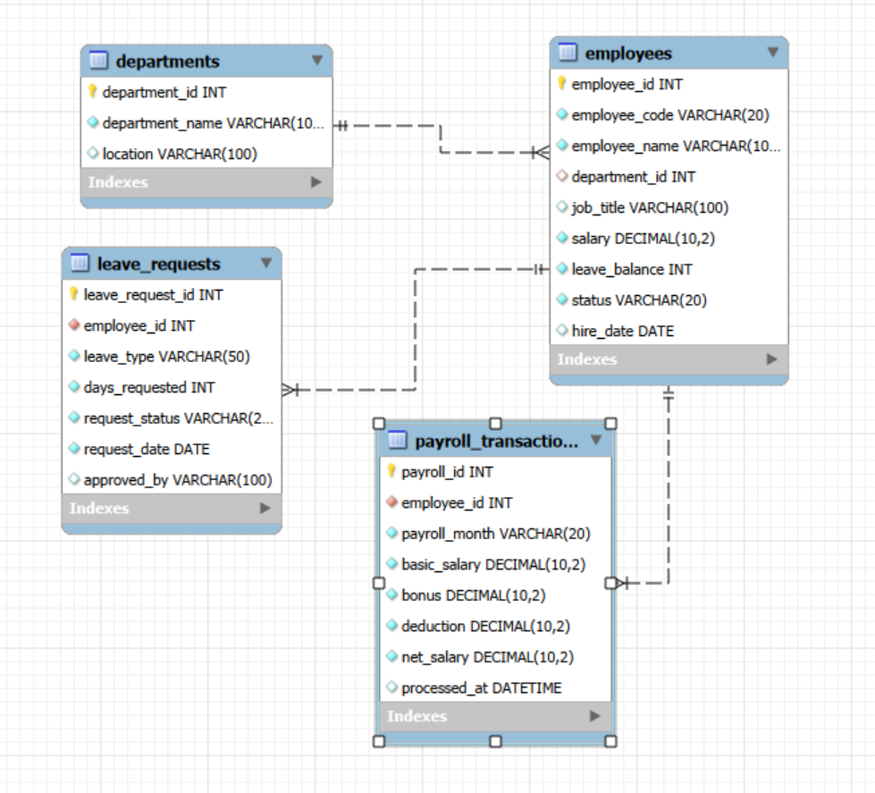
--3. INSERT SAMPLE DATA
INSERT INTO departments (department_name, location) VALUES
('HR', 'Yangon'),
('IT', 'Mandalay'),
('Finance', 'Naypyidaw'),
('Admin', 'Yangon'),
('Operations', 'Bago');

SELECT * FROM departments;
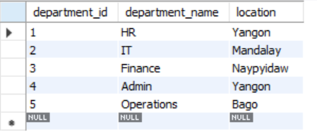

INSERT INTO employees
(employee_code, employee_name, department_id, job_title, salary, leave_balance, status, hire_date)
VALUES
('EMP001', 'Aung Aung', 2, 'Junior Developer', 800000, 10, 'Active', '2023-01-10'),
('EMP002', 'Su Su', 1, 'HR Officer', 650000, 8, 'Active', '2022-03-15'),
('EMP003', 'Kyaw Kyaw', 3, 'Accountant', 900000, 12, 'Active', '2021-06-01'),
('EMP004', 'Hla Hla', 4, 'Admin Assistant', 500000, 7, 'Active', '2024-02-20'),
('EMP005', 'Mya Mya', 2, 'System Engineer', 1200000, 15, 'Active', '2020-11-11'),
('EMP006', 'Ko Ko', 5, 'Operations Officer', 700000, 9, 'Active', '2023-08-08'),
('EMP007', 'Nyein Nyein', 1, 'Recruitment Specialist', 680000, 11, 'Active', '2022-12-01'),
('EMP008', 'Zaw Zaw', 3, 'Finance Analyst', 950000, 14, 'Active', '2021-09-09');
SELECT * FROM employees;
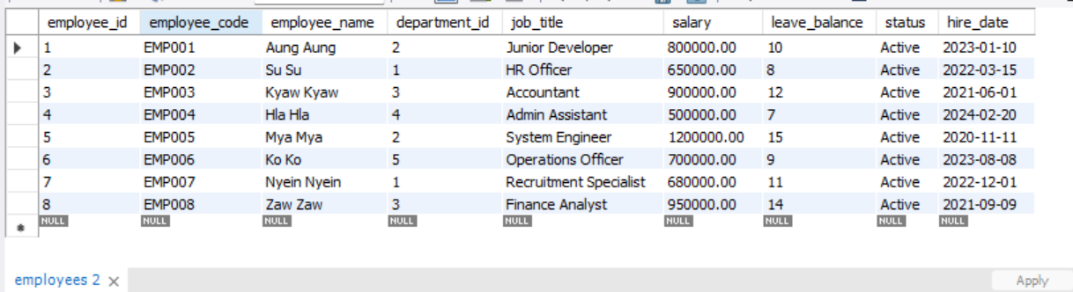

INSERT INTO payroll_transactions
(employee_id, payroll_month, basic_salary, bonus, deduction, net_salary)
VALUES
(1, '2026-04', 800000, 50000, 10000, 840000),
(2, '2026-04', 650000, 30000, 5000, 675000),
(3, '2026-04', 900000, 40000, 15000, 925000);

SELECT * FROM payroll_transactions;
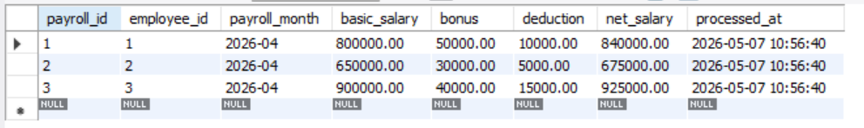

INSERT INTO leave_requests
(employee_id, leave_type, days_requested, request_status, request_date, approved_by)
VALUES
(1, 'Annual Leave', 2, 'Approved', '2026-04-01', 'HR Manager'),
(2, 'Medical Leave', 1, 'Approved', '2026-04-03', 'HR Manager'),
(4, 'Casual Leave', 2, 'Pending', '2026-04-05', NULL);

SELECT * FROM leave_requests;
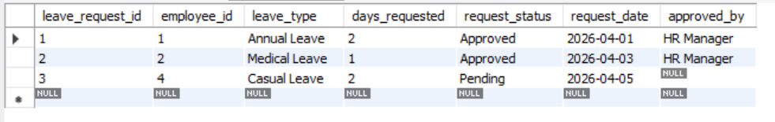
--3. VIEW INITIAL DATA
SELECT 'INITIAL DEPARTMENTS' AS info;
SELECT * FROM departments;
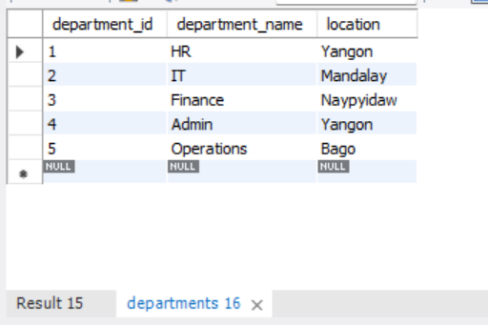

SELECT 'INITIAL EMPLOYEES' AS info;
SELECT * FROM employees;
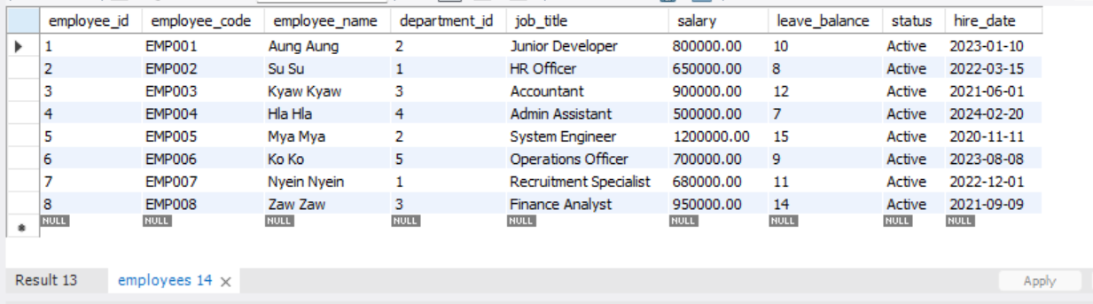

SELECT 'INITIAL PAYROLL' AS info;
SELECT * FROM payroll_transactions;
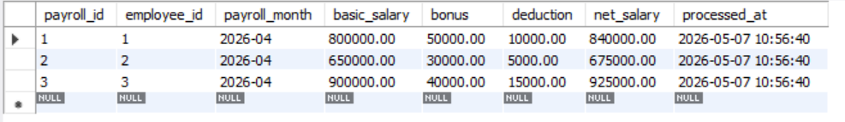

SELECT 'INITIAL LEAVE REQUESTS' AS info;
SELECT * FROM leave_requests;
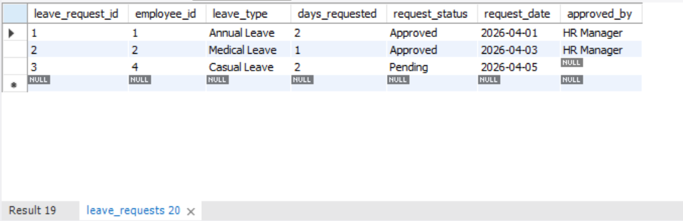

-- 4. ACID TEST 1 - ATOMICITY

SELECT 'ATOMICITY TEST - BEFORE' AS info;
SELECT employee_id, employee_name, leave_balance
FROM employees
WHERE employee_id = 1;
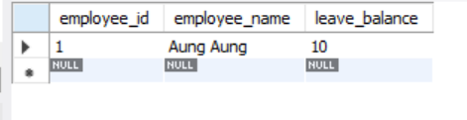

SELECT * FROM leave_requests WHERE employee_id = 1;
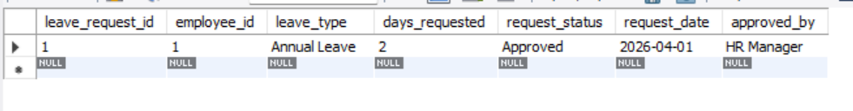
-- 4A. Successful atomic transaction
START TRANSACTION;

INSERT INTO leave_requests
(employee_id, leave_type, days_requested, request_status, request_date, approved_by)
VALUES
(1, 'Annual Leave', 3, 'Approved', CURDATE(), 'HR Manager');
SELECT * FROM leave_requests;

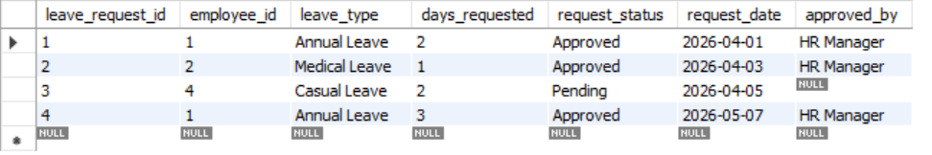
UPDATE employees
SET leave_balance = leave_balance - 3
WHERE employee_id = 1;
SELECT * FROM employees;
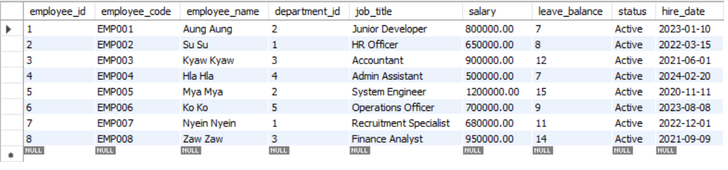
COMMIT;
SELECT 'ATOMICITY TEST - AFTER SUCCESSFUL COMMIT' AS info;
SELECT employee_id, employee_name, leave_balance
FROM employees
WHERE employee_id = 1;
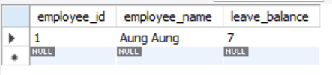
SELECT * FROM leave_requests WHERE employee_id = 1;
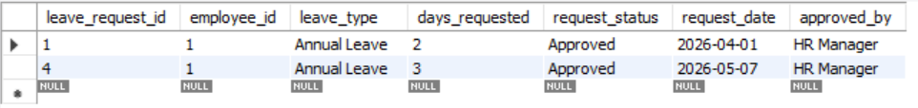

SELECT 'ATOMICITY TEST - BEFORE FAILED TRANSACTION' AS info;
SELECT employee_id, employee_name, leave_balance
FROM employees
WHERE employee_id = 2;
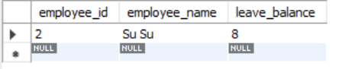
START TRANSACTION;

-- Step 1: Deduct leave balance
UPDATE employees
SET leave_balance = leave_balance - 2
WHERE employee_id = 2;
SELECT * FROM employees;
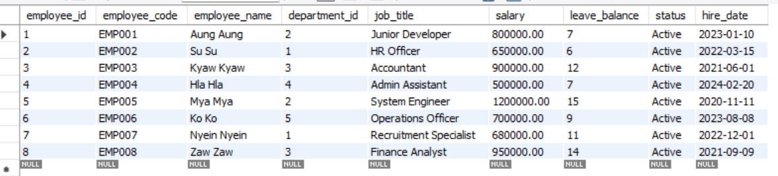
-- Step 2: Invalid insert to force error
-- employee_id 9999 does not exist, so FK constraint fails
INSERT INTO leave_requests
(employee_id, leave_type, days_requested, request_status, request_date, approved_by)
VALUES
(9999, 'Annual Leave', 2, 'Approved', CURDATE(), 'HR Manager');
ROLLBACK;

SELECT 'ATOMICITY TEST - AFTER ROLLBACK' AS info;
SELECT employee_id, employee_name, leave_balance
FROM employees
WHERE employee_id = 2;
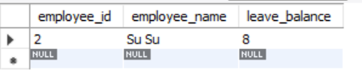
-- 5. ACID TEST 2 - CONSISTENCY
SELECT 'CONSISTENCY TEST - BEFORE' AS info;
SELECT employee_id, employee_name, salary, leave_balance
FROM employees
WHERE employee_id = 3;

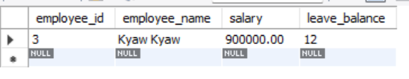
-- 5A. Valid transaction
START TRANSACTION;

UPDATE employees
SET leave_balance = leave_balance - 5
WHERE employee_id = 3
AND leave_balance >= 5;

COMMIT;

SELECT 'CONSISTENCY TEST - AFTER VALID UPDATE' AS info;
SELECT employee_id, employee_name, salary, leave_balance
FROM employees
WHERE employee_id = 3;
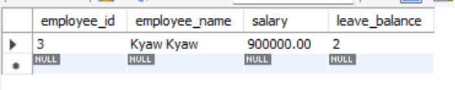
START TRANSACTION;

UPDATE employees
SET leave_balance = -1
WHERE employee_id = 4;

ROLLBACK;
SELECT 'CONSISTENCY TEST - AFTER INVALID UPDATE ROLLBACK' AS info;
SELECT employee_id, employee_name, salary, leave_balance
FROM employees
WHERE employee_id = 4;
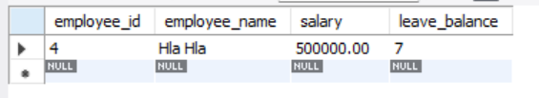
-- 5C. Invalid salary example
START TRANSACTION;

UPDATE employees
SET salary = -5000
WHERE employee_id = 5;

ROLLBACK;

SELECT 'CONSISTENCY TEST - AFTER INVALID SALARY ROLLBACK' AS info;
SELECT employee_id, employee_name, salary, leave_balance
FROM employees
WHERE employee_id = 5;
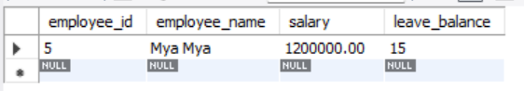

-- 6. ACID TEST 3 - ISOLATION
-- SESSION 1
-- Run in Window 1:
-- Run in Window 2:
--
USE hr_acid_demo;
-- SET SESSION TRANSACTION ISOLATION LEVEL READ COMMITTED;
SELECT * FROM employees WHERE employee_id = 6;
-- Then go back to Session 1:
COMMITS;
-- Then in Session 2 run again:
SELECT * FROM employees WHERE employee_id = 6;

-- 7. ACID TEST 4 - DURABILITY
SELECT 'DURABILITY TEST - BEFORE' AS info;
SELECT * FROM payroll_transactions WHERE employee_id = 7;
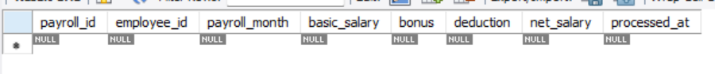
INSERT INTO payroll_transactions
(employee_id, payroll_month, basic_salary, bonus, deduction, net_salary)
VALUES
(7, '2026-05', 680000, 50000, 10000, 720000);

COMMIT;

SELECT 'DURABILITY TEST - AFTER COMMIT' AS info;
SELECT * FROM payroll_transactions WHERE employee_id = 7;
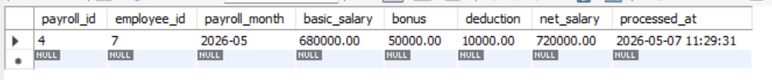
-- 8. PRACTICAL FULL ACID BUSINESS TEST
SELECT 'FULL BUSINESS TEST - BEFORE PROMOTION' AS info;
SELECT * FROM employees WHERE employee_id = 8;
START TRANSACTION;

UPDATE employees
SET department_id = 2,
job_title = 'Senior Finance Systems Analyst',
salary = salary + 150000
WHERE employee_id = 8;
COMMIT;

SELECT 'FULL BUSINESS TEST - AFTER PROMOTION COMMIT' AS info;
SELECT * FROM employees WHERE employee_id = 8;

SELECT * FROM payroll_transactions WHERE employee_id = 8;
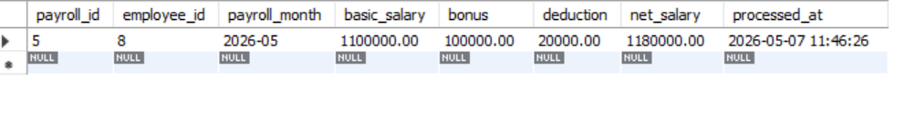
-- Failed promotion transaction example
SELECT 'FULL BUSINESS TEST - BEFORE FAILED PROMOTION' AS info;
SELECT * FROM employees WHERE employee_id = 5;
START TRANSACTION;

UPDATE employees
SET job_title = 'Lead System Engineer',
salary = salary + 200000
WHERE employee_id = 5;
SELECT * FROM employees WHERE employee_id=5;
-- Invalid foreign key department_id = 9999
UPDATE employees
SET department_id = 9999
WHERE employee_id = 5;

ROLLBACK;
SELECT 'FULL BUSINESS TEST - AFTER FAILED PROMOTION ROLLBACK' AS info;
SELECT * FROM employees WHERE employee_id = 5;

-- 9. FINAL DATA CHECK
SELECT 'FINAL EMPLOYEE DATA' AS info;
SELECT
e.employee_id,
e.employee_code,
e.employee_name,
d.department_name,
e.job_title,
e.salary,
e.leave_balance,
e.status,
e.hire_date
FROM employees e
LEFT JOIN departments d
ON e.department_id = d.department_id
ORDER BY e.employee_id;
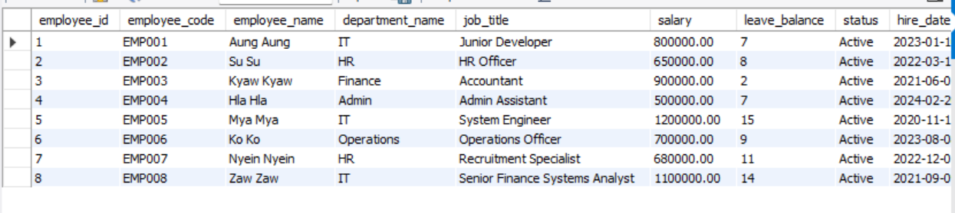

SELECT 'FINAL PAYROLL DATA' AS info;
SELECT * FROM payroll_transactions ORDER BY payroll_id;
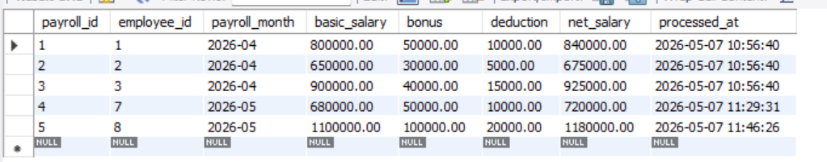

SELECT 'FINAL LEAVE REQUEST DATA' AS info;
SELECT * FROM leave_requests ORDER BY leave_request_id;
