--1. CREATE DATABASE

CREATE DATABASE hr_demo;
USE hr_demo;

-- 2. CREATE HR SAMPLE TABLE

CREATE TABLE employees (
employee_id INT PRIMARY KEY AUTO_INCREMENT,
employee_name VARCHAR(100) NOT NULL,
department VARCHAR(100),
salary DECIMAL(10,2) NOT NULL,
leave_balance INT NOT NULL DEFAULT 0
);

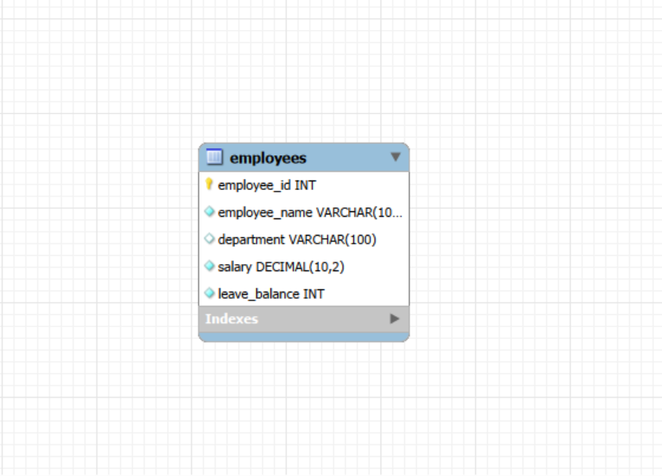

-- 3. INSERT SAMPLE DATA

INSERT INTO employees (employee_name, department, salary, leave_balance)
VALUES
('Aung Aung', 'IT', 800000, 10),
('Su Su', 'HR', 600000, 8),
('Kyaw Kyaw', 'Finance', 900000, 12),
('Hla Hla', 'Admin', 550000, 6),
('Mya Mya', 'IT', 750000, 9),
('Ko Ko', 'Operations', 700000, 11);

-- 4. VIEW INITIAL DATA

SELECT 'INITIAL EMPLOYEE DATA' AS info;
SELECT * FROM employees;
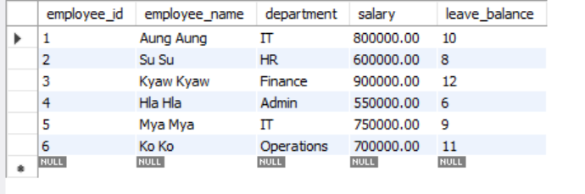

-- A — ATOMICITY

SELECT 'ATOMICITY TEST - BEFORE SUCCESSFUL TRANSACTION' AS info;
SELECT * FROM employees WHERE employee_id = 1;
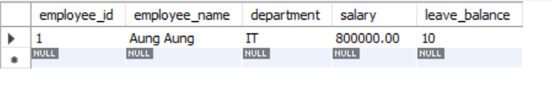

-- A1. SUCCESSFUL ATOMIC TRANSACTION

START TRANSACTION;

UPDATE employees
SET salary = salary + 50000
WHERE employee_id = 1;

UPDATE employees
SET leave_balance = leave_balance - 2
WHERE employee_id = 1;

COMMIT;

SELECT 'ATOMICITY TEST - AFTER SUCCESSFUL COMMIT' AS info;
SELECT * FROM employees WHERE employee_id = 1;
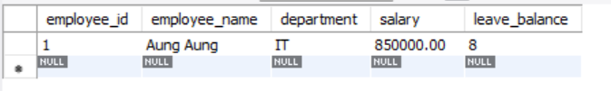
-- A2. ROLLBACK EXAMPLE

SELECT 'ATOMICITY TEST - BEFORE FAILED TRANSACTION' AS info;
SELECT * FROM employees WHERE employee_id = 2;
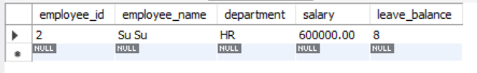

START TRANSACTION;

UPDATE employees
SET salary = salary + 50000
WHERE employee_id = 2;

-- Mistake / unexpected issue
-- This update affects no valid intended record
UPDATE employees
SET leave_balance = leave_balance - 100
WHERE employee_id = 999;

ROLLBACK;

SELECT 'ATOMICITY TEST - AFTER ROLLBACK' AS info;
SELECT * FROM employees WHERE employee_id = 2;
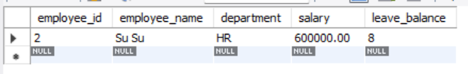

-- C — CONSISTENCY

SELECT 'CONSISTENCY TEST - BEFORE VALID UPDATE' AS info;
SELECT * FROM employees WHERE employee_id = 3;
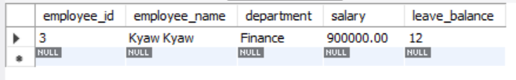

-- C1. VALID CONSISTENT TRANSACTION

START TRANSACTION;

UPDATE employees
SET leave_balance = leave_balance - 3
WHERE employee_id = 3
AND leave_balance >= 3;

COMMIT;

SELECT 'CONSISTENCY TEST - AFTER VALID UPDATE' AS info;
SELECT * FROM employees WHERE employee_id = 3;
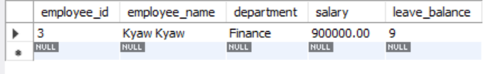

-- C2. INVALID BUSINESS CASE EXAMPLE

SELECT 'CONSISTENCY TEST - BEFORE INVALID ATTEMPT' AS info;
SELECT * FROM employees WHERE employee_id = 4;
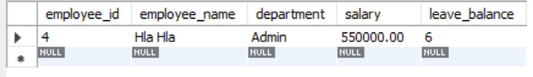

START TRANSACTION;

UPDATE employees
SET leave_balance = leave_balance - 20
WHERE employee_id = 4
AND leave_balance >= 20;

COMMIT;

SELECT 'CONSISTENCY TEST - AFTER INVALID ATTEMPT (NO CHANGE EXPECTED)' AS info;
SELECT * FROM employees WHERE employee_id = 4;
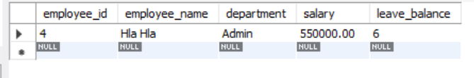

-- I — ISOLATION

-- SESSION 1
USE hr_demo;
SET SESSION TRANSACTION ISOLATION LEVEL READ COMMITTED;
START TRANSACTION;

UPDATE employees
SET salary = salary + 100000
WHERE employee_id = 5;

SELECT * FROM employees WHERE employee_id = 5;
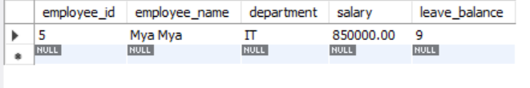

-- SESSION 2
USE hr_demo;
-- SET SESSION TRANSACTION ISOLATION LEVEL READ COMMITTED;

SELECT * FROM employees WHERE employee_id = 5;
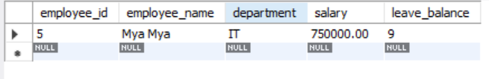

-- Then go back to Session 1 and run:
COMMIT;
--
-- Then in Session 2 run again:
SELECT * FROM employees WHERE employee_id = 5;
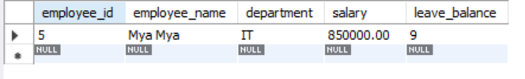

-- D — DURABILITY

SELECT 'DURABILITY TEST - BEFORE COMMIT' AS info;
SELECT * FROM employees WHERE employee_id = 2;
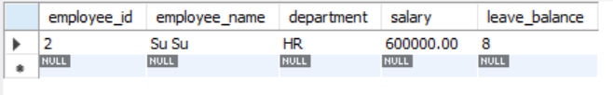

START TRANSACTION;

UPDATE employees
SET salary = 950000
WHERE employee_id = 2;

COMMIT;

SELECT 'DURABILITY TEST - AFTER COMMIT' AS info;
SELECT * FROM employees WHERE employee_id = 2;
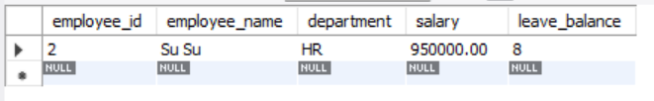

-- FULL PRACTICAL EXAMPLE

SELECT 'PROMOTION TEST - BEFORE SUCCESSFUL PROMOTION' AS info;
SELECT * FROM employees WHERE employee_id = 1;
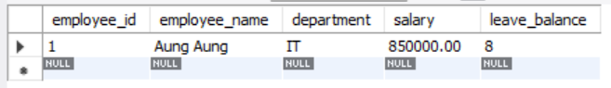

-- FULL SUCCESSFUL TRANSACTION

START TRANSACTION;

UPDATE employees
SET salary = salary + 150000
WHERE employee_id = 1;

UPDATE employees
SET department = 'Senior IT'
WHERE employee_id = 1;

UPDATE employees
SET leave_balance = leave_balance + 2
WHERE employee_id = 1;

COMMIT;

SELECT 'PROMOTION TEST - AFTER SUCCESSFUL PROMOTION' AS info;
SELECT * FROM employees WHERE employee_id = 1;
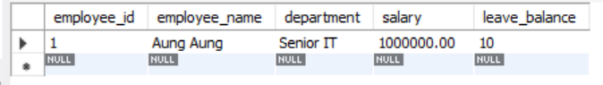

-- FAILED PROMOTION EXAMPLE

SELECT 'PROMOTION TEST - BEFORE FAILED PROMOTION' AS info;
SELECT * FROM employees WHERE employee_id = 6;
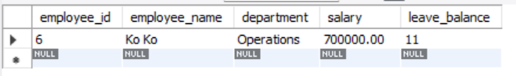

START TRANSACTION;

UPDATE employees
SET salary = salary + 150000
WHERE employee_id = 6;

UPDATE employees
SET department = 'Senior Operations'
WHERE employee_id = 6;

-- Suppose this is wrong
UPDATE employees
SET leave_balance = leave_balance + 2
WHERE employee_id = 999;

ROLLBACK;

SELECT 'PROMOTION TEST - AFTER FAILED PROMOTION ROLLBACK' AS info;
SELECT * FROM employees WHERE employee_id = 6;
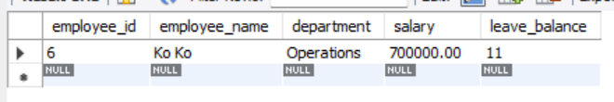

-- FINAL TEST DATA VIEW

SELECT 'FINAL EMPLOYEE DATA' AS info;
SELECT * FROM employees;
