Jacob Kaplan

Johanna Bauman

BIO 2110 Sect. 1

12 December 2019

Genetics Lab Report 2

**Introduction:**

           Working in the field of bioinformatics the primary focus of the research was on two proteins named JNK and CaM. These proteins are found in Homo sapiens genes are assumed to be an ortholog to Patiria miniata which is a species of starfish in the family Asterinidae. C- Jun N-terminal kinases or (JNK) are “members of the mitogen-activated protein kinase (MAPK) family” (Zeke et al., 2016) which is observed to have an effect on different physiological processes and neural networking along with other functions. JNK works similarly to CaM- dependent protein kinase (CaM) as its family is a “major class of calcium sensor proteins which collectively play a crucial role in cellular signaling.” (Ranty, Aldon, and Galaud, 2006) Both of these target proteins are used in eukaryotes to help signal functions throughout a cell via protein kinase. PCR was done to our protein’s DNA/RNA fragments to amplify our information allowing us to be able to work with these specific strands. With our amplified DNA/RNA we are then able to use agarose gel electrophoresis, which works to visually display separated bands formed at specific lengths, in this case, it was used to verify our product length.

**Research through Bioinformatics:**

Our group selected JNK protein on the list of T Cell Receptor Signalingto do our analysis and primer design though several steps of bioinformatics. Using National Center for Biotechnology Information (NCBI) we searched JNK using accession code GGEY02009090.1

 through its protein tblastn program under the database of Transcriptome Shotgun Assembly (TSA) which allowed us to search through NCBI’s databases for the nucleotide sequence in our primer JNK for Patiria miniata.

**PCR:**

           Using gloves prepare a sample containing Nuclease free H20, Reaction mix contains dNTP nucleotides and a buffer solution, Enzyme mix contains RTase, DNA polymerase, and Ligase, Forward and Reverse mix, and then lastly RNA sample of CaM. The sample was placed in a SB 12L shaking water bath for the times listed in the process repeated 40 times. (Table 1)

**Agarose Gel Electrophoresis:**

           To create the gel mold, we used 1% agarose with a boiled TAE solution then additional TAE buffer was added on top of solidified gel mold. To load the gel, we used the BlueGel system and cyber safe dye mixed with our CaM primer sample and inserted the solution inside the designed lanes. We created 9 lanes in which lane 3 contained the gene ladder (1Kb), then lanes 5, 6, and 7 contained our CaM primer sample at different quantities. Then we ran the gel at 45 V for 40 minutes to let the DNA run down the gel.

**Change of Protein:**

At first, our designed primer we selected was JNK which we did the bioinformatics portion for that primer, but due to certain circumstances, we used CaM to finish our primer design and analysis for PCR and agarose gel electrophoresis. Background information for CaM was provided in the introduction.

**Results:**

           The Bioinformatics resulted in many results for JNK protein shown in (Graphs 2 & 3) the query cover score was 87%, a percent identity of 71.11%, and the accession number GGEY- 02009090.1. We chose primer pair 10 in JNK which’s its theoretical product length is 882bp. Due to the changes in protein CaM was used further analyzed on which its theoretical product length was 552bp. (Graph 4) Visualized in (Figure 2) 3 bands in lanes 5,6, and 7 forms slightly above the first major band on the 1Kb Geneladder DNA mix in lane 3, which that band marks 500bp. This means it can be concluded the product length of our CaM primer lies close to 552bp in our gel.

**Discussion:**

The integrity of this experiment was to search to see if the genes JNK and CaM are an ortholog in Patiria miniata and Homo sapiens. Analyzing our bioinformatics for JNK it does seem possible that JNK be found in Patiria miniata. Going further into discussion our query cover value of 87% (Table 3) is extremely high as according to mycoflora.org “a high Query Cover value for the initial triage is in the 70%+ range.” (2019) This means our sample of JNK was found to be very likely to overlap sequences which can mean they can code for the same protein. The percent identity value from the accession number of 71.11% (Table 3) can mean that JNK can be an ortholog in both Patiria miniata and Homo sapiens. 71.11% means around 71 out of 100 base pairs match. This means the value definitely high enough to have a common ancestor, but more research is needed to determine if it’s an exact ortholog as 97-99 base pairs generally are needed to match in order to be considered an ortholog. Moving forward, with CaM protein we used gel electrophoresis to show that the product length is the same in all 3 lanes which means our gel was successful. Although, this isn’t able to be properly analyzed as our primer wasn’t designed to the specific target sequence. The practice lets us know that the theoretical product length can be visualized with gel electrophoresis. In group 1’s gel (Figure 2) it is seen the gel failed and the reasons behind this can vary, but mainly this can be caused by their group needing a much higher annealing temperature to make the primers sit on the DNA. This can explain why the DNA ladder and primer samples didn’t show up on the gel.

**Table 1: PCR shaking water bath procedure**

|  |  |  |  |  |  |  |  |
| --- | --- | --- | --- | --- | --- | --- | --- |
| Temp: | 48°C | 94°C | 94°C | 52°C | 68°C | 68°C | 4°C |
| Time: | 30’ | 1’ | 15’’ | 30’’ | 4’ | 5’ | ∞ |

**Table 2: Design Primer pair 10 in JNK**

|  |  |  |  |  |  |  |  |  |  |
| --- | --- | --- | --- | --- | --- | --- | --- | --- | --- |
|  | Sequence (5'->3') | Template strand | Length | Start | Stop | Tm | GC% | Self-complementarity | Self 3' complementarity |
| Forward primer | AAATCAGAAGTATGTCTCAG | Plus | 20 | 188 | 207 | 49.86 | 35.00 | 4.00 | 3.00 |
| Reverse primer | TCACCAAATATACAACCAAT | Minus | 20 | 1069 | 1050 | 49.88 | 30.00 | 4.00 | 2.00 |
| Product length | 882 bp | | | | | | | | |

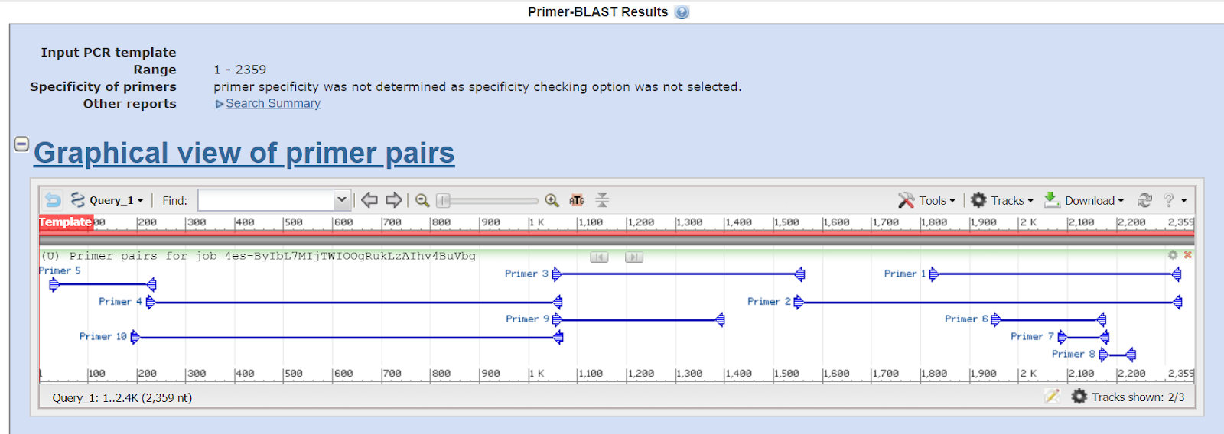

**Figure 1: Visual Primer Pairs for JNK**

**Table 3: Analysis of JNK from BLAST**

|  |  |  |  |
| --- | --- | --- | --- |
| Description | Query Cover | Percent Identity | Accession |
| TSA: Patiria miniata Cluster-18782.1, transcribed RNA sequence. | 87% | 71.11% | GGEY02009090.1 |

**Table 4: Design Primer given in CaM**

|  |  |  |  |  |  |  |  |
| --- | --- | --- | --- | --- | --- | --- | --- |
| Tube # | Protein Target | GGEY Accession | Sequence # | Seq 5’ to 3’ | Product Length | Temp | Percecnt GC |
| 1 | CaM | GGEY01022277.1 | ForteSec4FOR | AAGGTGCAACTTGGGCACT |  | 60°C | 52.6 |
| 2 |  |  | ForteSec4REV | GGCGCATCAAGTTACCACAC | 552 bp | 62.4°C | 55 |

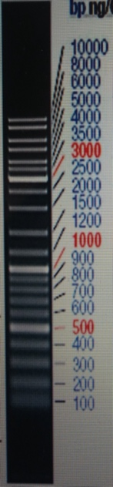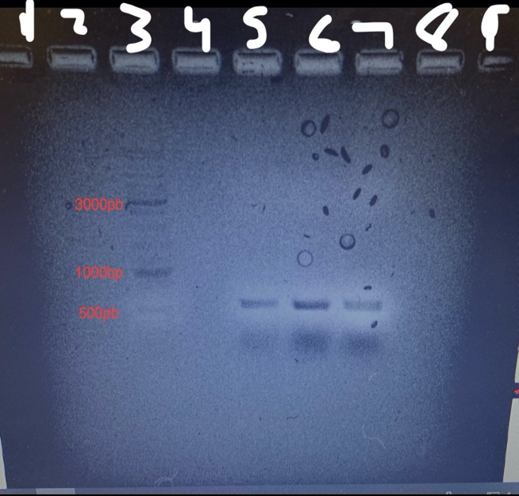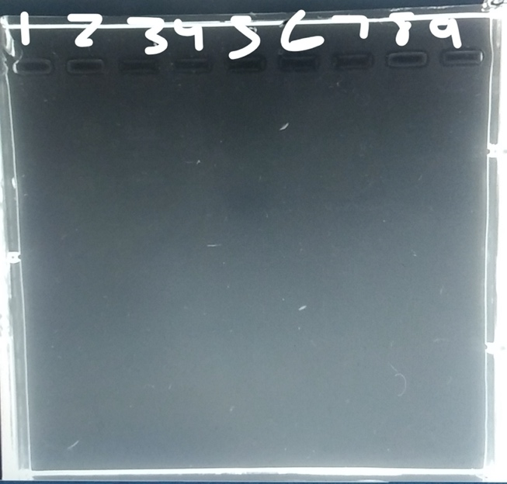

**Figure 2: 1Kb Geneladder DNA ladder mix with two gel images 1: CaM gel results 2: Group 1 (Fail)**

First image includes 1Kb Geneladder DNA ladder mix. Second image our design lane 3 contains 5μL of 1Kb Geneladder mix, lane 5 contains 1μL of dye with 5μL of sample, lane 6 contains 2μL of dye and 10μL of sample, lane 7 contains 3μL of dye and 15μL of sample. Third image contains group 1 fail gel image.

**Works Cited**

FAQ. (n.d.). Retrieved December 10, 2019, from

http://mycoflora.org/index.php/resources/faq/41-examining-your-blast-results.

Ranty, B., Aldon, D., & Galaud, J.-P. (2006). Plant Calmodulins and Calmodulin-Related

Proteins. *Plant Signaling & Behavior*, *1*(3), 96–104. doi: 10.4161/psb.1.3.2998

Zeke, A., Misheva, M., Reményi, A., & Bogoyevitch, M. A. (2016). JNK Signaling: Regulation

and Functions Based on Complex Protein-Protein Partnerships. *Microbiology and Molecular Biology Reviews*, *80*(3), 793–835. doi: 10.1128/mmbr.00043-14