Jacob Kaplan BIO 2010 – 01, Spring 2020

**Microbiology Unknown Identification Report**

Submitted: 4-23-20

**Abstract:**

Given a vile full of two different strains of unknown bacteria from a list of specific bacteria, our job was to correctly isolate the different bacteria and identify them correctly via several different tests. Most of our lab time was restricted due to the COVID-19 pandemic and all of the test results were given to us from Dr. Leonard. If lab had gone the way it should have gone, we would perform different test results each week and record results from each test. This information would help aid us in creating a flow chart. According to the test results reported to me it can be determined via the flow chart diagram (Figure 1) that the bacteria in vile 31 are *Lactococcus lactis (L. lactis)* and *Citrobacter freundi (C. freundii). L. lactis* is a gram-positive cocci that was determined by being catalase negative and a nitrate reduction negative bacteria. *C. freundi* is a gram-negative rod that was determined to be a facultative anaerobe that is motile, citrate test positive, and a gelatin hydrolysis positive bacterium.

**Introduction:**

Tests were used to aid identifying our bacteria, these tests were consistent on how colonies grew on certain differential or selective agar plates such as eosin methylene blue agar plate (EMB) and triple sugar iron agar (TSI). Identify a bacterium also depends on how these bacteria react to different biochemical environments and if they’re suitable to grow in those conditions examples of these tests include citrate test and catalase/oxidase test. There can also be physical determinable differences in the microorganisms such as the bacteria shape and colony morphology.

Many of these tests involve the use of staining bacteria samples on slides as a differential technique. Differential staining techniques are an essential way of gaining information about a bacterium. The most common example of practicing staining techniques is through the gram stain discovered by Danish bacteriologist Hans Christian Gram. (Wilhelm et al. 2015) This technique is vital as it is nearly the first differential test performed for the identification of bacteria. Gram staining technique classifies bacteria in two large groups based on the structure of its cell wall. (Delfiner et al. 2016) Being characterized by their cell walls, bacteria that are gram-negative have a thin layer of peptidoglycan between an inner cell membrane, and gram-positive bacteria have a thick layer of peptidoglycan. The differential aspect of the gram stain is in the cell wall’s ability to stand a decolorizing agent that removes parts of the peptidoglycan layer. Gram-positive bacteria can stan the decolorizer which has it retain the crystal violet color. Gram-negative bacteria lose its stain when decolorizing and turns pink due to the safranin counter stain because of its thin peptidoglycan layer.

Selective and differential media are common practices in the microbiology world as it is an extremely useful way to differentiate different bacteria by growth patterns. Selective media allow only certain types of organisms to grow. As differential media is used to differentiate closely related organisms by means of dyes or chemicals to change the growth patterns in the bacterium. Selective media such as Mannitol salt agar (MSA) is used selectively as it isolates staphylococci which grow and ferments mannitol. (Ayeni et al. 2017) Differential media such as EMB uses eosin and methylene blue as it inhibits gram-positive organisms.

These tests have significant importance to the world as it helps identify serious or even non-serious bacteria that cause diseases. Knowing these different test results can help with the diagnosis of a patient’s current illness. This helps the ability to combat the different pathogens as identifying the specific strain of bacteria or virus can expedite the process of treatment. The tests that are performed are very important as these tests inform us of techniques to be able to combat the pathogen.

**Methods**

Following the procedures from the lab manual textbook (Leboffee and Pierce, 2012) gram staining requires heat-fixing the sample to a slide of the test organism. Stain the heat-fixed sample with crystal violet and rinse after a minute. After, cover slide with grams iodine and rinse after a minute. Rinse slide briefly with decolorizer and immediately rinse. Then counterstain with safranin and rinse after a minute and dry with bibulous paper. Observe under microscope gram-positive bacteria will remain purple as gram-negative bacteria will be pink and you can tell under oil immersion if the bacteria are rod or cocci.

The pigment test is produced by streaking the unknown bacteria on nutrient agar plate Place plate in incubation at 35-37°C incubator for 24-48 hours (standard conditions) which allow colonies to grow. After the growth phase ends examine the plate and tell if any pigments of colonies are present.

Following the procedures from the lab manual textbook (Leboffee and Pierce, 2012) endospore stain starts with a heat fixing sample on a slide. Then set slide on steaming apparatus and stain with malachite green stain for 5-7 minutes. Rinse the slide then counterstain with safranin for one minute and rinse once again. Finish with drying with bibulous paper and observe for spores under oil immersion.

The phenylethyl alcohol agar (PEA) is a selective recipe media from (Leboffee and Pierce, 2012). The mixture contains selective ingredients such as sodium chloride and pancreatic digest of casein and soybean meal. Pour plate and let it solidify, then streak bacteria on a plate and incubate standard conditions then examine plate for heavy or poor growth. Poor or no growth generally means it’s a gram-negative organism and good growth generally means Probable Staphylococcus, Streptococcus, Enterococcus, or Lactococcus.

Xylose lysine desoxycholate (XLD) agar is a selective and differential recipe media from (Leboffee and Pierce, 2012). It contains several different ingredients including xylose, phenol red, and sodium chloride that makes this agar differentiable. Pour plate and let it solidify, then streak bacteria on a plate and incubate standard conditions then examine plate for heavy or poor growth and color changes. Results from the test are summarized under (Figure 2)

Agar deep stabs are prepared with tryptic soy agar (TSA) recipe media from (Leboffee and Pierce, 2012). Pouring agar in slant tubes and let them solidify, stab the agar with inoculating needle with unknown bacteria and let the sample incubate at standard conditions. Examine the growth of bacteria. Growth away from the stab means bacteria is a factitive anaerobe, and growth around the stabs means bacteria is aerobe.

Mannitol salt agar (MSA) is a selective recipe media (Leboffee and Pierce, 2012). The mixture contains sodium chloride and mannitol as a selective component of the media. Pour MSA in a plate and let it solidify, then streak bacteria on the plate and incubate at standard conditions then examine plate for heavy or poor growth. Good growth means its presumed as a Staphylococcus and no or low growth presumes as not a Staphylococcus species. Yellow growth means possible pathogenic Staphylococcus aureus and red growth means any other Staphylococcus.

Eosin methylene blue agar (EMB) is a differential recipe media from (Leboffee and Pierce, 2012). This mixture contains eosin and methylene blue as differential components of the media. Pour EMB in a plate and let it solidify, then streak bacteria on the plate and incubate at standard conditions then examine plate for heavy or poor growth. Results from the test are summarized under (Figure 3)

Methyl red and Voges-Proskauer requires test tubes with nutrient agar to be inoculated with pure culture. After inoculated let tubes incubate under standard conditions. A red color change result means for a positive mixed acid fermentation as yellow results in a negative no fermentation. A Voges-Proskauer positive result is indicated by red color and it means 2,3-butanediol fermentation (acetoin produced) and a negative stay yellow and results in 2,3-butanediol fermentation (acetoin is not produced).

The Sulfur reduction, Indole production, and motility test (SIM) use SIM media and Kovac’s reagent. These tests require test tubes with nutrient agar to be inoculated with pure culture. After inoculated let tubes incubate under standard conditions. The sulfur reduction is indicated by a black color change H2S positive as no color change means it’s an H2S negative. Indole test results were inoculated negative test shows no change as a positive result shows the red color change. Motility in SIM is determinable by negative results shows no radiating growth and a positive growth results in outward growth from the stab.

Triple Sugar Iron agar (TSI) is a differential recipe media (Leboffee and Pierce, 2012). This mixture contains several different ingredients to differentiate based on glucose fermentation, lactose fermentation, sucrose fermentation, and sulfur reduction. The test requires slant tubes with adding bacteria via fishtail streak and letting it incubate under standard conditions. Results from the test are summarized under (Figure 4)

The citrate utilization test is performed by using slant tubes using Simmons Citrate agar. Using an inoculating needle streak the slants with the organism and incubated under standard conditions. If there’s no growth and the media stay green, it is a negative result. In a positive result, the media turns blue or stays green but noticeable growth is detected.

Gelatin Hydrolysis is a test that uses nutrient gelatin in a test tube. Once gelatin media is loaded stab gelatin with test organism and incubate test tubes at 25°C for up to a week. A positive test would result in gelatinase being present and the gelatin being liquid. A negative test would result in no gelatinase being present, and the gelatin being solidified.

In the Catalase test following the procedures from the lab manual textbook (Leboffee and Pierce, 2012) you start by aseptically placing two drops of hydrogen peroxide onto bacteria while covering the lid of dish or slant immediately. Examine plate for any noticeable bubbling. A positive test would include catalase being present as bubbles would occur and a negative test while no catalase is present resulting in no bubbles.

The Oxidase test procedures from the lab manual textbook (Leboffee and Pierce, 2012) starts with placing a filter paper on a paper towel. Then you transfer culture aseptically on the filter paper. After, you add a few drops of oxidase reagent containing cytochrome c in it to the culture. If there’s a dark blue or purple color change oxidase is present indicating a positive test. If no color change happens oxidase is not present as it results as a negative test.

The phenol red sugar fermentation (PRSF) uses 4 different phenol red broths glucose, sucrose, lactose, and mannitol. Using an inoculating needle streak the slants with the organism and incubated under standard conditions. Red slant change results in negative fermentation and yellow results in positive fermentation.

The Starch hydrolysis or amylase test uses starch agar. After, pouring the agar in a plate and letting it solidify streak bacteria on the plate and incubate at standard conditions then add grams iodine to growth and examine. Clear around the growth indicates a positive result in a-amylase and/or oligo-1,6-glucosidase is present. No clearing around the growth indicates a negative result in neither a-amylase nor oligo-1,6-glucosidase is present.

The Nitrate reduction test uses nitrate broth. After, pouring the agar in a plate and letting it solidify streak bacteria on the plate and incubate at standard conditions and examine each tube for signs of gas production. Add 8 drops of each reagent that contain different chemicals in it and let the tube stand for 10 minutes and examine results. Results from the test are summarized under (Figure 5)

Lastly, the Urea hydrolysis or urease test uses Christensen’s urea agar largely made from urea. Pour agar slants and streak urea slants with test organisms. Incubate the slants at standard conditions but only for 24 hours and examine results. If the slant stays pink all the way through after incubation it is positive for urea hydrolysis and strong urea production. If slant starts partially pink or orange/yellow stays partially pink or orange/yellow after incubation it has slow urea hydrolysis and weak urea production. If the slant starts orange/yellow and stays orange/yellow after incubation it negative for urea hydrolysis and urea is absent.

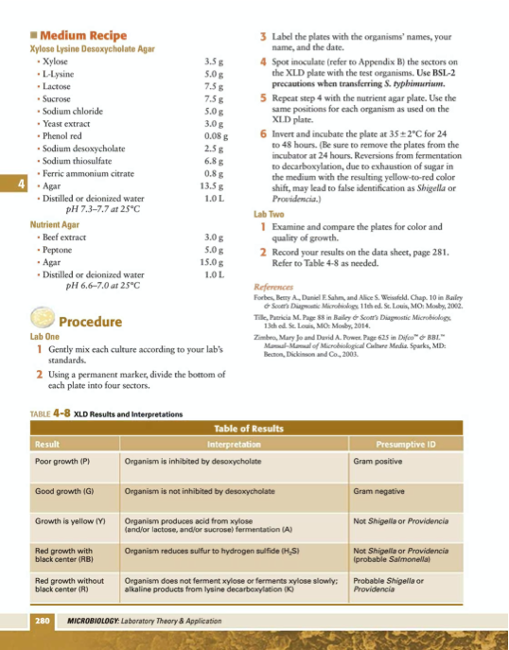

Figure 2: Summary of results from XLD test (Leboffee and Pierce, 2012)

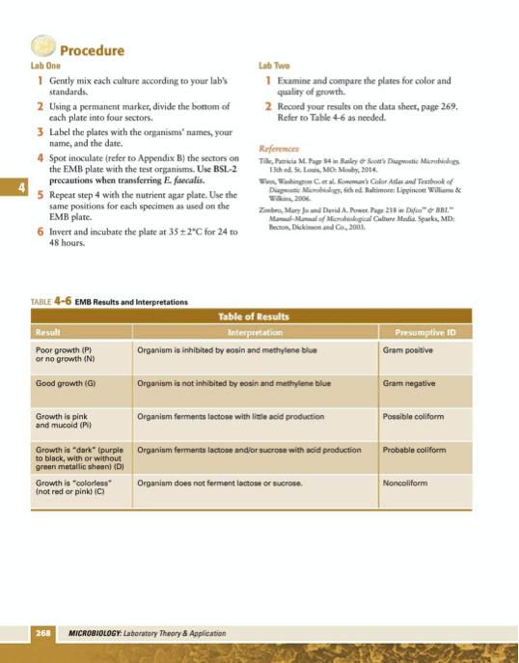

Figure 3: Summary of results from EMB test (Leboffee and Pierce, 2012)

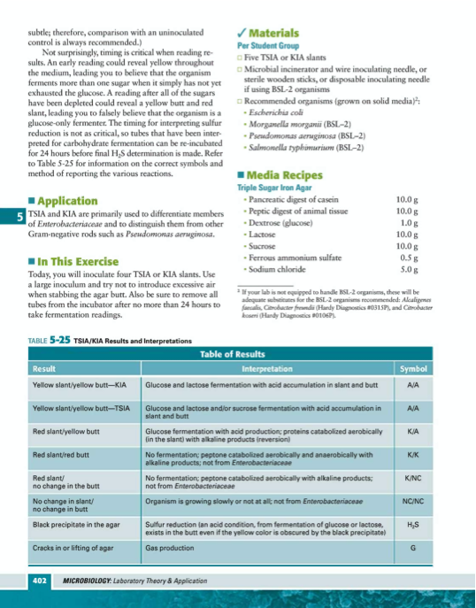

Figure 4: Summary of results from TSI test (Leboffee and Pierce, 2012)

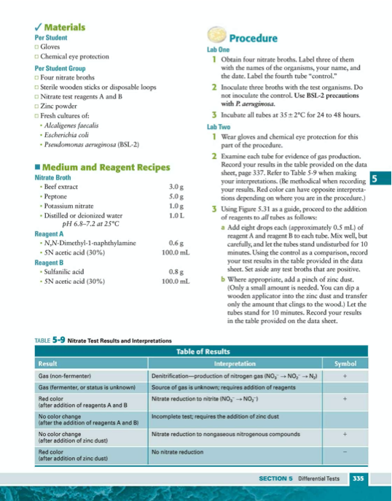

Figure 5: Summary of results from Nitrate Reduction test (Leboffee and Pierce, 2012)

**Results**

Table 1: Test result description for gram-negative rod and gram-positive cocci.

|  |  |  |
| --- | --- | --- |
|  | Gram Negative Rod | Gram Positive Cocci |
| Pigment | No | No |
| Endospore | No | No |
| PEA | No growth | Heavy Growth |
| XLD | Yellow growth | Poor growth |
| Agar Deep | Growth throughout stab | Growth throughout stab |
| MSA | No growth | No growth |
| EMB | Purple growth | No growth |
| MR tube | Red color | Red color |
| VP tube | No red color | Red color |
| SIM | H2S -, Indole -, motile + | H2S -, Indole -, motile - |
| TSI | Yellow throughout | Yellow throughout |
| Citrate | Color change from green to blue | No color change |
| Gelatin Hydrolysis | No liquid in tube | No liquid in tube |
| Catalase | Gas from hydrogen peroxide | No gas from hydrogen peroxide |
| Oxidase | Blue color with phenylenediamine reagent | No blue color with phenylenediamine reagent |
| PRSF | Glucose +, Sucrose +, Lactose +, Mannitol - | Glucose +, Sucrose +, Lactose +, Mannitol - |
| Starch Hydrolysis | No clearing of plate after iodine | No clearing of plate after iodine |
| Nitrate | No color change after addition of test reagents | No color change after addition of test reagents |
| Urease | No color change observed after incubation | No color change observed after incubation |

Figure 1: Final version of created flow chart

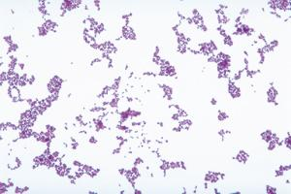

Figure 6: Gram test result for gram-positive cocci unknown. Source from Ward's® Live *Lactococcus lactis* Culture (2020)

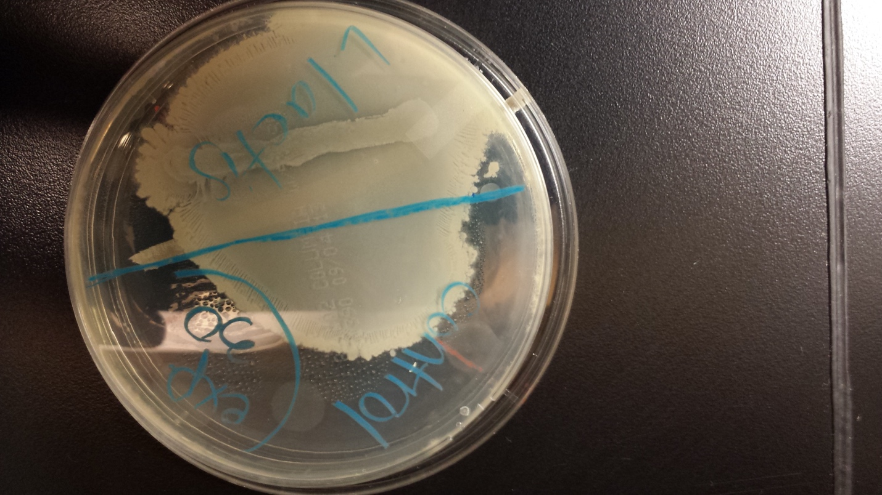

Figure 7: Catalase test for gram-positive cocci reaction of unknown is labeled *L. lactis* vs. a control. Source from Microbiology in Review Catalase Test (2014)

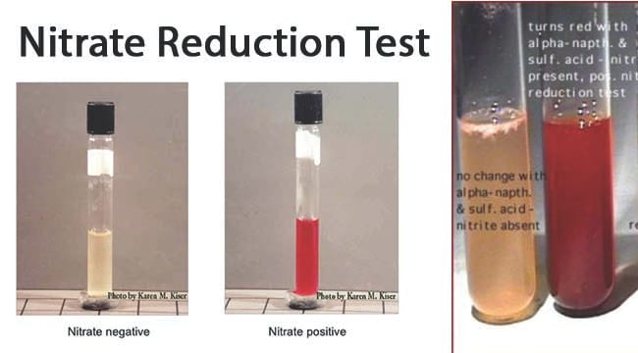

Figure 8: Nitrate reduction test for the gram-positive cocci resembles the negative test as no color change happens after adding reagents. (Aryal and Majid, 2020)

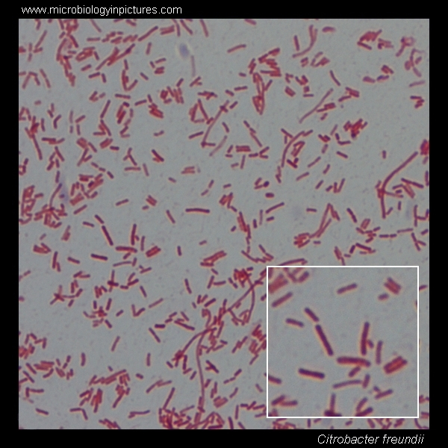

Figure 9: Gram test result for gram-negative rod unknown. Source from Microbiology in Pictures (2020)

Far right result similar to tesult for gram-negative bacteria


Figure 10: Agar deep stab results from the gram-negative rod closely resembles tube on the far right as growth shown throughout the stab. Source from Soil Micro Lab (2020)

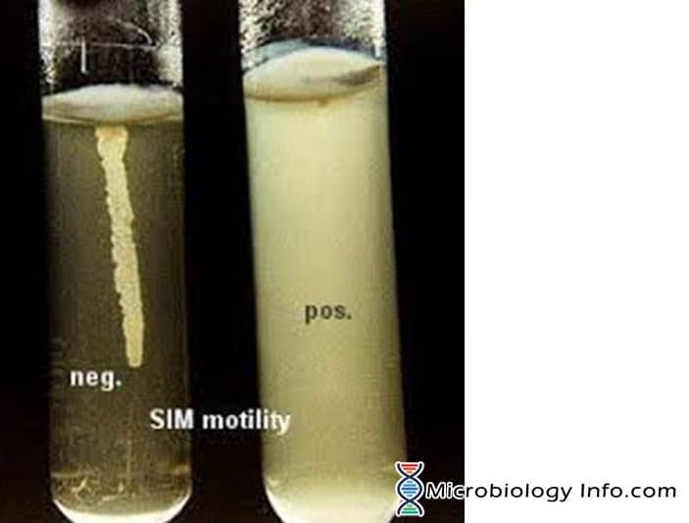

Figure 11: Motility test from the SIM test gram-negative rod results show positive closely resembles the image on the right growth extending from stab. (Aryal, 2019)

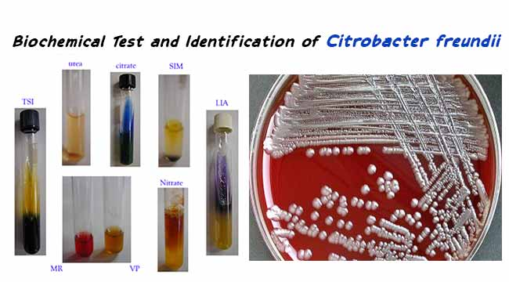

Figure 12: Citrate test result for gram-negative rod color change from green to blue. (Aryal and Devi, 2019)

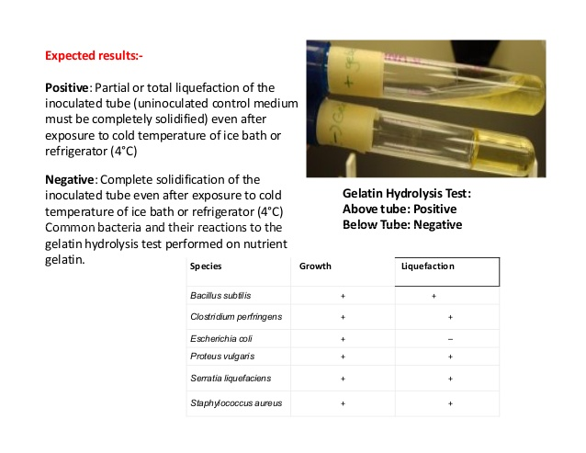

Figure 13: Gelatin hydrolysis test for gram-negative rod is negative resembling the tube on the bottom as no liquid forms in tube. (Kundur, 2019)

**Discussion**

Following the flow chart from (Figure 1), it can be determined that the gram-positive cocci is Lactococcus lactis (L. lactis) through the tests listed in the results section. L. lactis is classified as a lactic acid bacterium because of the bacteria’s ability to ferment lactose to lactic acid hence lactis name given. It uses enzymes to produce ATP from lactose to fuel the lactic acid cycle. (Todar and Madison, 2020) L. lactis is normally found in milk products as it’s important to the process of fermenting milk and varieties of cheese production.

Following the flow chart from (Figure 1), it can be determined that the gram-negative rod is the species Citrobacter freundii (C. freundii) through the tests listed in the results section. C. freundii is classified as a gammaproteobacterium as this bacterium is usually found in infections in the urinary tract and respiratory system from cases of infected water and food. This bacterium, in general, is very resistant to ampicillin-sulbactam and cephalosporins as it can cause neonatal meningitis. (Wanger et al. 2017)

If unsure about the determination of the unknown bacteria one can go back to the results and determine the characteristics of each bacteria. For the gram-positive cocci determined as L. lactis a similar bacterium to this can be Streptococcus faecalis as both of these bacteria test very similarly besides the nitrate reduction test. Streptococcus faecalis tests positive for nitrate reduction as L. lactis tests positive in this test. For the gram-negative rod determined as C. freundii, a similar bacterium can be Proteus mirabilis as both bacteria tests very similar besides the gelatin hydrolysis test. Proteus mirabilis test is positive for gelatinase as C. freundii tests are negative.

A few issues experienced throughout this process is the obvious issue with the COVID-19 restriction of lab time and in-person help with the writing of the lab report. Other issues include limited guidance of creating a flow chart. An accurate flow chart is essential to this process of identifying an unknown microorganism. Without an accurate chart the whole process can be messed up. It took several versions to create my final version of my flow chart to determine the species of both unknown bacteria. The fix to this problem was to keep making new versions that can distinguish the bacteria effectively test by test.

While testing microorganism it is important to keep tested samples fresh in order to record accurate results from tests. If a bacteria sample is exposed for 24-48 hours, it is a good idea to replenish the sample being tested due to factors of contamination. If the sample is contaminated it can produce false tests, resulting in giving the impression of different bacteria.

Just identifying a bacterium based on its colony morphology alone can only accurately determine a bacteria’s order and family not down to species level identification. In order to correctly identify a bacterium, it is necessary to study biochemical and physiological characteristics to correctly place the bacteria in the correct genus and species.

**Extra Credit**

For the research on L. lactis a study conducted L. lactis as a live vector for vaccines. The investigation for L. lactis mucosal vaccines was against a bacterium named Streptococcus mutans. Impressively an expressed gene in L. Lactis was effectively able to kill bacteria and act as a highly immunogenic property which effectively made it a vaccine against a different bacterium. (Azizpour et al., 2017) With this knowledge, it brings valuable information with therapy for these bacteria as L. lactis stimulates an immune response without prior knowledge of the bacteria strain. Streptococcus mutans are widely known to cause tooth decay so using L. lactis can successfully aid in recovery from certain diseases.

For research on C. Freundii, a study found that certain resistance mechanisms carried in C. Freundii are associated with a higher mortality rate. During the study 36 patients that were infected with polymicrobial infections with C. Freundii with a resistant gene had a 16.7% mortality rate. (Liu et al., 2017) Many different infections can cause comorbid diseases, but the trend with patients with C. Freundii seemed to carry a much higher risk of developing comorbid diseases such as diabetes, chronic kidney disease, and cancers. This is what caused patients to have a much higher fatality rate when C. Freundii with a resistance mechanism is found in an infection. With this knowledge it can be used to keep people informed about comorbid diseases and its risks with C. Freundii.

**Works Cited**

Aryal, S. (2019, June 14). Motility Test - Principle, Procedure, Uses and Interpretation.

Retrieved from https://microbiologyinfo.com/motility-test

Aryal, S., & Devi, D. (2019, August 15). Biochemical Test and Identification of Citrobacter

freundii. Retrieved from https://microbiologyinfo.com/biochemical-test-and-identification-of-citrobacter-freundii/

Aryal, S., & Majid, A. (2020, January 6). Nitrate Reduction Test- Objectives, Principle,

Procedure and Results. Retrieved from https://microbenotes.com/nitrate-reduction-test-objectives-principle-procedure-and-results/

Ayeni, F. A., Andersen, C., & Nørskov-Lauritsen, N. (2017). Comparison of growth on mannitol

salt agar, matrix-assisted laser desorption/ionization time-of-flight mass spectrometry, VITEK ® 2 with partial sequencing of 16S rRNA gene for identification of coagulase-negative staphylococci. *Microbial Pathogenesis*, *105*, 255–259. doi: 10.1016/j.micpath.2017.02.034

Azizpour, M., Hossenini, S. D., Jafari, P., & Akbary, N. (2017). Lactococcus lactis : A New

Strategy for Vaccination. Avicenna J Med Biotechnol, 9(4), 163–168. Retrieved from https://www.ncbi.nlm.nih.gov/pmc/articles/PMC5650732/

Catalase Test. (2014, April 8). Retrieved from https://microblog2014.wordpress.com/home-

page/catalase-test/

Delfiner, M. S., Martinez, L. R., & Pavia, C. S. (2016). A Gram Stain Hands-On Workshop

Enhances First Year Medical Students' Technique Competency in Comprehension and Memorization. *PLoS ONE*, *11*(10). doi: http://dx.doi.org.portal.lib.fit.edu/10.1371/journal.pone.0163658

Kundur, P. (2019, October 11). Biochemical tests for characterization of bacteria. Retrieved from

https://www.slideshare.net/PavanKundur/biochemical-tests-for-characterization-of-bacteria

Leboffe, M. J., & Pierce, B. E. (2012). *Microbiology: Laboratory theory & application*.

Englewood, CO: Morton Pub.

Liu, L.-H., Wang, N.-Y., Wu, A. Y.-J., Lin, C.-C., Lee, C.-M., & Liu, C.-P. (2018). Citrobacter

freundii bacteremia: Risk factors of mortality and prevalence of resistance genes. *Journal of Microbiology, Immunology and Infection*, *51*(4), 565–572. doi: 10.1016/j.jmii.2016.08.016

Microbiology in Pictures. Retrieved from https://www.microbiologyinpictures.com/bacteria-

micrographs/gram-stain/gram-negative/citrobacter.html

Soft Agar Deep Test. (n.d.). Retrieved from http://soilmicrolab.blogspot.com/2015/04/soft-agar-

deep-test.html

Todar, K., & Madison. (n.d.). Retrieved from

http://textbookofbacteriology.net/featured_microbe.html

Wanger, A., Chavez, V., Huang, R. S. P., Wahed, A., Actor, J. K., & Dasgupta, A. (2017).

Citrobacter freundii and Citrobacter koseri. *Microbiology and Molecular Diagnosis in Pathology*, 75–117. doi: https://doi.org/10.1016/B978-0-12-805351-5.00006-5

Ward's® Live *Lactococcus lactis* Culture. (n.d.). Retrieved from

https://us.vwr.com/store/product/8878855/ward-s-live-i-lactococcus-lactis-i-culture

Wilhelm, M. J., Sheffield, J. B., Gh., M. S., Wu, Y., Spahr, C., Gonella, G., … Dai, H.-L. (2015).

Gram’s Stain Does Not Cross the Bacterial Cytoplasmic Membrane. *ACS Chemical Biology*, *10*(7), 1711–1717. doi: 10.1021/acschembio.5b00042