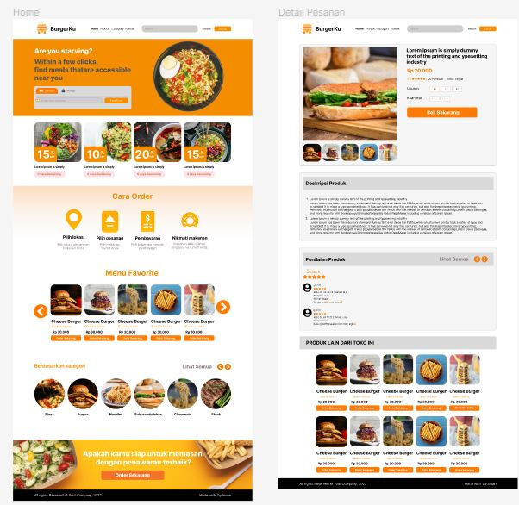

Home

Burgerku

**Are you starving?**

Within a few clicks,

find meals thatare accessible

near you

15

**10**

20

15

Cara Order

Menu Favorite

Cheese Berger Cheese Burger Cheese Burger Cheese Burger Cheese Burger

Benarkan kateg

Lihat Semua

Detail Pesanan

**Burgerku**

**Deskripsi Produk**

**Lorem Ipsum is simply dummy text of the printing and ypesetting Industry Rp 20.000**

**Penilaian Produk**

Lihat Semus 00

PRODUK LAIN DARI TOKO INI

Cheese Burger Choose Burger Cheese Burger Cheese Burger Cheese Burger

**Apakah kamu siap untuk memesan dengan penawaran terbaik?**

Order

Cheese Burger Che Burger Cheese Burger Cheese Burger Cheese Burger