UNIT TEST DOCUMENT
Module Name | REGISTRATION MODULE | Test Cycle No. | 1
Component Name | CREATE ACCOUNT | Type of System | Web Application
Date Tested | 10-31-2026 | Test Scope | Field-by-field validation
Pre-conditions | Registration page is open.
Action Description | Test each required field independently, then verify successful registration.
Verification Steps | For each field, use valid values in all other fields; leave only the field under test blank or invalid and submit.
FIELD TEST SCENARIOS
No. | Field | Data / Input Values | Expected Result | Actual Result from Supplied Screen | Status
1 | First name | Enter valid values elsewhere; leave First Name blank. | Show “First name is required” and block submission. | “First name is required” is visible in the all-blank screenshot; not isolated. | ISOLATE
2 | Last name | Enter valid values elsewhere; leave Last Name blank. | Show “Last name is required” and block submission. | “Last name is required” is visible in the all-blank screenshot; not isolated. | ISOLATE
3 | Address | Enter valid values elsewhere; leave Address blank. | Show “Address is required” and block submission. | “Address is required” is visible in the all-blank screenshot; not isolated. | ISOLATE
4 | Date of birth | Enter valid values elsewhere; do not select a date. | Show “Date of birth is required” and block submission. | “Date of birth is required” is visible below the date picker; not isolated. | ISOLATE
5 | Gender | Enter valid values elsewhere; leave Male, Female, and Rather not to say unselected. | Require a gender choice and block submission. Confirm the exact message. | The field is marked required and shows three choices. No gender error is visible in the supplied screenshot. | NEEDS RUN
6 | Phone number | Enter valid values elsewhere; leave phone blank, then separately try a value that does not match the displayed format. | Require a Philippines mobile number with 11 digits starting with 09; block invalid input. | The screen shows “For Philippines, enter an 11-digit mobile number starting with 09.” Individual invalid/blank behavior is not shown. | NEEDS RUN

FIELD TEST SCENARIOS CONTINUED
No. | Field | Data / Input Values | Expected Result | Actual Result from Supplied Screen | Status
7 | Email address | Enter valid values elsewhere; test blank email and malformed email separately. | Require a valid email address and block blank or malformed input. | “Enter a valid email address” is visible in the all-blank screenshot; separate blank/format behavior is not verified. | ISOLATE
8 | Password | Enter valid values elsewhere; test blank password and test each displayed password rule. | Require a password. Strength feedback should reflect 8+ characters, a letter, a number, and a special character. | “Password is required” and “Strength: Weak” are visible; the four criteria are listed. Rule-by-rule results are not shown. | NEEDS RUN
9 | Confirm password | Enter valid values elsewhere; leave confirmation blank, then test a value that does not match Password. | Require confirmation and reject a mismatch. Record the exact mismatch message. | “Confirm password is required” is visible in the all-blank screenshot; mismatch behavior is not shown. | NEEDS RUN
10 | Successful registration | Enter valid values in every field, including matching passwords, and submit. | Create the account and navigate to the Login page. | No successful-submission screenshot supplied yet. | PENDING
Supplied registration screen
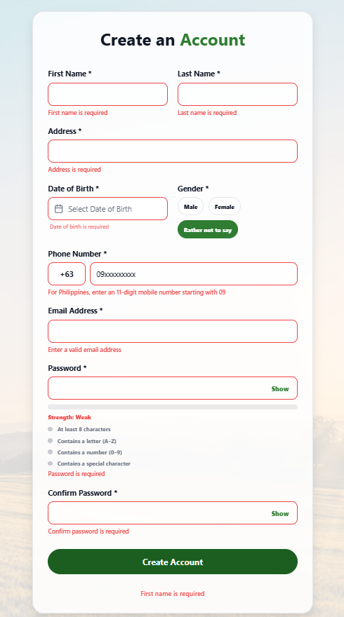
The screenshot shows several blank-field messages at once, so it does not confirm the isolated field tests above.

