UNIT TEST DOCUMENT |  | Module Name | ADMIN MODULE
Test Cycle No. | 5 | Module Name
Test Cycle No. | 5 | Component Name | LOGIN
Date Tested | 11/01/2026 | Type of System | Web Application
Pre-conditions | Open the AgriX website and use an authorized administrator account.
Action Description | Authenticate the administrator and open the protected administration area.
Verification Steps | The credentials are accepted and the administrator route is displayed.
Test Scenario | Data  (Input Values) |  |  | Expected Results | Actual Results | Remarks
1 | Valid administrator sign-in |  |  | Administrator dashboard/console opens. | Sign-in succeeded; AdminDashboard opened. | PASSED
2 | — |  |  | — | Not run. | NOT RUN
3 | — |  |  | — | Not run. | NOT RUN
4 | — |  |  | — | Not run. | NOT RUN
5 | — |  |  | — | Not run. | NOT RUN
Prepared By | Administered/Performed By
____________________________  Signature over Printed Name | ____________________________  Signature over Printed Name
UNIT TEST DOCUMENT |  | Module Name | ADMIN MODULE
Test Cycle No. | 5 | Module Name
Test Cycle No. | 5 | Component Name | ADMIN CONSOLE
Date Tested | 11/01/2026 | Type of System | Web Application
Pre-conditions | Sign in as an administrator and open the admin overview.
Action Description | Load the administration console and inspect its overview.
Verification Steps | The console shell and overview content appear without blocking errors.
Test Scenario | Data  (Input Values) |  |  | Expected Results | Actual Results | Remarks
1 | Open AdminDashboard overview |  |  | Admin console opens and displays overview. | AdminDashboard opened (shared Console/Dashboard route). Counts first showed zero/no users, then populated. | OBSERVED — TRANSIENT DATA STATE
2 | — |  |  | — | Not run. | NOT RUN
3 | — |  |  | — | Not run. | NOT RUN
4 | — |  |  | — | Not run. | NOT RUN
5 | — |  |  | — | Not run. | NOT RUN
Prepared By | Administered/Performed By
____________________________  Signature over Printed Name | ____________________________  Signature over Printed Name
UNIT TEST DOCUMENT |  | Module Name | ADMIN MODULE
Test Cycle No. | 5 | Module Name
Test Cycle No. | 5 | Component Name | PROFILE
Date Tested | 11/01/2026 | Type of System | Web Application
Pre-conditions | Sign in as an administrator and select Profile.
Action Description | Open the administrator profile page.
Verification Steps | Profile page loads and displays the signed-in account profile.
Test Scenario | Data  (Input Values) |  |  | Expected Results | Actual Results | Remarks
1 | Open administrator profile |  |  | Profile details are displayed. | Admin Profile loaded. | PASSED
2 | — |  |  | — | Not run. | NOT RUN
3 | — |  |  | — | Not run. | NOT RUN
4 | — |  |  | — | Not run. | NOT RUN
5 | — |  |  | — | Not run. | NOT RUN
Prepared By | Administered/Performed By
____________________________  Signature over Printed Name | ____________________________  Signature over Printed Name
UNIT TEST DOCUMENT |  | Module Name | ADMIN MODULE
Test Cycle No. | 5 | Module Name
Test Cycle No. | 5 | Component Name | USER MANAGEMENT
Date Tested | 11/01/2026 | Type of System | Web Application
Pre-conditions | Sign in as an administrator and open User Management.
Action Description | View the user list and available management controls without changing records.
Verification Steps | User list and search/actions are visible; no record is changed during this check.
Test Scenario | Data  (Input Values) |  |  | Expected Results | Actual Results | Remarks
1 | Open user list |  |  | User rows and controls are displayed. | User Management loaded with user rows, search, and actions. No records were modified. | PASSED — VIEW ONLY
2 | — |  |  | — | Not run. | NOT RUN
3 | — |  |  | — | Not run. | NOT RUN
4 | — |  |  | — | Not run. | NOT RUN
5 | — |  |  | — | Not run. | NOT RUN
Prepared By | Administered/Performed By
____________________________  Signature over Printed Name | ____________________________  Signature over Printed Name
UNIT TEST DOCUMENT |  | Module Name | ADMIN MODULE
Test Cycle No. | 5 | Module Name
Test Cycle No. | 5 | Component Name | NOTIFICATION
Date Tested | 11/01/2026 | Type of System | Web Application
Pre-conditions | Sign in as an administrator and open Notifications.
Action Description | Load the administrator notification view.
Verification Steps | The notification list or its empty state is displayed.
Test Scenario | Data  (Input Values) |  |  | Expected Results | Actual Results | Remarks
1 | Open administrator notifications |  |  | Notifications page loads and shows messages or an empty state. | Admin Notifications loaded and showed “All caught up / No updates yet.” | PASSED — EMPTY STATE
2 | — |  |  | — | Not run. | NOT RUN
3 | — |  |  | — | Not run. | NOT RUN
4 | — |  |  | — | Not run. | NOT RUN
5 | — |  |  | — | Not run. | NOT RUN
Prepared By | Administered/Performed By
____________________________  Signature over Printed Name | ____________________________  Signature over Printed Name
UNIT TEST DOCUMENT |  | Module Name | ADMIN MODULE
Test Cycle No. | 5 | Module Name
Test Cycle No. | 5 | Component Name | DASHBOARD
Date Tested | 11/01/2026 | Type of System | Web Application
Pre-conditions | Sign in as an administrator and view the dashboard.
Action Description | Load dashboard summary metrics.
Verification Steps | Dashboard metrics display and remain consistent after loading.
Test Scenario | Data  (Input Values) |  |  | Expected Results | Actual Results | Remarks
1 | Load dashboard metrics |  |  | Summary counts load and remain stable. | Admin dashboard loaded; summary values appeared after a transient zero/no-users state. | PARTIAL — VERIFY METRIC STABILITY
2 | — |  |  | — | Not run. | NOT RUN
3 | — |  |  | — | Not run. | NOT RUN
4 | — |  |  | — | Not run. | NOT RUN
5 | — |  |  | — | Not run. | NOT RUN
Prepared By | Administered/Performed By
____________________________  Signature over Printed Name | ____________________________  Signature over Printed Name
UNIT TEST DOCUMENT |  | Module Name | CLIENT MODULE
Test Cycle No. | 5 | Module Name
Test Cycle No. | 5 | Component Name | LANDING PAGE
Date Tested | 11/01/2026 | Type of System | Web Application
Pre-conditions | Open the AgriX website while signed out.
Action Description | Load the public landing page.
Verification Steps | Landing content and navigation render.
Test Scenario | Data  (Input Values) |  |  | Expected Results | Actual Results | Remarks
1 | Open website root |  |  | Public AgriX landing page is displayed. | Landing page loaded.  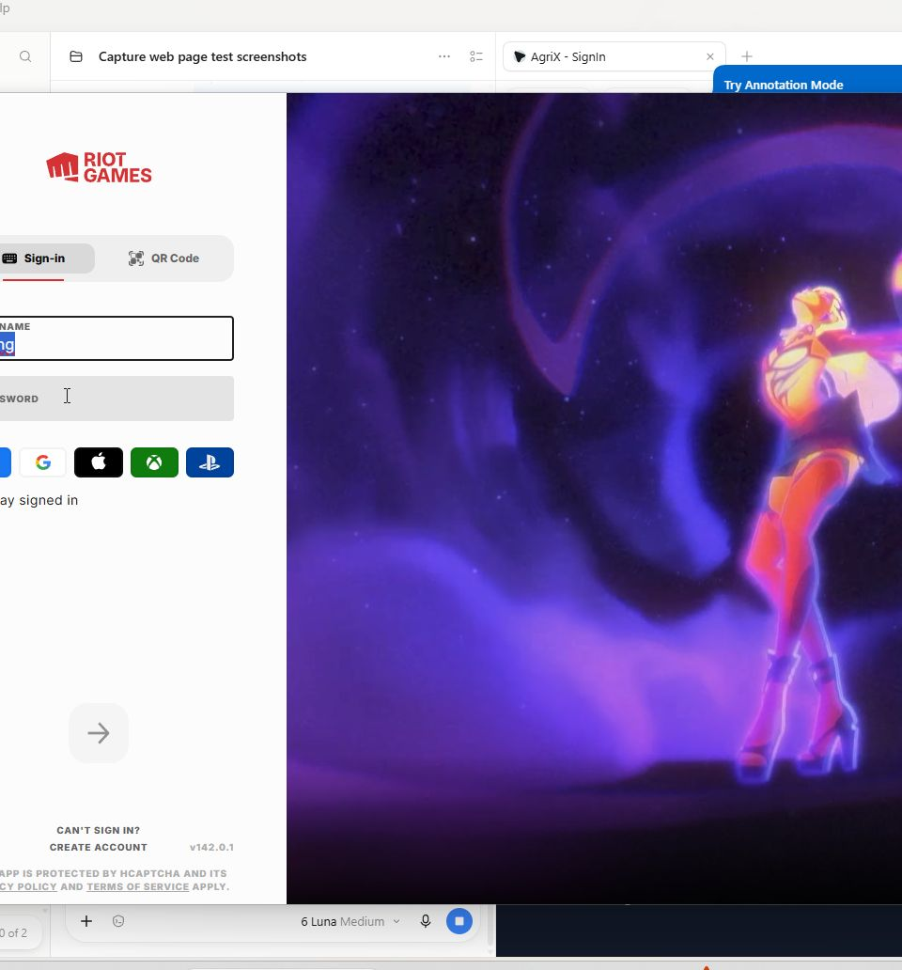 | PASSED
2 | — |  |  | — | Not run. | NOT RUN
3 | — |  |  | — | Not run. | NOT RUN
4 | — |  |  | — | Not run. | NOT RUN
5 | — |  |  | — | Not run. | NOT RUN
Prepared By | Administered/Performed By
____________________________  Signature over Printed Name | ____________________________  Signature over Printed Name
UNIT TEST DOCUMENT |  | Module Name | CLIENT MODULE
Test Cycle No. | 5 | Module Name
Test Cycle No. | 5 | Component Name | LOGIN
Date Tested | 11/01/2026 | Type of System | Web Application
Pre-conditions | Open the sign-in page and use an authorized client account.
Action Description | Authenticate and open the protected client area.
Verification Steps | Credentials are accepted and the client dashboard opens.
Test Scenario | Data  (Input Values) |  |  | Expected Results | Actual Results | Remarks
1 | Valid client sign-in |  |  | Client dashboard opens. | Sign-in succeeded and client dashboard opened. | PASSED
2 | — |  |  | — | Not run. | NOT RUN
3 | — |  |  | — | Not run. | NOT RUN
4 | — |  |  | — | Not run. | NOT RUN
5 | — |  |  | — | Not run. | NOT RUN
Prepared By | Administered/Performed By
____________________________  Signature over Printed Name | ____________________________  Signature over Printed Name
UNIT TEST DOCUMENT |  | Module Name | CLIENT MODULE
Test Cycle No. | 5 | Module Name
Test Cycle No. | 5 | Component Name | FORGOT PASSWORD
Date Tested | 11/01/2026 | Type of System | Web Application
Pre-conditions | Open the sign-in page and select Forgot Password.
Action Description | Open the password recovery form; do not submit a reset request.
Verification Steps | Recovery form is displayed and accepts an email input.
Test Scenario | Data  (Input Values) |  |  | Expected Results | Actual Results | Remarks
1 | Open recovery form |  |  | Forgot Password form is displayed. | Recovery screen was displayed; reset submission and email delivery were not tested. | PARTIAL — SUBMISSION NOT TESTED
2 | — |  |  | — | Not run. | NOT RUN
3 | — |  |  | — | Not run. | NOT RUN
4 | — |  |  | — | Not run. | NOT RUN
5 | — |  |  | — | Not run. | NOT RUN
Prepared By | Administered/Performed By
____________________________  Signature over Printed Name | ____________________________  Signature over Printed Name
UNIT TEST DOCUMENT |  | Module Name | CLIENT MODULE
Test Cycle No. | 5 | Module Name
Test Cycle No. | 5 | Component Name | DASHBOARD
Date Tested | 11/01/2026 | Type of System | Web Application
Pre-conditions | Sign in as a client and load Dashboard.
Action Description | Inspect dashboard cards, sensor status, and navigation.
Verification Steps | Dashboard renders current account state and available monitoring links.
Test Scenario | Data  (Input Values) |  |  | Expected Results | Actual Results | Remarks
1 | Load client dashboard |  |  | Dashboard content is displayed. | Dashboard loaded; no sensor readings were available in the account.  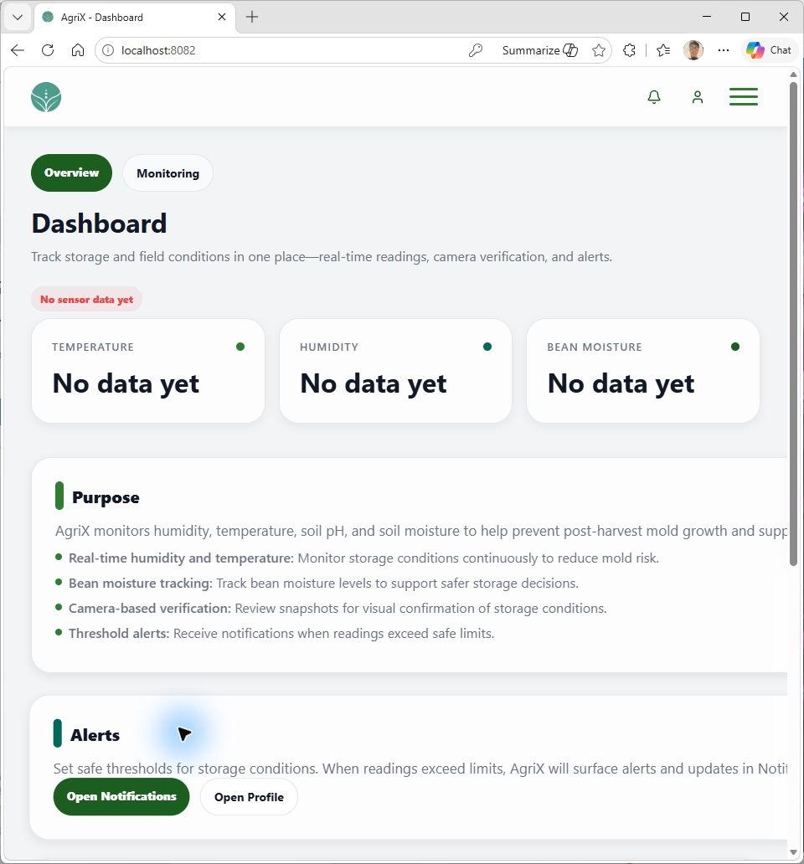 | PASSED — NO SENSOR DATA
2 | — |  |  | — | Not run. | NOT RUN
3 | — |  |  | — | Not run. | NOT RUN
4 | — |  |  | — | Not run. | NOT RUN
5 | — |  |  | — | Not run. | NOT RUN
Prepared By | Administered/Performed By
____________________________  Signature over Printed Name | ____________________________  Signature over Printed Name
UNIT TEST DOCUMENT |  | Module Name | CLIENT MODULE
Test Cycle No. | 5 | Module Name
Test Cycle No. | 5 | Component Name | NOTIFICATION
Date Tested | 11/01/2026 | Type of System | Web Application
Pre-conditions | Sign in as a client and open Notifications.
Action Description | Load the client notification list.
Verification Steps | The list or its empty state is displayed.
Test Scenario | Data  (Input Values) |  |  | Expected Results | Actual Results | Remarks
1 | Open client notifications |  |  | Notifications page loads and shows messages or an empty state. | Notifications loaded and showed “All caught up.”  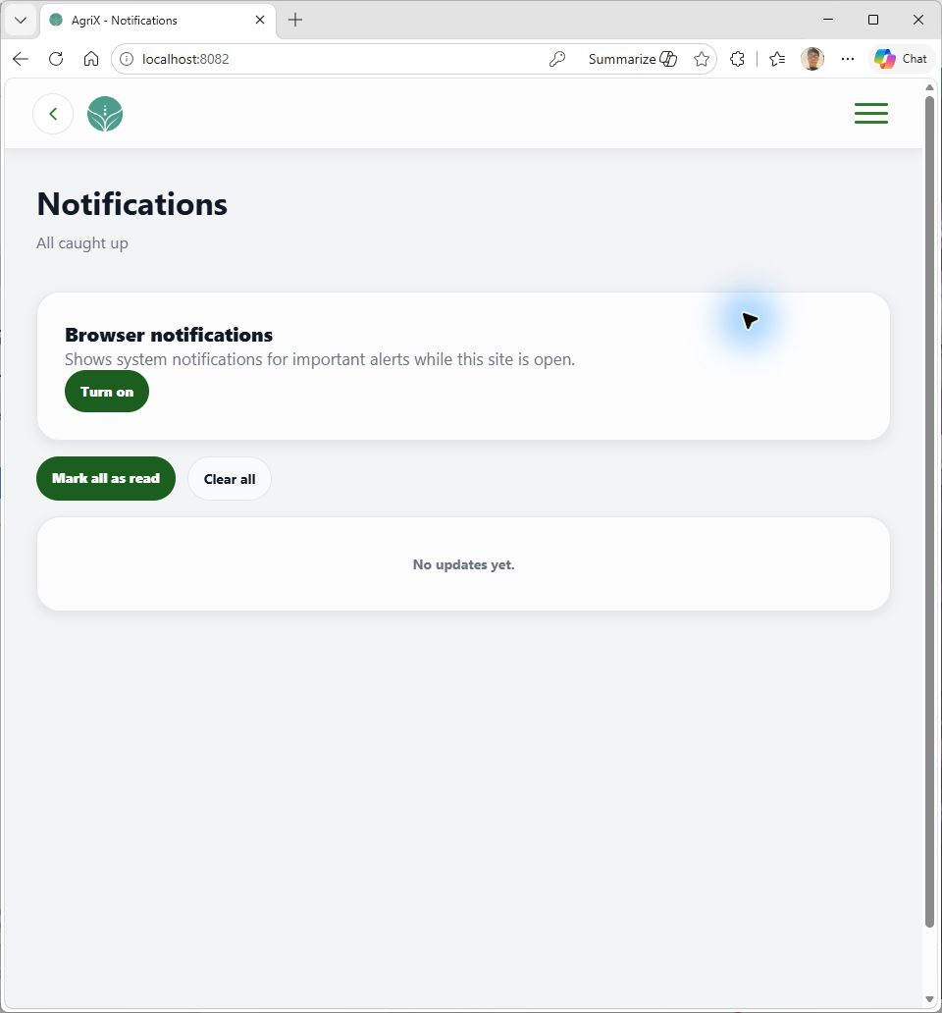 | PASSED — EMPTY STATE
2 | — |  |  | — | Not run. | NOT RUN
3 | — |  |  | — | Not run. | NOT RUN
4 | — |  |  | — | Not run. | NOT RUN
5 | — |  |  | — | Not run. | NOT RUN
Prepared By | Administered/Performed By
____________________________  Signature over Printed Name | ____________________________  Signature over Printed Name
UNIT TEST DOCUMENT |  | Module Name | CLIENT MODULE
Test Cycle No. | 5 | Module Name
Test Cycle No. | 5 | Component Name | PROFILE
Date Tested | 11/01/2026 | Type of System | Web Application
Pre-conditions | Sign in as a client and open Profile.
Action Description | View the client profile page.
Verification Steps | Profile page loads for the signed-in user.
Test Scenario | Data  (Input Values) |  |  | Expected Results | Actual Results | Remarks
1 | Open client profile |  |  | Profile details are displayed. | Client Profile loaded. Personal details are visible in the attached screenshot.  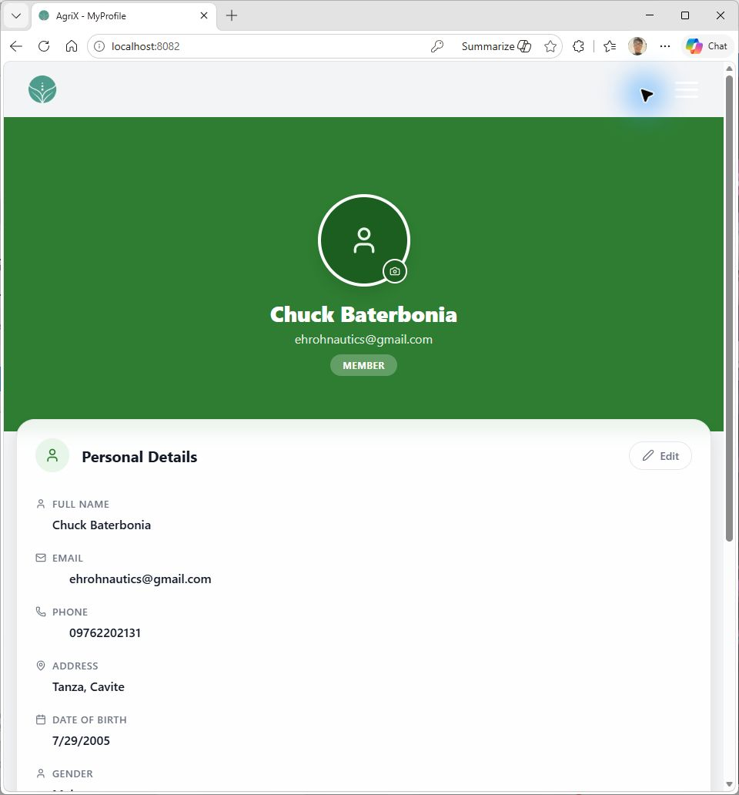 | PASSED
2 | — |  |  | — | Not run. | NOT RUN
3 | — |  |  | — | Not run. | NOT RUN
4 | — |  |  | — | Not run. | NOT RUN
5 | — |  |  | — | Not run. | NOT RUN
Prepared By | Administered/Performed By
____________________________  Signature over Printed Name | ____________________________  Signature over Printed Name
UNIT TEST DOCUMENT |  | Module Name | CLIENT MODULE
Test Cycle No. | 5 | Module Name
Test Cycle No. | 5 | Component Name | DEVICE SENSORS
Date Tested | 11/01/2026 | Type of System | Web Application
Pre-conditions | Sign in as a client and open Device & Sensors.
Action Description | Inspect device connection and current sensor status.
Verification Steps | Device status and any available sensor readings are displayed.
Test Scenario | Data  (Input Values) |  |  | Expected Results | Actual Results | Remarks
1 | Open device status |  |  | Connected device and current readings display when available. | ESP32 showed Offline; no readings were available. Mold/forecast status was unknown. | BLOCKED — NO LIVE SENSOR DATA
2 | — |  |  | — | Not run. | NOT RUN
3 | — |  |  | — | Not run. | NOT RUN
4 | — |  |  | — | Not run. | NOT RUN
5 | — |  |  | — | Not run. | NOT RUN
Prepared By | Administered/Performed By
____________________________  Signature over Printed Name | ____________________________  Signature over Printed Name
UNIT TEST DOCUMENT |  | Module Name | CLIENT MODULE
Test Cycle No. | 5 | Module Name
Test Cycle No. | 5 | Component Name | READING TIMELINE
Date Tested | 11/01/2026 | Type of System | Web Application
Pre-conditions | Sign in as a client and open Reading Timeline.
Action Description | View readings for the selected time filter.
Verification Steps | Timeline lists readings or clearly shows an empty state.
Test Scenario | Data  (Input Values) |  |  | Expected Results | Actual Results | Remarks
1 | Open timeline for current filter |  |  | Readings or a no-data state are displayed. | No readings were available for the selected filter. | BLOCKED — NO TEST DATA
2 | — |  |  | — | Not run. | NOT RUN
3 | — |  |  | — | Not run. | NOT RUN
4 | — |  |  | — | Not run. | NOT RUN
5 | — |  |  | — | Not run. | NOT RUN
Prepared By | Administered/Performed By
____________________________  Signature over Printed Name | ____________________________  Signature over Printed Name
UNIT TEST DOCUMENT |  | Module Name | CLIENT MODULE
Test Cycle No. | 5 | Module Name
Test Cycle No. | 5 | Component Name | GRAPH HISTORY
Date Tested | 11/01/2026 | Type of System | Web Application
Pre-conditions | Sign in as a client and open Graph History.
Action Description | Load historical sensor graphs.
Verification Steps | Metric graphs load or a clear no-data state is shown without a load error.
Test Scenario | Data  (Input Values) |  |  | Expected Results | Actual Results | Remarks
1 | Open graph history |  |  | Historical metrics render or show a no-data state. | Metrics showed “No data yet”; page also displayed “Failed to load readings.” | FAILED — LOAD ERROR OBSERVED
2 | — |  |  | — | Not run. | NOT RUN
3 | — |  |  | — | Not run. | NOT RUN
4 | — |  |  | — | Not run. | NOT RUN
5 | — |  |  | — | Not run. | NOT RUN
Prepared By | Administered/Performed By
____________________________  Signature over Printed Name | ____________________________  Signature over Printed Name
UNIT TEST DOCUMENT |  | Module Name | CLIENT MODULE
Test Cycle No. | 5 | Module Name
Test Cycle No. | 5 | Component Name | SNAPSHOT GALLERY
Date Tested | 11/01/2026 | Type of System | Web Application
Pre-conditions | Sign in as a client and open Snapshot Gallery.
Action Description | View available stored snapshots.
Verification Steps | Gallery displays snapshots or a clear empty state.
Test Scenario | Data  (Input Values) |  |  | Expected Results | Actual Results | Remarks
1 | Open snapshot gallery |  |  | Snapshots or a no-snapshots state are displayed. | Gallery showed no snapshots. | BLOCKED — NO TEST DATA
2 | — |  |  | — | Not run. | NOT RUN
3 | — |  |  | — | Not run. | NOT RUN
4 | — |  |  | — | Not run. | NOT RUN
5 | — |  |  | — | Not run. | NOT RUN
Prepared By | Administered/Performed By
____________________________  Signature over Printed Name | ____________________________  Signature over Printed Name
UNIT TEST DOCUMENT |  | Module Name | CLIENT MODULE
Test Cycle No. | 5 | Module Name
Test Cycle No. | 5 | Component Name | ALERT HISTORY
Date Tested | 11/01/2026 | Type of System | Web Application
Pre-conditions | Sign in as a client and open Alert History.
Action Description | View historical sensor alerts.
Verification Steps | Alert list or a clear empty state is displayed.
Test Scenario | Data  (Input Values) |  |  | Expected Results | Actual Results | Remarks
1 | Open alert history |  |  | Alerts or a no-alerts state are displayed. | No alerts were available. | BLOCKED — NO TEST DATA
2 | — |  |  | — | Not run. | NOT RUN
3 | — |  |  | — | Not run. | NOT RUN
4 | — |  |  | — | Not run. | NOT RUN
5 | — |  |  | — | Not run. | NOT RUN
Prepared By | Administered/Performed By
____________________________  Signature over Printed Name | ____________________________  Signature over Printed Name
UNIT TEST DOCUMENT |  | Module Name | CLIENT MODULE
Test Cycle No. | 5 | Module Name
Test Cycle No. | 5 | Component Name | OPEN MONITORING
Date Tested | 11/01/2026 | Type of System | Web Application
Pre-conditions | Sign in as a client and open Monitoring.
Action Description | Inspect current monitoring status and alert summary.
Verification Steps | Monitoring view shows current readings, alerts, and service status.
Test Scenario | Data  (Input Values) |  |  | Expected Results | Actual Results | Remarks
1 | Open monitoring view |  |  | Monitoring status and available readings/alerts are displayed. | No sensor readings or unread alerts; API status displayed Online.  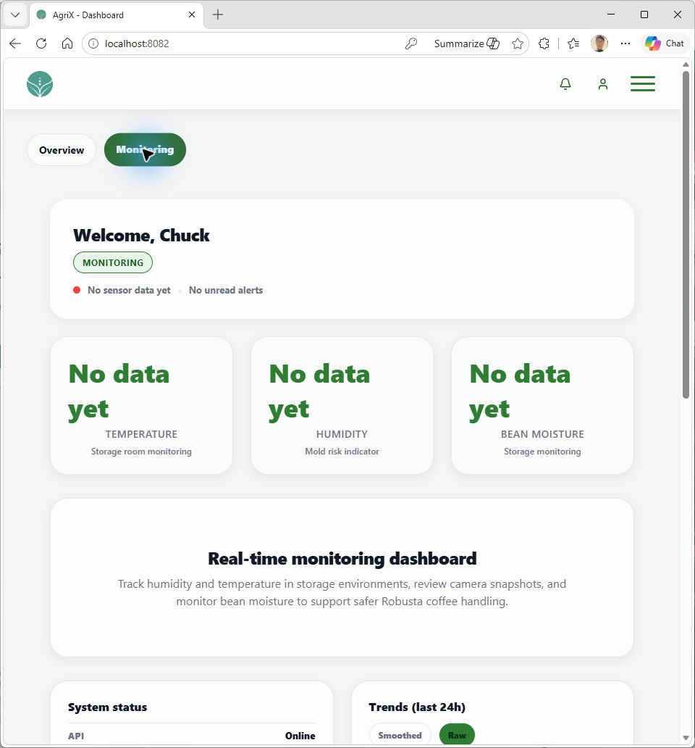 | PARTIAL — NO LIVE SENSOR DATA
2 | — |  |  | — | Not run. | NOT RUN
3 | — |  |  | — | Not run. | NOT RUN
4 | — |  |  | — | Not run. | NOT RUN
5 | — |  |  | — | Not run. | NOT RUN
Prepared By | Administered/Performed By
____________________________  Signature over Printed Name | ____________________________  Signature over Printed Name

