FUNCTIONALITY TEST DOCUMENT |  | Module Name | LANDING PAGE MODULE
Test Cycle No. | 5 | Function Name | LANDING PAGE
 |  | User/Access Type | Visitor / Mobile User
Date Tested | 11/02/26 | Type of System | Mobile Application
Pre-conditions | Open the AgriX mobile app fresh with no user logged in.
Action Description | Review the welcome screen, registration and sign-in entry points, mobile navigation, theme, scrolling, and device safe-area behavior.
Verification Steps | Confirm the welcome screen appears first, navigation opens the correct destinations, and theme, scrolling, and safe-area behavior work.

Test Scenario | Expected Results | Actual Results | Remarks
1 | Must display the AgriX welcome screen before sign-in or the dashboard, with Register and Sign In options. | 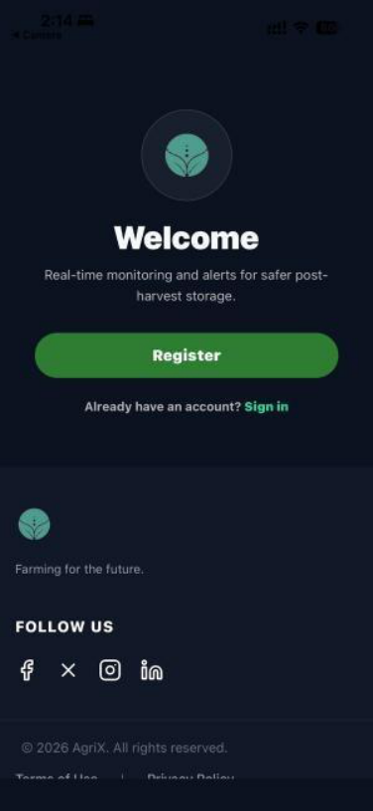 | PASSED
2 | Must open the selected destination, apply the chosen theme, scroll smoothly, and keep content clear of the device safe area. | 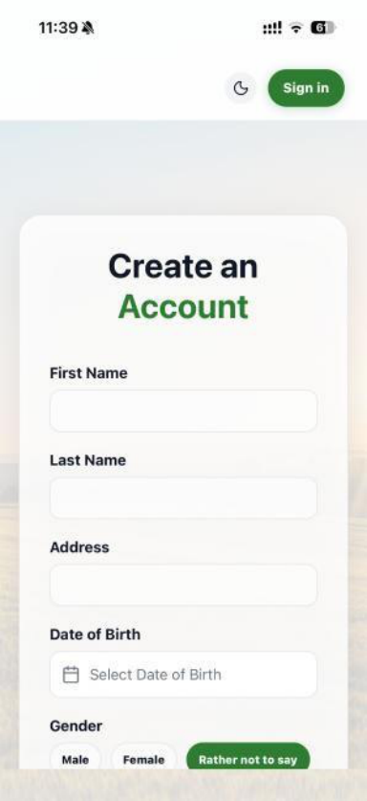 | PASSED

FUNCTIONALITY TEST DOCUMENT |  | Module Name | LOGIN MODULE
Test Cycle No. | 5 | Function Name | SIGN IN
 |  | User/Access Type | Client / Administrator
Date Tested | 11/02/26 | Type of System | Mobile Application
Pre-conditions | A verified client or administrator account is available.
Action Description | Validate sign-in errors and authenticate valid client and administrator accounts.
Verification Steps | Confirm invalid credentials are rejected and each valid account opens its authorized destination.

Test Scenario | Expected Results | Actual Results | Remarks
1 | Must reject invalid credentials and display the appropriate validation message without signing in. | 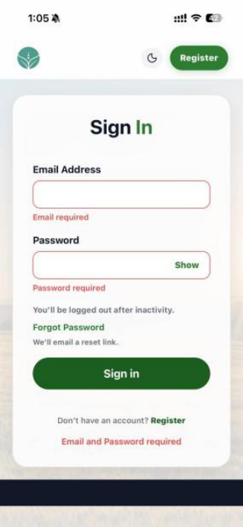  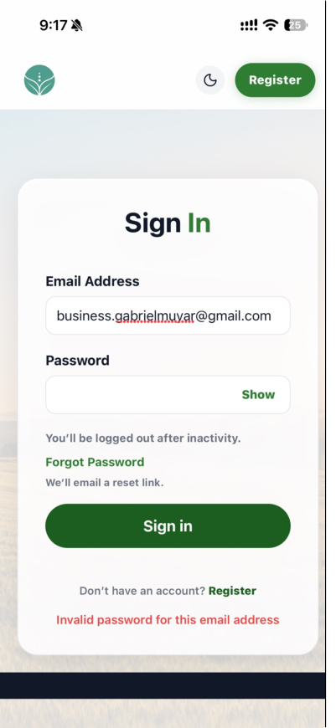 | PASSED
2 | Must authenticate the account and open its authorized mobile destination; the documented backup path must work when the primary service is unavailable. | 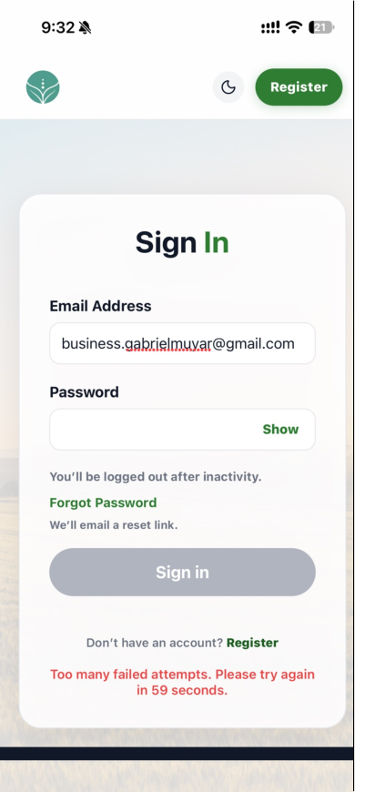  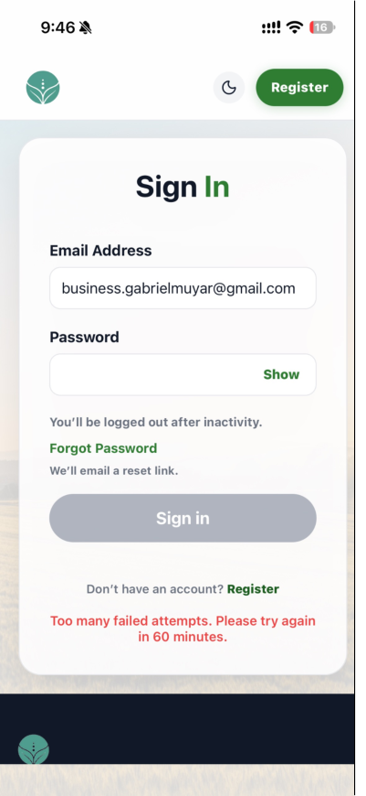 | PASSED

FUNCTIONALITY TEST DOCUMENT |  | Module Name | LOGIN - FORGOT PASSWORD MODULE
Test Cycle No. | 5 | Function Name | PASSWORD RECOVERY
 |  | User/Access Type | Visitor / Mobile User
Date Tested | 11/02/26 | Type of System | Mobile Application
Pre-conditions | A registered email address is available and the email service is configured.
Action Description | Request a password reset, open the email link on a phone, and set a new password.
Verification Steps | Confirm recovery does not disclose account registration, links expire, and new passwords follow the required rules.

Test Scenario | Expected Results | Actual Results | Remarks
1 | Must provide the same confirmation for registered and unregistered email addresses without revealing account status. | 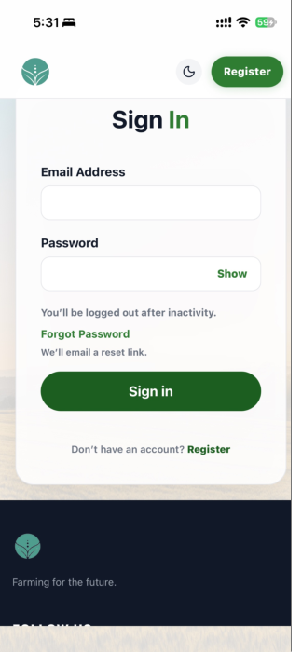 | PASSED
2 | Must accept a valid unexpired link, enforce password rules, and reject expired or invalid reset attempts. | 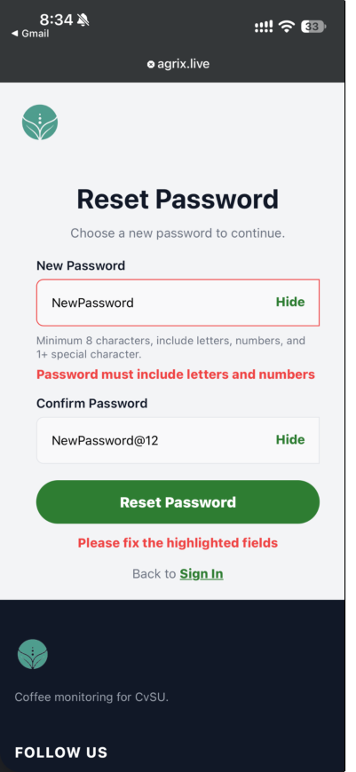  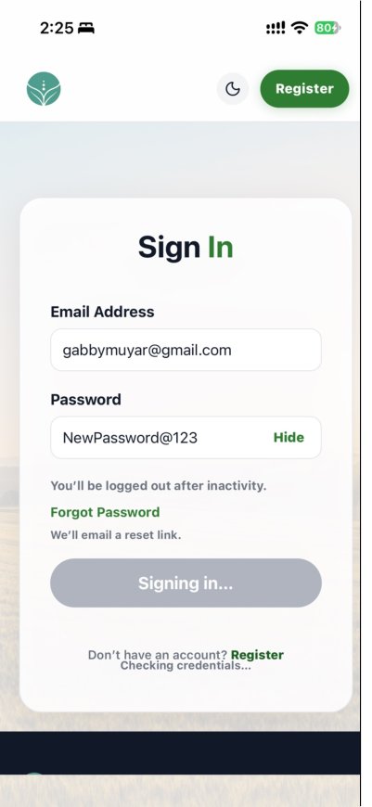 | PASSED

FUNCTIONALITY TEST DOCUMENT |  | Module Name | REGISTRATION - SIGN UP FORM MODULE
Test Cycle No. | 5 | Function Name | SIGN UP
 |  | User/Access Type | Prospective Client
Date Tested | 11/02/26 | Type of System | Mobile Application
Pre-conditions | Open the Sign Up page from the welcome screen.
Action Description | Validate registration details and submit a valid registration.
Verification Steps | Confirm invalid fields are identified, valid details proceed to OTP verification, and eligible pending registrations do not conflict.

Test Scenario | Expected Results | Actual Results | Remarks
1 | Must identify invalid or required fields and prevent registration until the details are valid. | 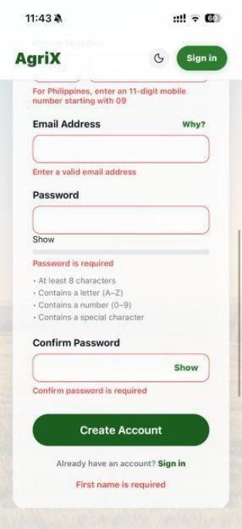  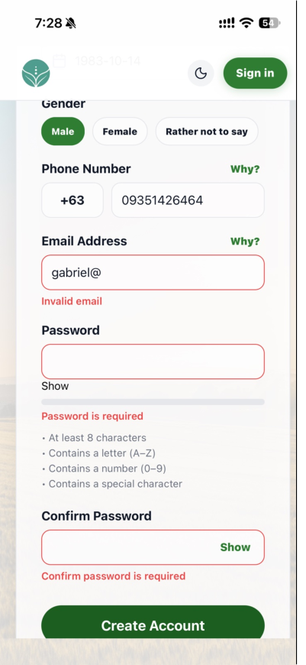 | PASSED
2 | Must accept valid details and proceed to OTP verification; a pending registration must not be blocked by an eligible retry. | 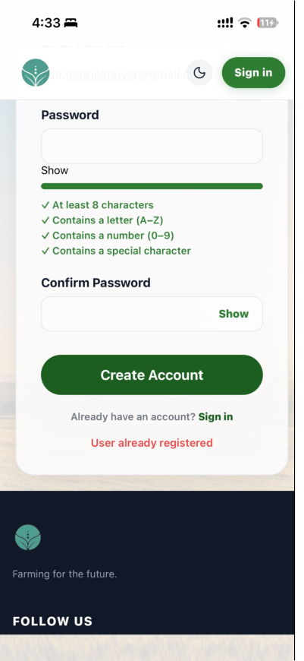  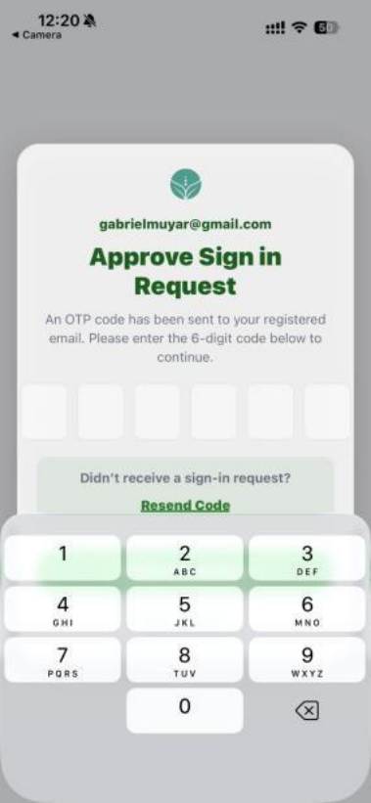 | PASSED

FUNCTIONALITY TEST DOCUMENT |  | Module Name | REGISTRATION - VERIFY OTP MODULE
Test Cycle No. | 5 | Function Name | REGISTRATION VERIFICATION
 |  | User/Access Type | Prospective Client
Date Tested | 11/02/26 | Type of System | Mobile Application
Pre-conditions | A valid Sign Up form has been submitted and the Verify Registration screen is open.
Action Description | Verify the six-digit email code, test invalid or expired codes, and resend after the cooldown.
Verification Steps | Confirm valid codes complete registration and invalid, expired, or locked codes show the appropriate message.

Test Scenario | Expected Results | Actual Results | Remarks
1 | Must accept a valid six-digit code and complete registration for the new account. | 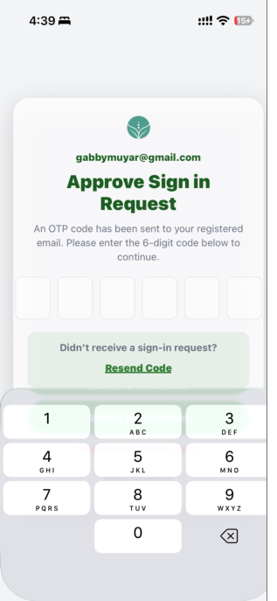 | PASSED
2 | Must reject invalid or expired codes with an appropriate message and allow a new code after the resend cooldown. | 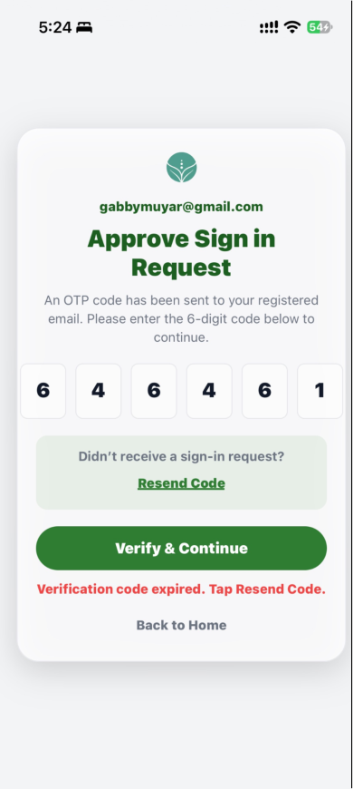  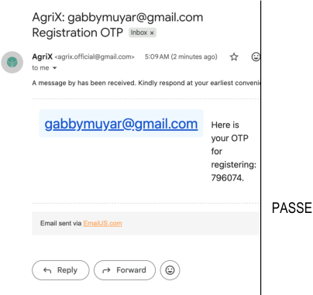 | PASSED

FUNCTIONALITY TEST DOCUMENT |  | Module Name | DASHBOARD MODULE
Test Cycle No. | 5 | Function Name | DASHBOARD
 |  | User/Access Type | Signed-in Client
Date Tested | 11/02/26 | Type of System | Mobile Application
Pre-conditions | The user is signed in and sensor readings are available.
Action Description | Review dashboard summaries and shortcuts, then verify offline and session behavior.
Verification Steps | Confirm sensor and alert summaries load, navigation shortcuts work, offline status is shown, and logout returns to the welcome screen.

Test Scenario | Expected Results | Actual Results | Remarks
1 | Must display the current sensor, risk, alert, and timeline summaries with the Device & Sensors shortcut. | 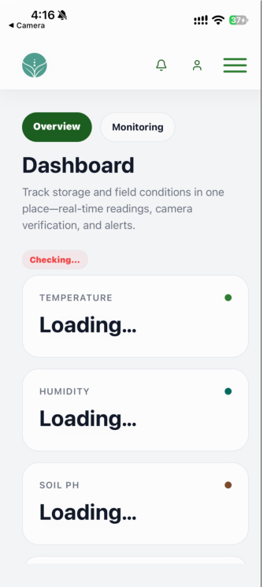 | PASSED
2 | Must open the selected destination, show offline status when required, and return to the welcome screen after logout. | 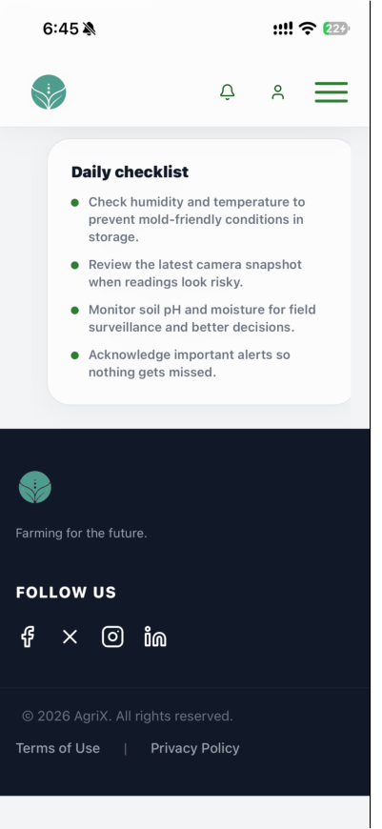  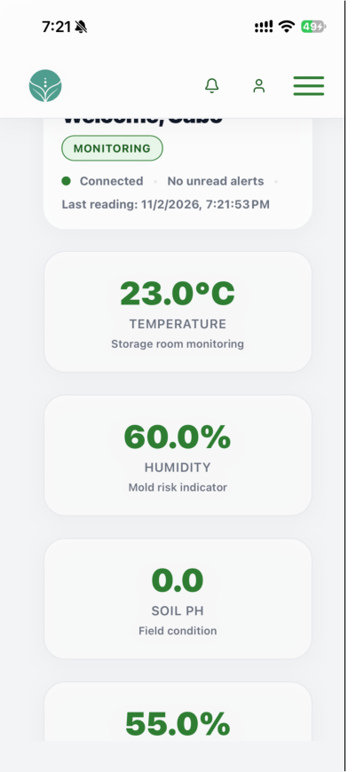 | PASSED

FUNCTIONALITY TEST DOCUMENT |  | Module Name | NOTIFICATION MODULE
Test Cycle No. | 5 | Function Name | NOTIFICATIONS AND ALERT HISTORY
 |  | User/Access Type | Signed-in Client
Date Tested | 11/02/26 | Type of System | Mobile Application
Pre-conditions | A high-risk sensor alert has been triggered and notifications are available.
Action Description | Review the in-app alert, notification list, alert history, and available history export.
Verification Steps | Confirm high-risk events are surfaced and notification and alert records are retained.

Test Scenario | Expected Results | Actual Results | Remarks
1 | Must display an in-app alert with the detected conditions and recommendations. | 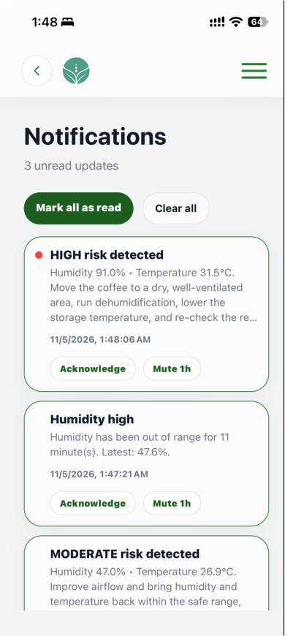 | PASSED
2 | Must retain notification and alert records and provide the available history and export functions. | 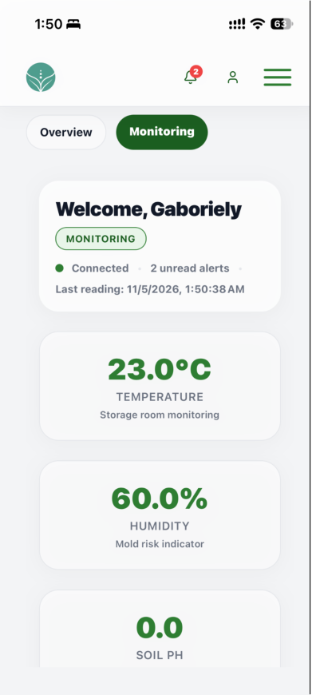 | PASSED

FUNCTIONALITY TEST DOCUMENT |  | Module Name | PROFILE MODULE
Test Cycle No. | 5 | Function Name | MY PROFILE
 |  | User/Access Type | Signed-in Client
Date Tested | 11/02/26 | Type of System | Mobile Application
Pre-conditions | The user is signed in and profile image storage is available.
Action Description | Review and update profile details, verify email or phone changes, and upload an avatar from the phone.
Verification Steps | Confirm profile changes are saved, contact changes require OTP, duplicate email is rejected, and unsupported avatar files are not accepted.

Test Scenario | Expected Results | Actual Results | Remarks
1 | Must display the current profile and save valid personal-detail changes. | 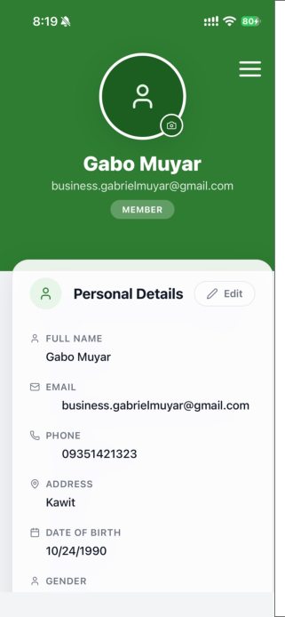 | PASSED
2 | Must verify contact changes with OTP, reject a duplicate email or unsupported image, and accept a valid avatar. | 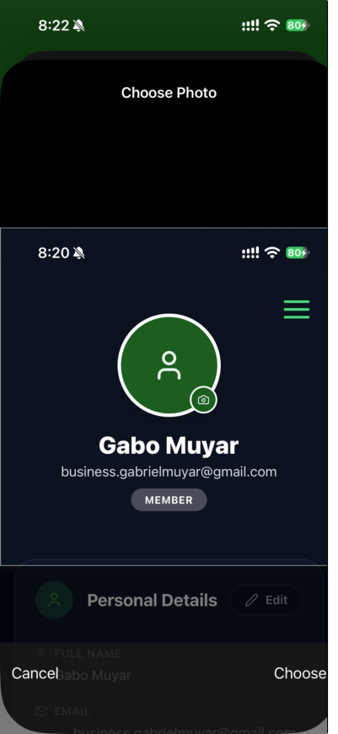  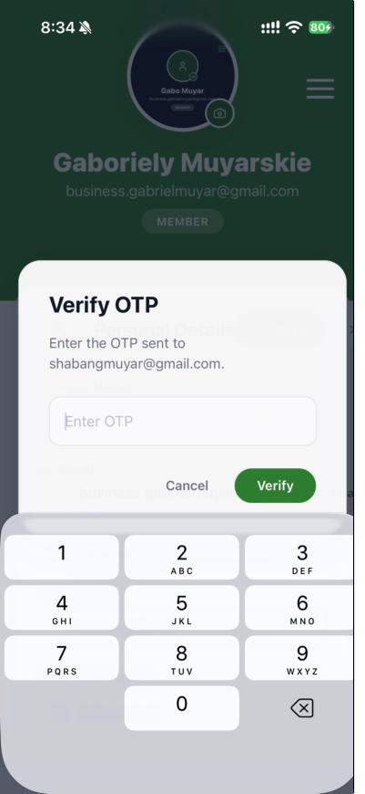 | PASSED

FUNCTIONALITY TEST DOCUMENT |  | Module Name | DEVICE & SENSORS MODULE
Test Cycle No. | 5 | Function Name | DEVICE AND SENSOR STATUS
 |  | User/Access Type | Signed-in Client
Date Tested | 11/02/26 | Type of System | Mobile Application
Pre-conditions | The ESP32 device is active and recent sensor readings are available.
Action Description | Review sensor values, connection status, risk level, device information, and alert thresholds.
Verification Steps | Confirm live values and connection status are accurate, risk badges match the readings, and threshold settings are available.

Test Scenario | Expected Results | Actual Results | Remarks
1 | Must display the latest humidity, temperature, and bean-moisture readings and accurately indicate online or offline status. | 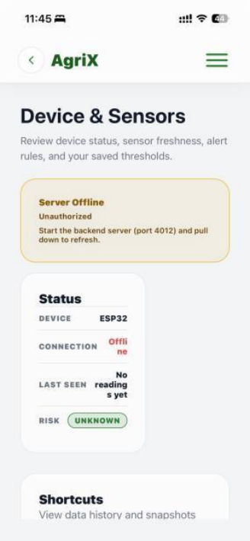  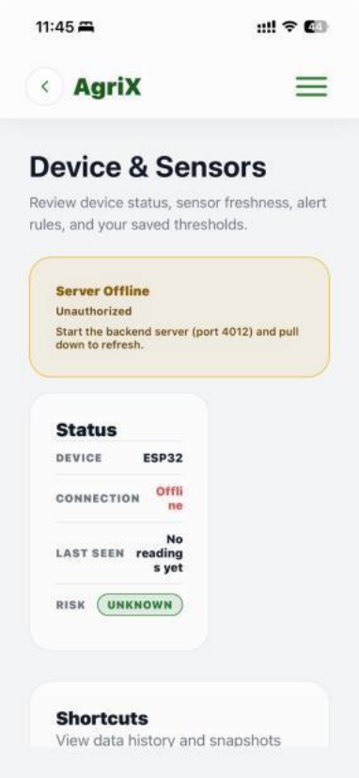 | PASSED
2 | Must show a risk state consistent with the readings and display the device information and saved alert thresholds. | 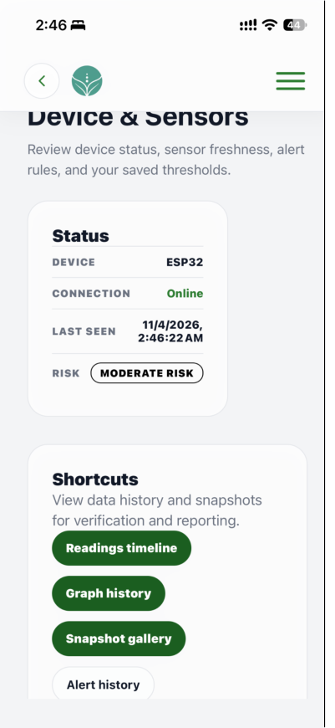  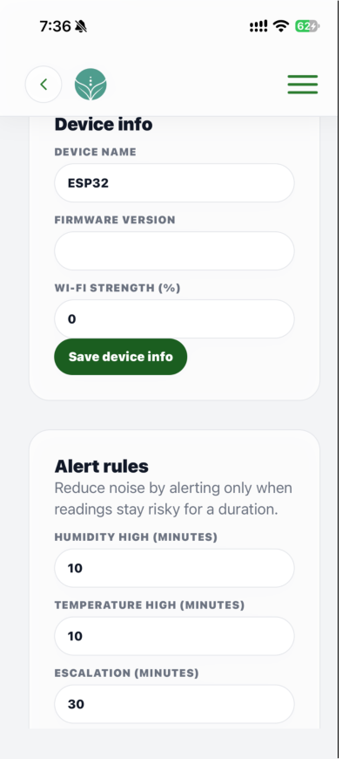 | PASSED

FUNCTIONALITY TEST DOCUMENT |  | Module Name | DEVICE & SENSORS - READING TIMELINE MODULE
Test Cycle No. | 5 | Function Name | READINGS TIMELINE
 |  | User/Access Type | Signed-in Client
Date Tested | 11/02/26 | Type of System | Mobile Application
Pre-conditions | Sensor readings are available across recent and older dates, including a filter combination with no matching readings.
Action Description | Review the timeline using its time-range and sensor-metric filters.
Verification Steps | Confirm the selected date range and metric control the displayed readings and that an empty state appears when no data matches.

Test Scenario | Expected Results | Actual Results | Remarks
1 | Must show readings for the selected 24-hour, seven-day, or all-time range. | 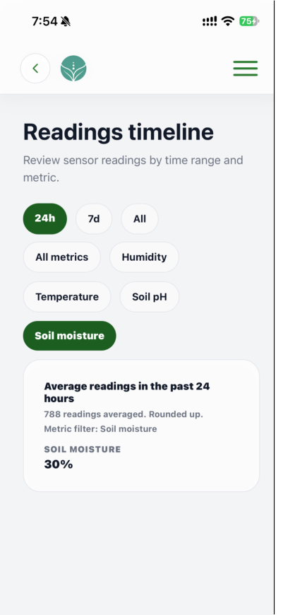 | PASSED
2 | Must show the selected sensor metric and display an empty state when no readings match the filters. | 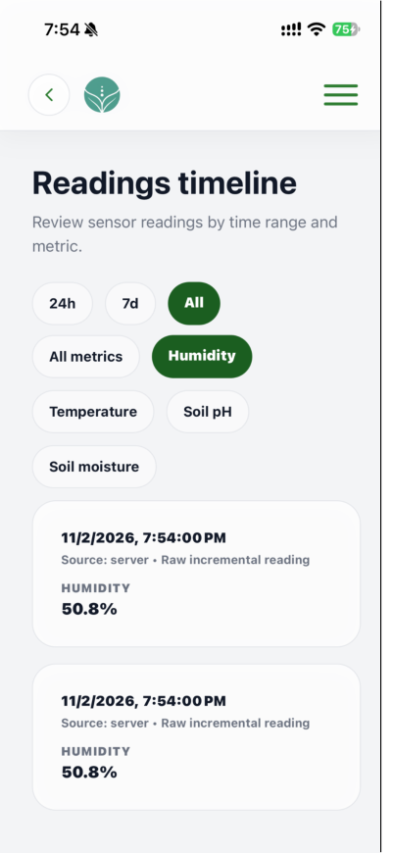  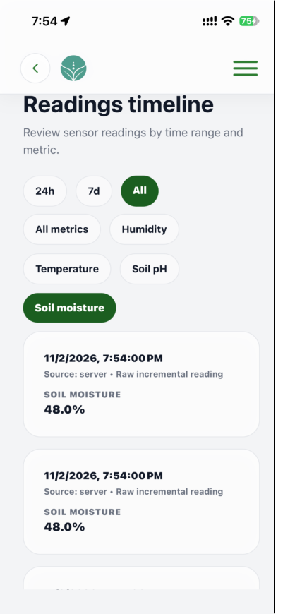 | PASSED

FUNCTIONALITY TEST DOCUMENT |  | Module Name | DEVICE & SENSORS - GRAPH HISTORY MODULE
Test Cycle No. | 5 | Function Name | GRAPH HISTORY
 |  | User/Access Type | Signed-in Client
Date Tested | 11/02/26 | Type of System | Mobile Application
Pre-conditions | Recent and older sensor readings are available for the supported metrics.
Action Description | Open Graph History and review charts using time-range, metric, and comparison controls.
Verification Steps | Confirm graph history opens and the selected range and metric update the charts to match available readings.

Test Scenario | Expected Results | Actual Results | Remarks
1 | Must plot available readings for the selected sensor metric and time period. | 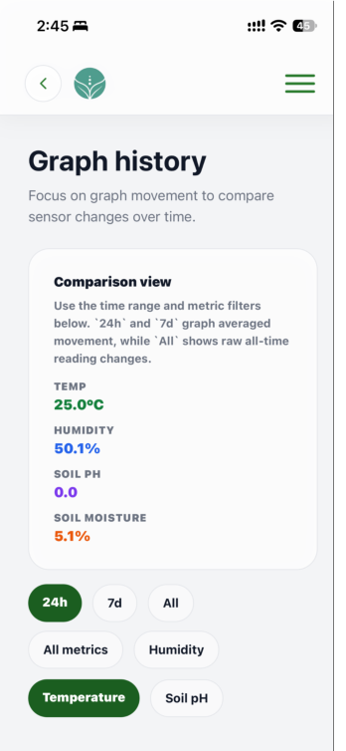  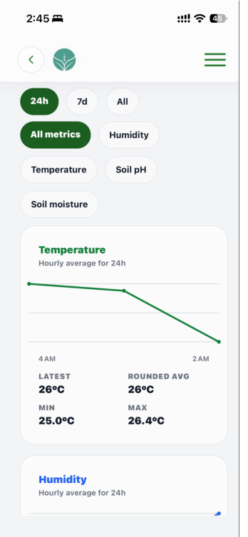 | PASSED
2 | Must display comparison graphs and values consistent with the available reading history. | 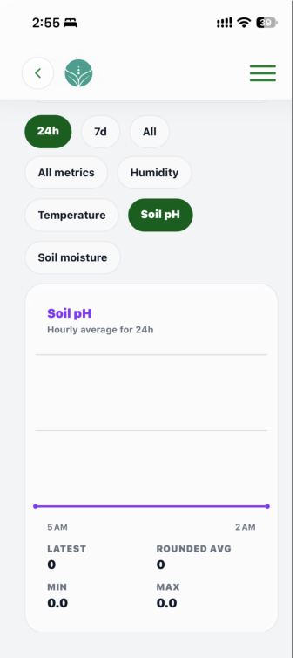 | PASSED

FUNCTIONALITY TEST DOCUMENT |  | Module Name | DEVICE & SENSORS - SNAPSHOT GALLERY MODULE
Test Cycle No. | 5 | Function Name | SNAPSHOT GALLERY
 |  | User/Access Type | Signed-in Client
Date Tested | 11/02/26 | Type of System | Mobile Application
Pre-conditions | A signed-in client account is available; supported images and a gallery with multiple snapshots are prepared.
Action Description | Capture or upload snapshots, select and compare images, and clear or delete selected snapshots.
Verification Steps | Confirm snapshots appear with timestamps, selection and comparison work, and deletion requires confirmation.

Test Scenario | Expected Results | Actual Results | Remarks
1 | Must capture or accept a supported image and add it to the gallery with its timestamp. | 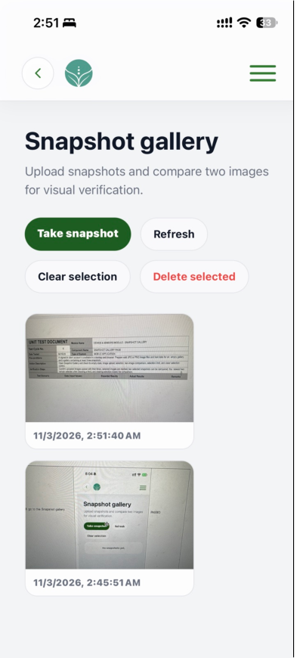 | PASSED
2 | Must mark selected snapshots and compare the latest two selected images within the supported selection limit. | 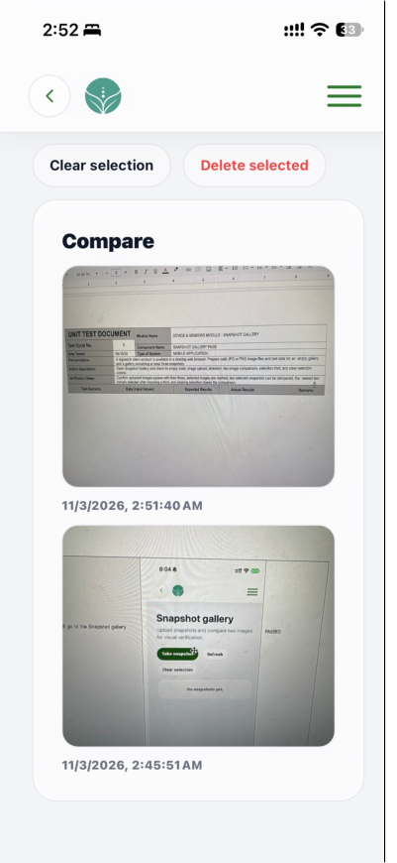 | PASSED
3 | Must clear the current selection or request confirmation before deletion, then remove the confirmed image. | 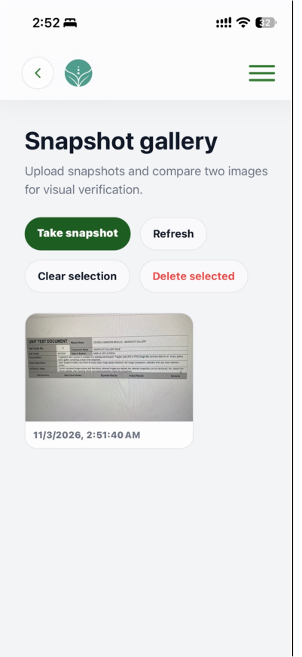 | PASSED

FUNCTIONALITY TEST DOCUMENT |  | Module Name | DEVICE & SENSORS - ALERT HISTORY MODULE
Test Cycle No. | 5 | Function Name | ALERT HISTORY
 |  | User/Access Type | Signed-in Client
Date Tested | 11/02/26 | Type of System | Mobile Application
Pre-conditions | Acknowledged and unacknowledged alerts are available, along with an empty state and a muteable alert category.
Action Description | Review alert filters, acknowledgement and mute actions, empty state, and navigation to Notifications.
Verification Steps | Confirm filters show matching alerts, alert state changes persist, and Open Notifications navigates correctly.

Test Scenario | Expected Results | Actual Results | Remarks
1 | Must filter acknowledged and unacknowledged alerts, update acknowledgement or mute state, show the empty state, and open Notifications. | 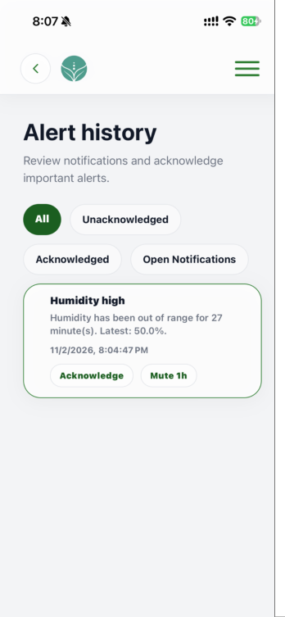 | PASSED

FUNCTIONALITY TEST DOCUMENT |  | Module Name | DEVICE & SENSORS - MONITORING MODULE
Test Cycle No. | 5 | Function Name | MONITORING
 |  | User/Access Type | Signed-in Client
Date Tested | 11/02/26 | Type of System | Mobile Application
Pre-conditions | The backend is reachable and test readings are prepared for live, offline, and risk-state checks.
Action Description | Review live readings, system status, risk classification, trends, and display mode.
Verification Steps | Confirm displayed readings, labels, and risk status match the selected test condition and remain readable.

Test Scenario | Expected Results | Actual Results | Remarks
1 | Must display the current sensor values and update them when new readings arrive. | 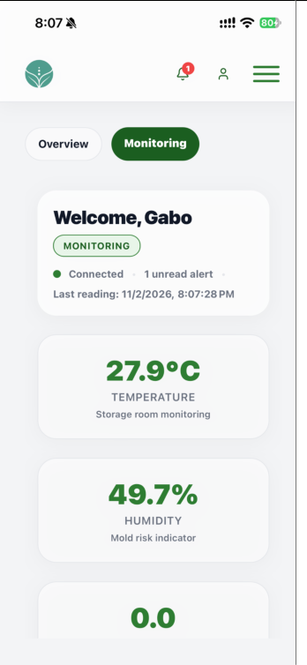  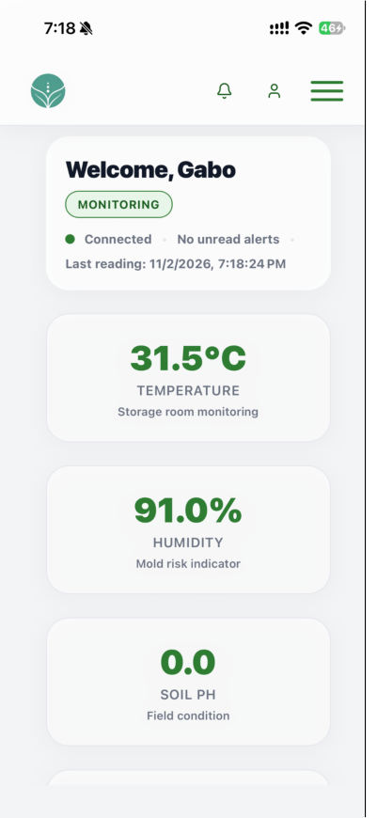 | PASSED
2 | Must show the matching high, moderate, or low risk state for the current readings. | 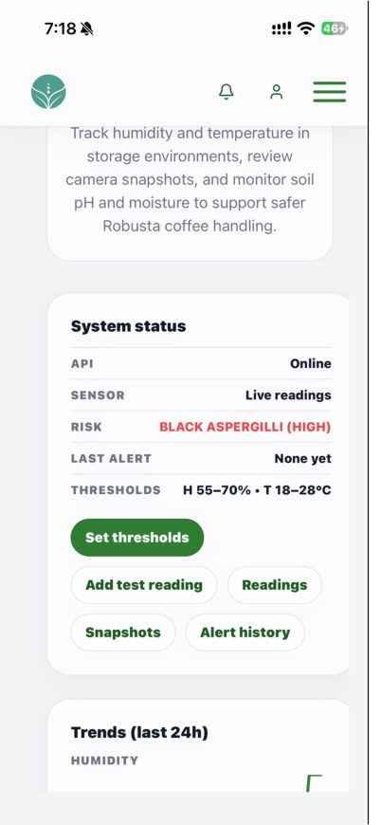  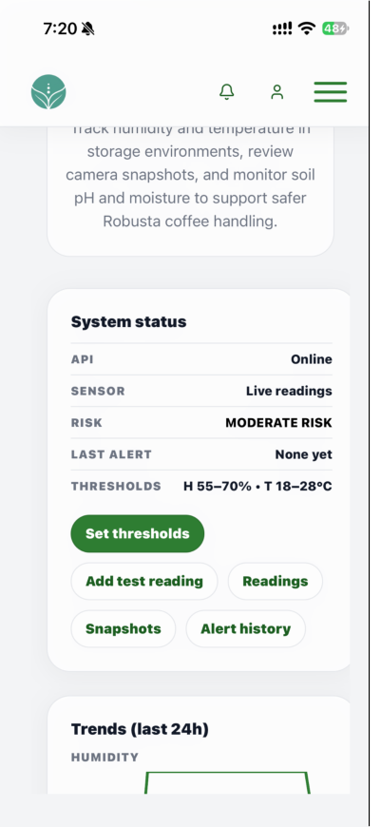  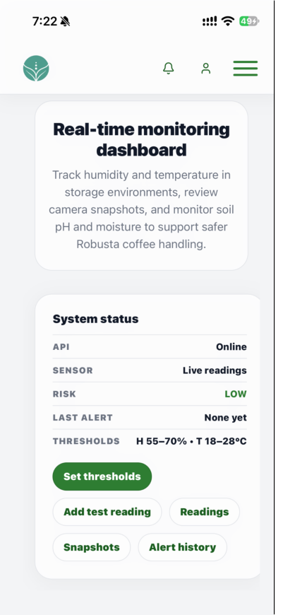 | PASSED
3 | Must plot changes from new readings and keep Monitoring and Trends readable in the selected theme. | 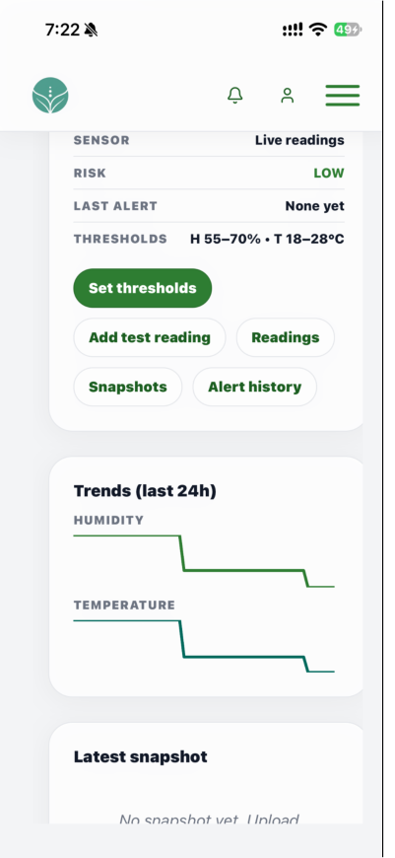  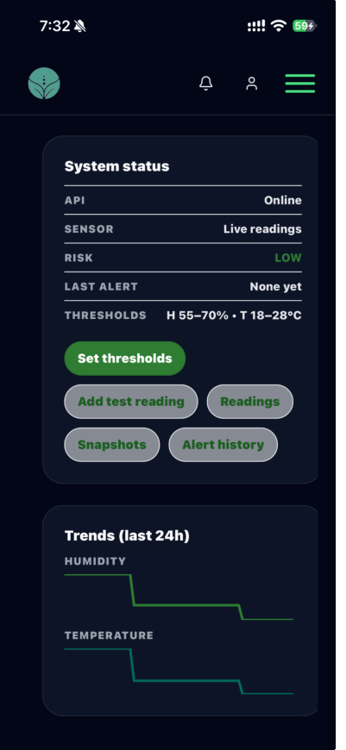 | PASSED

FUNCTIONALITY TEST DOCUMENT |  | Module Name | PHYSICAL HARDWARE MODULE
Test Cycle No. | 1 | Function Name | PHYSICAL HARDWARE UNITS
 |  | User/Access Type | Hardware Test
Date Tested | 11/02/26 | Type of System | IoT Hardware
Pre-conditions | The prototype is assembled with the motor, DHT22, bean-moisture sensor, heater, ESP32, LCD, and coffee-bean mixer connected. Reference meters, Wi-Fi, known-moisture samples, and the 5V/2A power adapter are available.
Action Description | Check each physical hardware unit in sequence, from the motor through the coffee-bean mixer.
Verification Steps | Confirm each unit responds to its input and produces the expected result.

Test Scenario | Expected Results | Actual Results | Remarks
1 | Must run while powered and stop when power is removed; the mixer must move beans through its case. | 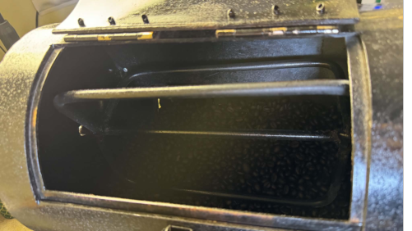  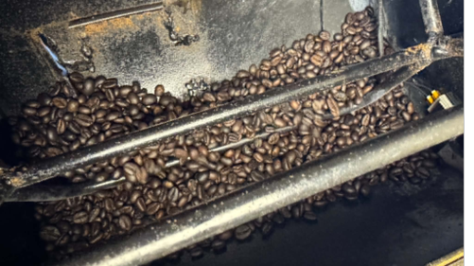 | PASSED
2 | Must reflect changes in environmental conditions and sample moisture. | 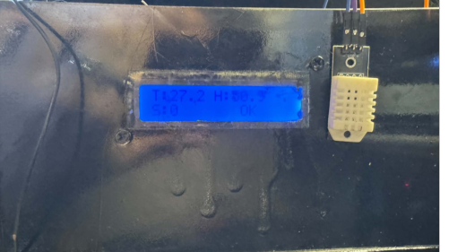  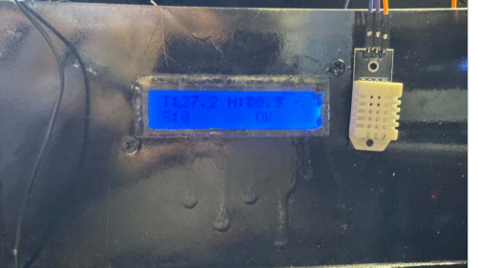 | PASSED
3 | Must raise chamber temperature while active and allow it to decrease after shutdown. | 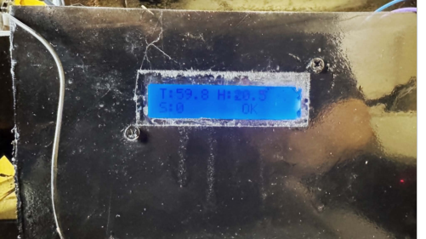 | PASSED
4 | Must connect to Wi-Fi, send readings to the system, and show current sensor values on the LCD. | 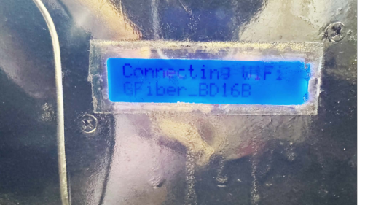  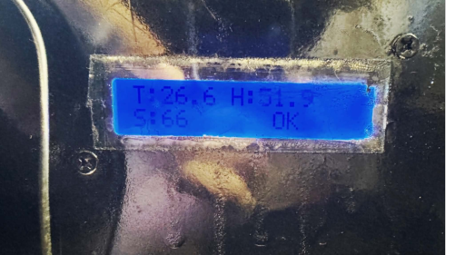 | PASSED

Prepared By | Administered/Performed By
____________________________  Signature over Printed Name | ____________________________  Signature over Printed Name

