FUNCTIONALITY  TEST DOCUMENT |  | Module Name | LOGIN MODULE
Test Cycle No. | 5 | Function Name | LOGIN PAGE
Test Cycle No. | 5 | User/Access Type | User
Date Tested | 10/27/2026 | Type of System | Web Application
Pre-conditions | The AgriX client portal is available. The user is signed out; active, invalid, and incomplete test credentials are available.
Action Description | Authenticate with valid and invalid account credentials and review the available account routes and sign-in controls.
Verification Steps | Must be able to sign in with a valid account and receive clear feedback for invalid credentials.
Runs | Expected Results | Actual Results | Remarks
1 | Must authenticate a valid active account and open the intended post-login page. | 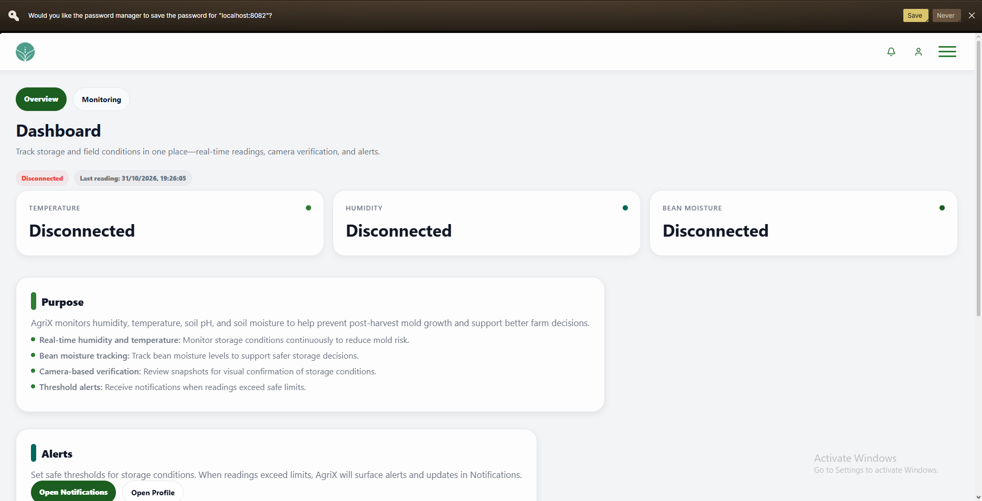 | PASSED
2 | Must block blank or malformed credentials and reject incorrect passwords with clear, privacy-safe feedback. | 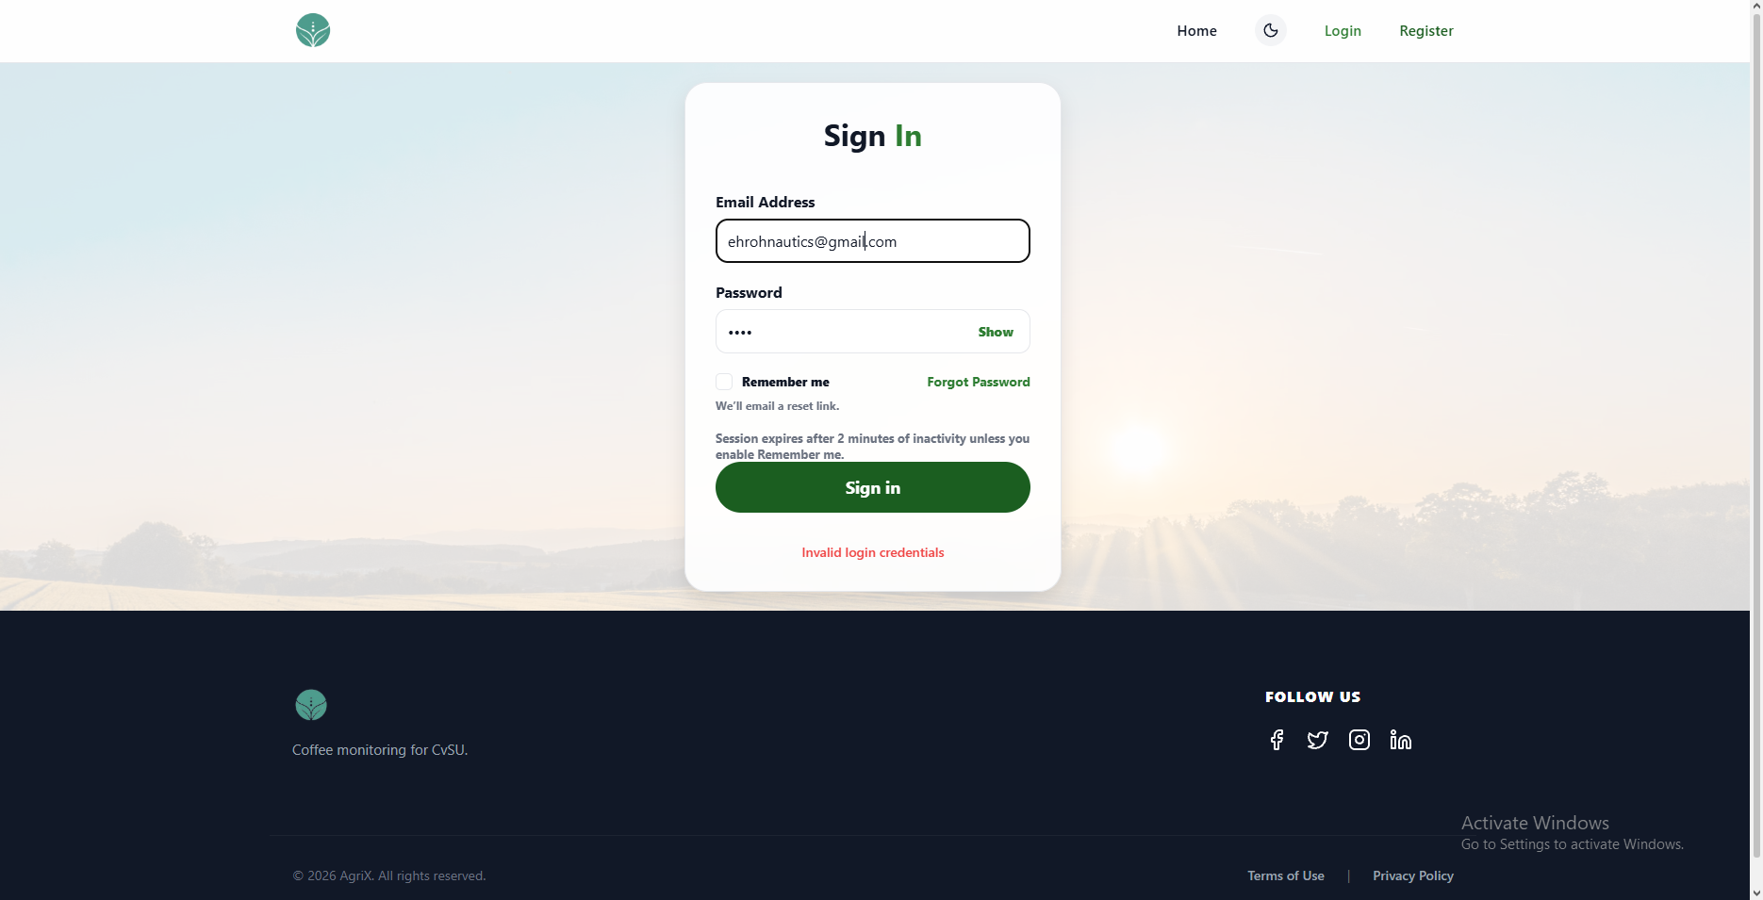 | PASSED
3 | Must keep password visibility and Remember me controls usable without changing the submitted credentials. | 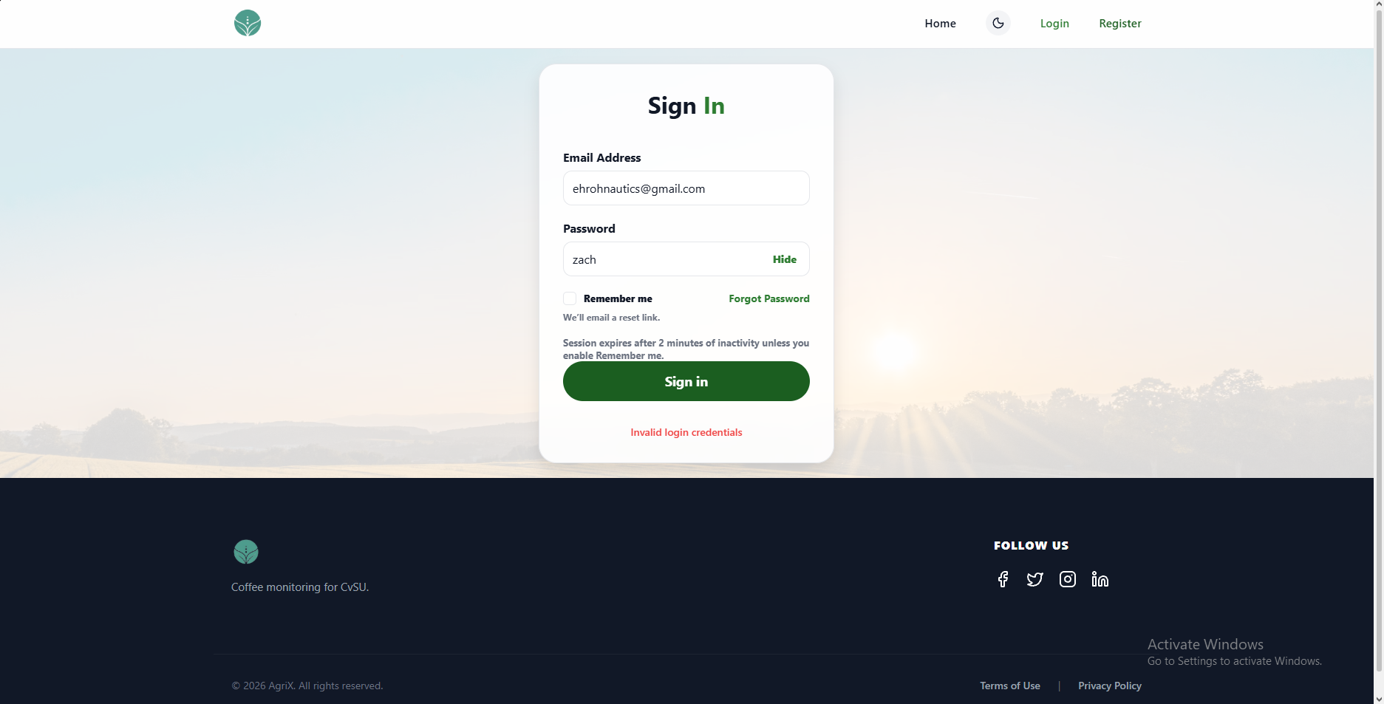 | PASSED
4 | Must open password recovery or registration when requested, return to Home, and keep the sign-in page readable in either theme. | 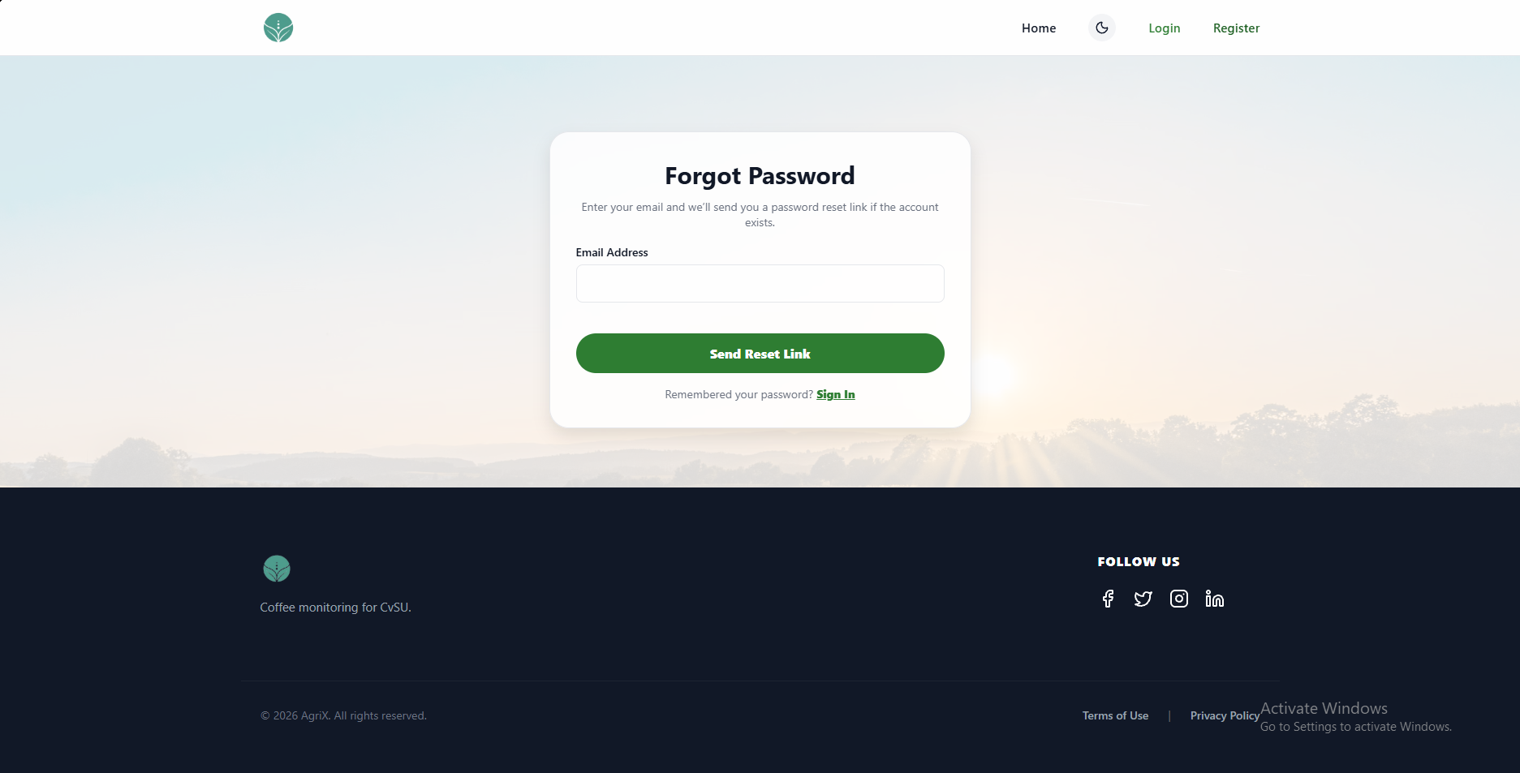 | PASSED

FUNCTIONALITY  TEST DOCUMENT |  | Module Name | LOGIN-FORGOT PASSWORD MODULE
Test Cycle No. | 5 | Function Name | FORGOT PASSWORD FLOW
Test Cycle No. | 5 | User/Access Type | User
Date Tested | 10/27/2026 | Type of System | Web Application
Pre-conditions | The user is signed out. A registered QA account and test mailbox are available.
Action Description | Request a password reset, validate reset links, and complete or reject password updates.
Verification Steps | Must be able to request and complete a secure password reset without revealing account existence.
Runs | Expected Results | Actual Results | Remarks
1 | Must reject a blank email and give the same privacy-safe confirmation for registered and unregistered addresses. | 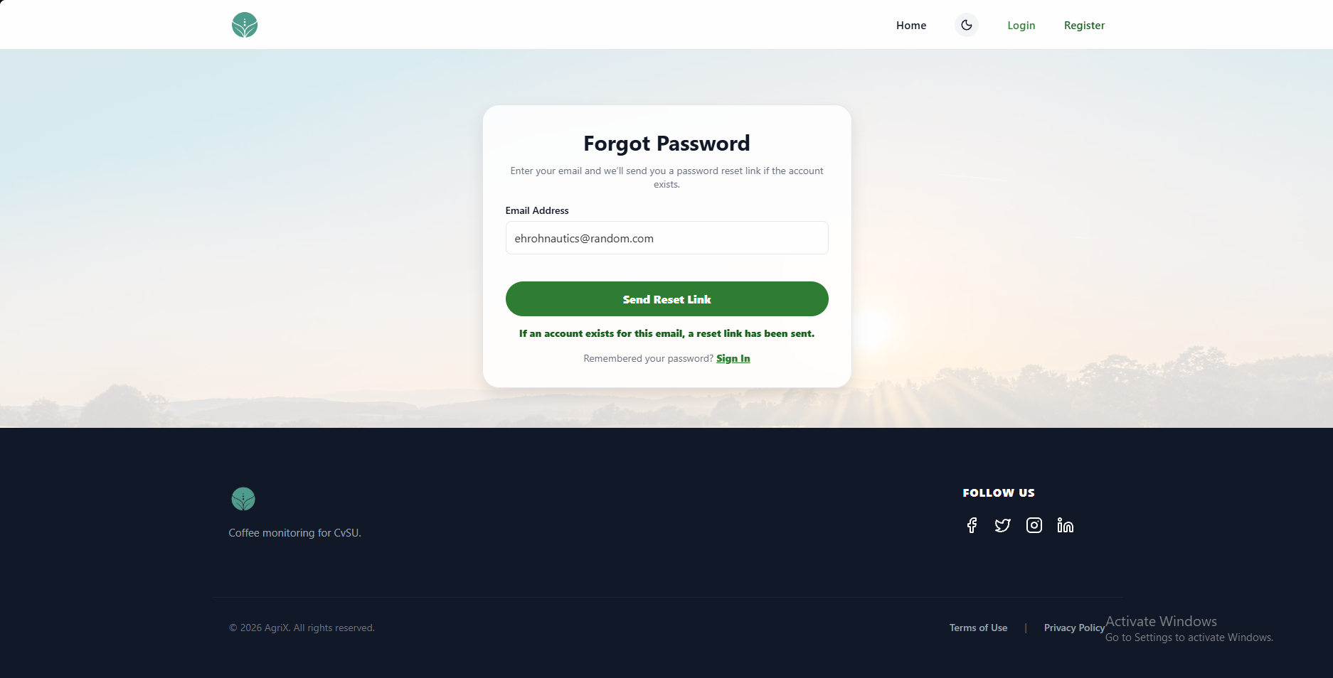 | PASSED
2 | Must open the password update form for the latest unused reset link. | 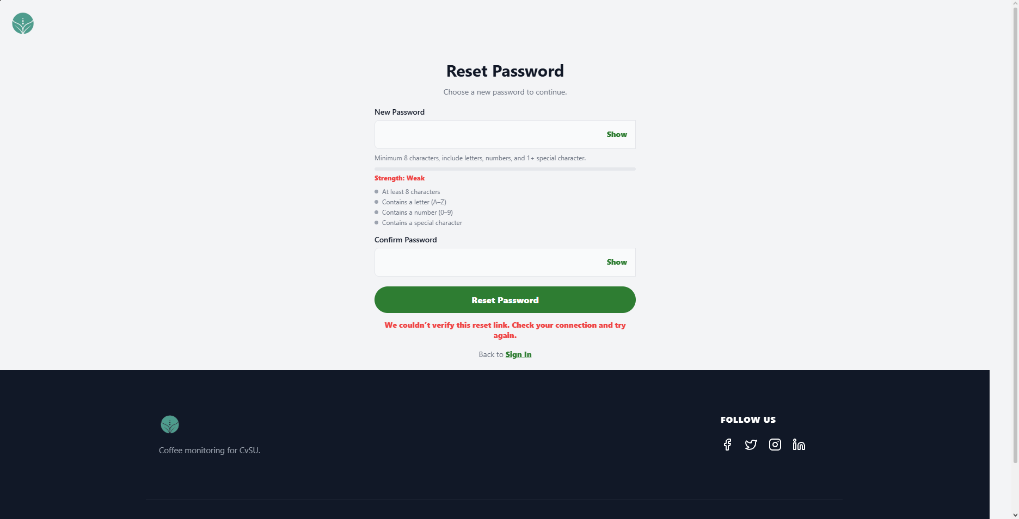 | PASSED
3 | Must reject expired and previously used links and allow a new reset request. | 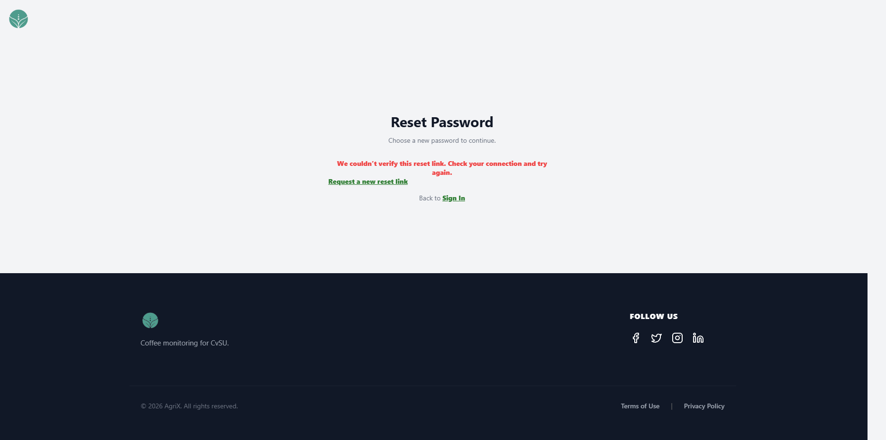 | PASSED
4 | Must reject mismatched or policy-invalid passwords, accept a valid matching password once, invalidate the old password and link, and explain any request limit. | 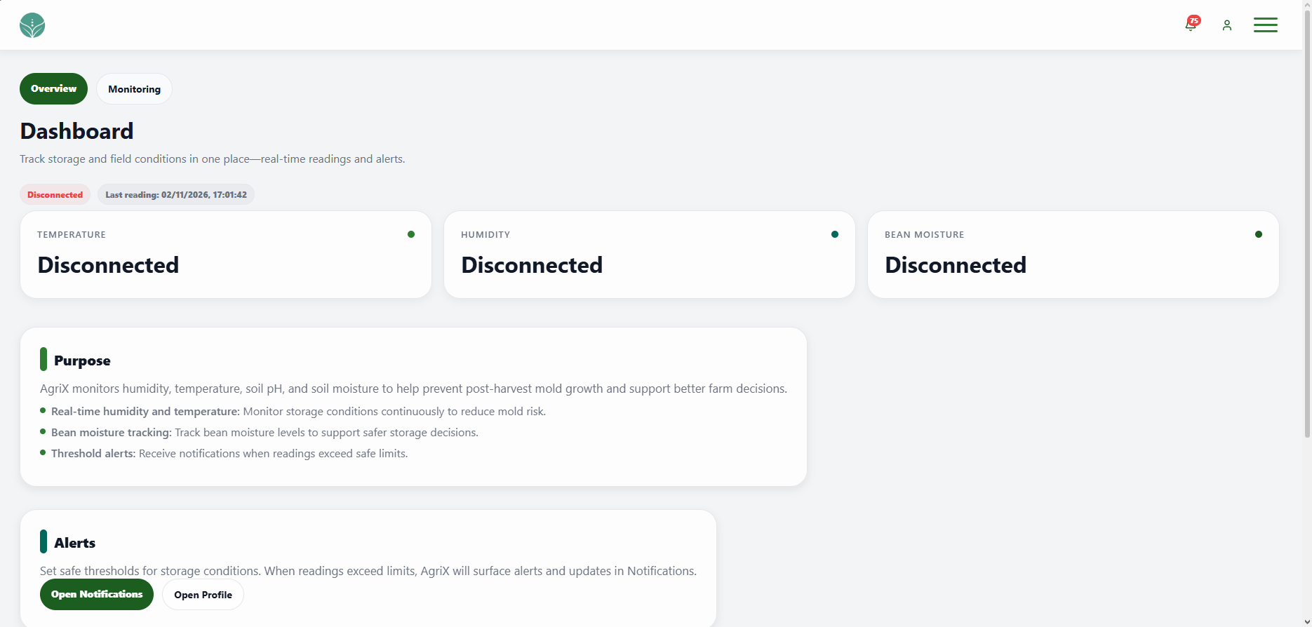 | PASSED

FUNCTIONALITY  TEST DOCUMENT |  | Module Name | REGISTRATION MODULE
Test Cycle No. | 5 | Function Name | REGISTRATION PAGE
Test Cycle No. | 5 | User/Access Type | User
Date Tested | 10/27/2026 | Type of System | Web Application
Pre-conditions | The registration page is available. Dedicated test email and phone values, including duplicate values, are prepared.
Action Description | Submit valid and invalid registration details covering identity, contact, demographic, and password fields.
Verification Steps | Must be able to create an account with valid details and receive an email verification code.
Runs | Expected Results | Actual Results | Remarks
1 | Must open the Create an Account form from the site navigation and keep its page controls readable. | 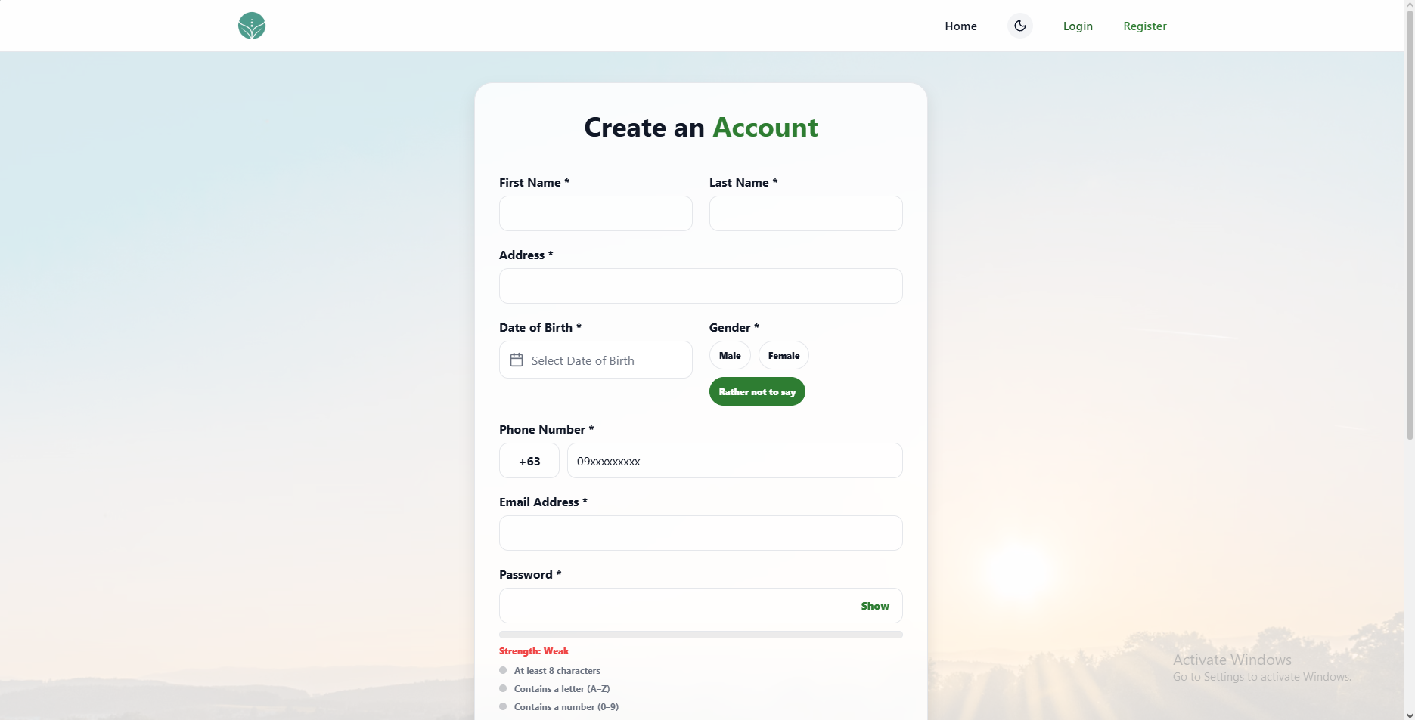 | PASSED
2 | Must require first and last names of at least two characters, remove digits, and enforce the documented input limits. | 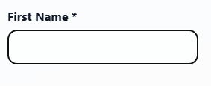 | PASSED
3 | Must accept addresses from 5 through 160 characters and reject blank, shorter, or over-limit values. | 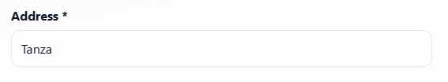 | PASSED
4 | Must reject missing, future, and under-18 birth dates and accept a valid adult date. | 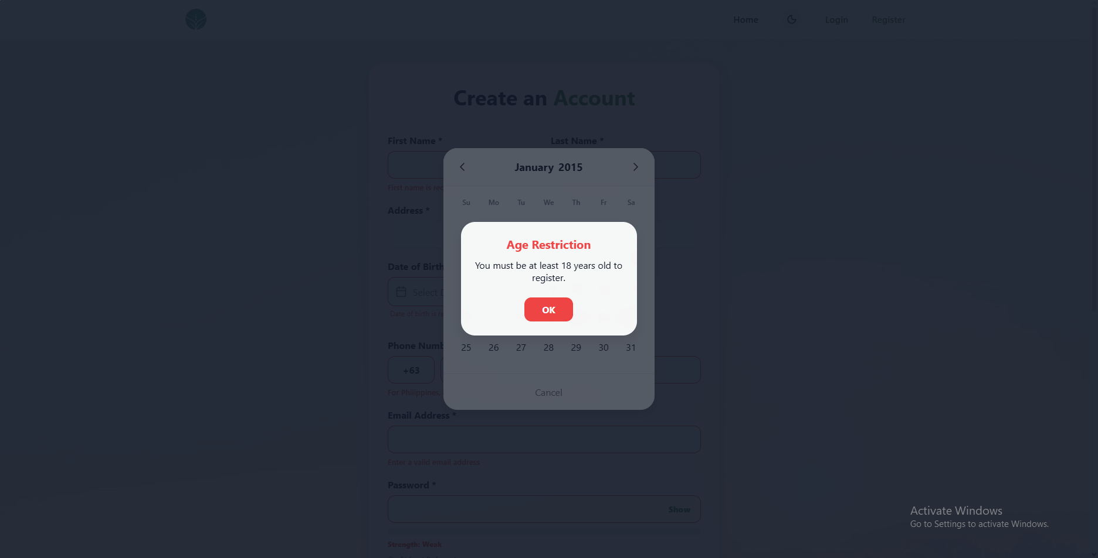 | PASSED
5 | Must default to Rather not to say and allow each supported gender option. | 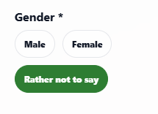 | PASSED
6 | Must reject missing, short, or duplicate numbers, accept a valid country-specific number, and update the entry format for a selected country code. | 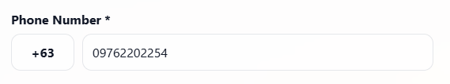 | PASSED
7 | Must reject missing, malformed, or duplicate email addresses and passwords that fail the required length and character rules. | 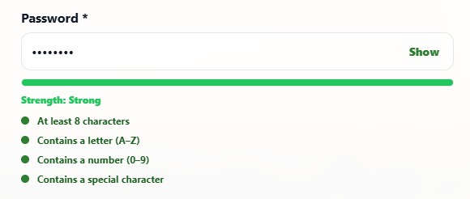 | PASSED
8 | Must reject mismatched password confirmation and create an account with valid unique details, then send an email verification code. | 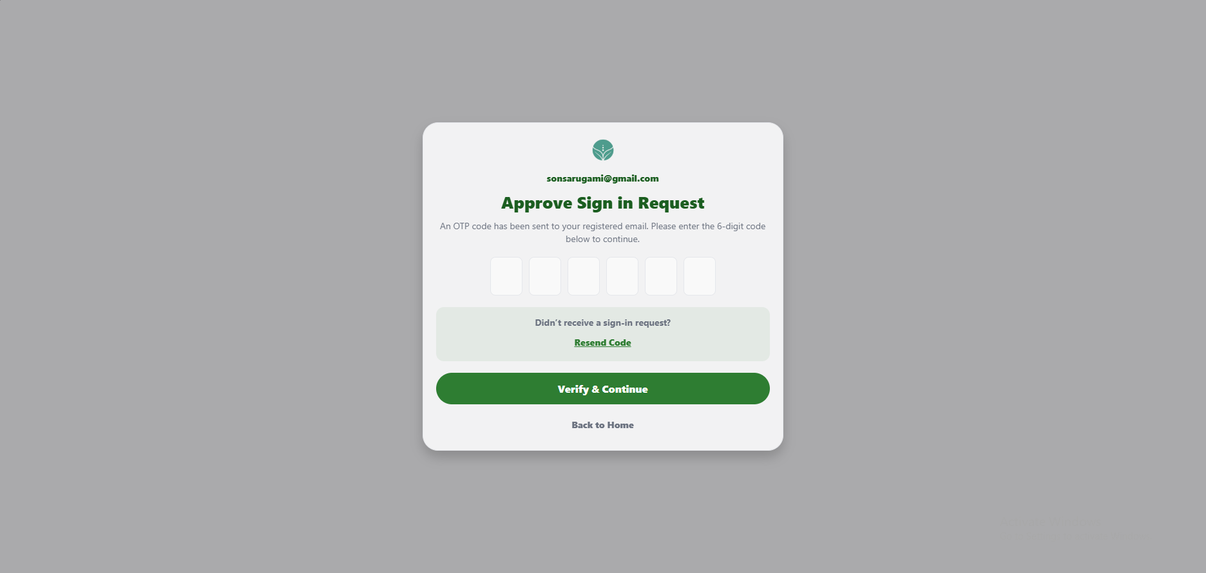 | PASSED

FUNCTIONALITY  TEST DOCUMENT |  | Module Name | REGISTRATION – OTP VERIFICATION MODULE
Test Cycle No. | 5 | Function Name | REGISTRATION – OTP VERIFICATION FLOW
Test Cycle No. | 5 | User/Access Type | User
Date Tested | 10/27/2026 | Type of System | Web Application
Pre-conditions | An unverified account, valid sign-in credentials, and access to the test email inbox are available.
Action Description | Submit valid, invalid, expired, and resent email verification codes.
Verification Steps | Must be able to verify an email address with the latest valid code and receive clear feedback for invalid codes.
Runs | Expected Results | Actual Results | Remarks
1 | Must show the account email and six code fields for an account that requires email verification. | 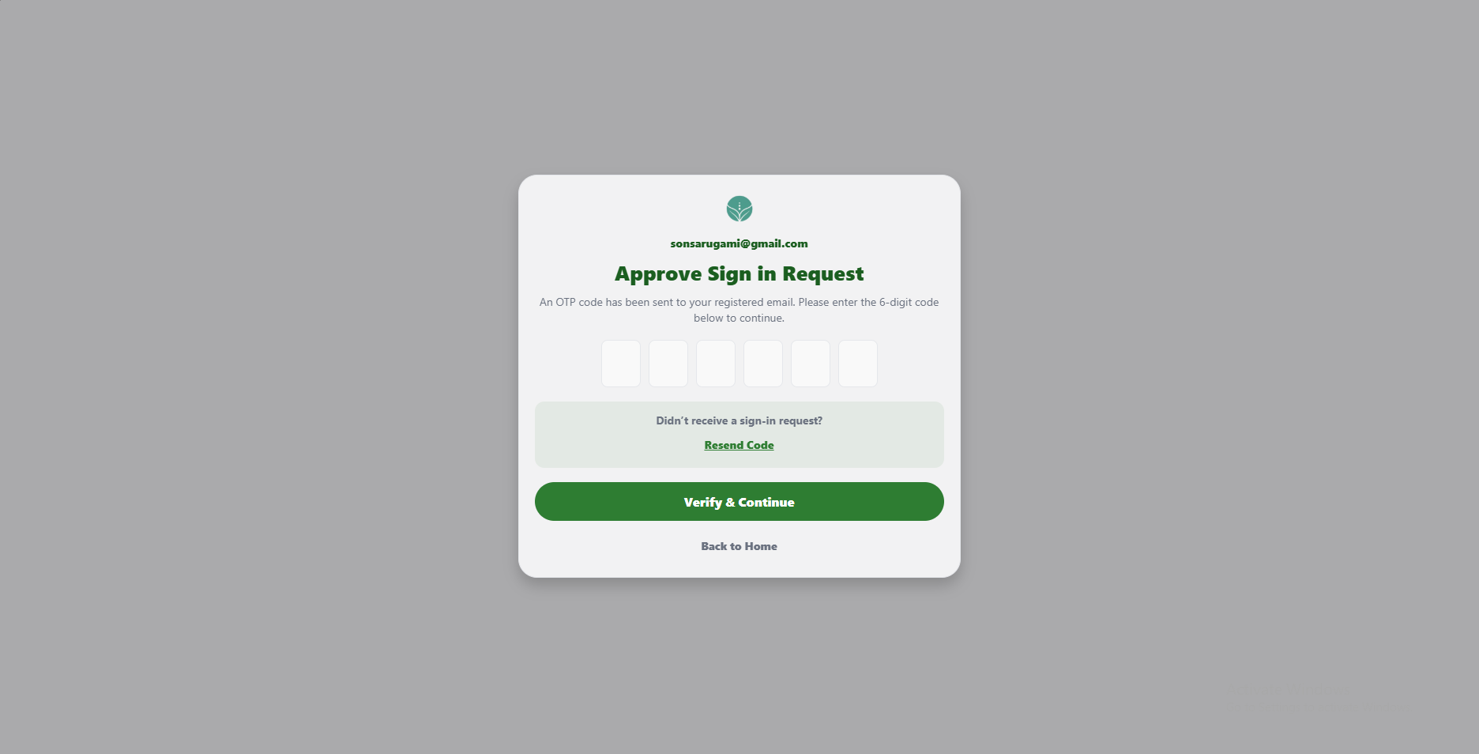 | PASSED
2 | Must reject blank, incomplete, nonnumeric, incorrect, expired, or repeatedly failed codes with clear guidance. | 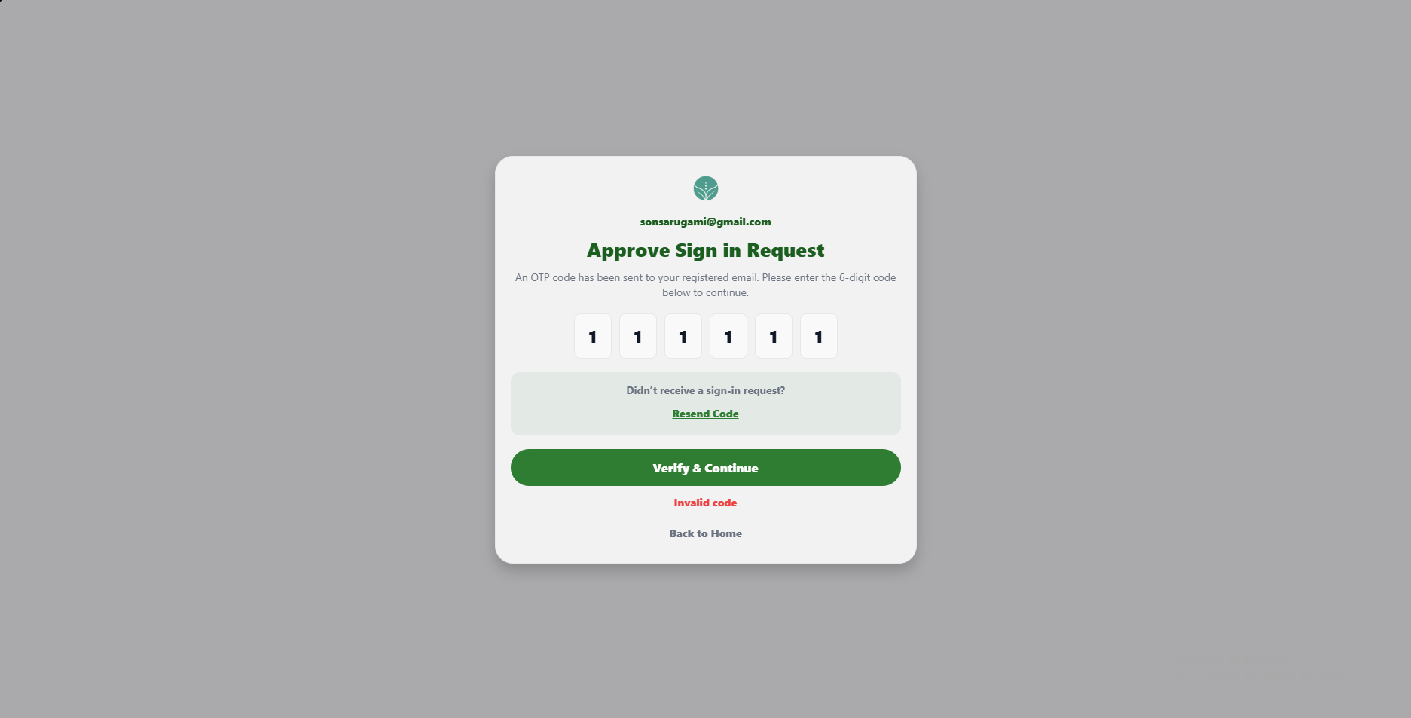 | PASSED
3 | Must verify the email using the latest valid code and return the user to sign in. | 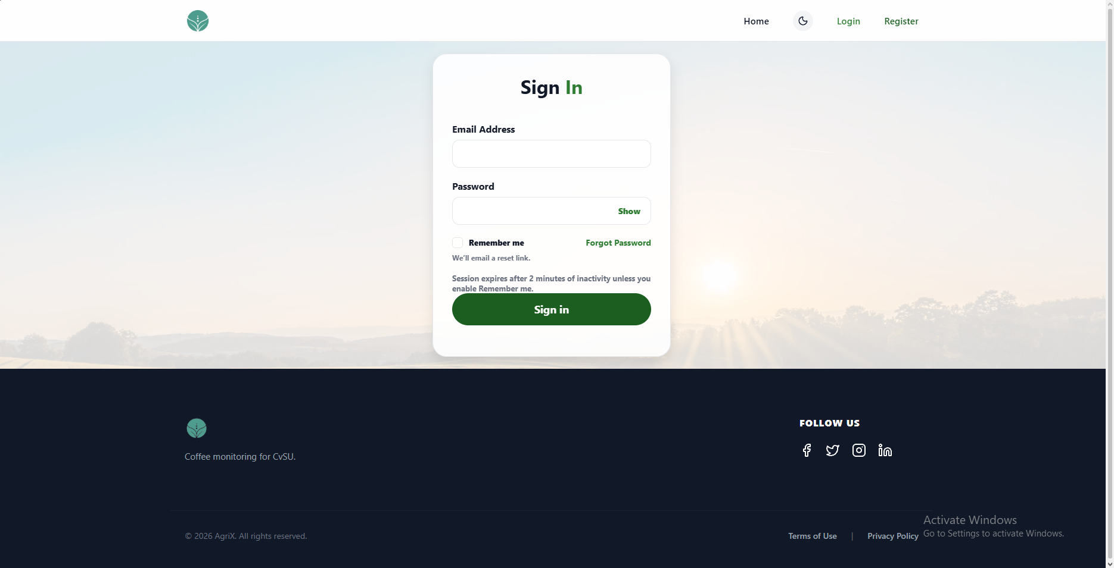 | PASSED
4 | Must send a replacement code, invalidate older codes, enforce resend limits, and provide a working return to Home. | 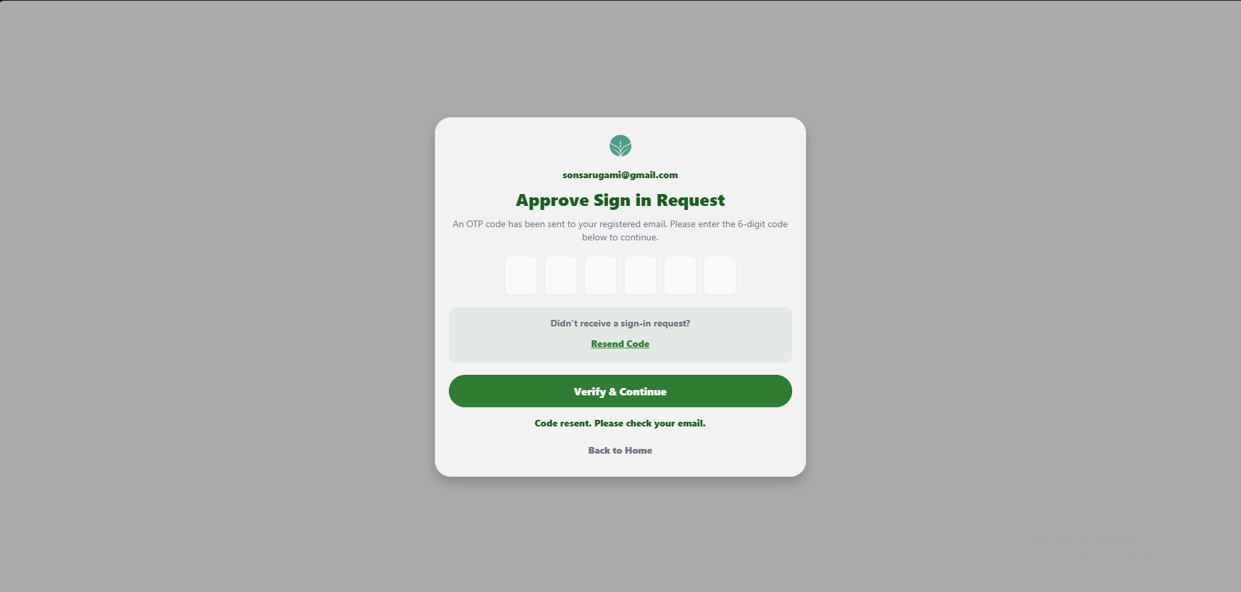 | PASSED

FUNCTIONALITY  TEST DOCUMENT |  | Module Name | DASHBOARD MODULE
Test Cycle No. | 5 | Function Name | DASHBOARD PAGE
Test Cycle No. | 5 | User/Access Type | User
Date Tested | 10/27/2026 | Type of System | Web Application
Pre-conditions | A signed-in client account and current, stale, disconnected, or missing sensor data are available as needed.
Action Description | Review client overview and monitoring information, sensor states, trends, thresholds, and navigation.
Verification Steps | Must display current dashboard and monitoring data, accurate sensor status, and working navigation.
Runs | Expected Results | Actual Results | Remarks
1 | Must open the signed-in client Dashboard with Overview selected and its navigation controls available. | 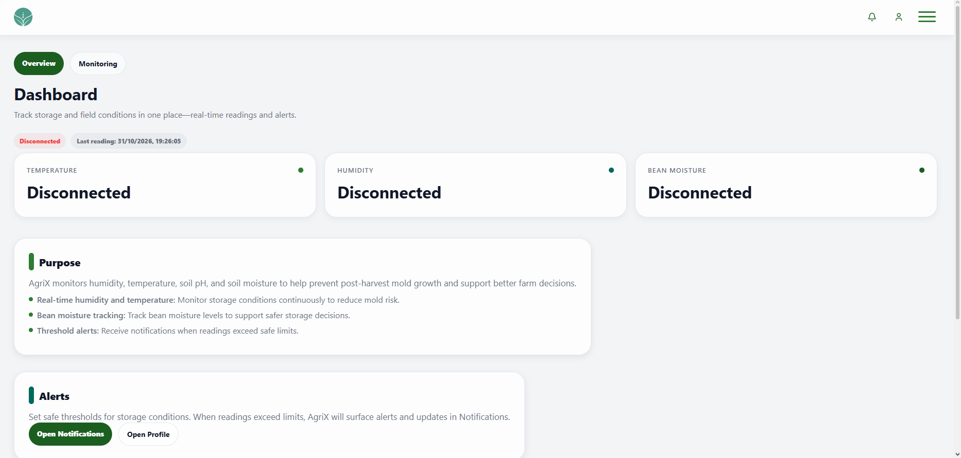 | PASSED
2 | Must show sensor status, readings, trends, snapshots, and checklist information without presenting stale readings as live. | 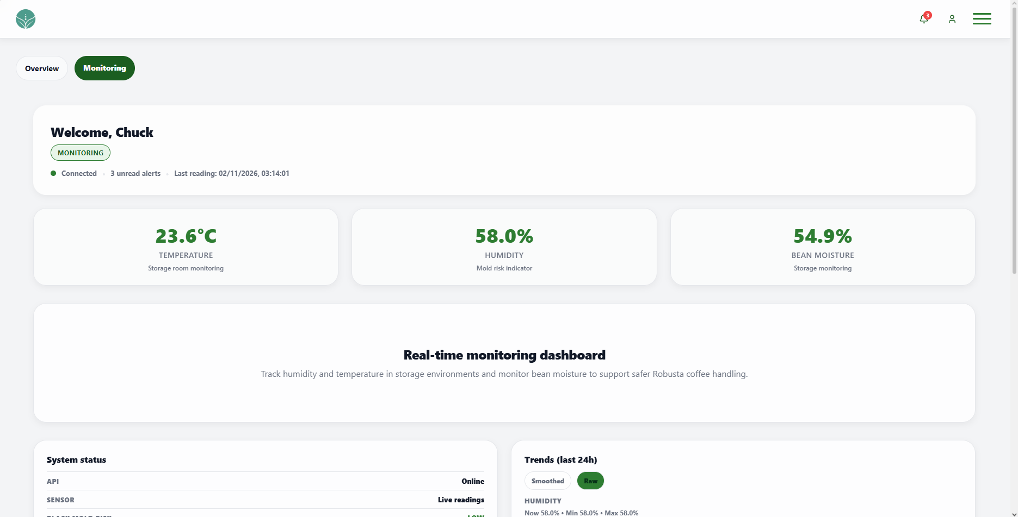 | PASSED
3 | Must display raw or smoothed trends and apply recommended or valid custom humidity and temperature thresholds. | 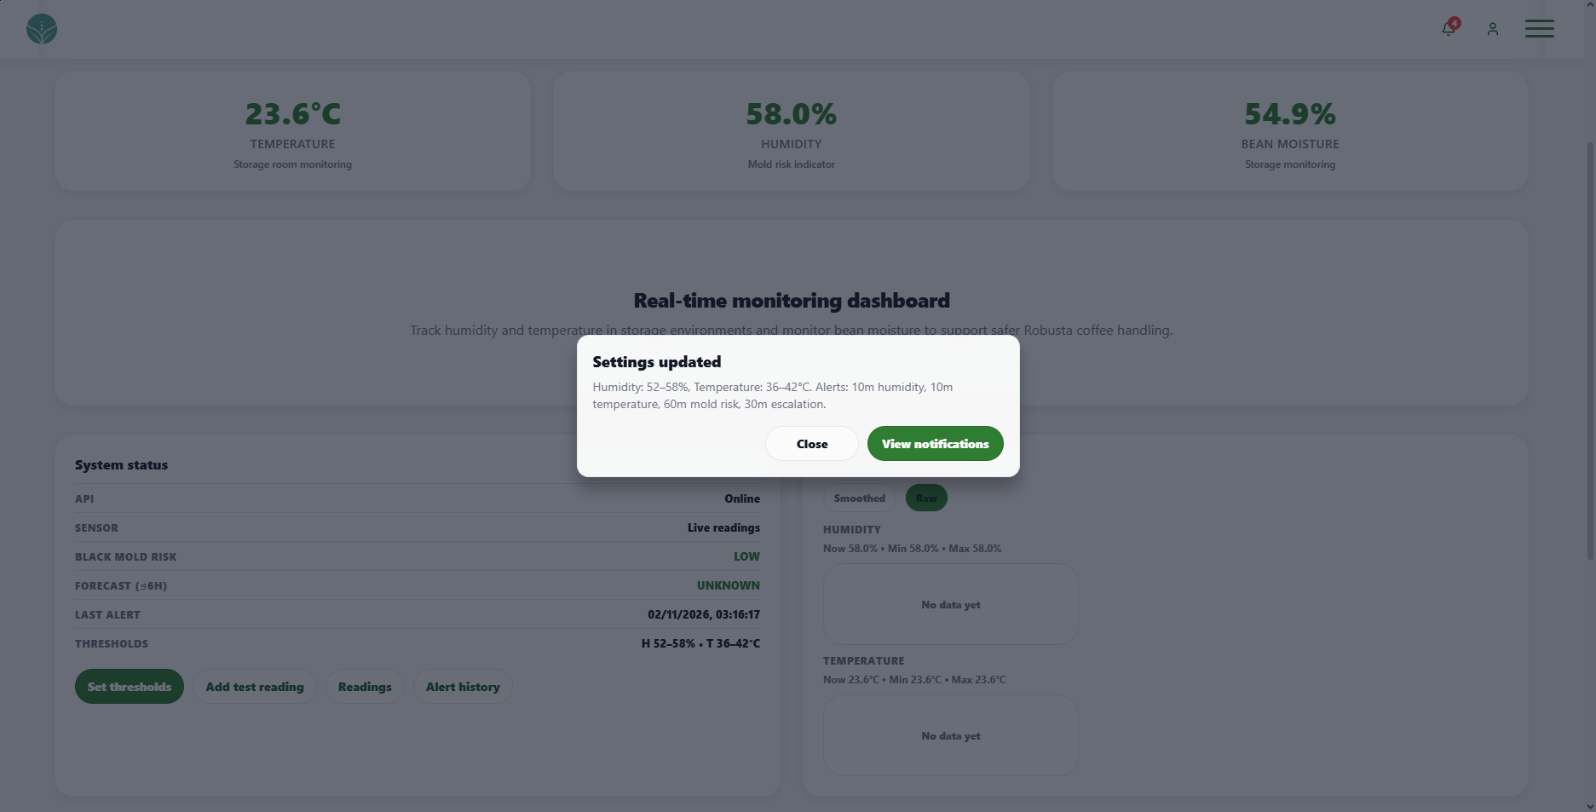 | PASSED
4 | Must open the readings timeline and alert history from the Dashboard. | 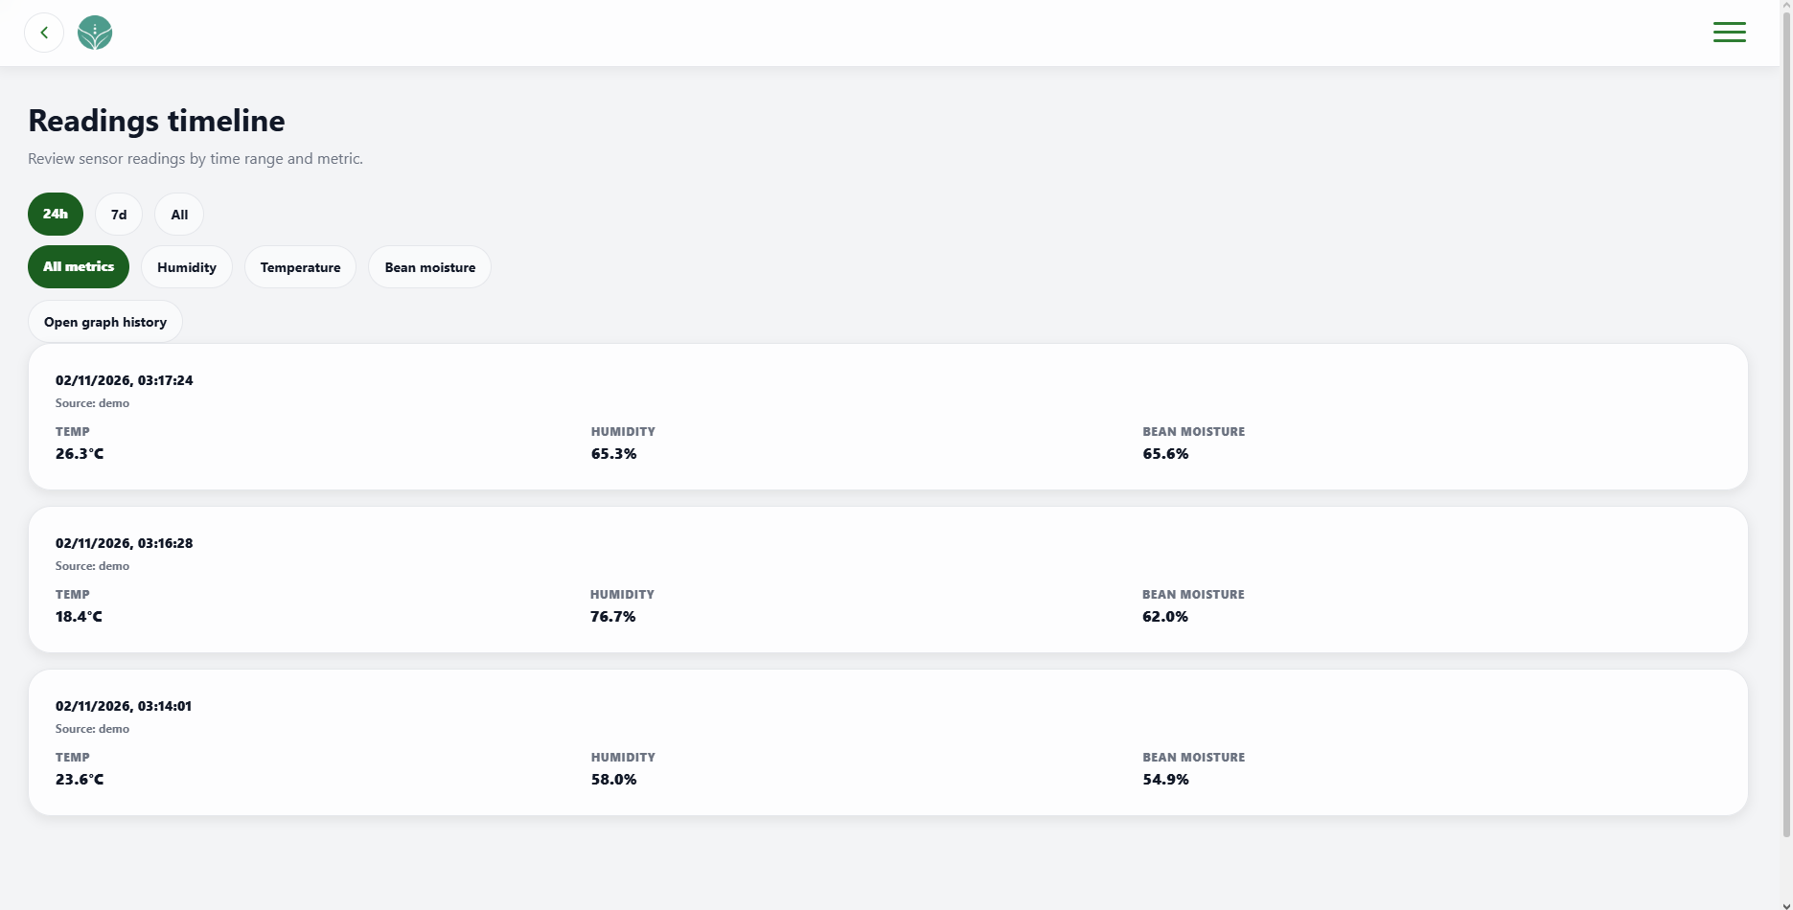 | PASSED
5 | Must open Notifications and Profile from the header and keep dashboard content readable in the selected theme. | 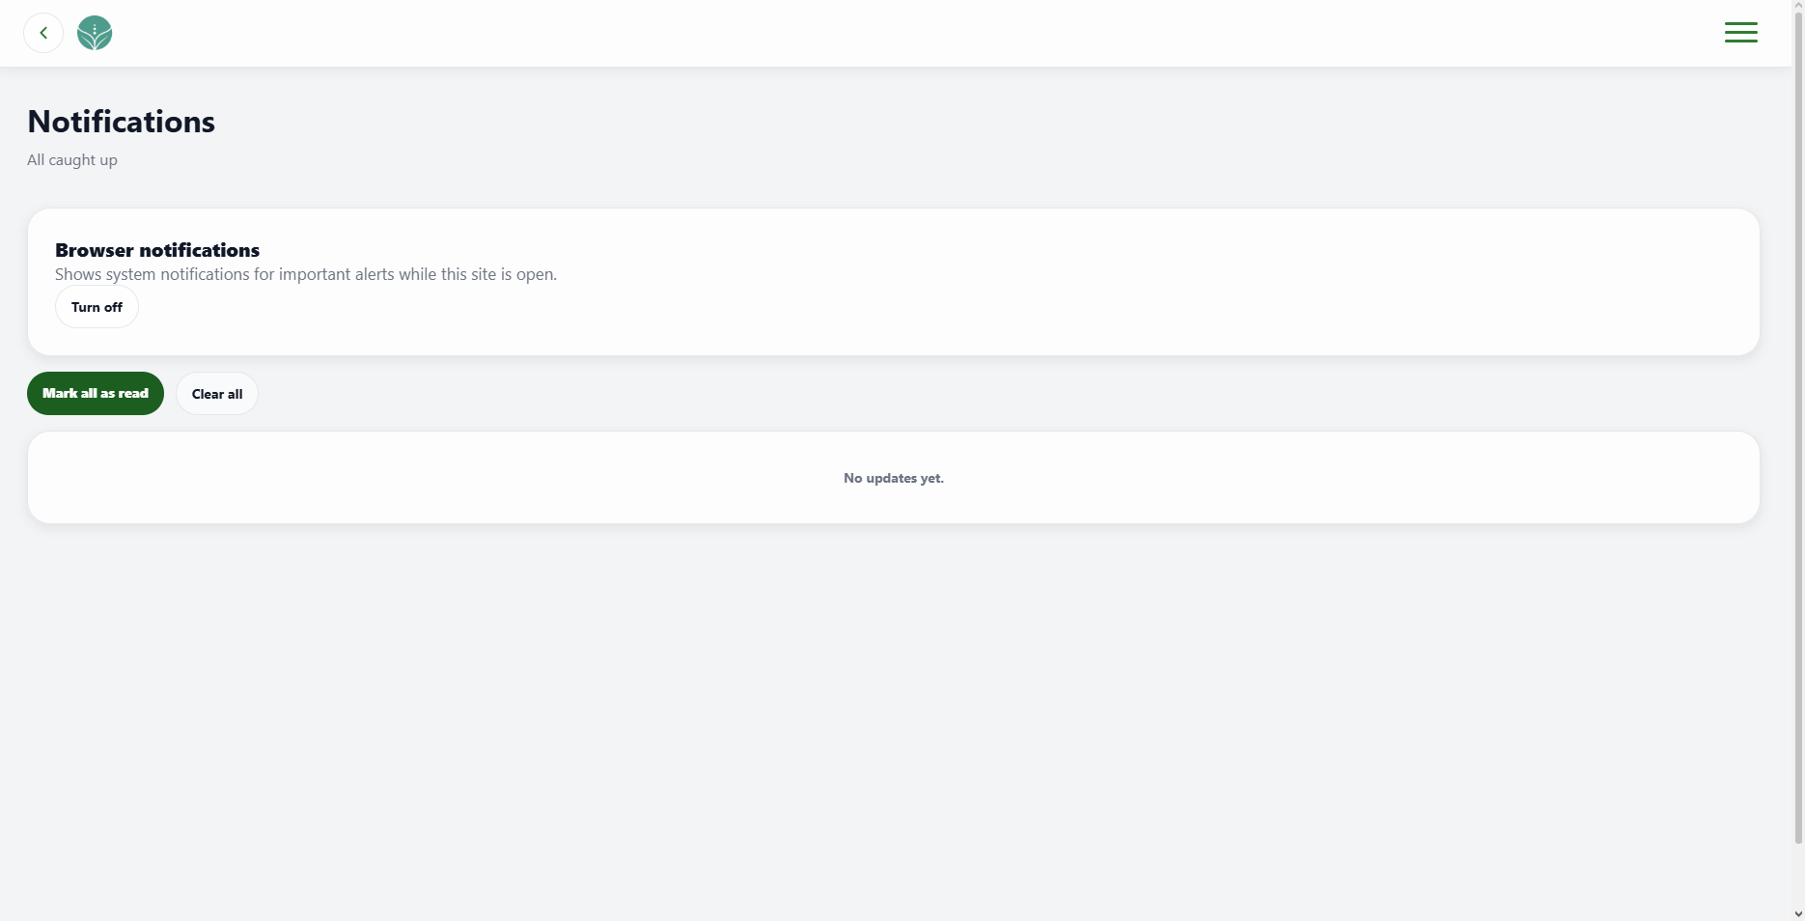 | PASSED

FUNCTIONALITY  TEST DOCUMENT |  | Module Name | NOTIFICATION MODULE
Test Cycle No. | 5 | Function Name | NOTIFICATION PAGE
Test Cycle No. | 5 | User/Access Type | User
Date Tested | 10/27/2026 | Type of System | Web Application
Pre-conditions | A signed-in client account has read and unread notifications in the test data.
Action Description | Review and manage client notifications, read states, category mute, browser notifications, and navigation.
Verification Steps | Must display and update client notifications, read state, and notification preferences correctly.
Runs | Expected Results | Actual Results | Remarks
1 | Must list notifications newest first with readable dates and unread count, or show the defined empty state when none exist. | 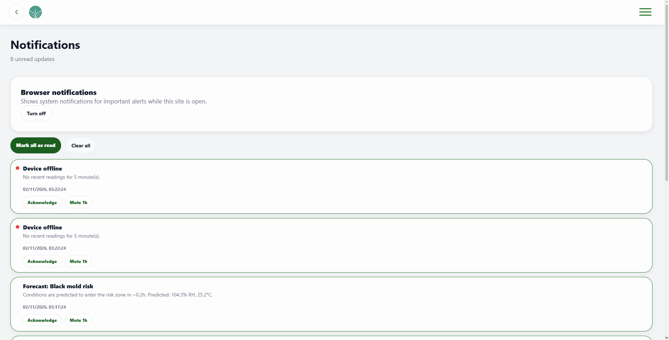 | PASSED
2 | Must update read status, unread count, and acknowledgement state consistently for individual and bulk actions. | 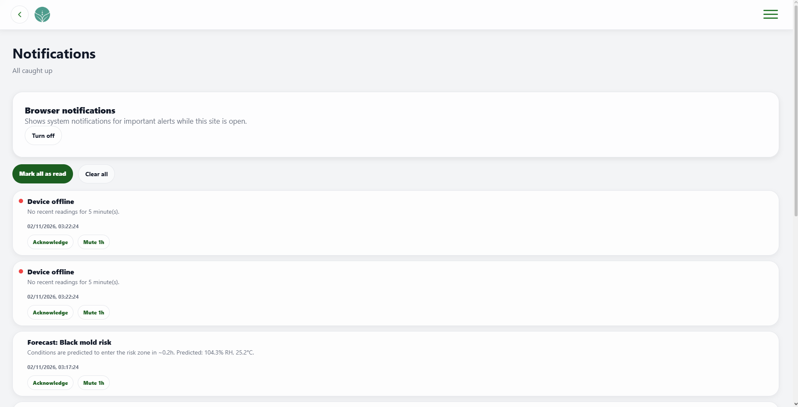 | PASSED
3 | Must show the mute expiration and provide an Unmute action for a muted category. | 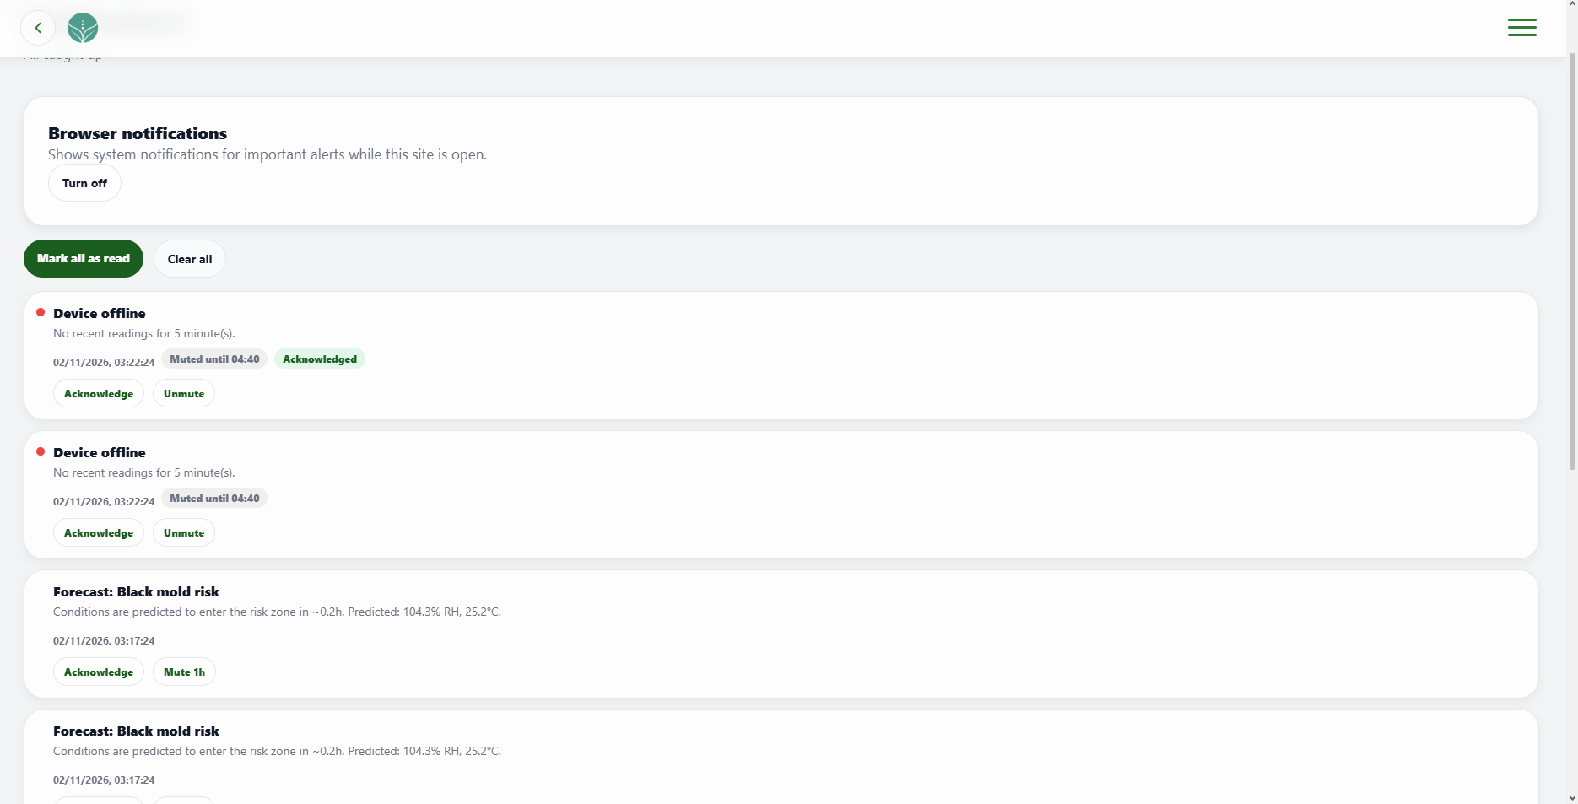 | PASSED
4 | Must clear the client notification list when confirmed and enable or disable browser notifications as selected. | 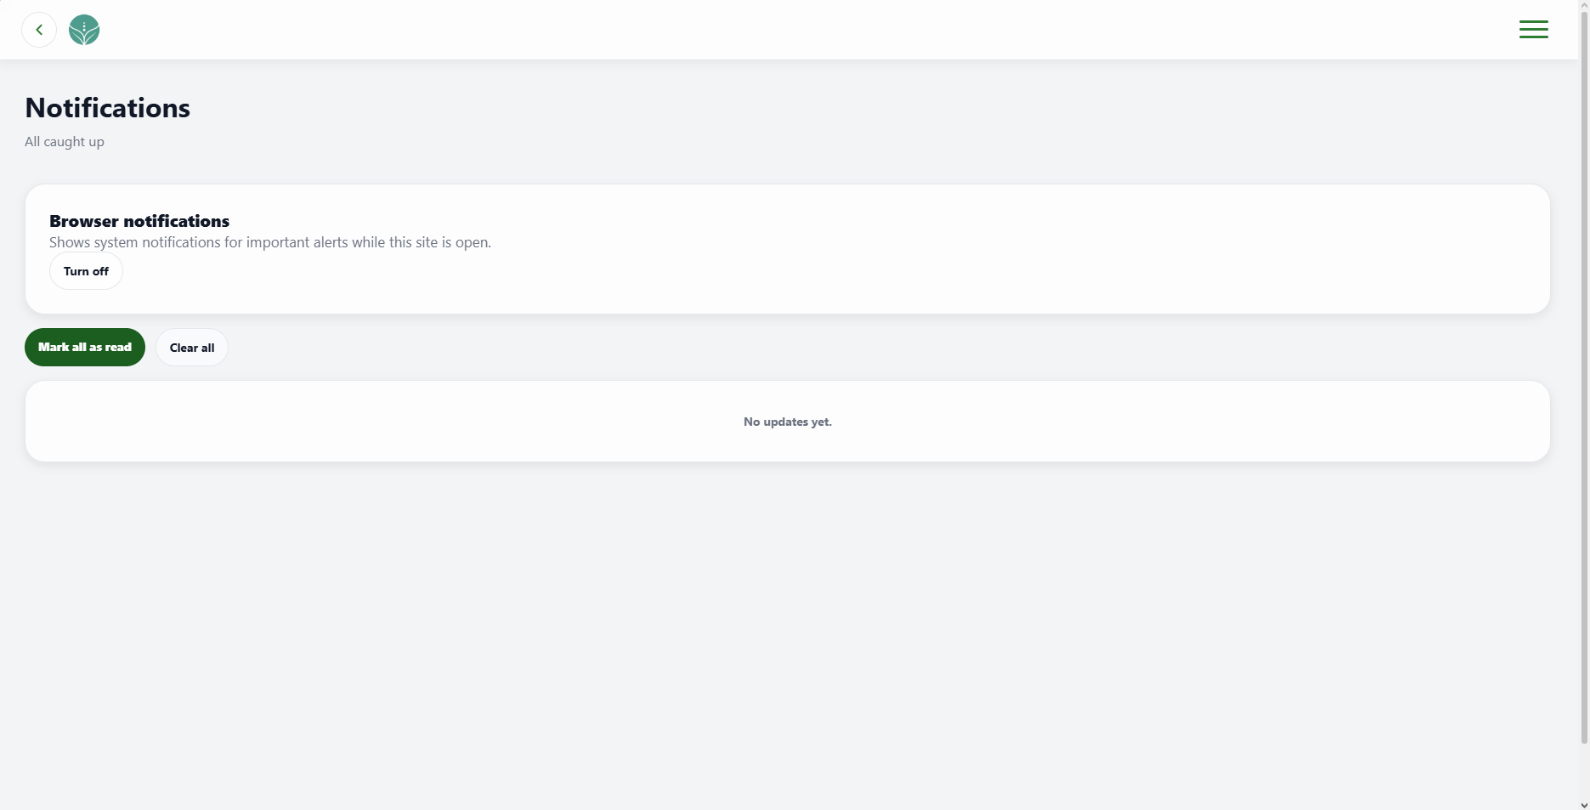 | PASSED
5 | Must return to the previous page or Dashboard and open the available navigation menu. | 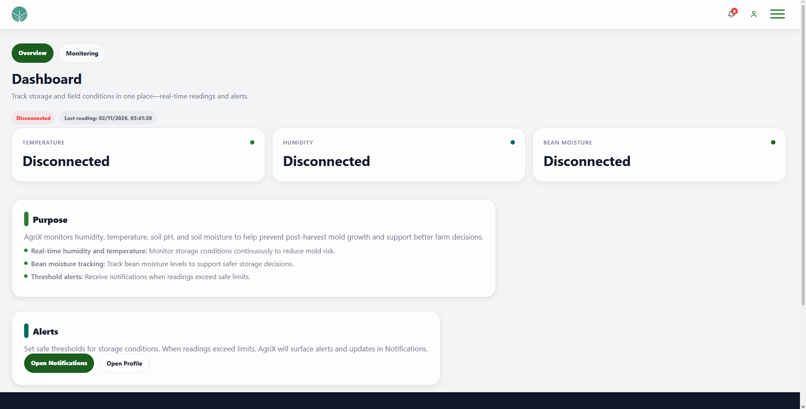 | PASSED

FUNCTIONALITY  TEST DOCUMENT |  | Module Name | PROFILE MODULE
Test Cycle No. | 5 | Function Name | PROFILE PAGE
Test Cycle No. | 5 | User/Access Type | User
Date Tested | 10/27/2026 | Type of System | Web Application
Pre-conditions | A signed-in client account and valid and invalid profile values are available.
Action Description | Review and update personal details, contact verification, unsaved changes, and profile photo.
Verification Steps | Must display and save valid profile details and reject invalid or unverified changes.
Runs | Expected Results | Actual Results | Remarks
1 | Must display the signed-in user details with the password masked and allow supported profile fields to enter edit mode. | 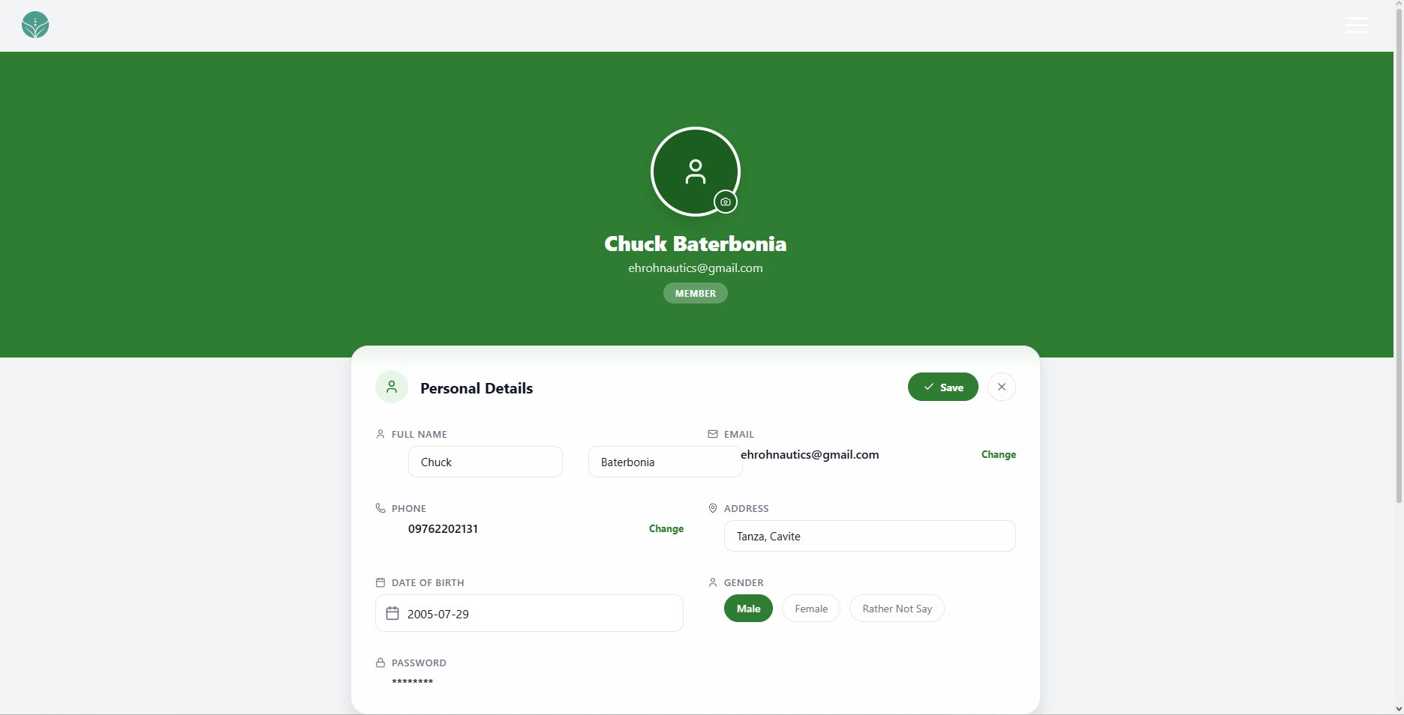 | PASSED
2 | Must reject missing or invalid names, addresses, and birth dates; enforce field limits; and accept valid profile values and gender choices. | 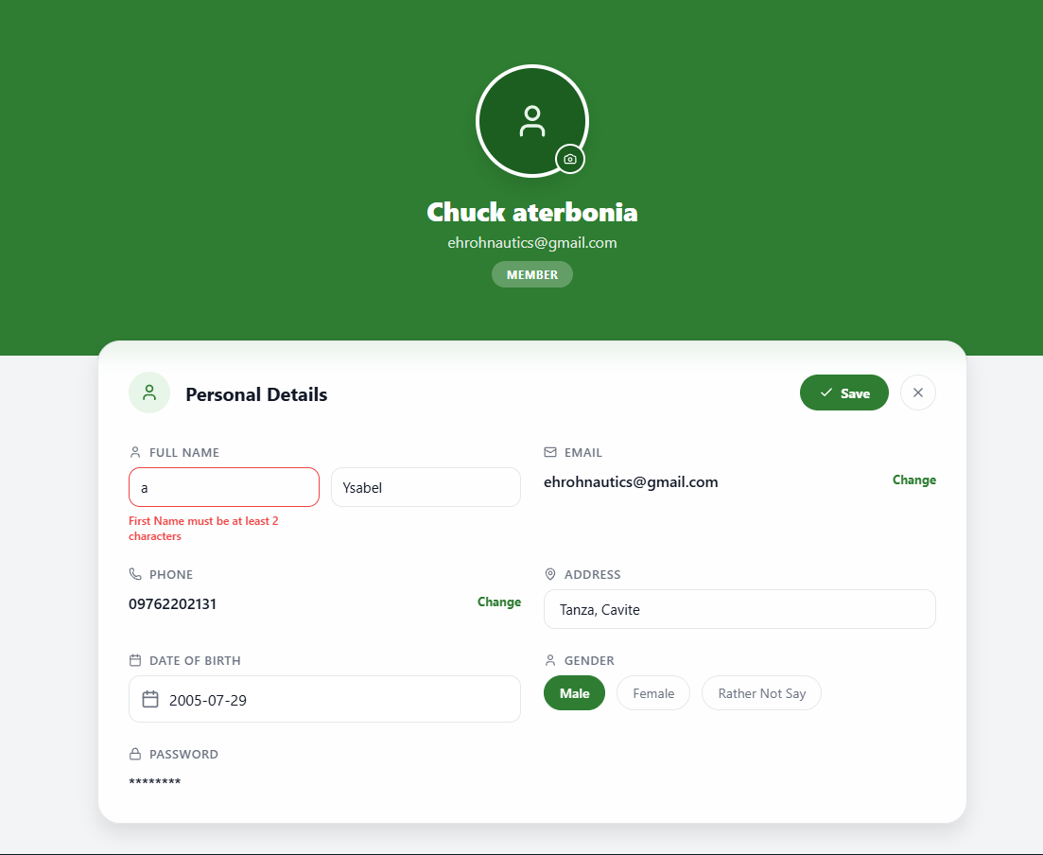 | PASSED
3 | Must save valid changes with confirmation and discard changes when editing is canceled. | 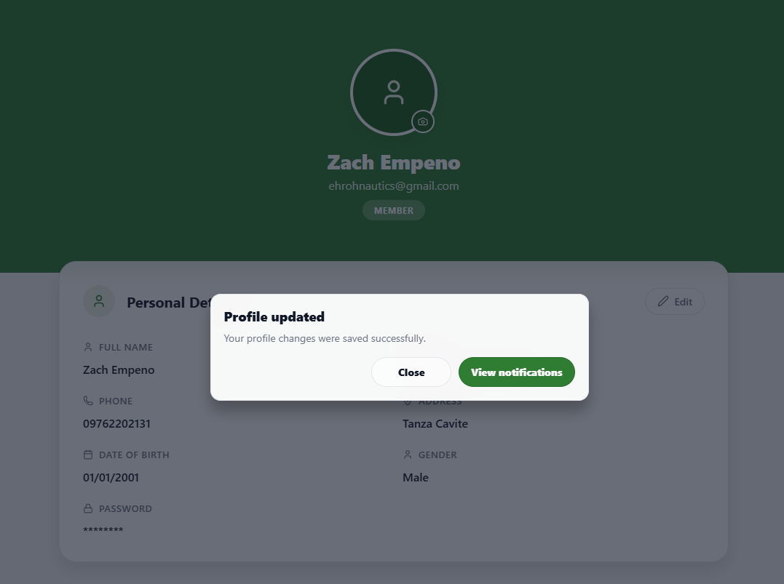 | PASSED
4 | Must let the user stay on the Profile page or leave without saving when unsaved-change confirmation appears. | 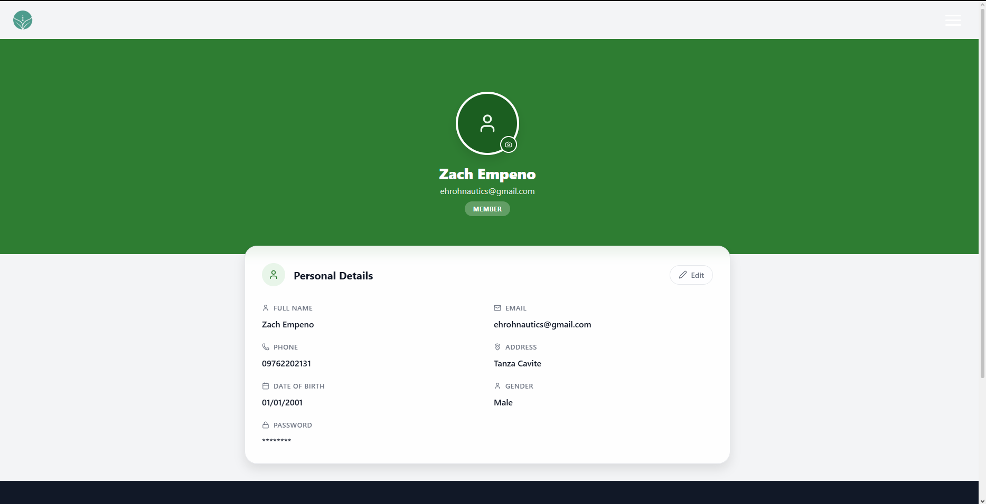 | PASSED
5 | Must validate new contact details, require a valid verification code, and update contact information only after verification. | 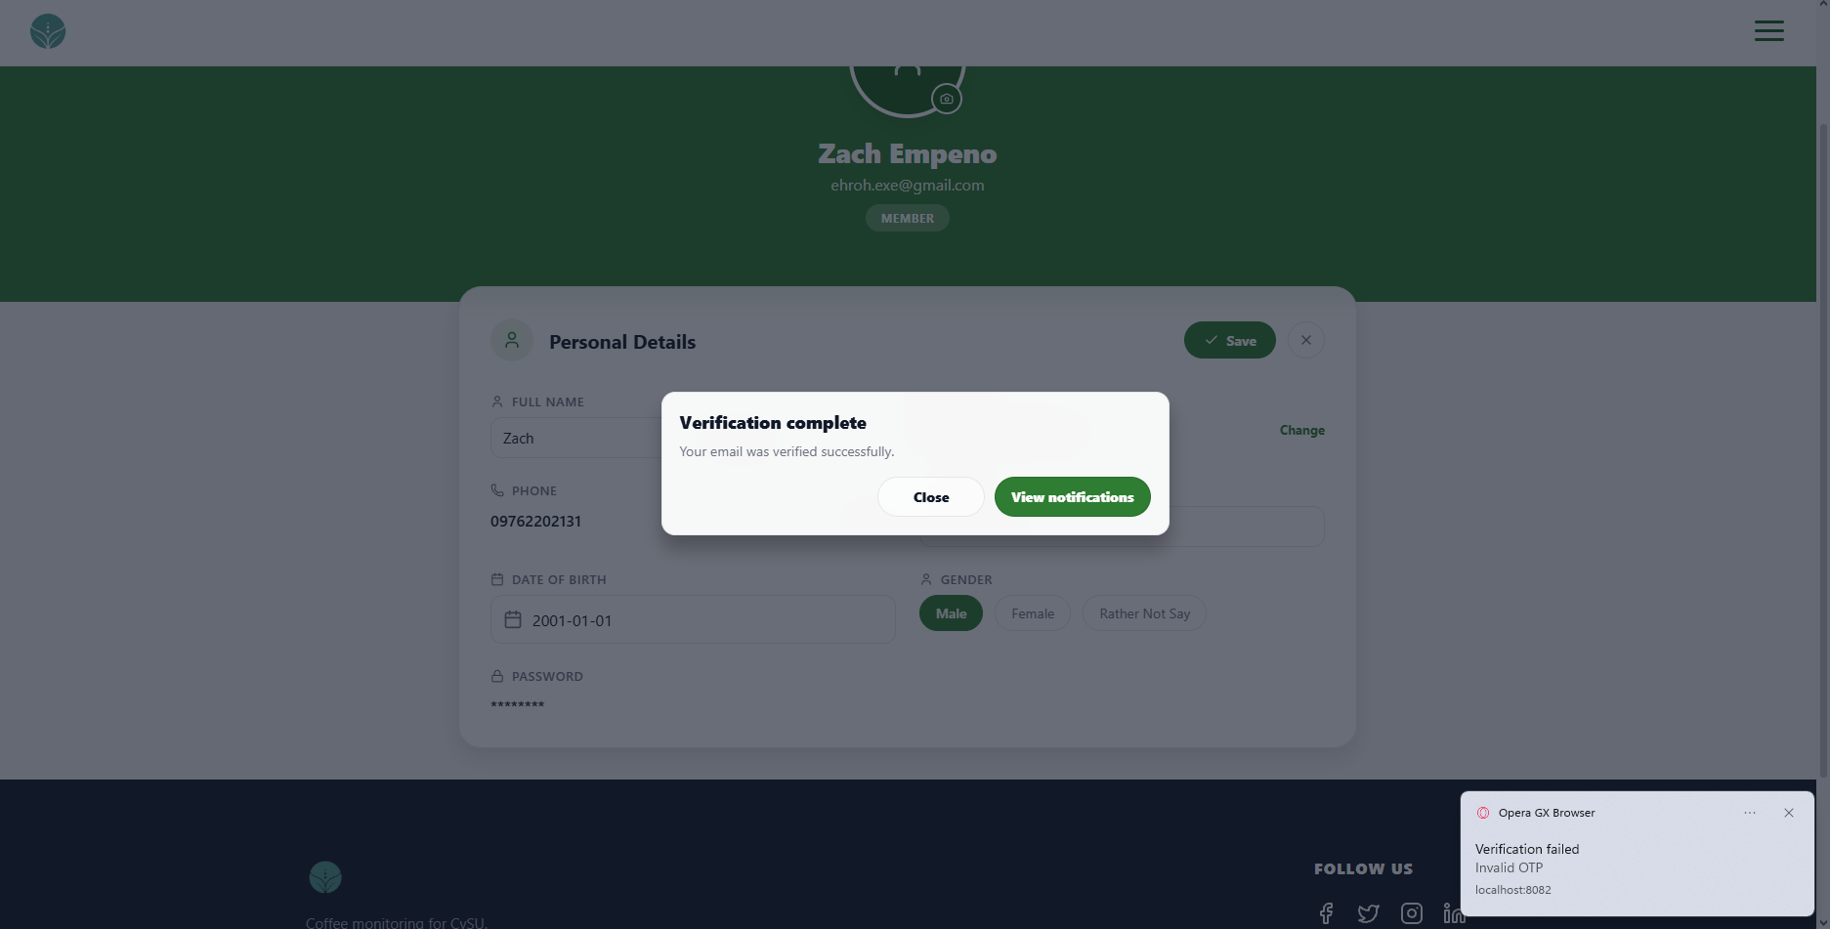 | PASSED
6 | Must reject images larger than 5 MB and display an uploaded valid image within the size limit. | 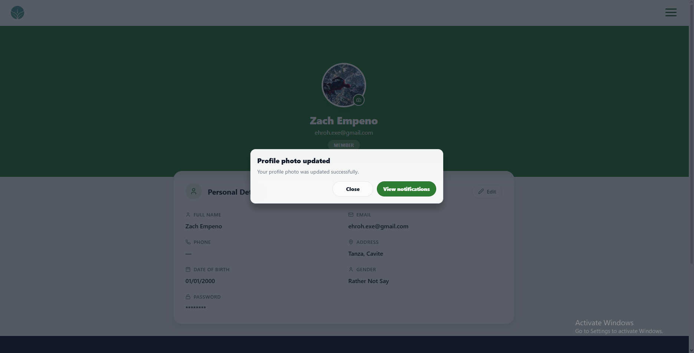 | PASSED

FUNCTIONALITY  TEST DOCUMENT |  | Module Name | DEVICE AND SENSORS MODULE
Test Cycle No. | 5 | Function Name | DEVICE SENSORS PAGE
Test Cycle No. | 5 | User/Access Type | User
Date Tested | 10/27/2026 | Type of System | Web Application
Pre-conditions | A signed-in client account, sensor readings, and IoT server test addresses are available.
Action Description | Review device status, server connectivity, shortcuts, device information, and saved alert rules.
Verification Steps | Must display accurate device status and save valid connection, device, and alert settings.
Runs | Expected Results | Actual Results | Remarks
1 | Must show Online with the latest reading time for a fresh reading and Offline when the configured timeout is exceeded. | 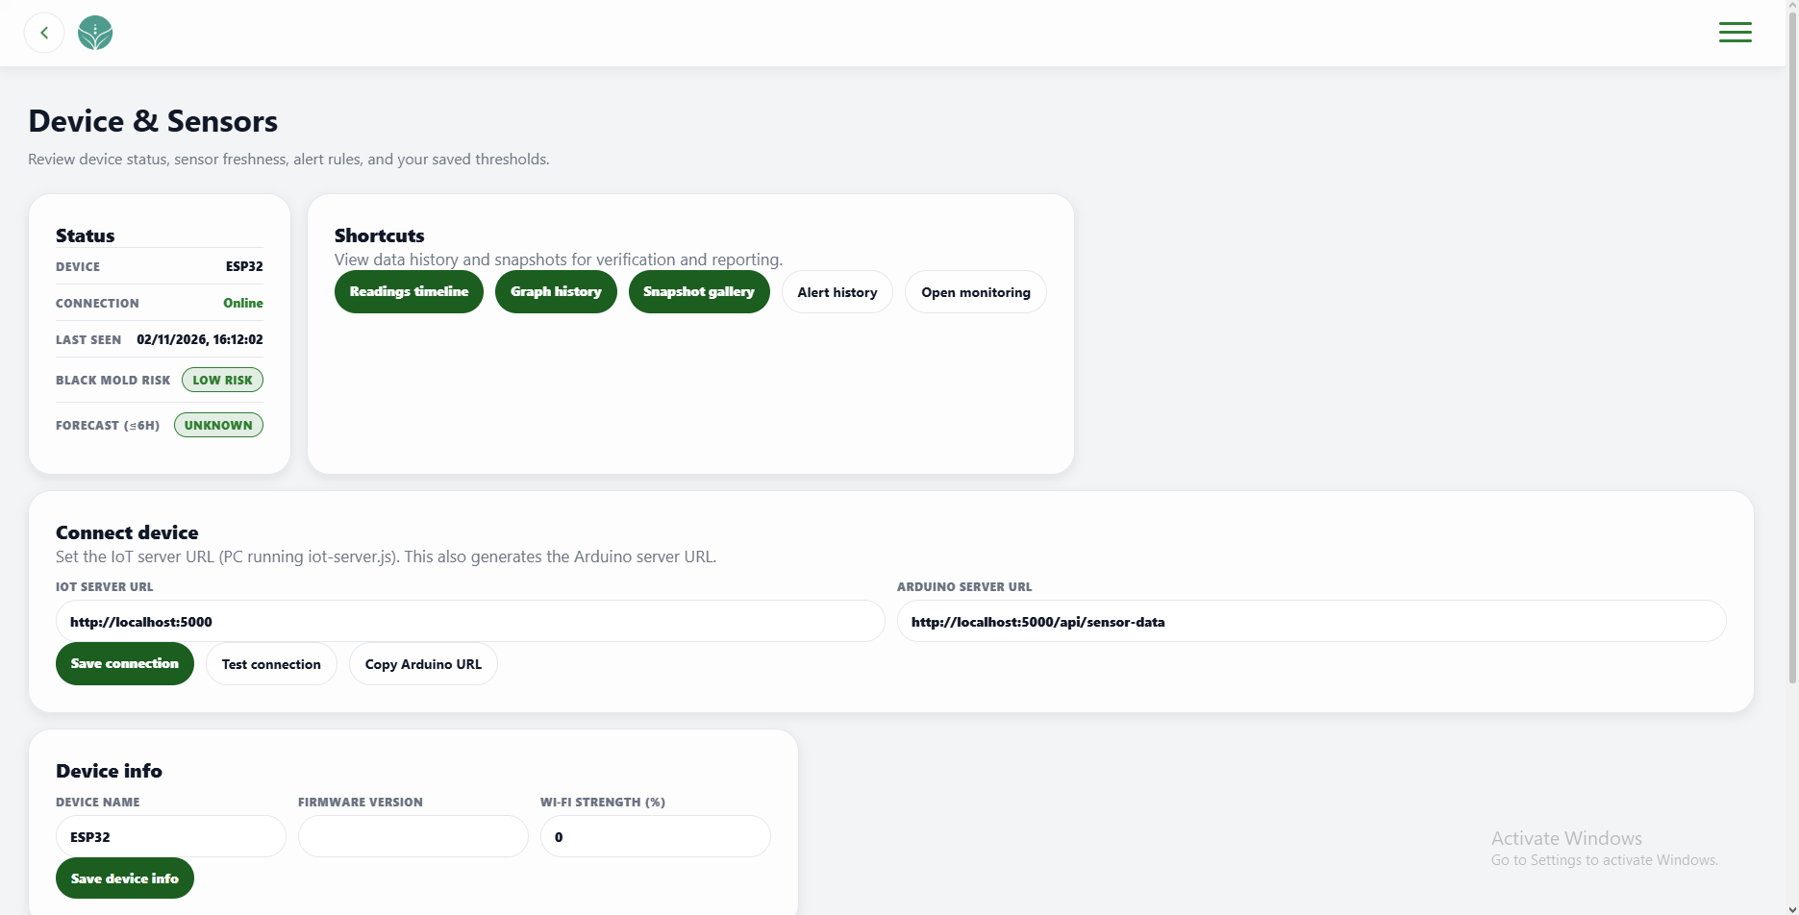 | PASSED
2 | Must open the reading timeline, graph history, snapshot gallery, alert history, and Dashboard Monitoring from the shortcuts. | 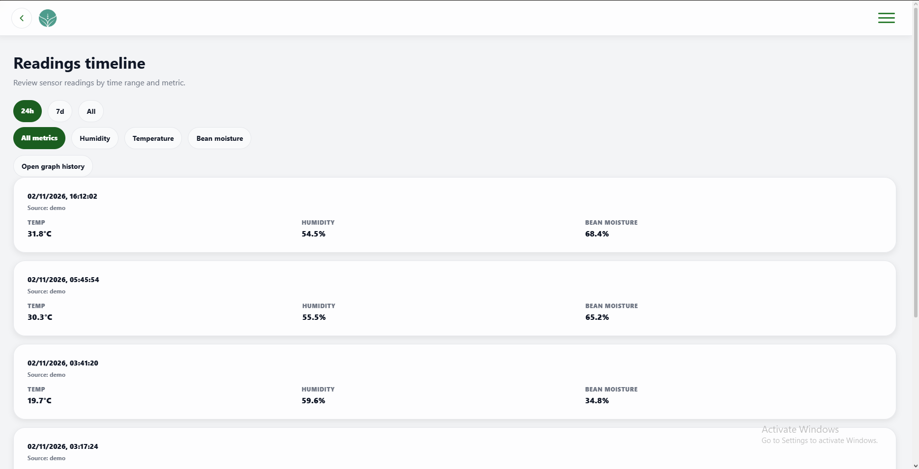 | PASSED
3 | Must save a reachable server address, report reachable or failed health checks correctly, and show the generated Arduino URL as read-only. | 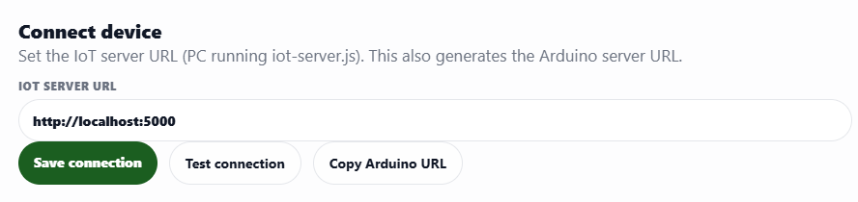 | PASSED
4 | Must save device name, firmware version, and Wi-Fi strength and retain them after reopening the page. | 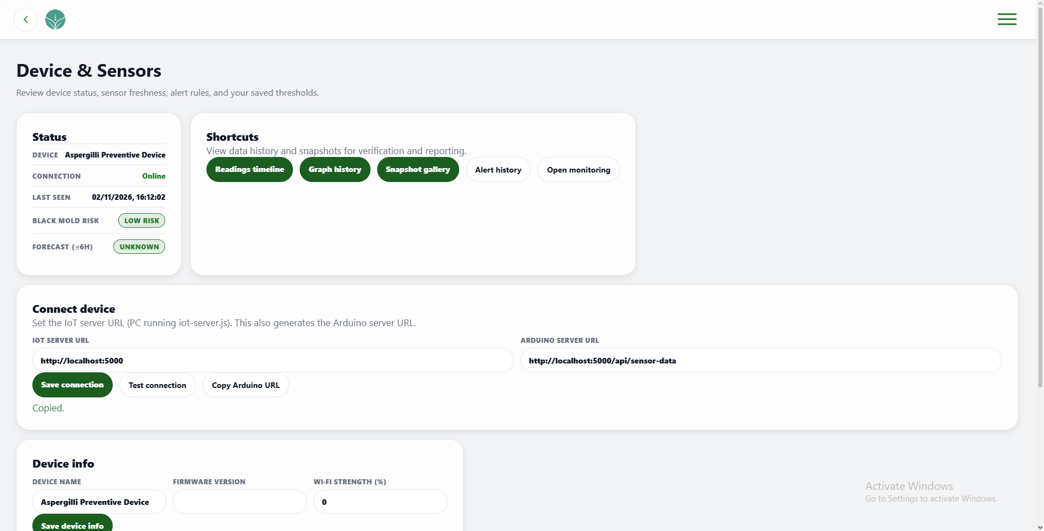 | PASSED
5 | Must save valid sensor alert durations, forecast horizon, and escalation and offline timeouts and apply them to device status. | 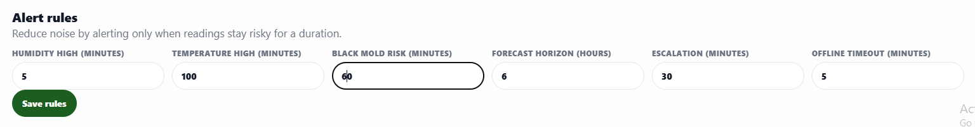 | PASSED
6 | Must copy the generated Arduino URL in a supported browser and confirm the copy. | 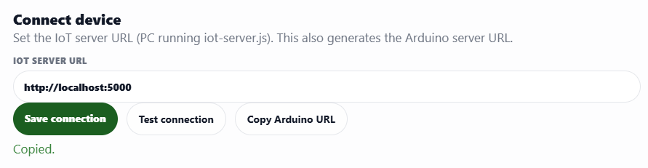 | PASSED

FUNCTIONALITY  TEST DOCUMENT |  | Module Name | DEVICE AND SENSORS - READING TIMELINE MODULE
Test Cycle No. | 5 | Function Name | READING TIMELINE PAGE
Test Cycle No. | 5 | User/Access Type | User
Date Tested | 10/27/2026 | Type of System | Web Application
Pre-conditions | The Readings Timeline is available with sensor readings across multiple dates and metrics.
Action Description | Filter sensor readings by time range and metric and open graph history.
Verification Steps | Must display only readings that match the selected time range and metric.
Runs | Expected Results | Actual Results | Remarks
1 | Must show only the selected 24-hour or seven-day range, or all available readings, excluding older records from limited ranges. | 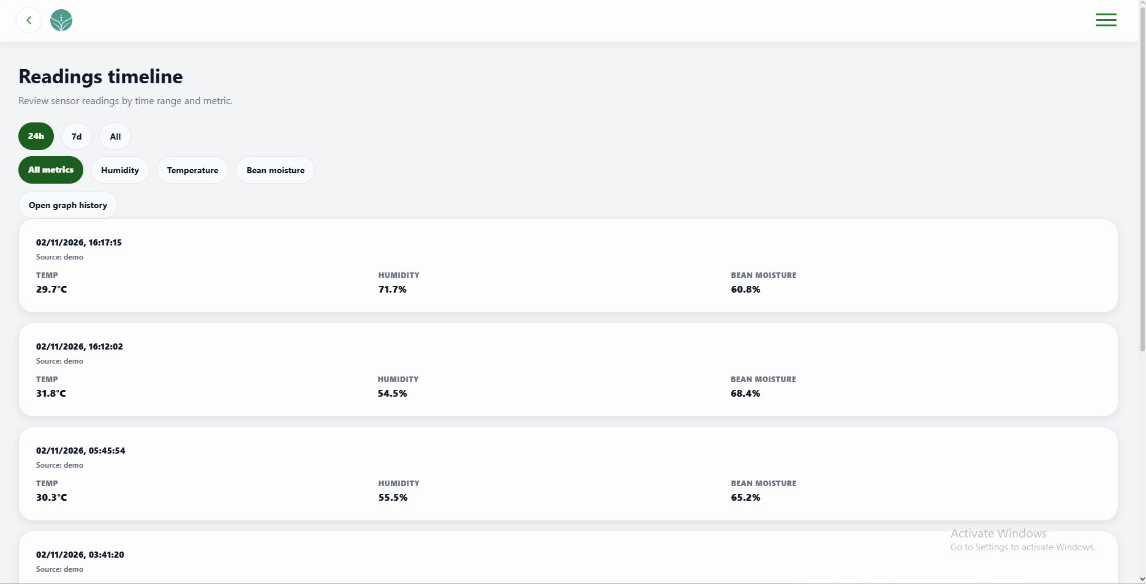 | PASSED
2 | Must show humidity, temperature, or bean moisture readings for the selected metric. | 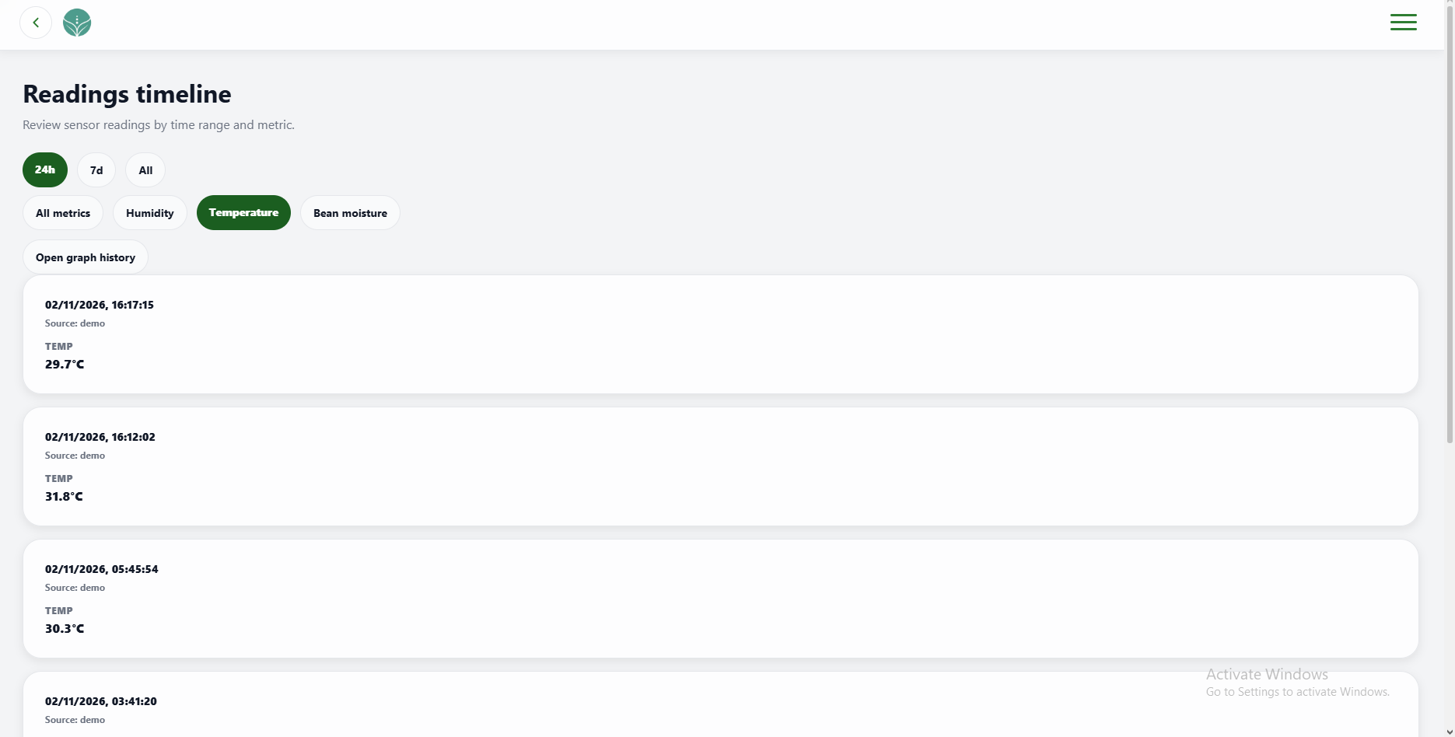 | PASSED
3 | Must display the defined empty state when the selected range and metric have no matching readings. | 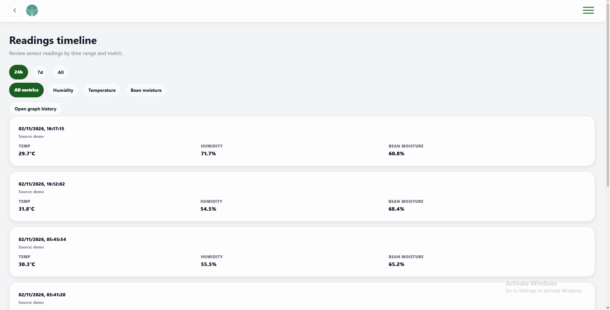 | PASSED
4 | Must open Graph History from the timeline page. | 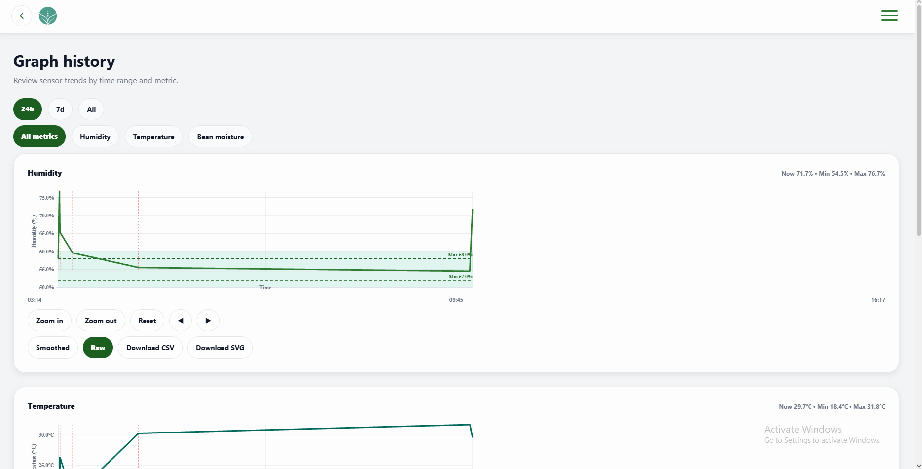 | PASSED

FUNCTIONALITY  TEST DOCUMENT |  | Module Name | DEVICE AND SENSORS - GRAPH HISTORY MODULE
Test Cycle No. | 5 | Function Name | GRAPH HISTORY PAGE
Test Cycle No. | 5 | User/Access Type | User
Date Tested | 10/27/2026 | Type of System | Web Application
Pre-conditions | Graph History is available with humidity, temperature, and bean moisture readings.
Action Description | Review historical sensor graphs, filters, navigation controls, refresh, and export.
Verification Steps | Must display, refresh, filter, navigate, and export the selected historical sensor data.
Runs | Expected Results | Actual Results | Remarks
1 | Must update graphs for 24-hour, seven-day, or all-history ranges and show only the selected sensor metric. | 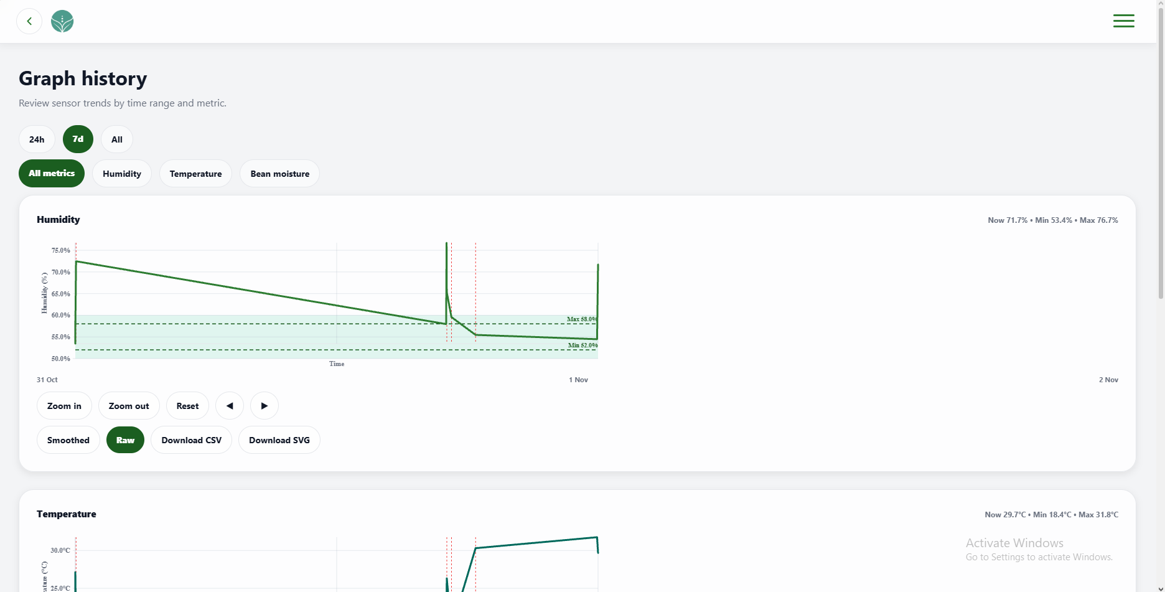 | PASSED
2 | Must zoom and pan the graph and restore its full range when Reset is selected. | 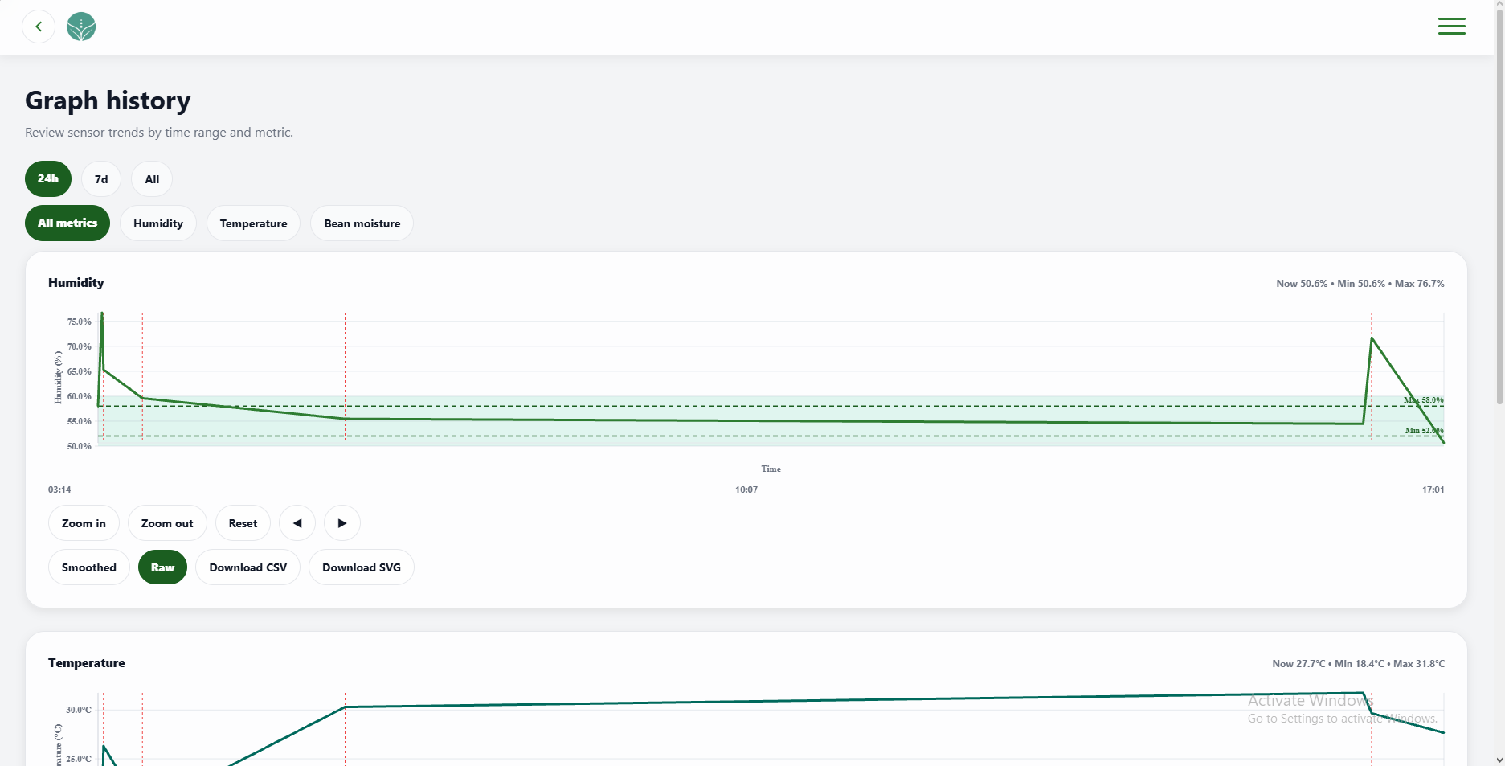 | PASSED
3 | Must show averaged trends in Smoothed mode and original points in Raw mode. | 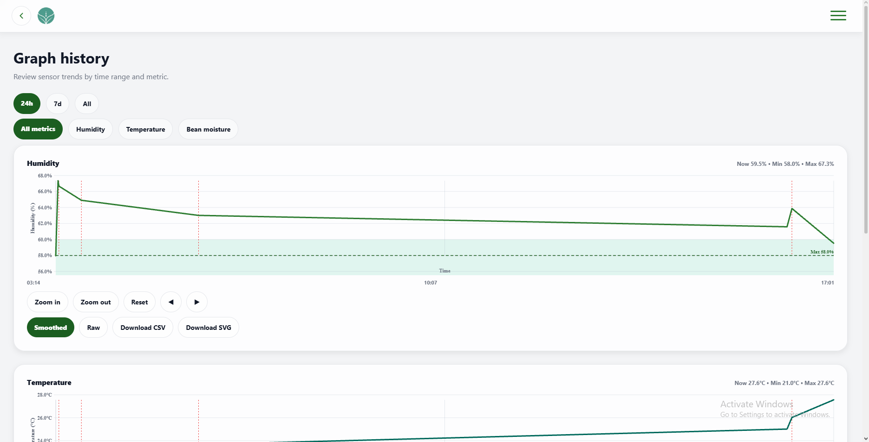 | PASSED
4 | Must show a loading state during refresh and update graphs when history is returned. | 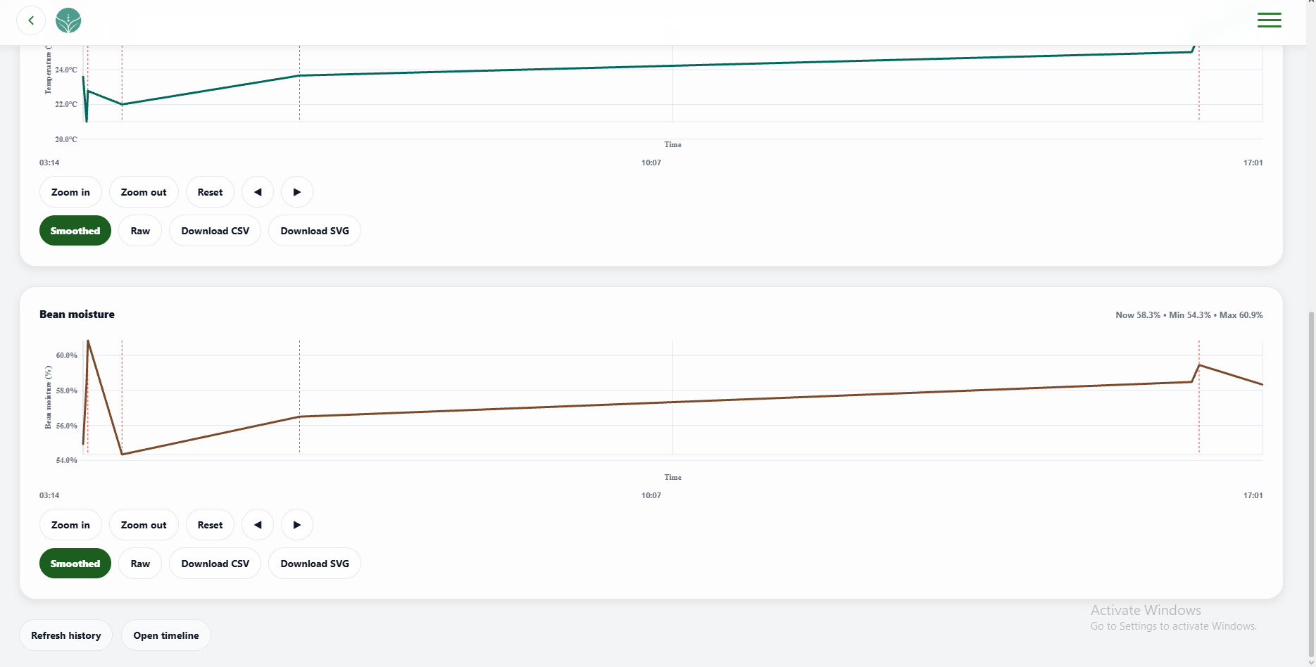 | PASSED
5 | Must download CSV readings or an SVG graph for the selected historical data. | 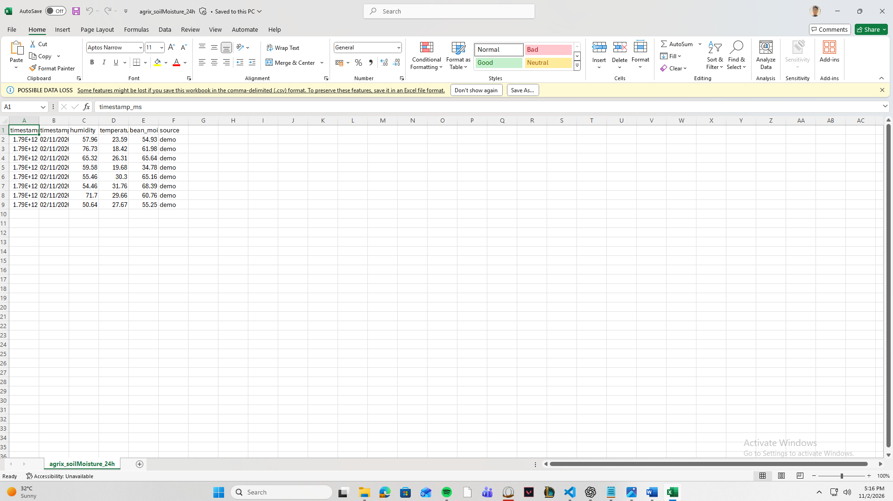 | PASSED

FUNCTIONALITY  TEST DOCUMENT |  | Module Name | DEVICE AND SENSORS – SNAPSHOT GALLERY MODULE
Test Cycle No. | 5 | Function Name | SNAPSHOT GALLERYPAGE
Test Cycle No. | 5 | User/Access Type | User
Date Tested | 10/27/2026 | Type of System | Web Application
Pre-conditions | The gallery is available with valid JPG and PNG snapshots and upload files.
Action Description | Review the snapshot gallery, upload images, compare selections, and clear selection.
Verification Steps | Must display uploaded snapshots and compare or clear selections correctly.
Runs | Expected Results | Actual Results | Remarks
1 | Must show the empty-gallery state and accept a valid JPG or PNG snapshot with its upload time. | 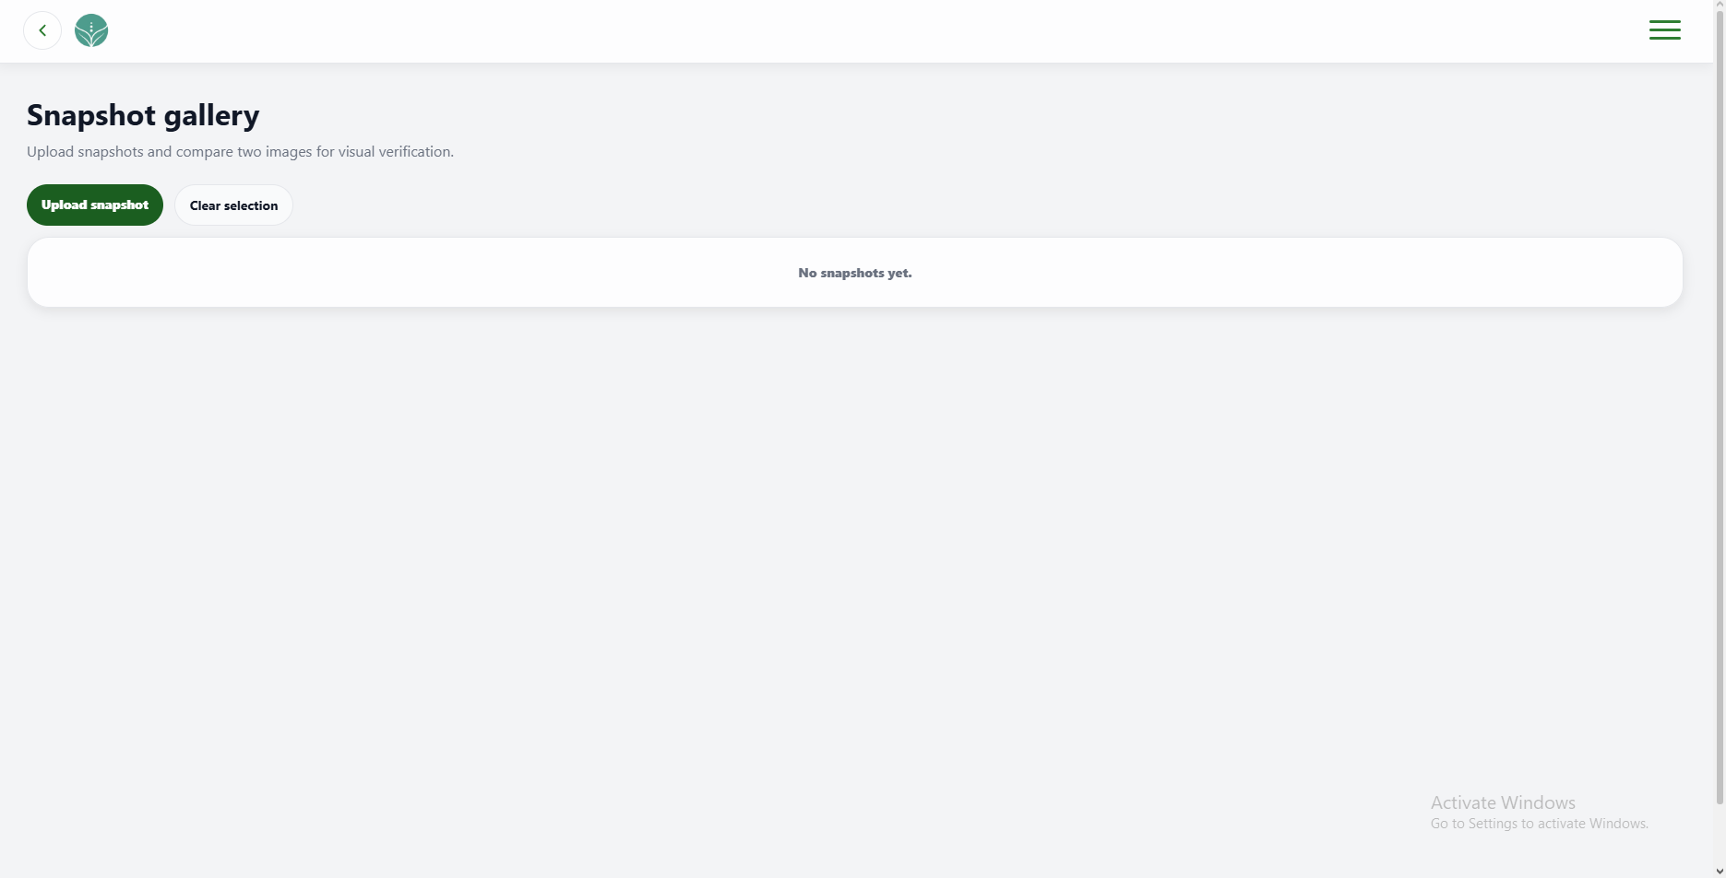 | PASSED
2 | Must mark one selected snapshot and compare two selected snapshots with their upload times. | 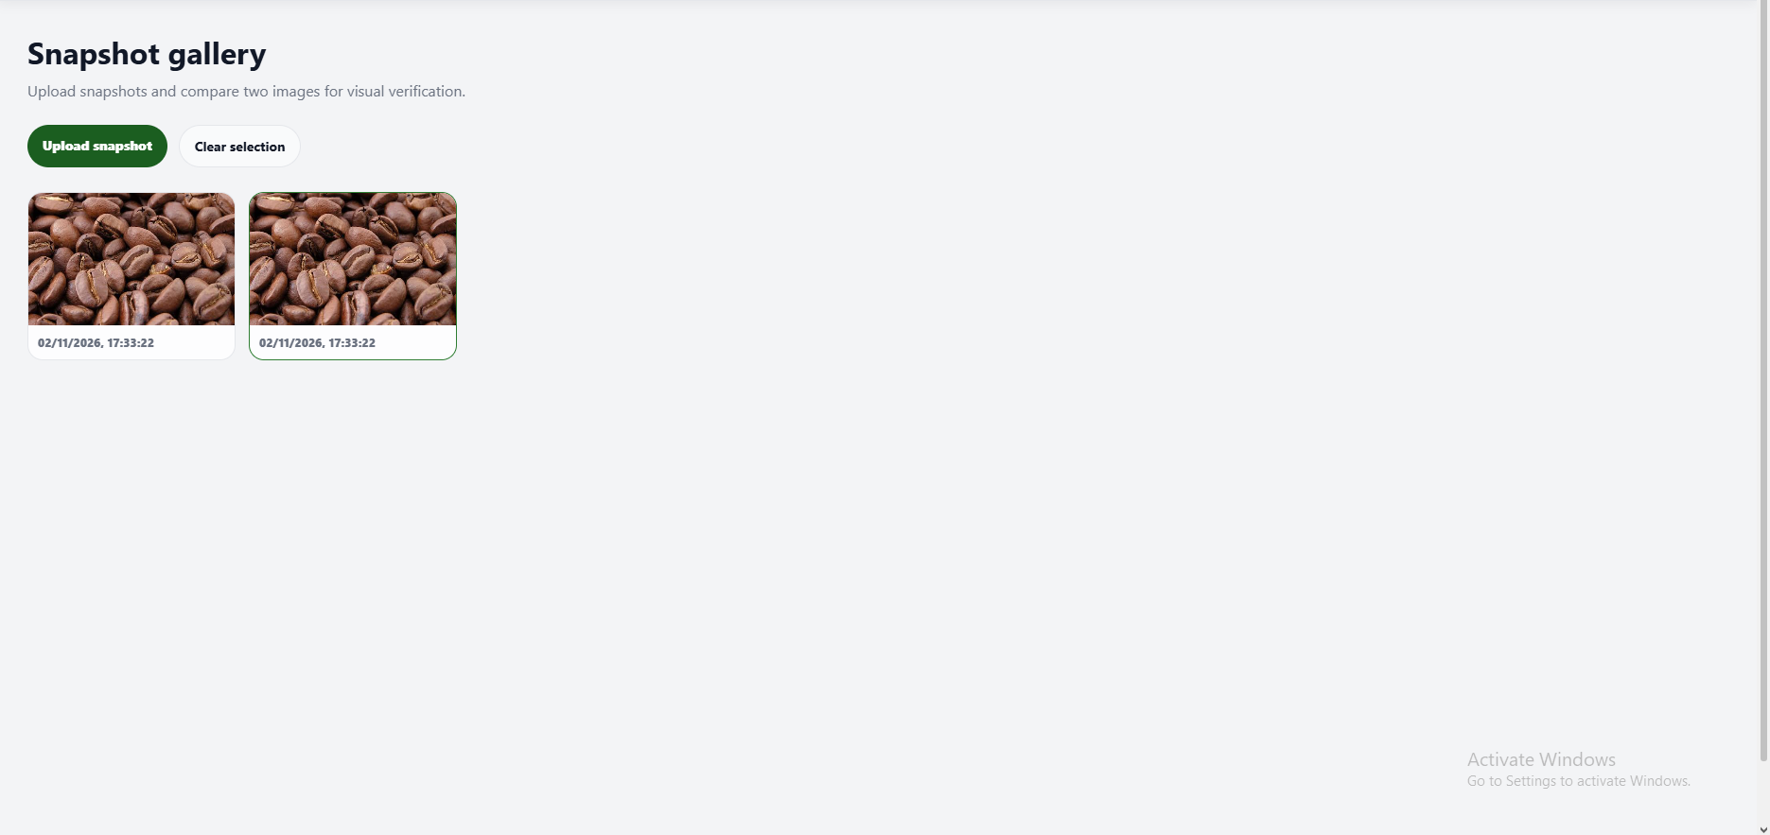 | PASSED
3 | Must keep the two most recently selected snapshots for comparison and close the comparison area when selection is cleared. | 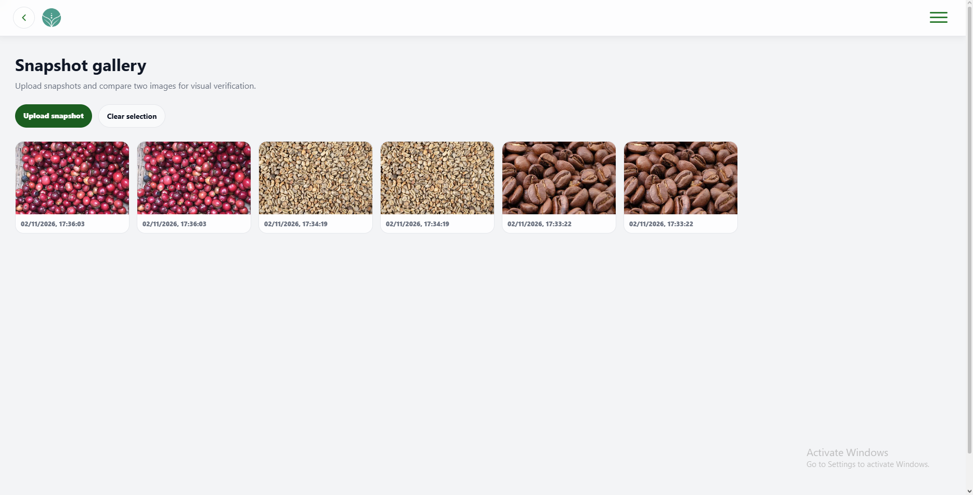 | PASSED

FUNCTIONALITY  TEST DOCUMENT |  | Module Name | DEVICE AND SENSORS - ALERT HISTORY MODULE
Test Cycle No. | 5 | Function Name | ALERT HISTORY PAGE
Test Cycle No. | 5 | User/Access Type | User
Date Tested | 10/27/2026 | Type of System | Web Application
Pre-conditions | Alert History contains acknowledged and unacknowledged alerts across categories.
Action Description | Filter alerts, acknowledge them, manage category mute, and open notifications.
Verification Steps | Must display alerts for the selected state and update acknowledgement and mute status correctly.
Runs | Expected Results | Actual Results | Remarks
1 | Must show all alerts or only acknowledged or unacknowledged alerts according to the selected filter. | 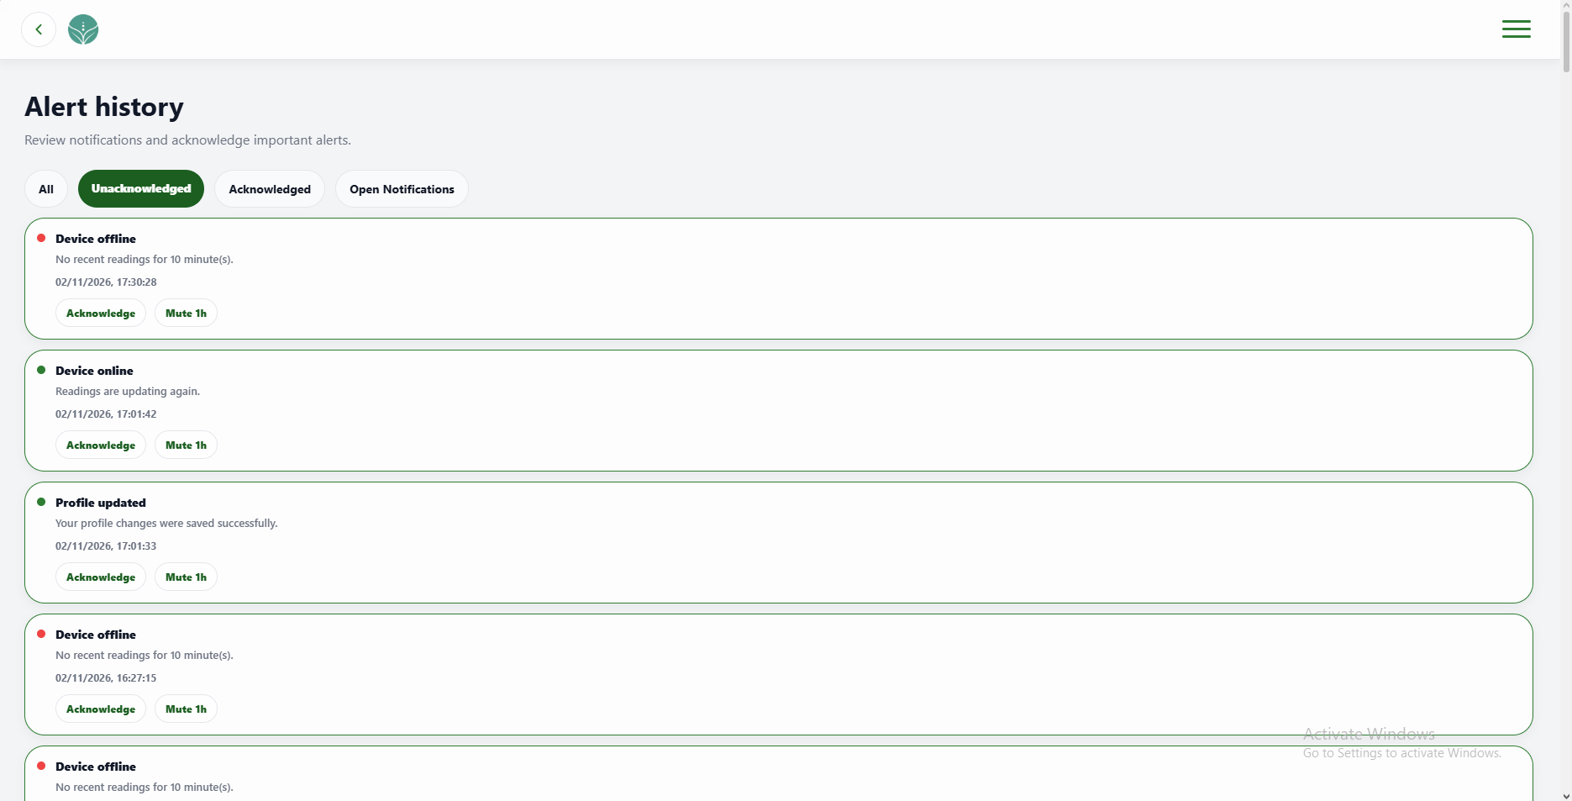 | PASSED
2 | Must mark an alert acknowledged and place it in the acknowledged list. | 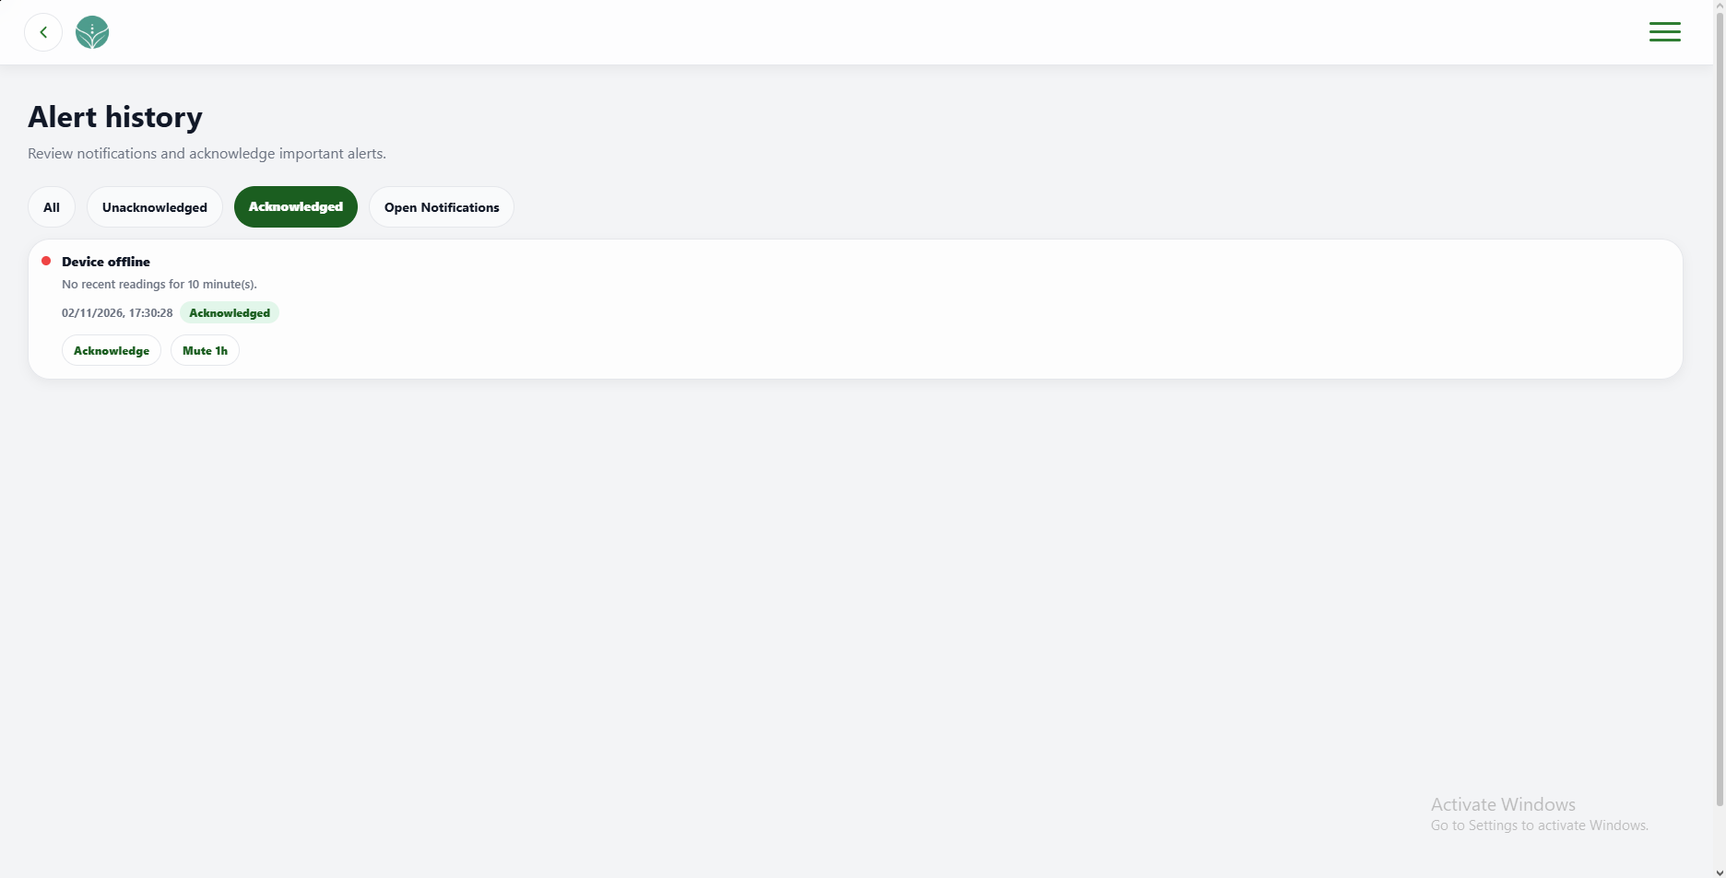 | PASSED
3 | Must show the mute expiration and allow the category to be unmuted. | 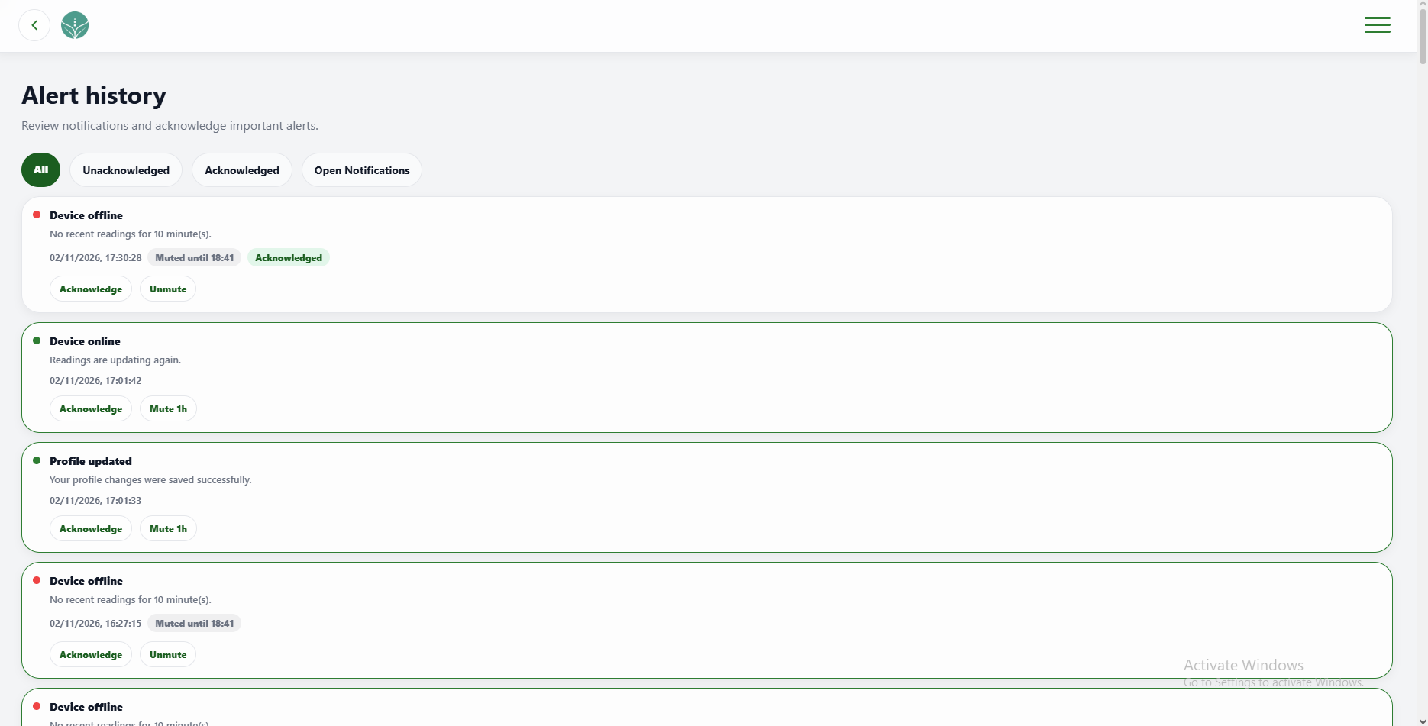 | PASSED
4 | Must open Notifications from Alert History. | 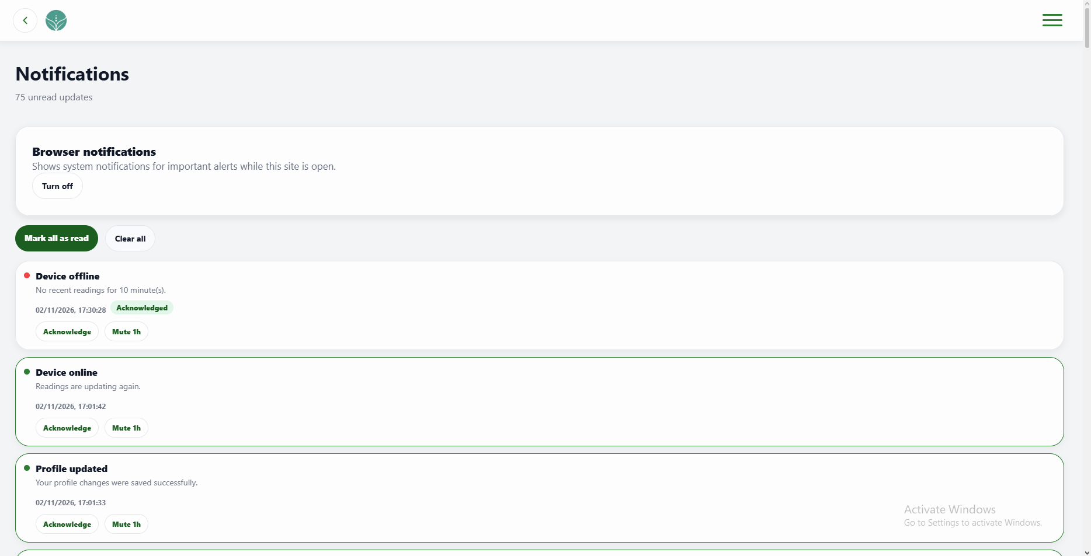 | PASSED

FUNCTIONALITY  TEST DOCUMENT |  | Module Name | DEVICE AND SENSORS - OPEN MONITORING MODULE
Test Cycle No. | 5 | Function Name | OPEN MONITORING PAGE
Test Cycle No. | 5 | User/Access Type | User
Date Tested | 10/27/2026 | Type of System | Web Application
Pre-conditions | A signed-in client account, sensor test data, and threshold settings are available.
Action Description | Review Monitoring status, readings, thresholds, and dashboard shortcuts.
Verification Steps | Must display the Monitoring view with accurate sensor status, thresholds, and navigation.
Runs | Expected Results | Actual Results | Remarks
1 | Must open the Dashboard directly in the Monitoring view. |  | PASSED
2 | Must show current sensor status, summaries, trends, snapshots, and checklist and distinguish stale or missing readings from live data. | 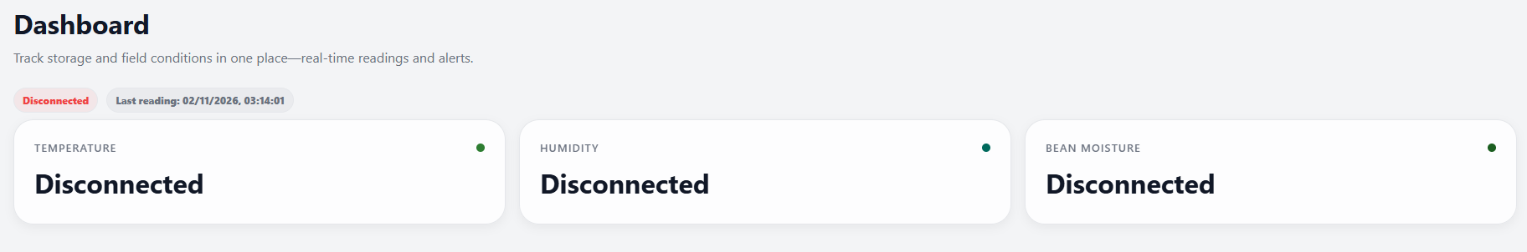 | PASSED
3 | Must apply recommended and valid custom thresholds and reflect saved settings in the view and notifications. | 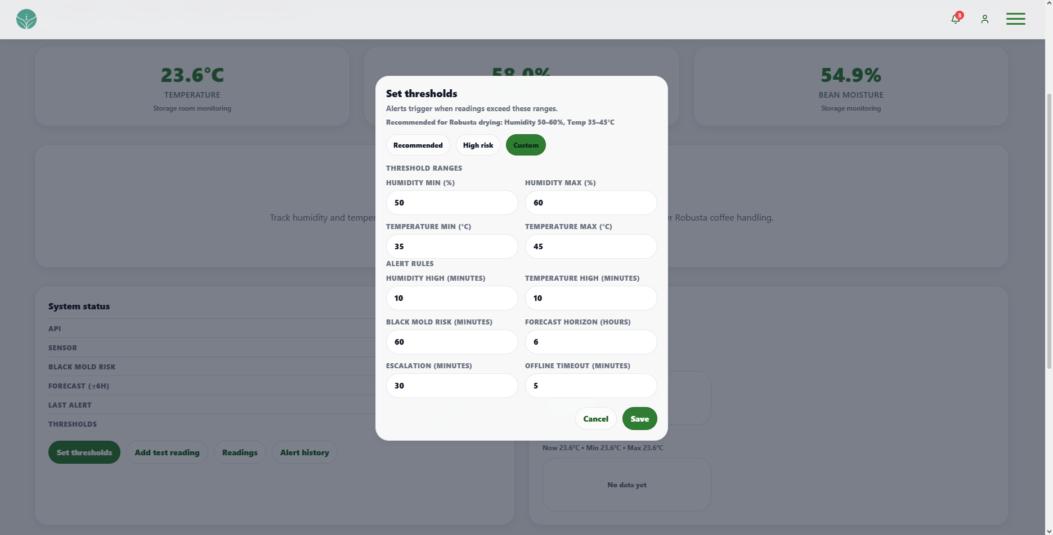 | PASSED
4 | Must open the readings timeline and alert history from Monitoring. | 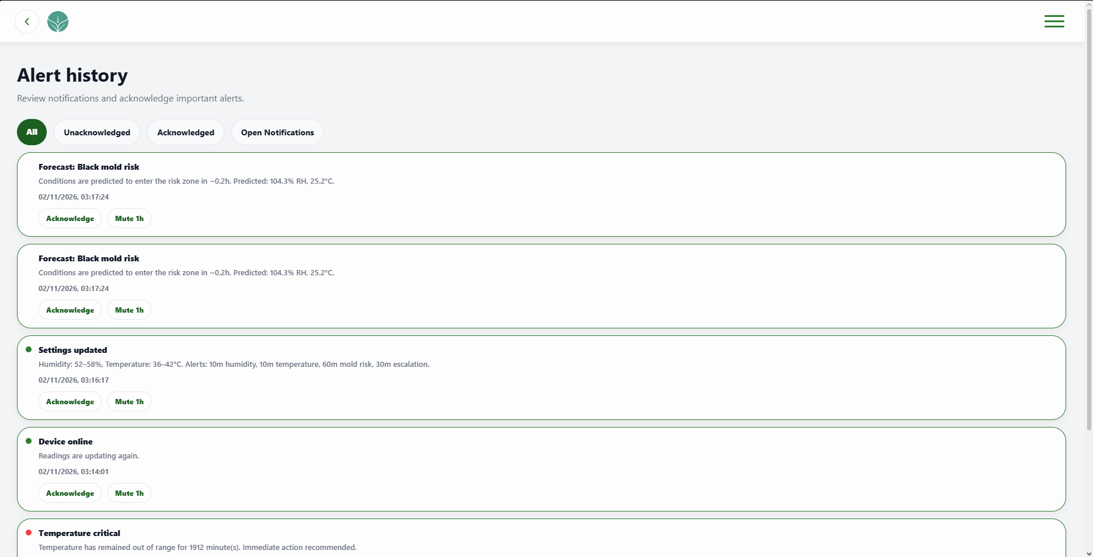 | PASSED

FUNCTIONALITY  TEST DOCUMENT |  | Module Name | PHYSICAL HARDWARE MODULE
Test Cycle No. | 5 | Function Name | PHYSICAL HARDWARE UNITS
Test Cycle No. | 5 | User/Access Type | User
Date Tested | 10/27/2026 | Type of System | Web Application
Pre-conditions | The hardware test setup, ESP32, sensors, actuators, and coffee samples are available.
Action Description | Operate the hardware and observe sensor readings, controller connectivity, and LCD output.
Verification Steps | Must operate the tested hardware and report sensor readings and controller status correctly.
Runs | Expected Results | Actual Results | Remarks
1 | Must run the DC gear motor and coffee bean mixer while powered and stop or move as expected when switched on or off. | 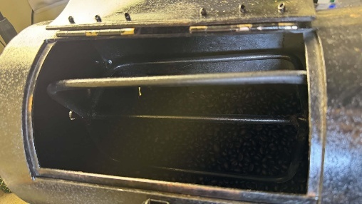 | PASSED
2 | Must change humidity, temperature, and bean moisture readings as surrounding conditions or sample moisture change. | 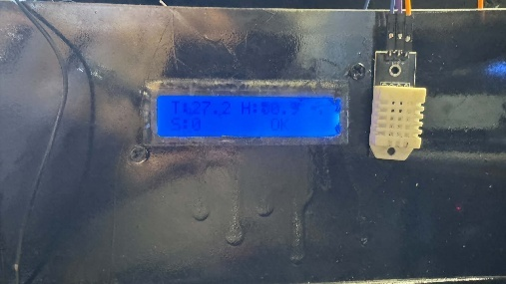 | PASSED
3 | Must raise chamber temperature while running and allow it to decrease after shutdown. | 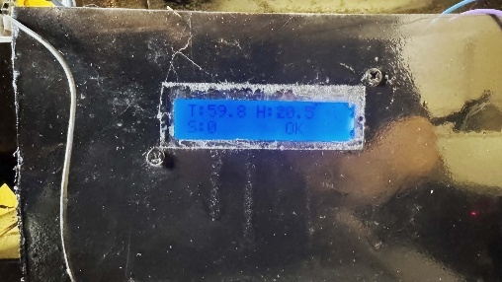 | PASSED
4 | Must start the ESP32, connect to Wi-Fi, and send sensor readings to the system. | 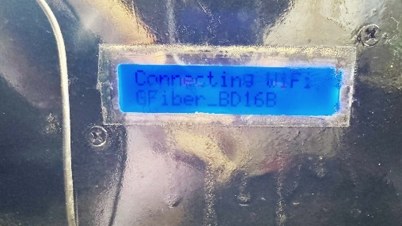 | PASSED
5 | Must display current temperature, humidity, and bean moisture and refresh when new readings arrive. | 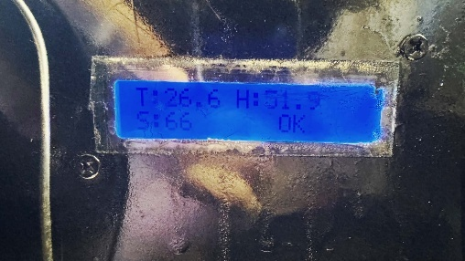 | PASSED

FUNCTIONALITY  TEST DOCUMENT |  | Module Name | LOGIN MODULE
Test Cycle No. | 5 | Function Name | LOGIN PAGE
Test Cycle No. | 5 | User/Access Type | Administrator
Date Tested | 10/27/2026 | Type of System | Web Application
Pre-conditions | The admin sign-in page is available. The administrator is signed out and test credentials are available.
Action Description | Authenticate with valid and invalid administrator credentials and review the available sign-in routes.
Verification Steps | Must be able to sign in as an administrator and receive clear feedback for invalid credentials.
Runs | Expected Results | Actual Results | Remarks
1 | Must authenticate a valid administrator account and open the intended admin page. | 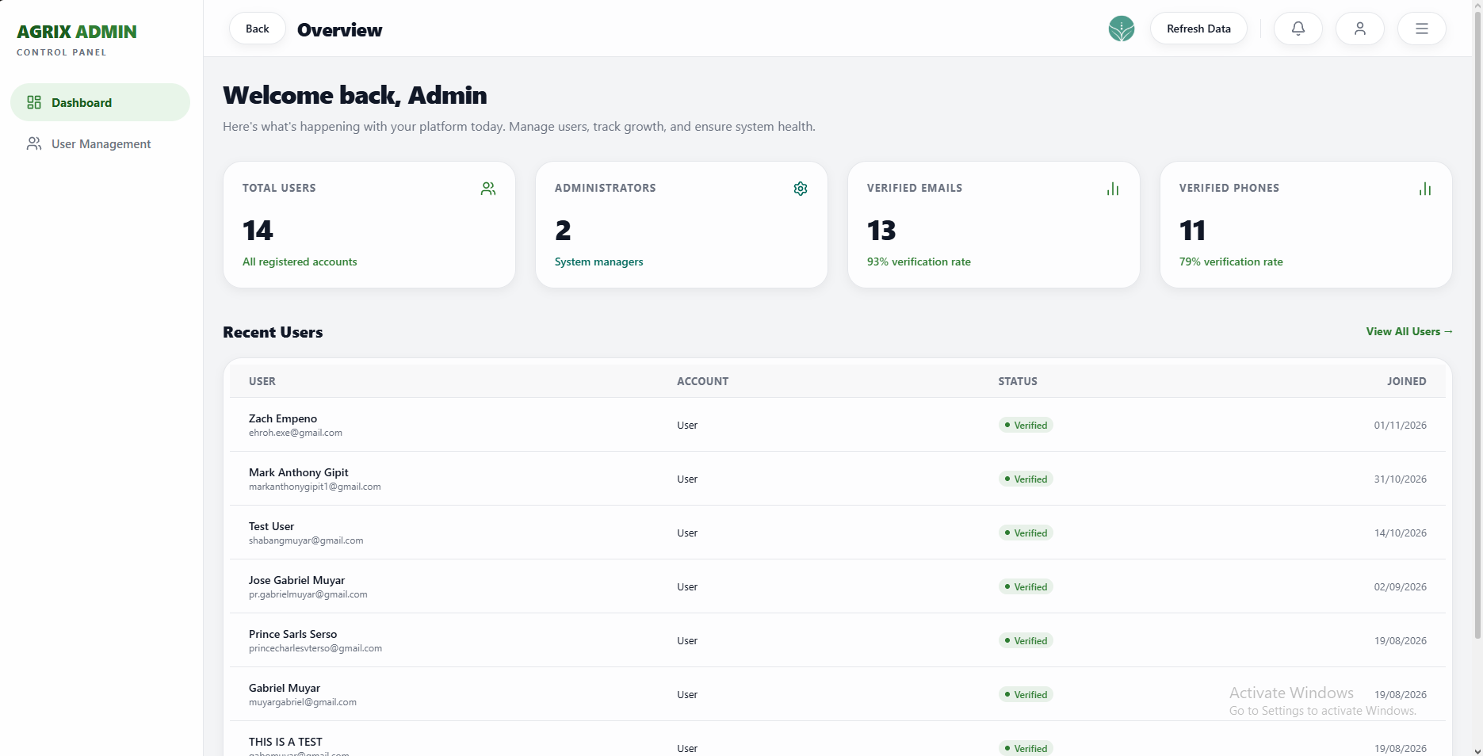 | PASSED
2 | Must reject blank, malformed, or incorrect credentials with clear validation and privacy-safe feedback. |  | PASSED
3 | Must keep password visibility and Remember me controls usable. |  | PASSED
4 | Must open recovery or registration as available, return to Home, and preserve readable page controls across themes. |  | PASSED

FUNCTIONALITY  TEST DOCUMENT |  | Module Name | DASHBOARD OVERVIEW MODULE
Test Cycle No. | 5 | Function Name | DASHBOARD OVERVIEW PAGE
Test Cycle No. | 5 | User/Access Type | Administrator
Date Tested | 10/27/2026 | Type of System | Web Application
Pre-conditions | A signed-in administrator account and current dashboard records are available.
Action Description | Review administrator summaries, recent users, data refresh, navigation, and session controls.
Verification Steps | Must display current administrator summary data and open the correct admin destinations.
Runs | Expected Results | Actual Results | Remarks
1 | Must display the welcome area, user summary cards, recent users, and admin navigation. | 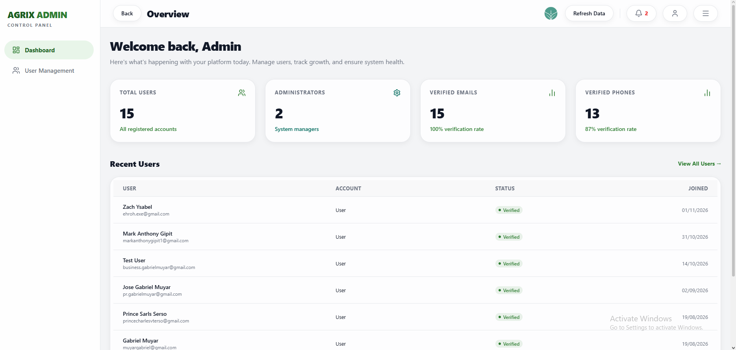 | PASSED
2 | Must show current totals and verification rates for users, administrators, verified emails, and verified phones. | 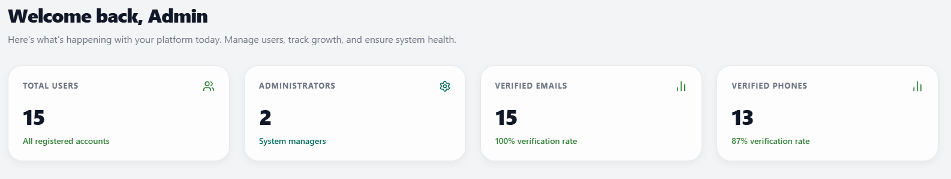 | PASSED
3 | Must show each recent user identity, account type, verification state, and join date and refresh with current data. | 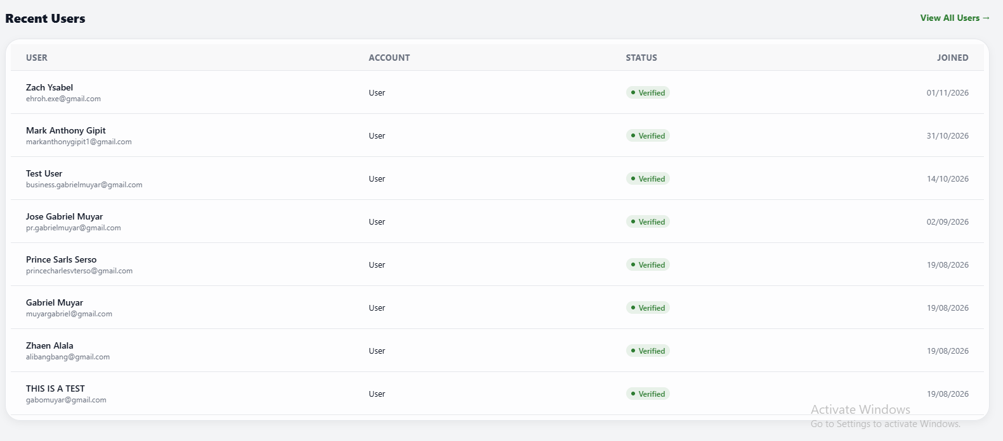 | PASSED
4 | Must open User Management, Notifications, and Profile and allow logout to be canceled or completed. | 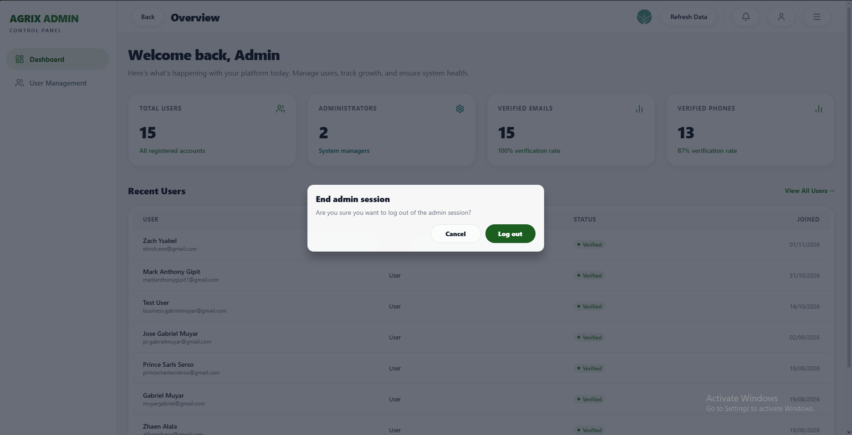 | PASSED

FUNCTIONALITY  TEST DOCUMENT |  | Module Name | USER MANAGEMENT MODULE
Test Cycle No. | 5 | Function Name | USER MANAGEMENT
Test Cycle No. | 5 | User/Access Type | Administrator
Date Tested | 10/27/2026 | Type of System | Web Application
Pre-conditions | A signed-in administrator account and user records for search, edit, role, and deletion checks are available.
Action Description | Search and manage user records, role assignment, editing, pagination, deletion, and session controls.
Verification Steps | Must be able to find, update, reclassify, and remove user records according to the selected action.
Runs | Expected Results | Actual Results | Remarks
1 | Must show user records and find users by name or email, or show the defined no-results state. | 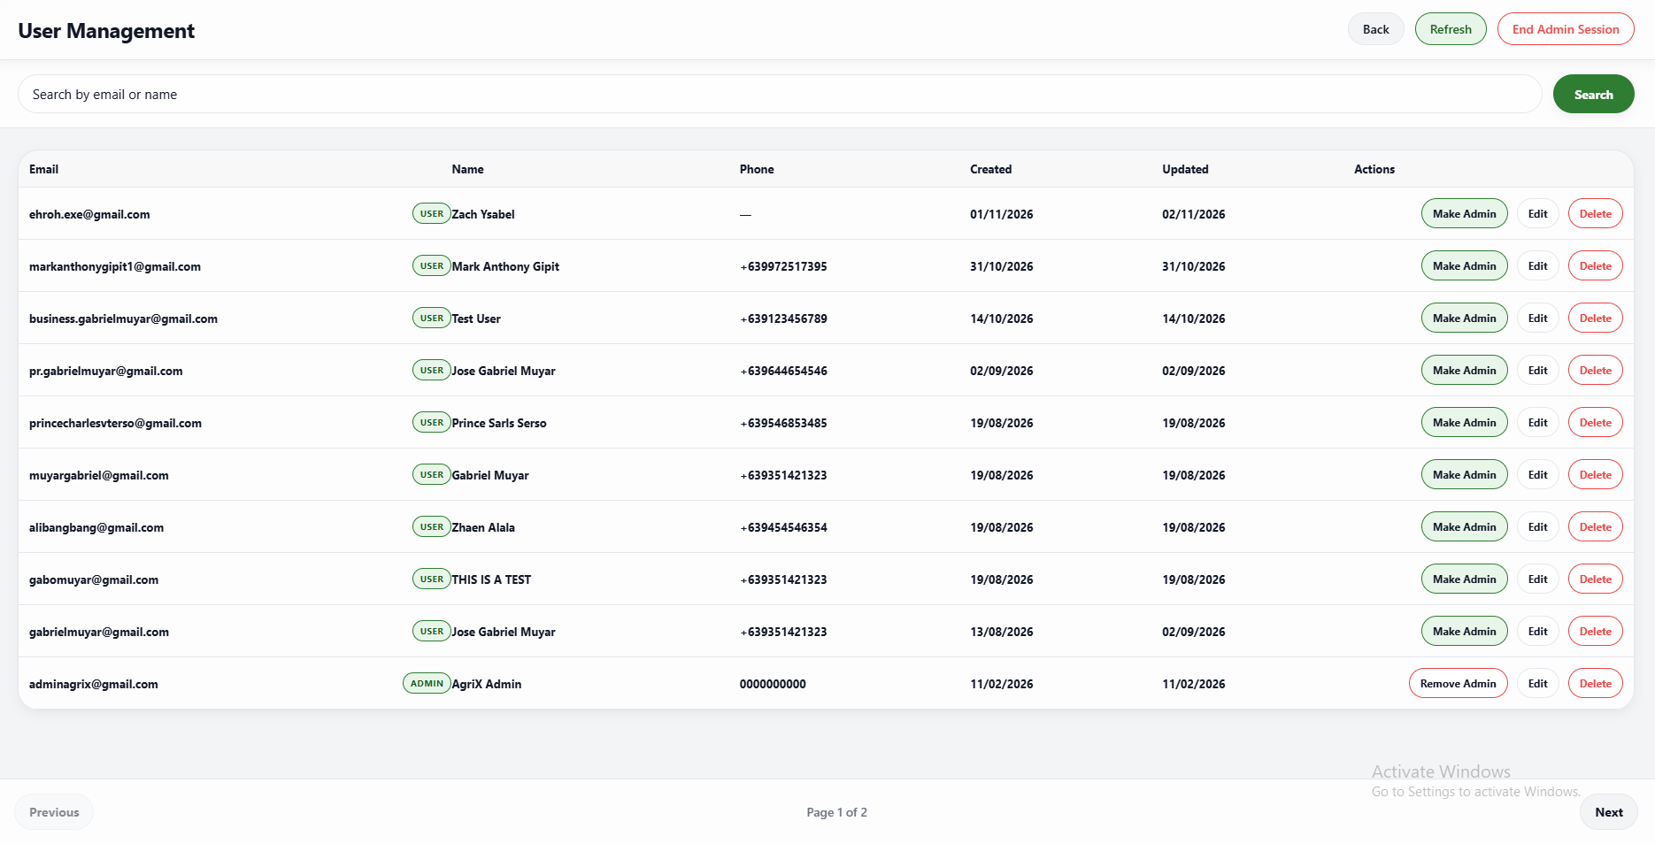 | PASSED
2 | Must reload current records and display the correct page of users when navigating forward or backward. | 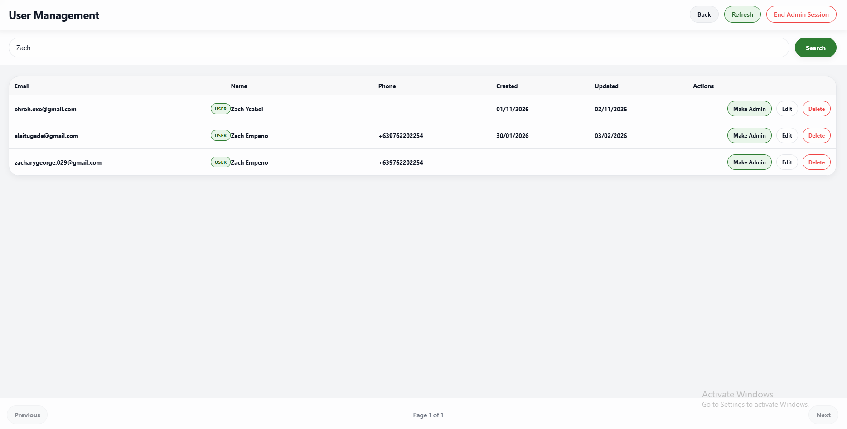 | PASSED
3 | Must apply or cancel administrator-role changes and update the available role action. | 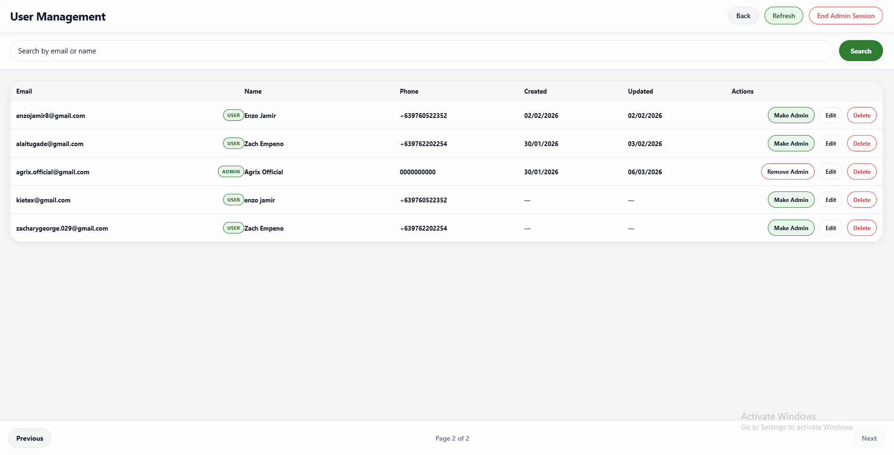 | PASSED
4 | Must open the selected user details, reject invalid profile values, and save valid edits. | 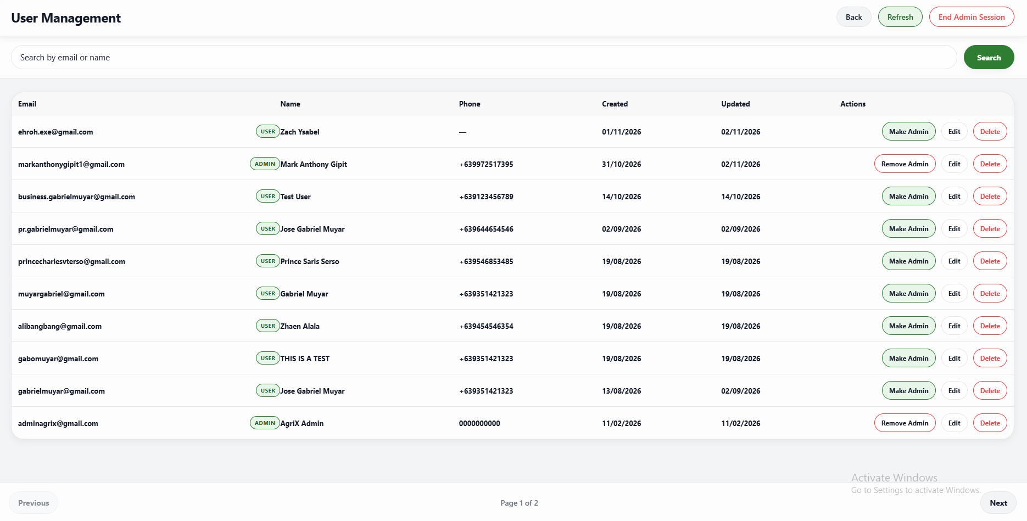 | PASSED
5 | Must close the edit form without changing the original user details when canceled. | 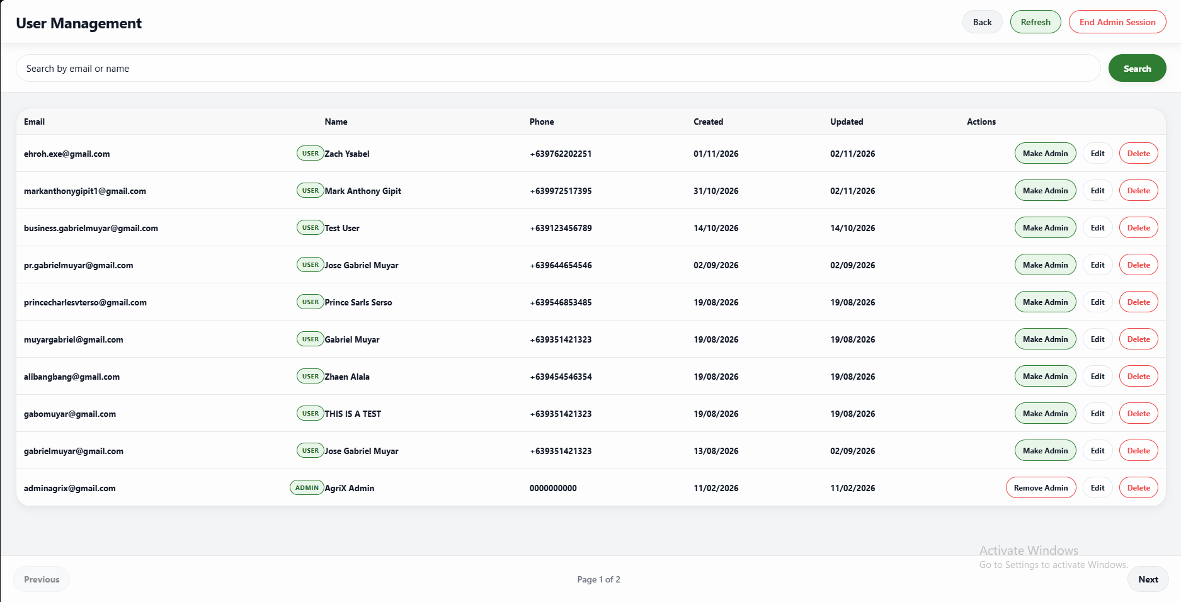 | PASSED
6 | Must retain a user when deletion is canceled, remove the user when confirmed, and allow the admin session to be canceled or ended. | 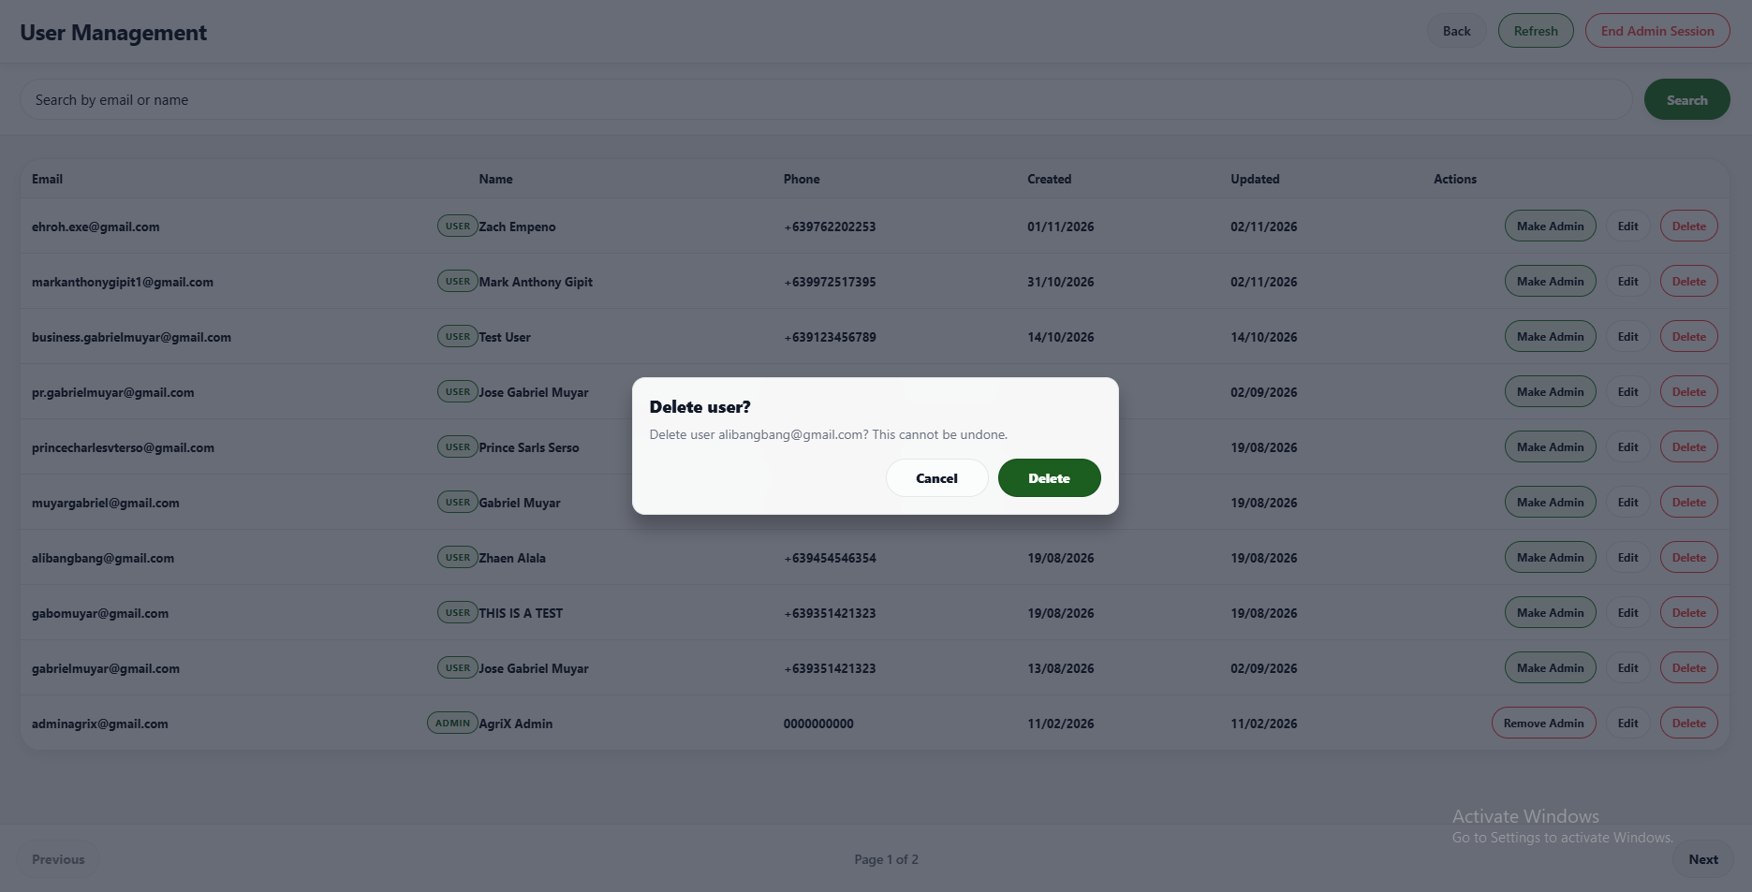 | PASSED

FUNCTIONALITY  TEST DOCUMENT |  | Module Name | NOTIFICATIONS MODULE
Test Cycle No. | 5 | Function Name | NOTIFICATIONS PAGE
Test Cycle No. | 5 | User/Access Type | Administrator
Date Tested | 10/27/2026 | Type of System | Web Application
Pre-conditions | A signed-in administrator account and activity records across categories and read states are available.
Action Description | Search and filter administrator activity, update read status, clear history, and use navigation and session controls.
Verification Steps | Must display and manage administrator activity according to search, filter, read, and clear actions.
Runs | Expected Results | Actual Results | Remarks
1 | Must filter admin activity by search, unread state, user updates, deletions, access changes, or all matching activity. | 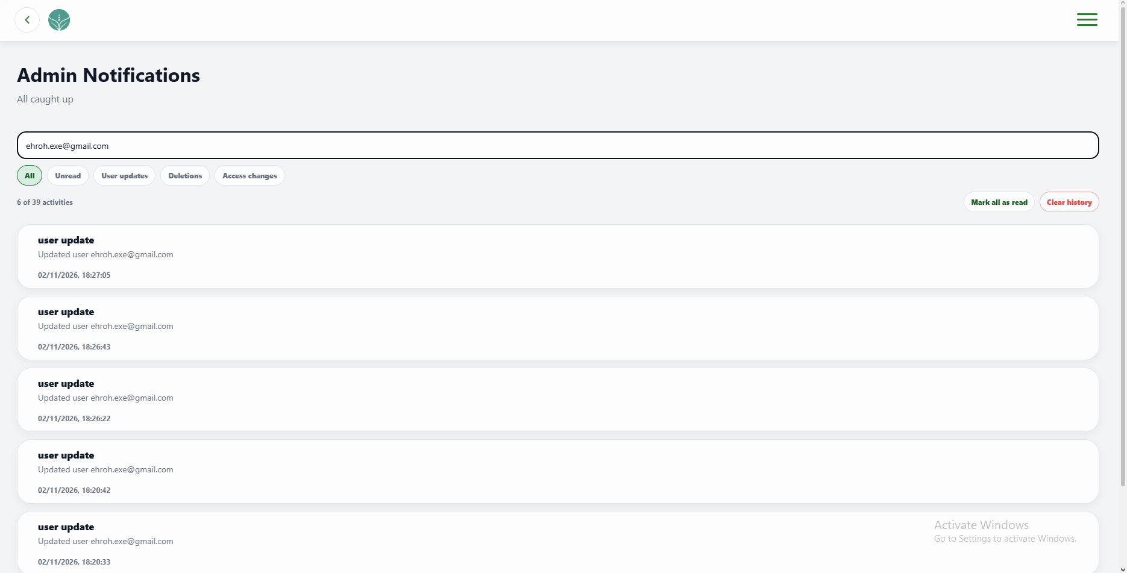 | PASSED
2 | Must show activity summary, result count, and relevant activity details. | 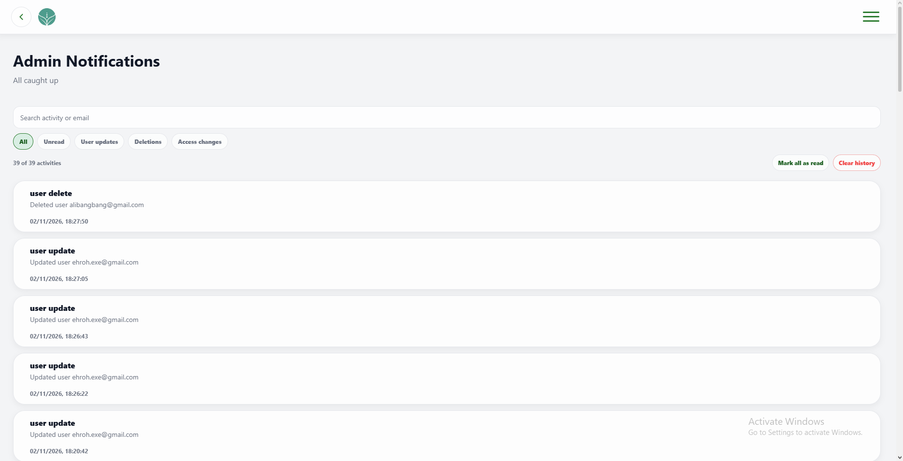 | PASSED
3 | Must mark all admin activity and notifications as read and leave no entries in the Unread filter. | 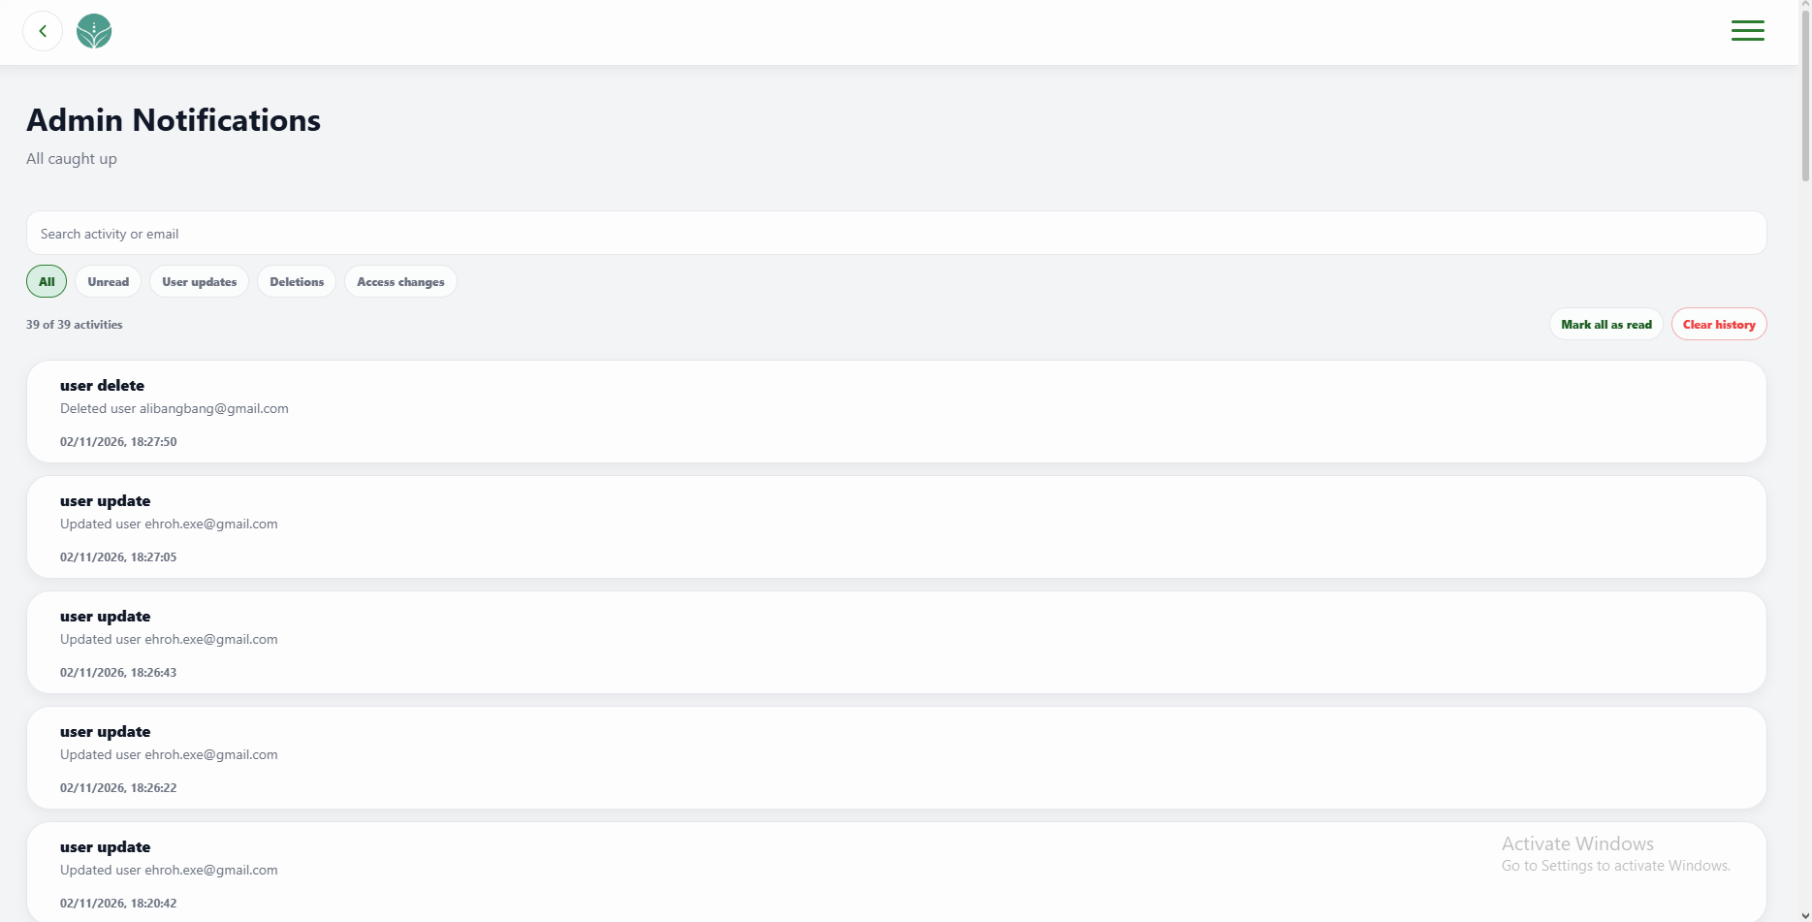 | PASSED
4 | Must preserve history when clearing is canceled and clear administrator activity and notifications when confirmed while retaining regular user notifications. | 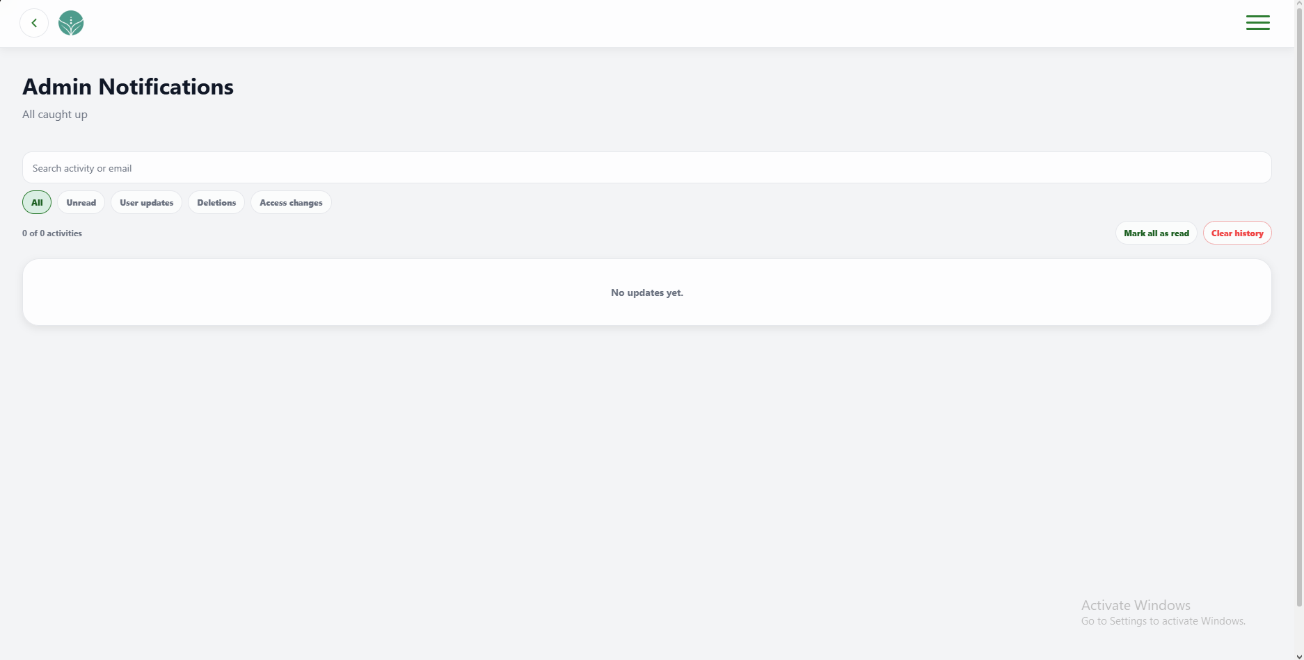 | PASSED
5 | Must open admin dashboard, user management, and profile and allow sign-out to be canceled or completed. | 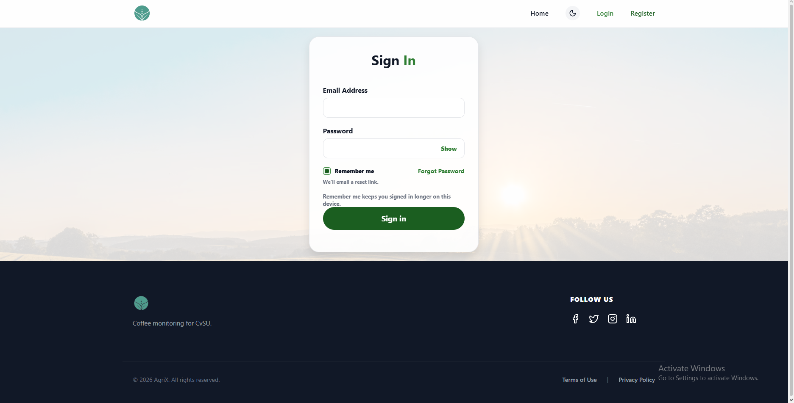 | PASSED

FUNCTIONALITY  TEST DOCUMENT |  | Module Name | PROFILE MODULE
Test Cycle No. | 5 | Function Name | PROFILE PAGE
Test Cycle No. | 5 | User/Access Type | Administrator
Date Tested | 10/27/2026 | Type of System | Web Application
Pre-conditions | A signed-in administrator account and valid and invalid profile values are available.
Action Description | Review and update administrator profile details and validate save, cancel, and dashboard navigation.
Verification Steps | Must display and update administrator profile details and open the Admin Dashboard.
Runs | Expected Results | Actual Results | Remarks
1 | Must display administrator details and calculated age and identify missing values as Not set. | 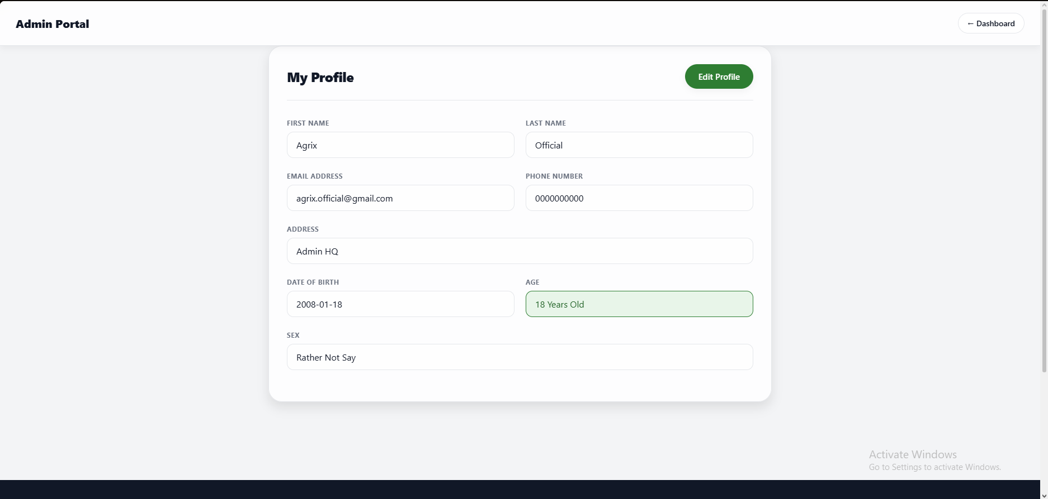 | PASSED
2 | Must allow valid profile updates and reject invalid names, email, phone, birth date, or other unsupported values with clear messages. | 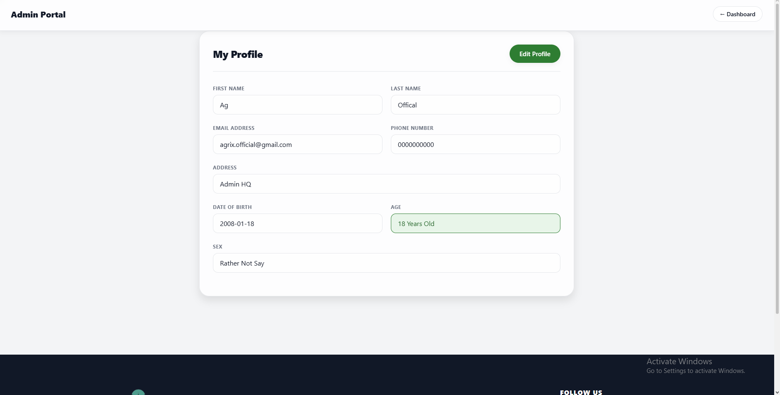 | PASSED
3 | Must save valid changes and discard unsaved changes when canceled. | 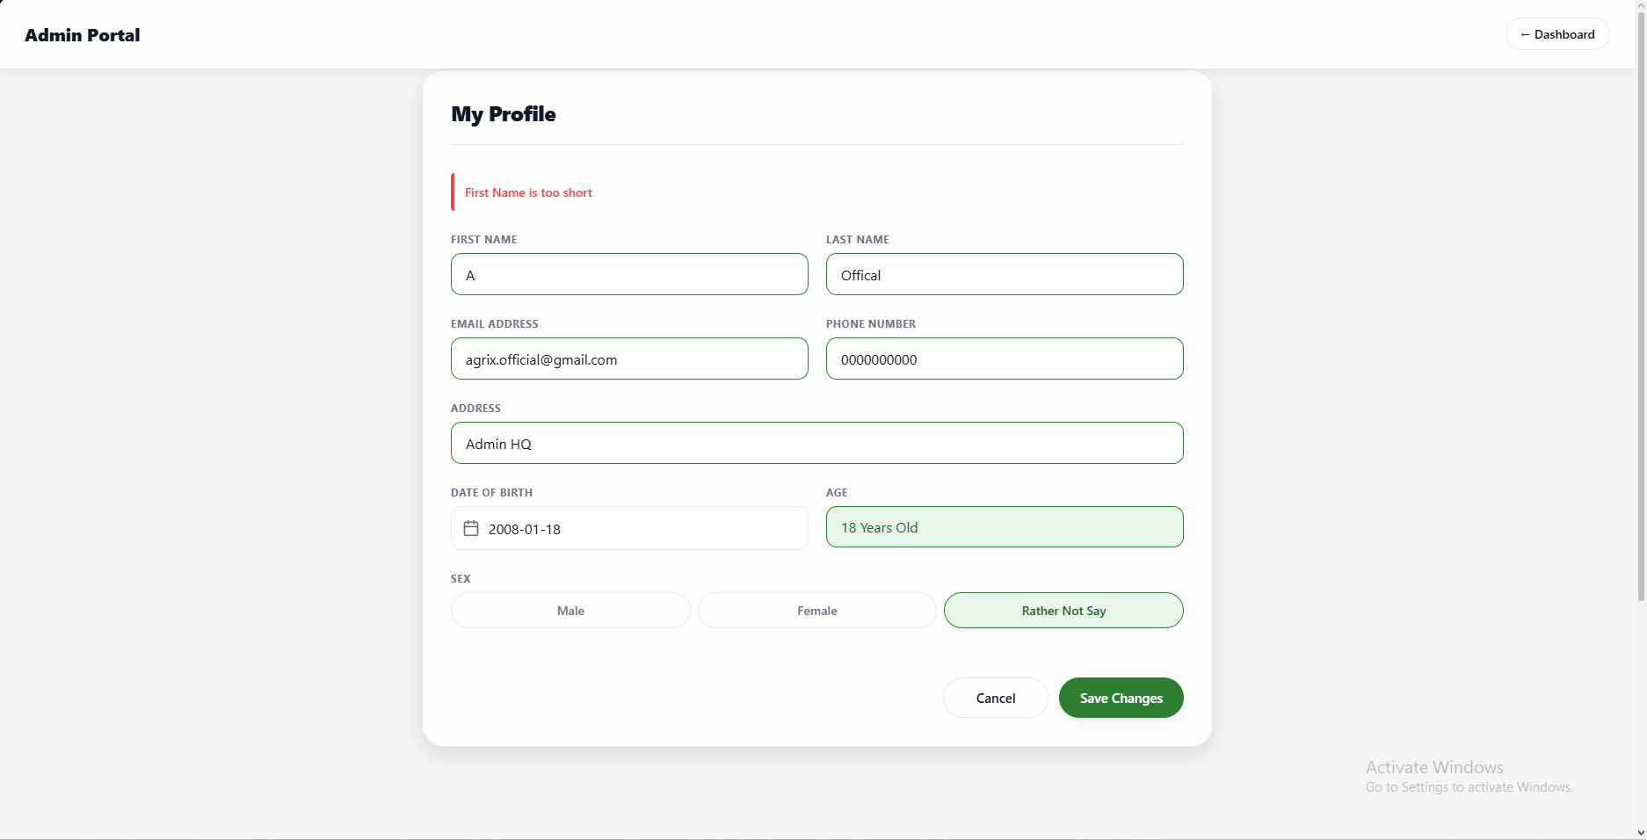 | PASSED
4 | Must open the Admin Dashboard from the profile page. | 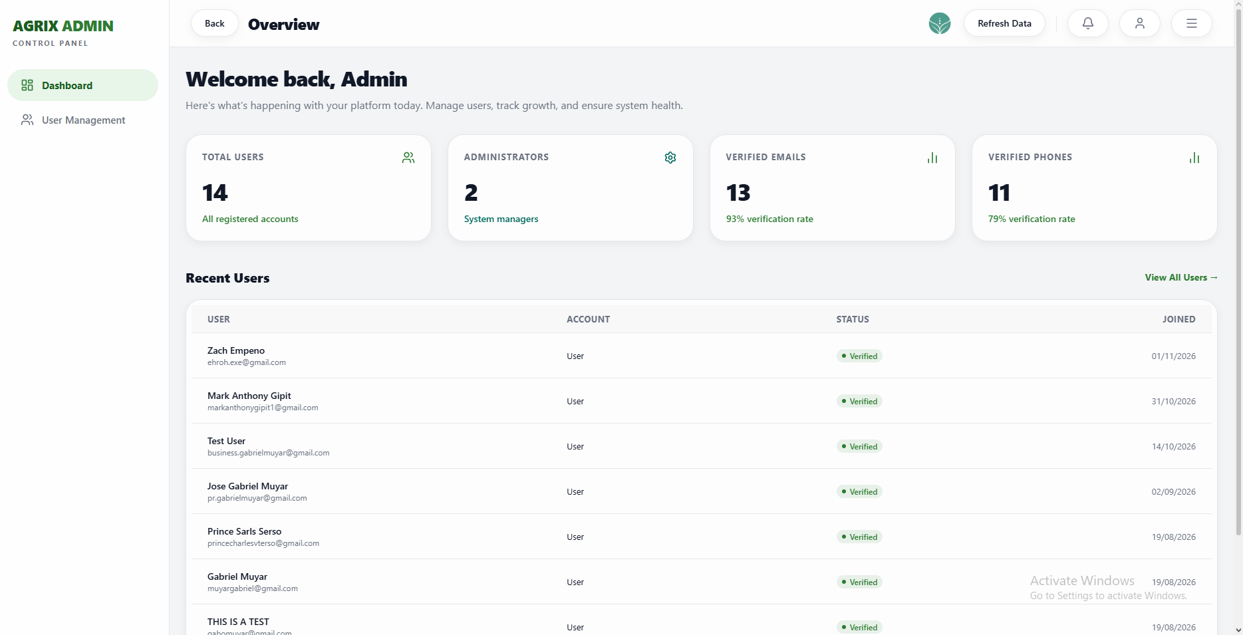 | PASSED

FUNCTIONALITY  TEST DOCUMENT |  | Module Name | LANDING PAGE MODULE
Test Cycle No. | 5 | Function Name | LANDING PAGE
Test Cycle No. | 5 | User/Access Type | User
Date Tested | 10/27/2026 | Type of System | Web Application
Pre-conditions | The AgriX web portal is available in a desktop browser.
Action Description | Review the public landing page, content sections, module cards, account routes, and appearance.
Verification Steps | Must display the AgriX landing page content and route visitors to the correct section or account page.
Runs | Expected Results | Actual Results | Remarks
1 | Must display the AgriX hero, monitoring summary, feature list, and sign-in and monitoring actions. | 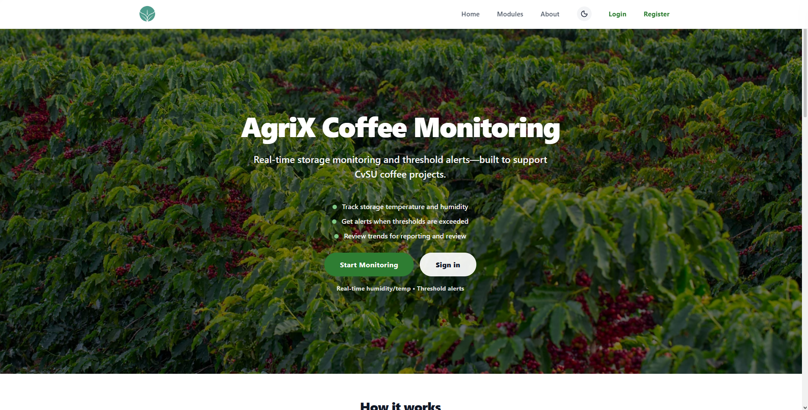 | PASSED
2 | Must navigate to Home, Modules, and About and show the documented module cards and project information. | 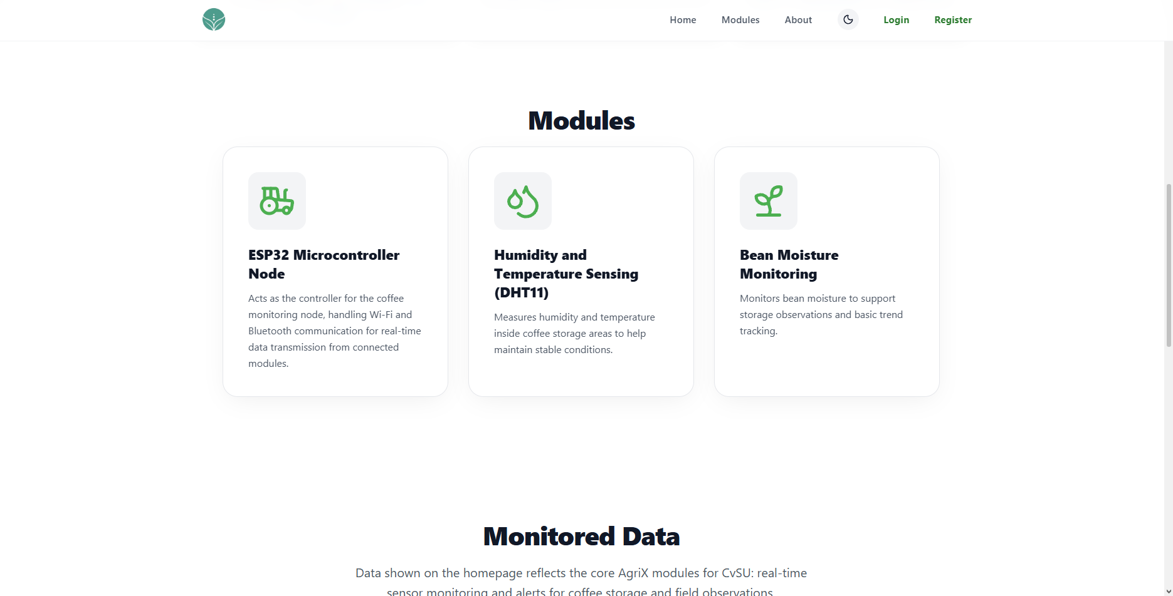 | PASSED
3 | Must open registration or sign-in from the landing page and keep content readable when the theme changes. | 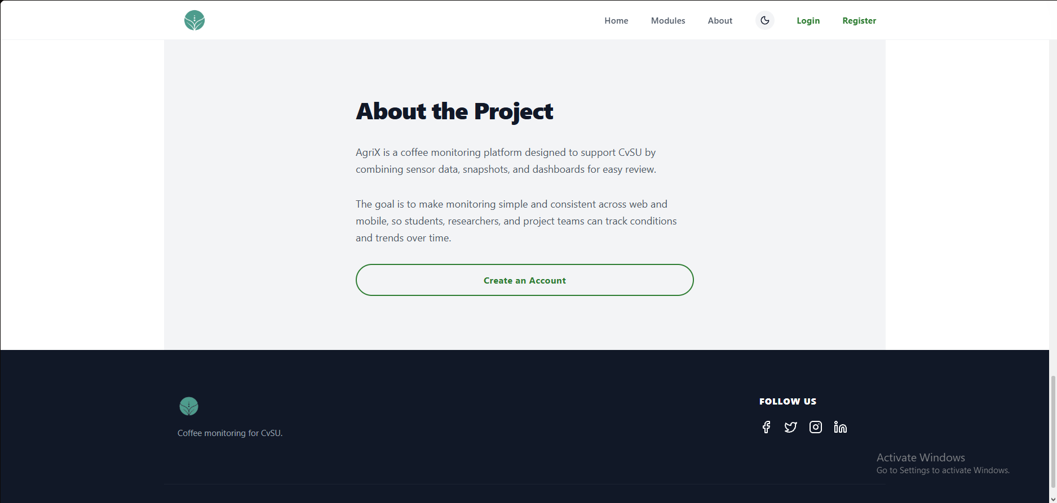 | PASSED
4 | Must display AgriX branding and social links and return to the Home section from the logo. | 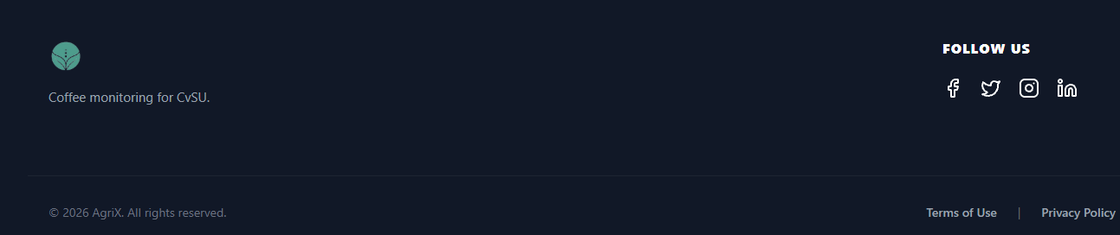 | PASSED

FUNCTIONALITY  TEST DOCUMENT |  | Module Name | LANDING PAGE MODULE
Test Cycle No. | 5 | Function Name | LANDING PAGE
Test Cycle No. | 5 | User/Access Type | User
Date Tested | 10/27/2026 | Type of System | Web Application
Pre-conditions | The AgriX web portal is available in a desktop browser. The visitor is signed out.
Action Description | Review the landing page content, sections, module cards, navigation, theme, footer, and account actions.
Verification Steps | Must display AgriX landing content and open the correct site sections and account destinations.
Runs | Expected Results | Actual Results | Remarks
1 | Must display the AgriX hero, monitoring description, feature summary, and primary account actions. |  | PASSED
2 | Must navigate to the Home, Modules, and About sections and show the documented module cards and project description. |  | PASSED
3 | Must open registration and sign-in and open monitoring or prompt for sign-in as required. |  | PASSED
4 | Must preserve readable content across themes and display AgriX branding and social links in the footer. | 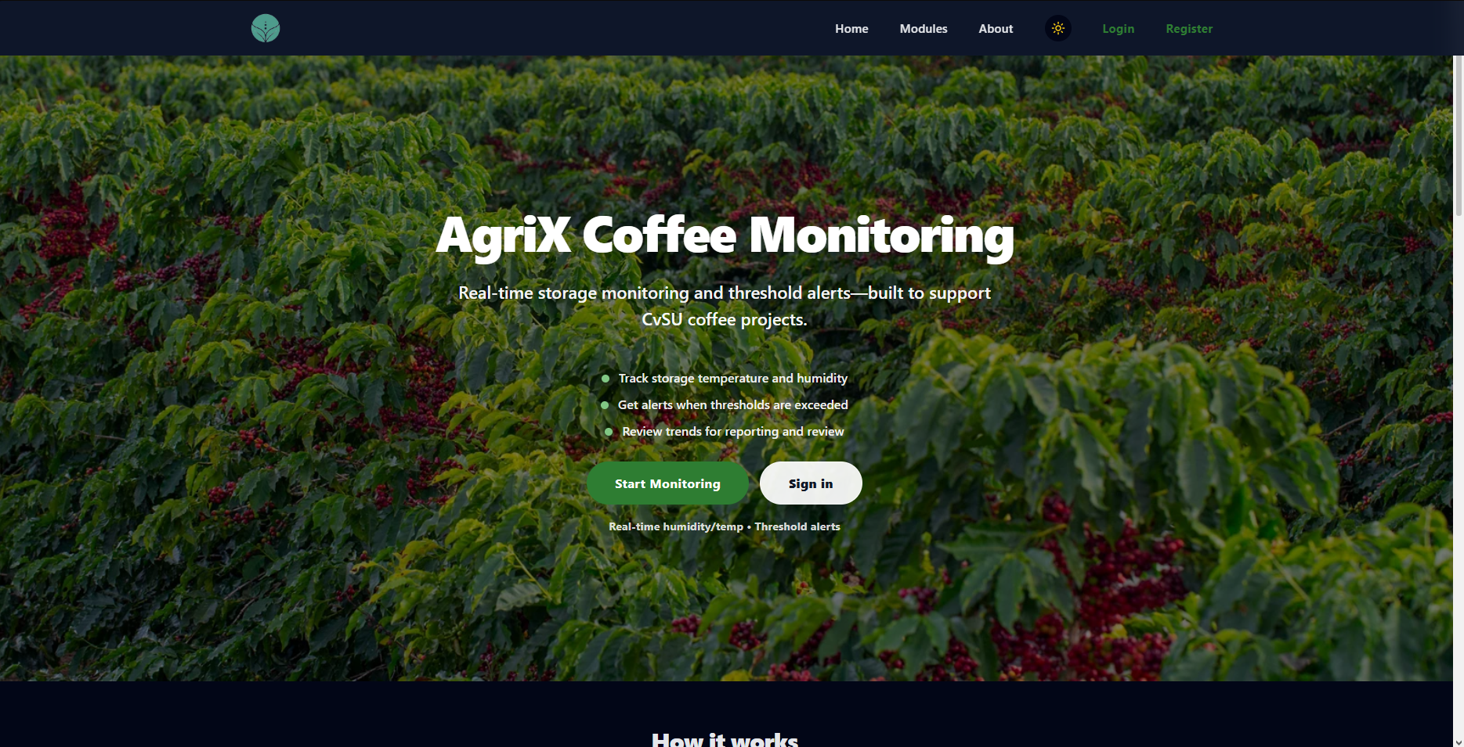 | PASSED
Prepared By | Administered/Performed By
____________________________  Signature over Printed Name | ____________________________  Signature over Printed Name

