An evaluation of discarded bycatch data collected by at-sea observers (draft #1). - Doc2

Seion Richardson

October 26, 2020

Table of Contents

1.1 Time-periods - Most common species by biomass 3

1.2 Fishing depths - Most common species by biomass 9

1.3 Time-periods - Most common species by cpue 15

1.4 Fishing depths - Most common species by cpue 22

1.5 Species length comparison - Time-period 29

1.6 Species length comparison - Fishing depth 30

1.7 Species weight comparison - Time-period 31

1.8 Species weight comparison - Fishing depths 32

1.9 Species cpue comparison - Time-periods 33

1.10 Species cpue comparison - Fishing depths 34

2 A tibble: 2 x 2 35

3 A tibble: 3 x 3 35

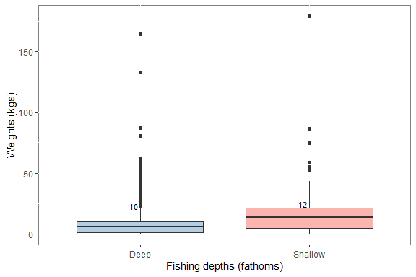

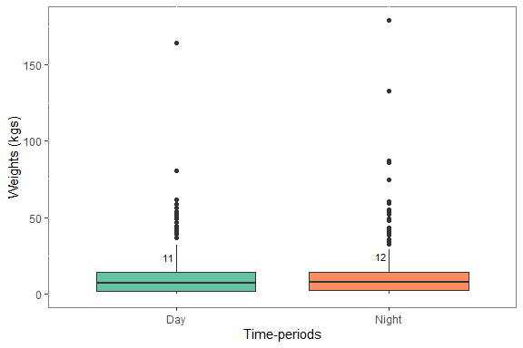

## Time-periods - Most common species by biomass

| drag_period | Sum_wt | Median_wt | Mean_wt | SD | Min. | Max. | Trips | Perc_wt |
| --- | --- | --- | --- | --- | --- | --- | --- | --- |
| Day | 620.95 | 18.44 | 27 | 33 | 3.51 | 163.97 | 23 | 50 |
| Night | 614.14 | 14.29 | 26 | 26 | 0.66 | 86.19 | 24 | 50 |

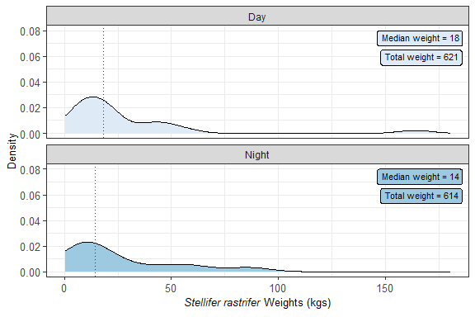

| drag_period | Sum_wt | Median_wt | Mean_wt | SD | Min. | Max. | Trips | Perc_wt |
| --- | --- | --- | --- | --- | --- | --- | --- | --- |
| Day | 535.28 | 14.29 | 23 | 20 | 3.90 | 80.47 | 23 | 48 |
| Night | 569.90 | 14.29 | 26 | 29 | 0.73 | 132.77 | 22 | 52 |

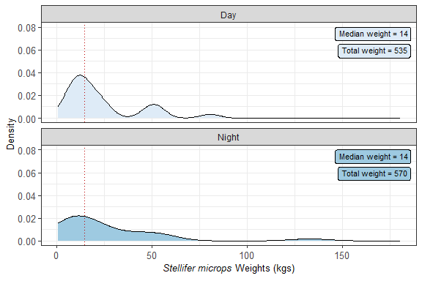

| drag_period | Sum_wt | Median_wt | Mean_wt | SD | Min. | Max. | Trips | Perc_wt |
| --- | --- | --- | --- | --- | --- | --- | --- | --- |
| Day | 452.06 | 14.480 | 19 | 13 | 3.45 | 58.80 | 24 | 53 |
| Night | 396.00 | 12.795 | 16 | 15 | 0.79 | 74.43 | 24 | 47 |

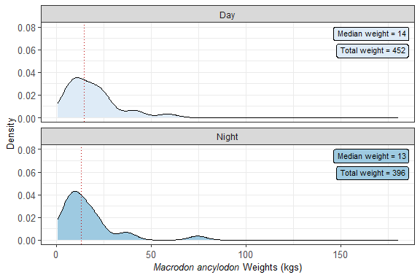

| drag_period | Sum_wt | Median_wt | Mean_wt | SD | Min. | Max. | Trips | Perc_wt |
| --- | --- | --- | --- | --- | --- | --- | --- | --- |
| Day | 277.86 | 9.74 | 12 | 9 | 0.27 | 40.23 | 23 | 52 |
| Night | 254.11 | 9.74 | 12 | 8 | 0.27 | 33.32 | 21 | 48 |

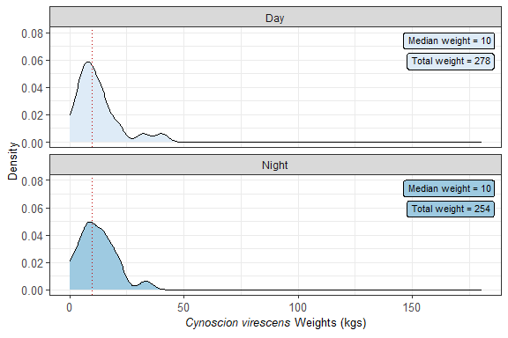

| drag_period | Sum_wt | Median_wt | Mean_wt | SD | Min. | Max. | Trips | Perc_wt |
| --- | --- | --- | --- | --- | --- | --- | --- | --- |
| Day | 294.50 | 12.48 | 15 | 11 | 1.11 | 51.84 | 20 | 57 |
| Night | 222.19 | 9.74 | 10 | 6 | 1.37 | 22.39 | 22 | 43 |

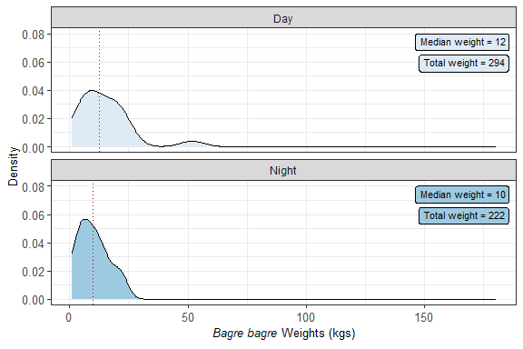

| drag_period | Sum_wt | Median_wt | Mean_wt | SD | Min. | Max. | Trips | Perc_wt |
| --- | --- | --- | --- | --- | --- | --- | --- | --- |
| Day | 159.26 | 4.27 | 8 | 8 | 0.04 | 27.86 | 21 | 31 |
| Night | 357.05 | 7.09 | 16 | 37 | 0.01 | 178.96 | 22 | 69 |

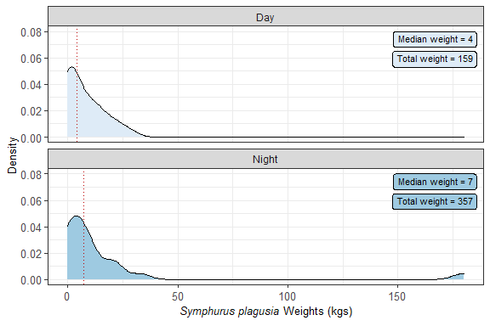

## Fishing depths - Most common species by biomass

| depth_sd | Sum_wt | Median_wt | Mean_wt | SD | Min. | Max. | Trips | Perc_wt |
| --- | --- | --- | --- | --- | --- | --- | --- | --- |
| Deep | 689.06 | 14.55 | 30 | 36 | 0.66 | 163.97 | 23 | 56 |
| Shallow | 546.03 | 14.29 | 23 | 22 | 0.71 | 86.19 | 24 | 44 |

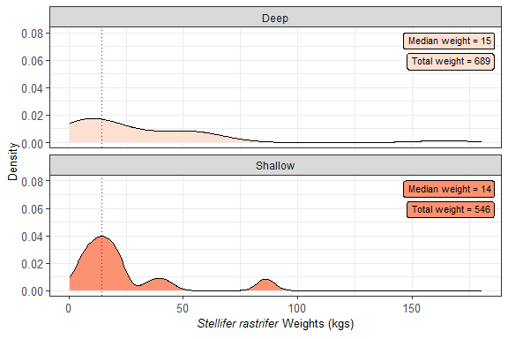

| depth_sd | Sum_wt | Median_wt | Mean_wt | SD | Min. | Max. | Trips | Perc_wt |
| --- | --- | --- | --- | --- | --- | --- | --- | --- |
| Deep | 703.70 | 19.19 | 32 | 31 | 3.57 | 132.77 | 22 | 64 |
| Shallow | 401.48 | 14.29 | 17 | 14 | 0.73 | 54.85 | 23 | 36 |

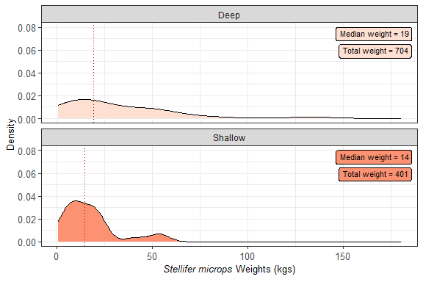

| depth_sd | Sum_wt | Median_wt | Mean_wt | SD | Min. | Max. | Trips | Perc_wt |
| --- | --- | --- | --- | --- | --- | --- | --- | --- |
| Deep | 416.14 | 12.975 | 17 | 12 | 0.79 | 41.92 | 24 | 49 |
| Shallow | 431.92 | 14.290 | 18 | 16 | 2.89 | 74.43 | 24 | 51 |

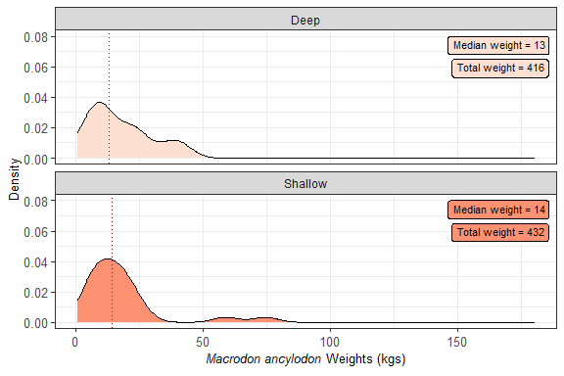

| depth_sd | Sum_wt | Median_wt | Mean_wt | SD | Min. | Max. | Trips | Perc_wt |
| --- | --- | --- | --- | --- | --- | --- | --- | --- |
| Deep | 266.63 | 9.74 | 13 | 11 | 0.27 | 40.23 | 21 | 50 |
| Shallow | 265.34 | 12.52 | 12 | 7 | 0.27 | 21.08 | 23 | 50 |

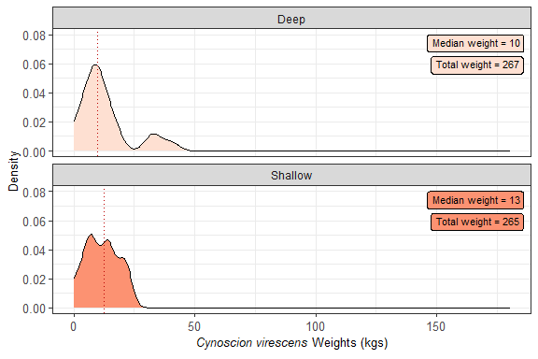

| depth_sd | Sum_wt | Median_wt | Mean_wt | SD | Min. | Max. | Trips | Perc_wt |
| --- | --- | --- | --- | --- | --- | --- | --- | --- |
| Deep | 261.25 | 9.74 | 12 | 11 | 1.84 | 51.84 | 21 | 51 |
| Shallow | 255.44 | 14.29 | 12 | 7 | 1.11 | 21.46 | 21 | 49 |

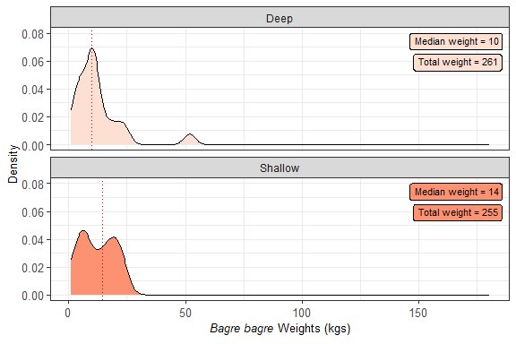

| depth_sd | Sum_wt | Median_wt | Mean_wt | SD | Min. | Max. | Trips | Perc_wt |
| --- | --- | --- | --- | --- | --- | --- | --- | --- |
| Deep | 105.74 | 2.14 | 5 | 8 | 0.06 | 33.09 | 20 | 20 |
| Shallow | 410.57 | 7.09 | 18 | 36 | 0.01 | 178.96 | 23 | 80 |

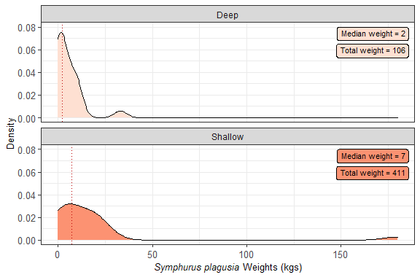

## Time-periods - Most common species by cpue

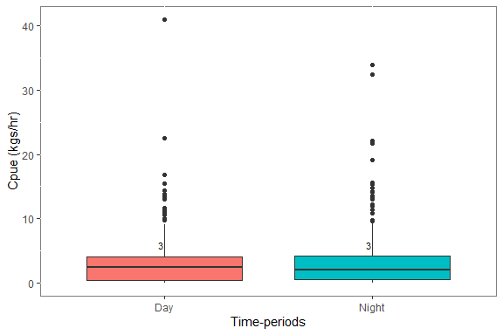# A tibble: 2 x 5 drag_period mn_cpue s_e Count Difference 1 Day 3 0.15 526 0 2 Night 3 0.18 496 0

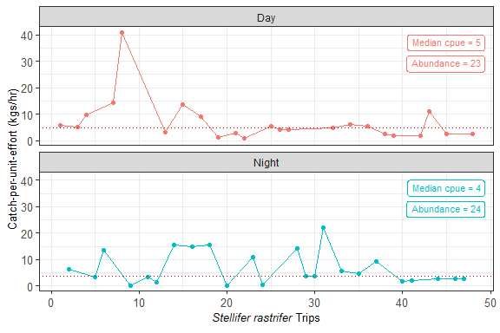

| drag_period | Median_wt | Mean_wt | SD | Min. | Max. | Trips |
| --- | --- | --- | --- | --- | --- | --- |
| Day | 4.87 | 7 | 8 | 0.88 | 40.99 | 23 |
| Night | 3.81 | 7 | 6 | 0.16 | 22.10 | 24 |

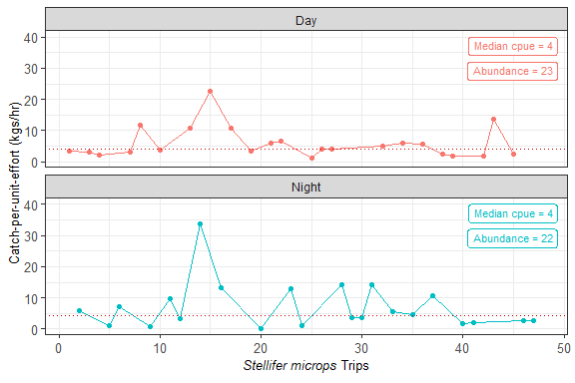

| drag_period | Median_wt | Mean_wt | SD | Min. | Max. | Trips |
| --- | --- | --- | --- | --- | --- | --- |
| Day | 4.08 | 6 | 5 | 1.11 | 22.48 | 23 |
| Night | 4.18 | 7 | 8 | 0.21 | 33.87 | 22 |

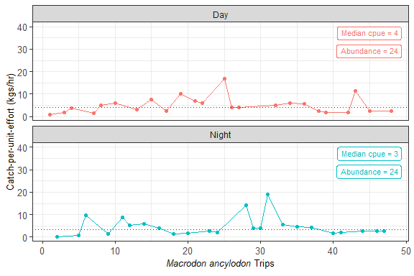

| drag_period | Median_wt | Mean_wt | SD | Min. | Max. | Trips |
| --- | --- | --- | --- | --- | --- | --- |
| Day | 4.08 | 5 | 4 | 0.86 | 16.80 | 24 |
| Night | 3.32 | 5 | 4 | 0.20 | 19.08 | 24 |

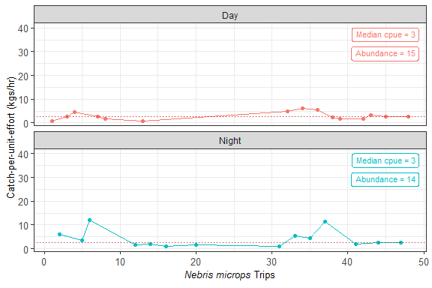

| drag_period | Median_wt | Mean_wt | SD | Min. | Max. | Trips |
| --- | --- | --- | --- | --- | --- | --- |
| Day | 2.6 | 3 | 2 | 0.75 | 6.02 | 15 |
| Night | 2.6 | 4 | 4 | 0.86 | 11.99 | 14 |

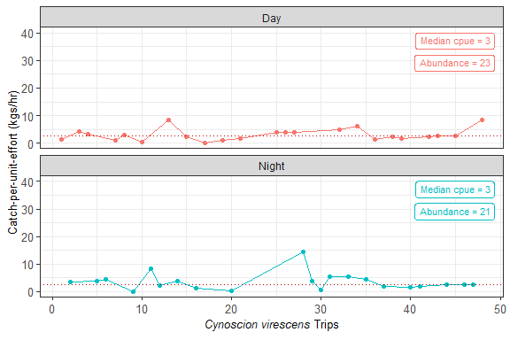

| drag_period | Median_wt | Mean_wt | SD | Min. | Max. | Trips |
| --- | --- | --- | --- | --- | --- | --- |
| Day | 2.6 | 3 | 2 | 0.06 | 8.56 | 23 |
| Night | 2.6 | 4 | 3 | 0.07 | 14.29 | 21 |

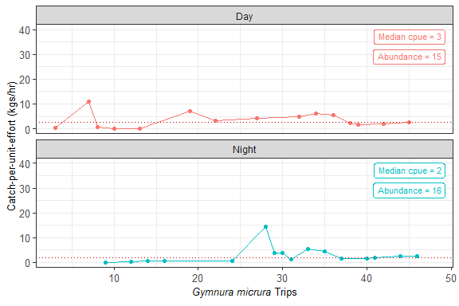

| drag_period | Median_wt | Mean_wt | SD | Min. | Max. | Trips |
| --- | --- | --- | --- | --- | --- | --- |
| Day | 2.60 | 3 | 3 | 0.01 | 11.02 | 15 |
| Night | 1.84 | 3 | 3 | 0.08 | 14.29 | 16 |

## Fishing depths - Most common species by cpue

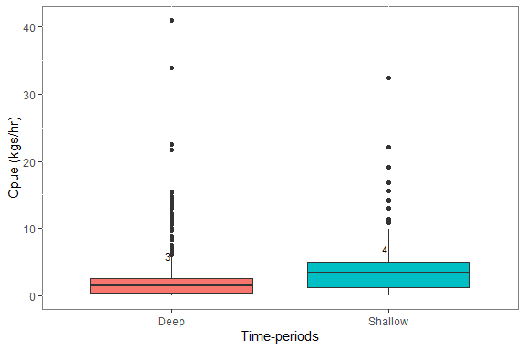

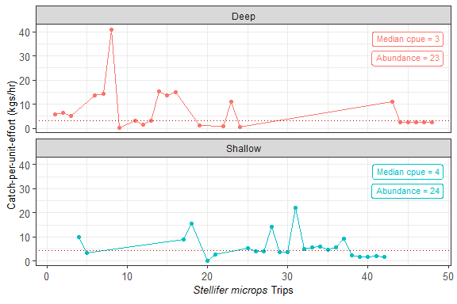

| depth_sd | Median_wt | Mean_wt | SD | Min. | Max. | Trips |
| --- | --- | --- | --- | --- | --- | --- |
| Deep | 3.270 | 8 | 9 | 0.16 | 40.99 | 23 |
| Shallow | 4.315 | 6 | 5 | 0.20 | 22.10 | 24 |

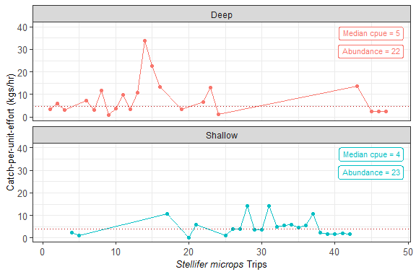

| depth_sd | Median_wt | Mean_wt | SD | Min. | Max. | Trips |
| --- | --- | --- | --- | --- | --- | --- |
| Deep | 4.81 | 8 | 8 | 0.89 | 33.87 | 22 |
| Shallow | 4.08 | 5 | 4 | 0.21 | 14.29 | 23 |

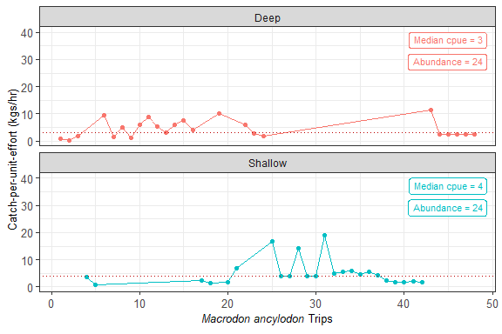

| depth_sd | Median_wt | Mean_wt | SD | Min. | Max. | Trips |
| --- | --- | --- | --- | --- | --- | --- |
| Deep | 2.930 | 4 | 3 | 0.20 | 11.27 | 24 |
| Shallow | 3.945 | 5 | 5 | 0.72 | 19.08 | 24 |

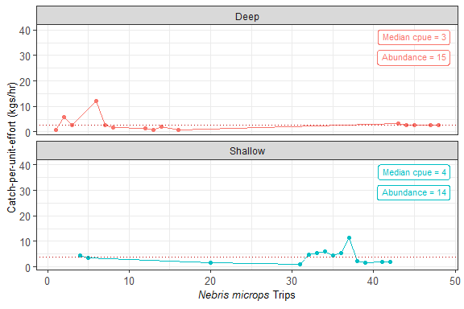

| depth_sd | Median_wt | Mean_wt | SD | Min. | Max. | Trips |
| --- | --- | --- | --- | --- | --- | --- |
| Deep | 2.60 | 3 | 3 | 0.75 | 11.99 | 15 |
| Shallow | 3.92 | 4 | 3 | 1.01 | 11.37 | 14 |

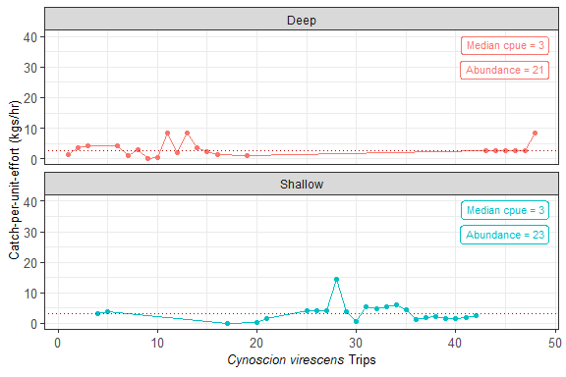

| depth_sd | Median_wt | Mean_wt | SD | Min. | Max. | Trips |
| --- | --- | --- | --- | --- | --- | --- |
| Deep | 2.60 | 3 | 2 | 0.07 | 8.56 | 21 |
| Shallow | 3.13 | 3 | 3 | 0.06 | 14.29 | 23 |

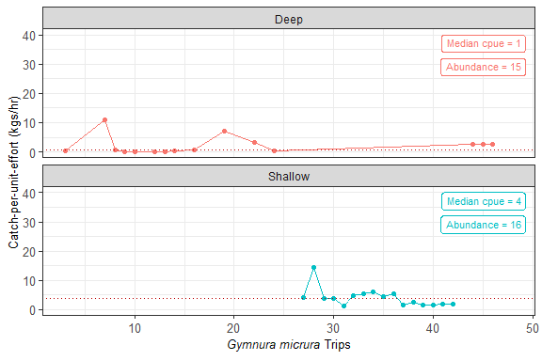

| depth_sd | Median_wt | Mean_wt | SD | Min. | Max. | Trips |
| --- | --- | --- | --- | --- | --- | --- |
| Deep | 0.62 | 2 | 3 | 0.01 | 11.02 | 15 |
| Shallow | 3.81 | 4 | 3 | 1.23 | 14.29 | 16 |

## Species length comparison - Time-period

|  | **Day** | | | **Night** | | | **Comparison** | |
| --- | --- | --- | --- | --- | --- | --- | --- | --- |
| **Species** | **Mean)** | **SE** | **n** | **Mean** | **SE** | **n** | **Difference.** | **P value** |
| Stellifer rastrifer | 9 | 0.14 | 541 | 10 | 0.15 | 448 | -11.11 | 0.01963 |
| Stellifer microps | 11 | 0.22 | 331 | 12 | 0.18 | 387 | -9.09 | 0.00000 |
| Macrodon ancylodon | 16 | 0.24 | 299 | 18 | 0.43 | 181 | -12.50 | 0.00059 |
| Nebris microps | 12 | 0.35 | 113 | 14 | 0.36 | 149 | -16.67 | 0.00011 |
| Bagre bagre | 13 | 0.71 | 120 | 10 | 0.37 | 119 | 23.08 | 0.00227 |
| Cynoscion virescens | 17 | 0.45 | 94 | 18 | 0.36 | 121 | -5.88 | 0.09223 |

## Species length comparison - Fishing depth

|  | **Deep** | | | **Shallow** | | | **Comparison** | |
| --- | --- | --- | --- | --- | --- | --- | --- | --- |
| **Species** | **Mean)** | **SE** | **n** | **Mean** | **SE** | **n** | **Difference.** | **P value** |
| Stellifer rastrifer | 9 | 0.18 | 448 | 10 | 0.11 | 541 | -11.11 | 0.09702 |
| Stellifer microps | 11 | 0.21 | 418 | 13 | 0.17 | 300 | -18.18 | 0.00000 |
| Macrodon ancylodon | 17 | 0.36 | 178 | 17 | 0.29 | 302 | 0.00 | 0.08235 |
| Nebris microps | 13 | 0.30 | 172 | 13 | 0.50 | 90 | 0.00 | 0.19958 |
| Bagre bagre | 13 | 0.59 | 149 | 9 | 0.32 | 90 | 30.77 | 0.00000 |
| Cynoscion virescens | 18 | 0.33 | 155 | 18 | 0.55 | 60 | 0.00 | 0.36658 |

## Species weight comparison - Time-period

|  | **Day** | | | **Night** | | | **Comparison** | |
| --- | --- | --- | --- | --- | --- | --- | --- | --- |
| **Species** | **Mean)** | **SE** | **n** | **Mean** | **SE** | **n** | **Difference.** | **P value** |
| Stellifer rastrifer | 27 | 6.96 | 23 | 26 | 5.26 | 24 | 3.70 | 0.87248 |
| Stellifer microps | 23 | 4.11 | 23 | 26 | 6.24 | 22 | -13.04 | 0.72673 |
| Macrodon ancylodon | 19 | 2.70 | 24 | 16 | 3.15 | 24 | 15.79 | 0.57592 |
| Cynoscion virescens | 12 | 1.97 | 23 | 12 | 1.74 | 21 | 0.00 | 0.99407 |
| Bagre bagre | 15 | 2.48 | 20 | 10 | 1.36 | 22 | 33.33 | 0.11253 |
| Symphurus plagusia | 8 | 1.82 | 21 | 16 | 7.97 | 22 | -100.00 | 0.30136 |

## Species weight comparison - Fishing depths

|  | **Deep** | | | **Shallow** | | | **Comparison** | |
| --- | --- | --- | --- | --- | --- | --- | --- | --- |
| **Species** | **Mean)** | **SE** | **n** | **Mean** | **SE** | **n** | **Difference.** | **P value** |
| Stellifer rastrifer | 30 | 7.44 | 23 | 23 | 4.50 | 24 | 23.33 | 0.41247 |
| Stellifer microps | 32 | 6.53 | 22 | 17 | 2.99 | 23 | 46.88 | 0.05227 |
| Macrodon ancylodon | 17 | 2.47 | 24 | 18 | 3.34 | 24 | -5.88 | 0.87512 |
| Cynoscion virescens | 13 | 2.29 | 21 | 12 | 1.41 | 23 | 7.69 | 0.66911 |
| Bagre bagre | 12 | 2.37 | 21 | 12 | 1.58 | 21 | 0.00 | 0.92325 |
| Symphurus plagusia | 5 | 1.70 | 20 | 18 | 7.54 | 23 | -260.00 | 0.11708 |

## Species cpue comparison - Time-periods

|  | **Day** | | | **Night** | | | **Comparison** | |
| --- | --- | --- | --- | --- | --- | --- | --- | --- |
| **Species** | **Mean)** | **SE** | **n** | **Mean** | **SE** | **n** | **Difference.** | **P value** |
| Stellifer rastrifer | 7 | 1.74 | 23 | 7 | 1.26 | 24 | 0.00 | 0.78220 |
| Stellifer microps | 6 | 1.05 | 23 | 7 | 1.62 | 22 | -16.67 | 0.32472 |
| Macrodon ancylodon | 5 | 0.75 | 24 | 5 | 0.90 | 24 | 0.00 | 0.78263 |
| Nebris microps | 3 | 0.42 | 15 | 4 | 0.96 | 14 | -33.33 | 0.33220 |
| Cynoscion virescens | 3 | 0.47 | 23 | 4 | 0.69 | 21 | -33.33 | 0.70938 |
| Gymnura micrura | 3 | 0.79 | 15 | 3 | 0.87 | 16 | 0.00 | 0.37714 |

## Species cpue comparison - Fishing depths

|  | **Deep** | | | **Shallow** | | | **Comparison** | |
| --- | --- | --- | --- | --- | --- | --- | --- | --- |
| **Species** | **Mean)** | **SE** | **n** | **Mean** | **SE** | **n** | **Difference.** | **P value** |
| Stellifer rastrifer | 8 | 1.87 | 23 | 6 | 1.05 | 24 | 25.0 | 0.37198 |
| Stellifer microps | 8 | 1.69 | 22 | 5 | 0.83 | 23 | 37.5 | 0.13117 |
| Macrodon ancylodon | 4 | 0.64 | 24 | 5 | 0.98 | 24 | -25.0 | 0.15723 |
| Cynoscion virescens | 3 | 0.54 | 21 | 3 | 0.61 | 23 | 0.0 | 0.41951 |

### COdes to manually check the number of observations used in T-tests

List of species reference vectors

what, Vectors (Data | Group (s) | Variables) Time-period length, names (lengths | time-period | length) Fishing depth length, namesl (lengths | depth_sd | length) Time-period and fishing depth biomass, namesw (obs_wt_db | drag_period , depth_sd | total_wt_kg) Time-period cpue, namescr (obs_wt_db | drag_period | cpue) Fishing depth cpue, namescr <- namescr[c(-4,-6)] (obs_wt_db | depth_sd | cpue)

Deep Shallow 5 6

Deep Shallow 5 6

Deep Shallow 5 6 < table of extent 0 >

| **Trips** | **Departure** | **Arrival** | **Days** | **Total weight (kgs)** | **Mean weight (kgs)** | **n** |
| --- | --- | --- | --- | --- | --- | --- |
| 1 | 14/02/2019 | 24/02/2019 | 11 | 720 | 6 | 123 |
| 2 | 22/03/2019 | 27/03/2019 | 6 | 1303 | 11 | 120 |
| 3 | 25/04/2019 | 02/05/2019 | 8 | 1452 | 12 | 117 |
| 4 | 19/06/2019 | 25/06/2019 | 7 | 940 | 8 | 111 |
| 5 | 01/08/2019 | 10/08/2019 | 10 | 1731 | 13 | 136 |
| 6 | 14/09/2019 | 19/09/2019 | 6 | 3207 | 19 | 168 |
| 7 | 05/10/2019 | 09/10/2019 | 5 | 1003 | 7 | 134 |
| 8 | 15/02/2020 | 23/02/2020 | 9 | 1171 | 10 | 113 |

# A tibble: 2 x 2

depth_sd n 1 Deep 463 2 Shallow 559

# A tibble: 3 x 3

groups wt per 1 Discarded bycatch 11.1 63.0 2 Retained bycatch 0.88 4.97 3 Target catch 5.67 32.1