Evaluating Discards using Observer Data - Guyana`s Shrimp Fishery

Seion Richardson

October 25, 2020

Table of Contents

# FIRST SUBMISSION

## Definition of Key terms

**Total catch** - the amount of fish caught by a fishing gear that reaches the vessels deck

**Target catch** - the main species which are sought after by a particular fishery e.g. cod or shrimp

**Incidental catch** - the species caught which are retained for consumption or marketing purposes

**Discarded catch** - the section of catch returned to the sea, usually dead or alive due to economic or legal considerations

**Bycatch** - Discarded catch combined with incidental catch

**Observers** - are specialists trained in collecting data onboard commercial fishing vessels

**Observer data** - data collected at-sea by observers

**Drag** - The act of fishing or trawling

**CPUE** - Catch per unit effort

## Data description

The data to be used was amassed by at-sea observers onboard seabob shrimp trawl vessels (2019 to 2020). All of the sampled hauls were collected within the seabob trawling zone i.e. 8 to 18 fathoms water depth (see Figure 1). The dataset generated includes haul-by-haul data for 8 fishing trips with an average of 6 sampled hauls per trip (i.e. 3 days and 3 nights). These were amassed at different fishing locations, fishing depths and by different fishing vessels (split between two fishing companies). Other key variables measured included the time taken for each drag, days-at-sea and GPS co-ordinates for the sampled hauls.

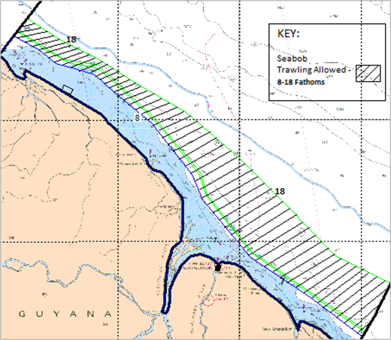

Figure 1: Seabob trawling zone (8 and 18-fathom lines) within the EEZ. Modified from (Maison 2015)

### Data Variables

The variables within the dataset are coded. A description for each variable is below:

1. company - Fishing company
2. dep_date - Date the vessel departs port for fishing
3. arr_date - Date the vessel returns from fishing
4. das - Days the vessel spends at-sea
5. trip - Unique trip identification number
6. drag - Unique drag identification number by
7. trip
8. drag_all - Sequential drag identification number 9. drag_date - Date the drag was done
9. drag_period - Binary variable of time-period for drag i.e. “Day” = 6:00hrs to 17:59 HRS and “Night” = 18:00 to 5:59 HRS
10. drag_time_s - Time the drag started (24:00 hrs) 12 drag_time_e - Time the drag ended (24:00 hrs)
11. time_fished_min - Time fished in hours
12. hrs_dec - Time fished converted to decimals
13. depth - Average fishing depth
14. depth_sd - Binary variable of fishing depth i.e. “Deep” = above 9 fathoms and “Shallow” = less than or equal to 9 fathoms
15. id_status - Binary variable of species identification i.e. “Yes” = Identified and “No” = Unidentified.
16. com_status - Binary variable of species economic status i.e. “Yes” = economic and “No” = Non-economical
17. order - Species taxonomy - Order 20.family - Species taxonomy - Family
18. class - Species taxonomy - Class
19. total_catch_cat - Catch categorization (see definitions)
20. total_catch_spp - Board species categorization
21. categories - More narrow species categorization
22. alpha_code - Unique 3-alpha species identifier used by FAO 26.vcom_name - Local name or “call name” for species 27. sample_wt_lbs - Species sample weight per drag (units = pounds)
23. total_wt_lbs - Species total weight per drag (units = pounds)
24. cpue - Catch rate or catch per unit of effort (units = pounds/hours fished)

### First 10 rows from data

### Renaming variables

## [1] "Company" "Departure" "Arrival" "DaysAtSea"   
## [5] "TripID" "DragID" "DragID2" "DragDate"   
## [9] "DragPeriod" "DragStart" "DragEnd" "TimeFishedHrs"   
## [13] "TimeFishedDec" "FishingDepth" "FishingDepth2" "SpeciesID"   
## [17] "EconomicStatus" "OrderTax" "FamilyTax" "ClassTax"   
## [21] "CatchCategory" "SpeciesCategory" "SpeciesCategory2" "LatinNames"   
## [25] "AplhaCode" "CommonName" "SampleWeightLB" "TotalWeightLB"   
## [29] "CpueLBHR"

### Creating a few additonal variables

Three new variables will be added. These variables will change the the current weight units from **Imperial** to **Metric** which is more common in Europe.

## [1] "Company" "Departure" "Arrival" "DaysAtSea"   
## [5] "TripID" "DragID" "DragID2" "DragDate"   
## [9] "DragPeriod" "DragStart" "DragEnd" "TimeFishedHrs"   
## [13] "TimeFishedDec" "FishingDepth" "FishingDepth2" "SpeciesID"   
## [17] "EconomicStatus" "OrderTax" "FamilyTax" "ClassTax"   
## [21] "CatchCategory" "SpeciesCategory" "SpeciesCategory2" "LatinNames"   
## [25] "AplhaCode" "CommonName" "SampleWeightLB" "TotalWeightLB"   
## [29] "CpueLBHR" "SampleWeightKG" "TotalWeightKG" "CpueLBSHR"

### Data summary

Here we see the **Mas102Discards** data comprises 1217 observations and 32 variables. The variables were imported as three different class i.e. character (17), difftime (3) and numeric (12). Missing data are contained in the variable **AlphaCode** (75) and this is due unavailability of unique codes for those species. In total 65 species were sampled from the total catch (see **LatinNames** variable). The mean days at sea by fishing vessel was **8 days** with 50% of the vessels spending 7 or less days (Vessels names were not included in the dataset). The average time per drag was 3.88 hrs, with only 25% of the drags being 4 to 5.53 hours.

Data summary

Name

Mas102Discards

Number of rows

1217

Number of columns

32

_______________________

Column type frequency:

character

17

difftime

3

numeric

12

________________________

Group variables

None

**Variable type: character**

skim_variable

n_missing

complete_rate

min

max

empty

n_unique

whitespace

Company

0

1.00

3

3

0

2

0

Departure

0

1.00

10

10

0

8

0

Arrival

0

1.00

10

10

0

8

0

DragDate

0

1.00

10

10

0

31

0

DragPeriod

0

1.00

3

5

0

2

0

FishingDepth2

0

1.00

4

7

0

2

0

SpeciesID

0

1.00

2

3

0

2

0

EconomicStatus

0

1.00

2

3

0

2

0

OrderTax

0

1.00

7

17

0

23

0

FamilyTax

0

1.00

7

18

0

42

0

ClassTax

0

1.00

7

14

0

8

0

CatchCategory

0

1.00

12

17

0

3

0

SpeciesCategory

0

1.00

14

15

0

2

0

SpeciesCategory2

0

1.00

5

10

0

4

0

LatinNames

0

1.00

5

26

0

65

0

AplhaCode

75

0.94

3

14

0

51

0

CommonName

0

1.00

4

27

0

79

0

**Variable type: difftime**

skim_variable

n_missing

complete_rate

min

max

median

n_unique

DragStart

0

1

4200 secs

73800 secs

09:30:00

41

DragEnd

0

1

1200 secs

86340 secs

13:00:00

34

TimeFishedHrs

0

1

3600 secs

19920 secs

03:55:00

21

**Variable type: numeric**

skim_variable

n_missing

complete_rate

mean

sd

p0

p25

p50

p75

p100

hist

DaysAtSea

0

1

7.69

2.00

5.00

6.00

7.00

10.00

11.00

<U+2587><U+2582><U+2582><U+2582><U+2585>

TripID

0

1

4.56

2.24

1.00

3.00

5.00

6.00

8.00

<U+2587><U+2585><U+2587><U+2585><U+2587>

DragID

0

1

3.45

1.70

1.00

2.00

3.00

5.00

6.00

<U+2587><U+2585><U+2583><U+2583><U+2583>

DragID2

0

1

24.80

13.62

1.00

13.00

26.00

36.00

48.00

<U+2587><U+2586><U+2587><U+2587><U+2587>

TimeFishedDec

0

1

3.88

0.55

1.00

3.75

3.92

4.00

5.53

<U+2581><U+2581><U+2582><U+2587><U+2581>

FishingDepth

0

1

8.87

1.77

5.00

7.00

9.00

10.00

12.00

<U+2582><U+2585><U+2587><U+2587><U+2583>

SampleWeightLB

0

1

1.93

3.91

0.00

0.10

0.43

1.70

45.00

<U+2587><U+2581><U+2581><U+2581><U+2581>

TotalWeightLB

0

1

33.64

76.74

0.01

4.72

18.22

31.43

1280.00

<U+2587><U+2581><U+2581><U+2581><U+2581>

CpueLBHR

0

1

8.91

19.03

0.00

1.15

5.20

8.98

320.00

<U+2587><U+2581><U+2581><U+2581><U+2581>

SampleWeightKG

0

1

0.88

1.78

0.00

0.05

0.20

0.77

20.45

<U+2587><U+2581><U+2581><U+2581><U+2581>

TotalWeightKG

0

1

15.29

34.88

0.00

2.15

8.28

14.29

581.82

<U+2587><U+2581><U+2581><U+2581><U+2581>

CpueLBSHR

0

1

4.05

8.65

0.00

0.52

2.36

4.08

145.45

<U+2587><U+2581><U+2581><U+2581><U+2581>

## Summary of key research variables

This research will look into discard weights, lengths and catch rates (CPUE) and more specifically to measure them against fishing depths and time-periods.

### Count of species sampled by trip and time-period

Here we see that data was across eight fishing trips. For each of those trip sampling was done across Day and Night time-periods i.e. 8 respectively. The number of Samples collected ranged from 54 (Trip 8 - Day) to 89 (Trip 6 - Day) with the mean number sampled being 67.

Count of species sampled across fishing trips and time-periods. Day = 6:00 hrs to 17:59 hrs and Night = 18:00 hrs to 5:59 hrs.

| Trips | Time-period | Counts |
| --- | --- | --- |
| 1 | Day | 70 |
| 1 | Night | 58 |
| 2 | Day | 68 |
| 2 | Night | 55 |
| 3 | Day | 75 |
| 3 | Night | 57 |
| 4 | Day | 55 |
| 4 | Night | 61 |
| 5 | Day | 75 |
| 5 | Night | 70 |
| 6 | Day | 89 |
| 6 | Night | 88 |
| 7 | Day | 66 |
| 7 | Night | 72 |
| 8 | Day | 54 |
| 8 | Night | 60 |

### Count of species sampled by trip and fishing depth

Here we see that data was across eight fishing trips. The samples were randomly collected across Deep and Shallow water depths. The number of samples collected ranged from 41 (Trip 3 - Shallow) to 177 (Trip 6 - Shallow) with the mean number sampled being 98.

Count of species sampled across fishing trips and dishing depths. Deep = above 9 fathoms and Shallow = equal to or less than 9 fathoms.

| Fishing Trips | Depths (fathoms) | Counts |
| --- | --- | --- |
| 1 | Deep | 86 |
| 1 | Shallow | 42 |
| 2 | Deep | 123 |
| 3 | Deep | 91 |
| 3 | Shallow | 41 |
| 4 | Deep | 71 |
| 4 | Shallow | 45 |
| 5 | Shallow | 145 |
| 6 | Shallow | 177 |
| 7 | Shallow | 138 |
| 8 | Deep | 114 |

## Research Questions

### First Submission

1. What were the species discarded and their relative proportions?
2. What proportions of the total catch were discarded?

### Second Submission

1. What were the relative weights and catch-rates of the species discarded?
2. Were the weights and catch-rates significantly impacted by time-periods and fishing depth?

### Third Submission (Joining weight and length data)

1. What were the relative lengths the species discarded?
2. Were the lengths significantly impacted by time-periods and fishing depth?

## Species discarded and their relative proportions (Research question 1)

In total, 60 fish taxa were identified (Table 1), belonging to 39 families in 21 orders, with Perciformes (22 species) being the dominant order. Samples contained between 11 and 31 fish species, with an average of 21 ± 4 species per sample. Three species; Callinectes ornatus, Macrodon ancylodon and Stellifer rastrifer were present in all the samples, where 22 species were present in more than 50% of the samples.

Fish taxa identified from the 48 bottom-trawl hauls sampled off the coast of Guyana. Where p = species presence in proportion within the total samples.Blue fonts highlights species p of &gt;= 0.5

| Orders | Families | Scientific names | Counts | Proportion |
| --- | --- | --- | --- | --- |
| Anguilliformes | Muraenidae | Gymnothorax ocellatus | 1 | 0.02 |
|  | Ophichthidae | Ophichthus gomesii | 37 | **0.77** |
| Batrachoidiformes | Batrachoididae | Batrachoides surinamensis | 34 | **0.71** |
|  |  | Porichthys pauciradiatus | 1 | 0.02 |
| Carcharhiniformes | Triakidae | Mustelus higmani | 6 | 0.12 |
| Clupeiformes | Clupeidae | Harengula jaguana | 27 | **0.56** |
|  | Engraulidae | Anchoa mitchilli | 22 | 0.46 |
|  |  | Anchoa spinifer | 18 | 0.38 |
|  |  | Anchoviella lepidentostole | 1 | 0.02 |
| Decapoda | Aethridae | Hepatus pudibundus | 3 | 0.06 |
|  | Calappidae | Calappa sulcata | 1 | 0.02 |
|  | Diogenidae | Clibanarius foresti | 2 | 0.04 |
|  |  | Petrochirus diogenes | 1 | 0.02 |
|  | Inachoididae | Paulita tuberculata | 3 | 0.06 |
|  | Leucosiidae | Persephona lichtensteinii | 21 | 0.44 |
|  | Malacostraca | Hepatus gronovii | 24 | **0.50** |
|  | Portunidae | Callinectes ornatus | 47 | **0.98** |
| Elopiformes | Elopidae | Elops saurus | 1 | 0.02 |
| Lophiiformes | Ogcocephalidae | Ogcocephalus darwini | 1 | 0.02 |
| Myliobatiformes | Dasyatidae | Dasyatis geijskesi | 6 | 0.12 |
|  |  | Dasyatis guttata | 27 | **0.56** |
|  | Gymnuridae | Gymnura micrura | 31 | **0.65** |
|  | Myliobatidae | Rhinoptera bonasus | 3 | 0.06 |
|  | Urotrygonidae | Urotrygon microphthalmum | 13 | 0.27 |
| Orectolobiformes | Ginglymostomatidae | Ginglymostoma cirratum | 1 | 0.02 |
| Paxillosida | Luidiidae | Luidia senegalensis | 1 | 0.02 |
| Pennatulacea | Renillidae | Renilla muelleri | 2 | 0.04 |
| Perciformes | Carangidae | Chloroscombrus chrysurus | 4 | 0.08 |
|  |  | Selene brownii | 20 | 0.42 |
|  | Centropomidae | Centropomus pectinatus | 4 | 0.08 |
|  |  | Centropomus undecimalis | 1 | 0.02 |
|  | Ephippidae | Chaetodipterus faber | 25 | **0.52** |
|  | Haemulidae | Conodon nobilis | 4 | 0.08 |
|  |  | Genyatremus luteus | 10 | 0.21 |
|  | Sciaenidae | Corvula sanctaeluciae | 2 | 0.04 |
|  |  | Cynoscion jamaicensis | 1 | 0.02 |
|  |  | Cynoscion virescens | 44 | **0.92** |
|  |  | Daysciaena albida | 1 | 0.02 |
|  |  | Larimus breviceps | 21 | 0.44 |
|  |  | Lonchurus elegans | 23 | 0.48 |
|  |  | Macrodon ancylodon | 48 | **1.00** |
|  |  | Micropogonias furnieri | 8 | 0.17 |
|  |  | Nebris microps | 29 | **0.60** |
|  |  | Paralonchurus brasiliensis | 38 | **0.79** |
|  |  | Stellifer microps | 45 | **0.94** |
|  |  | Stellifer rastrifer | 47 | **0.98** |
|  | Scombridae | Scomberomorus brasiliensis | 6 | 0.12 |
|  | Serranidae | Epinephelus flavolimbatus | 4 | 0.08 |
|  | Trichiuridae | Trichiurus lepturus | 42 | **0.88** |
| Pleuronectiformes | Achiridae | Achirus achirus | 38 | **0.79** |
|  | Cynoglossidae | Symphurus plagusia | 43 | **0.90** |
| Polymixiiformes | Polymixiidae | Polymixia lowei | 10 | 0.21 |
| Rajiformes |  | Dasyatis geijskesi | 15 | 0.31 |
| Rhinopristiformes | Rhinobatidae | Pseudobatos percellens | 6 | 0.12 |
| Siluriformes | Ariidae | Arius proops | 14 | 0.29 |
|  |  | Bagre bagre | 42 | **0.88** |
| Stomatopoda | Squillidae | Squilla mantis | 34 | **0.71** |
| Tetraodontiformes | Tetraodontidae | Colomesus psittacus | 23 | 0.48 |
|  |  | Sphoeroides testudineus | 14 | 0.29 |
| Teuthida | Loliginidae | Lolliguncula brevis | 10 | 0.21 |
| Torpediniformes | Narcinidae | Narcine brasiliensis | 11 | 0.23 |
| Unknown | Unknown | Scyphozoa sp. | 25 | **0.52** |
|  |  | Un id | 26 | **0.54** |

## Proportions of the total catch were discarded (Research Question 2)

### Catch categories

In total 18608 kgs of fish were landed. Of this amount, bony fish accounted for the highest i.e. 8,804 kgs, followed by shellfish (7,240 kgs), flatfish (1,938 kgs) and others (626 kgs). A similar trend was seen in the mean weights caught per trip for the different categories i.e. bony fish the highest 1,101 kgs/trip, followed by shell fish (905 kgs/trip), flat fish 242 kgs/trip and Others 78 kgs/trip. The minimum and maximum discard landed by category are as follows: bony fish discards ranged from 683 kgs (trip 4) to 2,410 kgs (trip 6), shell fish from 346 kgs (trip 7) to 1,885 kgs (trip 4), flat fish from 18 kgs (trip 1) to 577 kgs (trip 6) and others from 9 kgs to 257 kgs (trip 6).

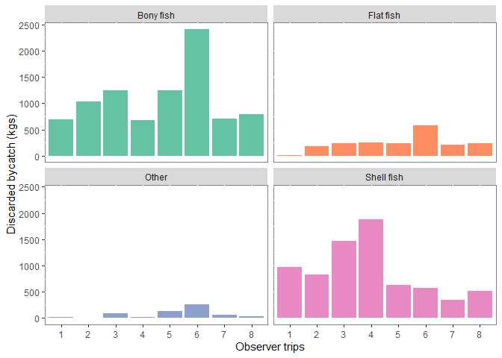

Barplot showing a breakdown of weights by species category across fishing trips

### Discard against target species across fishing trips

Of the total fish weight, bycatch species accounted for 11,956 kgs (68%) and target species 5,705 kgs (32%). Bycatch species proportions (by weight) within the total catch ranged from 37% (trip 4) to 95% (trip 6). Target species on the other hand ranged from 5% (trip 6) to 63% (trip 4).

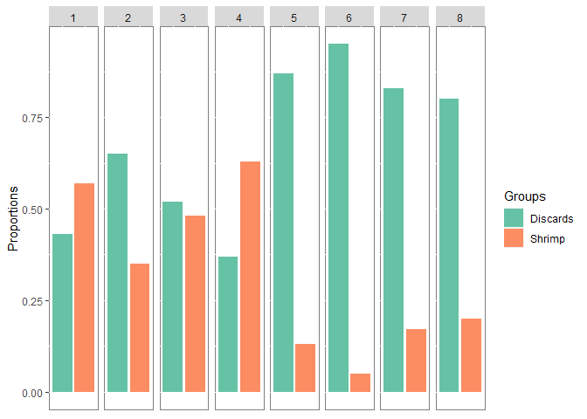

Barplot showing a breakdown of weights (proportions) by catch category for the different fishing trips

# SECOND SUBMISSION

# THIRD SUBMISSION