An evaluation of discarded bycatch data collected by at-sea observers (draft #1).

Seion Richardson

October 23, 2020

Table of Contents

# Abstract

**This is usually written last, but I am currently doing a course (Science Communication & Scientific Writing) where this was given as an assignment, so I include it as a draft.**

Anecdotal evidence suggested that discarding within Guyana`s main shrimp fishery is excessive and includes commercially viable juvenile species. For the first time unbiased data on discards were obtained by way of an At-sea Observer Program between 2019 to 2020. The observers sampled 48 fishing hauls across eight random fishing trips at an average of six fishing hauls per trip i.e. three days and nights, respectively. This study examined the dataset for the first time; with emphasis on species weights, rates, and lengths; across varying time-periods (days/nights) and fishing depths (≤ or > 9 fathoms). Where species count within the samples were copious, the assessment focused on the more common by weights, rates and lengths recorded. The composition of discards at the fishery level was also estimated using the observer data. The two-sample t-test were used to analyze the differences in mean species weights and sizes.The paired t-tests were used to analyze the differences in mean catch rates. In the 48 fishing hauls sampled, 70 fish taxa were identified from 36 families in 11 orders, with Perciformes (28 species) being the dominant order. Discards made up a substantial 40% of the total fishery biomass. Six of the more common species by weight (i.e. bangamary, butterfish, seatrout, rockhead, catfish and cuirass and butterfish) were of commercial importance and accounted for roughly 45% of the total biomass. The mean species weights (100 kg/trip), rates (60 kg/twin-net hour), and lengths recorded (15 cm) were significantly higher at nights and in shallow water conditions. These findings have significant economic and ecological implications on the sustainability of the fishery and therefore in the short term should influence management e.g. through improved policies and research.

# Introduction

**To be written.**

**I am doing the analysis in Rmarkdown, so I am integrating texts and codes as I go along.**

## Objective:

To determine the extent of discarding within Guyana`s main shrimp fishery by assessing discard composition, weights, rates, and lengths across dissimilar time-periods (day/night) and fishing depths (≤ or > 9 fathoms), using observer data.

## Research questions:

1. What proportion of the total catch do discards account for?
2. What proportion of the discards are commercially viable species?
3. What are the species discarded and what are their relative weights and catch rates?
4. Which species have the highest weights, catch rates and lengths?
5. What are the length distributions of the discarded bycatch species?
6. At which time-period and fishing depth is discarding most prevalent?
7. Does time-period significantly impact discard weights, catch rates and lengths?
8. Does fishing depth significantly impact discard weights, catch rates and lengths?

# Data and Methods

The data used was collected by at-sea observers onboard shrimp trawl vessels between 2019 to 2020. All samples were from within the seabob trawling zone i.e. the eight to eighteen fathoms - depth contour (see Figure 1). The data includes haul-by-haul records from eight fishing trips, with an average of six hauls per fishing trip i.e. three days and three nights, respectively. Fishing was carried out at different water depths i.e. ≤ and > 9 fathoms. In addition to these conditions, fishing locations and trawling speed were consistent with commercial fishing practices. Other key variables measured included the haul time (hrs.) and days-at-sea, among others.

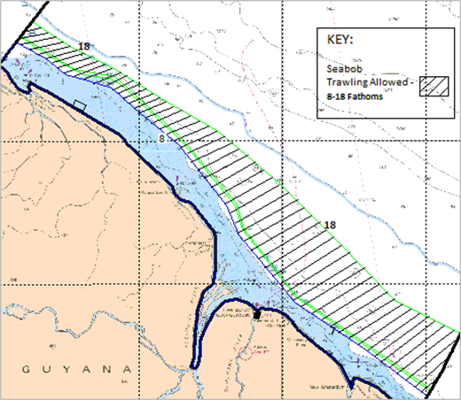

Seabob trawling zone (8 and 18-fathom lines) within the EEZ. Modified from (Maison 2015).

Microsoft Excel and R statistical software were used for the data manipulation and analysis, respectively. The evaluations investigated discard proportionality in terms of weights, catch rates, lengths, and general composition. These were measured against time-periods and fishing locations where practicable. Parametric statistical testing was used as the assumptions of normal distribution and homogeneity of variance were satisfied. The two-sample was used to assess for significance in the differences in mean species weights (lbs.) and sizes (cm). The paired t-tests was used to assess for significance in the differences in mean catch rates (lbs./twin-trawl hr.).

# Data Analysis

**These are just the random analysis done with very little structure. Only a few will make it into the final report. I have not addressed all the research questions at this point yet but I do have the data.**

## Overview

Tab. 1: Fish taxa identified from 48 bottom-trawl hauls sampled off Guyana. Count = species presence within the samples. With those identified in > 30 hauls colored blue

| Orders | Families | Scientific names | Counts | Proportion |
| --- | --- | --- | --- | --- |
| Anguilliformes | Muraenidae | Gymnothorax ocellatus | 1 | 0.02 |
|  | Ophichthidae | Ophichthus gomesii | 37 | **0.77** |
| Batrachoidiformes | Batrachoididae | Batrachoides surinamensis | 34 | **0.71** |
|  |  | Porichthys pauciradiatus | 1 | 0.02 |
| Carcharhiniformes | Triakidae | Mustelus higmani | 6 | 0.12 |
| Clupeiformes | Clupeidae | Harengula jaguana | 27 | **0.56** |
|  | Engraulidae | Anchoa mitchilli | 22 | 0.46 |
|  |  | Anchoa spinifer | 18 | 0.38 |
|  |  | Anchoviella lepidentostole | 1 | 0.02 |
| Decapoda | Aethridae | Hepatus pudibundus | 3 | 0.06 |
|  | Calappidae | Calappa sulcata | 1 | 0.02 |
|  | Diogenidae | Clibanarius foresti | 2 | 0.04 |
|  |  | Petrochirus diogenes | 1 | 0.02 |
|  | Inachoididae | Paulita tuberculata | 3 | 0.06 |
|  | Leucosiidae | Persephona lichtensteinii | 21 | 0.44 |
|  | Malacostraca | Hepatus gronovii | 24 | **0.50** |
|  | Portunidae | Callinectes ornatus | 47 | **0.98** |
| Elopiformes | Elopidae | Elops saurus | 1 | 0.02 |
| Lophiiformes | Ogcocephalidae | Ogcocephalus darwini | 1 | 0.02 |
| Myliobatiformes | Dasyatidae | Dasyatis geijskesi | 6 | 0.12 |
|  |  | Dasyatis guttata | 27 | **0.56** |
|  | Gymnuridae | Gymnura micrura | 31 | **0.65** |
|  | Myliobatidae | Rhinoptera bonasus | 3 | 0.06 |
|  | Urotrygonidae | Urotrygon microphthalmum | 13 | 0.27 |
| Orectolobiformes | Ginglymostomatidae | Ginglymostoma cirratum | 1 | 0.02 |
| Paxillosida | Luidiidae | Luidia senegalensis | 1 | 0.02 |
| Pennatulacea | Renillidae | Renilla muelleri | 2 | 0.04 |
| Perciformes | Carangidae | Chloroscombrus chrysurus | 4 | 0.08 |
|  |  | Selene brownii | 20 | 0.42 |
|  | Centropomidae | Centropomus pectinatus | 4 | 0.08 |
|  |  | Centropomus undecimalis | 1 | 0.02 |
|  | Ephippidae | Chaetodipterus faber | 25 | **0.52** |
|  | Haemulidae | Conodon nobilis | 4 | 0.08 |
|  |  | Genyatremus luteus | 10 | 0.21 |
|  | Sciaenidae | Corvula sanctaeluciae | 2 | 0.04 |
|  |  | Cynoscion jamaicensis | 1 | 0.02 |
|  |  | Cynoscion virescens | 44 | **0.92** |
|  |  | Daysciaena albida | 1 | 0.02 |
|  |  | Larimus breviceps | 21 | 0.44 |
|  |  | Lonchurus elegans | 23 | 0.48 |
|  |  | Macrodon ancylodon | 48 | **1.00** |
|  |  | Micropogonias furnieri | 8 | 0.17 |
|  |  | Nebris microps | 29 | **0.60** |
|  |  | Paralonchurus brasiliensis | 38 | **0.79** |
|  |  | Stellifer microps | 45 | **0.94** |
|  |  | Stellifer rastrifer | 47 | **0.98** |
|  | Scombridae | Scomberomorus brasiliensis | 6 | 0.12 |
|  | Serranidae | Epinephelus flavolimbatus | 4 | 0.08 |
|  | Trichiuridae | Trichiurus lepturus | 42 | **0.88** |
| Pleuronectiformes | Achiridae | Achirus achirus | 38 | **0.79** |
|  | Cynoglossidae | Symphurus plagusia | 43 | **0.90** |
| Polymixiiformes | Polymixiidae | Polymixia lowei | 10 | 0.21 |
| Rajiformes |  | Dasyatis geijskesi | 15 | 0.31 |
| Rhinopristiformes | Rhinobatidae | Pseudobatos percellens | 6 | 0.12 |
| Siluriformes | Ariidae | Arius proops | 14 | 0.29 |
|  |  | Bagre bagre | 42 | **0.88** |
| Stomatopoda | Squillidae | Squilla mantis | 34 | **0.71** |
| Tetraodontiformes | Tetraodontidae | Colomesus psittacus | 23 | 0.48 |
|  |  | Sphoeroides testudineus | 14 | 0.29 |
| Teuthida | Loliginidae | Lolliguncula brevis | 10 | 0.21 |
| Torpediniformes | Narcinidae | Narcine brasiliensis | 11 | 0.23 |

Tab. 2: Count of species sampled by trip and time-period

| Trips | Time-period | Counts |
| --- | --- | --- |
| 1 | Day | 70 |
| 1 | Night | 58 |
| 2 | Day | 68 |
| 2 | Night | 55 |
| 3 | Day | 75 |
| 3 | Night | 57 |
| 4 | Day | 55 |
| 4 | Night | 61 |
| 5 | Day | 75 |
| 5 | Night | 70 |
| 6 | Day | 89 |
| 6 | Night | 88 |
| 7 | Day | 66 |
| 7 | Night | 72 |
| 8 | Day | 54 |
| 8 | Night | 60 |

Tab. 3: Count of species sampled by trip and fishing depth

| Depths | Counts |
| --- | --- |
| 5 | 65 |
| 7 | 224 |
| 8 | 153 |
| 9 | 146 |
| 10 | 343 |
| 11 | 64 |
| 12 | 78 |

Tab. 4: Sample size measured by fishing trip

| Trips | Sample size (%) |
| --- | --- |
| 1 | 43 |
| 2 | 18 |
| 3 | 13 |
| 4 | 18 |
| 5 | 4 |
| 6 | 3 |
| 7 | 17 |
| 8 | 12 |

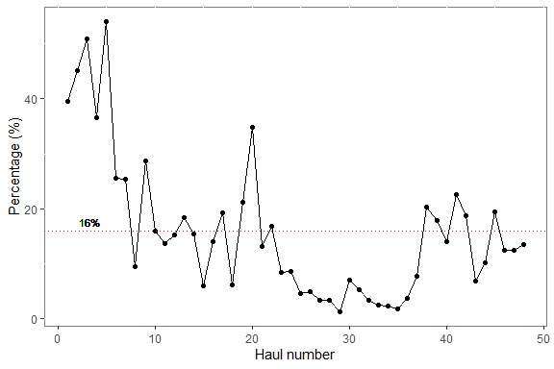

Figure 1: Line plot of sample size across hauls with the red horizontal represent the mean sample size.

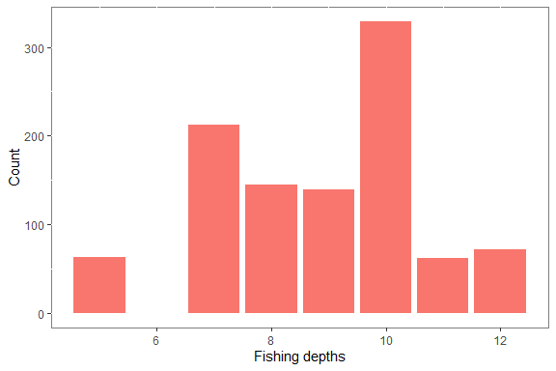

Figure 2: Barplot showing count of species sampled at different depths

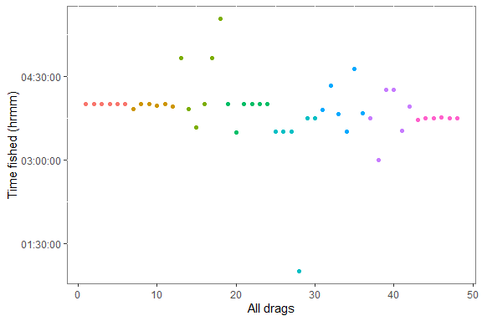

Figure 3: Scatterplot of time fished across all sampled hauls

## Weights

Tab. 5: Catch and effort for the top 15 species, ordered from highest to lowest catches.

| Sceintific names | Catch | Effort | Catch perc. | Effort perc. |
| --- | --- | --- | --- | --- |
| Stellifer rastrifer | 1235 | 182.26 | 10.71 | 4.60 |
| Stellifer microps | 1105 | 173.20 | 9.59 | 4.37 |
| Macrodon ancylodon | 848 | 186.23 | 7.36 | 4.70 |
| Cynoscion virescens | 532 | 168.70 | 4.62 | 4.26 |
| Bagre bagre | 517 | 166.23 | 4.49 | 4.20 |
| Symphurus plagusia | 516 | 169.31 | 4.48 | 4.27 |
| Callinectes ornatus | 425 | 182.26 | 3.69 | 4.60 |
| Nebris microps | 390 | 113.30 | 3.38 | 2.86 |
| Trichiurus lepturus | 384 | 163.56 | 3.33 | 4.13 |
| Paralonchurus brasiliensis | 375 | 146.56 | 3.25 | 3.70 |
| Batrachoides surinamensis | 341 | 134.24 | 2.96 | 3.39 |
| Gymnura micrura | 334 | 118.59 | 2.90 | 2.99 |
| Larimus breviceps | 315 | 80.21 | 2.73 | 2.03 |
| Ophichthus gomesii | 292 | 143.03 | 2.53 | 3.61 |
| Dasyatis guttata | 257 | 103.00 | 2.23 | 2.60 |

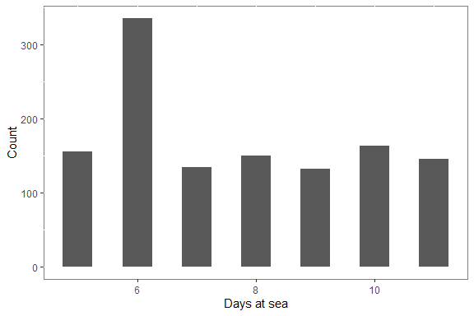

Figure 4: Histogram of days-at-sea

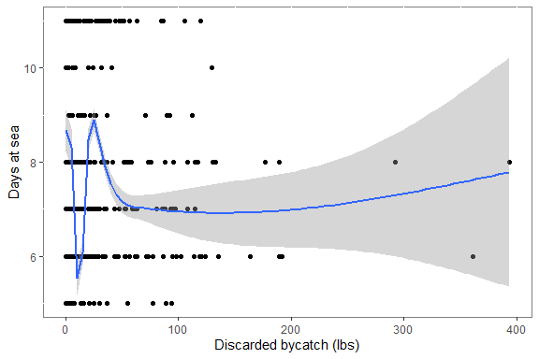

Figure 5: Scatter plot of days at sea against disacrded bycatch with trendine (blue) and standard error margin (grayed area)

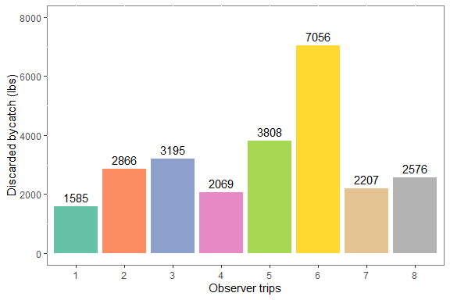

Figure 6: Barplot of disacrded bycatch for the six hauls sampled for each trip

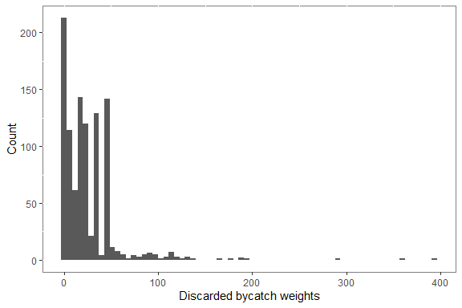

Figure 7: Histogram showing the count of discarded bycatch from all hauls

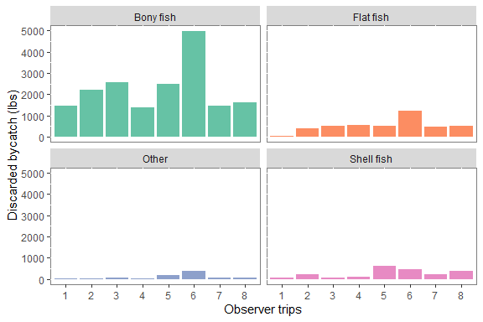

Figure 8: Barplots showing discarded bycatch against observer trips across the four different catch categories

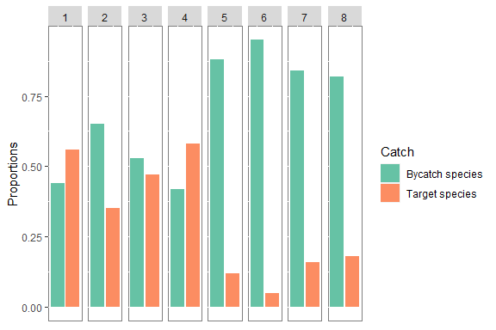

Figure 9: Barplot showing catch prportions for the different trips

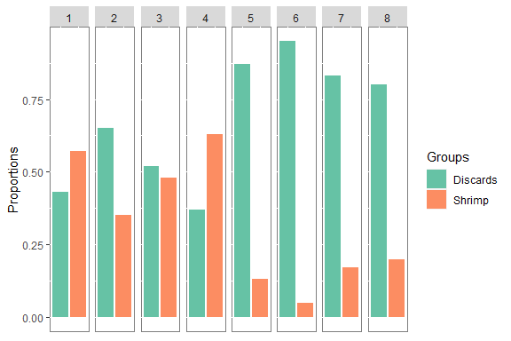

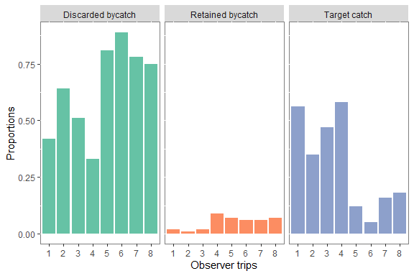

Figure 10: Barplot showing catch proportions for all trips

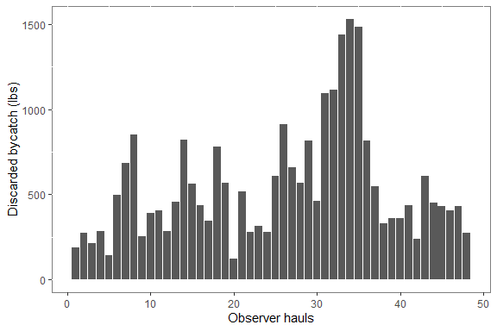

Figure 11: Barplot showing the discarded bycatch across all hauls

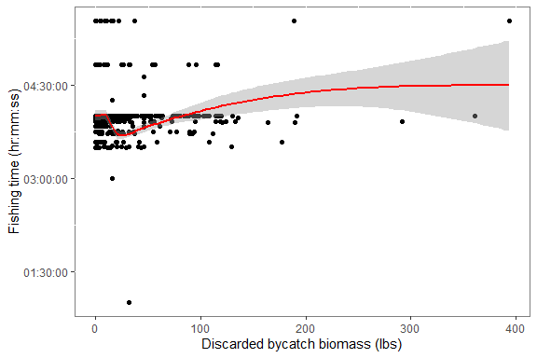

Figure 12: Scatter plot of fishing time against disacrded bycatch with trendine (red) and standard error margin (grayed area)Line plot of fishing time against disacrded bycatch

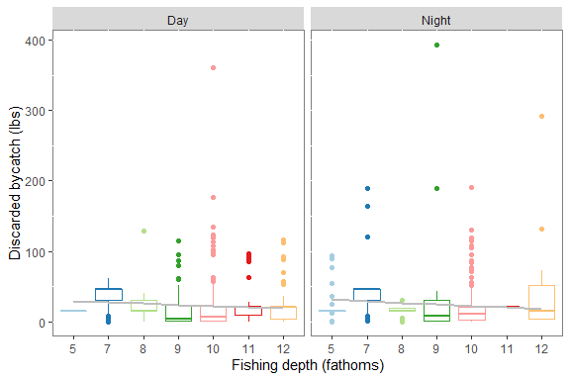

Figure 13: Boxplot of discarded bycatch against fishing depth across time-periods

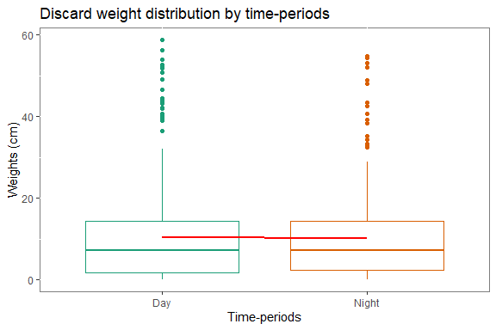

Figure 14: Boxplot of discarded bycatch against fishing depth across time-periods

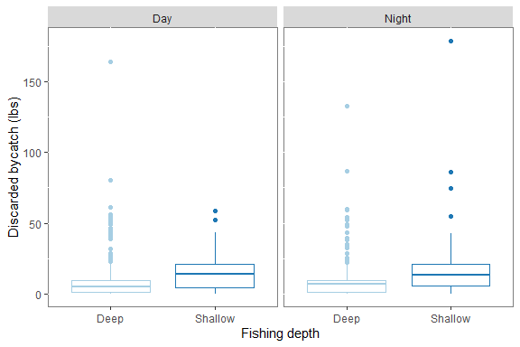

Figure 15: Boxplot of discarded bycatch against fishing depth. Where **shallow** is defined by waters <= 9 fathoms and **deep** means water deeper than 9 fathoms

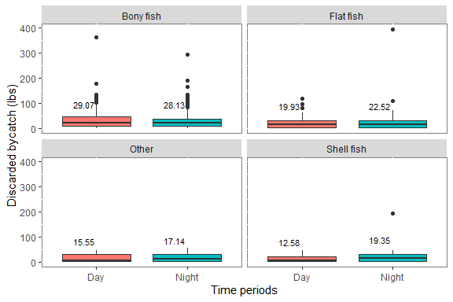

Figure 1: Boxplots showing mean discarded bycatch by categories and time-periods

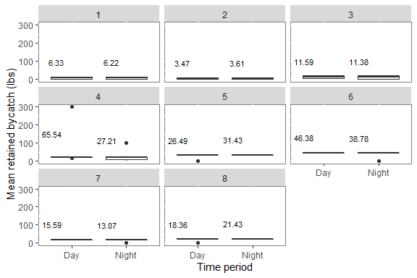

Figure 2: Boxplots showing mean ratained bycatch by trips and time-periods

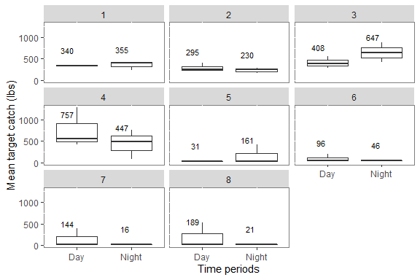

Figure 3: Boxplots showing mean target catch by trips and time-periods

## Catch rates

Tab. 6: Catch rates for the top 15 species in pounds per hour, ordered from highest to lowest catch rates.

| Sceintific names | Count | Catch rates (lbs/hr) |
| --- | --- | --- |
| Stellifer rastrifer | 47 | 6.78 |
| Stellifer microps | 45 | 6.46 |
| Macrodon ancylodon | 48 | 4.77 |
| Nebris microps | 29 | 3.45 |
| Cynoscion virescens | 44 | 3.33 |
| Gymnura micrura | 31 | 3.13 |
| Bagre bagre | 42 | 3.12 |
| Dasyatis guttata | 27 | 2.85 |
| Paralonchurus brasiliensis | 38 | 2.81 |
| Symphurus plagusia | 43 | 2.80 |
| Trichiurus lepturus | 42 | 2.60 |
| Batrachoides surinamensis | 34 | 2.59 |
| Callinectes ornatus | 47 | 2.55 |
| Ophichthus gomesii | 37 | 2.35 |
| Squilla mantis | 34 | 2.24 |

## Lengths

Tab. 7: Count of species measured across all hauls

| Scientific names | Counts | Min. | Max | Med. |
| --- | --- | --- | --- | --- |
| Trichiurus lepturus | 30 | 50 | 70 | 60.5 |
| Lonchurus elegans | 122 | 7 | 30 | 23.0 |
| Larimus breviceps | 62 | 11 | 23 | 19.0 |
| Cynoscion virescens | 215 | 8 | 33 | 18.0 |
| Macrodon ancylodon | 480 | 6 | 31 | 17.0 |
| Symphurus plagusia | 120 | 7 | 17 | 13.0 |
| Nebris microps | 262 | 6 | 27 | 12.0 |
| Stellifer microps | 718 | 2 | 23 | 12.0 |
| Anchoa spinifer | 30 | 9 | 17 | 11.0 |
| Harengula jaguana | 121 | 5 | 30 | 11.0 |
| Paralonchurus brasiliensis | 89 | 5 | 25 | 10.0 |
| Bagre bagre | 239 | 5 | 38 | 9.0 |
| Stellifer rastrifer | 989 | 2 | 24 | 9.0 |

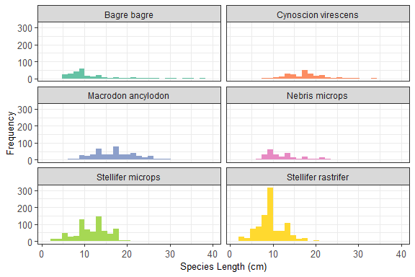

## Time-periods - Most abundant species

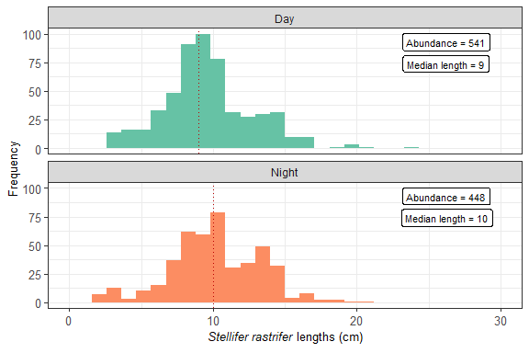

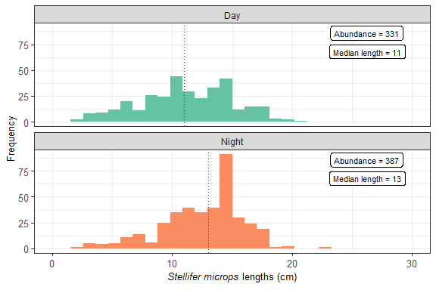

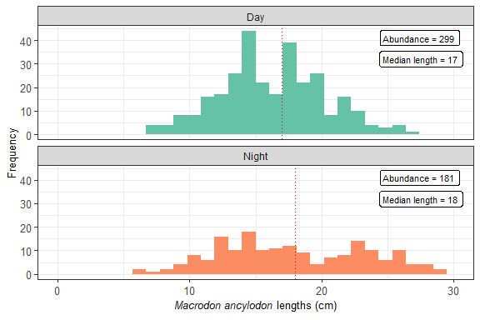

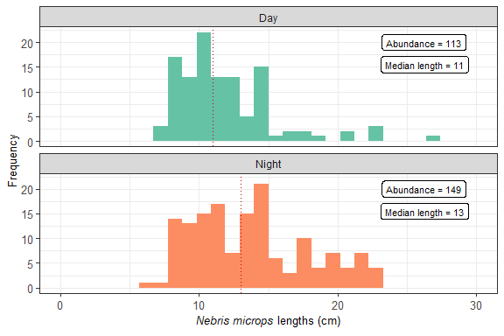

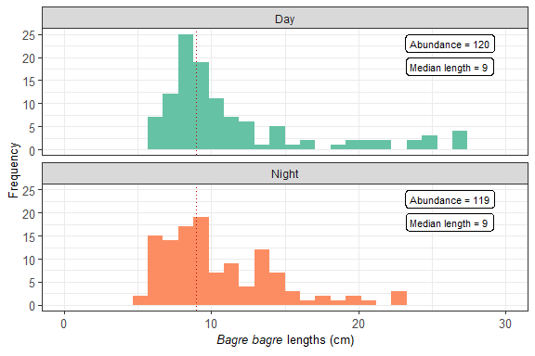

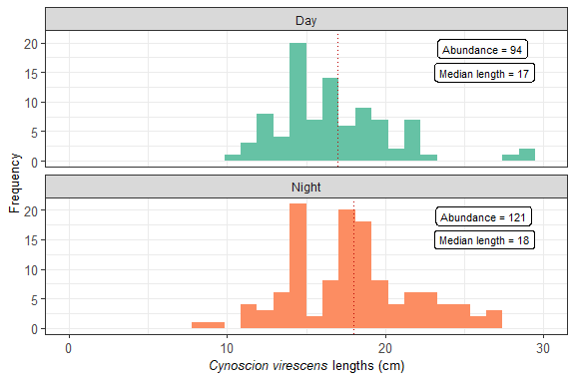

## Fishing depths - Most abundant species

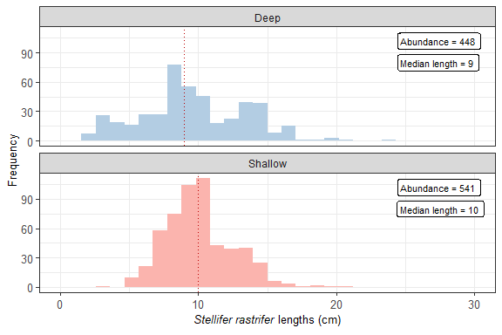

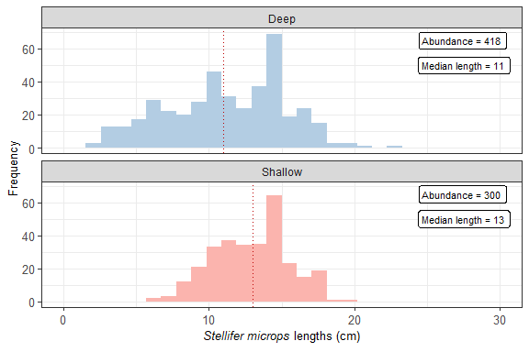

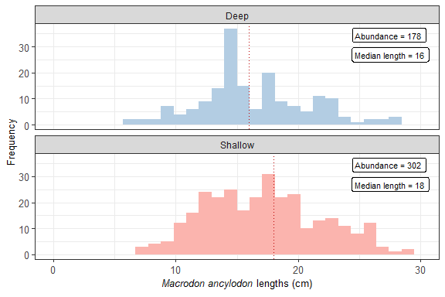

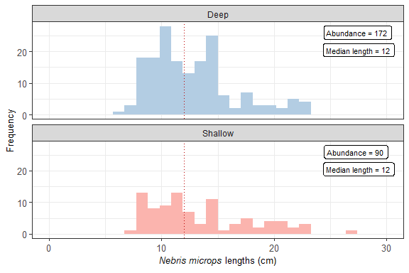

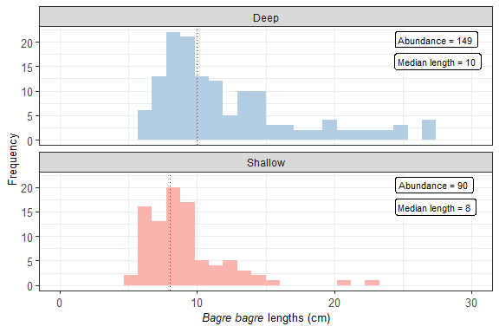

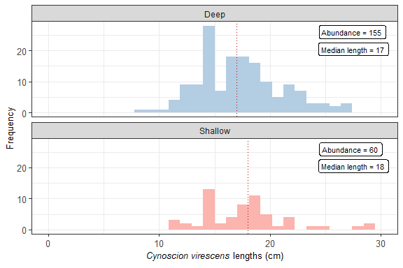

**Species accumulation curves by trip and hauls.**

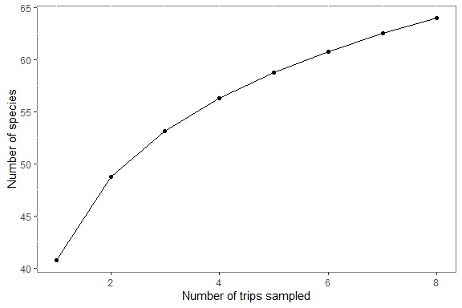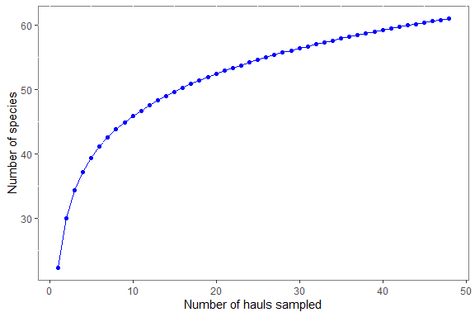

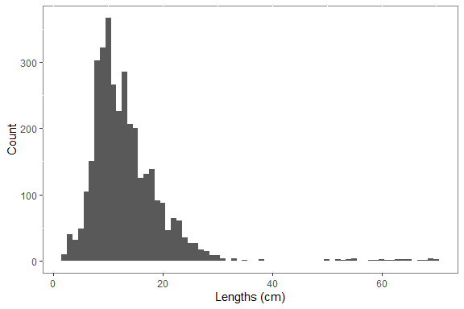

Figure 5: Histogram showing species length distribution for all hauls

Tab. 8: Lengths (cm) of all species measured, ordered from highest to lowest mean lengths.

| Sceintific names | Commercial status | Mean lengths (cm) | Count |
| --- | --- | --- | --- |
| Trichiurus lepturus | No | 60 | 30 |
| Lonchurus elegans | Yes | 22 | 122 |
| Larimus breviceps | No | 19 | 62 |
| Cynoscion virescens | Yes | 18 | 215 |
| Macrodon ancylodon | Yes | 17 | 480 |
| Nebris microps | Yes | 13 | 262 |
| Symphurus plagusia | No | 13 | 120 |
| Anchoa spinifer | No | 12 | 30 |
| Bagre bagre | Yes | 12 | 239 |
| Stellifer microps | No | 12 | 718 |
| Harengula jaguana | No | 11 | 121 |
| Paralonchurus brasiliensis | No | 11 | 89 |
| Stellifer rastrifer | No | 10 | 989 |

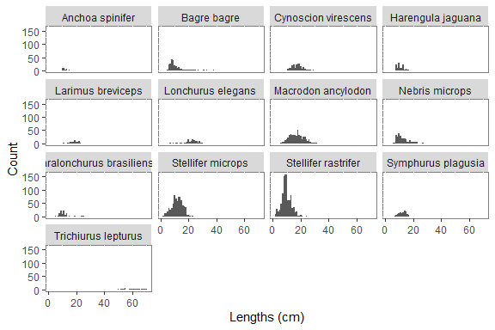

Figure 6: Histograms showing species length distributions

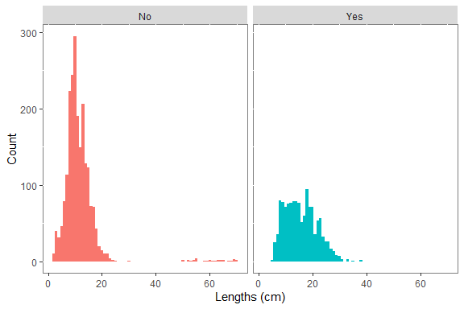

Figure 7: Histogram showing species length distribution by commercial status. Here, yes = Commercially important species and no = non-commercially important species

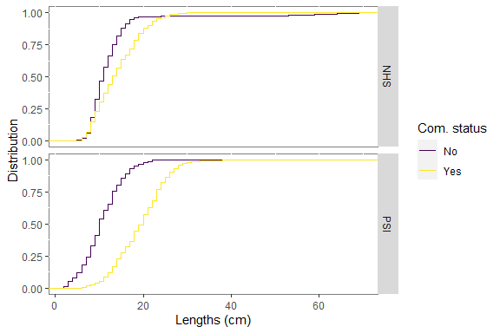

Figure 8: Empirical cumulative distribution for commercial (yes) and non-commercial species (no), stacked by fishing companies

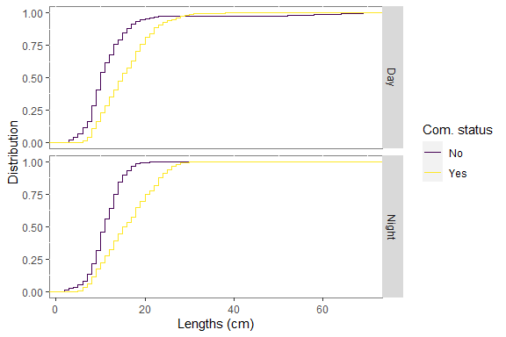

Figure 9: Empirical cumulative distribution for differen time-periods, showing commercial (yes) and non-commercial species (no), stacked by fishing companies

## Statistical tests

### Two sampled t-tests - Catch by time-periods

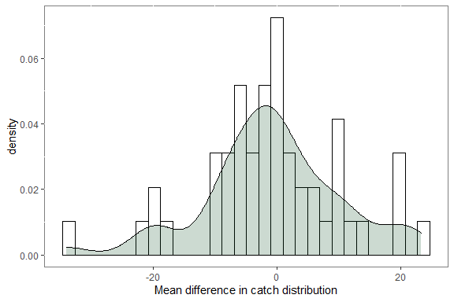

Figure 10: Histogram and density plots of the mean difference in catch distributions

Welch Two Sample t-test

data: catch by time_period t = -0.29926, df = 95.977, p-value = 0.7654 alternative hypothesis: true difference in means is not equal to 0 95 percent confidence interval: -5.714382 4.217117 sample estimates: mean in group day mean in group night 20.65637 21.40500

### Two sampled t-tests - Catch by fishing depths

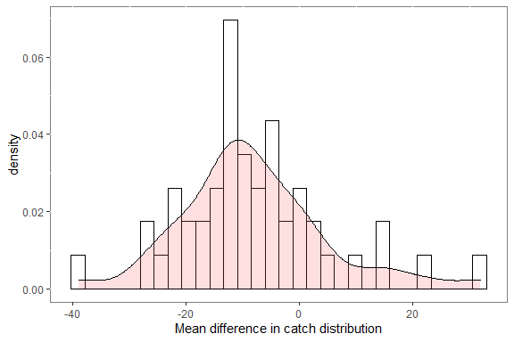

Figure 11: Histogram and density plots of the mean difference in catch distributions

Welch Two Sample t-test

data: catch by fishing_depth t = -3.1519, df = 83.004, p-value = 0.002257 alternative hypothesis: true difference in means is not equal to 0 95 percent confidence interval: -13.373605 -3.025289 sample estimates: mean in group deep mean in group shallow 16.21753 24.41698

### Paired t-tests - Cpue by time-periods

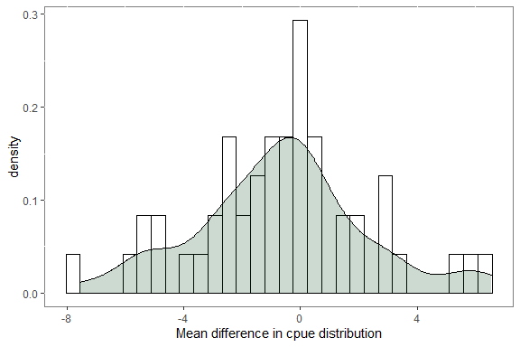

Figure 12: Histogram and density plots of the mean difference in cpue distributions

Paired t-test

data: cpue by time_period t = -1.557, df = 48, p-value = 0.126 alternative hypothesis: true difference in means is not equal to 0 95 percent confidence interval: -1.4981194 0.1904867 sample estimates: mean of the differences -0.6538163

### Paired t-tests - Cpue by fishing depths

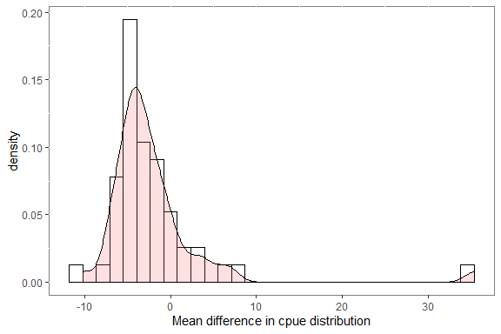

Figure 13: Histogram and density plots of the mean difference in cpue distributions

Paired t-test

data: cpue by fishing_depth t = -2.3172, df = 48, p-value = 0.02481 alternative hypothesis: true difference in means is not equal to 0 95 percent confidence interval: -3.9602266 -0.2805081 sample estimates: mean of the differences -2.120367

**In the draft #2 I will add some structure to the report and will remove some of the excess tables and plots and add some others in accordance with the research questions. I also plan to commence writing up the sections as I go along. The plan is send weekly or bi-weekly updates of my progress.**

Welch Two Sample t-test

data: total_wt_lbs by drag_period t = 0.1614, df = 41.372, p-value = 0.8726 alternative hypothesis: true difference in means is not equal to 0 95 percent confidence interval: -35.64598 41.84051 sample estimates: mean in group Day mean in group Night 59.39435 56.29708

# A tibble: 6 x 10

estimate estimate1 estimate2 statistic p.value parameter conf.low conf.high 1 -0.527 9.58 10.1 -0.527 0.607 12.9 -2.69 1.64 2 -1.21 11.4 12.6 -1.12 0.295 7.84 -3.71 1.29 3 -2.41 16.1 18.5 -1.89 0.182 2.33 -7.23 2.40 4 -2.46 11.6 14.1 -3.14 0.0879 2.01 -5.81 0.899 5 6.21 16.5 10.3 0.818 0.555 1.09 -74.1 86.5  
6 -1.72 16.7 18.4 -0.632 0.573 2.95 -10.4 7.01 # … with 2 more variables: method , alternative

# A tibble: 5 x 10

estimate estimate1 estimate2 statistic p.value parameter conf.low conf.high 1 0.00619 9.52 9.52 0.00434 0.997 5.28 -3.60 3.61 2 -1.45 11.4 12.8 -1.14 0.303 5.45 -4.64 1.75 3 -2.09 16.2 18.3 -1.42 0.232 3.86 -6.26 2.07 4 -1.26 12.6 13.9 -0.719 0.600 1.03 -22.1 19.6 5 4.27 12.7 8.42 1.22 0.327 2.44 -8.44 17.0 # … with 2 more variables: method , alternative

|  | Day | | | Night | | | Comparison | |
| --- | --- | --- | --- | --- | --- | --- | --- | --- |
| Species | Mean) | SE | n | Mean | SE | n | Difference. | P value |
| Stellifer rastrifer | 9 | 0.14 | 541 | 10 | 0.15 | 448 | -11.11 | 0.607 |
| Stellifer microps | 11 | 0.22 | 331 | 12 | 0.18 | 387 | -9.09 | 0.295 |
| Macrodon ancylodon | 16 | 0.24 | 299 | 18 | 0.43 | 181 | -12.50 | 0.182 |
| Nebris microps | 12 | 0.35 | 113 | 14 | 0.36 | 149 | -16.67 | 0.088 |
| Bagre bagre | 13 | 0.71 | 120 | 10 | 0.37 | 119 | 23.08 | 0.555 |
| Cynoscion virescens | 17 | 0.45 | 94 | 18 | 0.36 | 121 | -5.88 | 0.573 |

## Another table example

| Sepal length | Sepal width | Petal length | Petal width | Species |
| --- | --- | --- | --- | --- |
| 5.1 | 3.5 | 1.4 | 0.2 | setosa |
| 4.9 | 3.0 | 1.4 | 0.2 | setosa |
| 4.7 | 3.2 | 1.3 | 0.2 | setosa |
| 4.6 | 3.1 | 1.5 | 0.2 | setosa |
| 5.0 | 3.6 | 1.4 | 0.2 | setosa |
| 5.4 | 3.9 | 1.7 | 0.4 | setosa |

| Sepal length | Sepal width | Petal length | Petal width | Species |
| --- | --- | --- | --- | --- |
|  | length | width | length | width |
| 5.1 | 3.5 | 1.4 | 0.2 | setosa |
| 4.9 | 3.0 | 1.4 | 0.2 | setosa |
| 4.7 | 3.2 | 1.3 | 0.2 | setosa |
| 4.6 | 3.1 | 1.5 | 0.2 | setosa |
| 5.0 | 3.6 | 1.4 | 0.2 | setosa |
| 5.4 | 3.9 | 1.7 | 0.4 | setosa |

|  | Sepal | | Petal | |
| --- | --- | --- | --- | --- |
| Species | Length | Width | Length | Width |
| setosa | 5.1 | 3.5 | 1.4 | 0.2 |
| versicolor | 7.0 | 3.2 | 4.7 | 1.4 |
| virginica | 6.3 | 3.3 | 6.0 | 2.5 |

Tab. 9: Ten most common (by occurrence) fish species caught in 48 hauls sampled off Guyana.

| Species | Weight (kg) | Frequency (%) | Abundance (%) | Cumulative abundance (%) |
| --- | --- | --- | --- | --- |
| Macrodon ancylodon | 848 | 100.000 | 7.36 | 7.36 |
| Callinectes ornatus | 425 | 97.917 | 3.69 | 11.05 |
| Stellifer rastrifer | 1235 | 97.917 | 10.72 | 21.77 |
| Stellifer microps | 1105 | 93.750 | 9.59 | 31.36 |
| Cynoscion virescens | 532 | 91.667 | 4.62 | 35.98 |
| Symphurus plagusia | 516 | 89.583 | 4.48 | 40.46 |
| Trichiurus lepturus | 384 | 87.500 | 3.33 | 43.79 |
| Bagre bagre | 517 | 87.500 | 4.49 | 48.28 |
| Paralonchurus brasiliensis | 375 | 79.167 | 3.25 | 51.53 |
| Achirus achirus | 255 | 79.167 | 2.21 | 53.74 |

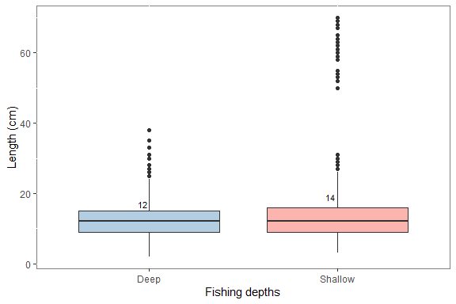

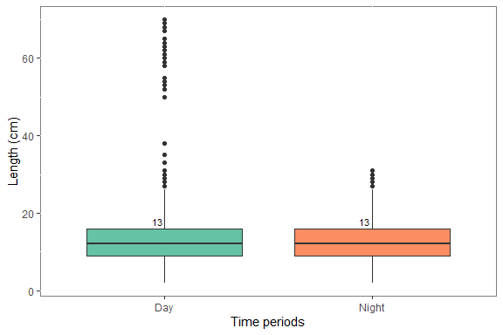

|  | Deep | | | Shallow | | | Comparison |  |
| --- | --- | --- | --- | --- | --- | --- | --- | --- |
| Species | Mean) | SE | n | Mean | SE | n | Difference. | P value |
| Stellifer rastrifer | 9 | 0.18 | 448 | 10 | 0.11 | 541 | -11.11 | 0.997 |
| Stellifer microps | 11 | 0.21 | 418 | 13 | 0.17 | 300 | -18.18 | 0.303 |
| Macrodon ancylodon | 17 | 0.36 | 178 | 17 | 0.29 | 302 | 0.00 | 0.232 |
| Nebris microps | 13 | 0.30 | 172 | 13 | 0.50 | 90 | 0.00 | 0.600 |
| Bagre bagre | 13 | 0.59 | 149 | 9 | 0.32 | 90 | 30.77 | 0.327 |