1️⃣ What is Pandas?
Pandas is a Python library used for data manipulation, cleaning, and analysis.
It provides fast, flexible, and easy-to-use data structures for working with structured data (tables, CSVs, Excel, databases).
Pandas helps you:
- Load data (CSV, Excel, SQL, JSON)
- Clean missing or messy data
- Filter, sort, and transform data
- Perform statistical analysis
- Prepare data for Machine Learning model

2️⃣ What is a DataFrame?
A DataFrame is a 2-D table with rows and columns.
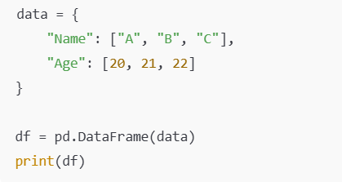

3️⃣ Difference between Series and DataFrame

Feature | Series | DataFrame
Definition | One-dimensional labeled array | Two-dimensional labeled data structure
Shape | 1D (single column) | 2D (rows × columns)
Data type | Can hold one data type at a time | Different columns can have different data types
Columns | ❌ 1 columns (only index + values) | ✅ Multiple columns
Rows (Index) | Has an index | Has both row index and column labels
Analogy | Like one column of a table | Like a full Excel table / SQL table
Creation | From list, array, or single column | From dict, list of dicts, 2D array, CSV, etc.
Use case | Work with a single feature | Work with full datasets

4️⃣ What is CSV?
CSV stands for Comma-Separated Values.
It is a plain text file format used to store tabular data (rows and columns), where each value is separated by a comma (,).

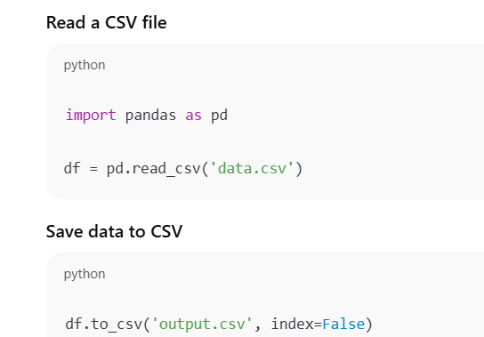

5️⃣ Why is pandas important for AI?
pandas is important for AI because AI models are only as good as the data, and pandas helps you prepare, clean, and understand data before feeding it to models.

1️⃣ Data Cleaning
AI models cannot work with dirty data.
With pandas you can:
- Handle missing values
- Remove duplicates
- Fix incorrect data
- Clean text data
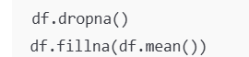

2️⃣ Data Preparation for Machine Learning
Before training an AI model, data must be structured properly.
pandas helps in:
- Selecting features
- Creating new features (feature engineering)
- Encoding categorical text data
- Scaling and transforming columns
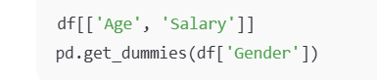

3️⃣ Handling Large Real-World Datasets
AI works on real-world datasets like:
- User behavior data
- Medical records
- Financial transactions
- Text datasets
pandas can:
- Load CSV, Excel, SQL data
- Filter millions of rows efficiently

4️⃣ Data Analysis & Insights
Before building AI, we must understand the data.
pandas allows:
- Statistical summaries
- Grouping and aggregation
- Detecting patterns and bias

5️⃣ Works Seamlessly with AI Libraries
pandas integrates perfectly with:
- NumPy
- scikit-learn
- TensorFlow
- PyTorch

6️⃣ Saves Time & Reduces Errors
Without pandas:
- Data prep takes longer
- Code becomes complex
- More chances of mistakes
With pandas:
✔ Less code
✔ Faster workflow
✔ Cleaner pipelines

