I Single Choice(10 points)
1. ( )For the following program fragment the running time(Big-Oh) is .
i = 0;
s = 0;
while(s <( 5*n*n + 2))
{ i++;
s = s + i;
}
a. O(n) b. O(n²) c. O(n^{1/2}) d. O(n³)

2. ( )Which is non-linear data structure_____.
a. queue b.stack c. tree d. sequence list

3.( )The worst-time for removing an element from a sequence list (Big-Oh) is .
a. O(1) b. O(n) c. O(n²) d. O(n³)

4.( )In a circular queue we can distinguish(区分) empty queues from full queues by .
a. using a gap in the array
b. incrementing queue positions by 2 instead of 1
c.keeping a count of the number of elements
d. a and c
- ( )A recursive function can cause an infinite sequence of function calls if .
  - the problem size is halved at each step
  - the termination condition is missing
  - no useful incremental computation is done in each step
  - the problem size is positive

6．( )The full binary tree with height 4 has nodes.
a. 15 b. 16 c.31 d.32
7. ( )Searching in an unsorted list can be made faster by using .
- binary search
- a sentinel（哨兵） at the end of the list
- linked list to store the elements
- a and c
8.（ ）Suppose there are 3 edges in an undirected graph G, If we represent graph G with a adjacency matrix, How many “1”s are there in the matrix?
a. 3 b. 6 c. 1 d. 9
9. ( ) Construct a Huffman tree by four leaf whose weights are 9, 2, 5, 7 respectively. The weighted path length is___________.
a. 29 b. 37 c. 46 d.44
10. Consider the following weighted graph.
Consider Dijkstra’s algorithm on this graph to find the shortest paths with s as a starting vertex. Which are the first four vertices extracted from the priority queue by the algorithm (listed in the order they are extracted) ?
a. s, y, t, x b. s, y, x, z c. s, t, y, x d. s, y, x, t
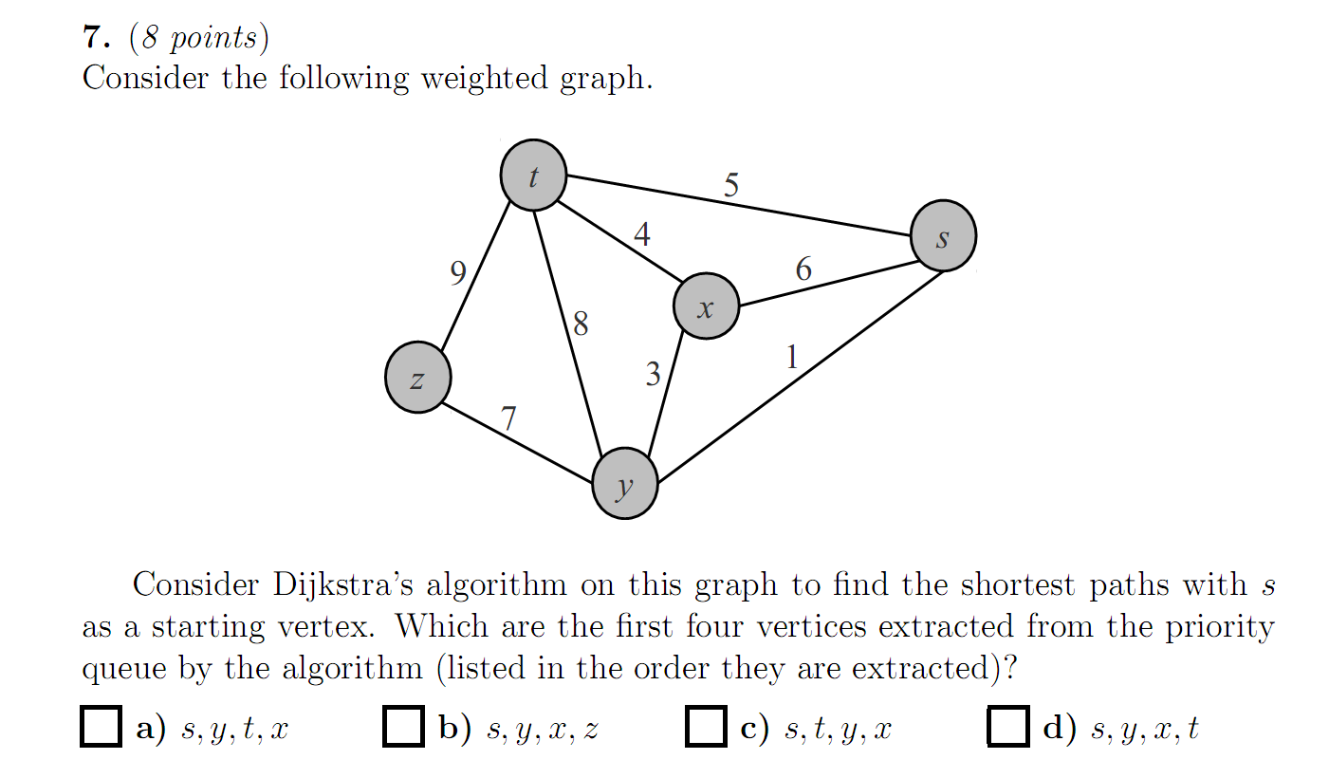
Fig. 1
11. Here is an array of ten integers:
5 3 8 9 1 7 0 2 6 4
Suppose we partition this array using quicksort's partition function and using 5 for the pivot. Which shows the array after partition finishes:
a. 5 3 4 2 1 0 7 9 6 8
b. 0 3 4 2 1 5 7 9 6 8
c. 3 1 0 2 4 5 8 9 6 7
d. 3 1 0 2 4 5 8 9 7 6
e. None of the above

II Fill in Blank (10 points)
1. For the following program fragment the running time(Big-Oh) is .
for ( int i = 0; i < n; i++ )
for ( int j = 0; j < =i; j++)
s; //s为某种基本操作
2. We store a 4×4 symmetric matrix A into an array B with row major order, Store the lower triangle only. the index of element a[2][3] in B is .
3． We can use 3 vector type to store value and of non-zero elements in a sparse matrix.
4. A______________ is a list where removal and addition occur at the same end . Frequently known a LIFO (Last-In-First-Out) structure.
- T( n ) = 2T( n/2 )+ cn, T(n) = T( n-1)+cn, T( n ) = O(___________)
6. There is a binary tree whose elements are characters. Preorder list of the binary tree is “ABECDFGHIJ” and inorder list of the binary tree is “EBCDAFHIGJ”. Postorder traversal sequence of the binary tree is .
7．There are leaf nodes in a full binary tree with n nodes.
8．When the input has been sorted ,the running time of insertion sort(Big-Oh) is .
9．We sort the sequence（43，02，80，48，26，57，15，73，21，24，66）with shell sort for increment 3, the result is ______ _ .
10、In a circular queue, “front” and “rear” are the front pointer and rear pointer respectively. Queue size is “maxsize”. When insert an element in the queue, rear = _________
11. A ____________________________________________ is an example of a search tree which is multiway (allows more than two children).
12. A tree in which every node is no smaller than its children is termed ______________________.

III Application of Algorithms （35 points）

1.Graph G shown in Fig 2 is a directed graph, please describe G with adjacency matrix and write the orders of breadth first traversal and depth first traversal.

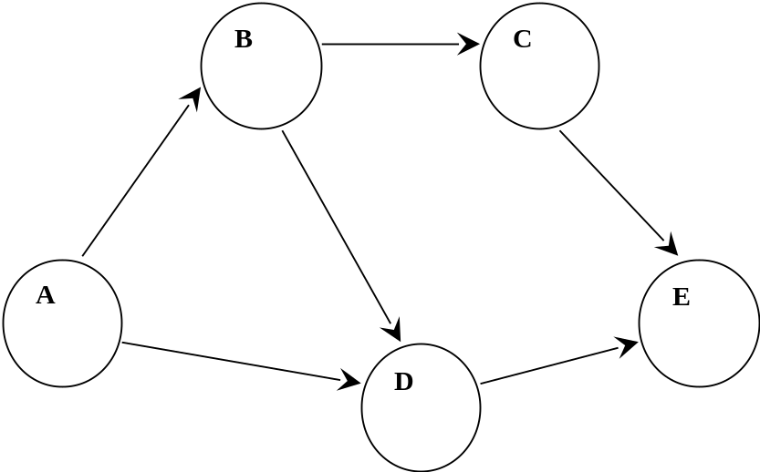
Fig.2

2．The sequence of input keys is shown below:
19，1，23，14，55，20，84，27，68，11，10，17
A fixed table size of 19 and a hash function H(key)=key%13，with linear probing(线性探测), fill the table below and compute the average length of successful search.

3. Show the results of inserting 53,17,78,09,45,65,87 each , one at a time, in a initially empty max heap（大根堆）

4. write the sequence of preorder,postorder traversals and add inorder threads in the tree.

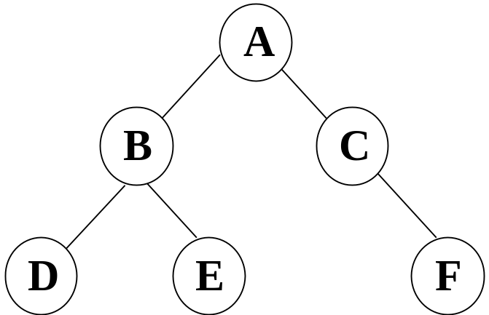
Fig. 3
5. Build a Huffman tree and determine Huffman code when the probability distribution(概率分布) over the 8 alphabets ( c1, c2, c3, c4, c5, c6, c7, c8 ) is (0.05, 0.25, 0.03, 0.06, 0.10, 0.11, 0.36, 0.04

6. Graph G shown in Fig 4 is a directed graph, please describe G with adjacency list and write topological ordering.
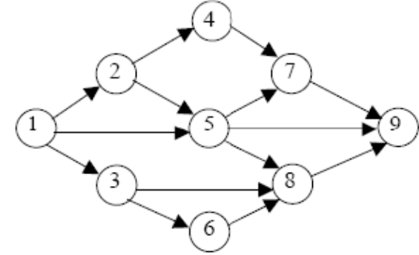
Fig. 4

IV Fill in blank of algorithms. （15）
- Here is single source shortest path algorithm Dijkstra. Fill in blank of the algorithm.
class Graph { //图的类定义
private:
float Edge[NumVertices][NumVertices];
float dist[NumVertices]; //最短路径长度数组
int path[NumVertices]; //最短路径数组
int S[NumVertices]; //最短路径顶点集
public:
void ShortestPath ( int, int );
int choose ( int );
};
void Graph :: ShortestPath ( int n, int v ){
//在具有 n 个顶点的带权有向图中, 各边上权值由Edge[i][j]给出。建立一个数组: dist[j], 0 ≤ j < n, //保存从顶点 v 到顶点 j 的最短路径长度, 同时用数组path[j], 0 ≤ j < n, 存放求到的最短路径。
for ( int i = 0; i < n; i++) {
dist[i] = Edge[v][i]; //dist数组初始化
S[i] = 0;
if ( i != v && dist[i] < MAXNUM) path[i] = v;
else path[i] = -1; //path数组初始化
}
S[v] = 1; dist[v] = 0; //顶点v加入顶点集合
//选择当前不在集合S中具有最短路径的顶点u
for ( i = 0; i < n ; i++ ) {
float min = MAXNUM; int u = v;
for ( int j = 0; j < n; j++ )
if ( !S[j] && dist[j] < min )
{ u = j; min = dist[j]; }
S[u] = 1; //将顶点u加入集合S
for ( int w = 0; w < n; w++ ) //修改
if ( !S[w] && Edge[u][w] < MAXNUM && dis[w] > (min+Edge[u][w]) ) {
dist[w] = min + Edge[u][w] ;
path[w] = u;
} }
}
3．Consider the following function to balance symbols stored in string exp that includes parentheses（圆括号） and numbers.Please Fill in blank.
#include <stack>
Using namespace std;
int matching(string &exp) {
//exp is a pointer to a string to check
int state = 1,i=0;
char e;
stack<char> s;
while ( i<exp.length() && state )
switch (exp[i]) {
case '(':
s.push(exp[i]) ;
i++;
break;
case ')':
if ( !s.empty() && s.front()==’(’ ) {
s.pop(); i++; }
else
state = 0; //an error occurs
break;
default:
i++; break;
} //end of while

if ( state && s.empty() ) return 1;
else return 0;

V Programming （30）

1. Write efficient functions (and give their Big-Oh running times)that take a pointer to a binary tree root T and compute:
  - The number of leaves of T
typedef struct BiTNode
{ TElemType data;
struct BiTNode *lchild,*rchild;
} BiTNode , *BiTree;

2.Write a method called maximumDegree of an undirectedh graph that returns the maximum degree of any vertex in the graph. The graph is stored with adjacency matrix. Write the definition of the graph. implement the function. Analyze space complexity and time complexity of your function.

3. Write a function with linked list that inserts a number into a sorted linked list. Firstly, you should write a function creates a list that like this:
L={3,5,8,12,32,48}
and then insert 25 into this list.

答案解析0-0，仅供参考，若有不同意见请联系QQ767954870☆_☆

有两点错误:
①填空2：存储下三角矩阵时，求二维a[i][j]存储在一维数组里时index计算公式如下：
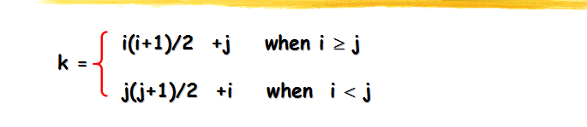
本题忘记了只存下三角所以a[2][3]要转化为a[3][2]来存储，
所以答案应该为3*(3+1)/2+2=8

②算法应用2: hash那题正确答案应该如下：
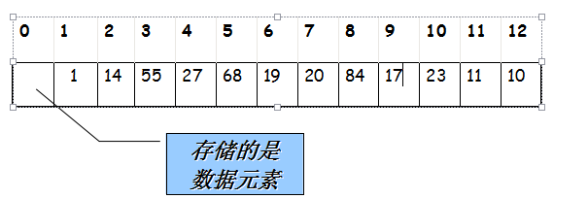

average length search = (1+1+1+2+1+1+3+4+3+1+3+6)/12=2.25次

选择题：1-5:ACBDB 6-11:CBBDDE
- 知识点：复杂度分析，必考
思路：复杂度主要计算算法的步数，可以看出，当前循环执行的步数与i的值是相等的，所以可列1+2+..+i=(5*n*n+2)，复杂度的计算忽略常数, (1+i)*i/2=(5*n*n+2), i ~ O(n)
- 知识点：non-linear与linear的区别
- 知识点：复杂度分析+线性序列
思路：很显然，当元素在sequence list的末尾的时候，removing元素复杂度最高O(n)
4、知识点：循环队列(circular queue)，重点
思路：主要区分循环队列判断空与满的条件。
主要有三个方法
①count计数，判断当前队列的元素与maxsize的大小
②vis标志，比如可以一开始设vis=0,满时设置vis=1
③就是题目中说的gap(....重点)
front代表头指针,rear代表尾指针
循环队列空时：front == rear; 满时：front == (rear+1)%maxsize
- 知识点：递归的定义,termination missing，终止条件缺失则可能无限调用。
- 知识点：完全二叉树(complete binary tree)与满二叉树(full binary tree)的区别
思路：学院PPT上有如下定义
depth of a node: number of ancestors
height of a tree: maximum depth of any node
并且有结点计算公式： 2^{h+1}-1(其中h为树的高度，与某XX百度定义树的高度 不一样，且照学院教材来做= =)
所以ans:2⁴⁺¹-1=31
- 知识点：查找
思路：有疑问的题...
单纯来说二分查找(binary search)的速度O(logN)是比较快的，可是题目仅仅要求 Searching in an unsorted list,只进行一次查找，那我们用二分还要先进行排序 O(NlogN)+O(logN)的复杂度是不如选项b的。
sentinel(哨兵...)的概念可见ppt讲插入排序的地方，貌似能加快查找速度吧...
- 知识点：图的邻接矩阵存储
思路：注意题目所问，无向图(undirected graph),每条边都是要存储两遍的
- 知识点：哈夫曼树(Huffman tree)
思路：离散上学过的。。。
weighted path length = 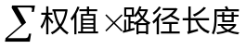
所以ans=9*1+7*2+5*3+2*3=44(自己构造哈夫曼树》。《)
- 知识点：Dijkstra/最短路,重点
- 知识点：快排,重点
10、11两题是重点，限文字难于描述清楚，请自主学习%>_<%
注意10题在priority_queue里进行更新时一开始肯定加入s、y结点，而后x结点会因 为松弛操作从而距离变为1+3=4<5(t结点)，所以x结点会比t结点先压入队列。

- 填空题
- O(n²)
- 8 数组元素存储地址的计算。注意题目中规定存储下三角矩阵lower triangle only
- location 在稀疏矩阵中sparse matrix，如果对每个元素都进行存储的话空间复杂度为 O(N²)，因为好多位置没有值所以这会造成空间的极大浪费。可以用题目所说的，只存 储有值元素的值与位置(即i,j下标)。
- stack 栈(stack)与队列(queue)的区别，重点
- 题目有问题。
正确问法应该是这样：
T( n ) = 2T( n/2 )+ cn, T( n ) = O(____logn_____)
T(n) = T( n-1)+cn, T( n ) = O(_____n______)
时间复杂度计算。
对题目有点疑问，故此题答案不确定。(不清楚这是按递归还递推进行计算得出，还有 cn中的n是下标还cn相乘。)
对于T( n ) = 2T( n/2 )+ cn，可以这样想，每次计算T(n)都会转化为2*T(n/2)+cn,对于T(n/2) 又会转化为T(n/4)的计算，如此计算下去，其实就是按2的指数次幂的程度在递减。可 以自己举个例子，比如计算T(16)，那计算过程为T(16)->T(8)->T(4)->T(2)->T(1),所以计 算次数为log16=4,类似T(n) = T( n-1)+cn的复杂度可以计算。
- 树的前、中、后序遍历，重点
首先要明白前、中、后序遍历是根据根的位置决定的，比如前序遍历就是(根左右)，中 序遍历为(左根右)....
首先你得能很熟练的写出一棵树的前、中、后序遍历(preorder、inorder、postorder)，然 后可以进行一下分析，对于前序遍历ABECDFGHIJ，中序遍历EBCDAFHIGJ，由前序 遍历可知根结点肯定为A，那么从中序遍历里面可以以A为中点进行分割，左边的部 分必定属于左子树，右边的部分肯定属于右子树，然后进行一步步分割，自己多尝试一 下就ok了
构造树如下：
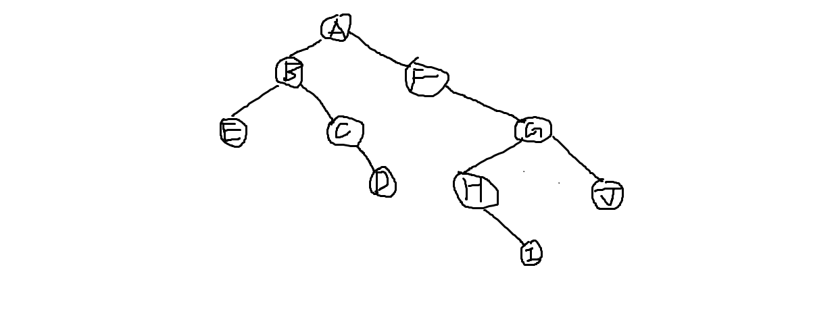
所以后序遍历为:EDCBIHJGFA
ps:已知前序遍历和后序遍历，不能确定唯一的中序遍历
- n/2+1
满二叉树,设叶子层leaf node为第p层，则非叶子结点2⁰+2¹+2²+...+2^{p-1} = 2^{p}-1
叶子结点：2^{p}
若总结点为n,那叶子结点为n/2+1
ps:有好多种答案，比如(n+1)/2,n/2取下界等。
- O(N)
关于插入排序，最好的情况就是序列已经有序，那就少去了比较的步数，直接进行 n个元素的插入，故复杂度为O(N)
9、15 02 21 24 26 57 43 66 80 48 73
希尔排序。每个数与增量处进行大小比较若大于则交换。
- (rear+1)%maxsize
前面讲过
11、B树
B树相对来说复杂一点，只会这样考了。。= =
- 大顶堆
大顶堆的定义，如题目所说
- 算法应用题
1、
邻接矩阵为：
A B C D E
A 0 1 0 1 0
B 0 0 1 1 0
C 0 0 0 0 1
D 0 0 0 0 1
E 0 0 0 0 0
dfs序列:ABCED
bfs序列:ABDCE
考点、重点：图的存储及dfs、bfs序列。
区分dfs与bfs，dfs为走子结点走到不能走为止，bfs为要先走遍所有的邻居结点。

- 考点：hash
hash序列如下
average length search = (1+1+1+2+1+1+3+4+3+1+3+6)/12=2.25次
(ps:hash这一章我们班还没有学,答案仅是靠自己感觉写的,当某链只有一个元素时 查询长度为1= =)
3、考点：大根堆的构造
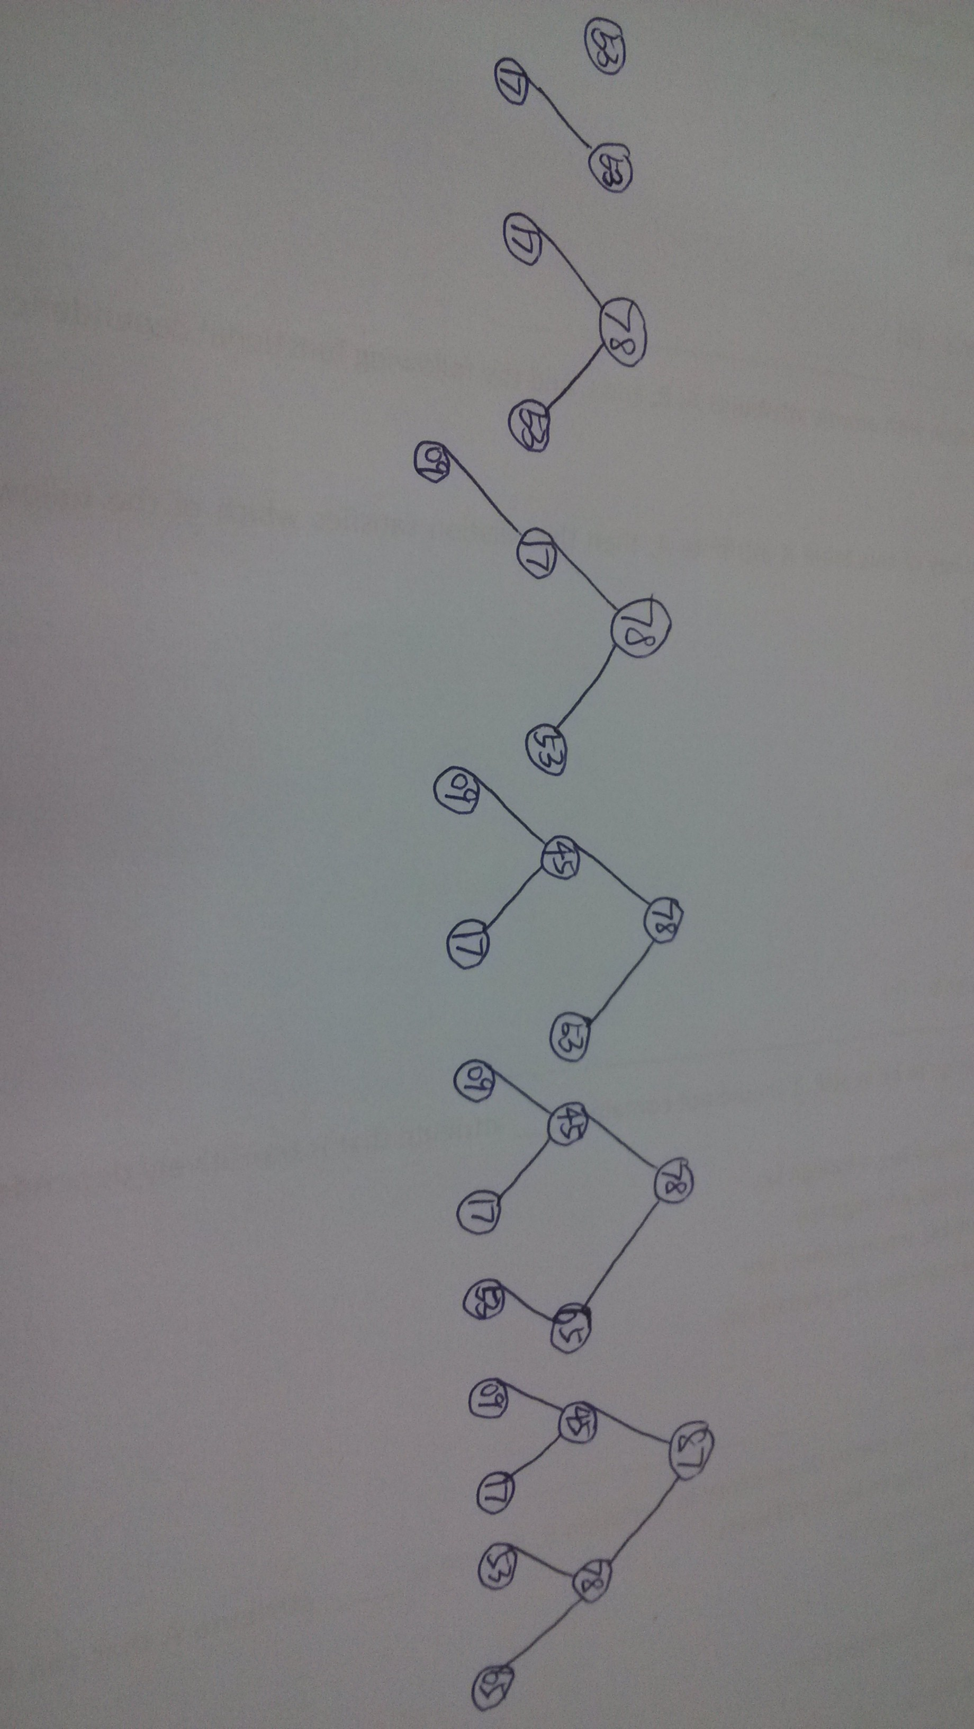
- 考点：前、中、后序遍历+线索树
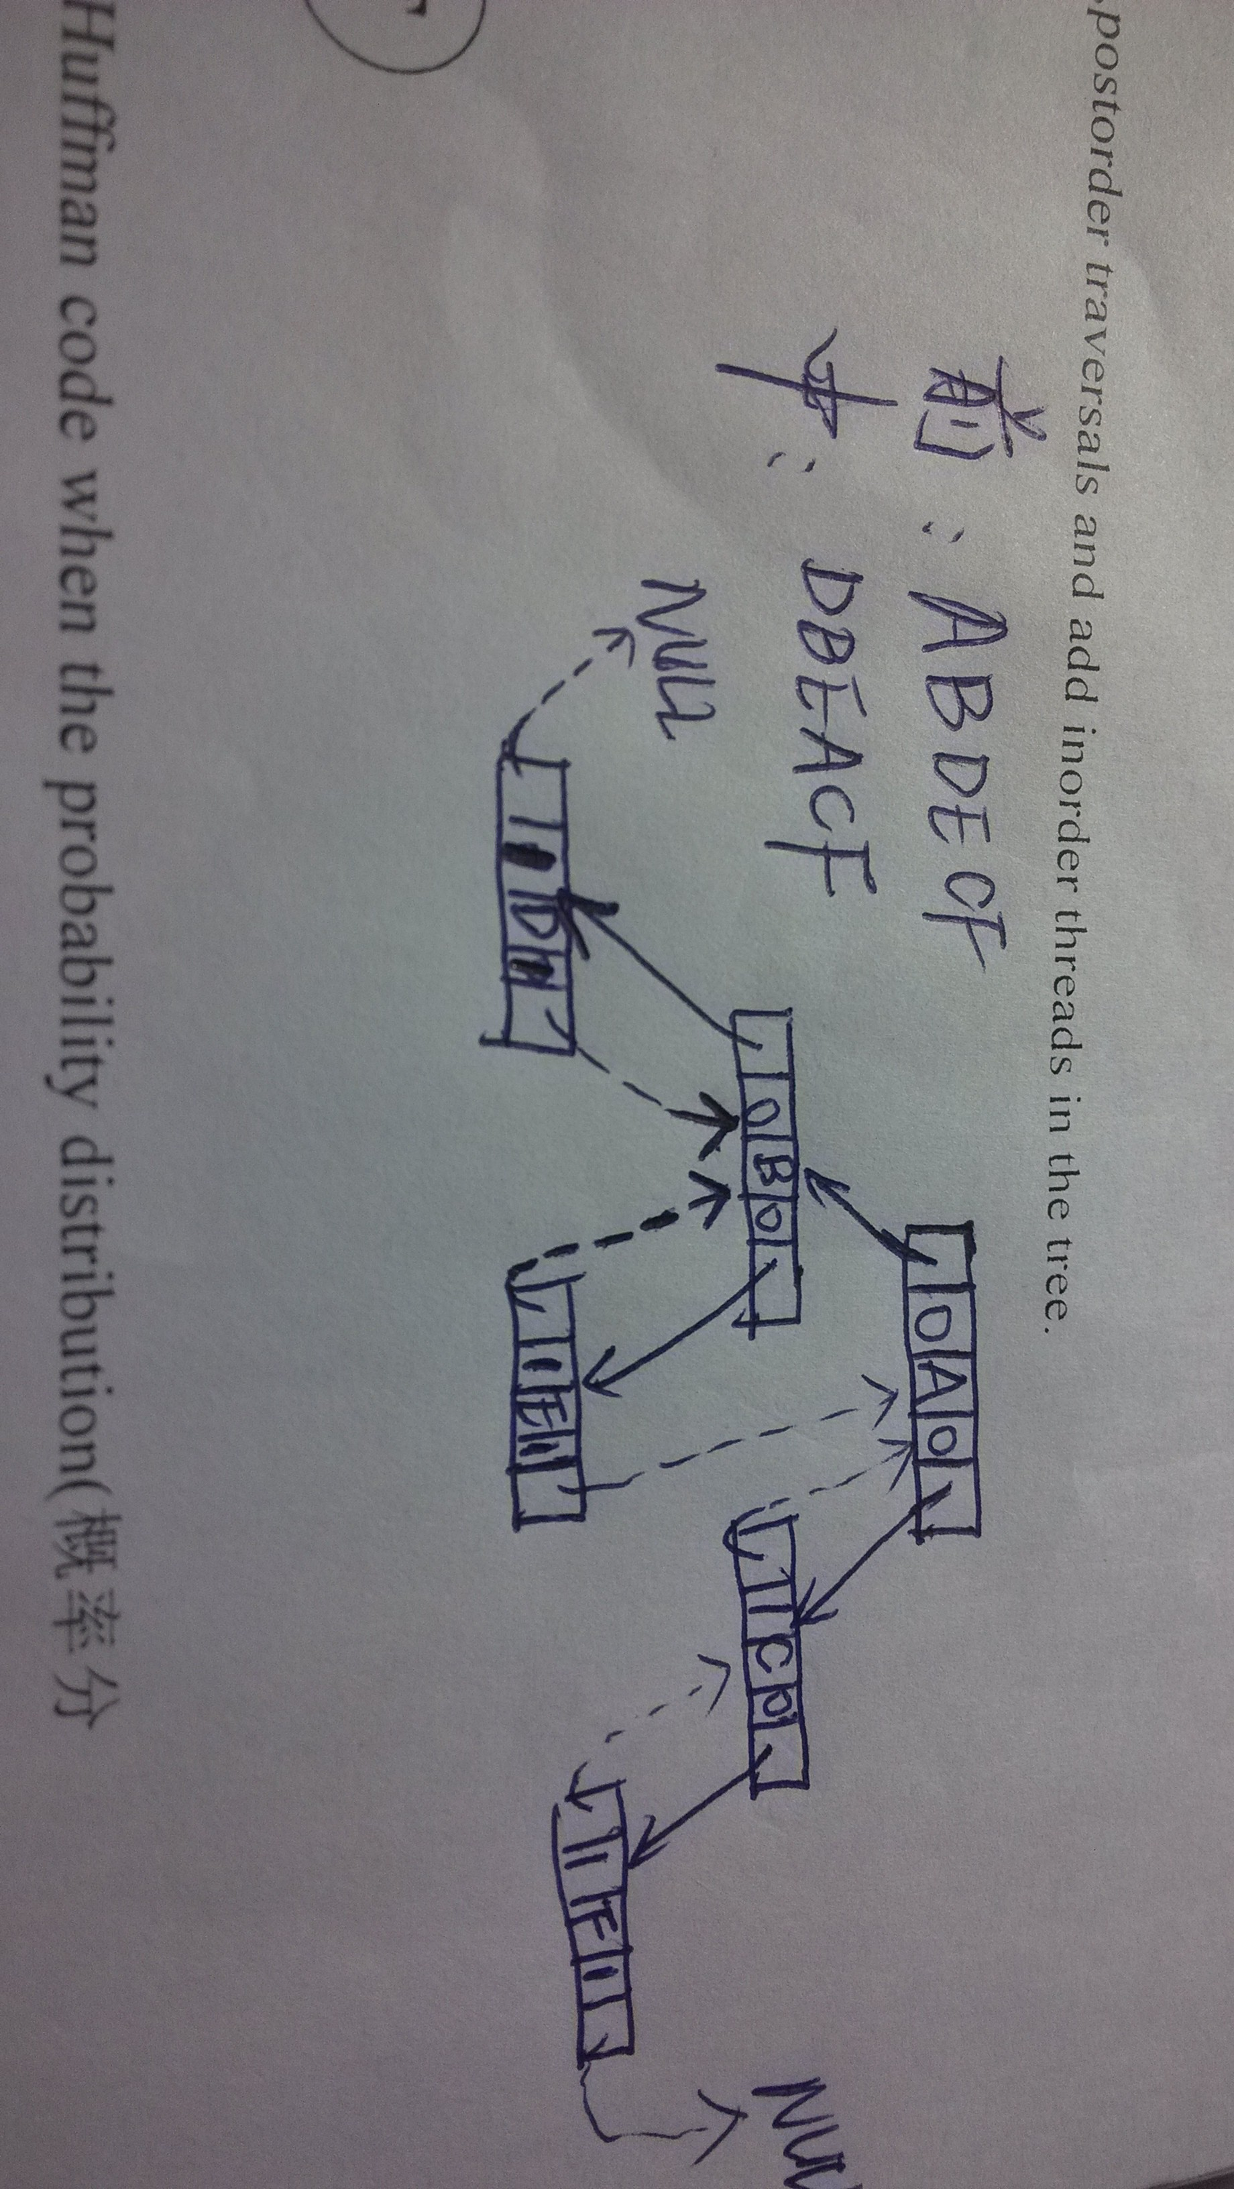

- 考点：哈夫曼树
构造树如下：
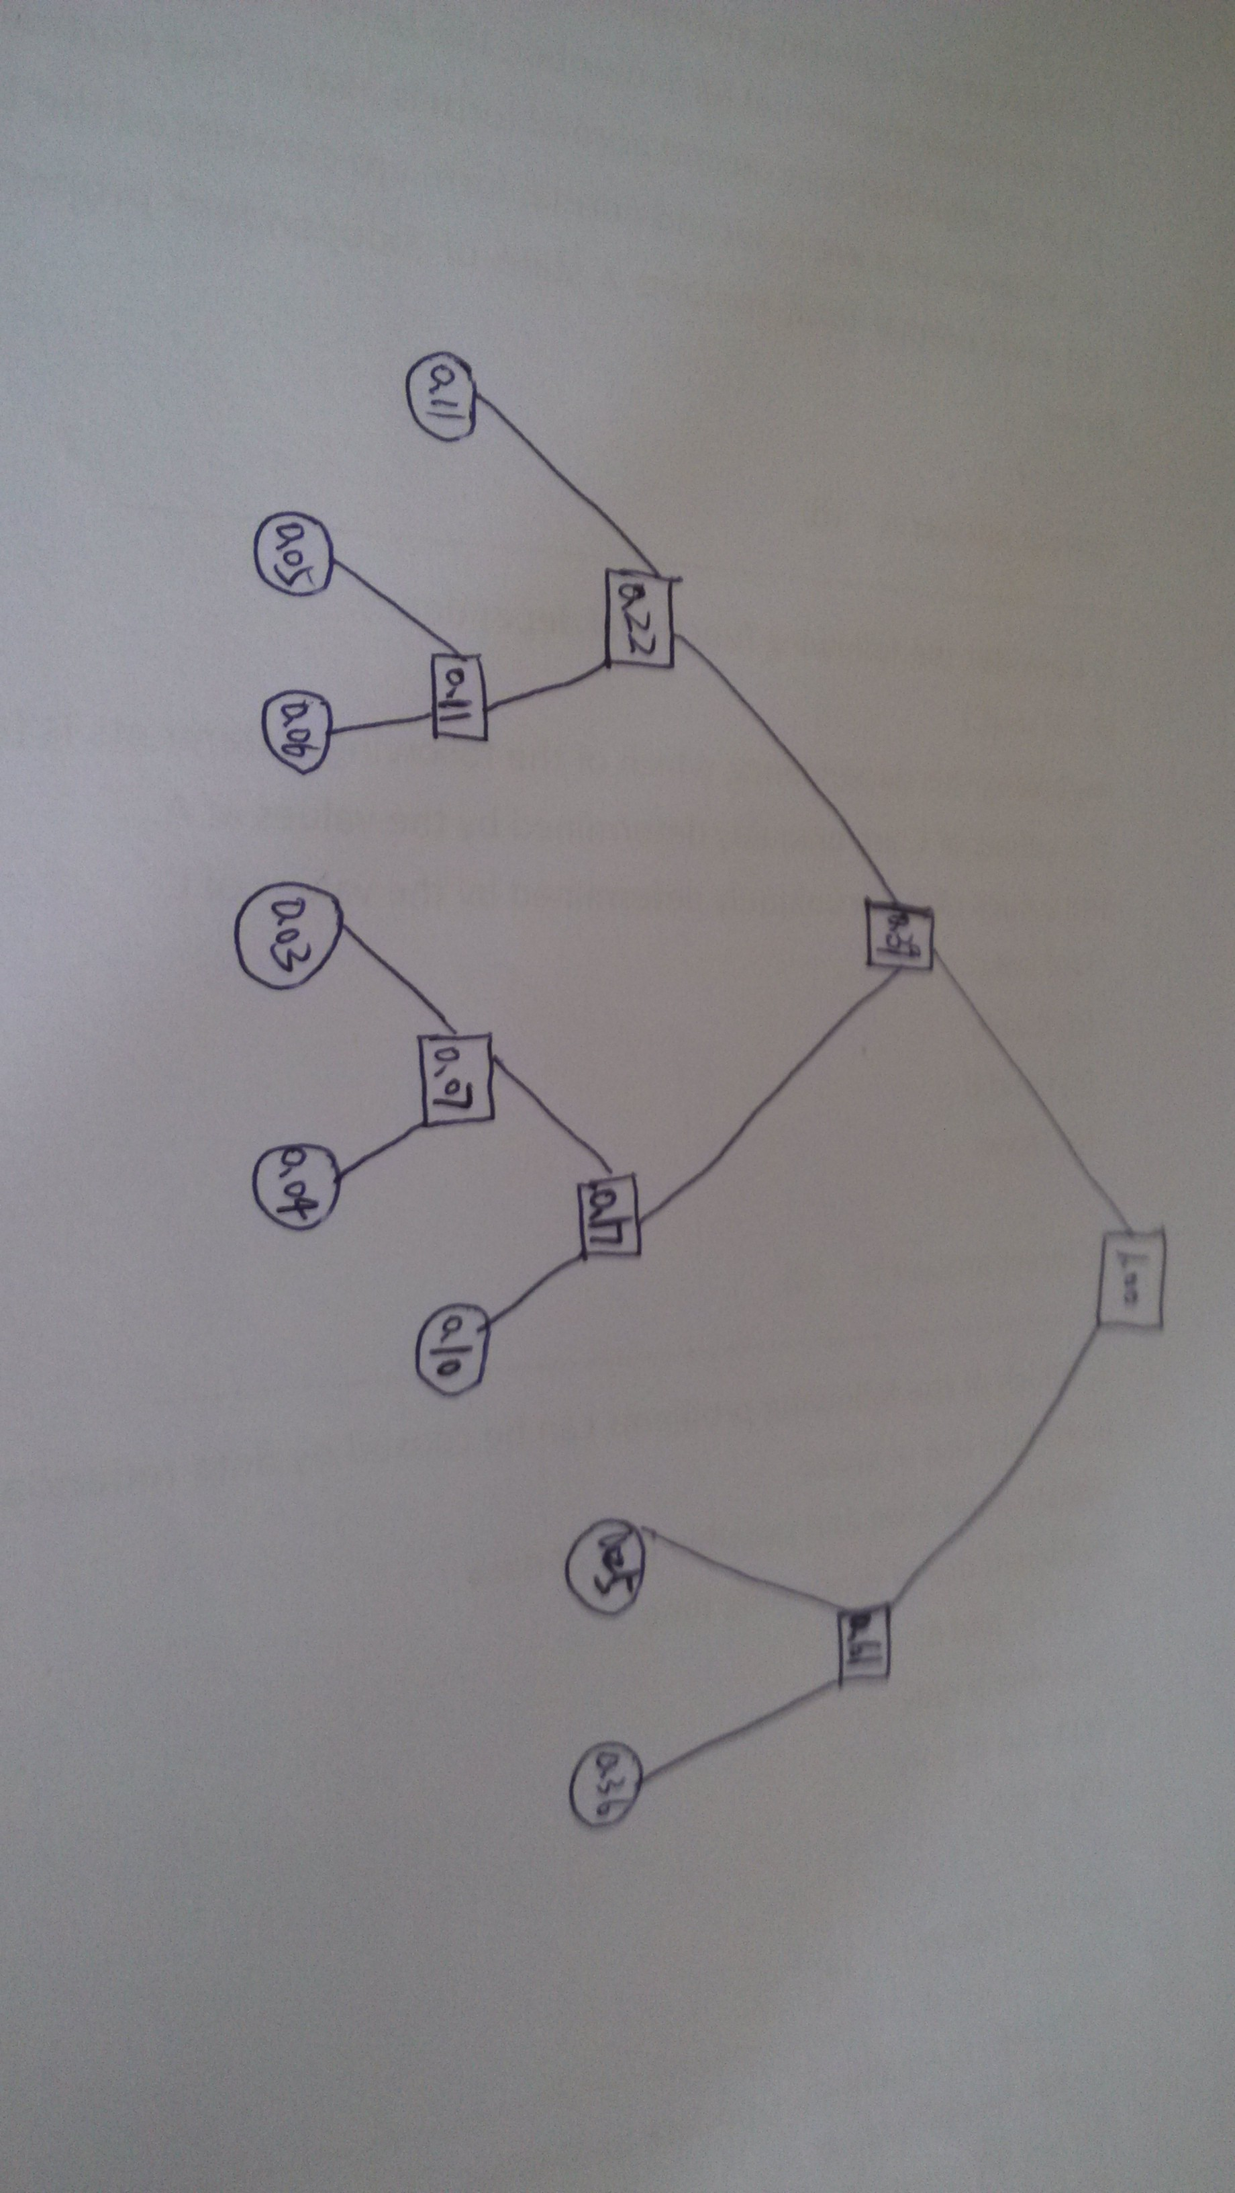

- 考点：拓扑排序
邻接表如下：
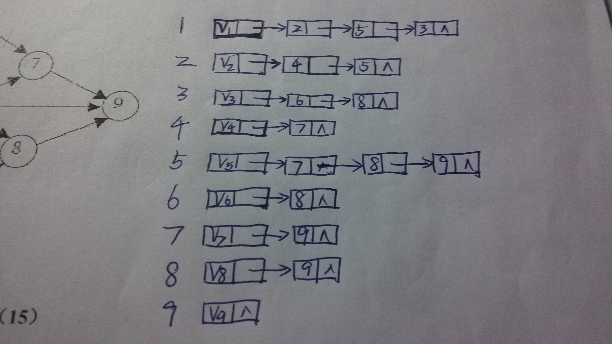
邻接表形式如上，构造拓扑序列的算法请自行看书，
主要是对入度为0的结点进行压队列(或栈)
一个可能的答案为：1 2 3 4 5 6 7 8 9

V、编程题
以下所有代码均为大致思路代码，细节请忽略(~~~)
- 计算叶子结点数
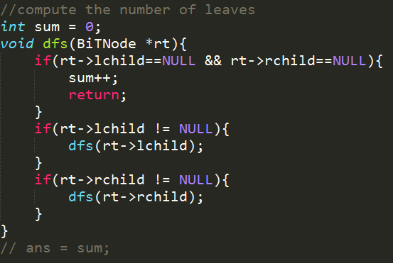
- 求无向图最大度数结点
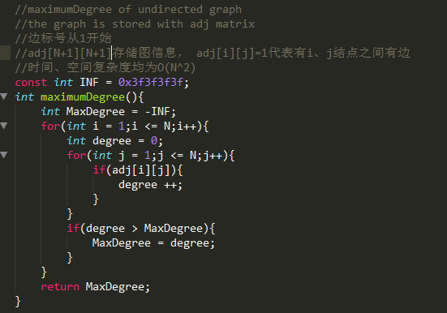
- 裸链表？随便写写。。
