**软件测试课堂测验**

第一次测验：

**一、Consider an application App that takes two inputs name and age, where name is a nonempty string containing at most 20 alphabetic characters and age is an integer that must satisfy the constraint 0≤age≤120. The App is required to display an error message if the input value provided for age is out of range. The application truncates any name that is more than 20-character in length and generates an error message if an empty string is supplied for name.**

**（1）Please find out the equivalence classes（等价类）. （30分）**

**（2）Construct test cases using the equivalence classes derived in（1） （20分）**

答案：

（1）等价类划分：

|  |  |  |
| --- | --- | --- |
| 输入 | 合理等价类 | 不合理等价类 |
| Name | 1. 0<name.length<20; 2. 全部是字母 | 3. name为空  4. name长度>20  5. name中包含非字母 |
| age | 1. 0<age<120; 2. Age是整数 | 8. age<0  9. age>120  10. age不是整数 |

（2）测试用例：

|  |  |  |  |
| --- | --- | --- | --- |
| 测试用例编号 | Name | age | 期望输出 |
| 1 | Wefree | 19 | 正常输出 |
| 2 |  | 19 | Invalide input |
| 3 | wefreewefreewefreewefreewe | 19 | Invalide input |
| 4 | @abc | 19 | Invalide input |
| 5 | wefree | -1 | Invalide input |
| 6 | wefree | 123 | Invalide input |
| 7 | wefree | 19.1 | Invalide input |

**二、Consider a method fp, brief for findPrice, that takes two inputs code and qty. The item code is represented by the integer code and the quantity purchased by another integer variable qty. fp accesses a database to find and display the unit price, the description, and the total price of the item corresponding to code. fp is required to display an error message, and return, if either of the two inputs is incorrect. Assuming that an item code must be in the range 99…999 and quantity in the range 1…100.**

**Please give your test cases using boundary-value analysis. (50分)**

答案：

边界值分析：

Code={99,100,500,998,999}

Quantity={1,2,50,99,100}

测试用例：

（注：正常输出的意思是输出“the unit price, the description, and the total price”。）

|  |  |  |  |
| --- | --- | --- | --- |
| 测试用例编号 | Code | Quantity | 期望输出 |
| 1 | 500 | 1 | 正常输出 |
| 2 | 500 | 2 | 正常输出 |
| 3 | 500 | 50 | 正常输出 |
| 4 | 500 | 99 | 正常输出 |
| 5 | 500 | 100 | 正常输出 |
| 6 | 99 | 50 | 正常输出 |
| 7 | 100 | 50 | 正常输出 |
| 8 | 998 | 50 | 正常输出 |
| 9 | 999 | 50 | 正常输出 |

**三、Develop a decision table for the descriptions below:**

**No charges are reimbursed（报销）to the patient until the deductible（扣除） has been met. After the deductible has been met, the amount to be reimbursed depends on whether or not the doctor or hospital is a "Preferred Provider." For preferred providers Doctor's office visits are reimbursed at 65% and Hospital visits are reimbursed at 95%. For other providers reimburse 50% for Doctor's Office visits or 80% for Hospital visits.**

答案：

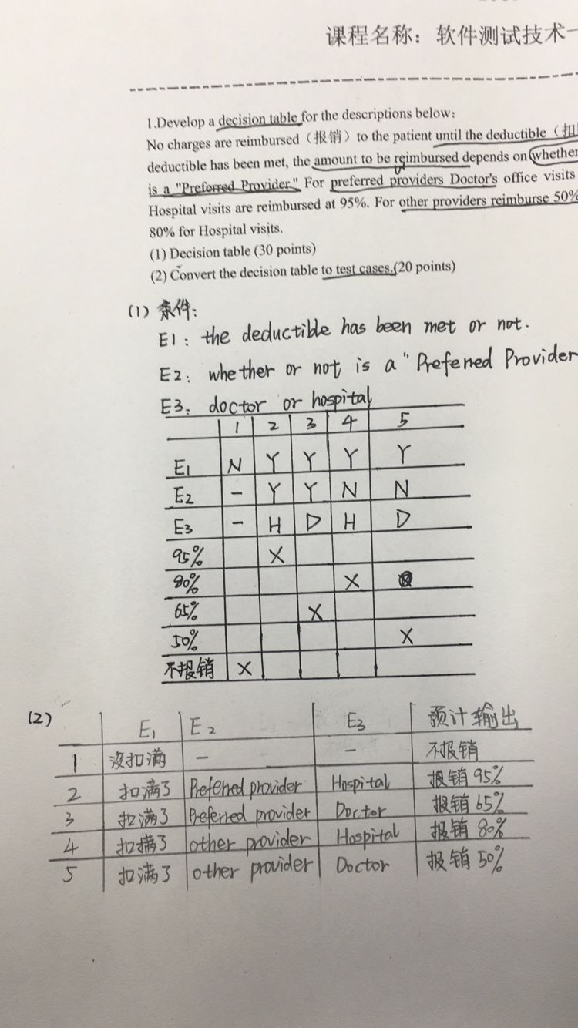

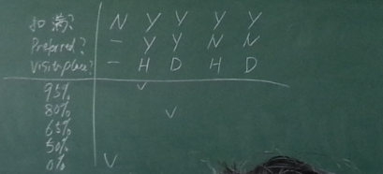

**四、Develop a decision table for the YesterDate function.**

答案：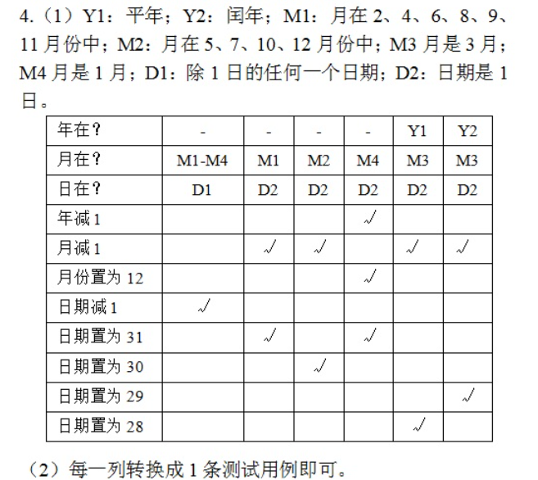

**五、Cause-Effect Testing：In a given network, the sendfile command is used to send a file to a user on a different file server. The sendfile command takes three arguments: the first argument should be an existing file in the sender’s home directory, the second argument should be the name of the receiver’s file server, and the third argument should be the receiver’s userid. If all the arguments are correct, then the file is successfully sent; otherwise the sender obtains an error message.**

答案：

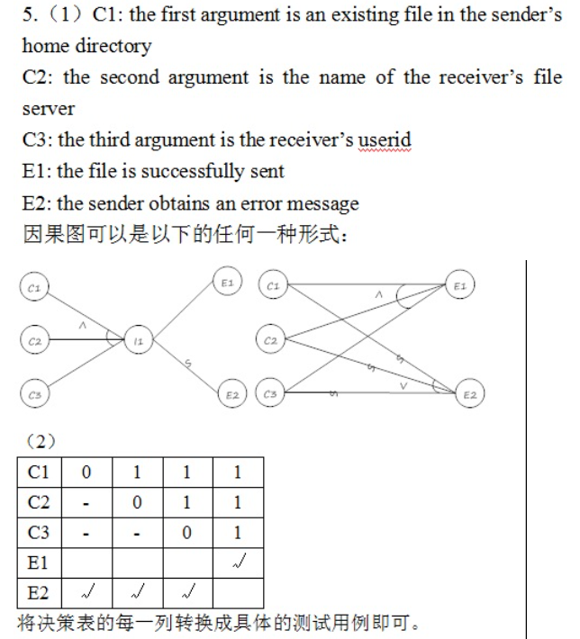

**六、中国象棋走马下法：**

**1. 如果落点在棋盘外，则不移动棋子；**

**2. 如果落点与起点不构成日字形，则不移动棋子；**

**3. 如果落点处有自己放棋子，则不移动棋子；**

**4. 如果在落点方向的邻近交叉点有棋子（绊马腿），则不移动棋子；**

**5. 如果不属于1-4，且落点处无棋子，则移动棋子；**

**6.如果不属于1-4，且落点处为对方棋子（非老将），则移动棋子并除去对方棋子；**

**7. 如果不属于1-4，且落点处为对方老将，则移动棋子，并提示战胜对方，游戏结束。**

**请画出因果图，并转换成判定表。**

答案：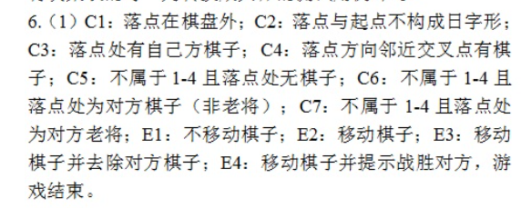

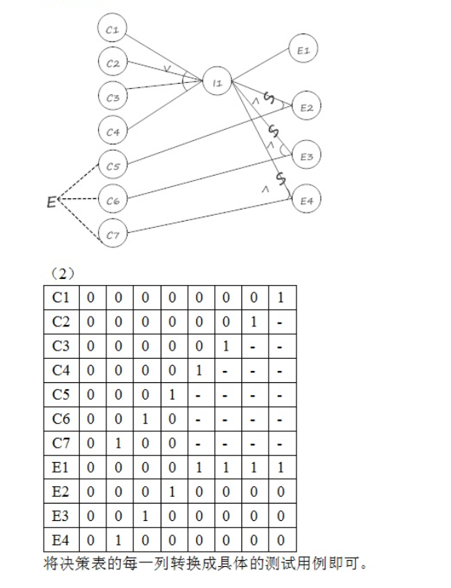

**七、Consider a web page with three distinct sections(Top, Midddle, and Bottom) that can be individually shown or hidden by the user. Please use orthogonal array testing to test the interactions of the different sections.**

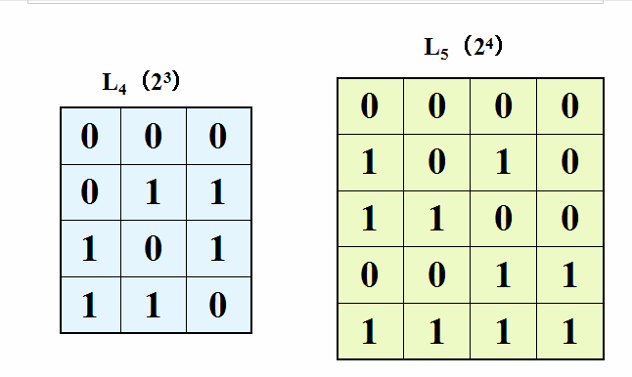

答案：

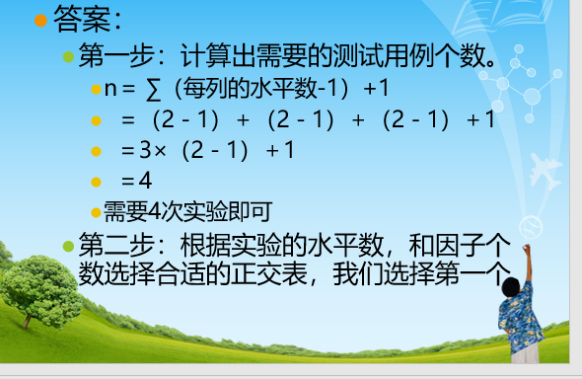

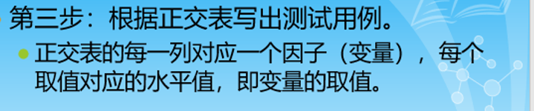

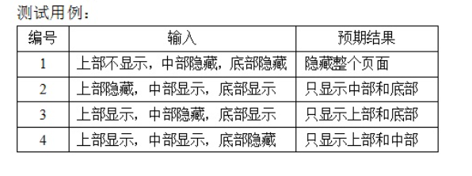

第四次：

**八、某电力公司有A、B、C、D共四类收费标准，并规定：**

**居民用电每月200度以下按A类收费，200度以上按B类收费。**

**动力电以每月1万度为分界：**

**非高峰用电不足1万度按B类收费，达到或超过1万度按C类收费。**

**高峰用电不足1万度按C类收费，达到或超过1万度按D类收费。**

**给出控制流图，并设计满足条件组合覆盖的测试用例。**

答案：

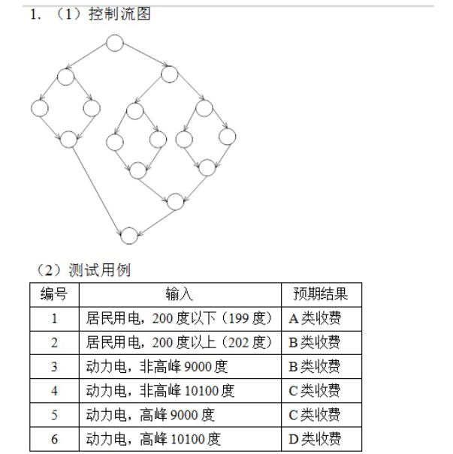

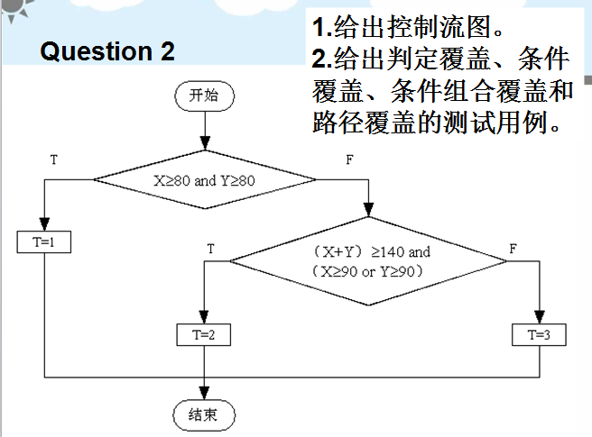

答案：

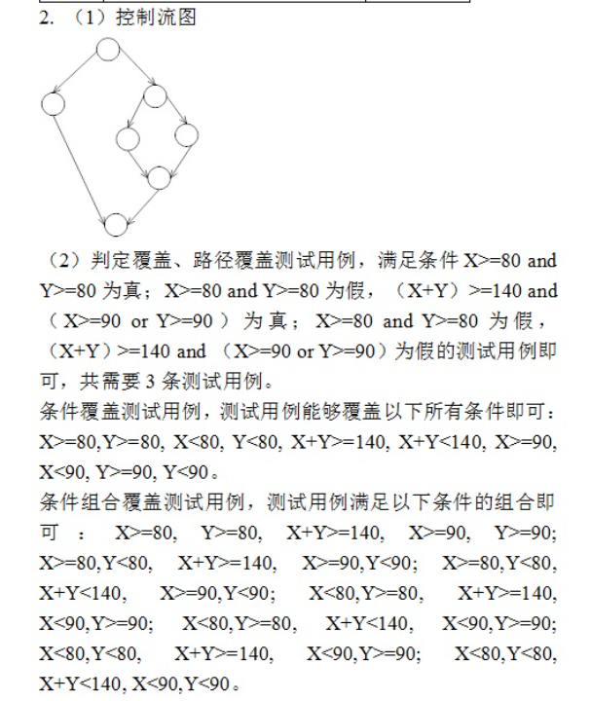

**九、**

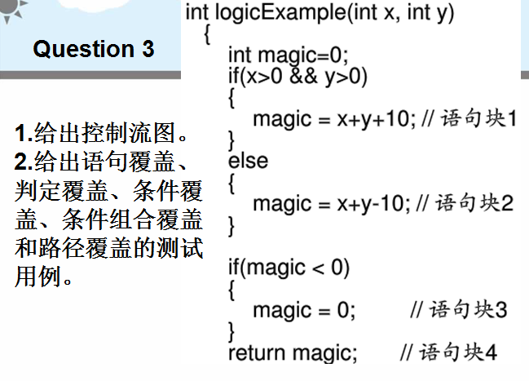

答案：

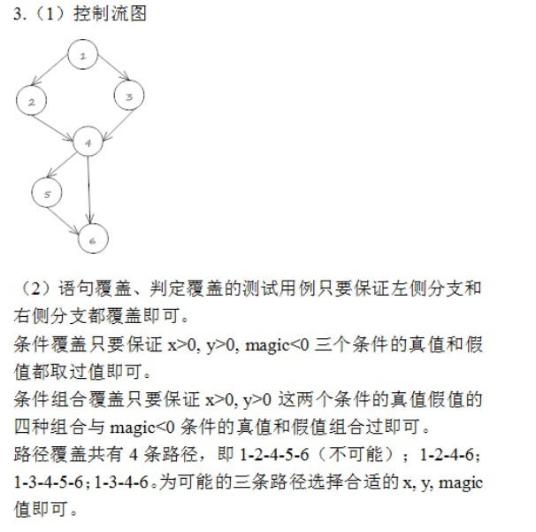

第五次：

**十、**

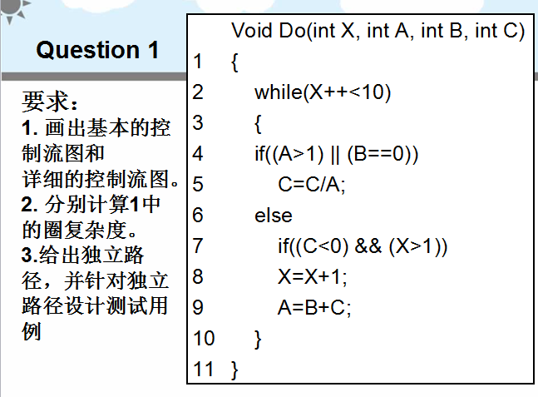

答案：

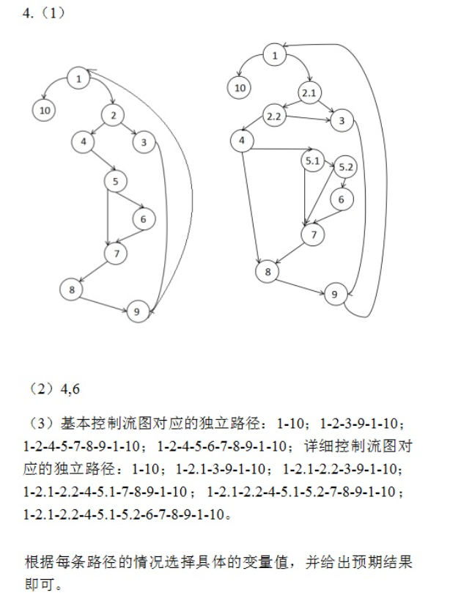

**十一、**

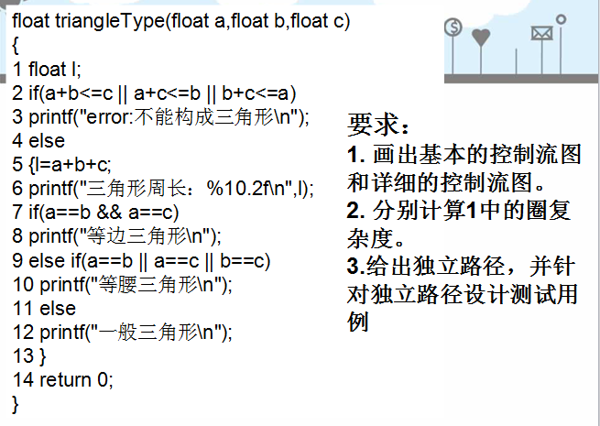

答案：

