Colluding against workers  
  
*Journal of Political Economy*  
2025 (Volume 133), June (No.6)

Vincent Delabastita and Michael Rubens, heavy lifting of drafting the memo is done by claude 4 sonnet, overseen by me

June 17, 2025, 09:06 +0900

[doi.org/10.1086/734780](https://doi.org/10.1086/734780)

## Summary

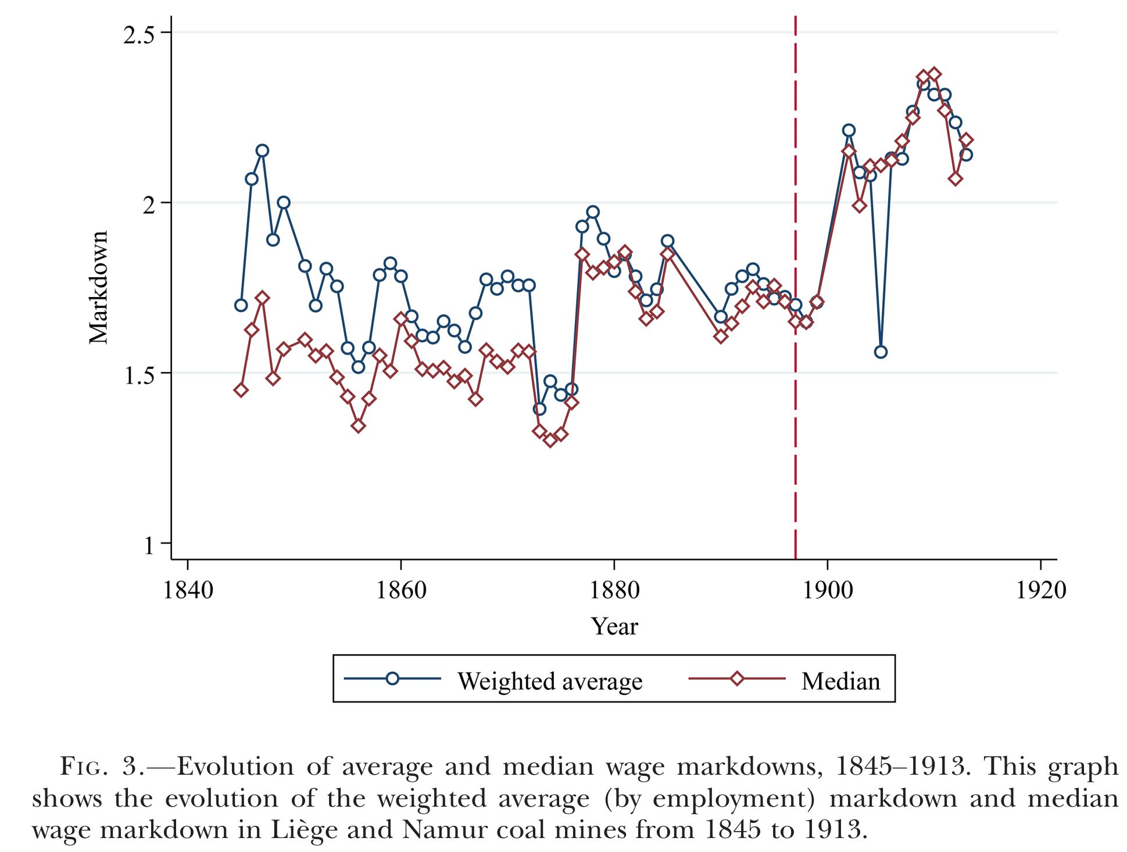

Wage markdown

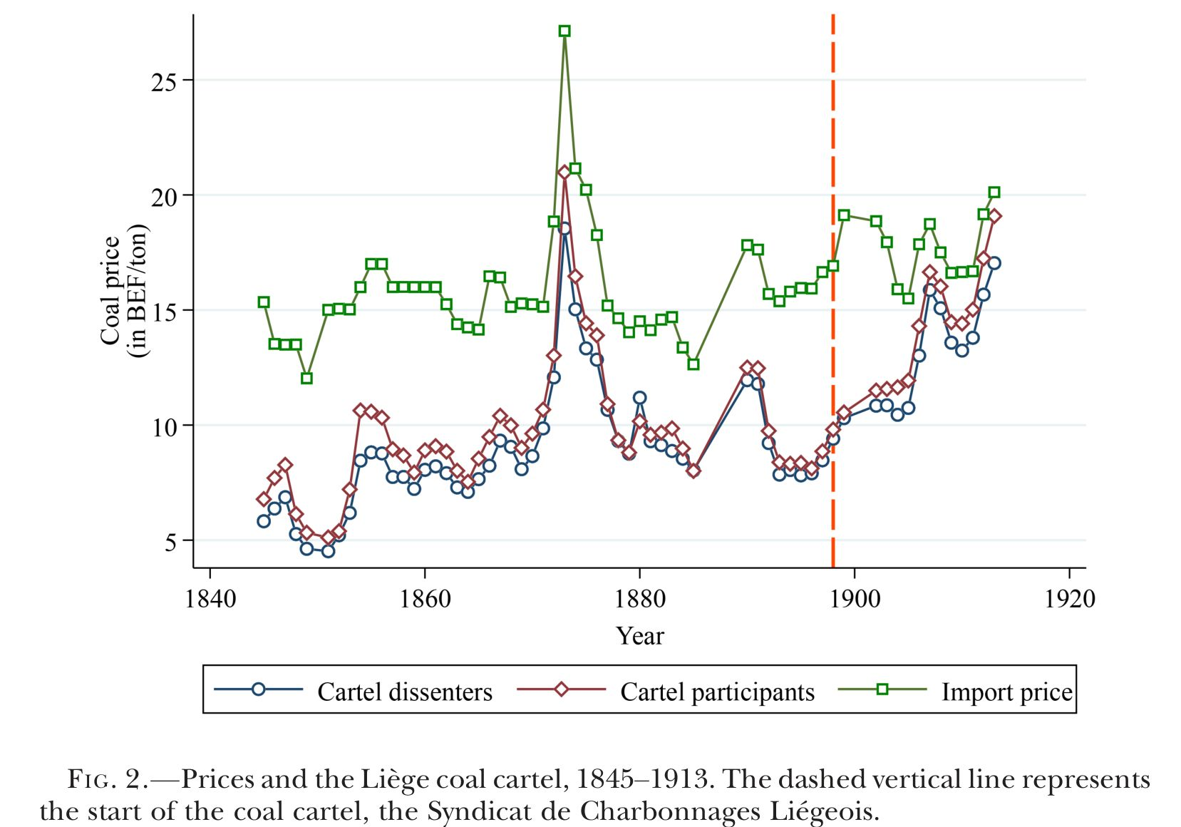

coal prices

* Workers are paid 67% - 45% of MRPL at the turn of 20th century Belgium coal mines
* Descriptive stat: Cartel ⇒ $P$ ↑ ⇒ wage markdown $\frac{MRPL}{W}$ ↑
* Regime change: Employer Association→coal price cartel
* Observe: Wage markdown estimates vs. “collusion” regime change
* Claim: Collusion↑ ⇒ markdown↑
* Literature: Friction, factor market power ⇒ wage markdown
* New: Downstream/employer collusion ⇒ upstream wage markdown

## Why the wage markdown matters

* Intrinsic interest: Is labour exploited?
* Analytical interest:
  + How big is the welfare (deadweight) loss?
  + Markdown↑, markups↑ ⇒ TFP↓, inflation↑[1]
* Need to look at both ends: An exploited (from steel plants, railways) needs to be an exploiter (coal mine)
* Measurement issue: What does the markup formula give under the upstream and downstream market power?

An extreme case: Monopsonistic-monopolistic profit maximisation (Syverson 2024)

FOC[2]

Markdown

So[3] [4]

Note , so

$$μ^{x}μ=\frac{θ_{x}}{α^{x}}$$

The popular markup formula $\frac{θ_{x}}{α^{x}}$ gives a product of markdown and markup.

$\frac{θ_{x}}{α^{x}}$ gives

* Markup, only when the firm is non-oligopsonistic
* Markdown, only when the firm is non-oligopolistic[5]
* Overestimation of markup/markdown when markup>1 and markdown>1, if attributing RHS to only one of the two→…De Loecker, Eeckhout, and Unger (2020)?

## Model

### Primitives

|  |  |  |  |  |  |  |  |  |  |  |  |  |  |  |  |  |  |  |
| --- | --- | --- | --- | --- | --- | --- | --- | --- | --- | --- | --- | --- | --- | --- | --- | --- | --- | --- |
| **Variable definitions**   | Variable | Definition | | --- | --- | | Markdown |  | | Percentage markdown |  | | Markup |  | | Labor market share |  | | Revenue share of labor |  | | Revenue share of materials |  | | Inverse labor supply elasticity (firm-level) |  | | Inverse materials supply elasticity (firm-level) | $θ_{ft}^{m}≡\frac{∂W_{ft}^{m}}{∂M_{ft}}\frac{M_{ft}}{W_{ft}^{m}}$ | |

Cost minimization

Cobb-Douglas production function[6]

TFP AR(1): Blundell and Bond way[7]

Labor supply[8]

FOC of labour



Imposing profit maximisation: marginal revenue = marginal cost:

$$\frac{∂R_{ft}}{∂Q_{ft}}=\frac{∂C_{ft}}{∂Q_{ft}}=\frac{P_{ft}}{\frac{P_{ft}}{\frac{∂C_{ft}}{∂Q_{ft}}}}=\frac{P_{ft}}{μ_{ft}}$$

Then, MRPL is

So[9]

Markup from variable material inputs[10]

### No collusion $λ_{fgt}=0$

FOC Rewrite $L_{ft}=s_{ft}^{ℓ}L_{it}$

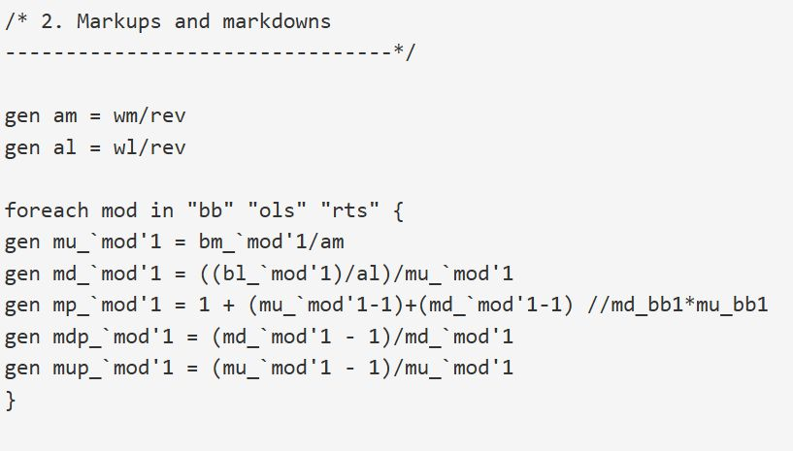

stata code

Markdown [11]

* Markdown is greater for larger firms

### Perfect collusion $λ_{fgt}=1$

FOC

$$W_{it}^{ℓ}+\frac{∂W_{it}^{ℓ}}{∂L_{it}}L_{it}=\frac{∂Q_{ft}}{∂L_{ft}}\frac{P_{ft}}{μ_{ft}}$$

Markdown

$${\overline{μ}}_{ft}^{ℓ}=1+Ψ^{ℓ}$$

* Markdown is uniform across firms

### Intermediate case $λ_{fgt}∈\left(0,1\right)$

Introduce conduct parameter ${\tilde{λ}}_{ft}$ by rewriting FOC to nest no collusion ${\tilde{λ}}_{ft}=s_{ft}$ and collusion ${\tilde{λ}}_{ft}=1$ (so ${\tilde{λ}}_{ft}∈\left[s_{ft},1\right]$):

Markdown

$$μ_{ft}^{ℓ}=1+{\tilde{λ}}_{ft}Ψ^{ℓ}$$

* Markdown is heterogenous across firms

Redefine conduct parameter [12]

|  |
| --- |
| **Summary of theoretical predictions $$\text{When market conduct is}\left\{\begin{matrix}\text{Cournot} \\ \text{intermediate} \\ \text{collusive}\end{matrix}\right. μ^{ℓ} \text{is}\left\{\begin{matrix}\text{size proportional }{\underline{μ}}_{ft}^{ℓ} \\ \text{heterogenous }μ_{ft}^{ℓ} \\ \text{uniform (size orthogonal) }{\overset{‾}{μ}}_{ft}^{ℓ}\end{matrix}\right.$$ $${\underline{μ}}_{ft}^{ℓ}≤μ_{ft}^{ℓ}≤{\overset{‾}{μ}}_{ft}^{ℓ}$$** |

## Identification of collusion

Markup from labour = markup from materials

* LHS sans ${\tilde{λ}}_{ft}$ is observed from wage elasticity $Ψ^{ℓ}$
* RHS is observed from CD production function $β_{ℓ},β_{m}$
* $Ψ^{ℓ}+β_{ℓ},β_{m}$ ⇒ ${\tilde{λ}}_{ft}$
* In general, Mertens (2022) showed:[13]
* Adding a factor supply elasticity gives factor market collusion index.

|  |
| --- |
| **Other approaches to wage markdown**   * Revenue based markdown: revenue elasticity of labour + labour cost share + specific form of output demand function → wage markdown (Treuren 2022)[14] [15] * Job search theory based markdown (Hirsh et al. Preliminary) |

* Can test ${\tilde{λ}}_{ft}=1,s_{ft}$ or just heterogenous within market $i$
* Not an equilibrium condition, so comparative statics is not tenable[16]

To get LHS of , rearrange FOC in .[17] [18]

Markup[19]

## Estimation

Moment conditions for production function (IVs: standard set + lagged regional wage)

$$E\left[u_{ft}|{\left(l_{fr−1},m_{fr−1},k_{fr},w_{r−1}^{agri}\right)}_{r∈\{2,...,t\}}\right]=0$$

GMM moment conditions for production function estimation

## Data

1. Administration des Mines (annual reports on mines)
2. Employer Association membership
   * monthly Bulletin of the Union des Charbonnages, Mines et Usines Métallurgiques de la Province de Liège
   * Association Charbonnière et l’Industrie Houillière des Bassins de Charleroi et de la Basse-Sambre
3. Cartel membership (De Leener data)
4. Other: Opening dates of railroad and tramway stations, agricultural wages

## Research design

* $μ_{ft}^{ℓ}$ using the production approach under material market competition
* Uses financial statement data from historical records when cartel was legal
* Only after using material FOC, we identify $μ_{ft}^{ℓ}$ and collusion index ${\hat{λ}}_{ft}$
* Under oligopsony, $μ_{ft}^{ℓ}∈\left[{\underline{μ}}_{ft}^{ℓ},{\overset{‾}{μ}}_{ft}^{ℓ}\right]$, depending on the extent of collusion
* The difference from lower- and upper-bound = degree of collusion
* Hypothesis: Degree of collusion vs. collusion regimes: collusion↑ (cartel) ⇒ markdown↑[20] [21]

## Results

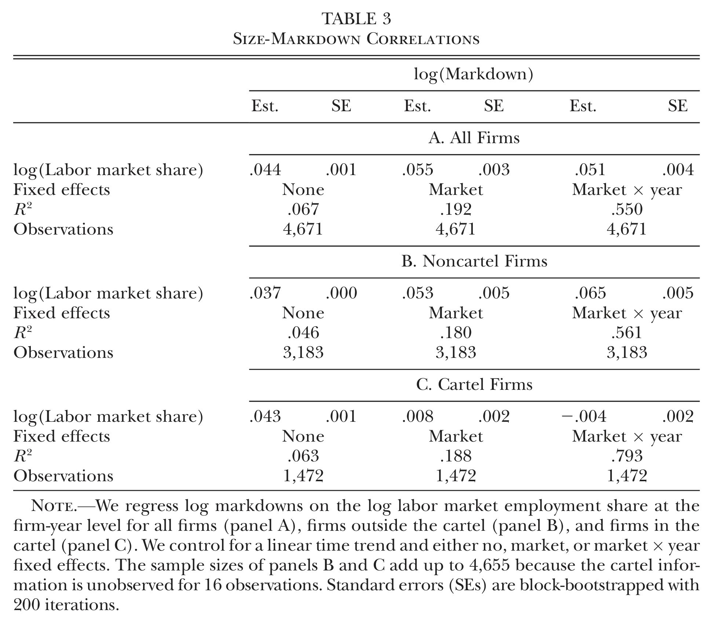

Table 3

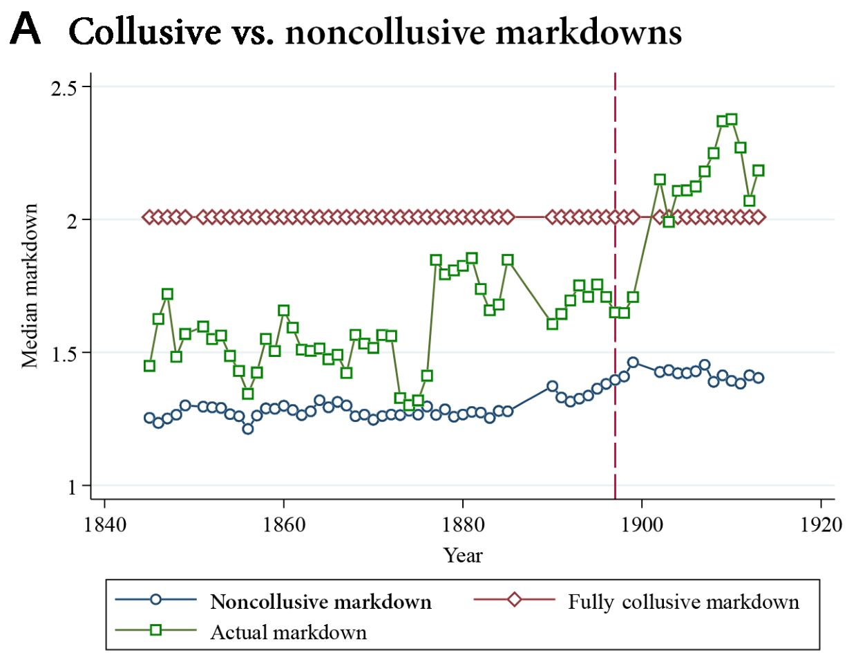

Figure 4A

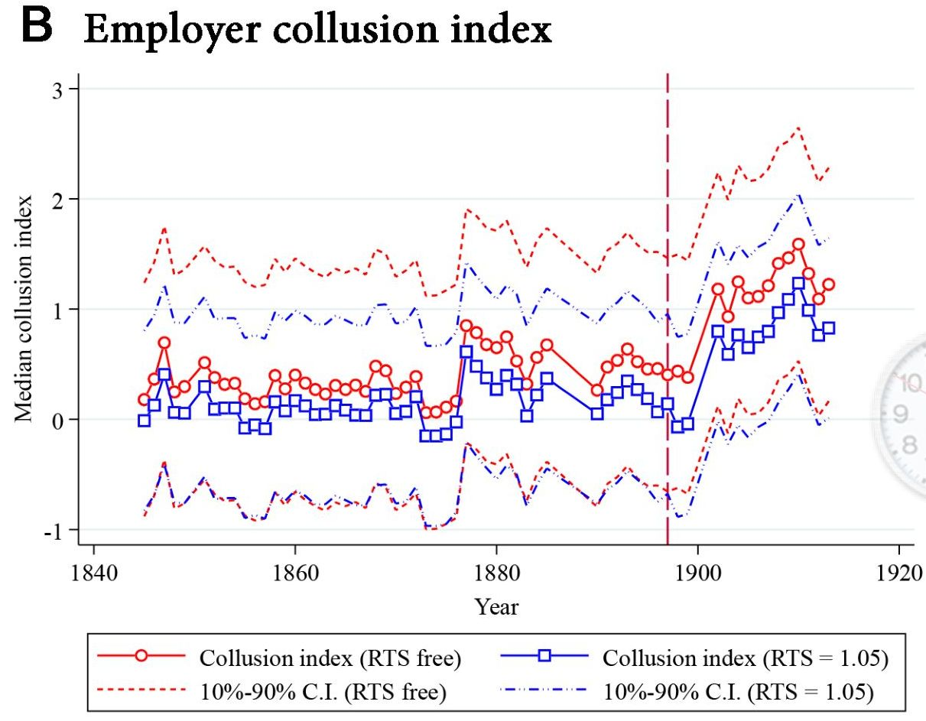

Figure 4B

|  |
| --- |
| **Wage markdown is pervasive**  Proportions of MPRL workers receive are:   * 67% (40’s - 70’s) → 57% (80’s - 90’s) → 45% (1897 - )[22] |

|  |
| --- |
| **Markdown $∝$ Employer Association membership (Table 2, B)**   * (pre cartel) $+$ → zero (post cartel) * Cartel took over the role of collusion device |

|  |
| --- |
| **Markdown $∝$ size (Table 3, TWFE) $+$**   * only for non-cartel firms ← Cournot non-collusion * Zero for cartel firms ← (almost) Perfect collusion = size insensitive |

|  |
| --- |
| **“Decomposition”: Collusive vs. noncollusive origin of markdowns (Figure 4A)**   * Median $μ_{ft}^{ℓ}$ ↑ after 1897 cartel formation, surpassing the upperbound (perfect collusion ${\overset{‾}{μ}}^{ℓ}$) * Noncollusive ${\underline{μ}}_{ft}^{ℓ}$ ↑ only up to 1987, then plateaued * Concludes: Wage collusion ⇒ post cartel ↑[23] * But can we say collusion is weaker under Employer Associations? Coal price levels increased by less in pre-cartel era. * Strange features:[24]   + is constant at 2   + ⇒   + ⇒ ? * Perfectly collusive ${\overset{‾}{μ}}_{ft}^{ℓ}$ estimates may not be reliable |

|  |
| --- |
| **Collusion index ${\hat{λ}}_{it}$ ↑ detects cartel based markdown collusion (Figure 4B)**   * Questionable ${\overset{‾}{μ}}_{ft}^{ℓ}=2$ enters as a constant in the denominator, so the relative changes in the index are not affected (but the level is) * From C.2. Testing for employer collusion: *the collusion estimates seem to be able to detect collusion due to the cartel, without requiring any a priori information about the cartel.* |

|  |
| --- |
| **Sensitivity analysis**   * Input adjustment costs (frictions): Immediate response of labour costs to 1871 demand shock * Factor biased tech change:[25] After increased investments ← No change in labour share, low correation between $μ_{ft}^{ℓ}$ and horsepower of machines, capital*labour interaction in prod function = 0 * Unionisation and socialist party popularity: Region’s strike participation is low, no difference in markdown between socialist and non-socialist districts * Labour supply: Time variant coefficients, linear time trend, different labour market definitions, incorporating expansion of railway, changes in IVs |

|  |
| --- |
| **Markup is smaller than 1 (Table 1)**   * .714 - .816, but statistically indistinguishable from 1 * Despite cartel formation, point estimates suggest oligpsony in coal market, effectively handing over the wage rents ← competitiion with imported coal * [26] |

|  |
| --- |
| **Simulation if there was no cartel (with/without coal market Cournot competition)**  Cournot vs. 2 scenarios: Exogenous output price, endogenous output price (output market full collusion)   * Wage: -10.3%, -25.9% (coal market collusion) * Employment: -10.2%, -24.9% (coal market collusion)   Employer Assoc. vs. 2 scenarios: Exogenous output price, endogenous output price (output market full collusion)   * Wage: -5.9%, -16.7% (coal market collusion) * Employment: -5.9%, -16.6% (coal market collusion)   When under full collusion, $μ_{ft}^{ℓ}$ ↑, $W_{ft}^{ℓ}$ ↓, $L_{ft}$ ↓, $Q_{ft}$ ↓, relative to no collusion/intermediate case |

## 感想

* Rubensは研究材料の幅が広い: 中国たばこ農家のデータを使って下流の企業統合がmarkdownに与えた影響を推計、ベルギーの古文書をデジタル化して共謀とmarkdownの関係を推計…IO専門家?
* 価格カルテルが合法だったときの古いデータを使うことで、素のカルテル効果を鮮明に示しているのは素晴らしい
* 下流の市場慣行→上流の市場慣行、しかも、下流の寡占買い手が鉱山労働者から得たレントを吸い上げている可能性を示す
* wage markdown=oligopsonyの識別そのものは目新しくないが、Cournot仮定下で共謀度の識別という付加価値がある
* 雇用者協会よりも価格カルテルの方が共謀の程度が強いと当然のように書いているが、なぜ?
* wage markdownはproduction approachが適用の範囲の広さで群を抜いているが、Hicks neutralityとmaterial market competition以外あまりに制約をかけないので、推計精度が低い(技術の同質的な大標本が必要)かも

De Loecker, Jan, Jan Eeckhout, and Gabriel Unger. 2020. “The Rise of Market Power and the Macroeconomic Implications.” *Quarterly Journal of Economics* 135 (2): 561–644. <https://doi.org/10.1093/qje/qjz041>.

Hirsh, B, Elke J Jahn, Alan Manning, and Michael Oberfichtner. Preliminary. “The Pass-Through of Monopsony Power to Wages,” Preliminary. <https://population-economics.committee.socialpolitik.de/sites/default/files/2024-01/Oberfichtner_Pass-through-BevOek.pdf>.

Mertens, Matthias. 2022. “Micro-Mechanisms Behind Declining Labor Shares: Rising Market Power and Changing Modes of Production.” *International Journal of Industrial Organization* 81: 102808. <https://doi.org/10.1016/j.ijindorg.2021.102808>.

Syverson, Chad. 2024. “Markups and Markdowns.” *NBER Working Paper*, no. w32871. <https://www.nber.org/papers/w32871>.

Treuren, Leonard. 2022. “Wage Markups and Buyer Power in Intermediate Input Markets.” *FEB Research Report Department of Economics*. <https://lirias.kuleuven.be/retrieve/771542>.

1. How much is TFP reduced/inflation hightened by the resource misallocation in the economy due to wage markdown, not just price markups?
2. is factor supply elasticity of price $ε_{x}≡\frac{dX}{dW}\frac{W}{X}$ inverted, or inverse price elasticity of factor suply.
3. 1st equality uses

 $$θ_{x}≡f′\left(X\right)\frac{X}{Q}$$

  or
4. 2nd equality uses FOC of factor $X$ from monopolist profit maximisation $PF\left(X\right)−C\{F\left(X\right)\}$, denoting $R′\left(X\right)=R′\left(Q\right)F′\left(X\right)$:

 $$\begin{matrix}P′\left(Q\right)F′\left(X\right)Q+P\left(Q\right)F′\left(X\right) & =C′\left(Q\right)F′\left(X\right) \\ & ⇔ \\ \{\underset{=R′\left(Q\right)}{\underset{⏟}{P′\left(Q\right)Q+P\left(Q\right)}}\}F′\left(X\right) & =C′\left(Q\right)F′\left(X\right) \\ & ⇔ \\ R′\left(Q\right)=P\left(Q\right)\left(1+P′\left(Q\right)\frac{Q}{P}\right) & =MC \\ & ⇔ \\ P\left(1+η^{−1}\right) & =MC\end{matrix}$$

  where $η^{−1}=\frac{dP}{dQ}\frac{Q}{P}$ is demand elasticity of price $η≡\frac{dQ}{dP}\frac{P}{Q}$ inverted, or inverse price elasticity of demand, so they say.
5. Same problem applies to this paper. It cancels off markup by $\frac{θ_{ℓ}}{α^{ℓ}}/\frac{θ_{m}}{α^{m}}=μ^{ℓ}μ/μ^{m}μ=μ^{ℓ}$ under the assumption of material market competition $μ^{m}=1$. See in Section 4
6. Results also follow with output elasticity + Hicks neutrality

 $$Q_{ft}=Ω_{ft}F\left(L_{ft},M_{ft},K_{ft}\right).$$

  Why CD?
7. Justification given in the paper: Input demand is affected by distributions of markdowns and output markups, otherwise one cannot invert. To avoid assumptions on the markdown and markup distributions, we use AR(1).
8. Estimated using demand shocks as IVs: 1987 coal demand shock, cartel membership
9. Can derive a similar expression under collusion $μ^{x}μ=\frac{θ_{x}}{α^{x}}$ as in Syverson (2022) by redefining elasticities .
10. Competitive cost minimization $W^{m}M−λ\left[Q\left(M\right)≥\overset{‾}{Q}\right]$ FOC gives
11. From data, it is shown that $μ_{ft}$ is empirically 1…
12.
13. This is exactly the same result as Syverson (2024). If both markets are oligopsonistic, expenditure shares and elasticities give a ratio of markdowns $\frac{μ^{ℓ}}{μ^{M}}$, which is not an interesting object…
14.
15. The challenge is in estimating revenue elasticity $θ_{R,it}^{L}$. Treuren (2022) assumes the inverse output demand to be multiplicably separable in quantity and shocks to use Olley-Pakes inversion.
16. Need to model output response to exogenous wage or coal price shocks. Wage↓ ⇒ $α_{ft}^{ℓ}$ ↓, $Ψ^{ℓ}$ ↓ ⇒ $μ_{ft}^{ℓ}$ ↑, ${\tilde{λ}}_{ft}$ ↑, but $Q$ (hence $P$) also changes. Also want to know $P_{ft}$ ↑ ⇒ $α_{ft}^{ℓ}$ ↓, $α_{ft}^{m}$ ↓ with $\frac{α_{ft}^{m}}{α_{ft}^{ℓ}}$ unchanged ⇒ $μ_{ft}^{ℓ}$ and ${\tilde{λ}}_{ft}$ unchanged, but this is wrong…MRPL *must* increase so must $μ_{ft}^{ℓ}$. Possible: ↑ ⇒ ↑ ⇒ ↑ ⇒ ↑.
17. Taking the derivative with respect to labor on $Q_{ft}=e^{β_{l}l_{ft}+β_{m}m_{ft}+β_{k}k_{ft}+ω_{ft}}$ gives
18. From equation (3): $W_{it}^{l}=L_{it}^{Ψ^{l}}η_{it}$, taking the derivative:
19. Using revenue share of labor:
20. The paper lacks a theoretical analysis of exogenous price increase when we are talking about the coal price cartel. The price increase could have been due to exogenous shocks/shifts. What happens to $μ_{ft}^{ℓ}$ and implied ${\hat{λ}}_{ft}$ when the price increase exogenously? I.e., when the market conduct remains the same in the degree of collusion, does a coal price increase leave the estimated $μ_{ft}^{ℓ}$ unchanged?
21. %↑ %↑, roughly 35% on eyeballs, early 1900’s. A possible exogenous impact: Price↑exogenously ⇒ $\frac{MRPL_{ft}↑}{W_{ft}^{ℓ}}=μ_{ft}^{ℓ}$ ↑ A possible endogenous response: $P_{ft}$ ↑ ⇒ $Q_{ft}$ ↑ ⇒ $Ψ^{ℓ}$ ↑ ⇒ $μ_{ft}^{ℓ}$ ↑. The former does not aggravate misallocation, but the latter does.
22. I can see: % $P$ ↑ $≃$% $μ^{ℓ}$ ↑, roughly 35% on eyeballs, early 1900’s. Firms did not pass coal price windfall to wages. Why did not they have to? Collusive oligopsony.
23. “Given that the noncollusive markdown does not grow after 1900, the vast increase in markdowns after the introduction of the coal cartel appears to have been entirely driven by wage collusion.”
24. No mention on these features.
25. Size sensitivity of $μ^{ℓ}=1+sΨ^{ℓ}$ can be due to tech change, not necessarily to collusion.
26. , or …?