イギリスの経済発展が始まった時期
  - Paul Boucasse, Emi Nakamura, Jon Steinsson
成朗
June 04, 2026, 18:06 +0900
doi.org/10.1093/qje/qjae046

産業革命の遙か前から成長していた
日の沈まない帝国を統治したエリザベス女王が現在のわれわれの生活を聞いたら、SFか、と思うでしょう。無理もありません。暑いときには冷房の効いた部屋にいながら好きなものが配達されます。お休みには空を飛んで外国に行き、雲を見下ろして食事をしながら宿泊先を予約できます。病気で死ぬ心配が減り、100歳まで生きる人が続出します。誰かから連絡が来ると機械の秘書がスケジュール帳を見て返答の選択肢を話しかけるので、「2番目、この前と違う程々の値段のお土産を買って」と話すと、丁寧な返事を出して相手が好きそうな名産品を程々の値段で注文し、アポ内容を記録してくれます。
こうした現実は経済成長をなしえたからこそ、享受できます。
では、経済成長、つまり、一人あたり所得の成長はなぜ可能になったのでしょうか。その問いに答えるためには、経済成長の開始時期を知る必要があります。経済成長が始まった時期を問われると、イギリスの産業革命(1800年前後)から、と多くの人は考えるかもしれません。しかし、1980年代頃からこうした見方は修正されるようになり、現在は遅くとも18世紀半ばには生産量が増えていたと主張されています。
今回紹介する研究は、驚くべきことに、さらに150年前まで開始時期が遡ると主張しています。彼らの研究では、イギリスでは1600年前後(産業革命の200年前)から成長が始まっていたことを示しています。19世紀の急速な経済成長の前に、200年もの成長期間があったのです。

研究デザイン
この研究の面白さはいろいろありますが、変わった面白さとして論文の著者たちがハードコアの経済史家ではないことが挙げられます。著者たちは資料を発掘しデータを作り上げる経済史家ではなく、マクロ経済学の専門家です。このため、この研究では他の経済史家が作成した資料を借用しています。主たる資料は実質賃金(Clark 2010 作成)と人口(Clark 2007; Wrigley et al. 1997 作成)で、いずれも1250-1850年の10年ごとの平均値です。既存資料を使いつつ新たな知見を示せたのは、異なる手法を用いたためです。
働き手が増えると賃金は低下します(労働需要曲線が右下がりだからです)。労働量の多寡に応じて決まる賃金水準は、経済全体の生産性(TFP)や労働が生産量に転化する比率(弾力性、正確には労働量1%増加したときの生産量変化率、完全競争労働市場では賃金の変化率に等しい)が高いほど高くなります。違う言い方をすれば、弾力性の値さえ分かれば、労働(=人口)と賃金のデータから生産性を逆算できるのです。これはマクロ経済学の教科書的な手法です。
弾力性の値を得るために、著者たちは黒死病により人口が急減した時期(1348-1366)に着目しました。そしてデータから1340年-1360年の賃金増加率と人口減少率の比を計算し、弾力性の値(0.7)を得ました。著者たちは黒死病という自然実験に着目することで弾力性を計算でき、それゆえに生産性を逆算できたのです。
計算した生産性を図に描くと、生産性は1600年頃から微増し、1810年以降は急激に増えていました。著者たちはモデルを拡張して、現実性を高めた設定でも結果が変わらないことを確認しています。たとえば、資本を生産関数に含めた場合、実質所得が増えることで人口が増えるマルサス的な人口動態を考慮した場合、などです。

ベイジアン推計
データは10年平均値なので観測できるのは61回だけ(T=61)です。生産性のように長期的に上昇傾向のあるデータは非定常的かもしれません。通常は(標本学派では)非定常性の検定をして、定常・非定常ごとに異なる分析をしますが、61だと非定常性検定のための観測数が十分とはいえません。一方、ベイジアン推計には定常・非定常の区別はなく、すべてに共通の分析ができます。こうした利点からか、著者たちはベイジアン推計を採用しています。 著者たちはデータの測定誤差に配慮し、その影響をベイジアン推計に巧みに取り込んでいます。

成長のきっかけは何か
1600年前後というタイミングを確定させることは何でもないように思えますが、学術的には大きな影響力を持っています。成長の契機として主張されてきた各学説のうち、1600年よりも大幅に遅い出来事は却下されるためです。最たる例が名誉革命(1688年)です。これ以降、議会によって王権は制限され、徴税が乱発されず私的所有権が保障され、囲い込み(エンクロージャ)にも発展しました。1600年前後は North and Weingast (1989) や Bogart and Richardson (2011) らの名誉革命→産業革命とする見解と矛盾するとまでいえませんが、第二義的な影響しかなかったといえそうです。
1600年前後と整合的な学説は、農業の生産性上昇と農業就労人口低下(Wallis, Colson, and Chilosi 2018)、ヘンリー8世の教会領没収(Heldring, Robinson, and Vollmer 2021)、ヨーマンの興隆(Allen 1992)、貿易・植民地とロンドン都市化[]、活版印刷と識字率上昇(Dittmar 2011)などです。一方、進歩主義思想・ブルジョワ的価値(Mokyr 2009, 2016; McCloskey 2006)やプロテスタンティズムの倫理(Weber 1904; Tawney 1926)などは整合的であるがタイミングを示しづらい、と著者たちは述べています。

エネルギー革命の証拠
産業革命といえば、蒸気機関+紡績機械=大量生産、というイメージがあるかもしれません。これを可能にしたのは、生産で用いる動力源を森林、役畜、人間などから石炭に代替させたエネルギー革命です。これを生産過程の入力・出力として表現すると、生産における土地の重要性低下と言い換えられます。森林、役畜、人間が動力を提供するためには、森林が土地を要するだけでなく、飼料、食料のために耕作地が欠かせません。石炭が動力源の主力になり工場生産が増えると、生産額一単位あたりに土地を以前ほど使わなくなります。つまり、容易に増やすことのできない土地の制約から経済を解放し、生産を(工場内で)増やせるようになったのです。これに応じて、年間労働日数も成長開始前の約150日から1800年代以降は2倍以上に延びています。
土地をあまり使わなくなると、土地の入力量の変化に対し生産量が反応しなくなります。つまり、生産の土地弾力性が下がります。著者たちは、労働、資本、土地の3要素を用いる生産関数を推計し、この解釈通りに産業革命以降に土地の弾力性が半減したことを示しました。それと対応して、資本と労働の弾力性が高まっていました。成長開始期の特定と直接の関係はないですが、エネルギー革命の証拠を生産関数を用いて示したのは画期的といえます。

マルサス的モデルの有効性
本研究はマルサス的な人口動態を考慮した理論モデルの枠組みにデータを流し込むことで、成長開始とその後の加速を示しています。これはマルサス的モデルの有効性を示すことにもなっています。第一に、マルサス的な貧困の罠に瀕しながら蒸気機関登場前のイギリスで成長が開始したことは、(古代ギリシャ、古代ローマ、宋代中国、イスラム黄金期など)古代から中世における持続的経済成長期(efforescence)もマルサス的な貧困の罠と矛盾しないことを示しました。第二に、18世紀に発生した生産拡大の中の賃金停滞(Engels’ Pause)は、マルサス的な人口増大によって引き起こしたものであり、エンゲルスが主張したような資本家による搾取、つまり、労働分配率(コブ・ダグラス型生産関数での労働弾力性)の低下が原因ではないことを示しました。

途上国への示唆
成長の開始時期を今まで考えられていたよりも昔の年代に特定したことだけでは、何が成長を引き起こしたか分かりません。よって、このこと自体に現代の途上国への示唆はないように思えます。自然に成熟して産業革命に到達したイギリスはそのまま成長を続けましたが、ベルギーやドイツのように、政府が主導して意識的に産業革命に到達した後発国の経験を学ぶべきかもしれません。むろん、国際競争環境は当時と現代では大きく異なります。石炭供給と鉄鋼生産(ベルギーの例は本コラム「共謀したのは労働者の搾取」でも紹介)などを現代風に置き換える必要があるでしょう。
一定の教育水準を備えた労働力の供給、技術と資本の(国外からの)誘致、インフラと生産に関わる諸制度の整備など、イギリスが時間をかけて得たものを圧縮して提供するのは大変です。しかし、さまざまな努力の結果、成長の開始から4と四半世紀を経て、バングラデシュやエチオピアといった一昔前の最貧国でも成長が始まっている例が出てきています。
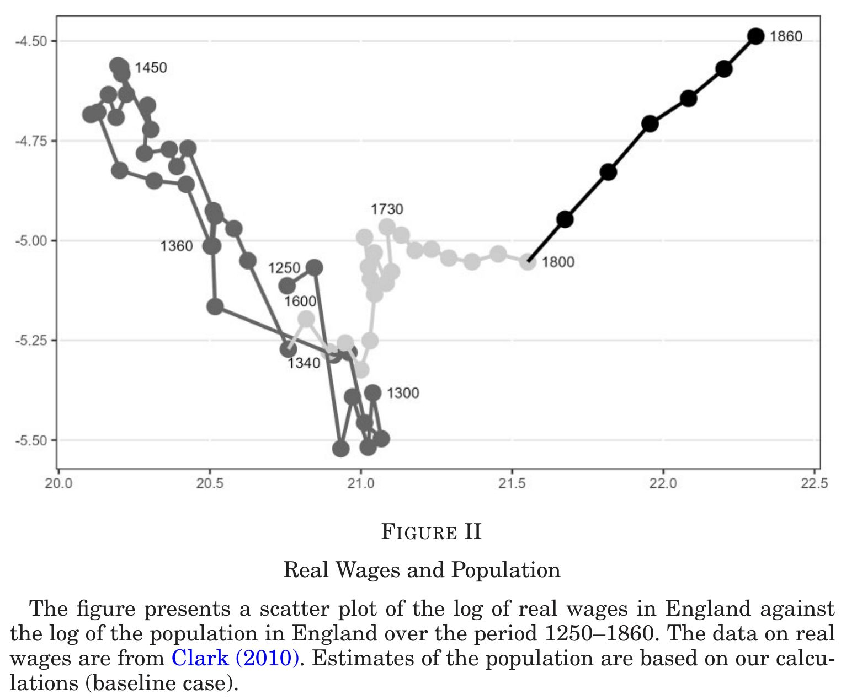
Figure 1: Population and real wage

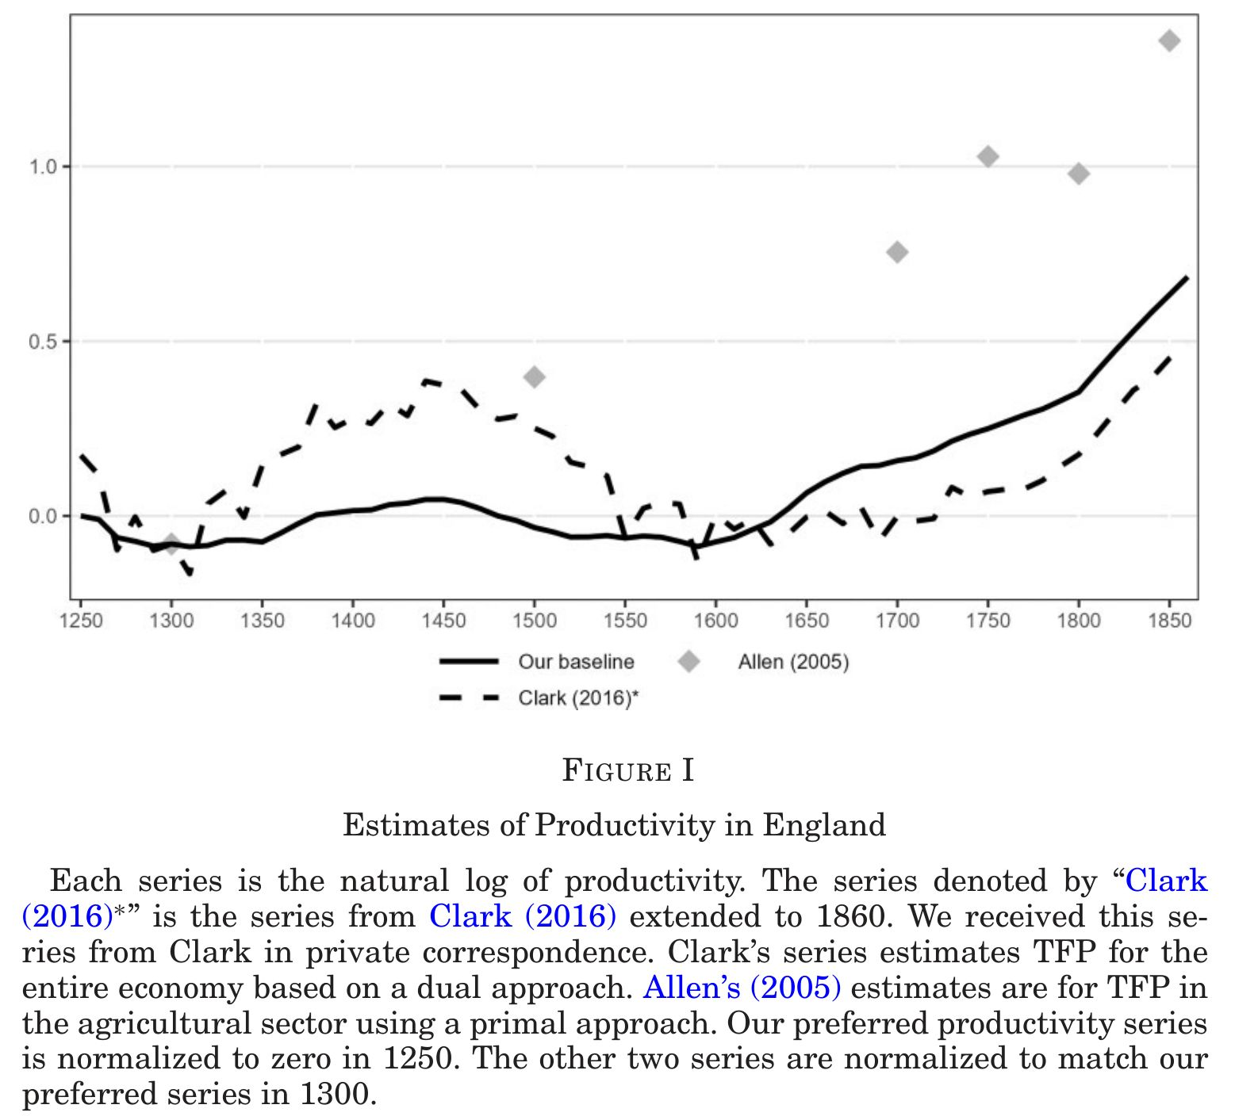
Figure 2: TFP
- Growth = Industrial Revolution began in 1600’s
- period
- growth
- - 1600
- 0%
- 1600 - 1810
- 2%
- 1810 -
- 5%
  - Not after the Glorious Revolution, as argued in the literature
  - Predates 100 years from the Glorious Revolution
- A new series of TFP (1250-) is computed by combining existing data, a labour demand function, and Black Death as an exogenous population shock
- Increased TFP growth may be due to:
  - Reformation 宗教改革
  - decline of feudalism
  - rise of yeoman
  - movable type printing and increase in literacy
  - international trade
- Post Industrial Revolution (1810-) growth is explained by release from fixed land constraint (steam engines) and increased days worked

Research design
Variable definitions
Category | Symbol | Definition / Description
Observed Data & State Variables | $w_{t}$ | Log of real wages
 | $l_{t}$ | Log of total labor supply
 | $n_{t}$ | Log of the population
 | $d_{t}$ | Log of days worked per worker per year
 | $k_{t}$ | Log of the capital stock
 | $s_{t}$ | Log of the rental price of land
 | $r_{t}$ | Rental rate for capital (Note: kept as a rate, appears in equations as $log\left(r_{t}+δ\right)$)
 | $Z$ | Fixed quantity of land (Appears in equations as $logZ$)
Productivity Measures | $a_{t}$ | Log of Total Factor Productivity (TFP)
 | ${\tilde{a}}_{t}$ | Permanent (random-walk) component of TFP
 | $m_{t}$ | Log of the Malmquist productivity index (Accounts for structural change when $α_{t},β_{t}$ vary)
 | ${\tilde{m}}_{t}$ | Permanent component of the Malmquist productivity index
 | $\overset{‾}{w}$ | Theoretical steady-state real wage (Derived from the Malthusian model)
 | ${\hat{x}}_{t}$ | Difference/growth from the previous period (i.e., $x_{t}−x_{t−1}$)
 | ${\overset{‾}{x}}_{t}$ | Average of the current and previous period (i.e., $\frac{x_{t−1}+x_{t}}{2}$)
Structural Parameters | $α,α_{t}$ | Elasticity of output with respect to land (Represents slope of labor demand in the simple model)
 | $β,β_{t}$ | Elasticity of output with respect to capital (Note: $1−α−β$ equals labor elasticity)
 | $δ$ | Rate of depreciation of capital
 | $λ$ | Log of the labor scaling constant $Λ$ (Maps population and days worked into total labor force)
 | $μ$ | Average growth rate of productivity (Drift parameter in the random walk process)
 | $γ$ | Elasticity of population growth to real income (Represents the “Malthusian population force”)
 | $ϕ,ϕ_{t},\tilde{ϕ}$ | Constant terms aggregating structural parameters, fixed land ($Z$), and the labor scaling constant ($λ$)
 | $ω$ | Constant drift term in the population growth equation
Shocks & Error Processes | $ϵ_{1t}$ | Permanent productivity shock (Innovation to the random walk of ${\tilde{a}}_{t}$ or ${\tilde{m}}_{t}$)
 | $ϵ_{2t}$ | Transitory productivity shock (Captures weather variations, short-term noise, etc.)
 | $ξ_{t}$ | Total exogenous shock to population growth
 | $ξ_{1t}$ | “Plague” shock (Rare, large negative shock modeled via mixture distribution)
 | $ξ_{2t}$ | Normal/transitory exogenous population shock
 | $σ_{ϵ_{1}}^{2},σ_{ϵ_{2}}^{2},σ_{ξ_{2}}^{2}$ | Variances of their respective independent normal distributions
 | $ι_{t}$ | Measurement errors mapping true unobserved variables to noisy observed data (e.g., $ι_{t}^{d}$ for days, $ι_{t}^{r}$ for rates)

Model and data
1. The Simple Model (Section II)
- Used for: Table I, Figure V, Figure VI
- Data: Real wages ($w_{t}$), Population ($l_{t}$)
- Equations:
  - $a_{t}=w_{t}+αl_{t}−ϕ$ (from 1)
  - $a_{t}={\tilde{a}}_{t}+ϵ_{2t}$ (6)
  - ${\tilde{a}}_{t}=μ+{\tilde{a}}_{t−1}+ϵ_{1t}$ (2)
- Plots/Estimates:
  - Table I: Estimates average growth $μ$.
  - Figure V: Plots posterior probability of structural breaks in $μ$.
  - Figure VI: Plots the permanent component ${\tilde{a}}_{t}$.
- Assumptions: $ϵ_{1t}∼N\left(0,σ_{ϵ_{1}}^{2}\right)$ and $ϵ_{2t}∼N\left(0,σ_{ϵ_{2}}^{2}\right)$ are assumed independent over time.
2. Full Malthusian Model: Constant $α,β$ (Section III.A)
- Used for: Table IV (“Constant $α,β$”), Figure X (“Constant $α,β$”)
- Data: Real wages ($w_{t}$), Population ($n_{t}$), Days worked ($d_{t}$), Rates of return ($r_{t}$)
- Equations:
  - $a_{t}=\left(1−β\right)\left(w_{t}−\tilde{ϕ}\right)+α\left(d_{t}+n_{t}\right)+βlog\left(r_{t}+δ\right)$ (from 8)
  - $a_{t}={\tilde{a}}_{t}+ϵ_{2t}$ (6)
  - ${\tilde{a}}_{t}=μ+{\tilde{a}}_{t−1}+ϵ_{1t}$ (7)
  - $n_{t}−n_{t−1}=ω+γ\left(w_{t−1}+d_{t−1}\right)+ξ_{t}$ (9)
  - $ξ_{t}=ξ_{1t}+ξ_{2t}$ (10)
- Plots/Estimates: $μ$ (Table IV), ${\tilde{a}}_{t}$ (Figure X).
- Assumptions: $ϵ_{1t}$ and $ϵ_{2t}$ are assumed independent. Population shocks consist of a rare plague mixture shock $ξ_{1t}$ (11) and a normal shock $ξ_{2t}∼N\left(0,σ_{ξ_{2}}^{2}\right)$, which are assumed independent.
3. Early Industrial Economy: Time-Varying $α_{t},β_{t}$ (Section III.B)
- Used for: Table IV (“Baseline”), Table V, Figure I, Figure X (“Baseline”), Figure XI, Figure XIII, Figure XVI, Figure XVII
- Data: $w_{t}$, $n_{t}$, $d_{t}$, $r_{t}$, Capital stock ($k_{t}$), Land rents ($s_{t}$)
- Equations:
  - $α_{t},β_{t}$ are pinned down by land and capital demand:
    - $s_{t}=w_{t}+n_{t}+d_{t}−logZ+logα_{t}−log\left(1−α_{t}−β_{t}\right)+λ$ (15)
    - $log\left(r_{t}+δ\right)=w_{t}+n_{t}+d_{t}−k_{t}+logβ_{t}−log\left(1−α_{t}−β_{t}\right)+λ$ (16)
  - $a_{t}$ is extracted via labor demand:
    - $w_{t}=ϕ_{t}+\frac{1}{1−β_{t}}a_{t}−\frac{α_{t}}{1−β_{t}}\left(d_{t}+n_{t}\right)−\frac{β_{t}}{1−β_{t}}log\left(r_{t}+δ\right)$ (13)
  - Converted to Malmquist productivity index ($m_{t}$) to account for structural change:
    - ${\hat{m}}_{t}={\hat{a}}_{t}+{\hat{α}}_{t}logZ+{\hat{β}}_{t}{\overset{‾}{k}}_{t}−\left({\hat{α}}_{t}+{\hat{β}}_{t}\right)\left({\overset{‾}{d}}_{t}+{\overset{‾}{n}}_{t}+λ\right)$ (18)
  - $m_{t}={\tilde{m}}_{t}+ϵ_{2t}$ (19)
  - ${\tilde{m}}_{t}=μ+{\tilde{m}}_{t−1}+ϵ_{1t}$ (20)
  - Population dynamics follow (9) and (10) as above.
- Plots/Estimates:
  - Table IV: Estimates $μ$.
  - Table V: Estimates population income elasticity $γ$.
  - Figure I, Figure X, Figure XIII: Plots the permanent component ${\tilde{m}}_{t}$ (${\tilde{a}}_{t}$).
  - Figure XI: Plots extracted structural parameters $α_{t},β_{t}$.
  - Figure XVI: Plots $n_{t}$ simulated iteratively forward using (9) with shocks set to zero.
  - Figure XVII: Plots $n_{t}$ estimated from the state-space model incorporating shock processes (10) and (11).
- Assumptions: Independence is assumed between $ϵ_{1},ϵ_{2}$ and between $ξ_{1},ξ_{2}$. Factor share simplex ($α_{t},β_{t},1−α_{t}−β_{t}$) is assumed to follow a Dirichlet prior distribution to discipline structural change after 1760. Input data assumed measured with independent error processes ($ι_{t}$).
4. Steady-State Analytics (Section V)
- Used for: Figure XIV, Figure XV
- Data: $w_{t}$, $d_{t}$ (as well as posterior parameters from Section III.B)
- Equations:
  - $\overset{‾}{w}=\frac{μ}{αγ}+\text{constant}$ (21)
- Plots/Estimates:
  - Figure XIV: Plots the theoretical $\overset{‾}{w}$ mapping across different values of $α$ and $μ$.
  - Figure XV: Plots the ratio of theoretical steady-state wage $\overset{‾}{w}$ derived via (21) against the actual data $w_{t}$.
5. Pure Data / No Structural Model Applied
- Used for: Table II, Table III, Figure II, Figure III, Figure IV, Figure VIII, Figure IX, Figure XII.
- Methodology: These display raw historical input data, simple transformations (scatter plots), or statistical priors (Table III). No structural equations or error processes are applied.

Simplest method
Data
Land, real wage, population
CD production
$Y_{t}=A_{t}Z^{α}L_{t}^{1−α}$ →FOC→ $w_{t}=ϕ+a_{t}−αl_{t}$, $ϕ=ln\left(1−α\right)+αlnZ$
Identification of $α$
$α=\frac{ΔW_{t}}{ΔL_{t}}$ before/after Black Death→$\hat{α}=.7$
Backing out TFP
${\hat{a}}_{t}=w_{t}−\hat{ϕ}+\hat{α}l_{t}$
Separate permanent and transitory TFP by Brownian motion with drift
${\tilde{a}}_{t}=μ+{\tilde{a}}_{t−1}+ϵ_{1t}$
Normalisation equation for real wages
$w_{t}=ϕ^{w}+{\tilde{w}}_{t} \text{where} ϕ^{w}∼N\left(0,{100}^{2}\right)$
Structural break in $μ$
Separating to 3 periods, data suggests break years at 1600, 1810

A fixed elasticity Malthusian model
Merit: Capital is incorporated
Add
Data
Interest rate (rent charges on collaterallised loans), days worked
Production function and optimisation
$Y_{t}=A_{t}Z^{α}K_{t}^{β}L_{t}^{1−α−β}$ →FOCs→ $w_{t}=ϕ+\frac{1}{1−β}a_{t}−\frac{α}{1−β}\left(d_{t}+n_{t}\right)−\frac{β}{1−β}ln\left(r_{t}+δ\right)$
Malthusian population dynamics
$n_{t}−n_{t−1}=ω+γ\left(w_{t−1}+d_{t−1}\right)+ξ_{t}$
Measurement equation
$r_{t}={\tilde{r}}_{it}+ι_{it}^{r} \text{where} ι_{it}^{r}∼t_{ν_{ir}}\left(0,{\tilde{σ}}_{ir}^{2}\right)$ for $i$= interest rates, land rents, if no interest rates or land rents, $r_{t}∼N_{\left(0,.2\right)}\left(r_{t−1},{0.01}^{2}\right)$

A varying elasticity Malthusian model
Merit: Structural change (elasticity change) is incorporated
Add
Data
Net capital stock, land rents $S_{t}$
3 factor CD production
$Y_{t}=A_{t}Z^{α_{t}}K_{t}^{β_{t}}L_{t}^{1−α_{t}−β_{t}}$ →FOCs→ $s_{t}=w_{t}+n_{t}+d_{t}−lnZ+lnα_{t}−ln\left(1−α_{t}−β_{t}\right)+λ$, $ln\left(r_{t}+δ\right)=w_{t}+n_{t}+d_{t}−k_{t}+lnβ_{t}−ln\left(1−α_{t}−β_{t}\right)+λ$ These 2 eqns give $α_{t},β_{t}$
Malmquist index
For time-variant production technology ${\hat{m}}_{t}={\hat{a}}_{t}+{\hat{α}}_{t}lnZ+{\hat{β}}_{t}{\overset{‾}{k}}_{t}−\left({\hat{α}}_{t}+{\hat{β}}_{t}\right)\left({\overset{‾}{d}}_{t}+{\overset{‾}{n}}_{t}+λ\right)$
Measurement errors
$s_{t}={\tilde{s}}_{t}+ι_{t}^{s} \text{where} ι_{t}^{s}∼t_{ν_{s}}\left(0,{\tilde{σ}}_{s}^{2}\right)$, $k_{t}={\tilde{k}}_{t}+ι_{t}^{k} \text{where} ι_{t}^{k}∼t_{ν_{k}}\left(0,{\tilde{σ}}_{k}^{2}\right)$, $m_{t}={\tilde{m}}_{t}+ϵ_{2t} \text{where} ϵ_{2t}∼N\left(0,σ_{ϵ_{2}}^{2}\right)$, ${\tilde{m}}_{t}=μ+{\tilde{m}}_{t−1}+ϵ_{1t} \text{where} ϵ_{1t}∼N\left(0,σ_{ϵ_{1}}^{2}\right)$
Normalisation equation
$K_{t}=ϕ^{K}+{\tilde{K}}_{t} \text{where} ϕ^{K}∼N\left(0,{100}^{2}\right)$, $S_{t}=ϕ^{S}+{\tilde{S}}_{t} \text{where} ϕ^{S}∼N\left(0,{100}^{2}\right)$

Data issues
- $T=61$ for real wages and population
- $T=10$ (1760-1860) for capital, interest rates, land rents
Despite the power limitations, the only estimate with large $p$ value is
- Table V baseline $\hat{γ}$ = 0.03, CI [−0.06, 0.12] — the Malthusian feedback is imprecisely estimated with fixed days worked

Bayesian estimation
Table 1
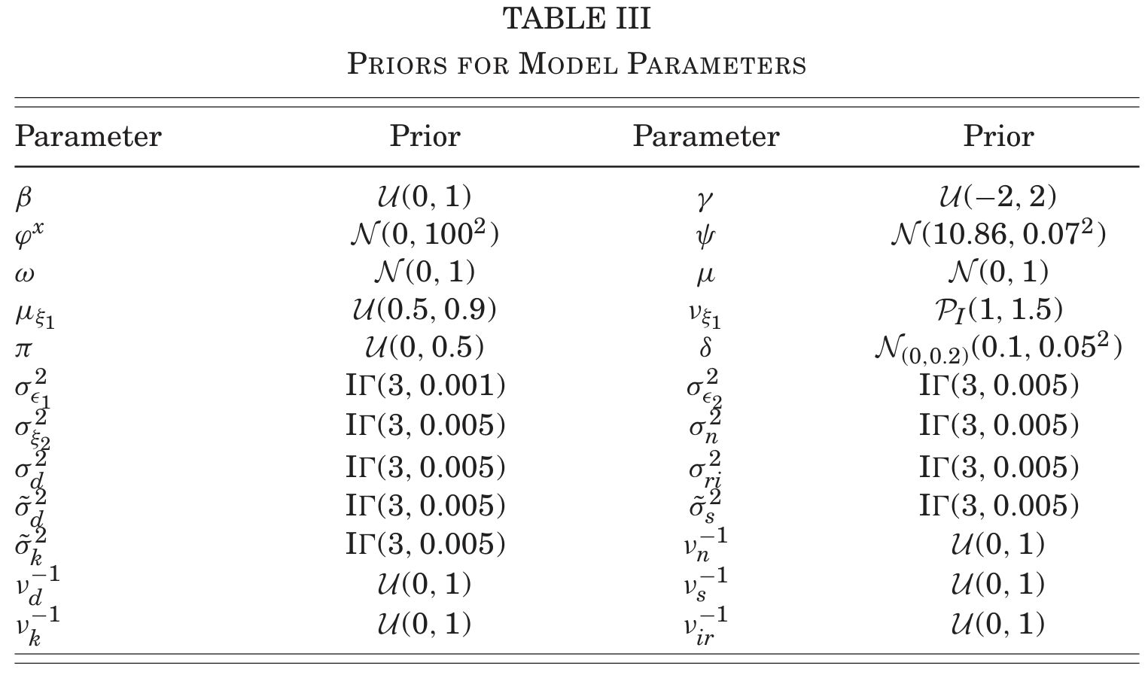
- MCMC (not Gibbs sampling, Hamiltonian MC)
- Assume Dirichlet likelihood for $α_{t},β_{t},1−α_{t}−β_{t}$

${\tilde{a}}_{t}$ likelihood
Substitute (6) into (8):
$$w_{t}=\underset{μ_{w,t}\left({\tilde{a}}_{t}\right)}{\underset{⏟}{ϕ+\frac{1}{1−β} {\tilde{a}}_{t}−\frac{α}{1−β}\left(d_{t}+n_{t}\right)−\frac{β}{1−β}ln\left(r_{t}+δ\right)}} + \frac{ε_{2t}}{1−β}$$
Wage conditional likelihood for (8) through transitory shock $ε_{2t}∼N\left(0,σ_{2}^{2}\right)$
$$
w_t \;\Big|\; \tilde{a}_t,\,n_t,\,d_t,\,r_t,\,\alpha,\beta,\phi
\;\sim\;
\mathcal N\left(\mu_{w,t}(\tilde{a}_t),\;
\left[\frac{\sigma_2}{1-\beta}\right]^{\!2}\right)
\tag{$\mathcal{L}_8$}
$$
where
$$μ_{w,t}\left({\tilde{a}}_{t}\right) ≡ ϕ+\frac{{\tilde{a}}_{t}}{1−β}−\frac{α}{1−β}\left(d_{t}+n_{t}\right)−\frac{β}{1−β}ln\left(r_{t}+δ\right)$$
(7) is the state transition for ${\tilde{a}}_{t}$. It contributes a separate likelihood factor (state equation) throgh $ε_{1t}∼N\left(0,σ_{1}^{2}\right)$:
$$
\tilde{a}_t \;\Big|\; \tilde{a}_{t-1},\mu,\sigma_1
\;\sim\; \mathcal N(\mu + \tilde{a}_{t-1},\;\sigma_1^2)
\tag{$\mathcal{L}_7$}
$$

$n_{t}$ likelihood
Define the deterministic part of equation (9):
$$μ_{n,t} ≡ ω+γ\left(w_{t−1}+d_{t−1}\right)+n_{t−1}$$
Then $n_{t}=μ_{n,t}+ξ_{1t}+ξ_{2t}$. The noise $ξ_{2t}∼N\left(0,σ_{ξ}^{2}\right)$ makes $n_{t}$ normal conditional on $ξ_{1t}$. The plague shock $ξ_{1t}$ shifts the mean; its occurrence is uncertain.
The plague indicator is not observed. Integrating over plague shock gives a two-component mixture: where $ξ_{1t}=ln\left({XI1}_{t}\right)$ and ${XI1}_{t}∼Beta\left(β_{1},β_{2}\right)$.
The plague intensity ${XI1}_{t}$ (fraction of population surviving) is itself a sampled parameter with its own likelihood:
$${XI1}_{t}∼Beta\left(β_{1},β_{2}\right), ξ_{1t}=ln\left({XI1}_{t}\right)≤0$$
So log-likelihood is where $ϕ_{σ}\left(⋅\right)$ is the $N\left(0,σ^{2}\right)$ density.

Dirichlet likelihood
- Simplex ($α_{t},β_{t},1−α_{t}−β_{t}$) is assumed to follow Dirichlet with concentration parameter $c_{s}$
- $c_{s}×\left(α_{t},β_{t},1−α_{t}−β_{t}\right)∼DirMult\left(θ|c_{b}\right)$
- $c_{s}=3$ ⇒ mean = first lag

Results

Onset
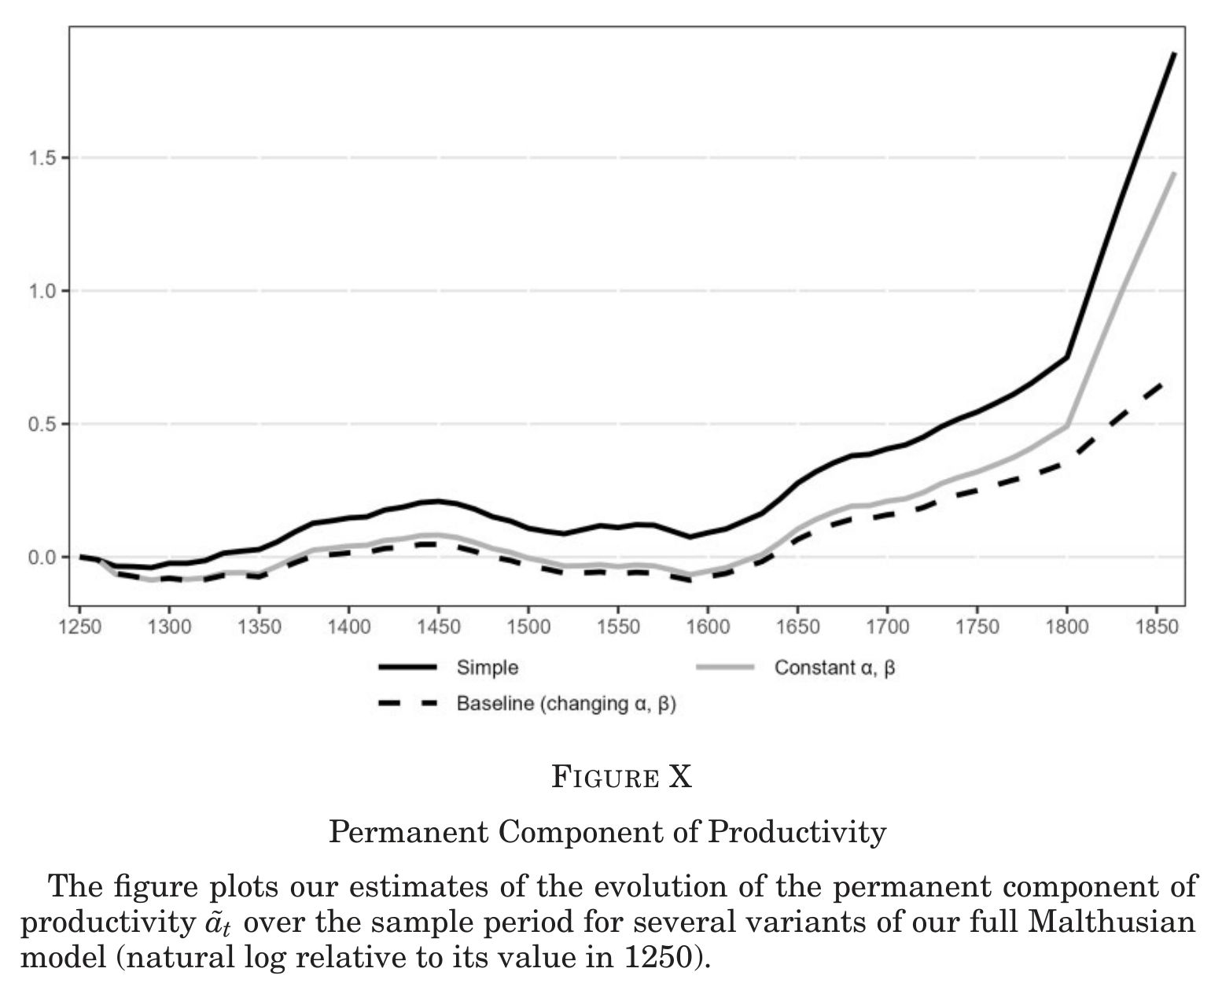
Figure 3: TFP by different methods

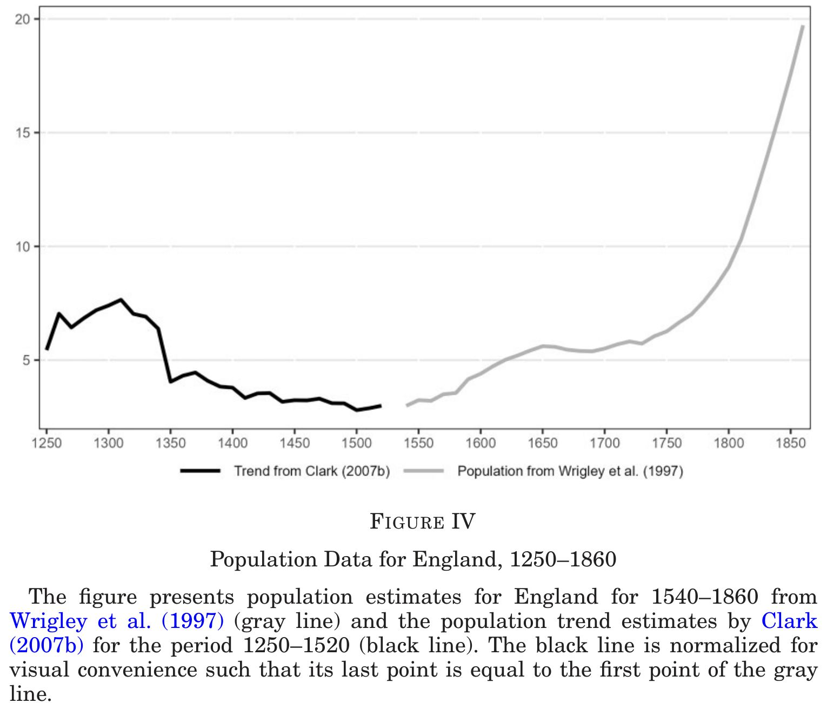
Figure 4: Population

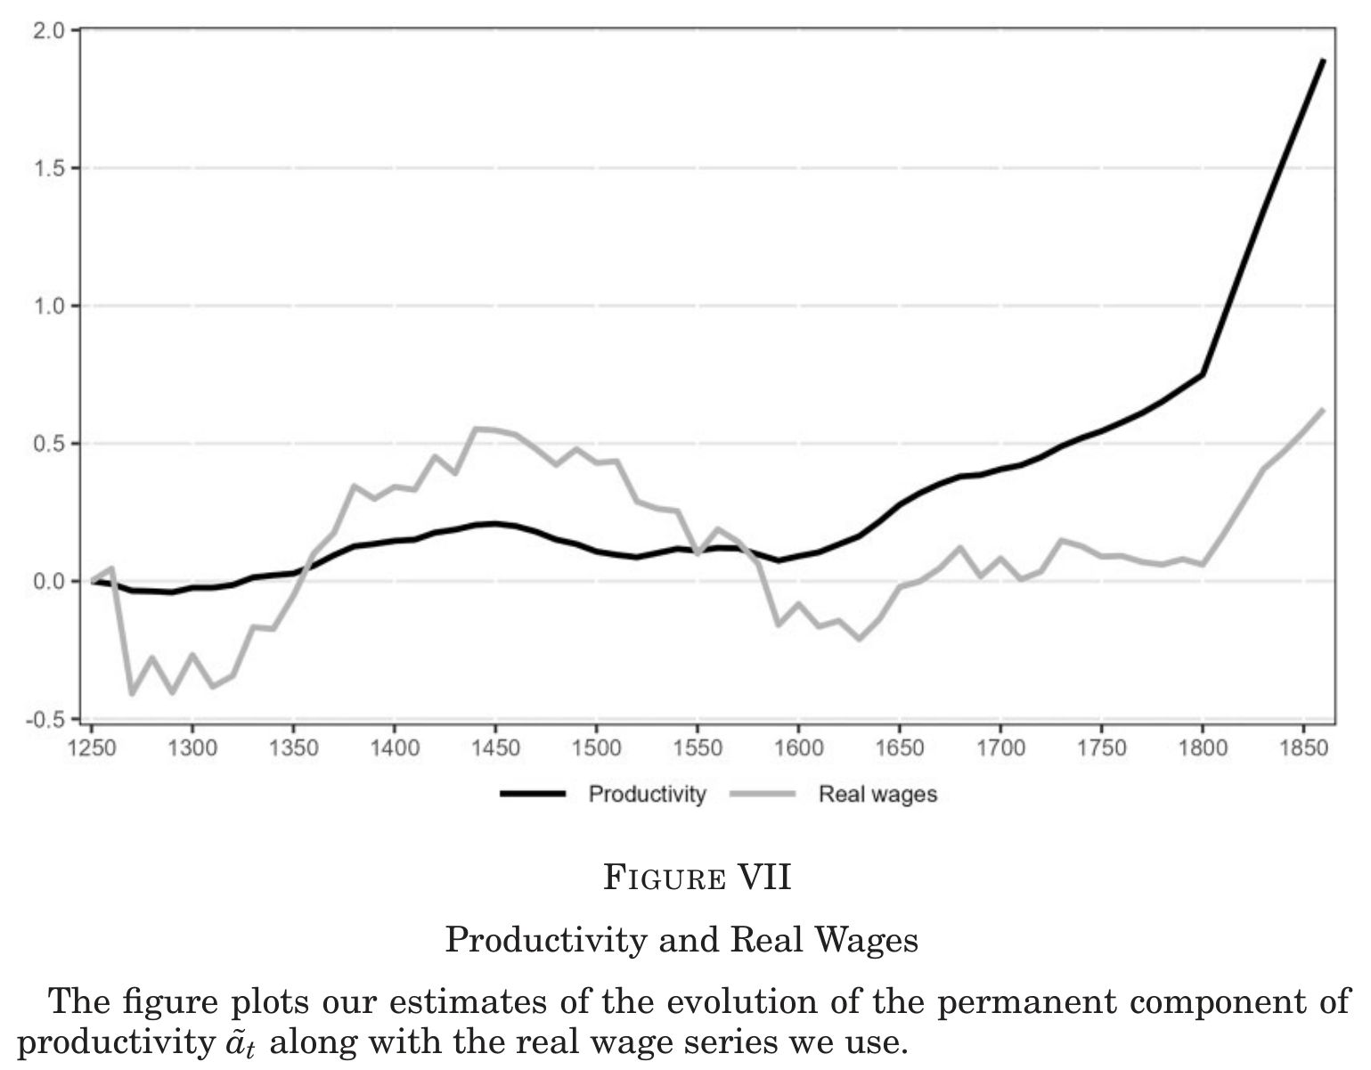
Figure 5: Engels’ Pause, 1730-1800
- No growth (- 1600) → low growth (1600-1810) → high growth (1810-) Figure 3
- Engels’ Pause (no wage growth despite increased TFP growth) is due to population growth, not a decline in labour share Figure 4

Off
By dating the onset of growth at 1600, below is ruled out:
- Glorious Revolution (1688) (North and Weingast 1989)
- English Civil War (1642–1651) and Glorious Revolution as joint cause (Acemoglu, Johnson, and Robinson 2005)
- Post-Glorious Revolution property rights and enclosure reforms (Bogart and Richardson 2011)
- Industrial Revolution (~1800) as the genesis of growth
- Capital capturing the gains from technical change as the explanation for Engels’ Pause (Allen 2009a; Acemoglu and Restrepo 2019)

Still on
Corroborating (external data independently confirm the timing)
- Onset of structural transformation away from agriculture (Wallis, Colson, and Chilosi 2018)
Consistent (timing of historical events aligns with 1600)
- Dissolution of the English monasteries and land-market shock (Heldring, Robinson, and Vollmer 2021)
- Rise of the yeoman class and gradual expansion of property rights (Allen 1992)
- Atlantic trade, colonisation, and London’s urbanisation
- Printing press and rising literacy (Dittmar 2011)
- Marxist view: economic change propels political change (Marx 1932; Marx and Engels 2008)
Consistent but timing hard to pin down
- Culture of progress and bourgeois values (Mokyr 2009, 2016; McCloskey 2006)
- Protestant ethic and Puritanism (Weber 1904; Tawney 1926)
Complementary (explains the character of the Industrial Revolution, not its onset)
- High-wage, cheap-coal theory of the Industrial Revolution (Allen 2009b)

Modest growth after the onset
Efforescence: Sustained growth prior to Industrial Revolution
- Ancient Greece, ancient Rome, Song China (宋960–1279), Islamic golden age, golden age of Holland
- Often used as evidence against a Malthusian model
- Similar to the Malthusian model of England 1600-1810

Post Industrial Revolution
This is more of a secondary research question, but a very insightful finding
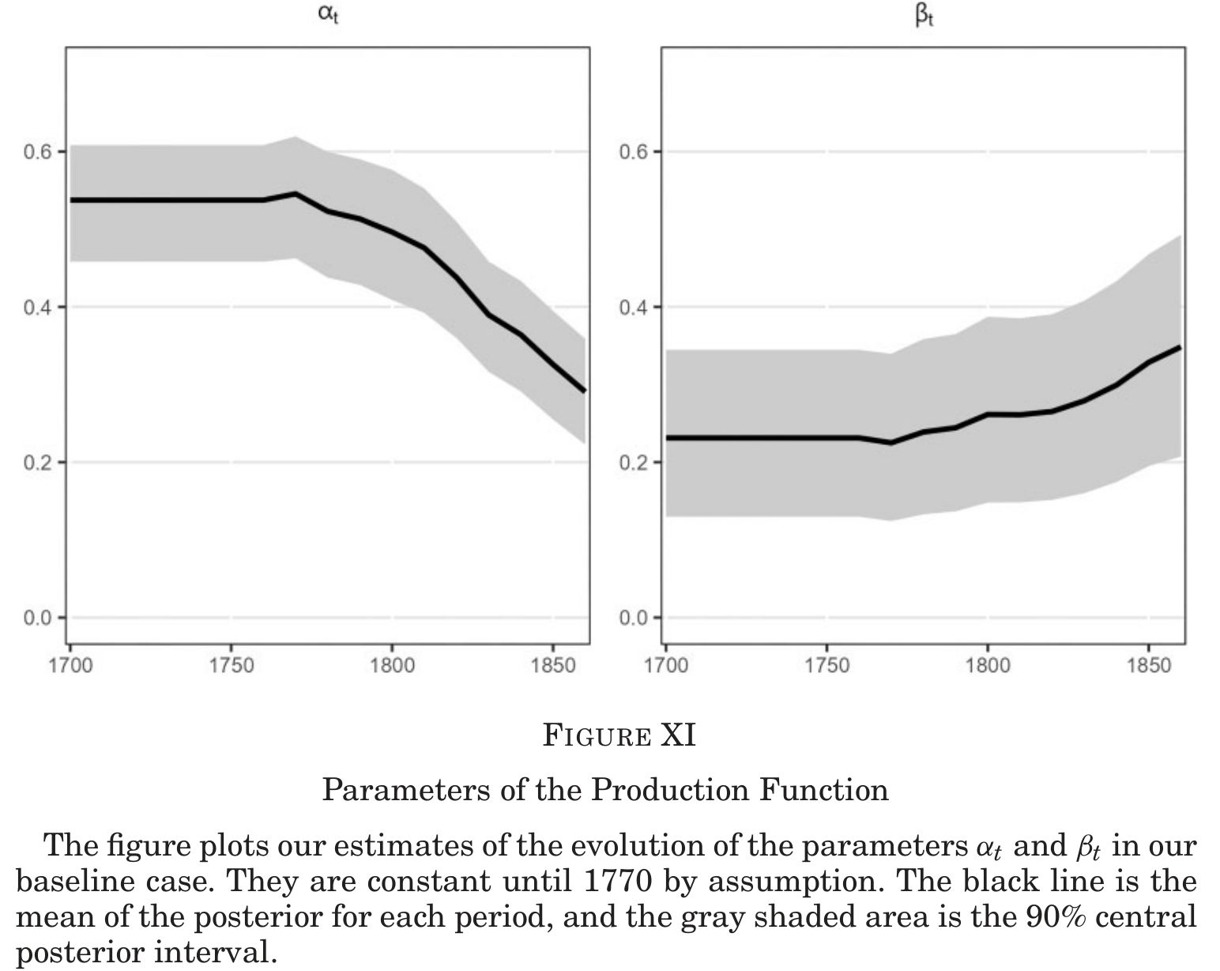
Figure 6: Land constraint is unimportant (left)

Table 2: Steam engine took over
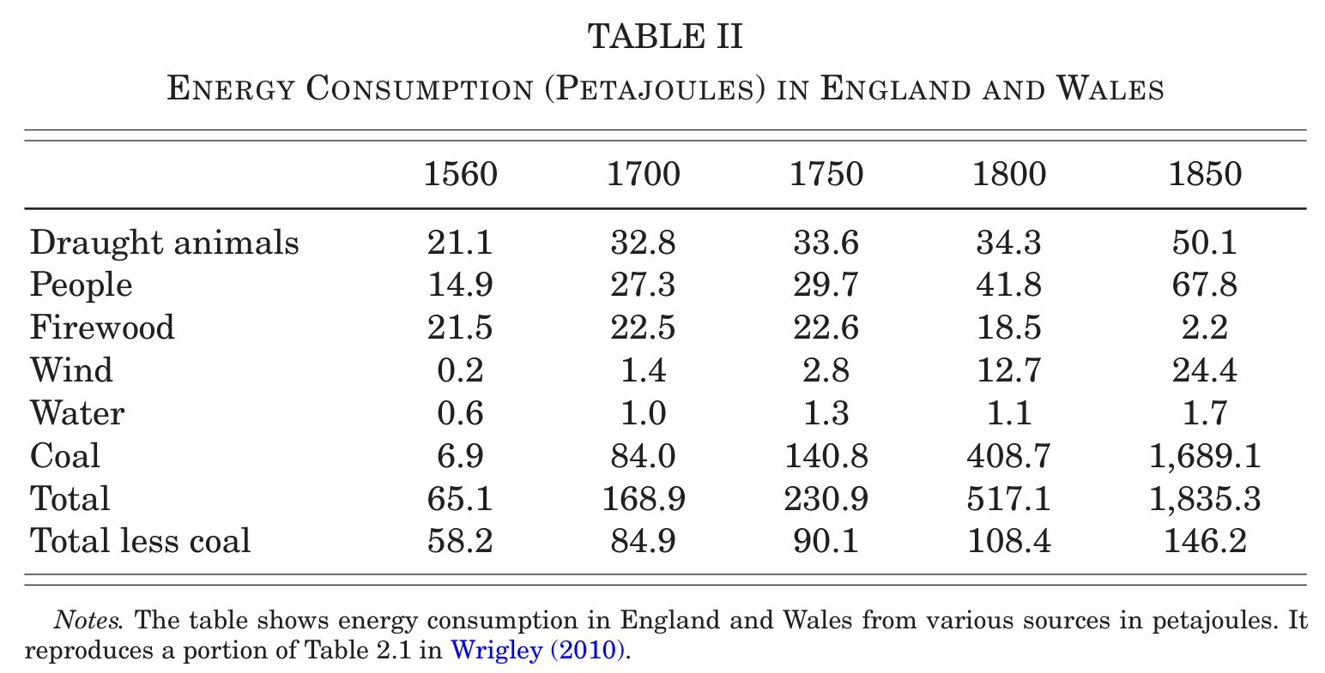

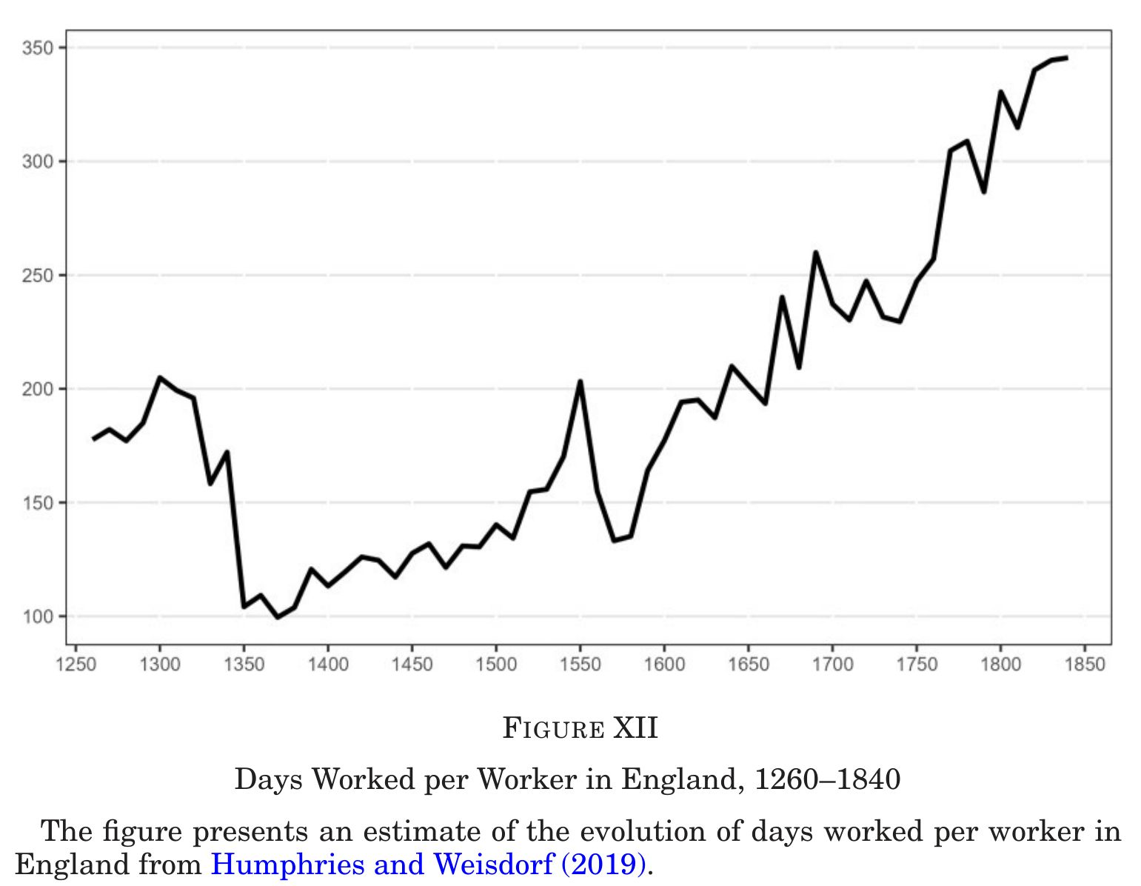
Figure 7: Days worked doubled
- Decline in importance of land in production (Figure 6)
- (Not a result): Steam engine took over after 1810 (Table 2)
- (Not a result): Days worked increased (Figure 7)
By easing the fixed land constraint, people started to work longer and production increased with more labour and capital

感想
- 世界で経済発展が開始した年代を特定した影響力のある論文
- 他人のデータを使いつつ、単純なモデルと組み合わせることで新たな発見を提供したお手軽論文かと思って読み始めた
- 読み進めると、Bayesianを使う仕掛けをそこら中に仕込んだ手の込んだ論文だと分かった
- 産業革命の解釈: 経済活動を土地制約から開放したこと
- 蒸気機関さまさま
- Vent for surplus: 余剰だった労働が不足になった
- T=61、仕方ないが…
- 今後もこの分野は、推計方法の改善よりもデータ構築の方が貢献度は高い
Acemoglu, Daron, Simon Johnson, and James Robinson. 2005. “The Rise of Europe: Atlantic Trade, Institutional Change, and Economic Growth.” American Economic Review 95: 546–79. https://doi.org/10.1257/0002828054201305.
Acemoglu, Daron, and Pascual Restrepo. 2019. “Artificial Intelligence, Automation, and Work.” In The Economics of Artificial Intelligence: An Agenda, edited by Ajay Agrawal, Joshua Gans, and Avi Goldfarb, 197–236. Chicago: University of Chicago Press.
Allen, Robert C. 1992. Enclosure and the Yeoman. Oxford: Oxford University Press.
———. 2009a. “Engels’ Pause: Technical Change, Capital Accumulation, and Inequality in the British Industrial Revolution.” Explorations in Economic History 46: 418–35. https://doi.org/10.1016/j.eeh.2009.04.004.
———. 2009b. The British Industrial Revolution in Global Perspective. Cambridge: Cambridge University Press.
Bogart, Dan, and Gary Richardson. 2011. “Property Rights and Parliament in Industrializing Britain.” Journal of Law and Economics 54: 241–74. https://doi.org/10.1086/652901.
Clark, Gregory. 2002. “Land Rental Values and the Agrarian Economy: England and Wales, 1500–1914.” European Review of Economic History 6: 281–308. https://doi.org/10.1017/S136149160200014X.
———. 2007. “The Long March of History: Farm Wages, Population, and Economic Growth, England 1209–1869.” Economic History Review 60: 97–135. https://doi.org/10.1111/j.1468-0289.2006.00358.x.
———. 2010. “The Macroeconomic Aggregates for England 1209–1869.” Research in Economic History 27: 51–140. https://doi.org/10.1108/S0363-3268(2010)0000027004.
Dittmar, Jeremiah E. 2011. “Information Technology and Economic Change: The Impact of the Printing Press.” Quarterly Journal of Economics 126: 1133–72. https://doi.org/10.1093/qje/qjr035.
Feinstein, Charles H. 1988. “National Statistics, 1760–1920.” In Studies in Capital Formation in the United Kingdom, 1750–1920, edited by Charles H. Feinstein and S. Pollard, 259–471. Oxford: Clarendon Press.
Heldring, Leander, James A. Robinson, and Sebastian Vollmer. 2021. “The Long-Run Impact of the Dissolution of the English Monasteries.” Quarterly Journal of Economics 136: 2093–2145. https://doi.org/10.1093/qje/qjab030.
Humphries, Jane, and Jacob Weisdorf. 2019. “Unreal Wages? Real Income and Economic Growth in England, 1260–1850.” Economic Journal 129: 2867–87. https://doi.org/10.1093/ej/uez017.
Marx, Karl. 1932. Capital. A Critique of Political Economy, Volume 1. Chicago: Charles H. Kerr & Company.
Marx, Karl, and Friedrich Engels. 2008. The Communist Manifesto. London: Pluto Press.
McCloskey, Deirdre. 2006. The Bourgeois Virtues: Ethics for an Age of Commerce. Chicago: University of Chicago Press. https://doi.org/10.7208/chicago/9780226556673.001.0001.
Mokyr, Joel. 2009. The Enlightened Economy: The Economic History of Britain, 1700–1850. New Haven, CT: Yale University Press.
———. 2016. A Culture of Growth: The Origins of the Modern Economy. Princeton, NJ: Princeton University Press.
North, Douglass C., and Barry R. Weingast. 1989. “Constitutions and Commitment: The Evolution of Institutions Governing Public Choice in Seventeenth Century England.” Journal of Economic History 49: 803–32. https://doi.org/10.1017/S0022050700009451.
Tawney, R. H. 1926. Religion and the Rise of Capitalism. New York: Routledge.
Wallis, Patrick, Justin Colson, and David Chilosi. 2018. “Structural Change and Economic Growth in the British Economy Before the Industrial Revolution, 1500–1800.” Journal of Economic History 78: 862–903. https://doi.org/10.1017/S0022050718000396.
Weber, Max. 1904. “The Protestant Ethic and the ’Spirit’ of Capitalism.” Archiv Für Sozialwissenschaft Und Sozialpolitik 20: 1–54.
Wrigley, E. A., R. S. Davies, J. E. Oeppen, and R. S. Schofield. 1997. English Population History from Family Reconstruction, 1580–1837. Cambridge: Cambridge University Press.

この点は筆者の同僚の橋口善弘さんの指摘によります。時間とともに変化する弾力性を推計するカルマン・フィルターも定常データにのみ適用され、かつ、線形性を仮定する必要があります。
一方、小標本なので事前分布の影響を受けやすいことを念頭に置く必要があります。
Clark (2010)
1250-1540 population is imputed with time and village/manor FEs in Clark (2007), 1540-1860 is from Wrigley et al. (1997)
Measurement errors in observed population $n_{t}$ with true population ${\tilde{n}}_{t}$ $$n_{t}=ψ+{\tilde{n}}_{t}+ι_{t}^{n}$$ $$ι_{t}^{n}∼t_{ν_{n}}\left(0,σ_{n}^{2}\right)$$
Assume: Fixed supply of labour ($∝$ population)
From Humphries and Weisdorf (2019)
More general prod func: $Y_{t}=A_{t}F\left(Z,L_{t},K_{t}\right)$ →FOCs and ln linearise→ $w_{t}≈\tilde{φ}+\left(1+\tilde{β}\right)a_{t}−\tilde{α}ℓ_{t}−\tilde{β}ln\left(r_{t}+δ\right)$ with $\tilde{α}=−\frac{L}{F_{L}F_{KK}}​\left(F_{LL}F_{KK}−F_{LK}^{2}\right),\tilde{β}=−\frac{F_{K}F_{LK}}{F_{L}F_{KK}}$
From Feinstein (1988)
From Clark (2002)
North and Weingast argue that the post-GR power-sharing arrangement among Parliament, the Crown, and the common law courts secured property rights and rule of law, laying the foundation for growth. Ruled out as the onset: productivity already rose 34% from 1600 to 1680—roughly a century before 1688.
Acemoglu, Johnson, and Robinson synthesize the Marxist and institutionalist views: Atlantic trade enriched a merchant class that then secured property rights through the Civil War and the Glorious Revolution. Ruled out as the trigger: growth preceded the Civil War by ~40 years, and no acceleration is detected in the immediate aftermath of either event (decadal TFP growth: 3.2% in 1600–1640, 4.2% in 1640–1680, 4.5% in 1680–1810).
Bogart and Richardson stress the post-GR regime’s reorganization of property rights through enclosures, statutory authority acts, and estate acts. Ruled out as the onset; the authors note these reforms may have helped sustain growth already underway.
The traditional view holds that growth began with industrialization around 1800. Ruled out: BNS estimate 2% per decade TFP growth from 1600 to 1800, well before the IR. The larger post-1810 acceleration (5% per decade) is attributed largely to structural change—a falling land share in production—not faster productivity growth.
The standard view of stagnant real wages in the late eighteenth century is that the fruits of technical change accrued to capital rather than labor—an idea with modern resonance in discussions of automation and AI. BNS instead attribute Engels’ Pause to rapid population growth exerting Malthusian downward pressure on the marginal product of labor.
Wallis, Colson, and Chilosi estimate that the share of workers in agriculture began a sustained fall around 1600 after being stable in the sixteenth century, and that labour productivity in agriculture, industry, and services all started rising around 1600. The paper calls this alignment “lines up well.”
Henry VIII’s confiscation of monastic lands (1530s–1540s) was a large shock to land ownership and the land market. England also became a destination for skilled Protestant immigrants fleeing persecution on the continent. The paper calls the Reformation “an obvious candidate.”
Allen argues that a 600-year process from the Norman Conquest culminated in the sixteenth century with the yeoman class holding a substantial proprietary interest in land, and hence an incentive to innovate. The paper notes this “lines up reasonably well” with the estimated onset.
The British East India Company was founded in 1600; the Virginia Company established its first permanent North American settlement in 1607. London’s population exploded from 55,000 (1520) to 475,000 (1670), driven by rapid expansion of international trade in woollens, intercontinental commerce, and privateering. Timing coincides directly with the 1600 break.
Spread of movable-type printing after 1450 produced large literacy gains in England in the sixteenth and seventeenth centuries and a sharp fall in book prices. Dittmar finds that cities exposed to printing grew substantially faster than otherwise comparable cities. Timing is consistent with the 1600 onset.
Marx stressed the transition from feudalism to capitalism—expulsion of peasants through enclosure creating a proletariat available for wage labour, ultimately driving political revolution. The finding that growth preceded both the Civil War and the Glorious Revolution is consistent with economic transformation causing political change rather than the reverse. The paper says this “lends support” to the Marxist view.
Mokyr and McCloskey argue that the crucial change was the emergence of a science-based culture holding that human conditions can be improved through rational thought. The paper notes the timing “lines up reasonably well” but acknowledges it is “not straightforward to pinpoint precisely what these theories imply about the timing of the onset of growth.”
Weber and Tawney link the Protestant Reformation to attitudes favouring diligence, thrift, and commercial activity. The paper applies the same caveat as for culture-of-progress theories: timing is reasonably consistent but imprecise.
Allen argues that the IR took the particular form it did—labour-saving textile machinery, steam engines—because growth in the seventeenth century had already pushed English wages high relative to coal prices, making it uniquely profitable to invent such technologies. The paper notes this “helps explain how growth was sustained and the particular direction it took” but does not point to it as the genesis of growth.

