Distributional growth accounting
Education and reduction of global poverty, 1980-2019
Quarterly Journal of Economics
2025 (Volume 133), November (No.11)
Amory Gethin
November 20, 2025, 14:11 +0900
Amory Gethin, Distributional Growth Accounting: Education and the Reduction of Global Poverty, 1980–2019, The Quarterly Journal of Economics, Volume 140, Issue 4, November 2025, Pages 2571–2618, https://doi.org/10.1093/qje/qjaf033
doi.org/10.1093/qje/qjaf033

TL; DR
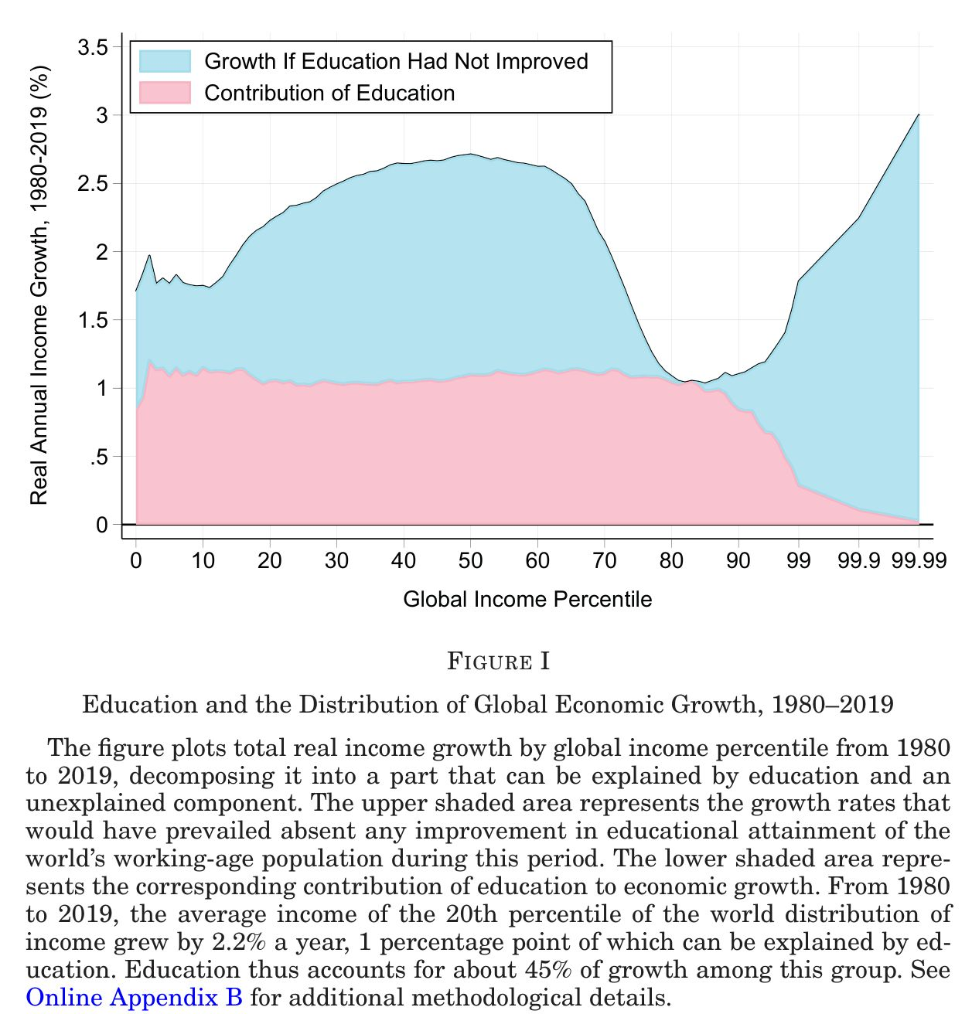
Elephant curve
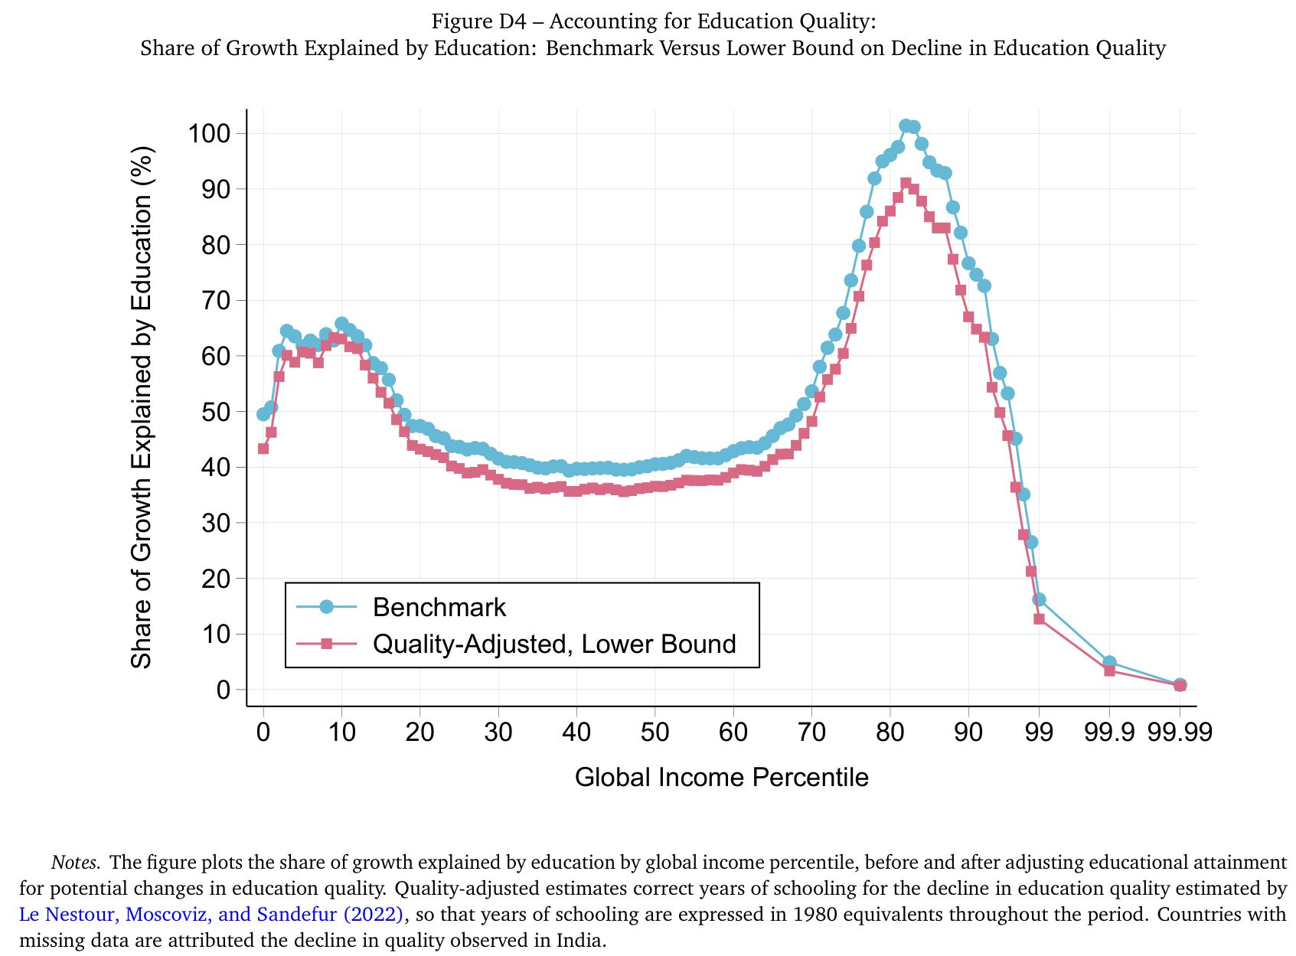
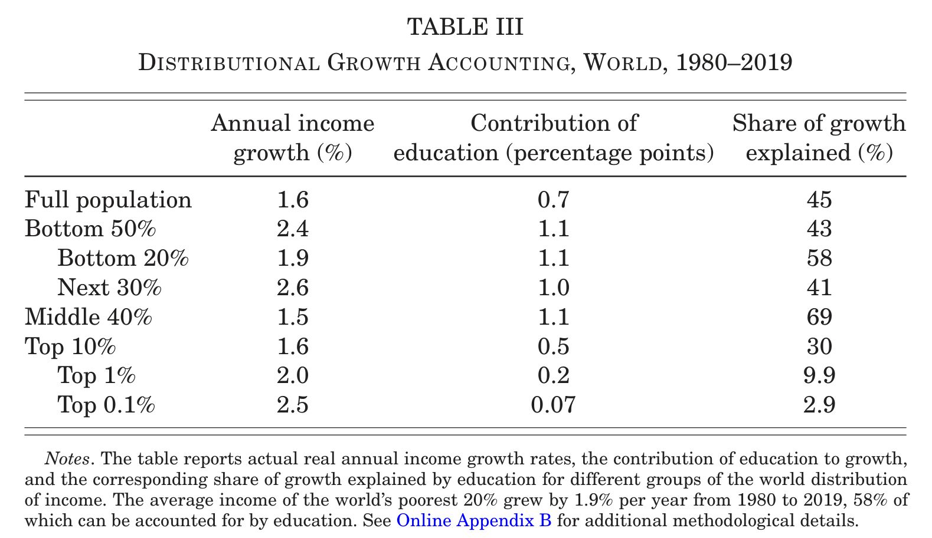
- Summary: Education expansion explains 40-70% of income growth for bottom 20% - middle 40% of world population
- New findings: Edu contribution is larger
  - Than standard growth accounting decomposition, because current returns to schooling is depressed by increased supply of skilled labour
  - For low income earners ← lower wage of skilled labour ← edu expansion
- Results validated: Compare with IV estimates under natural experiments in 3 countries
- Methodological innovation: Edu Contribution = independent edu expansion + skill biased tech change
  - Labor econ: Supply and demand of skilled labour, within country
  - Macro econ: Supply impacts of skilled labour, between country
  - This paper consolidates the two
- Data: 1980-2019, harmonising various surveys (ILO, World Bank, national, etc.), factor income data, world inequality data
- Estimation/computation:
  - OLS/IV for returns to schooling
  - Growth decomposition under CES ← incorporate imperfect substitutability between skilled and unskilled labour
  - Solve for SBTC using competitive profit maximisation given estimated schooling returns and human capital data
  - Allow for firms’ endogenous response of elasticity of substitution (long-run EOS, but does not play a major role in analysis)
- Mechanism: none proposed, decomposition with labour demand considerations
Click here to see the variable definitions.
Variable | Description
$Y^{t}$ | Output per capita at time t
$K^{t}$ | Per capita physical capital at time t
$H^{t}$ | Labor input per capita at time t
$z^{t}$ | Total factor productivity at time t
$α$ | Capital share of income
$L_{1}^{t},L_{2}^{t}$ | Shares of low-skilled and high-skilled workers
$θ_{1}^{t},θ_{2}^{t}$ | Factor-augmenting technology terms
$η$ | Elasticity of substitution between low-skilled and high-skilled workers
$θ$ | Technology level (skill bias)
$L$ | Relative supply of skilled workers
${\text{Share}}_{L}$ | Share of output growth accounted for by education
$κ_{1},κ_{2},ω$ | Parameters of the technology frontier
$A_{j}^{t}$ | Technology parameters for skill group j
$σ$ | Long-run elasticity of substitution
$w_{j}^{t}$ | Wage of skill group j at time t
$y_{i}$ | Total annual earned income of individual i
$D_{i,j}$ | Dummy for individual i having reached education level j (primary, secondary, tertiary)
$X_{i}$ | Vector of controls for individual i
$β_{j}$ | Coefficient for education level j
$r_{j}$ | Return to education level j
$L_{ter}^{t},L_{\underline{ter}}^{t}$ | Share of tertiary and non-tertiary educated workers
$L_{sec}^{t},L_{\underline{sec}}^{t}$ | Share of secondary and below-secondary educated workers
$L_{pri}^{t},L_{non}^{t}$ | Share of primary and no schooling workers
$σ_{1},σ_{2},σ_{3}$ | Elasticities of substitution between skill groups in the nested model
$r^{*\text{annual}}$ | “True” annualized return to schooling
$S^{t}$ | Average years of schooling at time t
$y_{iL}$ | Labor and mixed income of individual i
$s_{1},s_{2}$ | Education levels
$y^{p}$ | Income of group p
$α^{p}$ | Capital income share of group p
$y_{rt}^{i}$ | Average income of group i in region r at time t
$S_{rt}$ | Average years of schooling in region r at time t
$X_{rt}$ | Vector of controls for region r at time t
$Z_{rt}$ | Instrumental variable for schooling
$δ_{r},δ_{t}$ | Region and time fixed effects
$γ_{j}^{i}$ | Coefficients in the regression model
$H^{t,\text{standard}}$ | Standard measure of human capital at time t
$r$ | Mincerian return to schooling

Model
Production function
Labour aggregator
Time difference
Contribution of education
Total (given elevated skill bias of 2019)
Independent (given fixed skill bias of 1980)
Long-run (with profit maximising skill bias) elasticities $σ>η$ (short-run elasticities)
- A smaller (than $σ$), short-run elasticity of substitution (EOS) $η$ = a measure of imperfect substitutability between skilled and unskilled labour (relative to long-run substitutability)
This paper treat educational choice as exogenous
- There is no survey data from 1980’s that allows modeling household choice as a response to the firm labour demand
- Use long-run EOS $σ$
Return to schooling and human capital, skill bias
- Standard approach: human capital=f(fixed return to schooling, fixed skill bias)
- This paper:
  - Return to schooling and skill bias $\frac{A_{2}^{t}}{A_{1}^{t}}$ are determined simultaneously
  - Treat human capital $\frac{L_{2}^{t}}{L_{1}^{t}}$ as exogenous

Implications of simultaneity (returns to schooling $\frac{w_{2}^{t}}{w_{1}^{t}}$, skill bias $\frac{A_{2}^{t}}{A_{1}^{t}}$) on contribution of education expansion
- Share$​_{L}^{θ^{2019}}$↑
  - Education expansion ⇒ returns to schooling↓ ⇒ (returns to schooling×human capital)↓
  - Holding returns to schooling fixed ⇒ contribution of education expansion↑
- Share$​_{L}^{θ^{2019}}$↑ is greater at the lower end of EOS
  - Lower values of EOS = smaller adjustments of EOS by firms ⇒ smaller adjustments of skill bias if human capital reverts to 1980 level ⇒ larger decline in outputs in counterfactual
- Share$​_{L}^{θ^{2019}}$ - Share$​_{L}^{θ^{1980}}$ (Total - Independent) is greater at lower EOS in (2)
  - EOS↓ ⇒ $Δ$skill weights $\left|\frac{θ_{2}^{1980}}{θ_{1}^{1980}}−\frac{θ_{2}^{2019}}{θ_{1}^{2019}}\right|$↑ ⇒ $Δ$skill bias $\left|\frac{A_{2}^{1980}}{A_{1}^{1980}}−\frac{A_{2}^{2019}}{A_{1}^{2019}}\right|$↑
  - Lower EOS ⇔ smaller contribution of skill bias ⇔ larger contribution of human capital (educational expansion)
Distributional effects of increasing $L_{2}^{1980}$ to $L_{2}^{2019}$
Education↑ ⇒ labour income inequality↓
- Education expansion↑ ⇒ $\frac{w_{2}^{t}}{w_{1}^{t}}$↓
- Inequality↓ ⇐ EOS↓ (reduction impacts are larger when EOS is smaller)
- This effect is independent of skill bias $A_{j}^{t}$

Data sources
- International Labour Organization (ILO) Harmonized Microdata
  - Individual-level survey data
  - Coverage: 10 million individuals in 154 countries (c. 2019), representing over 95% of the world’s population
  - To estimate baseline returns to schooling and construct counterfactual income distributions
- World Bank’s I2D2 (International Income Distribution Database)
  - Historical household survey data
Survey Category | Typical Sample Size Range
smaller/targeted surveys | 2,000 - 8,000
standard national surveys | 10,000 - 30,000
large national/regional surveys | 40,000 - 100,000+
  - Coverage: Data for 109 countries (c. 2000), representing about 80% of the world’s population
  - To estimate skill-biased technical change
- Barro and Lee (2013) Database
  - Time-series data on educational attainment
  - Coverage: 146 countries from 1980-2019 (supplemented by other sources)
  - To quantify the change in the supply of skilled labor over time
- World Inequality Database (WID)
  - Macro-level income distribution data
  - Coverage: Global (all countries) from 1980-2019
  - To benchmark microdata against macroeconomic growth rates
- World Bank Data Portal
  - Global poverty statistics
  - Coverage: Global
  - To calculate education’s contribution to poverty reduction
- Penn World Tables & Bachas et al. (2022)
  - Country-level factor income shares
  - Coverage: Broad cross-country coverage
  - To conduct standard growth accounting comparisons
- Previous Academic Studies (Khanna 2023; Duflo 2001; etc.)
  - Regional data on education policy exposure
  - Coverage: Subnational regions within India, Indonesia, and the United States
  - To validate the model’s predictions using natural experiments
Estimation of returns to schooling
Marginal returns * Returns to schooling look convex (Figure II) * The paper also compiles 33 studies using both IV and OLS, show IV estimates are larger (Figure III) * It looks like it blows up OLS by some percentage to correct the bias, calling it as “upward-corrected using IV-OLS gaps” * Mean gap is about 40% * Convexity of returns remains in IV estimates

Methodology

Solve the model
- Assume nested CES production
- Set EOS $σ=4,6,8$
- Solve the model
  - 3 equations ⇒ recover unknowns $\frac{A_{pri}^{2019}}{A_{non}^{2019}},\frac{A_{sec}^{2019}}{A_{\overset{‾}{sec}}^{2019}},\frac{A_{ter}^{2019}}{A_{\overset{‾}{ter}}^{2019}}$
- Compute implied returns to schooling

Distributional growth accounting exercise
- Downgrade education levels as a policy exercise
- Adjust wages to downgraded education levels, recompute labour incomes
- Assume capital is unaffected and compute capital incomes
- Total income = labour income + capital income
- Growth accounting
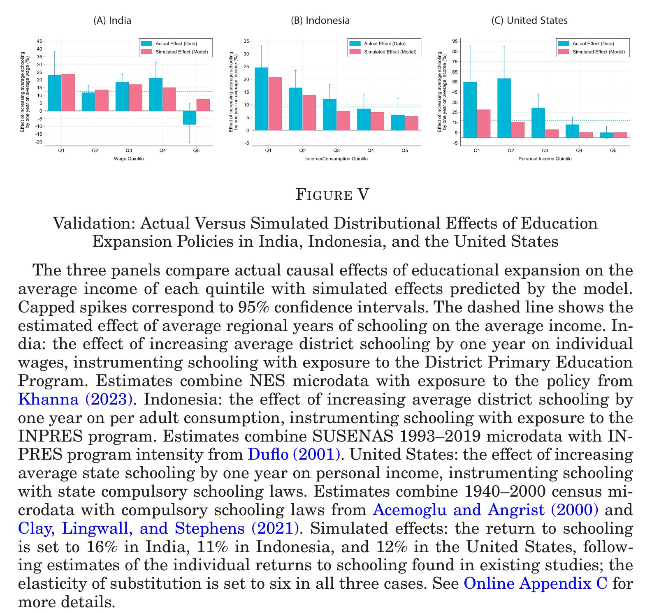
- Validation using DPEP (India, IV=RDD cutoff), INPRES (Indonesia, IV=number of schools built), Compulsory schooling laws (US, IV=Birth-State cohort) Figure V shows estimated returns to schooling: IV $≃$ OLS
  - OLS estimates are validated

Results

Main results
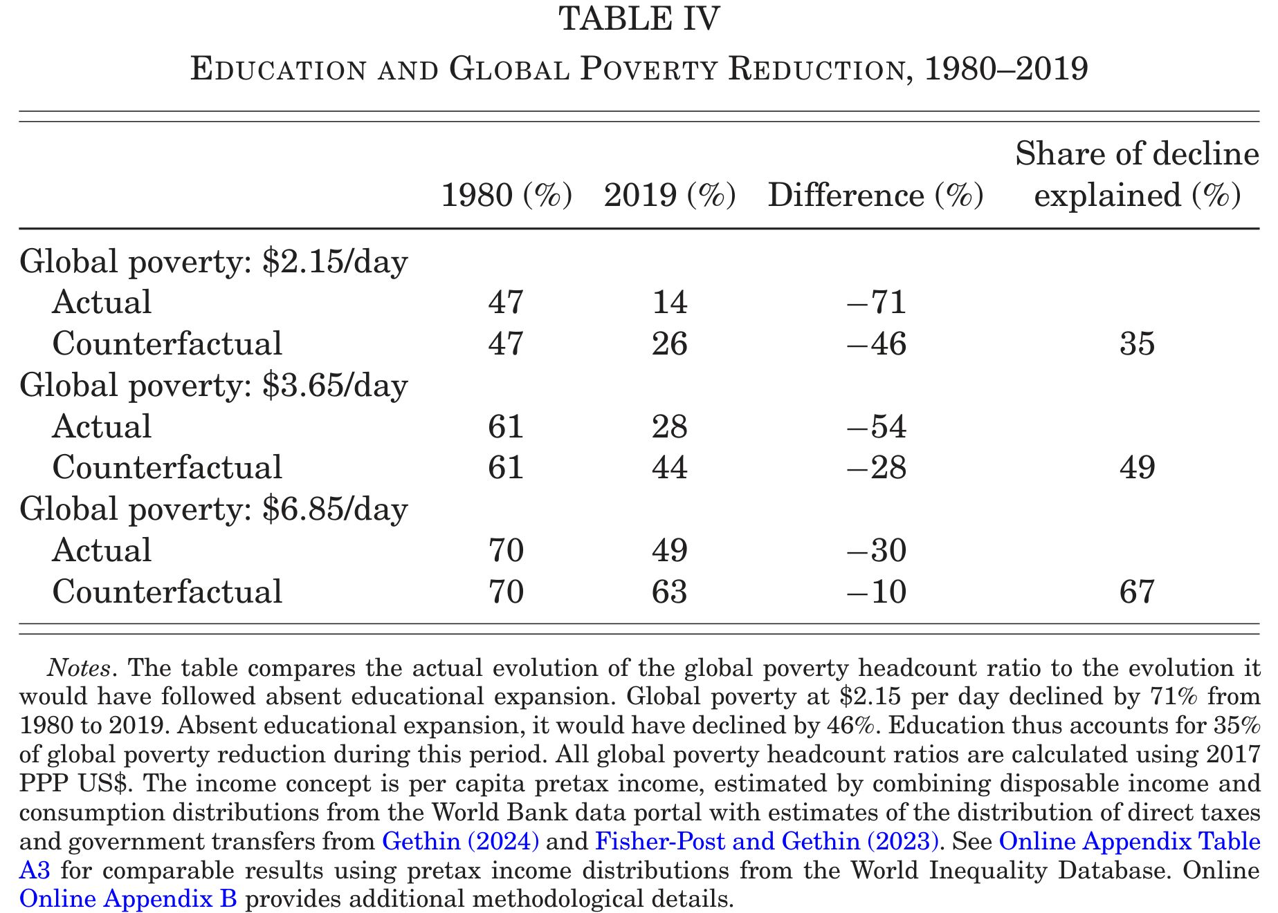
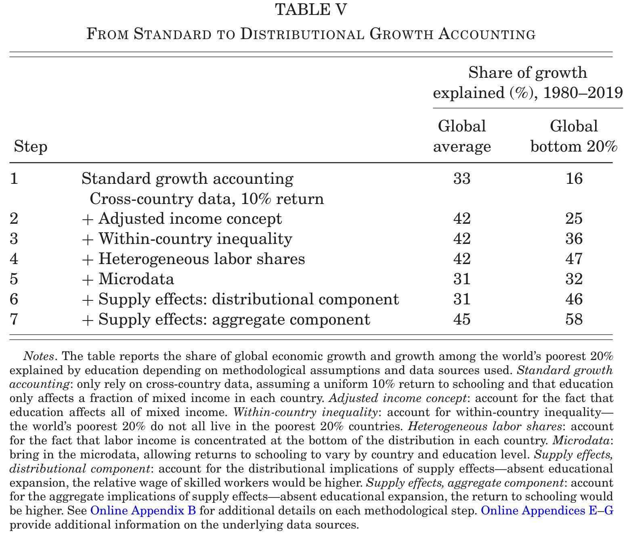
- Elephant curve (Fig 1)
  - Rise of China, India
  - Sluggish growth in low income countries
  - Weak income growth for most of HHs in high income countries
  - Sky rocketing top income inequality in many countries
- Share of below extreme poverty↓ (Tab 4)
  - Education: 35% of $Δ$share (USD 2.15/day)
- Use of returns to schooling on total income
  - OLS estimates: labour income $≃$ capital income
  - Bachas et al. (2022) factor share data, not Penn World Table
- Incorporate within-country inequality ⇒ contribution of education↑ for bottom 20% of the world, because:
  - Bottom 20% = low income + middle income (more improvements)
  - Inequality↑ in many countries ⇒ less growth to be explained for the poor
- Incorporate within-country capital income inequality ⇒ contribution of education↑ for bottom 20% of the world
  - Passthrough is 100% for low income earners, but only labour income share for top earners
- Microdata ⇒ returns differ by country and education level ⇒ contribution of education↓
  - Estimated mean returns are 8%, smaller than standard exercise 10%
- Relative supply of skilled workers↑ ⇒ contribution of education↑ for bottom 20% of the world
  - Relative wage of skilled↓ + increased skilled workers among low income↑
  - Restriction: Mean income is unchanged
- Aggregate growth effects of education ⇒ contribution of education↑ for bottom 20% of the world

Sensitivity to alternative specifications
- IV-corrected returns to schooling
- EOS
- Alternative nesting of CES, no nesting, imperfect substitution between age groups (single EOS for skill groups, single EOS for age groups)
- Physical capital adjustments to educational expansion
- Educational attainment categories
- Heterogenous educational expansion by age, gender, region (India), race (South Africa, US)
- School attendance
- Education quality

Heterogeneity
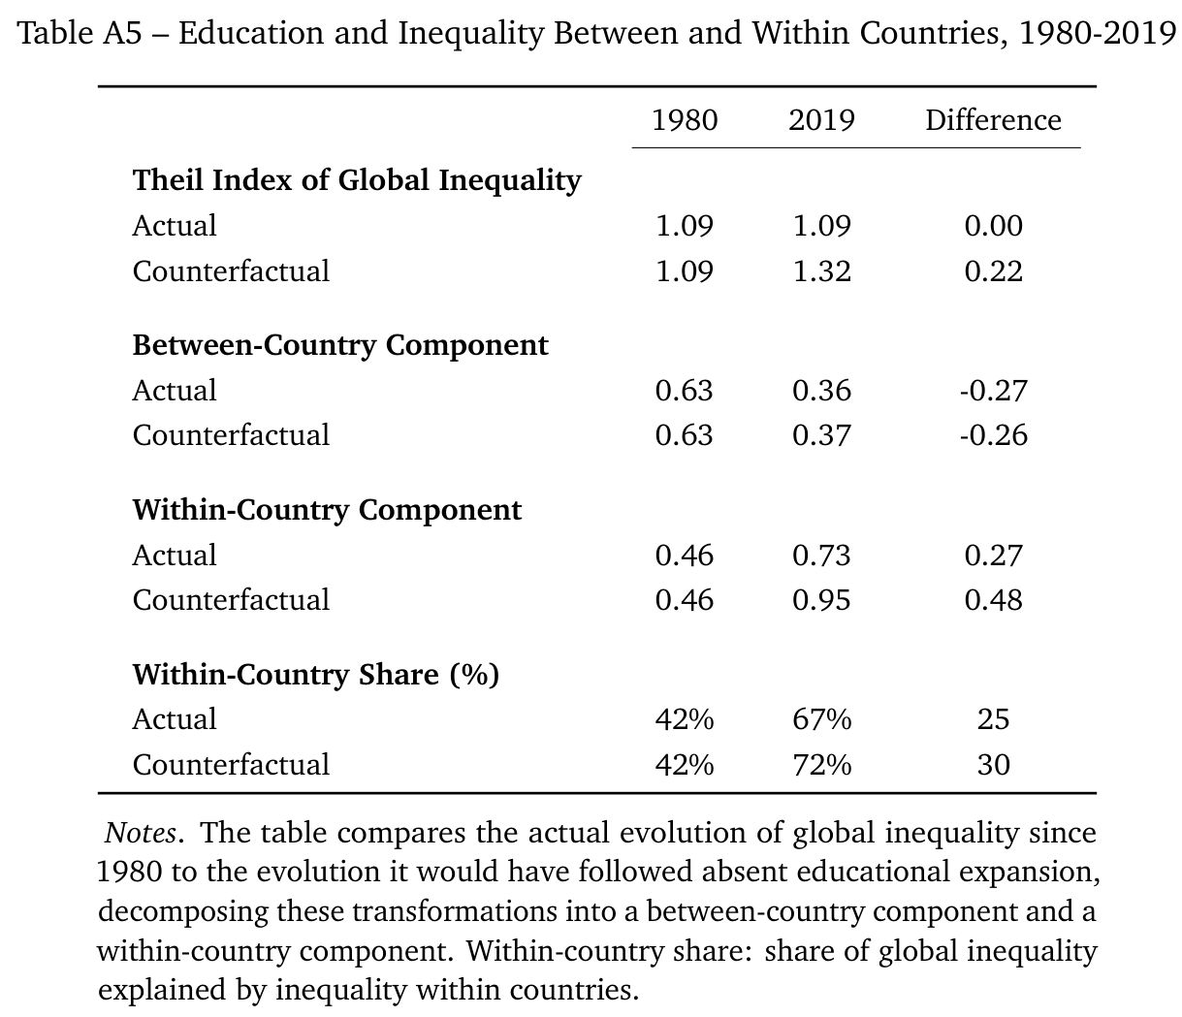
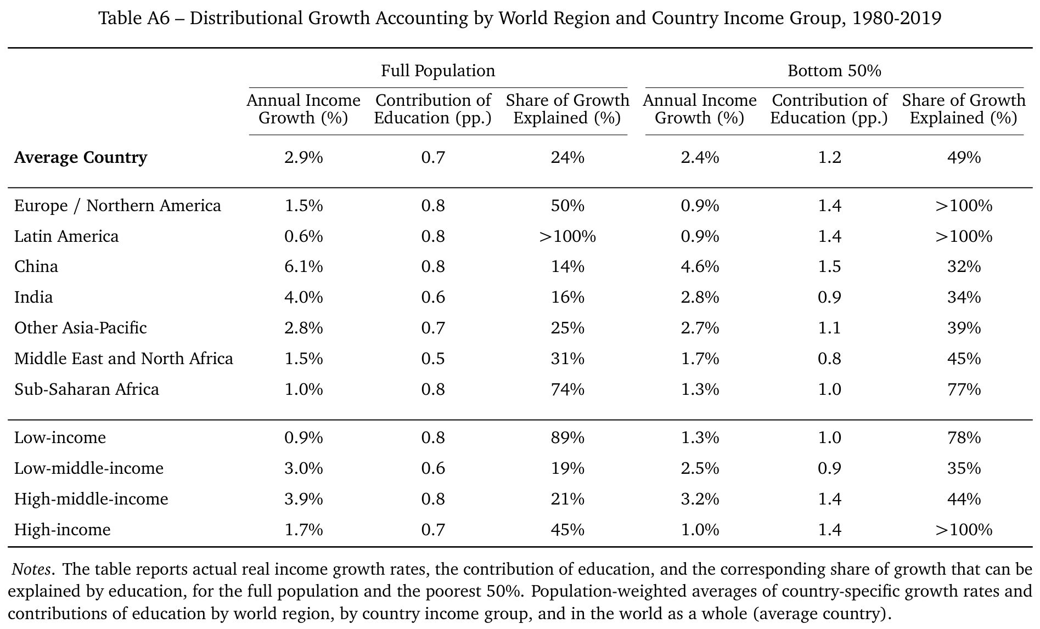
- Within and between countries (Tab A5)
  - No change in global inequality
  - Absent educational expansion, global inequality↑ by 20%
  - Between country inequality↓, within country inequality↑
- By world region (Tab A6)
  - Education explains 25% of income growth globally
  - Mean: Latin America > Sub-Saharan Africa > Europe and North America > MENA > APAC > China, India
  - Bottom 50%: Latin America, Europe and North America > Sub-Saharan Africa > MENA > APAC, China, India

Skill biased technological change
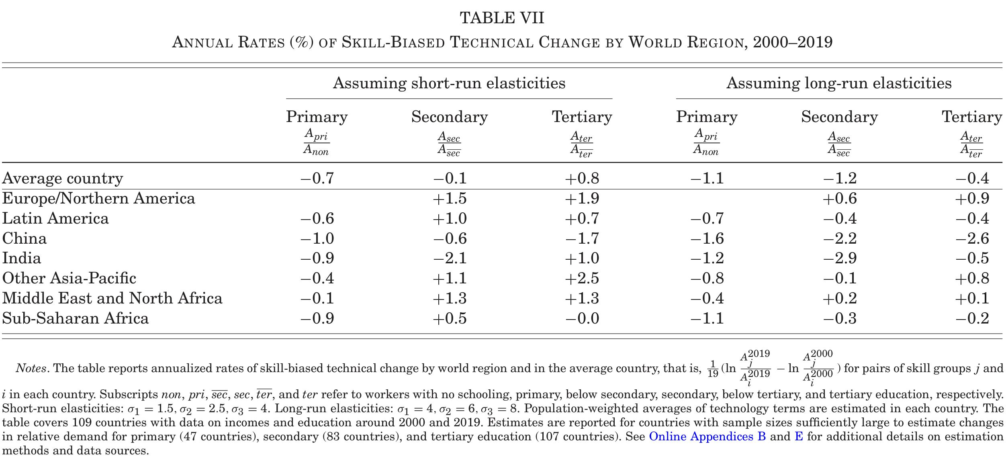
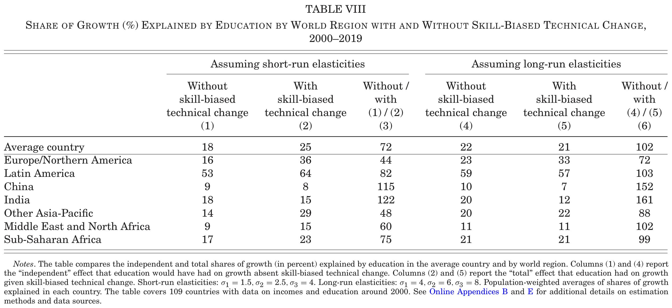
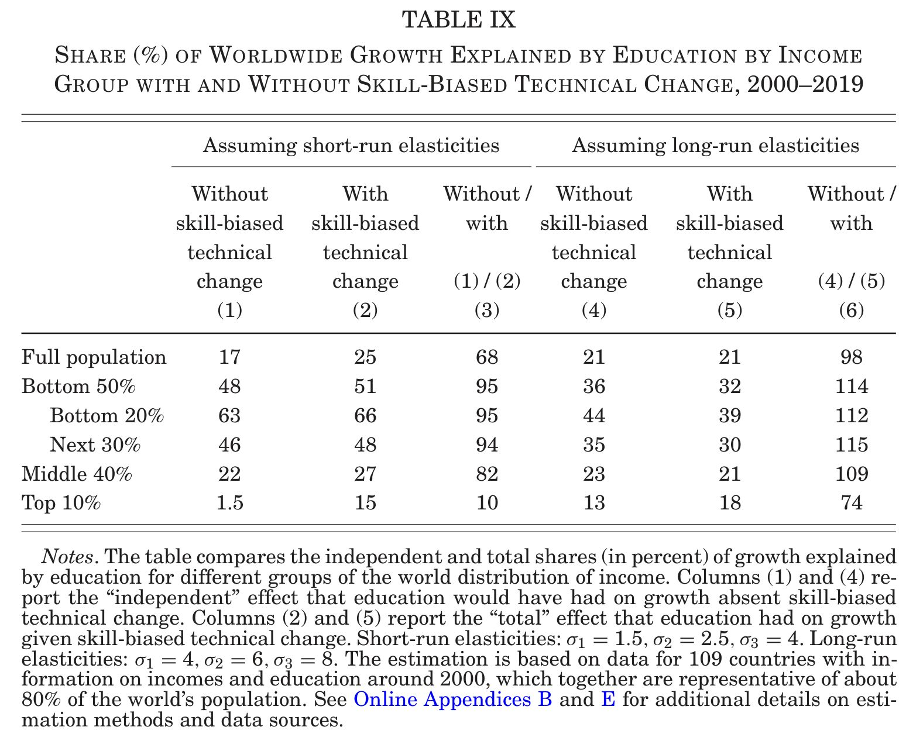
Long-run EOS = larger, educational expansion is accounted for → adjust with EOS ⇒ smaller SBTC
Short-run EOS = smaller, educational expansion is not accounted for → adjust with $θ_{j}$ ⇒ larger SBTC
SBTC
- Large: Tertiary, Europe/North America, APAC, MENA
- Negative: Primary, secondary China, seconday India, tertiry China
Education contribution
- SBTC increases education contribution (Tab 8)
  - 70% is educational expansion
  - 30% is SBTC
- Low income groups (Tab 9)
  - Larger than high income groups
  - Similar with/without SBTC
    - Low or negative skilled labour demand in low income countries
- High income groups (Tab 9)
  - Increases with SBTC
    - Growing skilled labour demand in high income countries

感想
- Goldin-Katzに似た枠組みをマクロ成長会計に導入した
- SBTCと就学収益率を同時決定することで、SBTCの影響を考慮できるようにしたのは素晴らしい
  - 機械的な収益率計算、技術パラメタを固定したマクロ生産関数による要因分解ではない
  - 収益率変化を許容することで、教育の貢献が過小評価されていることを示した
  - データ制約により推計できないため、人的資本は外生扱い
- skill biasパラメタを初年値に固定することで教育の独自効果independent effects、後年値に固定することで合計効果total effectsを計算するアイディアがよい
- データ作業量は想像を絶する (RA1人!)
- 余りに多岐にわたるデータ利用なので、全体を展望できるほど理解できていない
- 推計したらこうなっています、理由はこれだと思います、という論文
- CESパラメタや収益率推計値を低中高所得国グループ毎に変えるとどうなるのか
Hendricks, Lutz, and Todd Schoellman. 2023. “Skilled Labor Productivity and Cross-Country Income Differences.” American Economic Journal: Macroeconomics 15 (1): 240–68. https://doi.org/10.1257/mac.20200256.

$σ$ is defined under optimally chosen skill bias $θ_{j}$. So $σ$ reflects firm’s response to educational expansion.
Allowing firms to choose skill bias $θ_{j}$ under a skill constraint $${\left[{\left(κ_{1}θ_{1}\right)}^{ω}+{\left(κ_{2}θ_{2}\right)}^{ω}\right]}^{\frac{1}{ω}}≤B$$ yields a long-run CES labour aggregator form (Hendricks and Schoellman 2023):

