**Semi-Supervised Classification of Fluorescence in Ion Traps**

**Introduction**

The field of quantum computing and simulation has advanced significantly for the last 10 years, yet there are numerous challenges persist before we are able to build fault tolerant quantum computer. This technology has lots of issues, particularly in the realm of accurate state classification of ions in an ion trap platform. Scientists can prepare and run calculations on ions, but with growing ion systems detectors have become less reliable for classifying the state of ions. This project addresses this novel problem: the classification of fluorescence states of ions in real physical systems with lab provided dataset as binary sequences ranging from `0000` to `1111`, corresponding to 16 unique classes. Potentially such a model could be slightly modified to classify systems with 8, 16 and 32 ions.

**Background Review (Related Work)**

Previous studies on specifically Machine learning (ML) approach to quantum state readout have explored only supervised learning on simulated data. They had big advantage of using fully labeled data and controlled noise [1], additionally systems they classified where 1-2 ions [2].

*Extended:*

Recent published papers on quantum information processing (QIP) topic have demonstrated high-fidelity state readout. Spatially resolving the fluorescence from individual ions onto a detector enables simultaneous readout of multiple qubits. High readout fidelities exceeding 99.9% have been achieved using PMTs or CCDs together with adaptive threshold techniques that account for cross-talk between ions [7-10]. But they are vulnerable to noise from bigger systems of ions, more than 4.

To further improve readout performance and scalability, recent work has investigated integrating superconducting nanowire single photon detectors (SNSPDs) directly into surface electrode ion traps. Todaro et al. demonstrated such a trap-integrated SNSPD could achieve state readout of a single 9Be+ ion qubit with 99.91(1)% average fidelity, limited primarily by polarization impurity of the readout laser and off-resonant optical pumping. Using the ion as a calibrated photon source, they characterized the detector quantum efficiency and its angular dependence, showing agreement with theoretical models. This integrated photonic readout approach frees up optical access and paves the way for scalable parallel qubit readout in large trap arrays without external optics or detectors.

In parallel, machine learning techniques have emerged as a promising approach to optimize readout fidelity and automate the extraction of qubit states from fluorescence images of multi-ion chains. Teoh et al. developed a feedforward neural network (FFNN) to learn the point spread function (PSF) of ions and classify their states from simulated fluorescence data [2]. Interestingly, they found the trained network uses learned weights that resemble the PSF and functions similarly to a linear classifier used in adaptive thresholding. To improve scalability, they propose a two-stage readout process that first determines a region of interest (ROI) for each ion from a calibration image taken during Doppler cooling, then applies the FFNN to the ROI of each ion in the measurement image to predict its state. This approach eliminates the need to retrain the network if ions shift position and enables scaling to larger qubit numbers.

**Dataset Explanation**

The dataset consists of fluorescence images of ions. There are 4 ions in the system, we cropped each ion from the original 4 ion image and created a dataset, where we sorted datapoint by their labels (0, 1 or -1) and ion position in each system in key name. Cropping procedure make sense, because outside 5x5 area we can observe only useless noise or void from which we can’t learn anything, in addition to that we will make learning procedure faster and ML model architecture more flexible. In general, we have 20,000 batches of 4 individual index dependent images of labelled ions - `0000` and `1111` states and 10,000 batches of uniformly distributed across the 16 intermediate states mixed states. Our objective is to achieve a classification accuracy as close as possible to 99% to ensure reliable quantum calculations. The uniform distribution of classes in unlabeled data gives us advantage which we can use to learn from those images more effectively, meaning mixed states have equal representation of 625 images per class, presents a unique opportunity to employ the mean squared error (MSE) loss function for model adjustment, aiming at a predicted distribution that aligns with this uniformity.

Illustration:

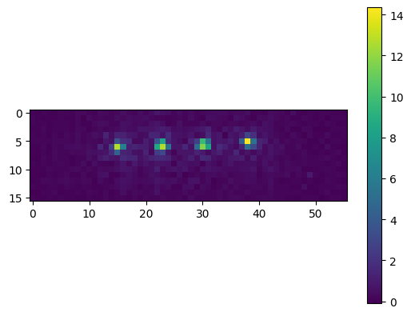

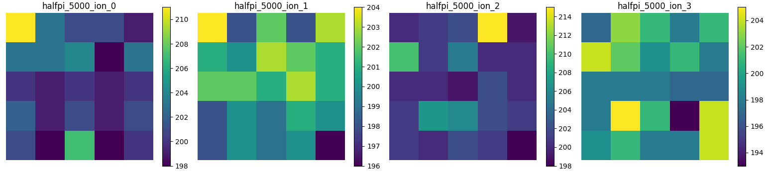

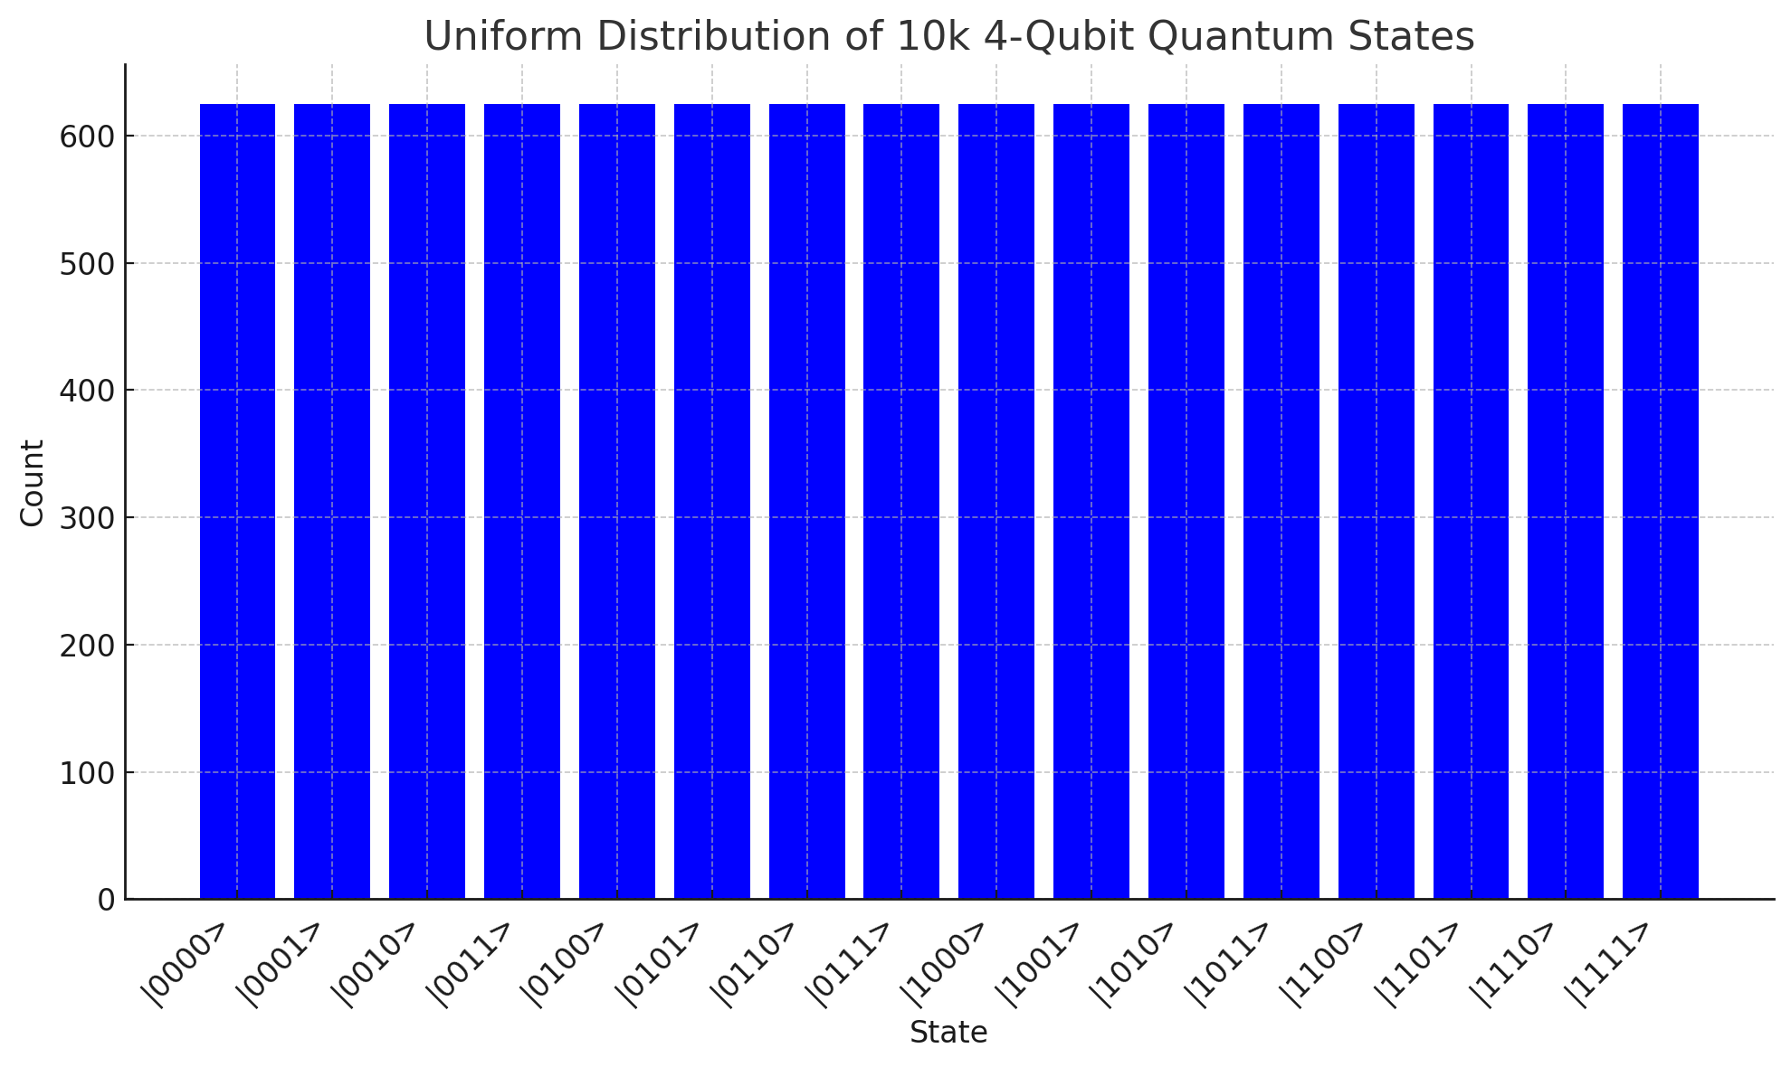

**Experiments**

Our methodology integrates a Fully Connected Network (FCN) with four separate image channels as the primary model, also drawing on the recommendation we have implemented Convolutional Neural Networks (CNNs) and Residual Networks (ResNets) for comparative analysis. The FCN is designed to accommodate the unique structure of our data, allowing for a tailored approach to the classification task. In parallel, we apply semi-supervised learning techniques, including Pseudo Labeling, Label Propagation, and Self-Training, to leverage the unlabeled data effectively.

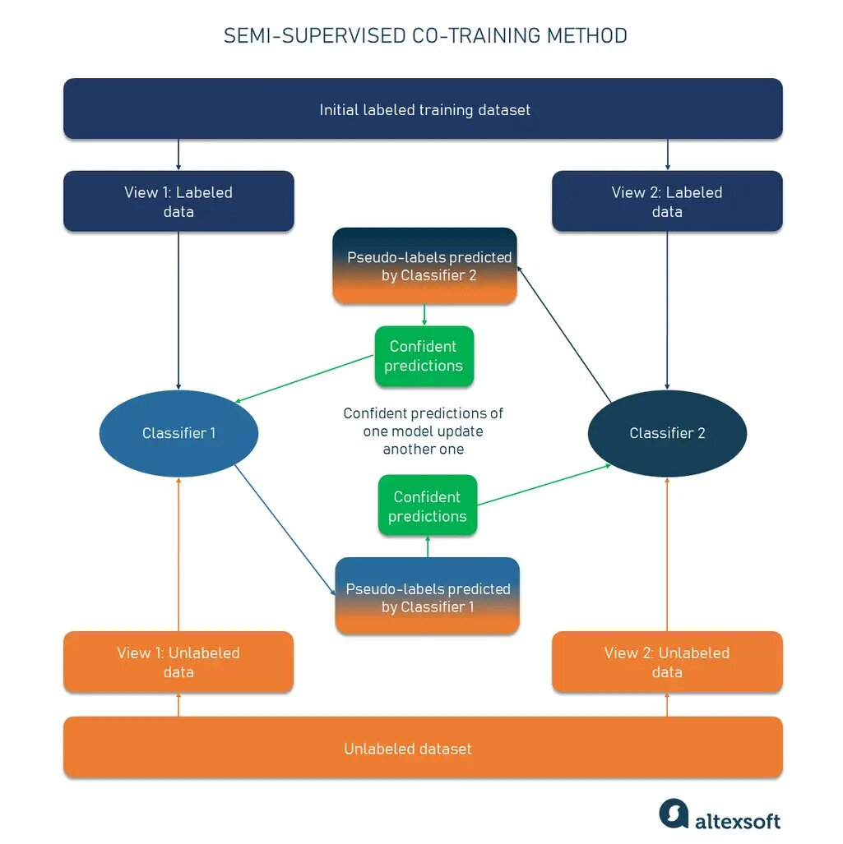

**Results and Comparisons**

-

-

-

-

**Conclusion**

-

-

-

-

**#### References**

[1] Laine, S., & Aila, T. (2018). Temporal Ensembling for Semi-Supervised Learning. arXiv:1804.07718.

[2] Teoh, Y.-H. (2018). Deep Learning for Quantum State Preparation and Quantum Gate Synthesis. University of Waterloo. https://uwspace.uwaterloo.ca/handle/10012/17322

[3] Weng, L. (2021, December 5). Semi-Supervised Learning Overview. https://lilianweng.github.io/posts/2021-12-05-semi-supervised/

[4] Analytics Vidhya. (2017, September). Pseudo Labelling: A Semi-Supervised Learning Technique. <https://www.analyticsvidhya.com/blog/2017/09/pseudo-labelling-semi-supervised-learning-technique/>

[5] Negnevitsky, V., Marinelli, M., Mehta, K.K. et al. Repeated multi-qubit readout and feedback with a mixed-species trapped-ion register. Nature 563, 527–531 (2018). <https://doi.org/10.1038/s41586-018-0668-z>

[6] J. Hilder, D. Pijn, O. Onishchenko, A. Stahl, M. Orth, B. Lekitsch, A. Rodriguez-Blanco, M. Müller, F. Schmidt-Kaler, and U. G. Poschinger, "Fault-Tolerant Parity Readout on a Shuttling-Based Trapped-Ion Quantum Computer," Phys. Rev. X, vol. 12, no. 011032, Feb. 17, 2022.

[7] A. H. Myerson, D. J. Szwer, S. C. Webster, D. T. C. Allcock, M. J. Curtis, G. Imreh, J. A. Sherman, D. N. Stacey, A. M. Steane, and D. M. Lucas, High-Fidelity Readout of Trapped-Ion Qubits, Phys. Rev. Lett. 100, 200502 (2008).

[8] A. H. Burrell, D. J. Szwer, S. C. Webster, and D. M. Lucas, Scalable simultaneous multiqubit readout with 99.99% single-shot fidelity, Phys. Rev. A 81, 040302(R) (2010).

[9] J. E. Christensen, D. Hucul, W. C. Campbell, and E. R. Hudson, High-fidelity manipulation of a qubit enabled by a manufactured nucleus, npj Quantum Inf. 6, 35 (2020).

[10] L. A. Zhukas, P. Svihra, A. Nomerotski, and B. B. Blinov, High-fidelity simultaneous detection of trapped ion qubit register, arXiv:2006.12801.

[11] S. L. Todaro, V. B. Verma, K. C. McCormick, D. T. C. Allcock, R. P. Mirin, D. J. Wineland, S. W. Nam, A. C. Wilson, D. Leibfried, and D. H. Slichter, "State Readout of a Trapped Ion Qubit Using a Trap-Integrated Superconducting Photon Detector," Phys. Rev. Lett., vol. 126, no. 010501, Jan. 6, 2021.