**ISRO IMMERSION CHALENGE 2024**

**Team Name**: **Terra_Spatial**

**Solution Title : Geospatial Data Retrieval system**

**Track : Student Research – Spatial Informatic**

**Mentor :** Prof. Geeta Kodabagi

**Team members** :

1. Raunak Jha

2. Atharva Gorale

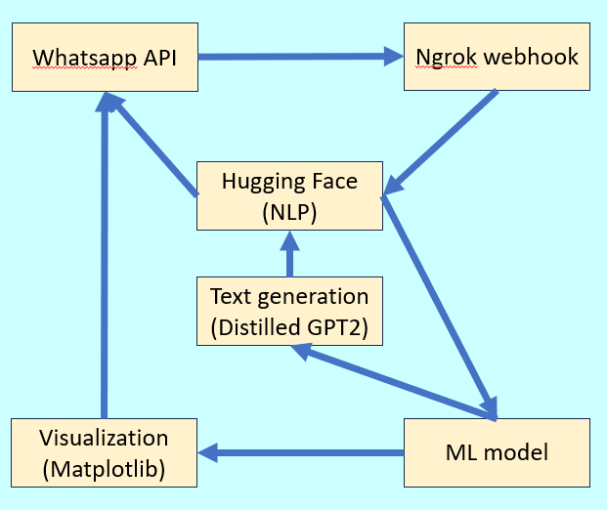3. Prathamesh Badgujar

**Implementation procedure:**

1. Input of user query and location through Whatsapp chat.
2. Natural language to executable query using NLP model.
3. Query sent to ML model trained on geospatial datasets.
4. Result generated.
5. Result converted to Natural language.
6. Result displayed through Whatsapp chat window.

**Project Details :**

* The present solution aims to provide an easy to use interface for users to access geospatial data in natural language.
* Accessible by users with low processing power devices and weak internet.
* This solution has a wide use case in disaster management, city planning and monitoring, agriculture, land mapping and feature extraction, water management and infrastructure construction, encroachment removal and water level monitoring.
* It also presents 3 unique commercialization potential with huge application.
* Since we aim to build platform softwares, this project holds extensive future use case.
* An extensive network of ML models would be trained and deployed to provide multiple geospatial services.
* The NLP model would be trained to handle more complex user queries and produce easier to understand results (text, image, short video).
* Infrastructure constructors, farmers, government and civic bodies, disaster relief teams and ordinary citizens would be able to derive huge value from our platform.
* If our platform is authorized to get real time data, it would be a game changer in real time disaster management and resource tracking.
* Several aspects of this project can be tweaked to provide customized results on custom datasets.
* The geospatial ML models may be used by users on their unique platforms too.

