;l

Foundations of Programming

Assignment No. : 01

PROBLEM STATEMENT:

Write a program in C to check whether a given year is a Leap Year

OBJECTIVE:
- To understand the use of conditional statements in C programming.
- To implement logical conditions for solving real-world problems.
- To develop problem-solving skills using decision control structures.

THEORY:
Theory for conditional statements with syntax (if , if-else, if-else ladder) are used in C programming
Theory for a Leap Year - year that contains 366 days instead of the usual 365 days.
Rules:
• A year is a leap year if it is divisible by 400, OR
• A year is a leap year if it is divisible by 4 but not divisible by 100.

ALGORITHM:
Step 1: Start
Step 2: Declare and read the variable, here year.
Step 3: Check if year is divisible by 400
if yes, go to step 7
if no, go to step4
Step 4: Check if year is divisible by 100
if yes, go to step 7
if no, go to step 5
Step 5: Check if year is divisible by 4
if yes, go to step 6
if no, go to step 7
Step 6: Print "Leap Year"
Step 7: Print "Not a Leap Year"
Step 8: Stop

FLOWCHART:
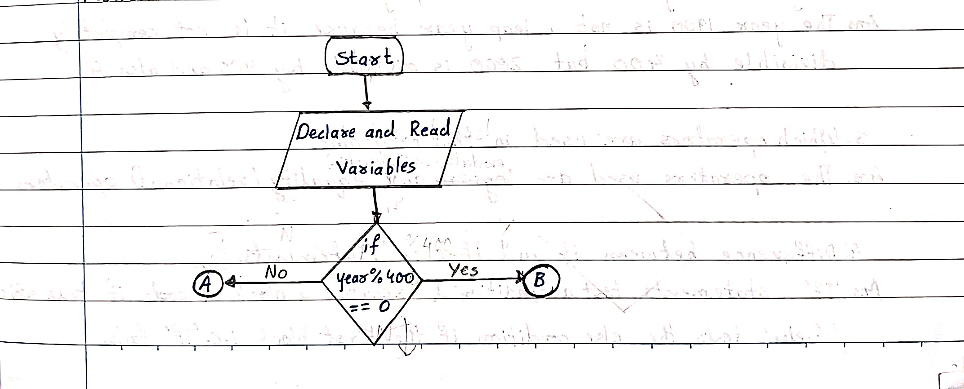
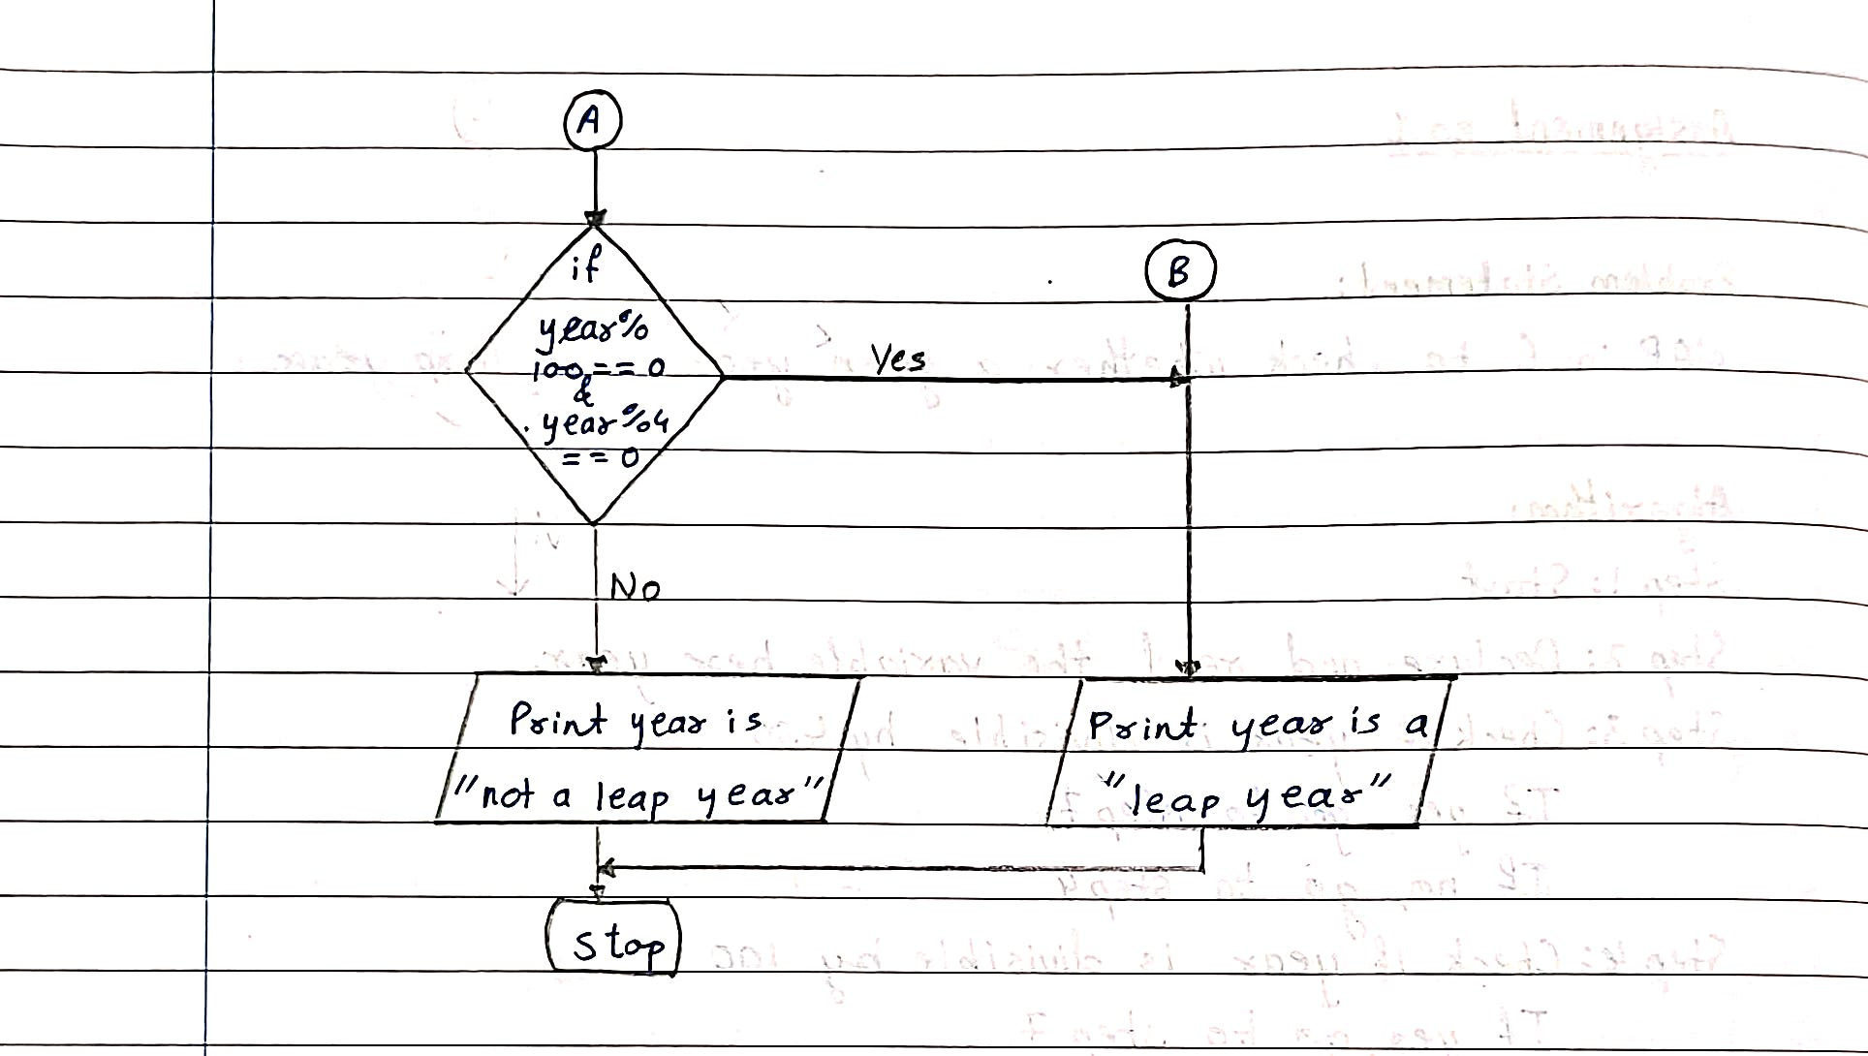

PROGRAM:
#include <stdio.h>

int main()
{
int year;
printf("Enter a year: ");
scanf("%d", &year);
if (year % 400 == 0)
{
printf("Leap Year");
}
else
{
if (year % 100 == 0)
{
printf("Not a Leap Year");
}
else
{
if (year % 4 == 0)
{
printf("Leap Year");
}
else
{
printf("Not a Leap Year");
}
}
}

return 0;
}
PLATFORM:
Linux

INPUT:
Enter a year (integer value).

OUTPUT:
Displays whether the entered year is a Leap Year or Not a Leap Year.
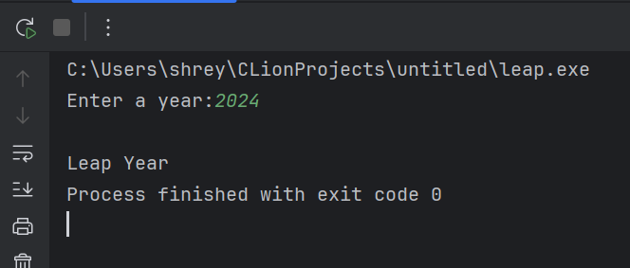

Sample Input:
2024

Sample Output:
2024 is a Leap Year

CONCLUSION:
Thus, the program successfully checks whether a given year is a Leap Year using conditional statements in C.

FAQs:
- What is a leap year?
- Why is the year 1900 not a leap year but 2000 is?
- Which operators are used in this program?
- Difference between if and if–else statements.

