

Foundations of Programming

Assignment No.: 4

PROBLEM STATEMENT:

Write a C Program to calculate the salary of an employee given his basic pay (taken as input from the user). Calculate gross salary of employee. Let HRA be 10 % of basic pay and TA be 5% of basic pay. Let employees pay professional tax as 2% of total salary. Calculate net salary payable after deductions.

OBJECTIVE:
- To understand the importance of flowchart for any programming model.
- To learn simple flowchart symbols and arrows to define relationships.
- To understand and develop visual representations of flow of data.

THEORY:
Define Algorithm.

What are the different characteristics of an algorithm.

ALGORITHM:
Step 1: Start
Step 2: Declare variables bp,hra, ta, gr, pt, net as float
Step 3: Input the value of bp (basic pay) from the user
Step4: Calculate 10% of bp and store in hra.
Calculate 5% of bp and store in ta
Step 5: Calculate gross salary by adding bp, hra and ta. Store in gr
Step 6: Calculate professional tax by multiplying 0.02 with gr and store the result in pt
Step 7: Calculate net salary by substracting pt from gr
Step 8: Display Gross and net salary
Step 9: Stop.

FLOWCHART:

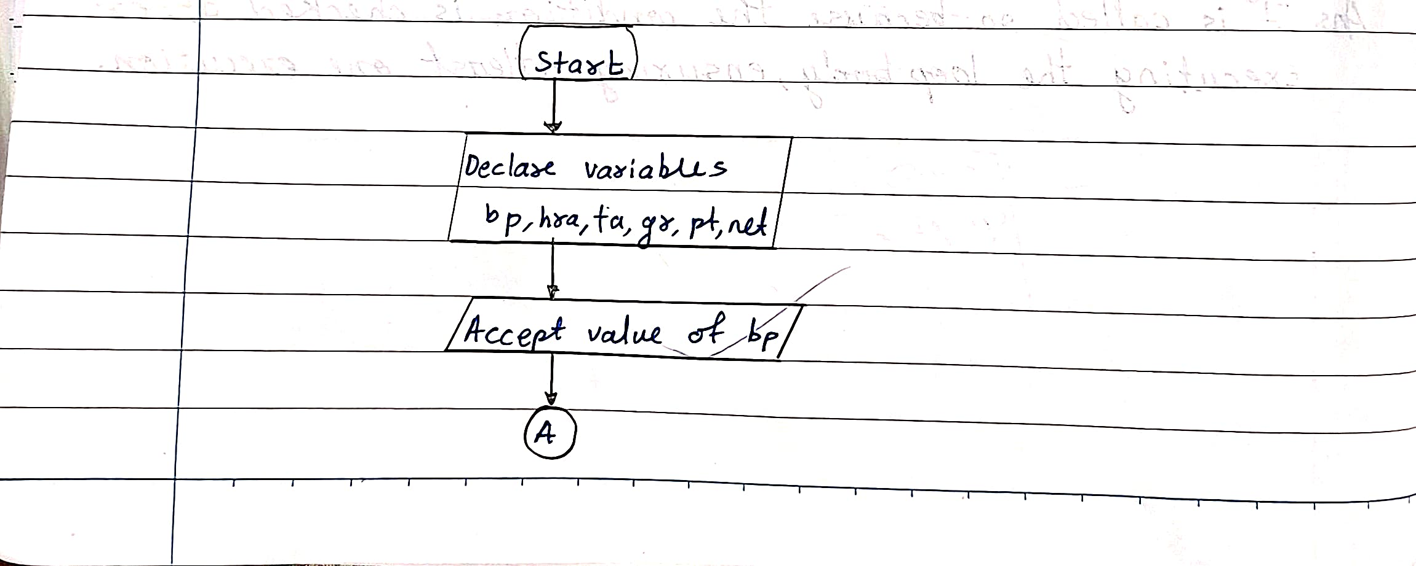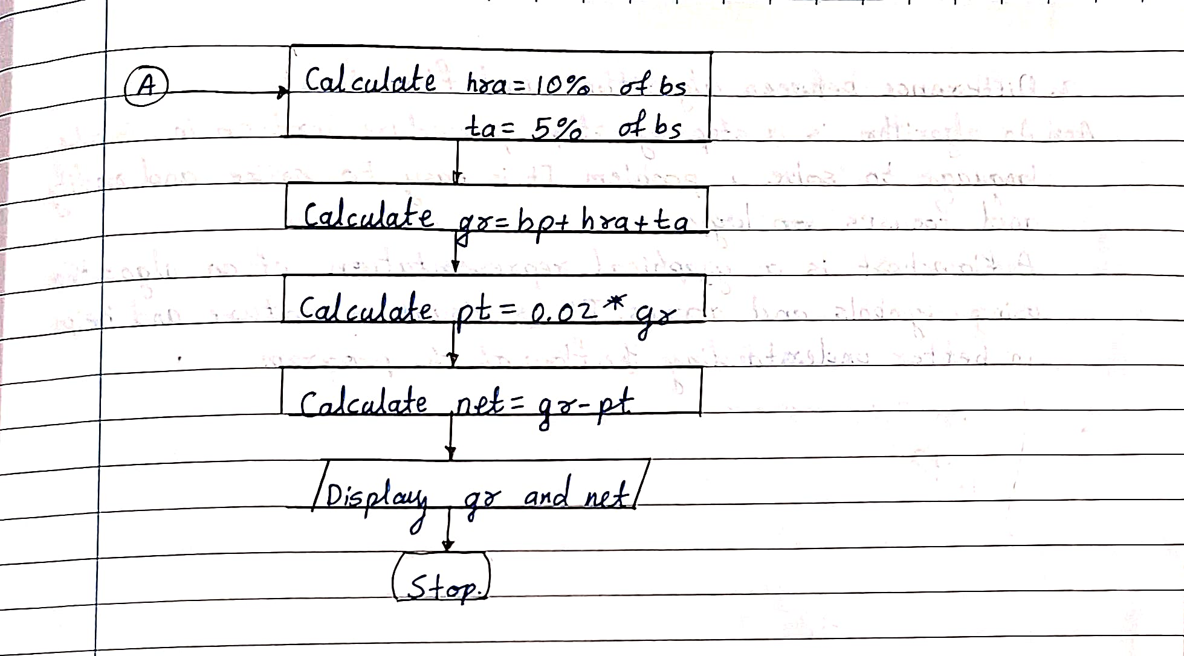

PROGRAM:
#include <stdio.h>

int main() {
float bp, hra, ta, gr, pt, net;
printf("Enter Basic Pay: ");
scanf("%f", &bp);
hra = 0.10 * bp;
ta = 0.05 * bp;
gr = bp + hra + ta;
pt = 0.02 * gr;
net = gr - pt;
printf("\nGross Salary = %.2f", gr);
printf("\nNet Salary = %.2f", net);

return 0;
}

PLATFORM:

Linux

INPUT:

Enter the basic salary of the employee

OUTPUT:

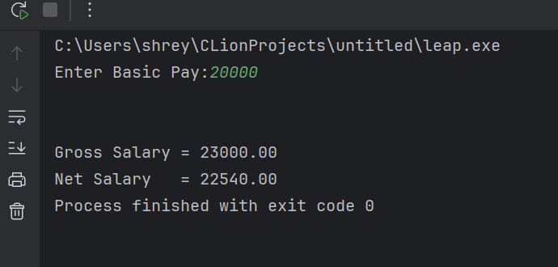

CONCLUSION:

Thus, we have learned to write algorithms and to draw its representation in terms of flowchart.

FAQs:
Describe various symbols and their use in flowchart.
Difference between Algorithm and Flowchart.

