a3-403a-07@a3403a-07:~$ docker version
Client: Docker Engine - Community
Version: 23.0.1
API version: 1.42
Go version: go1.19.5
Git commit: a5ee5b1
Built: Thu Feb 9 19:46:56 2023
OS/Arch: linux/amd64
Context: default

Server: Docker Engine - Community
Engine:
Version: 23.0.1
API version: 1.42 (minimum version 1.12)
Go version: go1.19.5
Git commit: bc3805a
Built: Thu Feb 9 19:46:56 2023
OS/Arch: linux/amd64
Experimental: false
containerd:
Version: 1.6.18
GitCommit: 2456e983eb9e37e47538f59ea18f2043c9a73640
runc:
Version: 1.1.4
GitCommit: v1.1.4-0-g5fd4c4d
docker-init:
Version: 0.19.0
GitCommit: de40ad0

a3-403a-07@a3403a-07:~$ cd Desktop
a3-403a-07@a3403a-07:~/Desktop$ ls
33309_WADL 33324 33325
a3-403a-07@a3403a-07:~/Desktop$ cd 33324
a3-403a-07@a3403a-07:~/Desktop/33324$ ls
Assignment2B
a3-403a-07@a3403a-07:~/Desktop/33324$ cd Assignment2B

a3-403a-07@a3403a-07:~/Desktop/33324/Assignment2B$ git clone https://github.com/docker/getting-started.git
Cloning into 'getting-started'...
remote: Enumerating objects: 952, done.
remote: Total 952 (delta 0), reused 0 (delta 0), pack-reused 952
Receiving objects: 100% (952/952), 5.18 MiB | 1.17 MiB/s, done.
Resolving deltas: 100% (541/541), done.

a3-403a-07@a3403a-07:~/Desktop/33324/Assignment2B$ ls
getting-started
a3-403a-07@a3403a-07:~/Desktop/33324/Assignment2B$ cd getting-started
a3-403a-07@a3403a-07:~/Desktop/33324/Assignment2B/getting-started$ ls
app docker-compose.yml docs mkdocs.yml requirements.txt
build.sh Dockerfile LICENSE README.md

a3-403a-07@a3403a-07:~/Desktop/33324/Assignment2B/getting-started$ cd app
a3-403a-07@a3403a-07:~/Desktop/33324/Assignment2B/getting-started/app$ touch Dockerfile

//Docker file code
# syntax=docker/dockerfile:1

FROM node:18-alpine
WORKDIR /app
COPY . .
RUN yarn install --production
CMD ["node", "src/index.js"]
EXPOSE 3000

a3-403a-07@a3403a-07:~/Desktop/33324/Assignment2B/getting-started/app$ sudo usermod -aG docker $USER

a3-403a-07@a3403a-07:~/Desktop/33324/Assignment2B/getting-started/app$ newgrp docker

a3-403a-07@a3403a-07:~/Desktop/33324/Assignment2B/getting-started/app$ docker run hello-world

Hello from Docker!
This message shows that your installation appears to be working correctly.

To generate this message, Docker took the following steps:
1. The Docker client contacted the Docker daemon.
2. The Docker daemon pulled the "hello-world" image from the Docker Hub.
(amd64)
3. The Docker daemon created a new container from that image which runs the
executable that produces the output you are currently reading.
4. The Docker daemon streamed that output to the Docker client, which sent it
to your terminal.

To try something more ambitious, you can run an Ubuntu container with:
$ docker run -it ubuntu bash

Share images, automate workflows, and more with a free Docker ID:
https://hub.docker.com/

For more examples and ideas, visit:
https://docs.docker.com/get-started/

a3-403a-07@a3403a-07:~/Desktop/33324/Assignment2B/getting-started/app$ docker build -t getting-started .
[+] Building 67.6s (11/11) FINISHED
=> [internal] load build definition from Dockerfile 0.2s
=> => transferring dockerfile: 184B 0.0s
=> [internal] load .dockerignore 0.3s
=> => transferring context: 2B 0.0s
=> resolve image config for docker.io/docker/dockerfile:1 2.4s
=> CACHED docker-image://docker.io/docker/dockerfile:1@sha256:39b85bbfa7536a5feceb7372 0.0s
=> [internal] load metadata for docker.io/library/node:18-alpine 3.1s
=> [1/4] FROM docker.io/library/node:18-alpine@sha256:f605fcd5254d0e398e04d93c7b11e2a 34.8s
=> => resolve docker.io/library/node:18-alpine@sha256:f605fcd5254d0e398e04d93c7b11e2ae 0.2s
=> => sha256:f605fcd5254d0e398e04d93c7b11e2aec2a6e1aeb7da1f99bc40cd101 1.43kB / 1.43kB 0.0s
=> => sha256:19eaf41f3b8c2ac2f609ac8103f9246a6a6d46716cdbe49103fdb116e 1.16kB / 1.16kB 0.0s
=> => sha256:f520ad35ba68f1ed1301a5eda87eaa722e468a9fc3a179868a035dc4c 6.48kB / 6.48kB 0.0s
=> => sha256:f41005eb563ce84e6c742a787d6a598fde273c134e94c90acc6115 47.54MB / 47.54MB 29.6s
=> => sha256:69dcb013f10fed3864b0f9915d6721b09f0c6717e5452ee96e04fde60 2.35MB / 2.35MB 3.9s
=> => sha256:00a00d31565028f3c00c64959dafe4587320e8c99a39982ccda8a8a9ccef7 449B / 449B 1.3s
=> => extracting sha256:f41005eb563ce84e6c742a787d6a598fde273c134e94c90acc6115853a7f83 2.3s
=> => extracting sha256:69dcb013f10fed3864b0f9915d6721b09f0c6717e5452ee96e04fde6082322 0.1s
=> => extracting sha256:00a00d31565028f3c00c64959dafe4587320e8c99a39982ccda8a8a9ccef71 0.0s
=> [internal] load build context 0.4s
=> => transferring context: 4.59MB 0.1s
=> [2/4] WORKDIR /app 3.6s
=> [3/4] COPY . . 1.1s
=> [4/4] RUN yarn install --production 17.5s
=> exporting to image 2.8s
=> => exporting layers 2.6s
=> => writing image sha256:6e8f5d5282cb17448634895087c51be105cca371e43d6aff9f12ceaaf25 0.1s
=> => naming to docker.io/library/getting-started 0.1s

a3-403a-07@a3403a-07:~/Desktop/33324/Assignment2B/getting-started/app$ docker run -dp 3000:3000 getting-started
5b5b59121214381412c2f180216843e5babe1cb1f4266fdedbb84bdddfe5a9f9

a3-403a-07@a3403a-07:~/Desktop/33324/Assignment2B/getting-started/app$

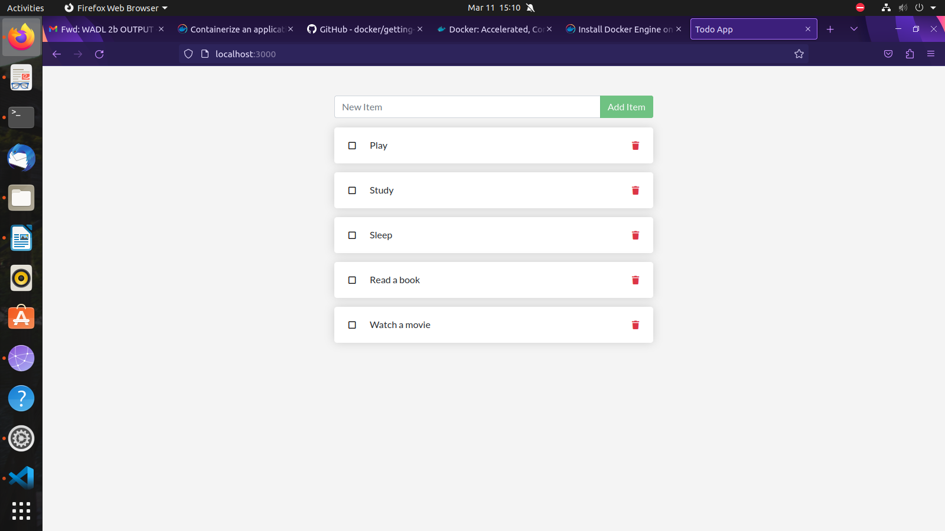
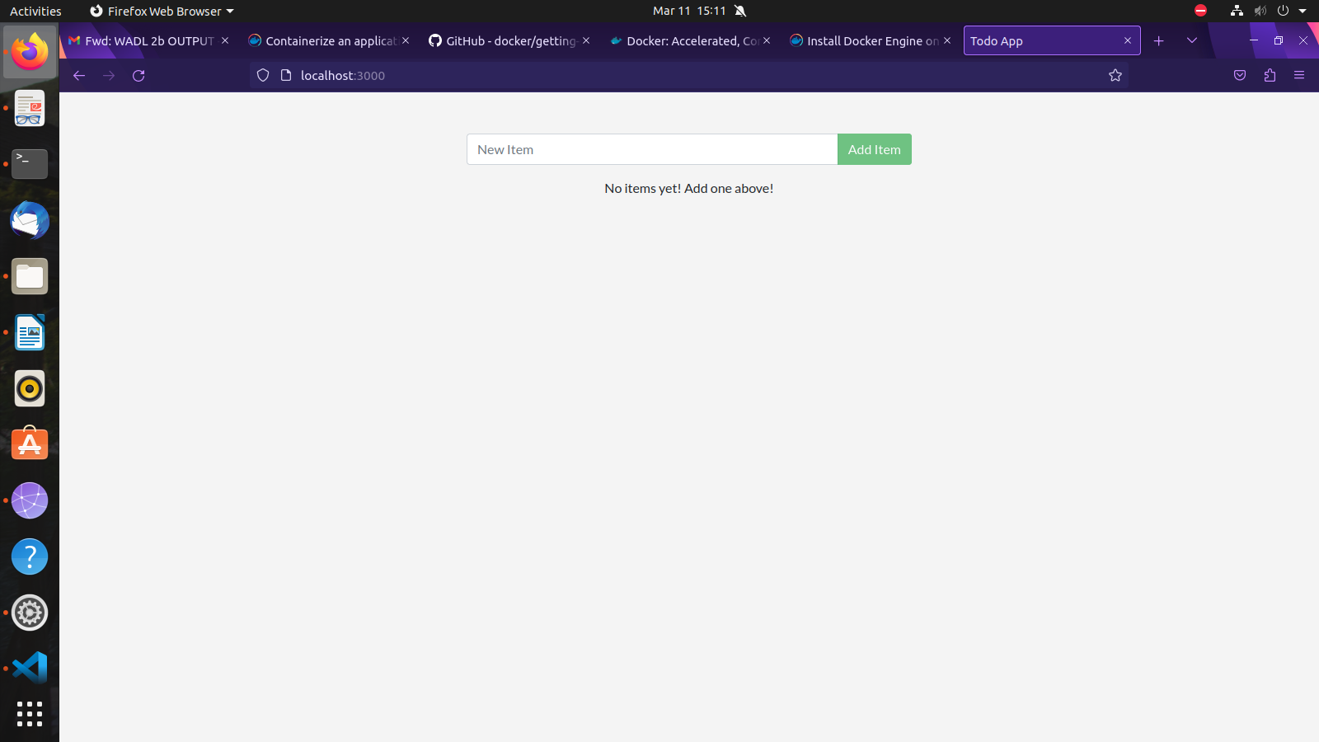
OUTPUT:

