VeriModern Architecture and Technology Stack
Project Behavior-Preserving Legacy Code Transformation through AI and Characterization Testing
Version 1.1 | 12 October 2026 | Current prototype and proposed production path

Purpose and architectural position
VeriModern lets a user authorize a GitHub repository, inspect declared language versions, request a scoped modernization, and review a code pull request with functional and technical change summaries. This document explains how the available prototype is assembled and which technologies perform each job. It is intended for project reviewers and developers who need a precise current-state architecture, not a claim that every planned research feature is already complete.
The current prototype is one Next.js service with a GitHub App for repository access. It launches Claude CLI headlessly on the local Mac; Claude directs migration inside Daytona. The POC investigates whether an LLM can transform legacy code; Maven Java 8 to Java 21 is its first demonstrated case, not a language boundary. Detecting other languages does not prove migration support.

Current system architecture
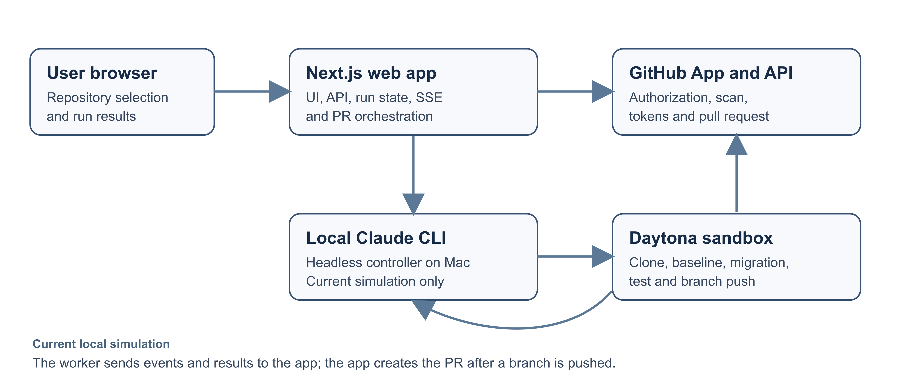
Figure 1. Current local simulation and trust boundaries.
Component | Responsibility | Execution location
Browser UI | Collects repository URL, displays scan evidence, scope and target controls, live status, PR and summaries. | User browser
Next.js server | Handles GitHub authorization, scans manifests, records runs, streams events, mints worker credentials and creates PRs. | Local Node.js server
Claude CLI controller | Reads a private work order, starts a Daytona sandbox and directs the migration workflow. | Hidden process on local Mac
Daytona sandbox | Clones the authorized repository, runs baseline checks, changes code, verifies and pushes a branch. | Isolated cloud sandbox
GitHub App | Restricts repository access and provides short-lived installation tokens and PR API operations. | GitHub

Runtime sequence
1. The user enters a repository URL; the app starts GitHub App installation and verifies that the installation can access that exact repository.
2. The server reads tracked repository paths and recognized manifests; the UI presents file-level findings and lets the user choose a whole-repository or selected-file scope and target.
3. A run is stored locally; a private work order starts the headless Claude CLI controller. The controller obtains a short-lived installation token and creates a Daytona sandbox.
4. The repository is cloned inside Daytona. The worker records baseline evidence, performs the scoped migration, runs final checks and pushes a branch only when there is a real diff.
5. The worker posts events and a structured result to the app. After a branch push, the app creates the GitHub PR. Server-sent events update the browser until completion or failure.

Technology stack
The following table describes the implementation present in the web application, not proposed or target-repository technologies.
Layer | Technology | Use
Frontend | React 19.2.8; Next.js 16.3.6 App Router; TypeScript 5 | Interactive pages and stateful run flow in TSX.
Visual UI | Tailwind CSS 4; shadcn 4.21; Base UI; Radix UI; lucide-react | Styling, reusable components, accessible controls and icons.
Backend | Next.js Route Handlers on Node.js; TypeScript | Auth, scan, run lifecycle, worker callbacks, GitHub PR and event stream.
Worker launcher | Node.js ES module script; Claude CLI | Starts a hidden local agent process from a private work order.
External services | GitHub App and REST API; Daytona | Repository authorization and PR; isolated migration execution.
Run storage | Local JSON files under .runtime | Prototype run records and work orders; no database in this app.

Target project and verification technologies
The code being modernized is separate from VeriModern's implementation stack. The POC question is language-agnostic, while its current validated example is a Maven Java project moving from Java 8 to Java 21. Maven and project tests, including any JUnit suite already present, run inside the sandbox. Java is the demonstrated target language, not the language of the web application's backend. A successful compilation on a later JDK is not proof that tests ran on an exact JDK 21 runtime; that evidence must be recorded separately.

Data and security boundaries
Boundary | Current mechanism | Implication
Browser to app | Signed, HTTP-only session cookie after GitHub installation access check. | Browser receives run progress and results, not installation tokens or worker secrets.
App to GitHub | GitHub App JWT exchanges for installation access tokens. | Repository read and PR operations use installation-scoped authority.
App to worker | Private 0600 work order and run-specific worker token. | Callbacks and credential redemption are tied to the run; local file protection matters.
Worker to Daytona | Short-lived token passed as an ephemeral command environment value. | Clone and push happen in the sandbox; token must not enter Git config, logs or PR text.
App to browser | Server-sent events return a redacted run record. | Live status can be displayed without exposing the worker token.

Run state currently resides in a local JSON file. This is suitable for a controlled prototype, but not a resilient multi-instance production service: concurrent writes, worker recovery, retention, auditing and secret lifecycle need stronger infrastructure.

Version discovery and user scope
The scanner lists tracked paths from GitHub and inspects recognized manifests. It currently parses Java pom.xml, Node package.json engine declarations, Python pyproject.toml or requirements declarations, and Go go.mod. The scan is bounded to 500 tracked blobs and 40 manifest candidates. The UI can select the full repository or specific tracked files; folder selection is not implemented. A detected version is evidence of a declaration, not a guarantee that the repository builds or that a migration adapter exists. For non-Java options, a latest target may remain unresolved and needs validation before production use.

Current status and production direction
Area | Current prototype | Production requirement
Agent placement | Claude CLI runs headlessly on the local Mac and controls Daytona. | Run the agent within an isolated, queue-managed sandbox or equivalent trusted worker.
Persistence | Local JSON run store and work-order files. | Durable database, job queue, idempotent callbacks, retention and recovery.
Language support | Multi-language manifest detection; one Maven Java 8 to 21 case study. | Validated adapters, supported-version matrix and tests for each language path.
Behavior evidence | Baseline and final build/test steps directed to the worker. | Automatic characterization-test generation, behavioral comparison and exact target-runtime execution.
Policy | Worker instructions constrain scope and report results. | Server-side diff policy, secret handling, audit trail and failure/retry controls.

Implementation basis: modernization-webapp/package.json, src/app/page.tsx, src/lib, src/app/api and scripts/run-claude-work-order.mjs. Reviewed 12 October 2026.

