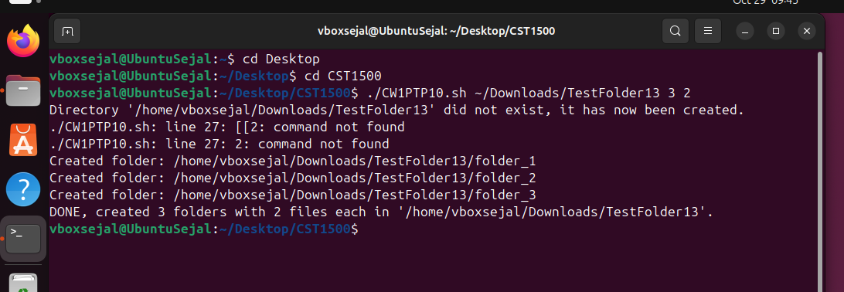
Fig. 1: Creating folders and files with Bash.

