**Programs on File Handling**

**1.Example of reading an entire file**

fp = open('file.txt','r')

content = fp.read()

print(content)

fp.close()



**2.Example of reading line by line**

fp = open('file1.txt','r')

print("Line-1: " + fp.readline())

print("Line-2: " + fp.readline())

fp.close()

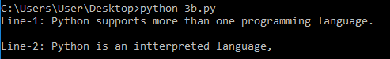

**3.Example of reading a certain number of bytes**

fp = open('file1.txt','r')

content = fp.read(10)

print(content)

fp.close()



**4.Example of getting the current position of read**

fp = open('file1.txt','r')

content = fp.read(10)

print(content)

currentpos = fp.tell

print(currentpos)

fp.close()



**5.Example of seeking to a certain position**

fp = open('file1.txt','r')

fp.seek(10,0)

content = fp.read(10)

print(content)

fp.close()



**6.Example of writing to a file**

fo = open('file.txt','w')

content='This is an example of writing to a file in Python.'

fo.write(content)

fo.close()

fo = open('file.txt','r')

toread = fo.readline()

print(toread)

fo.close()

