**Mini – Project CFL**

**Roll no :** 512

**Name :** Sejal Pawar

**Class :**  M.S c CS P2

**Subject :**  CFL

**Topic :** Mini Project

AIM : **User Authentication System using python built-in functions**

**Steps :**

**1 ) Open Jupyter Notebook :**

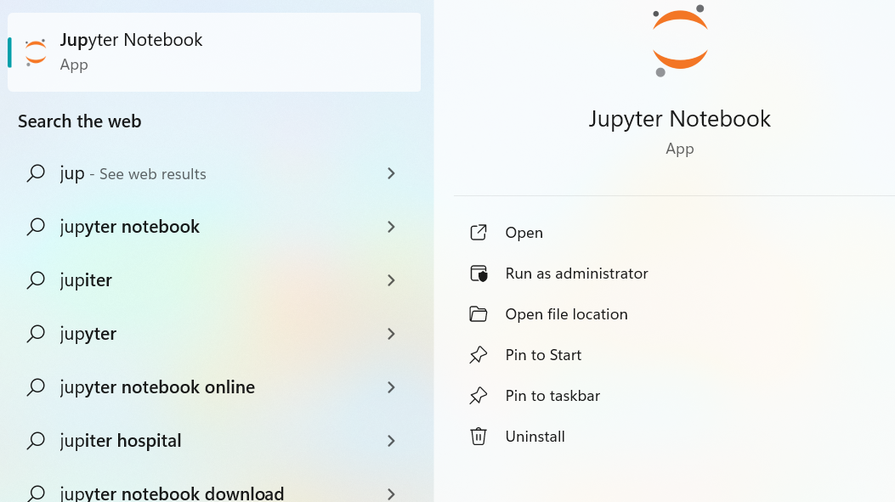

2 ) Create and Give Name to file for program code

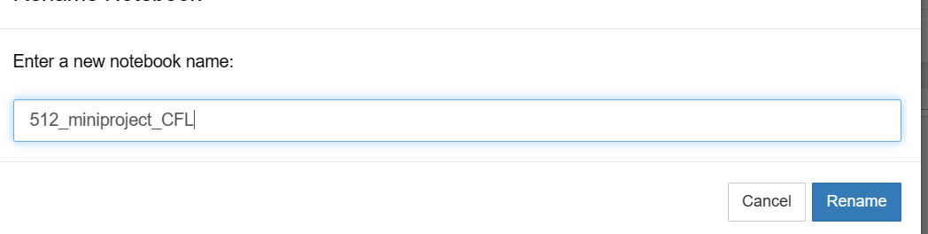

3) Importing of libraires is not required as this program is made on built In functions

In the code provided using several built-in functions and features of Python:

1. **input()**: This built-in function is used to get user input from the console.
2. **print()**: Another built-in function used for displaying output to the console.
3. **if**, **else**: These are control flow statements, not functions, but they are built-in features of Python that allow you to perform conditional branching.
4. **in**: The **in** operator is used to check if a value exists in a sequence, such as a list or dictionary.
5. **str** concatenation: You're using string concatenation with the **+** operator to build strings for the output messages.

These are standard features of Python that are available without the need to import any external libraries.

The aim of the program you provided is to demonstrate a simple authentication system. Here are the main objectives of this program:

1. **User Authentication:** The program allows users to enter their username and password.
2. **Authentication Check:** It checks whether the provided username exists in a predefined user database and if the entered password matches the stored password for that username.
3. **Authentication Result:** Based on the authentication check, the program provides feedback to the user:
   * If the authentication is successful, it welcomes the user by their username.
   * If the authentication fails (either due to an incorrect username or password), it informs the user of the failure.

In summary, the program's aim is to simulate a basic login system, where users can enter their credentials, and the program checks if those credentials are valid. It serves as a simple demonstration of user authentication without storing or handling user data in a secure or production-ready manner.

Top of Form

**Program Code :**

Program code to Create and verify the authencation of user :

# User database (for demonstration purposes)

user_database = {

"user1": "password1",

"user2": "password2",

"user3": "password3"

}

# Function to check if a username and password are valid

def authenticate(username, password):

# Check if the username exists in the database

if username in user_database:

# Check if the provided password matches the stored password

if password == user_database[username]:

return True

return False

# Main program

if __name__ == "__main__":

print("Welcome to the Authentication System")

# Prompt the user to enter their username and password

username = input("Enter your username: ")

password = input("Enter your password: ")

# Authenticate the user

if authenticate(username, password):

print("Authentication successful. Welcome, " + username + "!")

else:

print("Authentication failed. Invalid username or password.")

Program to Add Register New user and verify the authencation :

import bcrypt

# User database (for demonstration purposes)

user_database = {}

# Function to register a new user

def register(username, password):

# Check if the username already exists

if username in user_database:

return False # Username is already taken

else:

# Hash the password before storing it

hashed_password = bcrypt.hashpw(password.encode('utf-8'), bcrypt.gensalt())

user_database[username] = hashed_password

return True # Registration successful

# Function to check if a username and password are valid

def authenticate(username, password):

# Check if the username exists in the database

if username in user_database:

# Verify the provided password against the hashed password

if bcrypt.checkpw(password.encode('utf-8'), user_database[username]):

return True

return False

# Main program

if __name__ == "__main__":

print("Welcome to the Authentication System")

while True:

print("\nOptions:")

print("1. Register a new user")

print("2. Authenticate")

print("3. Quit")

choice = input("Enter your choice (1/2/3): ")

if choice == "1":

username = input("Enter a username: ")

password = input("Enter a password: ")

if register(username, password):

print("Registration successful.")

else:

print("Username already exists. Please choose another.")

elif choice == "2":

username = input("Enter your username: ")

password = input("Enter your password: ")

if authenticate(username, password):

print("Authentication successful. Welcome, " + username + "!")

else:

print("Authentication failed. Invalid username or password.")

elif choice == "3":

print("Exiting the program.")

break

else:

print("Invalid choice. Please select 1, 2, or 3.")

Output of the program :

