SMART POPULATION GROWTH AND MIGRATION ANALYSIS SYSTEM
Project Report
Sejal Choudhari
B.Tech CSE (AI)

Chapter 1: Introduction
This project simulates population growth considering annual growth and migration loss. The system performs forecasting, milestone detection, statistical analysis, visualization and dashboard deployment.

Chapter 2: Mathematical Model
Initial Population = 1000, Growth Rate = 8%, Migration Loss = 2%, Net Growth = 6%. Population Formula: P(n) = 1000 × (1.06)^n

Population Simulation (Sample)
Year | Starting Population | Growth | Migration Loss | Final Population
1 | 1000 | 80 | 20 | 1060
2 | 1060 | 84.8 | 21.2 | 1123.6
3 | 1123.6 | 89.89 | 22.47 | 1191.02

Chapter 3: Milestone Detection
Milestone | Year
5000 | 28
10000 | 40
50000 | 68
100000 | 80
1000000 | 119

Chapter 4: Long-Term Forecasting
Years | Population
50 | 18420.15
100 | 339302.08
200 | 115125903.88
500 | 4497100906035837

Chapter 5: Population Doubling Analysis
Population exceeds 2000 in Year 12 with population 2012.20.

Chapter 6: City Comparison
City | Growth % | Migration % | Net Growth % | Final Population
A | 8 | 2 | 6 | 339302.08
B | 10 | 3 | 7 | 867716.33
C | 12 | 5 | 7 | 867716.33

Chapter 7: Statistical Analysis
Metric | Value
Maximum Population | 18420.15
Minimum Population | 1060
Average Population | 6155.12
Median Population | 4420.62
Standard Deviation | 4909.59
Variance | 24104035.09

Chapter 8: Conclusion
The project successfully implements population simulation, forecasting, Monte Carlo analysis, visualization, CSV/Excel generation, GitHub integration and Streamlit deployment.
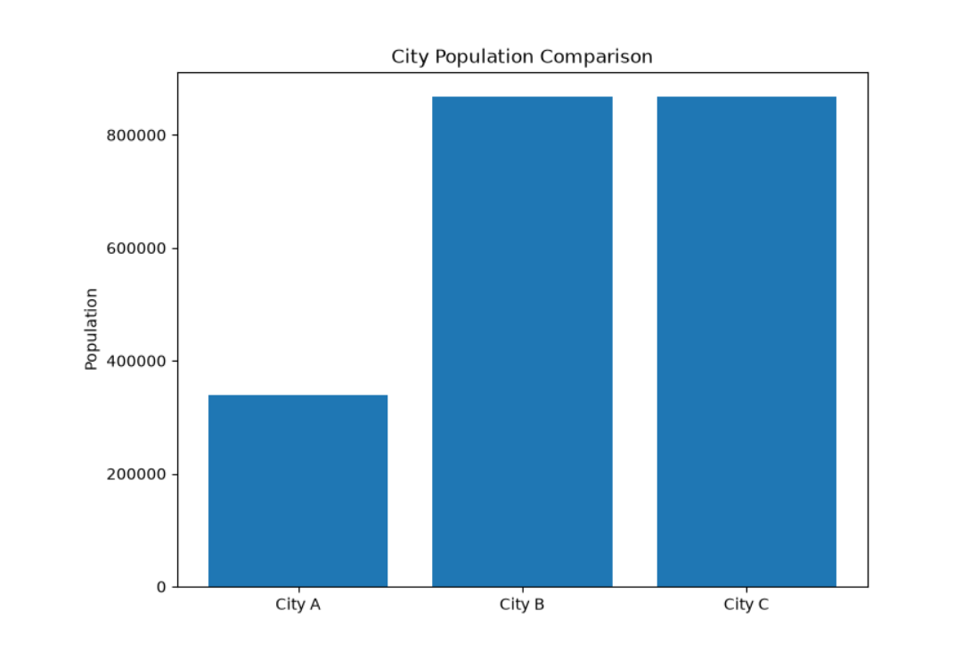
Fig.Comparison Chart
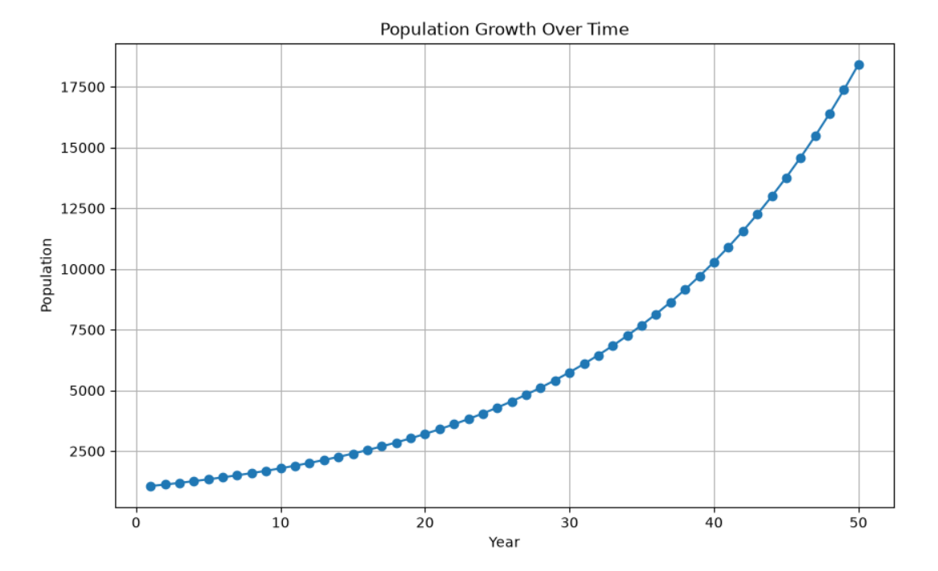
Fig. Line Chart

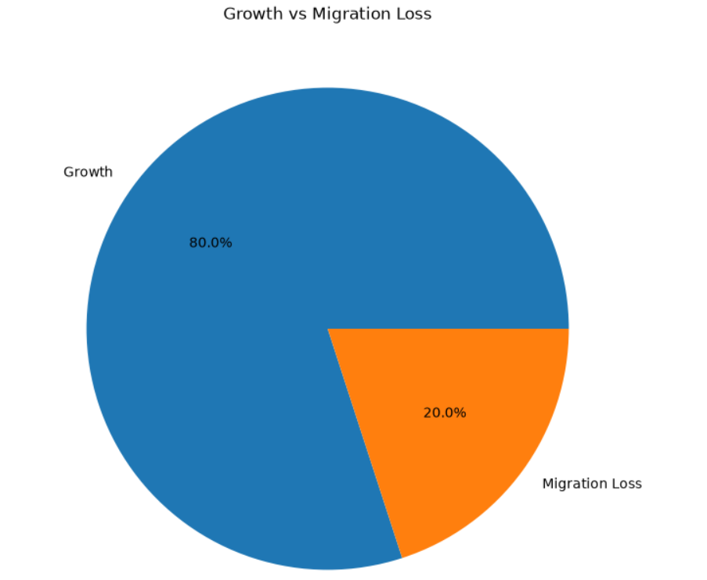
Fig.Pie Chart
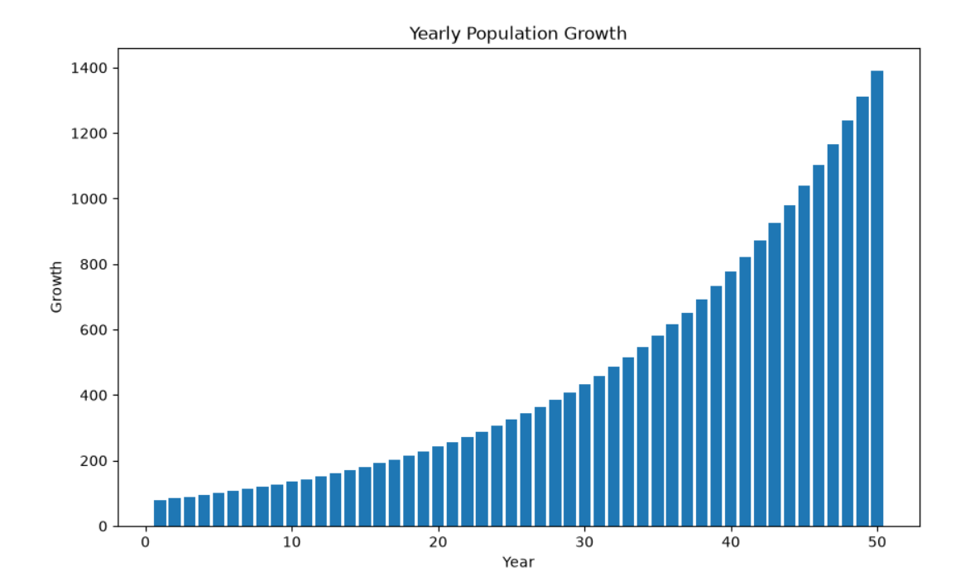
Fig.Bar Chart

