Mutual Fund Analytics & Risk Assessment Platform

Executive Summary
This project develops an end-to-end Mutual Fund Analytics and Risk Assessment Platform using Python, SQLite, Pandas, Matplotlib, and Power BI. The solution integrates data engineering, financial analytics, risk assessment, and interactive business intelligence dashboards. Key metrics including Annual Return, Sharpe Ratio, Value at Risk (VaR), and Conditional Value at Risk (CVaR) were implemented to evaluate fund performance and investment risk.

Project Objectives
• Build a centralized mutual fund analytics database.
• Perform ETL and data preprocessing.
• Analyze fund performance and investor trends.
• Calculate Sharpe Ratio, VaR, and CVaR.
• Create interactive Power BI dashboards.
• Develop a rule-based fund recommendation framework.

Data Sources
1. Fund Master Data
2. NAV History Data
3. AUM by Fund House
4. Monthly SIP Inflows
5. Category Inflows
6. Portfolio Holdings
7. Scheme Performance Data
8. Benchmark Indices

Data Engineering & ETL Process
The ETL pipeline was implemented using Python and Pandas. Raw CSV datasets were cleaned, validated, transformed, and loaded into a SQLite database. Missing values, formatting inconsistencies, and duplicate records were handled during preprocessing.

Exploratory Data Analysis
The analysis focused on:
• Top Fund Houses by AUM
• Monthly SIP Trends
• Category-wise Investment Inflows
• Sector Allocation Analysis
• Portfolio Concentration Insights

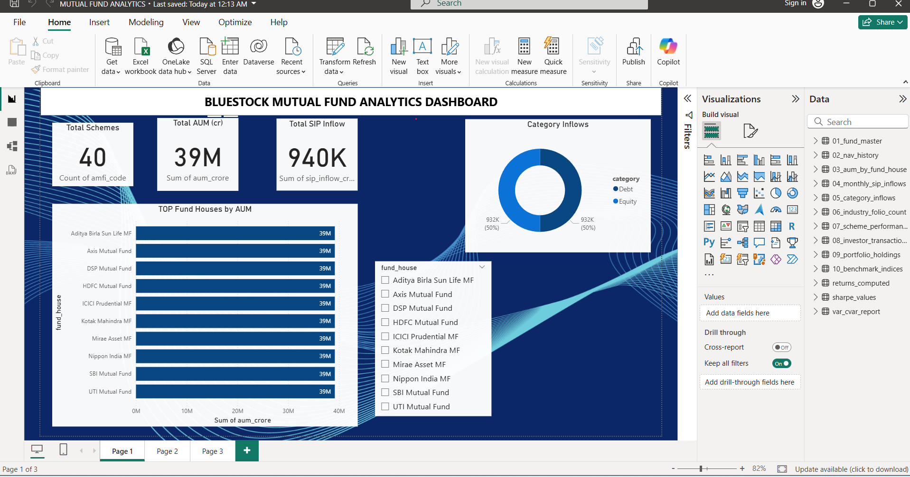

Performance Analysis
Annual returns were computed from NAV data and compared across schemes. Sharpe Ratio was used to measure risk-adjusted performance and identify superior funds.
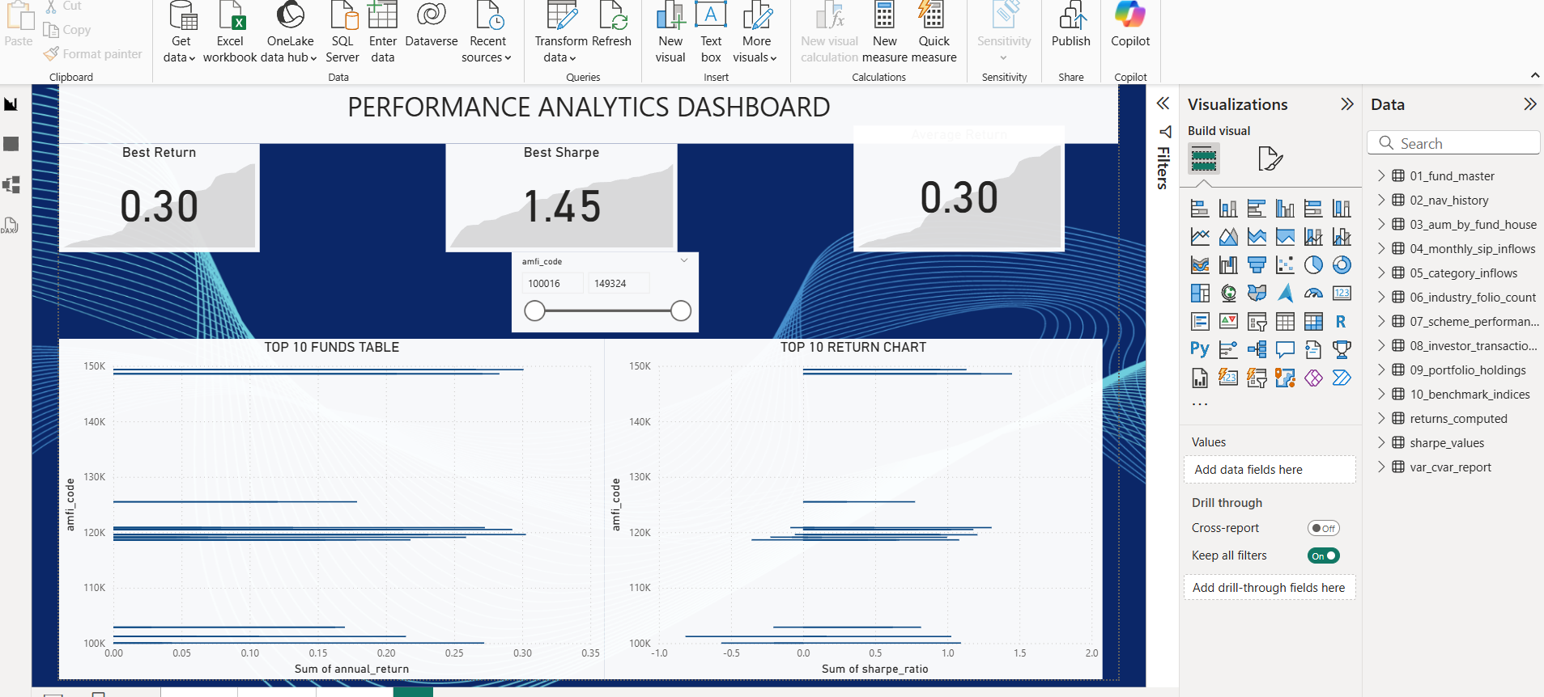

Risk Analysis
Historical VaR (95%) and CVaR (95%) were calculated to estimate downside risk. These metrics provided a realistic assessment of potential losses under adverse market conditions.

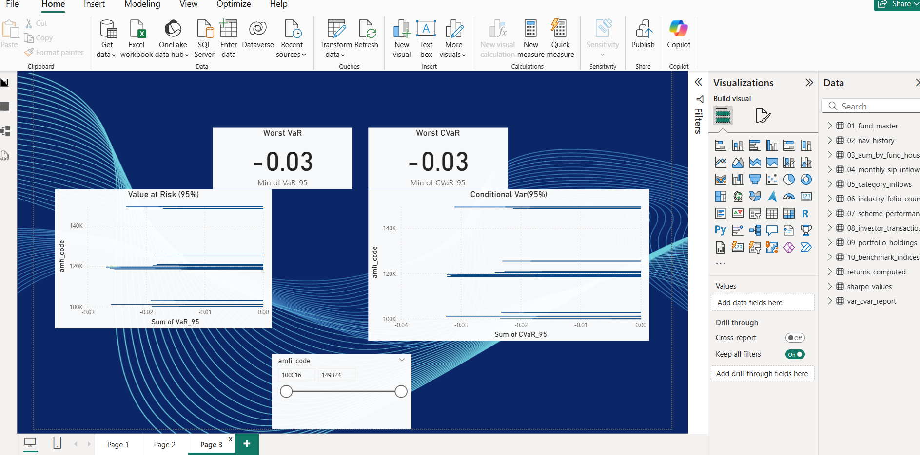

Fund Recommendation Framework
Funds were classified into BUY, HOLD, and AVOID categories based on return performance, Sharpe Ratio, and risk metrics. The framework provides simplified investment decision support.

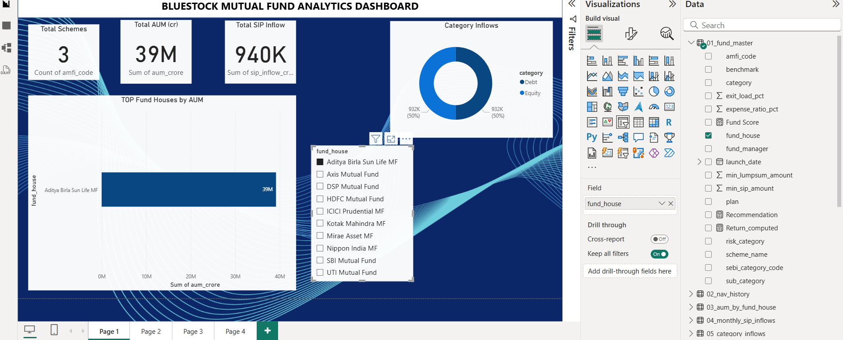

Key Business Insights
• Total Assets Under Management exceeded ₹39 Million.
• SIP inflows reached approximately ₹940K.
• Top-performing funds generated annual returns close to 30%.
• Funds with Sharpe Ratios above 1 delivered superior risk-adjusted performance.
• Maximum observed downside risk was approximately 3%.
• High-scoring funds were identified through the recommendation framework.

Challenges & Limitations
• Limited historical data availability.
• Static recommendation rules.
• Dependence on historical market behavior.
• No real-time API integration.
• Results may vary under changing market conditions.

Future Enhancements
• Real-time NAV integration.
• Machine Learning-based recommendation engine.
• Investor segmentation analytics.
• Predictive performance forecasting.
• Cloud deployment through Power BI Service.

Conclusion
The project successfully demonstrates how data analytics, risk modeling, and business intelligence tools can be combined to evaluate mutual fund performance. The platform provides actionable insights that support informed and risk-aware investment decisions.

