DESCRIPTIVE ANALYTICS REPORT

Product / Service Performance Analysis: RedBus Bus-Ticket Booking Service
Business Analytics — Individual Assignment

- Name: Sejal
- Roll Number: 1250258406
- Course: BCA(DS&AI)
- Batch: BCADS27
- Roll Number: 24
- Date: 10 August 2026

Note on Data Source
Note: This revised report is built directly from the official redBus India Bus Track FY2025 dataset (annual FY2025 indicators plus the Jan–Mar 2025 snapshot and its Jan–Mar 2024 comparison). All charts, tables and KPIs below have been re-checked against that dataset; any figure not present in it has been removed or replaced with the closest matching official metric.

1. Introduction & Objectives
This report uses the official redBus India Bus Track FY2025 report as its data source. The figures describe both the wider intercity bus market (as tracked by redBus) and redBus's own platform-level indicators for FY2025 (1 April 2024 – 31 March 2025) and the Jan–Mar 2025 quarter.
The report is a descriptive study. It presents what the Bus Track data shows and does not attempt to explain why the changes happened.

Objective
The main objective of this report is to study redBus travel and booking trends using the FY2025 Bus Track dataset and answer the following questions:
- How did passengers, gross ticketing value (GTV) and operators grow between Q4 FY24 and Q4 FY25?
- How do Pilgrimage, Leisure and Student travel segments differ in comfort and booking-timing behaviour?
- What type of buses and seats did passengers prefer in FY2025?
- What was the average fare/seat price, and how did it change year-on-year?
- Which regions and time-of-day slots accounted for the most travel?
- How did smaller cities, pilgrimage routes and occupancy vary across the network?
- What are the main findings from the FY2025 Bus Track data?

2. How This Would Work at Real Scale
At a real company, redBus receives a very large number of booking records every day. These records are grouped by date, route, city, bus type, fare and customer segment, and summarised into indicators such as the ones published in the Bus Track report. The results are then shown in dashboards for regular business decisions.
Layer | Purpose | Simple tools
Data collection | Collect booking and travel information | Website / App
Data cleaning | Check missing or incorrect records | Excel / Python
Analysis | Find totals, averages and trends | Excel / Python
Charts | Show the results clearly | Excel / Power BI
Report | Explain the main findings | MS Word / PDF

3. Q4 FY25 vs Q4 FY24 Growth
The Bus Track Jan–Mar 2025 snapshot can be compared with the Jan–Mar 2024 figures it reports alongside it. Passengers grew from 50.90 million to 59.59 million, and gross ticketing value (GTV) grew from ₹49.31 billion to ₹59.62 billion.
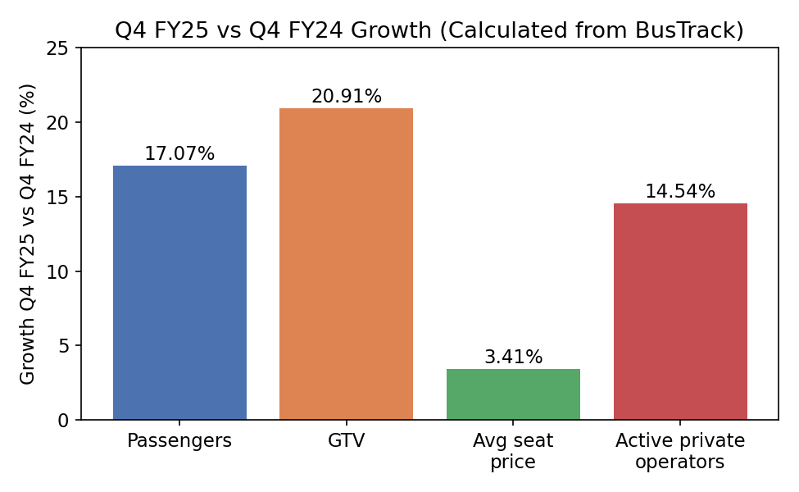
INSIGHTS:
- Passenger volume grew 17.07% year-on-year in Q4.
- GTV grew faster than passenger volume, at 20.91%, reflecting the 3.41% rise in average seat price.
- The active private-operator base grew 14.54%, roughly in line with passenger growth.
- All four figures are calculated directly from the official Q4 FY25 / Q4 FY24 Bus Track comparison.
KPI | Passenger Growth Rate
Formula | (Q4 FY25 passengers − Q4 FY24 passengers) ÷ Q4 FY24 passengers × 100
FY2025 / Q4 result | 17.07% (59.59M vs 50.90M)
KPI Insight: Passenger volume grew by just over 17% year-on-year in the Jan–Mar quarter, the base rate against which the faster GTV growth (20.91%) can be compared.

4. Segment-Level Growth Indicators
Beyond the overall Q4 comparison, Bus Track reports one FY2025 year-on-year growth figure at segment level: Student segment rides grew 26% year-on-year. A second, much larger, growth figure applies to a specific pilgrimage route (Tiruchendur–Thanjavur, +860%), covered in Section 13.
Indicator | Value | Period
Passenger growth | 17.07% | Q4 FY25 vs Q4 FY24
GTV growth | 20.91% | Q4 FY25 vs Q4 FY24
Average seat price growth | 3.41% | Q4 FY25 vs Q4 FY24
Active private-operator growth | 14.54% | Q4 FY25 vs Q4 FY24
Student segment ride growth | 26% | FY2025 YoY
Tiruchendur–Thanjavur pilgrimage route growth | 860% | FY2025 YoY

INSIGHTS:
- Growth was broad-based across passengers, revenue and the operator base.
- The Student segment grew faster (26%) than the overall passenger base (17.07%).
- One pilgrimage route saw an extreme, event-driven surge, shown separately in Section 13 so it does not distort the general growth picture.

5. Travel Purpose — Segment Comparison
Bus Track profiles three travel-purpose segments — Pilgrimage, Leisure and Student — each with its own comfort and booking-timing pattern.
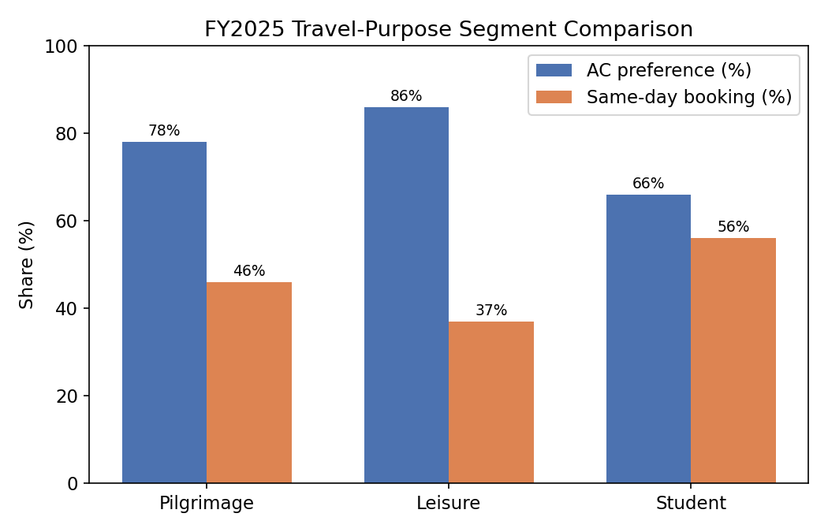
Segment | AC preference | Same-day booking | Other notable share
Pilgrimage | 78% | 46% | —
Leisure | 86% | 37% | Overnight trips 74%; Sleeper 52%
Student | 66% | 56% | Male 69% / Female 31%; Sleeper 62%; Night travel (10PM–6AM) 25%
INSIGHTS:
- Leisure travellers had the highest AC preference (86%) among the three segments.
- Student travellers booked same-day most often (56%), suggesting less advance planning than Pilgrimage or Leisure travellers.
- Leisure travel had a strong overnight-trip share (74%), consistent with longer weekend or holiday journeys.

6. Bus Comfort Preference
Passengers showed a strong preference for AC buses. AC buses made up 67% of FY2025 bookings; the Q4 FY25 snapshot shows a very similar 68% AC share.
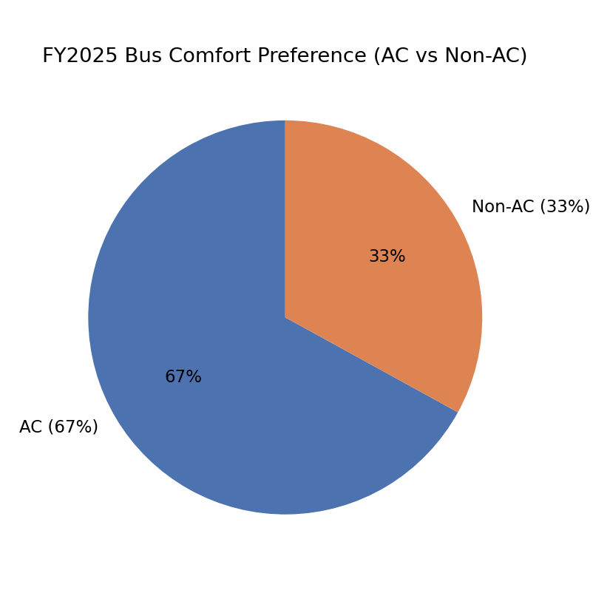
INSIGHTS:
- Just over two-thirds of bookings were for AC buses in FY2025.
- The AC share stayed stable between the FY2025 annual figure (67%) and the Q4 FY25 quarter (68%).
- Non-AC buses retained roughly a third of bookings.
KPI | AC Booking Share
Formula | AC bookings ÷ Total bookings × 100
FY2025 / Q4 result | 67% (FY2025 annual); 68% (Q4 FY25)
KPI Insight: Comfort remains the dominant driver of bus-type choice, with roughly two out of three passengers booking AC buses.

7. Seat Type Preference
Sleeper seats were the most common seat type in FY2025, followed by hybrid and seater options.
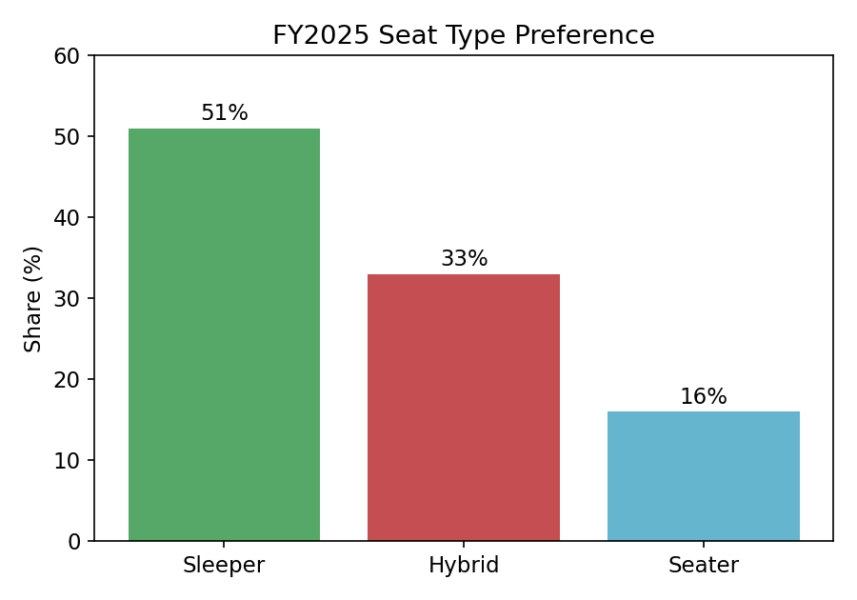

INSIGHTS:
- Sleeper seats had the highest share at 51%.
- Hybrid seats had a 33% share.
- Seater-only buses had the smallest share, at 16%.
- The Q4 FY25 snapshot (Sleeper 51%, Hybrid 34%, Seater 15%) closely matches the FY2025 annual figures.

8. Passenger Origin & Student Profile
BusTrack reports passenger origin by city tier rather than by age group. Non-metro (Tier 2 & 3) cities accounted for the majority of FY2025 passengers. Within the Student segment, BusTrack additionally reports a gender split.
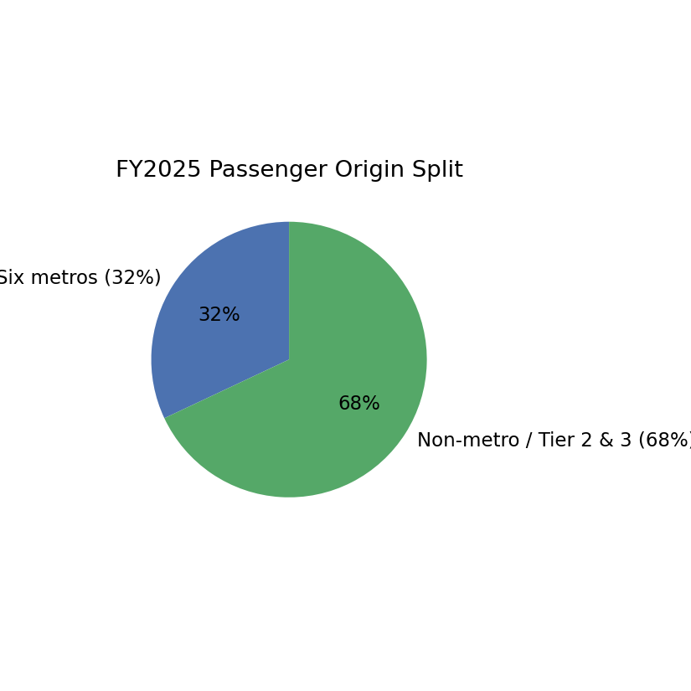
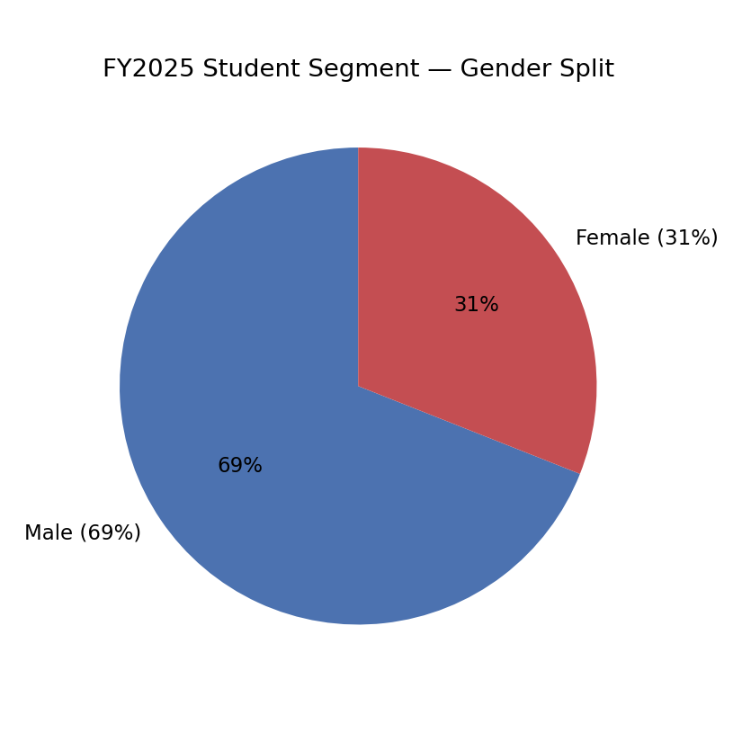
INSIGHTS:
- Non-metro (Tier 2 & 3) origins accounted for 68% of FY2025 passengers, more than double the six-metro share (32%).
- Within the Student segment, male riders (69%) outnumbered female riders (31%).
- The origin split confirms that demand is not concentrated in the six largest metro cities.
KPI | Non-Metro Origin Share
Formula | Non-metro (Tier 2 & 3) passengers ÷ Total passengers × 100
FY2025 / Q4 result | 68% (FY2025)
KPI Insight: More than two-thirds of FY2025 passengers originated outside the six major metro cities, underlining the importance of smaller-city demand.

9. Ticket Price / Fare Analysis
The FY2025 annual average fare was ₹969 per seat. At quarter level, the average seat price rose from ₹968 in Q4 FY24 to ₹1,001 in Q4 FY25.
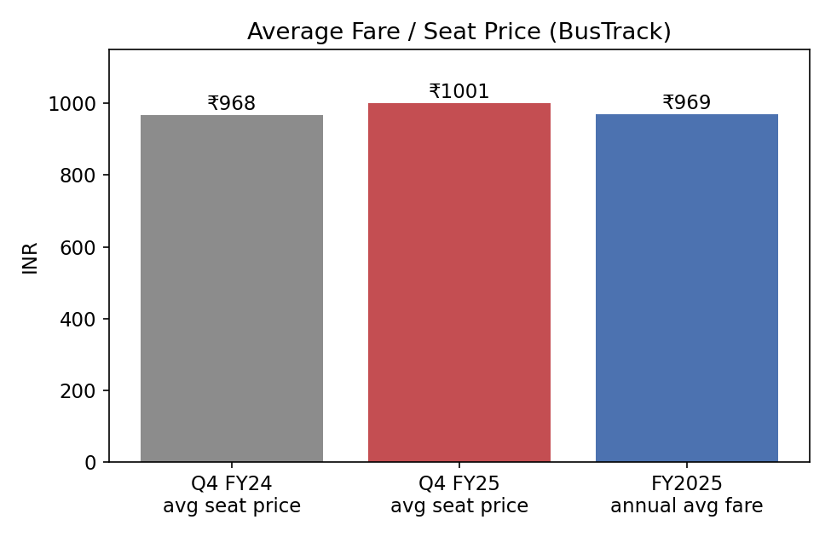
INSIGHTS:
- The Q4 FY25 average seat price (₹1,001) grew 3.41% over Q4 FY24 (₹968).
- The FY2025 full-year average fare (₹969) sits close to the Q4 FY24 level, consistent with prices rising through the year.
- The dataset does not report a separate Maharashtra-specific average fare; Maharashtra & Goa's contribution is instead measured by seat share (Section 12).
KPI | Average Seat Price Growth
Formula | (Q4 FY25 avg seat price − Q4 FY24 avg seat price) ÷ Q4 FY24 avg seat price × 100
FY2025 / Q4 result | 3.41% (₹968 → ₹1,001)
KPI Insight: Fares rose modestly faster than inflation-neutral, in a quarter where GTV (20.91%) grew much faster than price alone — pointing to volume as the larger driver of revenue growth.

10. Market Size and Supply
The FY2025 Bus Track report describes a large intercity bus market: around 40,000 buses running daily, more than 6,500 private operators, about 6,400 new buses added, 265,000 new daily seats created, 760 electric bus schedules, and 72,000 new intercity routes launched during the year.
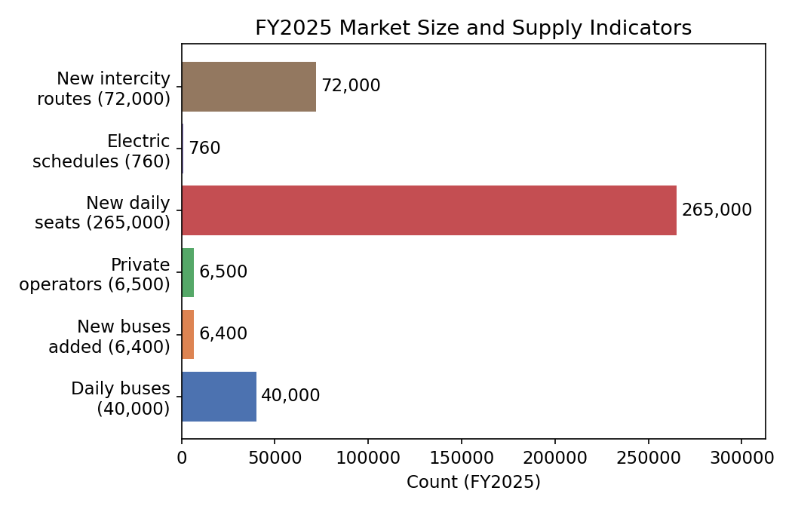
INSIGHTS:
- The bus market had a large and growing number of buses, operators and routes.
- New buses and new daily seats expanded available capacity for passengers.
- Electric bus schedules, while still a small share of the total, were part of the reported FY2025 supply.
- A larger, more connected bus market gives online booking platforms more services to list.

11. Journey Timing
Bus Track reports the share of FY2025 journeys by time of departure. Evening and night departures (6 PM–12 AM) dominated, accounting for 77% of journeys.
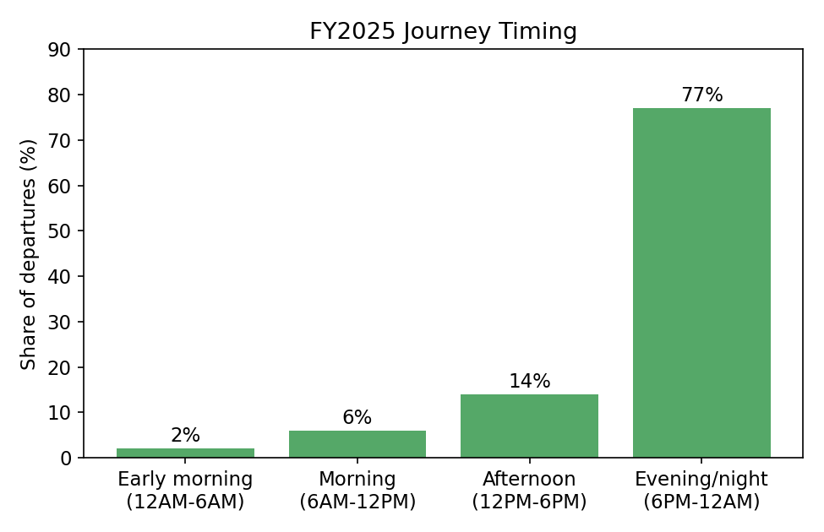
INSIGHTS:
- Evening/night departures (6 PM–12 AM) made up more than three-quarters of FY2025 journeys.
- Afternoon departures were a distant second, at 14%.
- Early-morning departures (12 AM–6 AM) were the least common, at 2%.
- This pattern is consistent with the high sleeper-seat share reported in Section 7, since overnight travel favours sleeper berths.

12. Major Routes and Regional Demand
The Q4 FY25 snapshot reports each region's share of seat bookings. Maharashtra & Goa led with 17%, followed by Tamil Nadu (13%) and Karnataka (12%).
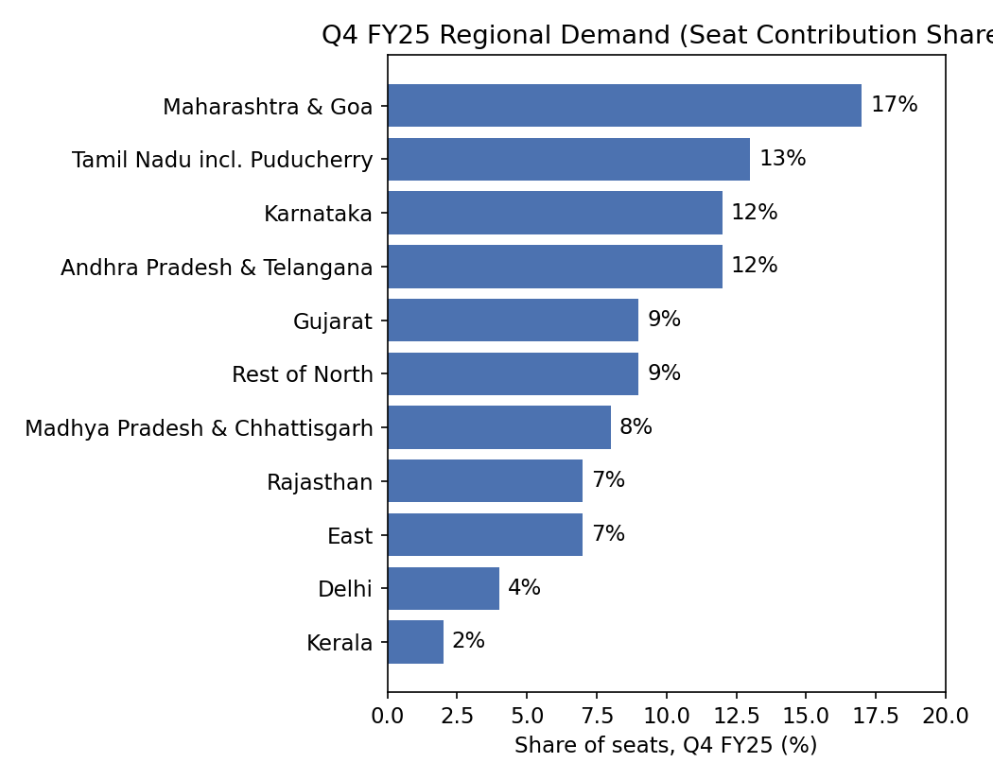
INSIGHTS:
- Maharashtra & Goa accounted for the largest regional seat share (17%) in Q4 FY25.
- Southern states (Tamil Nadu, Karnataka, Andhra Pradesh & Telangana) together accounted for a large combined share.
- Kerala and Delhi had the smallest reported regional shares, at 2% and 4%.
- Long routes (over 250 km) made up 66% of Q4 FY25 journeys, against 34% for short routes (under 250 km).

13. Festivals and Pilgrimage Surge
Bus Track highlights one pilgrimage route as an especially large FY2025 surge: bookings on the Tiruchendur–Thanjavur route grew 860% year-on-year.
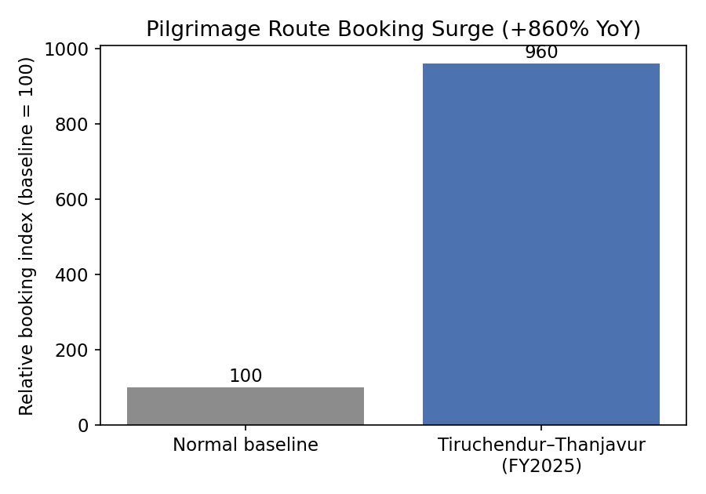
INSIGHTS:
- The Tiruchendur–Thanjavur route saw a very large, event-driven booking increase (+860% YoY).
- Pilgrimage travel overall also showed the highest AC preference (78%) and highest same-day booking share (46%) among the segments in Section 5, apart from Student.
- Extreme, route-specific surges like this can create sudden local demand for extra buses and seats.
KPI | Pilgrimage Route Booking Growth
Formula | (Current year route bookings − Previous year route bookings) ÷ Previous year route bookings × 100
FY2025 / Q4 result | 860% YoY (Tiruchendur–Thanjavur)
KPI Insight: A single pilgrimage route recorded nearly a ten-fold jump in bookings, showing how concentrated event- or festival-driven demand can be.

14. Occupancy Rate
The Q4 FY25 snapshot reports average bus occupancy nationally and for two regional groupings. All-India occupancy was 78%, ranging from 83% in Andhra Pradesh & Telangana to 65% in Madhya Pradesh & Chhattisgarh.
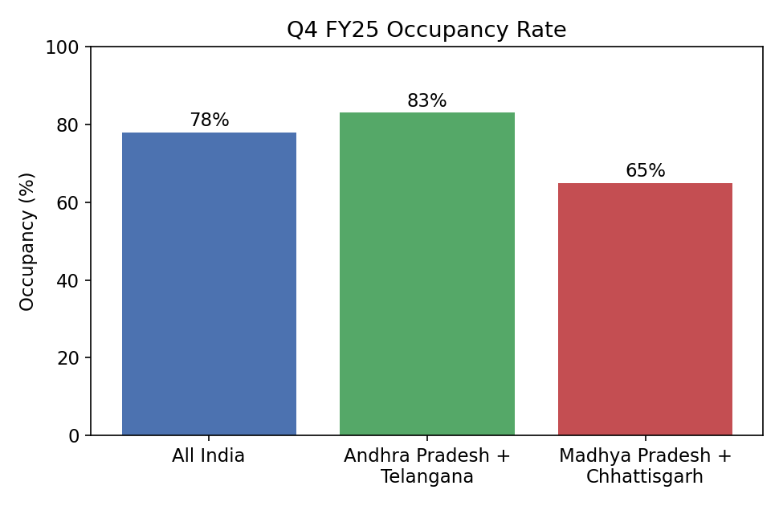
INSIGHTS:

- All-India occupancy stood at 78% in Q4 FY25.
- Andhra Pradesh & Telangana had the highest reported occupancy (83%) among the groupings shown.
- Madhya Pradesh & Chhattisgarh had the lowest reported occupancy (65%), a gap of 18 percentage points versus the highest region.

KPI | Bus Occupancy Rate
Formula | Seats sold ÷ Total seats available × 100
FY2025 / Q4 result | 78% (All India, Q4 FY25)
KPI Insight: Roughly one in five available seats went unsold nationally in Q4 FY25, with regional occupancy varying by up to 18 percentage points.

16. Summary of Key Metrics

Metric | Value | Period
Passenger growth | 17.07% YoY | Q4 FY25 vs Q4 FY24
GTV growth | 20.91% YoY | Q4 FY25 vs Q4 FY24
Average seat price growth | 3.41% YoY | Q4 FY25 vs Q4 FY24
Active private-operator growth | 14.54% YoY | Q4 FY25 vs Q4 FY24
Student ride growth | 26% YoY | FY2025
Pilgrimage route (Tiruchendur–Thanjavur) growth | 860% YoY | FY2025
AC booking share | 67% | FY2025 annual

These figures are taken from the official redBus India Bus Track Report: FY 2025. They cover different periods (full-year FY2025 vs the Jan–Mar quarter) and should be read as separate indicators rather than a single combined figure.

DESCRIPTIVE TO PREDECTIVE

Step 1 — Descriptive baseline (what happened)
Pulled actual FY2025 figures from the Bus Track dataset: Q4 FY24 vs Q4 FY25 passengers (50.90M → 59.59M), GTV (₹49.31B → ₹59.62B), average seat price (₹968 → ₹1,001), operators (4,753 → 5,444) — plus static shares like AC 67%, Sleeper 51%, non-metro origin 68%.

Step 2 — Calculate growth rates (the bridge)
Converted each actual-to-actual comparison into a YoY % growth rate:
Passengers: 17.07%
GTV: 20.91%
Avg seat price: 3.41%
Operators: 14.54%
This is the pivot point — a growth rate is inherently forward-looking, unlike a raw count.

Step 3 — Choose a forecasting method
With only two time periods (not a multi-year series), a trained model (ARIMA/regression) isn't justified. Used naive growth-rate extrapolation: Forecast (FY26) = Actual (FY25) × (1 + growth rate). Stated this limitation explicitly rather than pretending more rigor than the data supports.

Step 4 — Build scenarios, not a single number
Since one growth rate repeating exactly is uncertain, added Conservative (½ rate), Base (full rate), Optimistic (1.5× rate) — turning a point estimate into a range (e.g., Q4 FY26 passengers: 64.7M–74.9M).

Step 5 — Decide what not to extrapolate
Judgment step: the 860% pilgrimage-route surge is a one-off event, not a trend — extrapolating it would be a modelling error, so it was explicitly excluded and flagged instead.

Step 6 — State limitations
Documented that the forecast assumes past growth continues, ignores external shocks (fuel prices, competition, regulation), and should be replaced once real FY2026 data exists.

18. KPI Dashboard

Consolidated KPIs from Sections 3–14, all calculated or sourced directly from the official Bus Track FY2025 dataset.

KPI | Formula | Result
Passenger growth | (Q4FY25 − Q4FY24) ÷ Q4FY24 × 100 | 17.07% YoY
GTV growth | (Q4FY25 GTV − Q4FY24 GTV) ÷ Q4FY24 GTV × 100 | 20.91% YoY
Average seat price growth | (Q4FY25 price − Q4FY24 price) ÷ Q4FY24 price × 100 | 3.41% YoY
Active private-operator growth | (Q4FY25 ops − Q4FY24 ops) ÷ Q4FY24 ops × 100 | 14.54% YoY
AC booking share | AC bookings ÷ Total bookings × 100 | 67% (FY2025)
Non-metro origin share | Non-metro passengers ÷ Total passengers × 100 | 68% (FY2025)

Overall KPI Insight: growth in FY2025 was broad-based across passengers, revenue and operators, with comfort (AC) and non-metro demand as the two clearest structural patterns in the data, and pilgrimage travel as the single largest source of short-term demand spikes.

