Time-varying cross-spectra

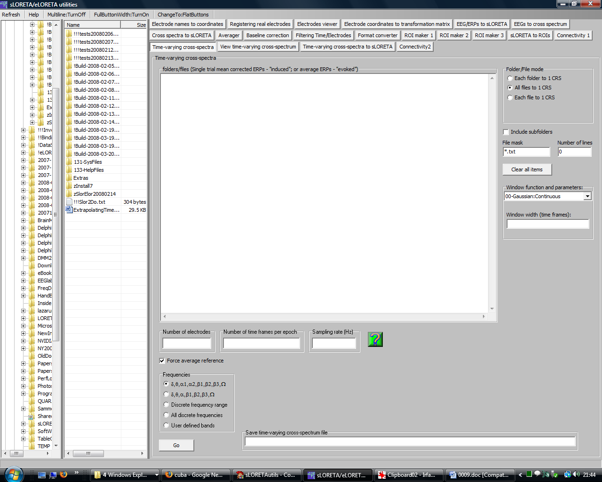

This module will compute time-varying cross-spectra from a group of ERP files. If average ERP files are used, the time-varying cross-spectra contain information on the evoked time-varying oscillations. If single trial ERP files are used, the time-varying cross-spectra contain information on the induced time-varying oscillations. When analyzing single trial ERP files, it is valid to either:
1. Use them as they are.
2. Or to subtract the average ERP from each single trial before analysis. The module “Utilities\Averager” can produce such files.

Note that time-varying cross-spectra can be computed from a single file, or from several.

This module is very similar to the EEG to cross-spectrum module. In this case, the user must additionally specify two items:
1. The window function
2. The window width

Note that the idea behind time-frequency analysis is a simple one: perform a local FFT with a sliding time window. Some of the windows implemented here are found in the Wiki page on window function:
http://en.wikipedia.org/wiki/Window_function

By default, the continuous Gaussian window is used. As a rule of thumb, the width (in time frame units) can be about one-sixth of the total number of time frames in the ERP files. However, the User is free to choose any value. A very large window width is equivalent to making a plain FFT without any window, i.e. all time resolution is lost. A very narrow window will have high time resolution, but will miss all information on slow frequencies.

Time-varying cross-spectrum files are generally very large. The total number of distinct, non-redundant numbers is (NTFxNDFxNExNE), where NTF is number of time frames, NDF is number of frequencies, and NE is number of electrodes. Let the 4-dimensional array m[1...NTF, 1...NDF, 1...NE, 1...NE] denote the time-varying cross-spectrum. Consider the element m[t,w,i,j]. Note that i=j denotes the spectral density at the i-th electrode, at time instant t, at frequency w; i<j contains the real part of the Hermitian covariance between electrodes i and j; i>j contains the imaginary part of the Hermitian covariance between electrodes i and j.

This module performs an enormous amount of computations, and is very slow, especially for files with a large number of time frames.

