Time-varying cross-spectra to sLORETA

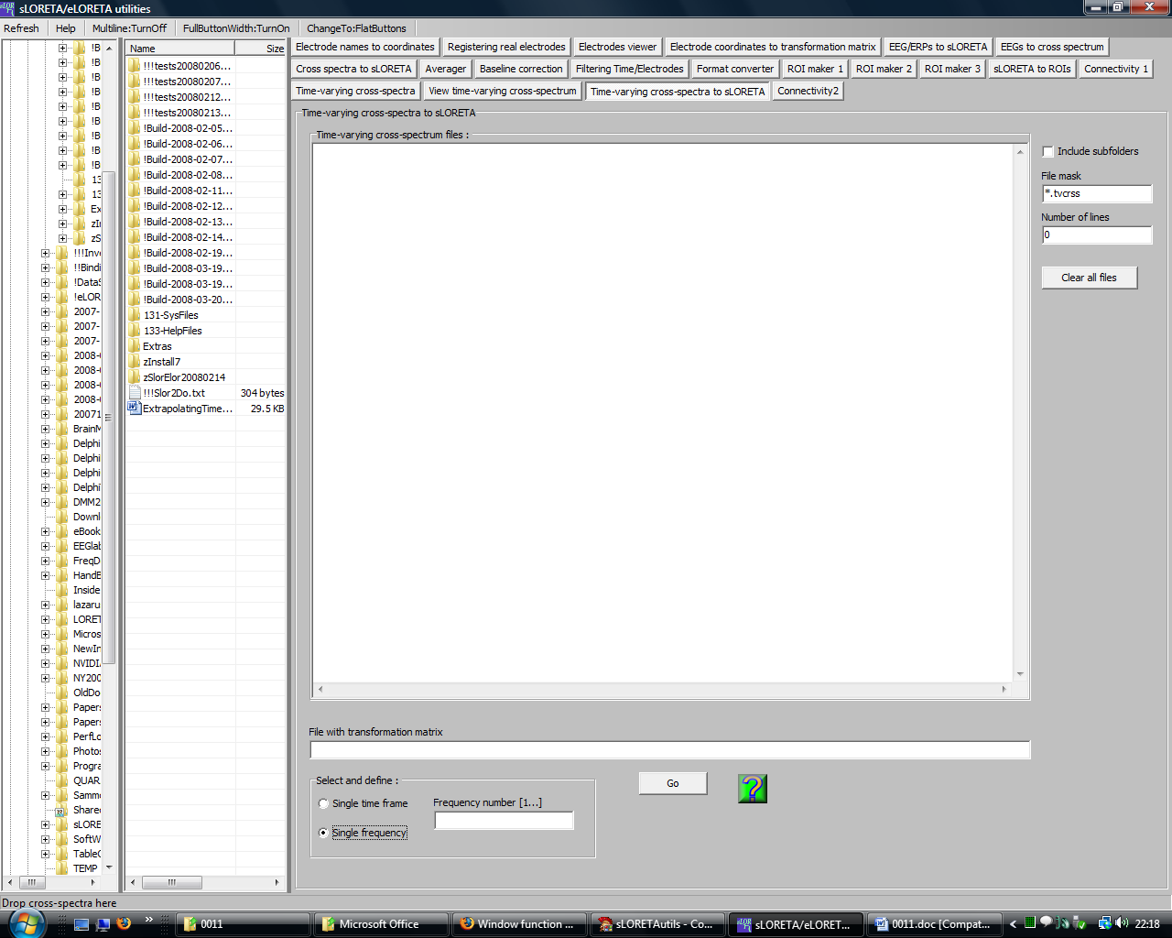

This module is similar to the module Cross-spectra to sLORETA.

sLORETA can be computed in one of two ways:
1. If you specify a time instant, you can obtain the generators (electric neuronal activity) of each oscillation (for all frequencies).
2. If you specify a frequency, you can obtain the generators (electric neuronal activity) of this specific oscillation as it dynamical changes through time.

