Averager:

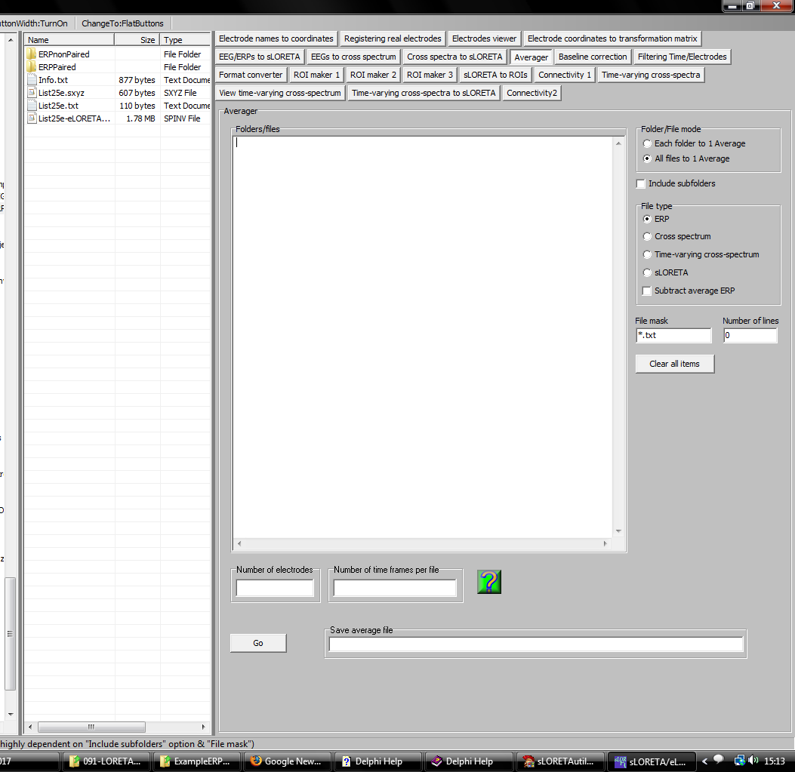

This module will average groups of files. Files to be averaged can be dropped onto the Folders/files pane. Be sure to set properly the File mask: only files that match the extension will be added to the list. The user must specify the file name for the average (Save average file).

Alternatively, folders can be dropped onto the Folders/files pane. In this case, all the files within each folder will be averaged, and the averages will be saved to files with file names equal to the folder name, but with the corresponding extension of the file type. Be sure to set properly the File mask: only files that match the extension will be averaged. These files will be placed in the same folder that contains the added folders.

Note that when averaging ERP files, a special option appears: Subtract average ERP. This option is intended for use with single trial ERPs, but can be used for any ERP-type files. Assuming that the input files are single trial ERPs, checking this option does the following: in addition to the average of single trials, new files will be created, one for single trial, containing the single trial minus the average. The files will have extension
*-MinusAve.txt
or
*-MinusAve.asc

These files are appropriate for use in time-frequency analyses, for the study of induced oscillations. Note that it is incorrect to use the single trials without average subtracted for the study of induced oscillations, because this mixes induced and evoked oscillations.

