sLORETA to ROIs:

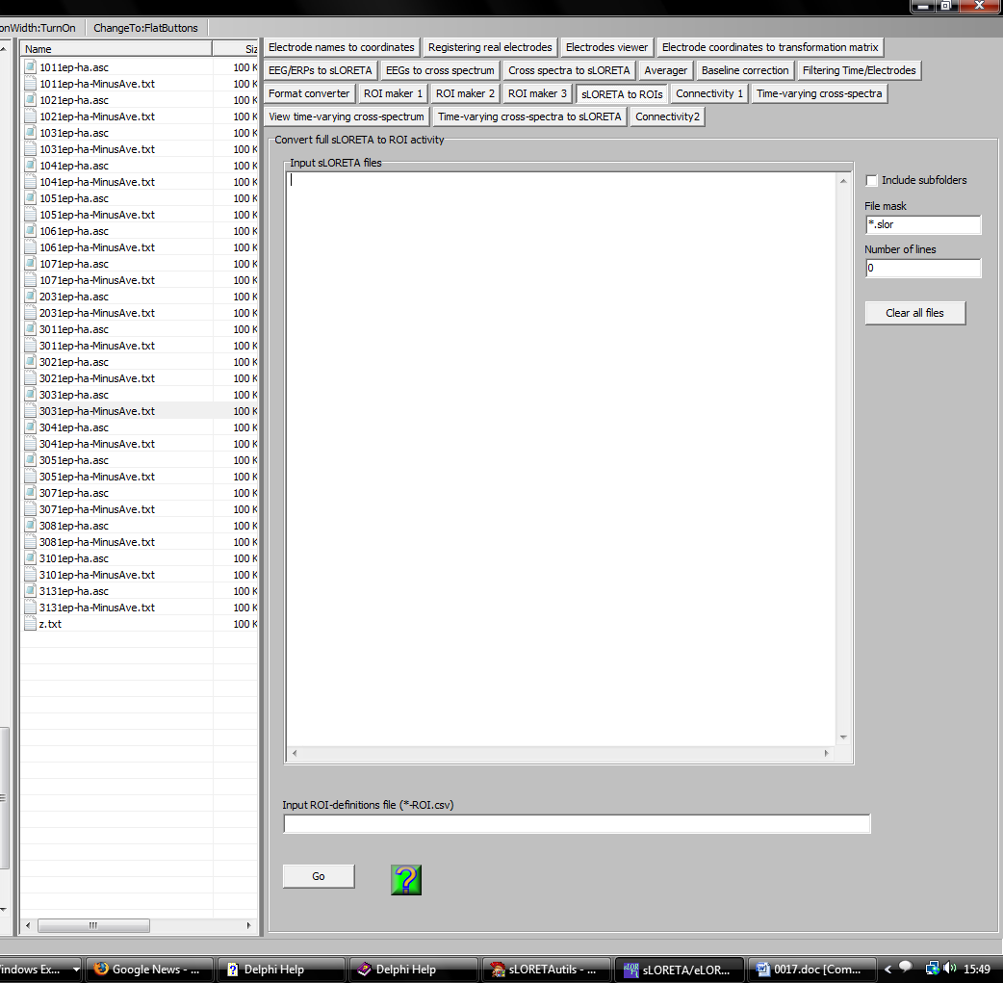

This module is a region of interest (ROI) extractor. It will process sLORETA files and produce text files with the sLORETA values at the specified ROIs. sLORETA files to be processed can be dropped onto the Input sLORETA files pane. Be sure to set properly the File mask: only files that match the extension will be added to the list. sLORETA files should have *.slor as File mask.

The ROIs are specified in the ROI-definitions file (*ROI.csv). Such files can be produced in the modules ROI maker 1, ROI maker 2, and ROI maker 3. Read carefully the help text within these modules.

Corresponding to each sLORETA file, a file with extension *-sLorRoi.txt will be produced. This text file will have Nroi columns, and NT rows. Nroi is equal to the number of regions of interest. NT is equal to the number of sLORETA images in the sLORETA file (typically, but not always, equal to the number of time frames or of discrete frequencies).

