Format converter

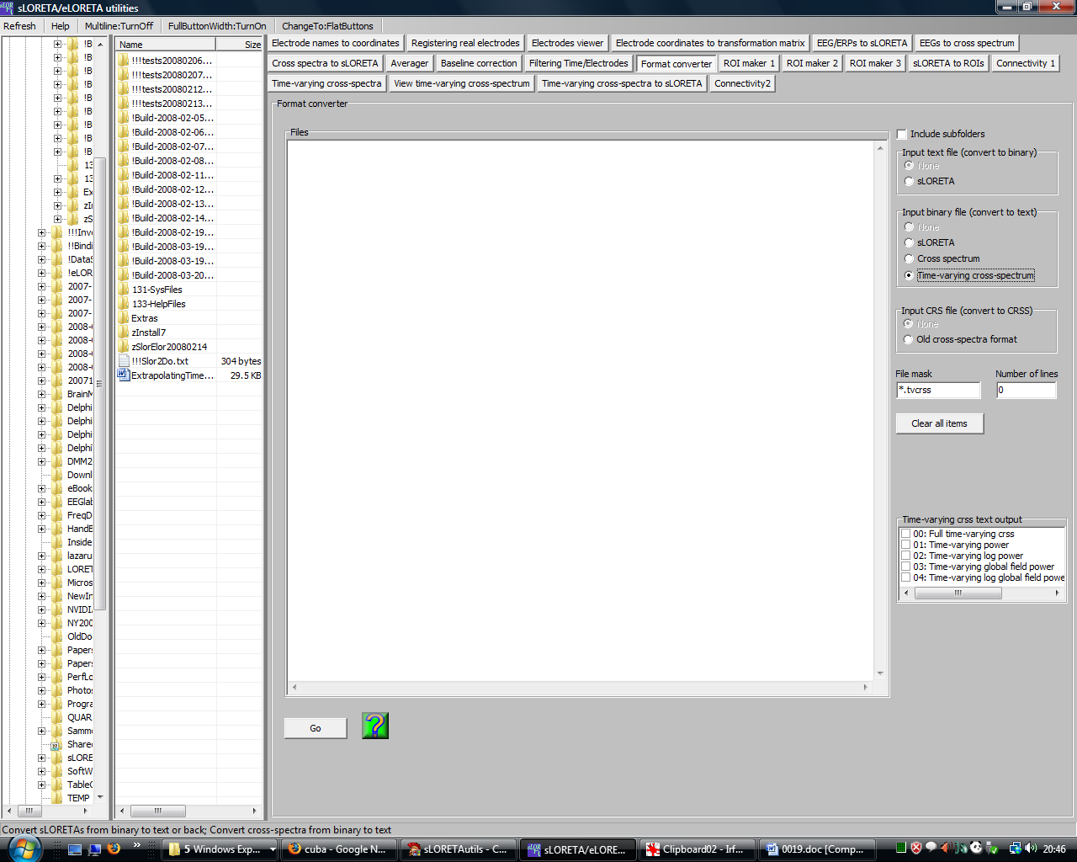

This module will convert the format of files. Files to be converted can be dropped onto the files pane. Be sure to set properly the File mask: only files that match the extension will be added to the list. Newly created files will keep the same name, but with the new extension corresponding to the format.

Note that time-varying cross-spectrum files can be converted to text files. Time-varying cross-spectra can be computed using the Time-varying cross-spectra module.

Time-varying cross-spectrum files are generally very large. The total number of distinct, non-redundant numbers is (NTFxNDFxNExNE), where NTF is number of time frames, NDF is number of frequencies, and NE is number of electrodes. Let the 4-dimensional array m[1...NTF, 1...NDF, 1...NE, 1...NE] denote the time-varying cross-spectrum. Consider the element m[t,w,i,j]. Note that i=j denotes the spectral density at the i-th electrode, at time instant t, at frequency w; i<j contains the real part of the Hermitian covariance between electrodes i and j; i>j contains the imaginary part of the Hermitian covariance between electrodes i and j.

When converting to text format, several options are available:

1. Full time-varying crss: This will produce extremely large text files, with all the information in m[t,w,i,j], for t=1...NTF, w=1...NDF, i=1...NE, j=1...NE.

2. Time-varying power: This will produce only the spectral densities m[t,w,i,i], for t=1...NTF, w=1...NDF, i=1...NE.

3. Time-varying log power: This will produce only the logarithm of spectral densities ln(m[t,w,i,i]), for t=1...NTF, w=1...NDF, i=1...NE.

4. Time-varying global field power: This will produce only the global field power spectral density SumOverI(m[t,w,I,I]), for t=1...NTF, w=1...NDF.

5. Time-varying log global field power: This will produce only the logarithm of global field power spectral density ln(SumOverI(m[t,w,I,I])), for t=1...NTF, w=1...NDF.

The time-varying log global field power can be used as a basis for statistical tests, in the sLORETA SnPM statistics module.

