Help on Scaling and Baseline-Correction utilities

This utility allows you to perform transformations on ERP or sLORETA files. The transformations are of the scaling (i.e. normalization) or baseline-correction types.

When the “Scaling & Baseline” tab is invoked for the first time, you should see the following screen:
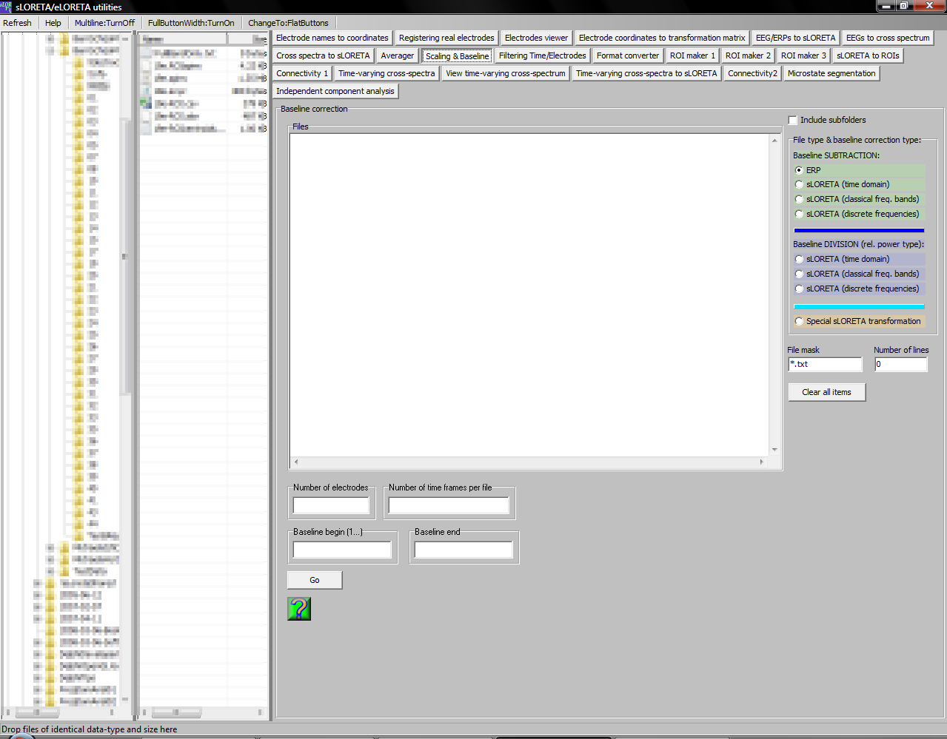

Performing baseline subtraction on ERP files

1. Select the option “ERP” in the “Baseline SUBTRACTION” box, as shown in the figure above.

2. The file mask must have the filename extension corresponding to your ERP files.

3. ERP files must be text files, containing only numbers (microvolt values). No header, no footer. The text file must have number of rows equal to the number of time frames, i.e. number of discrete time samples. The text file must have number of columns equal to the number of electrodes. This means that rows correspond to time samples; columns correspond to electrodes. An example EEG/ERP text file with five discrete time frames and three electrodes should look thus:
-0.162 -0.095 -0.027
-0.041 -0.004 0.049
-0.010 0.042 0.102
0.007 0.021 0.052
-0.056 -0.094 -0.127

The separators between numbers can be spaces or tabs. Decimal “point” should be used, not a decimal “comma”. Numbers can be represented in exponential notation, e.g.:
-0.162 can equivalently be written as -1.62E-01

4. From the left panes that display folders/files, drag and drop the ERP files onto the “Files” box.

5. Fill out correctly the information on number of electrodes, number of time frames, time frame number for the start of the baseline, and time frame number for the end of the baseline. Time frames start at value 1, NOT at value zero. All selected files must have same values for these four items.

6. Click Go.

7. For each file processed, a new file will be created, with same filename, but different extension, containing the base-line corrected data.

8. Baseline subtraction corresponds to:
8.a. Make average scalp map in the defined baseline time interval.
8.b. Subtracting from every scalp map the baseline average scalp map.

Performing baseline subtraction on time domain sLORETA files

1. Select the option “sLORETA (time domain)” in the “Baseline SUBTRACTION” box.

2. The file mask will reset itself to “*.slor”. Do not change this.

3. From the left panes that display folders/files, drag and drop the sLORETA files onto the “Files” box.

4. Fill out correctly the information on time frame number for the start of the baseline, and time frame number for the end of the baseline. Time frames start at value 1, NOT at value zero. All selected files must have same values for these two items.

6. Click Go.

7. For each file processed, a new file will be created, with same filename, but different extension, containing the base-line corrected data.

8. Baseline subtraction corresponds to:
8.a. Make average sLORETA image in the defined baseline time interval.
8.b. Subtracting from every sLORETA image the baseline average sLORETA image.

Performing baseline subtraction on frequency domain (corresponding to classical frequency bands) sLORETA files

1. Select the option “sLORETA (classical freq. bands)” in the “Baseline SUBTRACTION” box. Note that these files must have originated from EEG cross-spectra that were obtained for classical frequency bands (see the “EEGs to cross spectrum” tab). There are two possible classical frequency band selections:

8ClassicalBands: δ(1.5-6Hz) , θ(6.5-8Hz) , α₁(8.5-10Hz) , α₂(10.5-12Hz) , β₁(12.5-18Hz), β₂(18.5-21Hz) , β₃(21.5-30Hz) , Ω(1.5-30Hz)

7ClassicalBands: δ(1-3Hz) , θ(4-7Hz) , α(8-12Hz) , β₁(13-18Hz), β₂(19-21Hz) , β₃(22-30Hz) , Ω(1-30Hz)

2. The file mask will reset itself to “*.slor”. Do not change this.

3. From the left panes that display folders/files, drag and drop the sLORETA files onto the “Files” box.

4. Fill out correctly the information on band number for the start of the baseline, and band number for the end of the baseline. Band numbers start at value 1, NOT at value zero. The maximum value for band number for the end of the baseline is 7 for 8ClassicalBands or 6 for 7ClassicalBands. This is because the last band is the redundant full-total-band (Ω). All selected files must have same values for these two items.

6. Click Go.

7. For each file processed, a new file will be created, with same filename, but different extension, containing the base-line corrected data (the total band will be excluded in the baseline corrected files).

8. Baseline subtraction corresponds to:
8.a. Make average sLORETA image in the defined baseline band.
8.b. Subtracting from every sLORETA image the baseline average sLORETA image.

Performing baseline subtraction on frequency domain (corresponding to discrete frequencies, not to classical bands) sLORETA files

1. Select the option “sLORETA (discrete frequencies)” in the “Baseline SUBTRACTION” box. Note that these files must have originated from EEG cross-spectra that were obtained for some discrete frequency range (see the “EEGs to cross spectrum” tab).

2. The file mask will reset itself to “*.slor”. Do not change this.

3. From the left panes that display folders/files, drag and drop the sLORETA files onto the “Files” box.

4. Fill out correctly the information on frequency number for the start of the baseline, and frequency number for the end of the baseline. Frequency numbers start at value 1, NOT at value zero. The correspondence between discrete frequency number and actual Hz depends on the discrete frequency range that was used when computing EEG cross-spectra, and on the frequency resolution of your analysis. For instance, if your EEG files had 256 time frames sampled at 128 Hz, then the frequency resolution is 0.5 Hz. If you computed EEH cross-spectra starting at 3 Hz and ending at 5 Hz, then your corresponding sLORETA files will have 5 discrete frequencies:
Discrete frequency number 1 corresponds to 3 Hz;
Discrete frequency number 2 corresponds to 3.5 Hz;
Discrete frequency number 3 corresponds to 4 Hz;
Discrete frequency number 4 corresponds to 4.5 Hz;
Discrete frequency number 5 corresponds to 5 Hz.

6. Click Go.

7. For each file processed, a new file will be created, with same filename, but different extension, containing the base-line corrected data.

8. Baseline subtraction corresponds to:
8.a. Make average sLORETA image in the defined baseline band.
8.b. Subtracting from every sLORETA image the baseline average sLORETA image.

Performing baseline division on sLORETA files

These options are similar to those described above for baseline subtraction on sLORETA files. With these options, instead of subtracting the baseline, division is used:

1. Baseline division corresponds to:
1.a. Make average sLORETA image in the defined baseline.
8.b. Make a voxel-by-voxel division of sLORETA image by the baseline average sLORETA image.

Special sLORETA transformation

When the option “Special sLORETA transformation” is selected, new options are displayed as shown here:
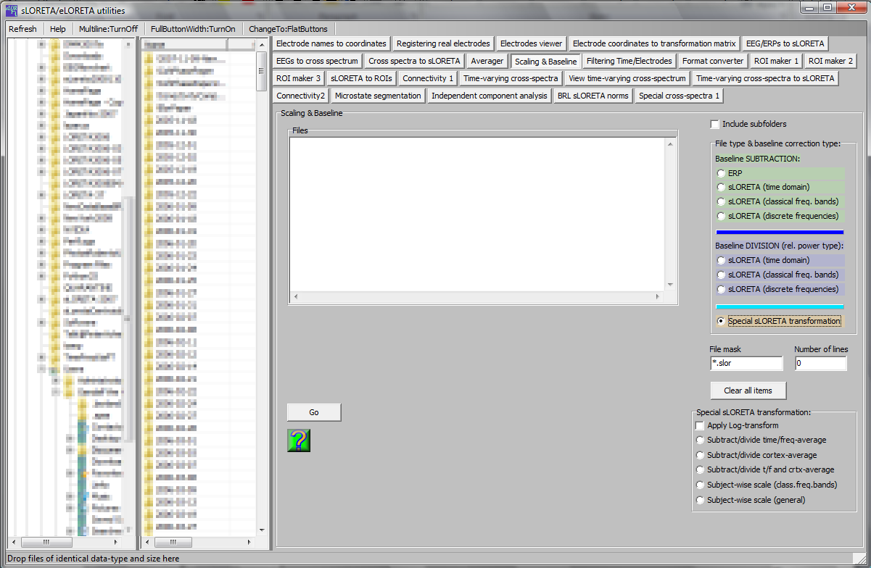

Corresponding to each input sLORETA file, the output file will be transformed in the following way:

1. “Subtract/divide time/freq-average”: TimeFrame/Frequency-wise normalized (scaled) sLORETA files.

2. “Subtract/divide cortex-average”: voxel-wise normalized (scaled) sLORETA files.

3. “Subtract/divide t/f and crtx-average”: both normalizations (scalings) are applied: TimeFrame/Frequency-wise AND voxel-wise.

4. “Subject-wise scale (classical frequency bands)”: In this case the last sLORETA image is ignored (since it contains the full-band). The total activity over all voxels and bands is computed, giving a single number, used as divisor for scaling the data (except the last sLORETA image). The output file has one sLORETA image less.

5. “Subject-wise scale (general)”: The total activity over all voxels and time-frames or frequencies is computed, giving a single number, used as divisor for scaling the data. The output file has the same number of sLORETA images (time-frames or frequencies).

Note that you can choose to output log-transformed normalized (scaled) values.

Note that all these options correspond to a generalization of “baseline division”, where the baseline consists of either all time frames or all voxels or both. The term “division” applies if no log-transform is used; but if log-transform is selected, then the division turns into subtraction (elementary math). This explains the basic ideas and terminology.

