Functional independent component analysis

The method of analysis used here goes under the name of “functional data analysis”. This is a relatively recent development in the field of statistics. A textbook reference is:
Ramsay, J. O. and Silverman, B. W. (2002). Applied Functional Data Analysis. New York: Springer-Verlag

The main idea is explained with an example.

Consider the case where for each subject, eyes closed EEG is recorded. From here, compute LORETA in the frequency domain. The basic data for analysis now is spectral power 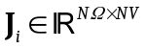, for i=1…NS, where NS is number of subjects, NΩ is number of frequencies, NV is number of voxels.

The idea of functional data analysis is to treat the data as a function, and to study the statistical properties of the function (e.g. mean and variance). In this sense, J is a function of frequency and space (cortical grey matter). Let 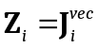, which simply strings in one vector the whole function (frequency and space). Then the data matrix is:
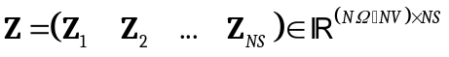
Note that each subject consists of a column, with the column vector being a function of frequency and space.

Of interest are:
- The mean function
- The variability around the mean

The mean function is the vector given by the mean of the column vectors.

The mean is then subtracted from each column. In addition, one may optionally standardize each variable (each row), in such a way that the elements of the row have zero mean and unit variance.

Once the data matrix is mean-corrected and optionally standardized, the modes of functional variability are given by the left eigenvectors. The eigenvectors can be rotated to an independent component basis.

