Sparse SVD

The main idea is explained with an example.

Consider the case where for each subject, eyes closed EEG is recorded. From here, compute LORETA in the frequency domain. The basic data for analysis now is spectral power 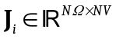, for i=1…NS, where NS is number of subjects, NΩ is number of frequencies, NV is number of voxels.

Define:
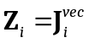
which simply strings in one vector the whole function (frequency and space). Now define the data matrix is:
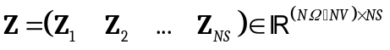
Note that each subject consists of a column, with the column vector being a function of frequency and space.

Take each row of the data matrix , and standardize it to zero mean and unit variance. This then means that 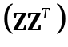 is the correlation matrix between all pairs of points on the 4D hyperspace (cortical location X frequency).

Consider the singular value decomposition of the data matrix:
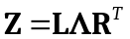
with 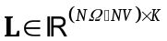 containing the left eigenvectors, 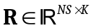 containing the right eigenvectors, 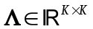 is diagonal and contains the eigenvalues in descending order, and 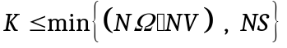. Both and 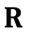 are orthonormal, i.e. 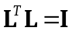 and 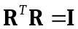.

This program will output the left eigenvectors with files named “-PC-”. These eigenvectors will optionally be made sparse (via varimax rotation), and will output files named “-SparseC-“.

All these components (left eigenvectors and their rotated versions) are “components”, as legitimate as those of ICA, and might be interpretable as spatio-frequency (or spatio-temporal) brain modes. They should allow the discovery of cortico-cortical, cross-frequency interactions.

These ideas are applications of the SVD method advocated by Worsley:
Worsley KJ, Chen JI, Lerch J, Evans AC. Comparing functional connectivity via thresholding correlations and singular value decomposition. Phil. Trans. R. Soc. B, 2005; 360: 913-920.

In addition, these ideas are also related to “functional data analysis”:
Ramsay, J. O. and Silverman, B. W. (2002). Applied Functional Data Analysis. New York: Springer-Verlag

Note that this idea differs from functional independent component analysis (fICA). In fICA, super-independence was forced only on the right matrix factor from . In the SVD and its rotated versions, independence is forced on both left and right matrix factors, and rotation is used to sparsify and make interpretable the left (space-frequency-time) factor.

