Registering real electrodes

The second “tab” in the “sLORETA utilities” program can be used to register any electrodes onto the MNI152 scalp. There are two main options.

Option 1: using electrode coordinates from the old LORETA-KEY software

If you have electrode coordinates produced by any of the programs in the old LORETA-KEY software (files with extension *.xyz), then you can register them onto the MNI152 scalp. Select the option A:
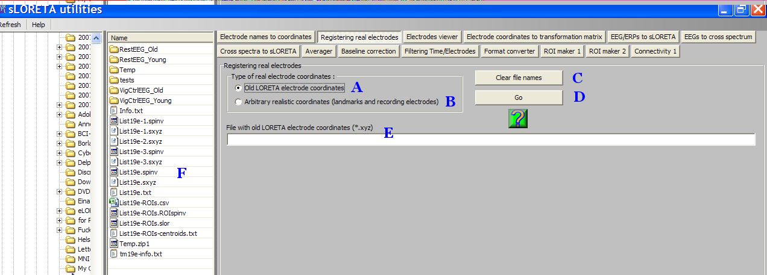
and drag/drop a file with extension “*.xyz” (created by one of old LORETA-KEY programs) from F onto E, and click Go (D). Once the program finished, the display looks thus:
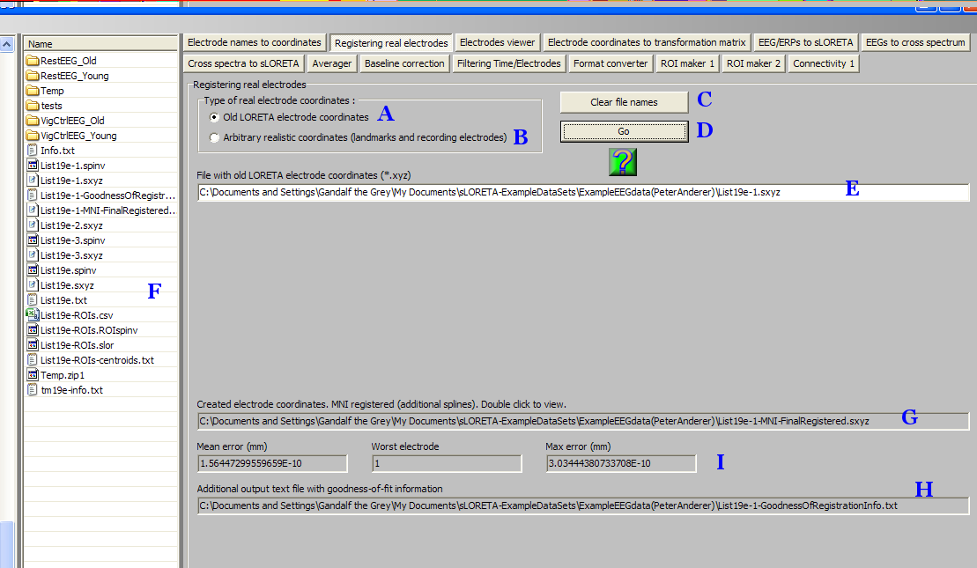
In G appears the file name for the registered electrodes. Note that it is the same as the original, but with “-MNI-FinalRegistered.sxyz” appended. In H appears the file name with information on the quality of the registration (same as original but with “-GoodnessOfRegistrationInfo.txt” appended). The “quality of registration” information appears also in I: the mean error, the worst electrode, and the worst electrode’s error.

The registration from old LORETA-KEY electrode coordinates to the MNI152 scalp is based on projecting the electrodes onto the scalp, using the minimum possible displacement of the original positions (using spherical splines, explained in the appendix).

Double-clicking on G will display the electrodes in three orthogonal slices in the MNI152 template. It is the User’s responsibility to perform this visual inspection in order to check the quality of the registration.

-------------------------------------

Option 2: using realistic electrode coordinates

In this case select option B:
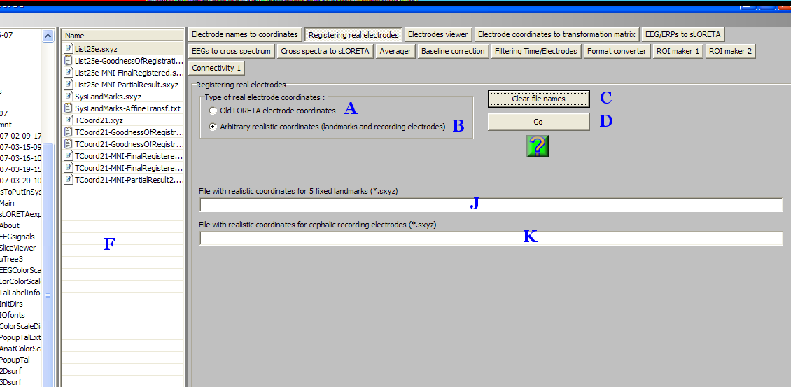

It will be assumed that there are two text files available, already prepared by the User. Both files must have extension “*.sxyz”.

One file must contain the coordinates of 5 landmarks. The second file must contain the coordinates of the actual cephalic recording electrodes. Both files must use the same Cartesian coordinate system, with units in millimeters. The origin and orientation of the orthogonal axes may be arbitrary. It is up to the User how to go about and make these realistic measurements.

The first file must contain the coordinates of 5 landmarks used for the first step of the registration process. This first step is known as the 12-parameter affine transformation (see the appendix below). An example for this file is:
5
1.60 80.00 -41.42 Nz
-1.68 -120.55 -21.49 Iz
76.59 -28.17 -52.31 RPA
-76.62 -27.39 -53.53 LPA
0.23 -11.28 99.81 Cz
This file must have 6 lines. The first line must contain the number five (which means that five landmarks will follow). The next five lines must have 4 items each: three numbers (xyz coordinates in the User’s system) and a landmark name, all separated by the “space” character. The landmarks must be in the exact order as shown above: Nz (nasion), Iz (inion), RPA (right preauricular), LPA (left preauricular), and Cz. Units must be millimeters.

The preauricular points (RPA, LPA) are defined as the anterior root of the center of the peak region of the tragus (blue dot in the figure):
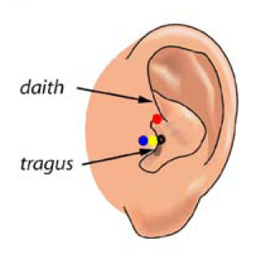
(Figure copied from Valer Jurcak, Daisuke Tsuzuki and Ippeita Dan. 10/20, 10/10, and 10/5 systems revisited: Their validity as relative head-surface-based positioning systems. NeuroImage 2007, 34:1600-1611)

The Cz landmark is defined as the half-way distance point from Nz to Iz along the midline.

The second file must contain the recording electrode coordinates in the User’s system. If the number of electrodes is 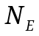, then this file must have 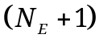 lines. On the first line must appear the number of electrodes. The next lines must have 4 items each: three numbers (xyz coordinates in the User’s system) and an electrode name. Actually, electrode names are optional and can be omitted. Electrode names are arbitrary and need not correspond to any naming convention. But if electrode names are used, they must be kept short (a maximum of 5 characters). Units must be millimeters. An example:
19
-26.81 84.06 -10.56 Fp1
29.41 83.74 -10.04 Fp2
-66.99 41.69 -15.96 F7
-48.05 51.87 39.87 F3
0.90 57.01 66.36 Fz
50.38 51.84 41.33 F4
68.71 41.16 -15.31 F8
-83.36 -16.52 -12.65 T7
-65.57 -13.25 64.98 C3
0.23 -11.28 99.81 Cz
66.50 -12.80 65.11 C4
84.44 -16.65 -11.79 T8
-71.46 -75.17 -3.70 P7
-55.07 -80.11 59.44 P3
-0.87 -82.23 82.43 Pz
53.51 -80.13 59.40 P4
71.10 -75.17 -3.69 P8
-28.98 -114.52 9.67 O1
26.89 -114.68 9.45 O2

Drag/drop the corresponding User-made files (with extension “*.sxyz”) from F onto J and K, and click Go (D). Once the program finished, the display looks thus:
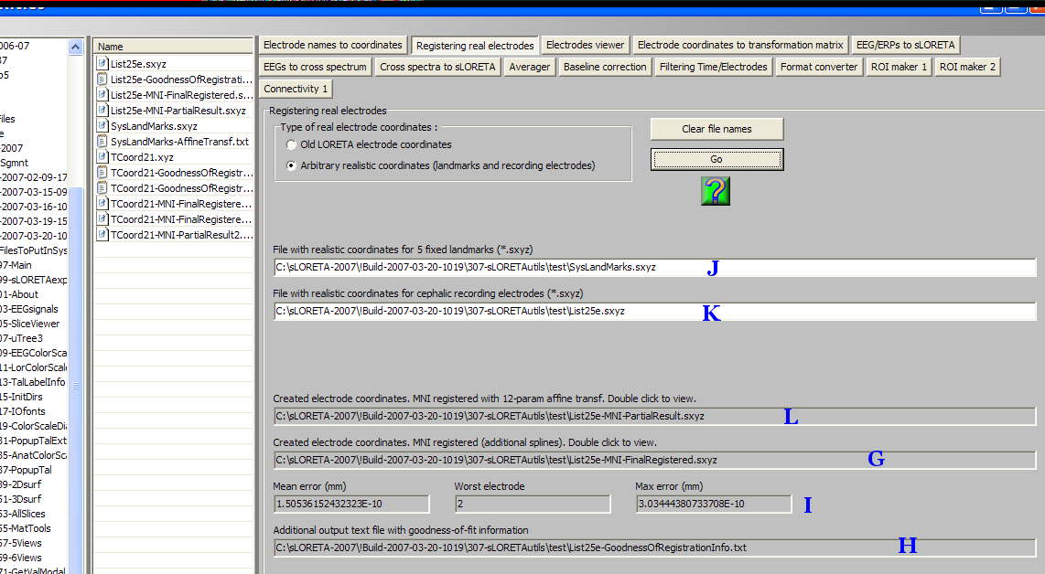
In G appears the file name for the registered electrodes. Note that it is the same as the original, but with “-MNI-FinalRegistered.sxyz” appended. In H appears the file name with information on the quality of the registration (same as original but with “-GoodnessOfRegistrationInfo.txt” appended). The “quality of registration” information appears also in I: the mean error, the worst electrode, and the worst electrode’s error.

In L appears the file name for the first-step partially-registered electrodes. Note that it is the same as the original, but with -MNI-PartialResult.sxyz” appended. This first step corresponds to the 12-parameter affine transform (see appendix below). The second step, used to produce the final registration (producing the file in G), employs spherical splines to project the electrodes onto the MNI152 scalp (see appendix below).

Double-clicking on G will display the electrodes in three orthogonal slices in the MNI152 template. It is the User’s responsibility to perform this visual inspection in order to check the quality of the registration.

Note that double-clicking on L will display the partially-registered electrodes in three orthogonal slices in the MNI152 template.

-------------------------------------

Appendix

The 12-parameter affine transformation

The aim is to convert realistic electrode coordinates measured with some device, and fit them onto the MNI152 scalp. The procedure follows.

Let the position vectors 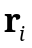, 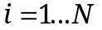, denote the full set of electrode coordinates in MNI space for all the 5% system electrodes. Units are in millimeters throughout.

Let the position vectors 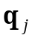, 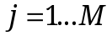, denote the measured coordinates. Units are in millimeters throughout.

Using as landmark positions Nz (nasion), Iz (inion), RPA (right preauricular), LPA (left preauricular), and Cz (defined as the half-way distance point from Nz to Iz along the midline), the aim is to find the best linear transformation:
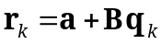
Eq. 1
for the landmarks 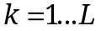 (in this case 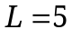), where 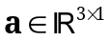 and 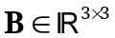 are unknown. The least squares estimators are obtained by solving:
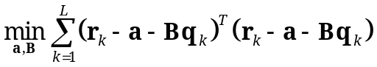
Eq. 2

The expanded functional in Eq. 2 is:
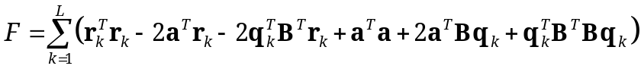
Eq. 3
Setting to zero its partial derivative with respect to gives:
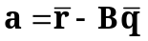
Eq. 4
where and 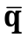 are mean values.

If this result is plugged into the original equations, then the new problem is:
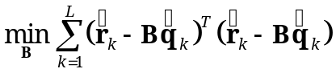
Eq. 5
with:
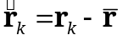
Eq. 6
and:
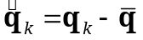
Eq. 7

The new expanded functional is:
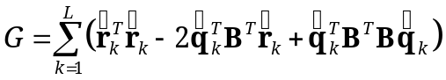
Eq. 8
Setting to zero its partial derivative with respect to  gives:
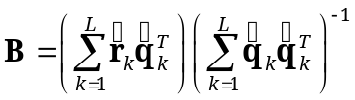
Eq. 9

[Note: Sadly, there was a bug with this equation, incorrectly written as 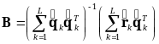
and this was corrected on 2009-10-23].

This solves the first part of the problem, where an approximate linear transformation is achieved from the real coordinates to the MNI152 scalp and system.

Spherical splines

The last step must force the transformed electrodes onto the scalp.

Let the position vectors 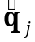, , denote the transformed measured coordinates (already in MNI space):
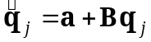
Eq. 10
with the transformation parameters given by Eq. 9 and Eq. 4.

Now let 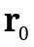 denote the average of , , over the full set of electrode coordinates in MNI space for all the 5% system electrodes. Redefine both sets and by subtracting (i.e. origin at ).

On the set (centered at ), transform the coordinates to the spherical system, and make the interpolating spherical spline fit:
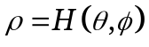
Eq. 11

Transform the set (centered at ) to the spherical system 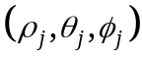. Substitute the radius with its spline interpolated value:
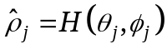
Eq. 12
and retransform back to Cartesian coordinates, and add the center . This will finally produce coordinates that really lie on the MN152 scalp.

