Notes on time-varying spectra

Let 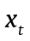, for 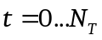, denote a time series. Its discrete Fourier transform is defined as:

If it is stationary, then it can be quite well characterized

