# Lehmann's atoms of thought: brain microstates

Brain field data can be viewed as a series of momentary, spatial (scalp) electric potential distributions (map landscapes). These sequences can be parsed into microstate segments of quasi-stable landscape, the putative "Atoms of Thought".

Main original publication:

Lehmann, D., Ozaki, H. and Pal, I.: EEG alpha map series: brain micro-states by space-oriented adaptive segmentation. Electroenceph. Clin. Neurophysiol. 67: 271-288 (1987).

The microstates program implements the estimation of the microstate model as described in:

Pascual-Marqui, R.D., Michel, C.M. and Lehmann, D. Segmentation of brain electrical activity into microstates: model estimation and validation. IEEE T. Bio-Med. Eng. 42: 658-665 (1995).

The abstract reads:

A brain microstate is defined as a functional/physiological state of the brain during which specific neural computations are performed. It is characterized uniquely by a fixed spatial distribution of active neuronal generators with time varying intensity. Brain electrical activity is modeled as being composed of a time sequence of non-overlapping microstates with variable duration. A precise mathematical formulation of the model for evoked potential recordings is presented, where the microstates are represented as normalized vectors constituted by scalp electric potentials due to the underlying generators. An algorithm is developed for estimating the microstates, based on a modified version of the classical k-means clustering method, in which cluster orientations are estimated. Consequently, each instantaneous multichannel evoked potential measurement is classified as belonging to some microstate, thus producing a natural segmentation of brain activity. Use is made of statistical image segmentation techniques for obtaining smooth continuous segments. Time varying intensities are estimated by projecting the measurements onto their corresponding microstates. A goodness of fit statistic for the model is presented. Finally, a method is introduced for estimating the number of microstates, based on nonparametric datadriven statistical resampling techniques.

View the paper as a PDF file (old scanned copy, some equations not too clear)

View author’s preprint version (clear text and equations).

Informally, for a given multichannel EEG/ERP recording, a small set of scalp maps (scalp electric potential differences over many electrodes) is estimated that best explains the recording in the following way: time segments are estimated, and within each time segment, only one scalp map with time varying amplitude explains to a high level of accuracy the actual measurements. The same idea extends to a group of EEG/ERP files: a small set of scalp maps is estimated, and the scalp maps within this set are common to all files. The time-segmentation is performed separately for each file.

Upon selecting the “Microstate segmentation” tab, the following is displayed:

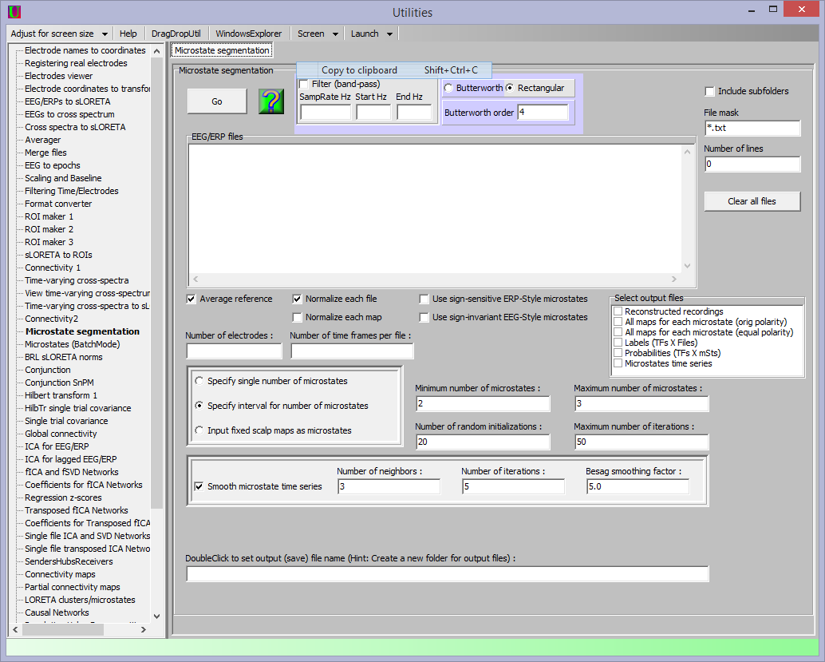

1. The file mask must have the filename extension corresponding to your EEG/ERP files.

2. EEG/ERP files must be text files, containing only numbers (microvolt values). No header, no footer. The text file must have number of rows equal to the number of time frames, i.e. number of discrete time samples. The text file must have number of columns equal to the number of electrodes. This means that rows correspond to time samples; columns correspond to electrodes. An example EEG/ERP text file with five discrete time frames and three electrodes should look thus:

-0.162 -0.095 -0.027

-0.041 -0.004 0.049

-0.010 0.042 0.102

0.007 0.021 0.052

-0.056 -0.094 -0.127

The separators between numbers can be spaces or tabs. Decimal “point” should be used, not a decimal “comma”. Numbers can be represented in exponential notation, e.g.:

-0.162 can equivalently be written as -1.62E-01

3. From the left panes that display folders/files, drag and drop the EEG/ERP files onto the “EEG/ERP files” box.

4. Fill out correctly the information on number of electrodes, number of time frames. All selected files must have same values for these parameters.

5. The option “Force average reference” is highly recommended.

6. If your files are of the EEG type, then select the option “Use sign-invariant EEG-Style microstates”.

7. If your files are of the ERP type, then select the option “Use sign-sensitive ERP-Style microstates”.

8. It is recommended to use the default settings in the box with option “Smooth microstate time series”. Otherwise, read carefully the paper quoted above (Pascual-Marqui et al) before changing these settings.

9. If the option “Specify interval for number of microstates” is selected, then this utility will sequentially solve the microstate segmentation problem for different numbers of microstate-scalp-maps. In this case, fill out correctly the information on minimum and maximum number of microstates (e.g. 2 to 10). It is recommended to not change number of random initializations nor the maximum number of iterations.

10. If the option “Specify single number of microstates” is selected, then this utility will solve the microstate segmentation problem for the number of microstate-scalp-maps specified (e.g. 7). It is recommended to not change number of random initializations nor the maximum number of iterations.

11. If the option “Input fixed scalp maps as microstates” is selected, then fill out correctly the number of microstates (it must correspond to the number of maps in the input file). The user must drag and drop the input file with the scalp maps into the input box. See below “Special case of interest”!

12. The user must specify the output filename (generic, no need for extensions). It is highly recommended to create a new folder first, and define the output filename within that folder, since there are many output files created.

13. Click Go.

A typical output sequence will look thus:

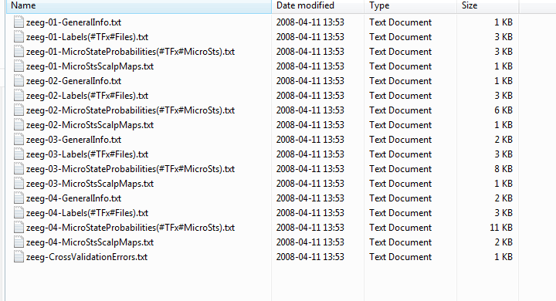

In this example, the output filename was “zeeg”.

The minimum number of microstates was 1.

The maximum number of microstates was 4.

For each given number of microstates, four files are created. For instance, files with names of type “zeeg-03-*****” all correspond to the microstate model with 3 scalp maps.

The file “zeeg-03-GeneralInfo.txt” will look thus:

Using microstate model of the sign-invariant-EEG type

Number of EEG files = 2

Number of MicroSts = 3

Mean global field power (data) = 1678.947754

Mean global field power (model) = 1151.668579

Global % explained variance = 68.594665

Estimated numerical dimension = 18

cv = 42.182335

Global % explained variance (S) per MicroSt

15.626 14.710 38.258

Matrix of MicroSt landscape correlations (range[-1...+1])

1.000 0.117 0.768

0.117 1.000 0.719

0.768 0.719 1.000

Matrix of squared MicroSt landscape correlations (*100)

100.000 1.375 59.032

1.375 100.000 51.730

59.032 51.730 100.000

% of total time in each MicroSt

23.438 26.563 50.000

Markov transition rates, in changes per time unit

NOTE: 1 time unit is 1 eeg epoch!

-32.000000 6.400000 25.600000

9.411765 -24.470589 15.058824

8.000000 10.000000 -18.000000

Embedded Markov Chain transition probabilities

0.000000 0.200000 0.800000

0.384615 0.000000 0.615385

0.444444 0.555556 0.000000

As the name indicates, this contains general information on the microstate model with three scalp maps.

Note that the transitions between microstates are modeled as a continuous time Markov process. This is because a finite amount of time is spent in each microstate. Under these conditions, it would be basically incorrect to model this as a plain Markov chain with transition probabilities. The more appropriate descriptors are the Markov transition rates. Corresponding to a Markov transition rate matrix, there is an embedded Markov transition probability matrix. Technical details can be found in:



All the information in the “*-GeneralInfo.txt” is common to all files processed.

Microstates are labeled by integer numbers starting at 1 (NOT zero).

The next output file is “zeeg-03-Labels(#TFx#Files).txt”. This file will have number of rows equal to the number of time frames, and it will have number of columns equal to the number of EEG/ERP files that were processed. The numbers in this file will point to the microstate label that was active at each time frame, for each file. Because this file contains a multiple time series, they can be viewed in the sLORETA viewer/explorer. However, it can be viewed properly only if there are no electrode coordinates loaded, nor any transformation matrix loaded, without average reference, without filters.

The next output file is “zeeg-03-MicroStateProbabilities(#TFx#MicroSts).txt”. This file will have number of rows equal to the number of time frames, and it will have number of columns equal to the number of microstates (in this case there are three microstates, i.e. three columns). The numbers in this file are probabilities (as %, i.e. the numbers are in the range 0 to 100). These probabilities correspond to the percent (over all processed files) that a given microstate was active at a given time frame. Because this file contains a multiple time series, they can be viewed in the sLORETA viewer/explorer. However, it can be viewed properly only if there are no electrode coordinates loaded, nor any transformation matrix loaded, without average reference, without filters.

The next output file is “zeeg-03-MicroStsScalpMaps.txt”. This file will have number of rows equal to the number of microstates (in this case there are three microstates, i.e. three columns), and it will have number of columns equal to the number of electrodes. Here are the scalp maps corresponding to the microstates. These maps have global field power 1, and can be viewed in the sLORETA viewer/explorer. To view them properly, it is convenient to load both the electrode coordinates and the transformation matrix. However, the filter must be off, because this file does not correspond to a time series, but to a collection of maps (the microstate maps).

NOTE: This is a very preliminary release of the BRAIN MICROSTATES module. File formats may change in future releases. More output files will be included, containing all microstates parameters (e.g. Markov matrices, label time series, etc) for each processed EEG/ERP file. However, for any group of files analyzed jointly, there will always be a unique set of microstate scalp maps. In order to produce microstate scalp maps particular to each EEG/ERP file, then the program must be used on each file separately.

Special case of interest in which this software can be used:

1. Given two groups of subjects (or two conditions).

2. Fit the microstate model to ALL the data. This will give common mSt maps, and the average common parameters.

3. Given the common mSt maps, select the option “Input fixed scalp maps as microstates”. Next, go to steps #4 or #5 or #6.

4.a. Set NumberOfRandomInitializations=0; the MaximumNumberOfIterations value will be ignored.

4.b. Given the “Input fixed scalp maps as microstates”, this will calculate the new labels and new parameters. These are the individual parameters, ready for use in statistics.

4.c. Finally, the parameters may be compared (e.g. mapA has higher %Time in Condition1).

5.a. Set NumberOfRandomInitializations=1 and set MaximumNumberOfIterations=1.

5.b. Given the “Input fixed scalp maps as microstates”, this will calculate the new labels and new parameters, and given the new labels, it will recomputed the new mSt maps without further iterations. These are the individual parameters and mSt maps, ready for use in statistics.

5.c. Finally, the parameters may be compared (e.g. mapA has higher %Time in Condition1) and the mSt maps may be compared (e.g. after computing loretas for all output microtstate maps, MapB has more left frontal activity in Group2).

6.a. Set NumberOfRandomInitializations=1 and set MaximumNumberOfIterations>1.

6.b. Given the “Input fixed scalp maps as microstates” as a starting point, this will iterate to find the best new labels and mSt maps. These are the individual parameters and mSt maps, ready for use in statistics. They will have more variance than those obtained from Step#5.

6.c. Finally, the parameters may be compared (e.g. mapA has higher %Time in Condition1) and the mSt maps may be compared (e.g. after computing loretas for all output microtstate maps, MapB has more left frontal activity in Group2).