Start the LORETA program:

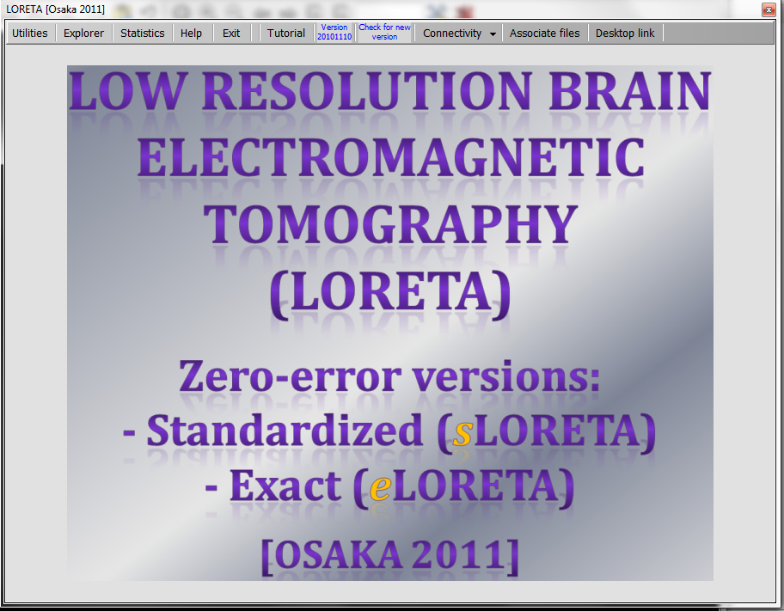

Click once (do not double-click) the “Associate files” button:



If all goes well (if you are the administrator of the computer), then you should see a message:

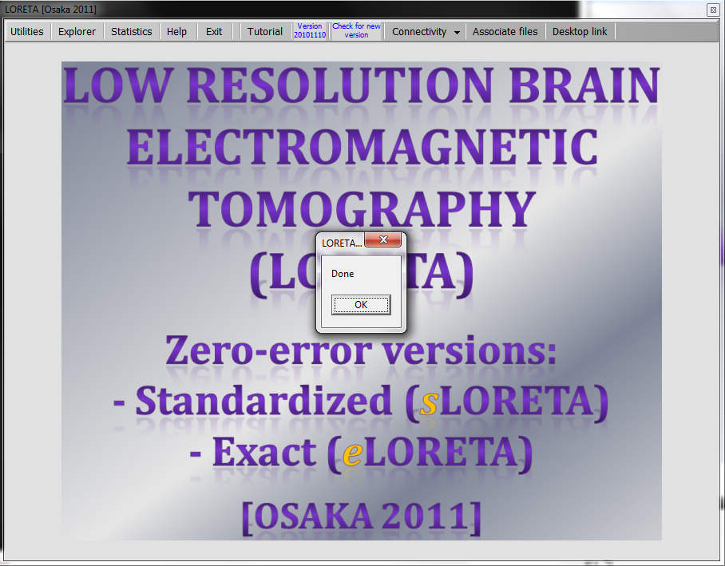

The consequence of this action is that files of the sLORETA type with extension (\*.slor), and files of the cross-spectral matrices type with extension (\*.crss), will be associated with the sLORETA viewer (also called the sLORETA explorer).