Routine healthcare access, insurance coverage, and hypertension awareness: NHANES 2011–2018
Academic research-training writing sample | Author name to be added after verification | October 2026
Not peer reviewed. Analysis is observational; the published-study reconstruction is approximate.

Abstract
Background. Understanding hypertension recognition requires distinguishing access to routine clinical care from insurance coverage. We reconstructed a published analysis of routine care and hypertension unawareness, and extended an existing insurance-awareness study from one to four NHANES cycles.
Methods. We used NHANES 2011–2018 with cycle-harmonized questionnaires and examination data, examination weights, strata, and masked primary sampling units. Study A considered adults aged 18–64 with measured blood pressure at least 130/80 mmHg; Study B considered adults aged 20–64 with measured elevation or reported current antihypertensive medication. Survey-design-adjusted modified Poisson and logistic models estimated associations, with sensitivity analyses and cross-implementation checks.
Results. The Study A reconstruction included 4,930 adjusted-model participants and estimated hypertension unawareness at 55.9%, with adjusted prevalence ratio (aPR) 1.27 (95% CI 1.18–1.36) for lacking a defined non-emergency usual place of care. Published benchmarks were 5,345 participants and aPR 1.20 (1.12–1.29). In Study B, weighted awareness was 58.2% among insured and 45.7% among uninsured adults; the fully adjusted odds ratio (aOR) was 0.60 (0.49–0.75; n=6,191).
Conclusions. Associations were directionally compatible with existing evidence, but the reconstruction was not exact. Historical cross-sectional estimates are vulnerable to selection, temporality, measurement, and missing-data limitations. This project demonstrates transparent methods and reproducibility rather than a new causal or clinical claim.

Introduction
Hypertension recognition is an important step in the clinical care pathway. Yet what a survey classifies as “hypertension” is not identical to a diagnosis established through repeated clinical evaluation. A participant may have elevated blood pressure at one survey visit without recalling a prior clinician diagnosis; another participant may report previous hypertension while medication keeps measured blood pressure below a selected threshold. Both scenarios matter when estimating awareness and interpreting differences between groups.
Health insurance and a usual source of healthcare are related but different exposures. Insurance may facilitate affordable contact with clinicians, yet it does not guarantee an available primary-care provider. Conversely, uninsured individuals may receive consistent services from community clinics. The timing matters as well: NHANES measures current coverage, while awareness refers to a diagnosis that may have occurred years earlier. Associations between these variables cannot establish what would happen if coverage were changed.
Calixte and colleagues examined routine healthcare access and hypertension unawareness among nonelderly U.S. adults using NHANES 2011–2018 [1]. Earlier literature describes insurance-related gaps in hypertension detection and management [2–4], while historical surveillance demonstrates that awareness and blood-pressure control are distinct endpoints [5]. Our objective was not to claim these questions as new. Instead, we asked whether a documented, survey-aware reconstruction of a published study could be paired with a rigorously matched extension of a prior 2017–2018 insurance analysis. The scientific emphasis was on replicability, the comparability of estimands, and transparent interpretation of differences.

Study objectives and design
We report two distinct, cross-sectional analyses of NHANES 2011–2012, 2013–2014, 2015–2016, and 2017–2018. Study A investigated whether lacking an operational usual place of non-emergency care was associated with hypertension unawareness among adults 18–64 with measured systolic blood pressure (SBP) at least 130 mmHg or diastolic blood pressure (DBP) at least 80 mmHg. Study B examined whether self-reported current lack of insurance was associated with lower reported hypertension awareness among adults 20–64 meeting a medication-inclusive case definition. Thus Study A’s outcome was unawareness and Study B’s was awareness, but they were not complementary estimates for the same sampled population.
The analyses used released public-use survey data. The project was specified after earlier single-cycle and preliminary multicycle work had been seen; it must not be described as prospectively preregistered. No additional data collection, intervention, or participant recruitment was performed.

Methods
Data source and processing. CDC demographics (DEMO), blood-pressure examinations (BPX), blood-pressure questionnaires (BPQ), healthcare utilization (HUQ), and insurance (HIQ) files were joined within each cycle by unique participant identifier (SEQN); the cycles were then appended. Study A additionally used body-measures and smoking questionnaires. Each merge was checked for one-to-one integrity, response-code differences, and missingness. Raw downloads and codebooks are traceable through the repository’s source manifest. No interrupted 2019–2020 survey records were included.
Blood pressure and eligibility. For the primary definition, the analysis computed separate averages of available first-three valid SBP and DBP measurements and retained the documented treatment of zero diastolic readings. Study A required measured elevation and a nonmissing prior-diagnosis response. Study B included measured elevation or a report of currently taking prescribed medication for high blood pressure (BPQ050A), and measured awareness from BPQ020. “Ever told to take medication” (BPQ040A) was not treated as current use. Refused, unknown, and inapplicable questionnaire codes were not automatically recoded as “no.” The populations are operational survey groups, not clinically confirmed hypertensive cohorts.
Exposures. The primary Study A exposure combined the reported existence of a usual healthcare place with the type of facility. A respondent reporting no usual place or indicating an emergency department as the usual/most-often location was categorized as lacking an operational non-emergency routine-care place. Cycle-specific follow-up variables and unresolved responses were harmonized explicitly. This is a defensible proxy, but the exact coding used by Calixte et al. could not be verified. Study B used HIQ011 for current insured versus uninsured status, with unknown responses excluded; this was deliberately not treated as equivalent to routine-care access.
Statistical models. The full positive-weight examination survey design was declared before defining analysis domains. Four-cycle examination weights were constructed as WTMEC2YR divided by four, retaining masked strata and primary sampling units and using design-based uncertainty consistent with CDC guidance and R survey methods [6,7]. The pooled survey contained 59 strata and 121 masked PSUs (62 full-design degrees of freedom). Study A fitted modified Poisson log-link working models for the prevalence of unawareness, adding demographic, socioeconomic, and selected clinical covariates in stages. Study B fitted logistic models for awareness: an unadjusted model, an age/sex-adjusted model, and a full model additionally including race/ethnicity, education, and the income-to-poverty ratio. Corresponding modified Poisson models estimated prevalence ratios; odds ratios were not interpreted as prevalence ratios.
Validation, missingness and sensitivity. R’s survey package supplied the primary inference; Python produced independent transformations, descriptive calculations, and variance comparisons. Repository QA reports agreement across model coefficients and covariance elements and agreement of refitted delete-one-PSU jackknife and Taylor standard errors. Complete-case sample changes were documented. A secondary response-weighting analysis for missing income assumes response-model adequacy and missing-at-random conditional on observed predictors; this assumption was not established. Prespecified checks varied measured versus medication-inclusive case ascertainment, blood-pressure reading rules, routine-place coding, cycle adjustment, and covariate selections. Since a log-link Poisson working model is not inherently bounded by one, fitted values above one were specifically flagged and not used as predicted probabilities.

Results
Study A: approximate reconstruction. Among 5,571 measured case-eligible participants, 4,930 were included in the fully adjusted model. Weighted hypertension unawareness was 55.9% (95% CI 54.0–57.9); operational non-emergency routine-care prevalence was 78.9% (77.1–80.5). The adjusted prevalence ratio for lack of that care was 1.27 (1.18–1.36). Calixte et al. reported an analytic sample of 5,345, unawareness of 56.2%, a routine-care prevalence of 81.7%, and adjusted prevalence ratio of 1.20 (1.12–1.29) [1]. These are directionally compatible but nonidentical quantities. Importantly, matching one published figure by changing exclusions would not establish an exact reproduction in the absence of the original full coding and modeling specification.
Study B: pooled insurance extension. The operational case-eligible group included 6,864 adults. Weighted descriptive awareness was 58.2% (95% CI 56.0–60.5) among 5,408 insured adults and 45.7% (42.1–49.3) among 1,443 uninsured adults; these subgroup counts are not the same as the fully adjusted complete-case denominator. Among 6,191 fully adjusted-model observations, the insured-versus-uninsured comparison (coded uninsured relative to insured) gave adjusted odds ratio 0.60 (0.49–0.75) and adjusted prevalence ratio 0.81 (0.73–0.89). Model-standardized awareness was 57.8% under insured coding and 46.5% under uninsured coding, an adjusted difference of −11.4 percentage points (95% CI −16.1 to −6.6).
Comparison with the original 2017–2018 analysis. The preserved single-cycle matched model included 1,534 adults and reported adjusted odds ratio 0.60 (0.22–1.62). The point estimate was close to the pooled result, but its confidence interval was far wider. The single cycle forms part of the pooled analysis, so agreement is not independent replication. It instead illustrates how the uncertainty of a comparable historical regression changes when additional survey cycles are included.
Table 1. Study definitions and principal estimates from the manuscript and published benchmark.
Dimension | Study A: routine-care reconstruction | Study B: insurance extension
Target adults | 18–64; measured BP ≥130/80 | 20–64; measured BP ≥130/80 or current BP medication
Exposure / outcome | No operational non-ER usual place / unawareness | Uninsured / awareness
Fully adjusted n | 4,930 | 6,191
Adjusted estimate | aPR 1.27 (95% CI 1.18–1.36) | aOR 0.60 (0.49–0.75); aPR 0.81 (0.73–0.89)
Literature comparison | Calixte: n=5,345; aPR 1.20 (1.12–1.29) | Original 2017–2018: n=1,534; aOR 0.60 (0.22–1.62)

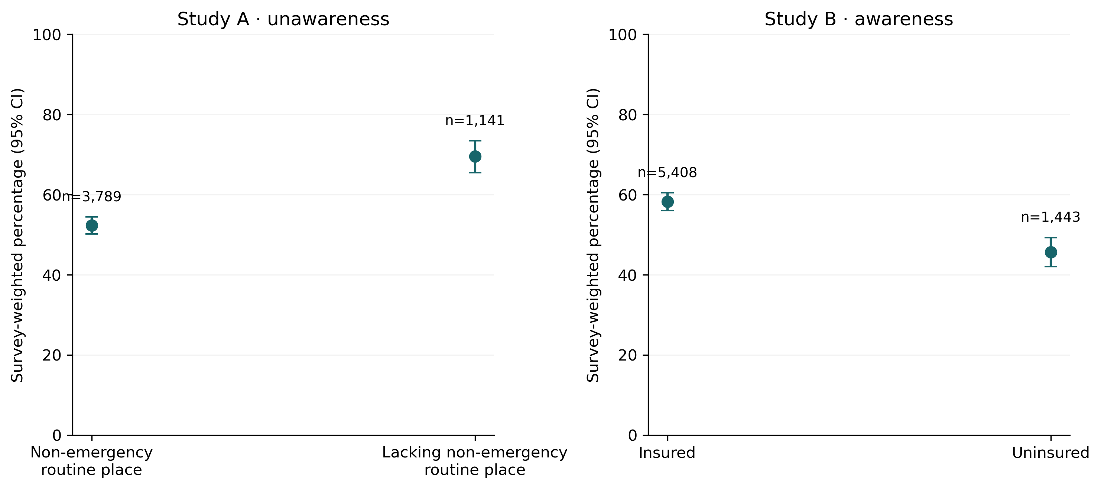
Figure 1. Survey-weighted descriptive outcomes with 95% confidence intervals. Outcomes and populations differ between Study A and Study B.
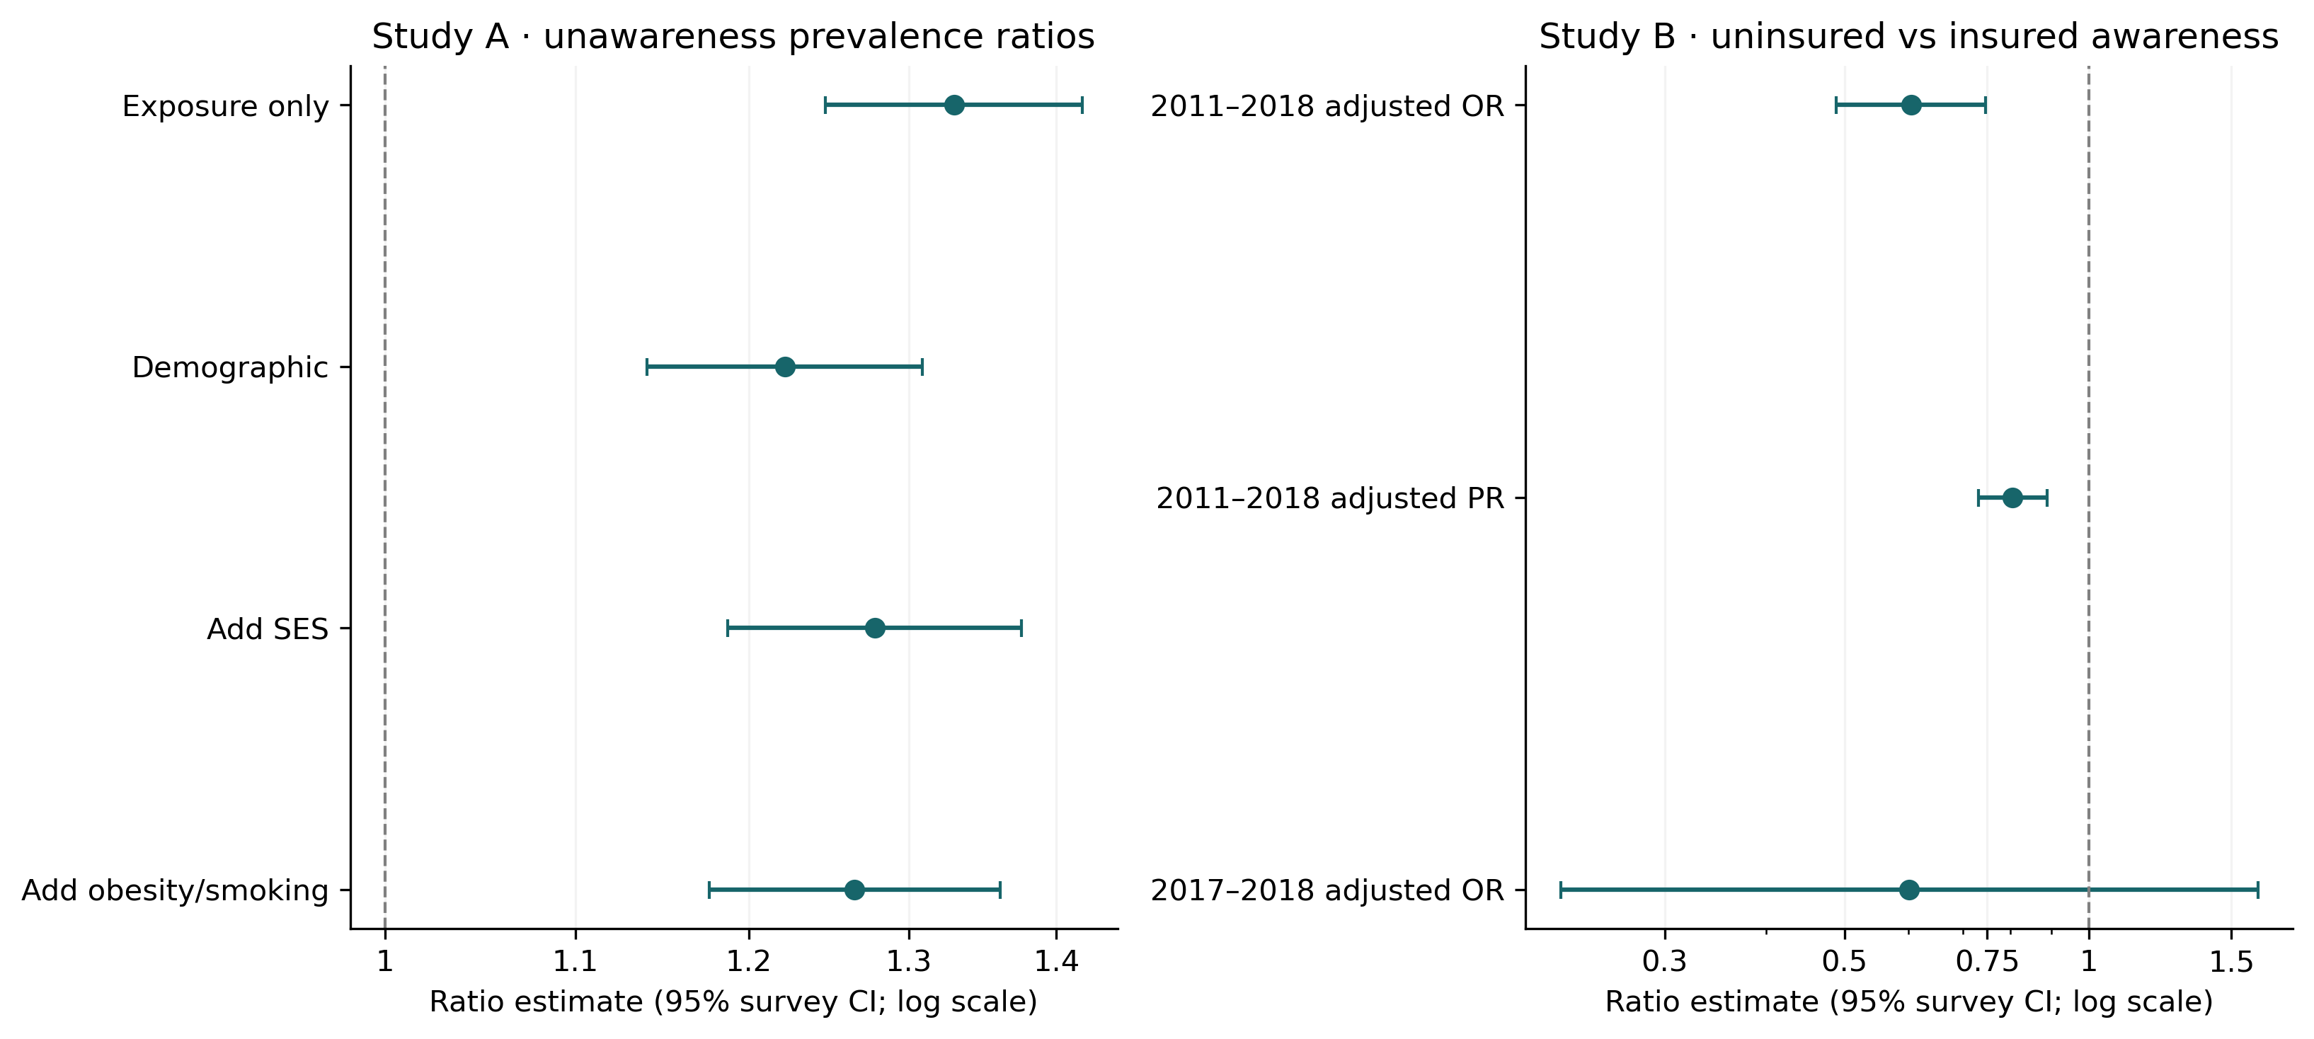
Figure 2. Study A prevalence ratios and Study B adjusted insurance estimates. OR and PR quantify different comparisons; 2017–2018 observations overlap the pooled sample.

Sensitivity analyses and methodological checks
Several robustness analyses were informative without constituting a test of causality. In Study A, defining lack of care as “no usual place” without the additional emergency-room proxy gave adjusted prevalence ratio 1.24 (1.17–1.33), while restricting the place definition to respondents reporting one place gave 1.21 (1.13–1.30). These differences indicate that seemingly small healthcare-utilization coding choices change the analytic comparison. A more restrictive blood-pressure reading rule reduced the complete-case group without materially altering the main association.
In Study B, restricting eligibility to measured elevation yielded adjusted odds ratio 0.73 (0.58–0.92; n=4,951), compared with 0.60 under the medication-inclusive rule. An alternative 140/90 threshold produced adjusted odds ratio 0.62 (0.45–0.87; n=3,989); adding cycle indicators produced 0.59 (0.48–0.73). Removing the income-to-poverty adjustment resulted in 0.67 (0.56–0.81), on a larger sample. These checks suggest a persistent inverse association but also show that eligibility, adjustment and missingness affect the magnitude and the population to which an estimate applies.
The repository’s QA report documents R/Python agreement and a delete-one-PSU jackknife check. These are computational validation activities, not evidence that the chosen exposure, outcome or confounder structures are biologically or causally correct. Modified Poisson fits generated predictions above one for some observations, so the ratios are presented as adjusted associations under working models, not as probabilities for individuals. Predicted and standardized probabilities were derived from the bounded logistic model instead.

Discussion
The two analyses reinforce the importance of distinguishing healthcare access dimensions when interpreting hypertension-recognition research. Study A found a higher reported prevalence of unawareness for individuals without a reconstructed usual non-emergency care location. Study B found lower awareness among uninsured individuals under a different, medication-inclusive case definition. Although these directions are consistent with published concerns about gaps in screening and recognition [1–4], the odds ratio from Study B and prevalence ratio from Study A are not interchangeable, nor do they refer to the same denominator.
The most important contribution for a research-training portfolio is not numerical novelty. It is the ability to move from a documented survey question to auditable variable definitions, model a complex probability sample, compare results with literature, and explain disagreements without adjusting the analysis merely to resemble a benchmark. The 415-person discrepancy between the published Calixte sample and our fully adjusted sample remains unresolved. Routine-place prevalence also differed by approximately 2.8 percentage points. Differences may relate to questionnaire coding, blood-pressure averaging, exclusions and covariate completeness; no particular cause was established from the available published information.
For Study B, the association is substantially more precise in pooled 2011–2018 data than it was in a single survey cycle. However, the temporal direction cannot be inferred: a participant may obtain or lose insurance after an earlier diagnosis, and preexisting illness can influence both coverage and healthcare utilization. Medication-inclusive case selection also conditions eligibility partly on care received, which can select previously aware patients. Race/ethnicity and income measure important social distributions but do not resolve unmeasured insurance history, local access, health literacy, comorbidity or clinician communication.
The survey methods are as important as the choice of regression family. Because NHANES uses stratified clustered multistage sampling, naïve standard errors can give misleading confidence intervals. Weighted estimates, proper subpopulation treatment and masked PSUs were therefore central. Still, survey weighting cannot eliminate all biases associated with nonresponse, questionnaire measurement or item-level missingness. Similar coefficients across R and Python verify implementation consistency, not the scientific validity of every research assumption.

Strengths and limitations
Strengths include harmonization of four public-use NHANES cycles, preserved original single-cycle comparators, documented data provenance, explicit care-place recoding, survey-aware inference, independent computational checks, robust reporting of denominators, and sensitivity analyses that do not conceal unfavorable or ambiguous outcomes. The project deliberately avoids claiming an exact publication replication when the full author-level analytic specification is unavailable.
Limitations include historical cross-sectional sampling; one-visit blood-pressure measurements; self-reported prior diagnosis, medication and current coverage; potential selection bias from medication-inclusive eligibility; residual confounding; structural differences in availability of some variables for ages 18–19; and reliance on a constructed usual-care proxy. Complete-case and response-weighted results require assumptions about missingness. Some log-link working-model predictions exceed one. The published benchmark and the present analyses use overlapping source data, so agreement is not an external validation experiment. Findings describe 2011–2018 and do not estimate contemporary U.S. hypertension awareness.

Next research steps
A replication-focused follow-up should begin by acquiring the full published methods or analytic code for Calixte et al., if accessible, and documenting the exact exclusion flow, usual-place-of-care recoding, blood-pressure averaging algorithm, and prespecified adjustment terms. The immediate objective would not be to obtain a statistically “matching” result, but to determine which verified analytic differences explain the observed variation in sample size and estimates. Differences that persist under identical definitions would then warrant checks of data releases, factor coding, variance estimators, and handling of item nonresponse.
A second extension could compare insurance-associated awareness gaps across prespecified subgroups or later NHANES periods, but only after establishing that group-specific estimates are reliable and survey periods are methodologically comparable. Such work would require a new literature search, suitable interaction estimands, explicit precision criteria, and attention to changes in blood-pressure measurement and survey design. A clinically meaningful question and defensible design should determine the use of advanced statistical tools—not the other way around. Faculty review of these choices would be valuable preparation for doctoral epidemiology research.

Conclusion
This project paired an explicitly approximate reconstruction of Calixte et al. with a four-cycle extension of an existing insurance-awareness analysis. Lower reported hypertension awareness among uninsured adults was estimated with greater precision in the pooled data, while the published-study reconstruction remained methodologically nonidentical despite directionally compatible associations. Transparent decisions, reproducible code, candid uncertainty, and informed interpretation are the principal outcomes of this research-training exercise. Additional expert survey-methods review would be appropriate before presenting the work as a submission-ready journal manuscript.

References
1. Calixte R, Chahal K, Besson A, Kaplan MS. Access to routine health care and awareness of hypertension status among adults: results from NHANES, 2011–2018. Preventive Medicine. 2024;179:107843. doi:10.1016/j.ypmed.2023.107843.
2. Egan BM, et al. The growing gap in hypertension control between insured and uninsured adults: NHANES 1988–2010. Hypertension. 2014;64:997–1004. doi:10.1161/HYPERTENSIONAHA.114.04276.
3. Duru OK, et al. Health insurance status and hypertension monitoring and control in the United States. American Journal of Hypertension. 2007;20:348–353. doi:10.1016/j.amjhyper.2006.11.007.
4. National Center for Health Statistics. Data Brief 278: Hypertension unawareness among US adults, 2011–2014. https://www.cdc.gov/nchs/products/databriefs/db278.htm.
5. Muntner P, et al. Trends in blood pressure control among US adults with hypertension, 1999–2000 to 2017–2018. JAMA. 2020;324:1190–1200. doi:10.1001/jama.2020.14545.
6. CDC/NCHS. NHANES survey methods: weighting and variance estimation. https://wwwn.cdc.gov/nchs/nhanes/tutorials/weighting.aspx; https://wwwn.cdc.gov/nchs/nhanes/tutorials/varianceestimation.aspx.
7. R Core Team and survey package. Survey: analysis of complex survey samples. https://cran.r-project.org/package=survey.
8. STROBE Initiative. Strengthening the Reporting of Observational Studies in Epidemiology. https://www.strobe-statement.org/.

Research integrity and use
Prepared as an AI-assisted research-training writing sample from stored analysis outputs. The applicant must personally verify methods, findings, references and individual contributions before sharing it with faculty. No faculty supervision, peer review, original discovery, or participant-specific IRB determination is claimed. The source repository documents unresolved methodological questions and the distinction between computed and independently reproduced results.

