PSG COLLEGE OF TECHNOLOGY, COIMBATORE – 641 004
DEPARTMENT OF COMPUTER APPLICATIONS
Academic Year 2025-2026 MCA G1 & G2 Sem 4
23MX41- Project Work
Software Requirement Specification (SRS) Document
1) Title of the Project
Predictive Risk Evaluation for Software Modules
2) Student Detail
Roll No. | Name of the Student | Name of the Faculty Guide
24mx124 | Sekar C | Mrs.Manoranjitham A

3) Project Goal:
The goal of this project is to design and develop a Predictive Risk Evaluation system for software modules. The system aims to identify potentially high-risk modules using historical software metrics and machine learning models, enabling development teams to prioritize testing, maintenance, and quality assurance activities efficiently. It also provides a user-friendly web interface for dataset management, model training, and visualization of module risk levels.
4) Project Abstract
Predictive Risk Evaluation is a machine learning–based system designed to improve software quality by identifying risky software modules early in the development process. The system analyzes historical software metrics such as code complexity, module size, defect history, and test coverage to classify modules as low, medium, or high risk.
Users can upload module datasets, perform preprocessing, train prediction models, and view risk predictions through an interactive web interface. By highlighting high-risk modules, the system helps development teams prioritize testing and maintenance efforts. This data-driven approach reduces manual inspection, improves system reliability, and supports effective software quality management.

5) Project Flow Analysis

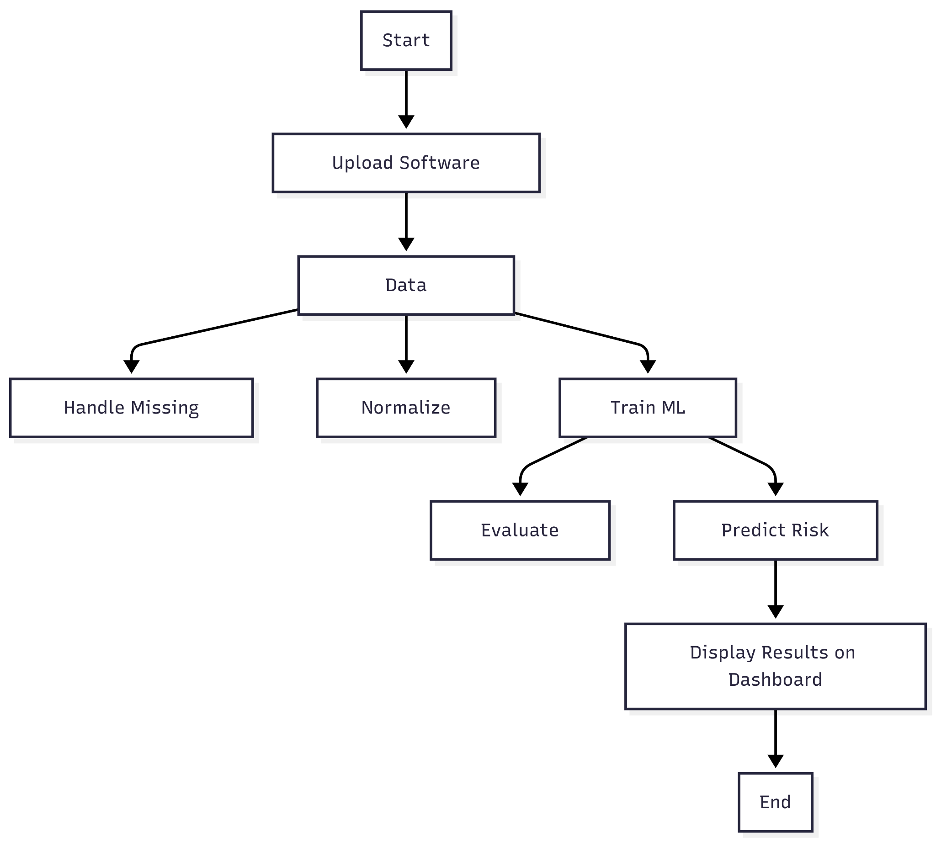

6) Existing System
Current software quality assessment approaches rely mainly on manual code reviews and rule-based tools. While these methods work for basic metrics, they are time-consuming and often fail to capture complex risk patterns in software modules. As a result, they cannot effectively predict future high-risk modules, leading to increased defects and maintenance costs.\

Literature Review
1. Catal, C., Diri, B. – Software Defect Prediction: A Survey, Journal of Systems and Software, 2009.
2. Lessmann, S., et al. – Benchmarking Classification Models for Software Defect Prediction, IEEE Transactions on Software Engineering, 2008.
3. Hall, T., Beecham, S., et al. – A Systematic Literature Review on Software Defect Prediction, IEEE Transactions, 2012.
4. Scikit-learn Documentation – Machine learning algorithms for Python.
5. Scapy Documentation – Packet Manipulation Tool for Python.

7) Outcome of the Proposed Project
- Early identification of high-risk software modules: The system analyzes historical software metrics and predicts modules that are likely to be problematic, allowing developers to focus on critical areas.
- Automated risk assessment using machine learning: Modules are automatically classified into low, medium, or high-risk categories without manual inspection.
- Improved testing efficiency and resource allocation: Development teams can prioritize testing and maintenance on high-risk modules, reducing unnecessary effort on low-risk areas.
- Enhanced project visibility through an interactive dashboard: A web-based dashboard provides real-time insights into module risk levels, highlighting high-risk modules and supporting data-driven decision-making.
- Reduced likelihood of post-deployment failures: By focusing on high-risk modules and leveraging predictive analytics, the system helps prevent defects in production, improving overall software quality.

8) Modules of the Proposed Project – Functional Requirements
- Dataset Management Module
o Upload software module datasets
o Store and manage multiple datasets
- Data Preprocessing Module
o Handle missing values and noisy data
o Normalize and transform features for ML analysis
- Feature Selection Module
o Identify significant software metrics
o Reduce irrelevant and redundant features
- Machine Learning Risk Prediction Module
o Train machine learning models on historical data
o Classify software modules into low, medium, and high risk
- Model Evaluation Module
o Evaluate model performance using accuracy, precision, recall, and F1-score
o Compare multiple models and select the best-performing one
- Dashboard Module
o Display predicted risk levels of software modules
o Visualize results using charts and tables for easy interpretation
9) Non- functional requirements of the Project
- Performance: Efficient and fast processing of software datasets with minimal response time for risk prediction.
- Scalability: Ability to handle large and growing software module datasets across multiple projects.
- Reliability: Consistent and accurate risk predictions without system failure during repeated usage.
- Security: Secure handling and storage of software metrics and project-related data.
- Usability: Simple and intuitive web-based user interface suitable for non-machine learning users.

10) Project Deliverables
- Requirement Specification Document: Contains detailed functional and non-functional requirements of the predictive risk evaluation system.
- Cleaned Datasets and Preprocessing Scripts: Preprocessed and balanced datasets prepared for effective machine learning training.
- Trained ML Models: Machine learning models trained to classify software modules into low, medium, and high risk categories.
- Risk Prediction Engine: Core machine learning engine responsible for evaluating and predicting risk levels of software modules.
- Web-Based Application (MERN Stack): Interactive web application enabling dataset upload, model execution, and visualization of module risk levels.
- Visualization and Reporting Dashboard: Dashboard displaying predicted risk levels, charts, and summary reports for decision support.
- Final Project Report: Complete documentation covering design, implementation, testing, and results.

11) Technology to be used
Technology  Python  Scapy / NumPy  Scikit-learn  Flask / FastAPI  Node.js & Express.js  React.js  HTML, CSS, JavaScript Chart.js  MongoDB  Linux / Windows | Reason for Selection  Easy integration of ML and networking  Efficient data handling and processing  ML model development  Lightweight backend framework  Backend integration and API handling  Frontend development  User interface development  Data visualization  Data storage and management  Secure and reliable development environment

12) Timeline of Activities planned

Sprint | Activities | Duration
Sprint 1 | Requirement analysis, literature review, dataset collection | Jan 1 – Jan 21
Sprint 2 | Data preprocessing, feature selection, ML model training and evaluation | Jan 22 – Feb 25
Sprint 3 | Machine learning risk prediction engine development | Feb 26 – Mar 17
Sprint 4 | Web application (MERN) and dashboard development | Mar 18 – Mar 31
Sprint 5 | Integration, testing, documentation | Apr 1 – Apr 14

Signature of the Student Signature of the Guide

