

Student Name: Ganesh Kumar C

**Final Project: Face emotion recognition**

**PROJECT TITLE: Music Recommendation Based on Face Emotion Recognition.**



**AGENDA:**

1. **Research and Planning**
2. **Data Collection**
3. **Preprocessing**
4. **Face Emotion Recognition Model**
5. **Music Recommendation Model**
6. **Integration**
7. **Testing and Evaluation**
8. **Optimization and Scalability**
9. **Deployment and Maintenance**
10. **Documentation and Presentation**

# PROBLEM STATEMENT:

Nowadays, in the digital age, music is consumed in a more customized way thanks to streaming services that offer enormous libraries based on user preferences. Nevertheless, user input—such as listening history or explicit preferences—is frequently necessary for current recommendation systems to function well, and this input can be sparse and occasionally unreliable. More attention is being paid to creating proactive and more intuitive recommendation systems that take advantage of new technologies like facial emotion recognition in order to improve user experience and engagement Our goal is to develop a novel music recommendation system that can recognize and react to users' emotional states in real-time using facial emotion recognition. The technology will dynamically modify music recommendations based on the user's current mood by analyzing their facial expressions, creating a more immersive and personalized listening experience.

# PROJECT OVERVIEW:

* We benefit from the user-music player interaction that the proposed system presents. The system's goal is to properly capture the face using the camera. The Convolutional Neural Network receives input from captured images and predicts the emotion.
* The playlist of songs is then generated by utilizing the emotion that was captured in the picture. Our suggested system's primary goal is to automatically provide a playlist of songs to alter the user's emotions, which can range from happy to sad to surprised.
* The system under consideration has the ability to identify emotions. In the event that a topic elicits negative emotions, a playlist comprising the most appropriate music genres will be played to elevate the person's mood. Four modules make up the facial emotion recognition-based music recommendation system.
* Real-Time Capture
* Face Recognition
* Emotion Detection
* Music Recommendation

**WHO ARE THE END USERS?**

1. **Individual Music Listeners**
2. **Music Artists**
3. **Mental Health Professionals**
4. **Event Organizers**
5. **Retailers**
6. **Fitness Instructors**

y

YOUR SOLUTION AND ITS VALUE PROPOSITION:

Solution:

1. **Emotion Detection Algorithm**
2. **User Emotion Assessment**
3. **Music Database Enrichment**
4. **Matching Algorithm**
5. **Personalization and Feedback Loop**

Value proposition:

1. **Tailored Listening Experience**
2. **Discovery of New Music**
3. **Mood Regulation**
4. **Enhanced User Engagement**

**5.Competitive Advantage**

# THE WOW IN YOUR SOLUTION:

* Utilize cutting-edge machine learning techniques, such as deep learning and natural language processing, to analyze both musical features and user-generated content (like reviews or sentiment analysis) to understand the emotional context of songs.
* Tailor recommendations based not only on the emotional state but also considering factors like the user's past listening history, cultural background, and current context (time of day, location, etc.). This ensures that recommendations are relevant and meaningful to the user at that moment.
* Implement features that allow users to actively engage with the recommendation system, such as providing feedback on suggested songs or creating custom playlists based on specific emotions or moods. This interactivity increases user satisfaction and helps fine-tune future recommendations.
* Incorporate various input modalities beyond just textual input, such as voice commands, gestures, or even physiological data (like heart rate or facial expressions), to further enhance the accuracy of emotion detection and recommendation.
* Leverage collaborative filtering techniques to identify similarities between users with similar emotional preferences and recommend music based on the collective wisdom of the user community. Additionally, integrate social media features to allow users to share their emotional music experiences and discover new songs through their social networks.
* Encourage users to explore a diverse range of music genres and styles by recommending songs that evoke similar emotions but may belong to different musical categories. This helps broaden users' musical horizons and fosters a deeper appreciation for various forms of music.
* Continuously update the recommendation models based on user feedback and evolving musical trends to ensure that the system remains relevant and effective over time.

MODELLING:

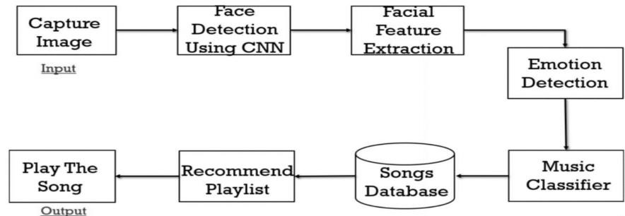

# RESULTS:

