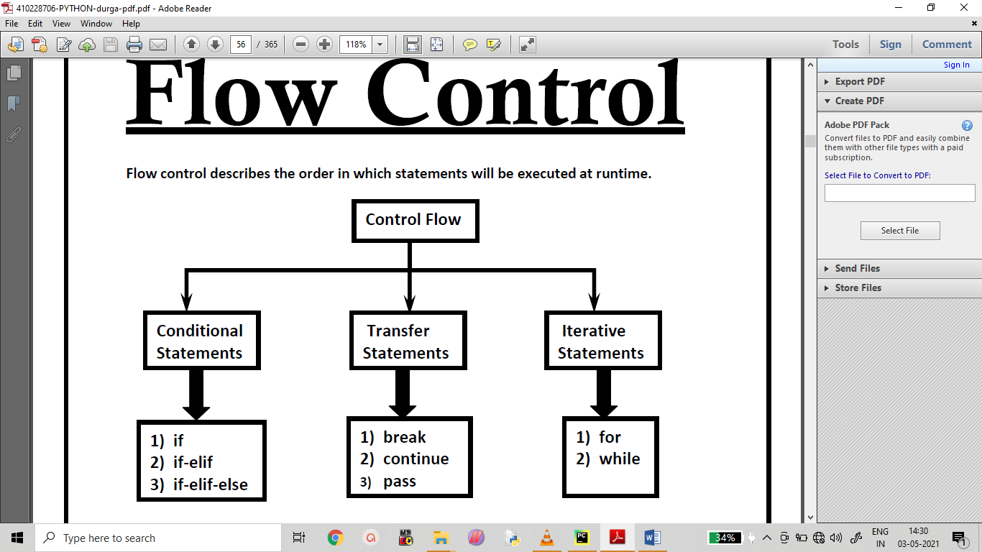

**Conditional Statements**

**1) if**

**if condition : statement**

**or**

**if condition :**

**statement-1**

**statement-2**

**statement-3**

**If condition is true then statements will be executed.**

**Ex 1:**

**name=input("Enter Name:")  
if name=="sekhar" :  
 print("Hello sekhar Good Morning")  
 print("How are you!!!")**

**output:**

**Enter Name:sekhar**

**Hello sekhar Good Morning**

**How are you.**

**Ex 2:**

**x = int(input("enter a no"))  
  
if x > 10:  
 print("x is greater")**

**output:**

**enter a no:11**

**x is greater**

**Ex3:**

**a = int(input("enter a no"))  
if (a == 5):  
 print("The value of a is 5")**

**output:**

**enter a no5**

**The value of a is 5**

**Ex4:**

**x = int(input("enter a no"))  
  
if x <10:  
 print("x is smaller")**

**output:**

**enter a no6**

**x is smaller**

**if-else:**

**if condition:**

**Action-1**

**else :**

**Action-2**

**if condition is true then Action-1 will be executed otherwise Action-2 will be executed.**

**Ex:**

**n1=int(input("Enter First Number:"))  
n2=int(input("Enter Second Number:"))  
if n1>n2:  
 print("Biggest Number is:",n1)  
else :  
 print("Biggest Number is:",n2)**

**output:**

**Enter First Number:12**

**Enter Second Number:34**

**Biggest Number is: 34**

**Ex1:**

**name=input("Enter Name:")  
if name=="sekhar" :  
 print("Hello sekhar Good Morning")  
else:  
 print("Hello Guest Good Moring")  
 print("How are you!!!")**

**output:**

**Enter Name: sekhar**

**Hello sekhar Good Morning**

**Ex2:**

**n=int(input("Enter Number:"))  
if n>=1 and n<=100 :  
 print("The number",n,"is in between 1 to 100")  
else:  
 print("The number",n,"is not in between 1 to 100")**

**output:**

**Enter Number:40**

**The number 40 is in between 1 to 100**

**Ex 3:**

**n=int(input("enter a no"))  
if n%2==0 :  
 print("no is even",n)  
else :  
 print("no is odd",n)**

**output:**

**enter a no24**

**no is even 24**

**Ex4:**

**a = 10  
b = 20  
  
if a > b:  
 print("a is greater than b")  
else:  
 print("b is greater than a")**

**output:**

**b is greater than a**

**Ex5:**

**marks = int(input(" Please Enter Your Subject Marks: "))  
if marks >= 50:  
 print(" Congratulations ") #s1  
 print(" You cleared the subject ") #s2  
else:  
 print(" You Failed") #s3  
 print(" Better Luck Next Time") #s4**

**output:**

**Please Enter Your Subject Marks: 45**

**You Failed**

**Better Luck Next Time**

**if-elif-else:**

**Syntax:**

**if condition1:**

**Action-1**

**elif condition2:**

**Action-2**

**elif condition3:**

**Action-3**

**elif condition4:**

**Action-4**

**...**

**else:**

**Default Action**

**Based condition the corresponding action will be executed.**

**Ex:**

**n1=int(input("Enter First Number:"))  
n2=int(input("Enter Second Number:"))  
n3=int(input("Enter Third Number:"))  
if n1>n2 and n1>n3:  
 print("Biggest Number is:",n1)  
elif n2>n3 :  
 print("Biggest Number is:",n2)  
else :  
 print("Biggest Number is:",n3)**

**output:**

**Enter First Number:1**

**Enter Second Number:2**

**Enter Third Number:34**

**Biggest Number is: 34**

**Ex 1:**

**#0==>ZERO  
#1 ==>ONE  
n=int(input("Enter a digit from o to 9:"))  
if n==0 :  
 print("ZERO")  
elif n==1:  
 print("ONE")  
elif n==2 :  
 print("TWO")  
elif n==3 :  
 print("THREE")  
elif n==4:  
 print("FOUR")  
elif n==5 :  
 print("FIVE")**

**elif n==6 :  
 print("SIX")  
elif n==7:  
 print("SEVEN")  
elif n==8 :  
 print("EIGHT")**  
**elif n==9 :  
 print("NINE")  
else:  
 print("PLEASE ENTER A DIGIT FROM 0 TO 9")**

**Output:**

**Enter a digit from o to 9:3**

**THREE**

**Ex 2:**

**a = int(input("enter a no"))  
b = int(input("enter a no"))  
  
if a > b:  
 print("a is greater than b")  
elif a == b:  
 print("a and b are equal")  
else:  
 print("b is greater than a")**

**output:**

**enter a no23**

**enter a no45**

**b is greater than a**

**Ex 3:**

**s1=input("enter string1")  
s2=input("enter string 2")  
if s1==s2:  
 print("strings are equal")  
elif s1!=s2 :  
 print("strings are not equal")**

**output:**

**enter a no12**

**enter a no23**

**b is greater than a**

**Ex4:**

**brand=input("Enter Your Favourite Brand:")  
if brand=="RC" :  
 print("It is childrens brand")  
elif brand=="KF" :  
 print("It is not that much kick")  
elif brand=="FO":  
 print("Buy one get Free One")  
else :  
 print("Other Brands are not recommended")**

**output:**

**Enter Your Favourite Brand:FO**

**Buy one get Free One**

**NOTE:**

**else part is always optional**

**Hence the following are various possible syntaxes.**

**1. if**

**2. if - else**

**3. if-elif-else**

**4.if-elif**

**There is no switch statement in Python**

**Iterative Statements**

**If we want to execute a group of statements multiple times, then we should go for**

**Iterative statements.**

**Python supports 2 types of iterative statements.**

**1. for loop**

**2. while loop**

**for loop:**

**If we want to execute some action for every element present in some sequence(it may be**

**string or collection) then we should go for for loop.**

**Syntax:**

**for x in sequence:**

**body**

**where sequence can be string or any collection.**

**Body will be executed for every element present in the sequence.**

**Ex:**

**fruits = ["apple", "banana", "cherry"]  
for x in fruits:  
 print(x)**

**output:**

**apple**

**banana**

**cherry**

**Ex1:**

**for x in range(10,0,-1) :  
 print(x)**

**output:**

**10**

**9**

**8**

**7**

**6**

**5**

**4**

**3**

**2**

**1**

**Ex2:**

**for x in range(21) :  
 if (x%2!=0):  
 print(x)**

**output:**

**1**

**3**

**5**

**7**

**9**

**11**

**13**

**15**

**17**

**19**

**Ex3:**

**list=eval(input("Enter List:"))  
sum=0;  
for x in list:  
 sum=sum+x;  
 print("The Sum=",sum)**

**output:**

**Enter List:[1,2,4,5]**

**The Sum= 1**

**The Sum= 3**

**The Sum= 7**

**The Sum= 12**

**Ex4:**

**for x in range(6):  
 print(x)  
else:  
 print("Finally finished!")**

**output:**

**0**

**1**

**2**

**3**

**4**

**5**

**Ex5:**

**for x in range(6):  
 if x == 3:  
 break  
 print(x)  
else:  
 print("Finally finished!")**

**output:**

**0**

**1**

**2**

**Ex6:**

**for x in range(10) :  
 print("Hello")**

**output:**

**Hello**

**Hello**

**Hello**

**Hello**

**Hello**

**Hello**

**Hello**

**Hello**

**Hello**

**Hello**

**Ex7:**

**s=input("Enter some String: ")  
i=0  
for x in s :  
 print("The character present at ",i,"index is :",x)  
 i=i+1**

**output:**

**Enter some String: sekhar**

**The character present at 0 index is : s**

**The character present at 1 index is : e**

**The character present at 2 index is : k**

**The character present at 3 index is : h**

**The character present at 4 index is : a**

**The character present at 5 index is : r**

**Ex8:**

**for x in range(6):  
 print(x)**

**output:**

**0**

**1**

**2**

**3**

**4**

**5**

**Ex9:**

**for x in range(2, 6):  
 print(x)**

**output:**

**2**

**3**

**4**

**5**

**Ex10:**

**for x in range(2, 30, 3):  
 print(x)**

**output:**

**2**

**5**

**8**

**11**

**14**

**17**

**20**

**23**

**26**

**29**

**Ex11:**

**for x in range(11) :  
 print(x)**

**output:**

**0**

**1**

**2**

**3**

**4**

**5**

**6**

**7**

**8**

**9**

**10**

**Ex12:**

**fruits = ["apple", "banana", "cherry"]  
for x in fruits:  
 print(x)  
 if x == "banana":  
 break**

**output:**

**apple**

**banana**

**Ex13:**

**fruits = ["apple", "banana", "cherry"]  
for x in fruits:  
 if x == "banana":  
 break  
 print(x)**

**output:**

**apple**

**Ex14:**

**for i in range(10):  
 if i==7:  
 print("processing is enough..plz break")  
 break  
 print(i)**

**output:**

**processing is enough..plz break**

**Ex15:**

**cart=[10,20,600,60,70]  
for item in cart:  
 if item>500:  
 print("To place this order insurance must be required")  
 break  
 print(item)**

**output:**

**To place this order insurance must be required**

**Ex 16:**

**adj = ["red", "big", "tasty"]  
fruits = ["apple", "banana", "cherry"]  
for x in adj:  
 for y in fruits:  
 print(x, y)**

**output:**

**red apple**

**red banana**

**red cherry**

**big apple**

**big banana**

**big cherry**

**tasty apple**

**tasty banana**

**tasty cherry**

**Ex 17:**

**for i in range(4):  
 for j in range(4):  
 print("i=", i , " j=", j)**

**output:**

**i= 0 j= 0**

**i= 0 j= 1**

**i= 0 j= 2**

**i= 0 j= 3**

**i= 1 j= 0**

**i= 1 j= 1**

**i= 1 j= 2**

**i= 1 j= 3**

**i= 2 j= 0**

**i= 2 j= 1**

**i= 2 j= 2**

**i= 2 j= 3**

**i= 3 j= 0**

**i= 3 j= 1**

**i= 3 j= 2**

**i= 3 j= 3**

**break:**

**We can use break statement inside loops to break loop execution based on some**

**condition.**

**continue:**

**We can use continue statement to skip current iteration and continue next iteration.**

**Ex :**

**fruits = ["apple", "banana", "cherry"]  
for x in fruits:  
 if x == "banana":  
 continue  
 print(x)**

**output:**

**apple**

**cherry**

**Ex1:**

**cart=[10,20,500,700,50,60]  
for item in cart:  
 if item>=500:  
 print("We cannot process this item :",item)  
 continue  
 print(item)**

**output:**

**We cannot process this item : 500**

**We cannot process this item : 700**

**while loop:**

**If we want to execute a group of statements iteratively until some condition false ,then we**

**should go for while loop.**

**Syntax:**

**while condition :**

**body**

**Ex:**

**i = 1  
while i < 6:  
 print(i)  
 i += 1**

**output:**

**1**

**2**

**3**

**4**

**5**

**Ex 1:**

**x=1  
while x <=10:  
 print(x)  
 x=x+1**

**output:**

**1**

**2**

**3**

**4**

**5**

**6**

**7**

**8**

**9**

**10**

**Ex2:**

**i = 1  
while i < 6:  
 print(i)  
 i += 1  
else:  
 print("i is no longer less than 6")**

**output:**

**1**

**2**

**3**

**4**

**5**

**i is no longer less than 6**

**Ex3:**

**n=int(input("Enter number:"))  
sum=0  
i=1  
while i<=n:  
 sum=sum+i  
 i=i+1  
 print("The sum of first",n,"numbers is :",sum)  
 # print("sum:",sum)**

**output:**

**Enter number:6**

**The sum of first 6 numbers is : 1**

**The sum of first 6 numbers is : 3**

**The sum of first 6 numbers is : 6**

**The sum of first 6 numbers is : 10**

**The sum of first 6 numbers is : 15**

**The sum of first 6 numbers is : 21**

**Ex 4:**

**name=""  
while name!="sree":  
 name=input("Enter Name:")  
 print("Thanks for confirmation")**

**output:**

**Enter Name: sree**

**Thanks for confirmation**

**Ex 5:**

**i = 1  
while i < 6:  
 print(i)  
 if i == 3:  
 break  
 i += 1**

**output:**

**1**

**2**

**3**

**Ex 6:**

**count =0  
  
while count < 10:  
 count += 1  
 if count == 5:  
 break  
 print("inside loop", count)  
  
print("out of while loop")**

**output:**

**inside loop 1**

**inside loop 2**

**inside loop 3**

**inside loop 4**

**out of while loop**

**Ex 7:**

**i = 0  
while i < 6:  
 i += 1  
 if i == 3:  
 continue  
 print(i)**

**output:**

**1**

**2**

**4**

**5**

**6**

**Pass:**

**Ex :**

**for n in range(1,10) :  
 if n==3:  
 pass  
  
 else :  
 print(n)**

**output:**

**1**

**2**

**4**

**5**

**6**

**7**

**8**

**9**

**Ex1:**

**n=["sekhar","lakshmi","ashok","deepu","harinath"]  
for x in n :  
 if x=="ashok" :  
 pass  
 else:  
 print(x)**

**output:**

**sekhar**

**lakshmi**

**deepu**

**harinath**

**Ex2:**

**n=(20,30,40,5)  
for x in n :  
 if x>=30 :  
 pass  
 else :  
 print(x)**

**output:**

**20**

**5**

**Ex 3:**

**numbers = [ 1, 2, 4, 3, 6, 5, 7, 10, 9 ]  
#loop through the numbers  
for n in numbers:  
 #check if the number is even  
 if n% 2 == 0:  
 #if even, then pass ( No operation )  
 pass  
 else :  
 print("current no is odd",n)**

**output:**

**current no is odd 1**

**current no is odd 3**

**current no is odd 5**

**current no is odd 7**

**current no is odd 9**

**Ex 4:**

**for i in range(100):  
 if i%9==0:  
 print(i)  
 else :pass**

**output:**

**0**

**9**

**18**

**27**

**36**

**45**

**54**

**63**

**72**

**81**

**90**

**99**